Vincent Ryan

8/20/2024

CSD 340 – Module 3 Landing Page

Web Link:

<https://vfrtist.github.io/BellevueWeb/>

Final Page:

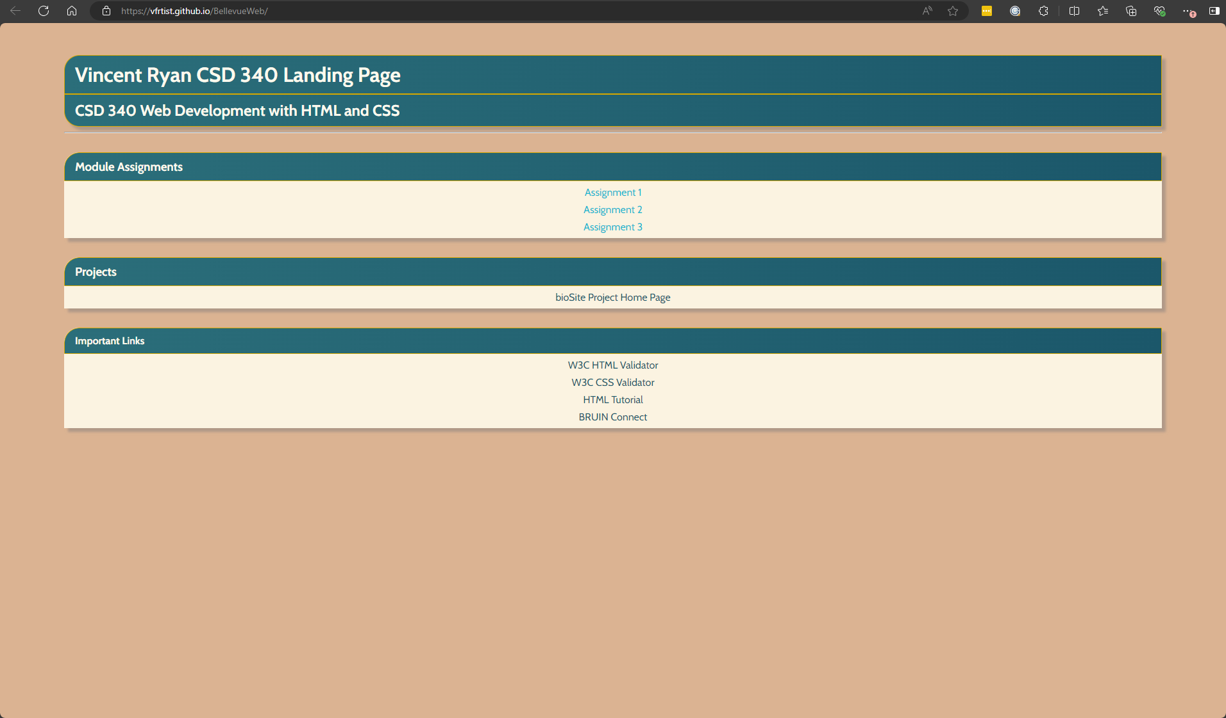

HTML No Errors:

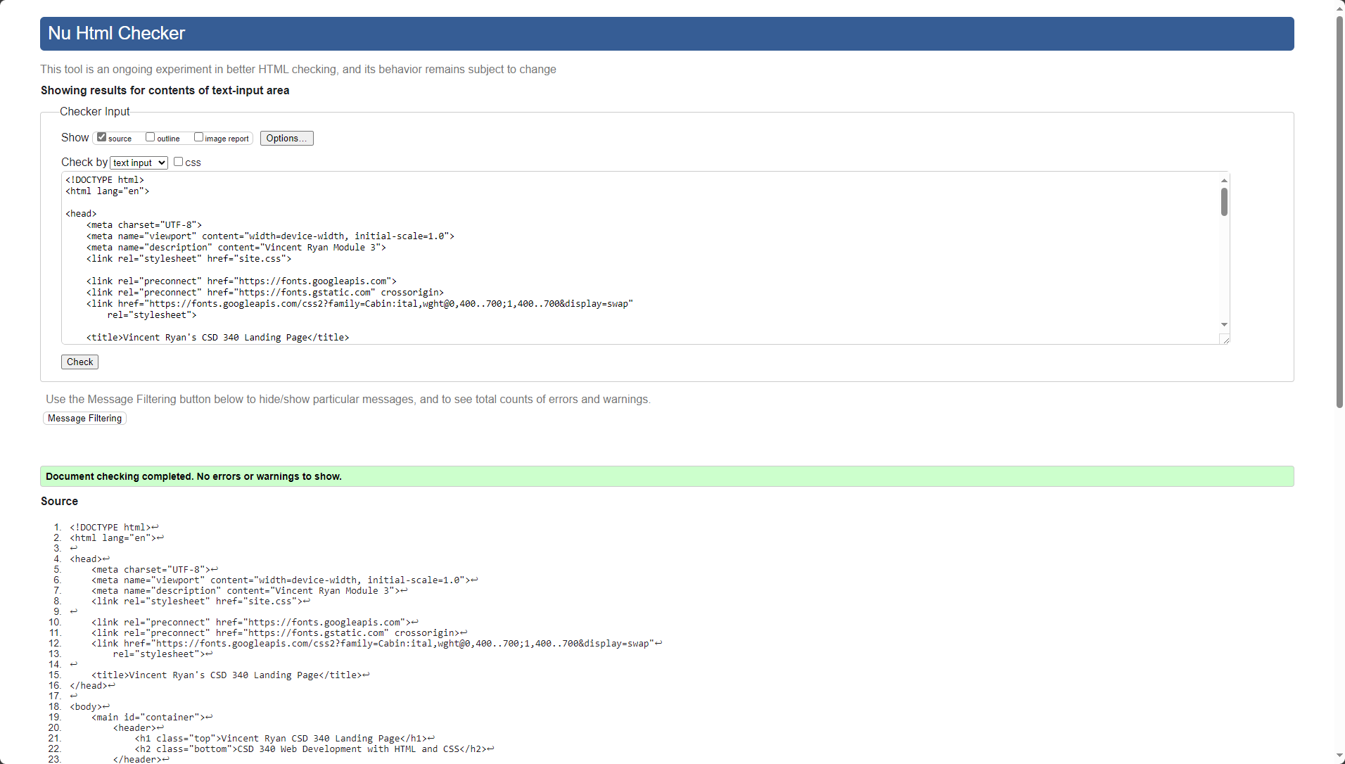

CSS No Errors:

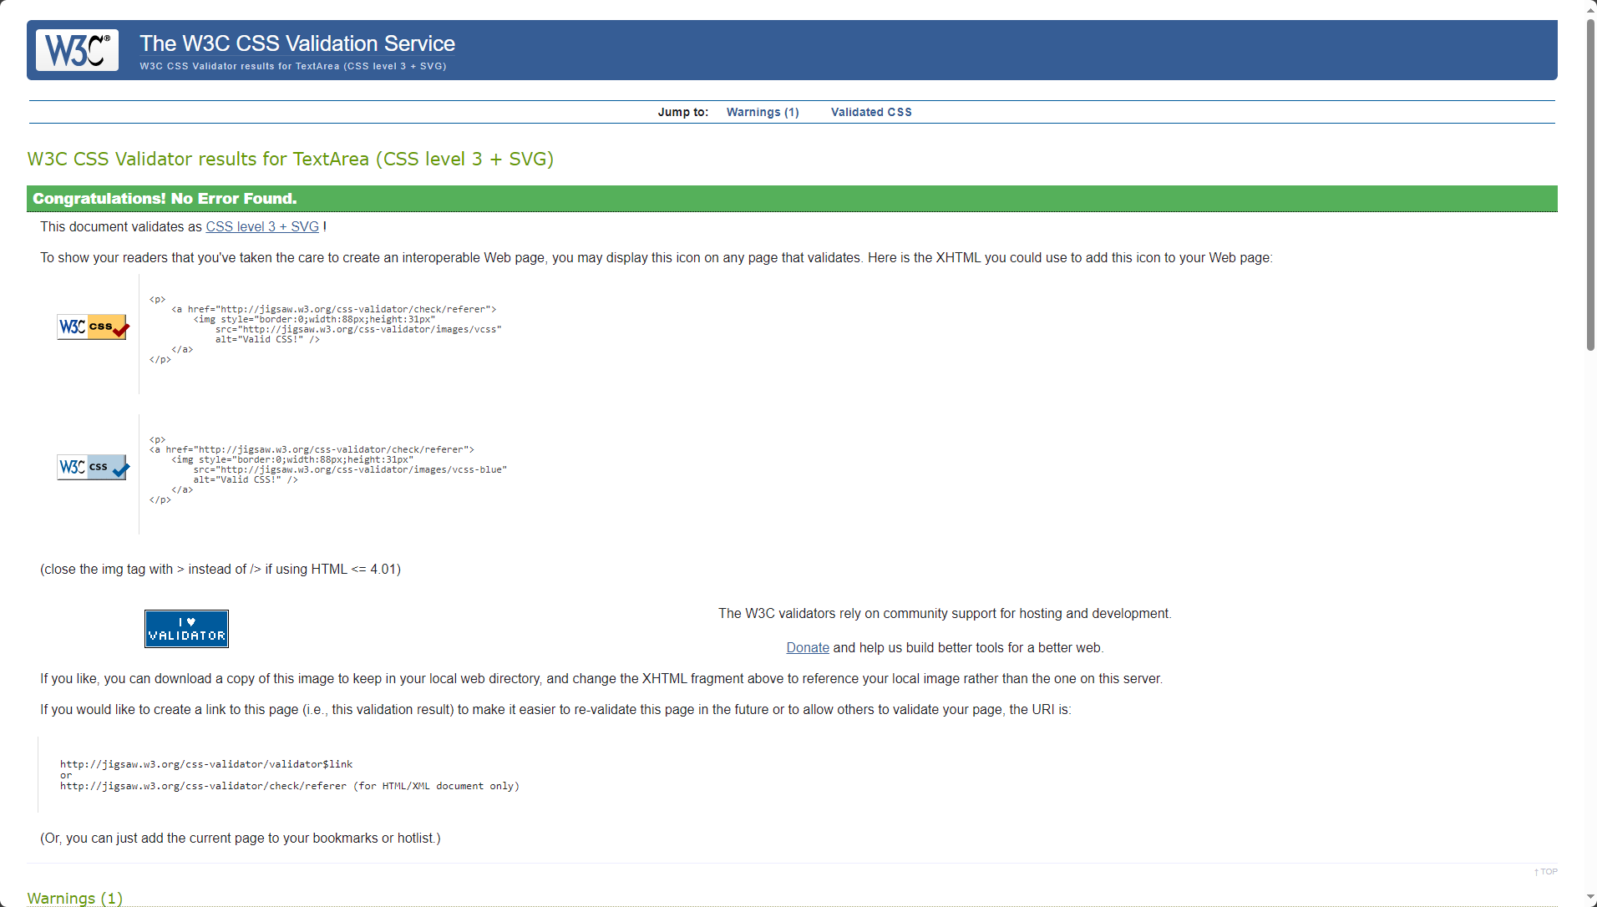The one warning was about variables which were used for colors, so I don’t think they are an issue.