ERA2-DOCX-MARKER

Baseline OOXML document
This paragraph tests bold, italic, and underline text. BASELINE-TEXT-MARKER
- BULLET-ONE
- BULLET-TWO
- BULLET-THREE
- NUMBER-ONE
- NUMBER-TWO
- NUMBER-THREE
TABLE-R1C1 | TABLE-R1C2 | TABLE-R1C3
TABLE-R2C1 | TABLE-R2C2 | TABLE-R2C3
TABLE-R3C1 | TABLE-R3C2 | TABLE-R3C3
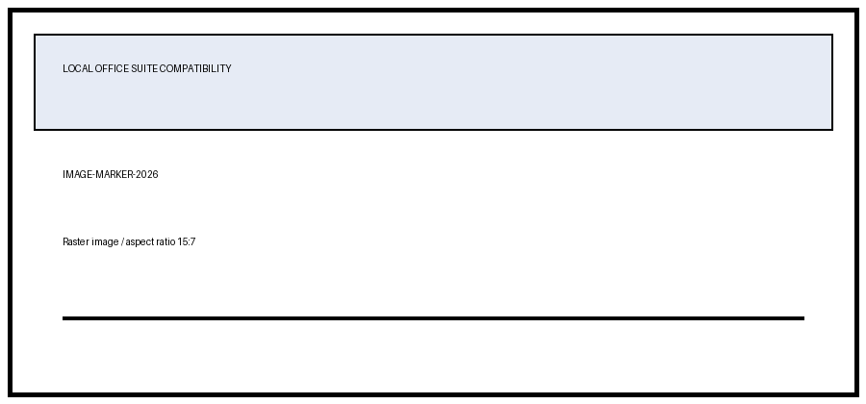
PAGE-BREAK-BEFORE

Second page
ERA2-DOCX-PAGE2-MARKER

