ERA3-DOCX-MARKER
MODERN-BASE-TEXT-MARKER with Aptos-like modern layout.
MODERN-SDT-MARKER
TRACKED-INSERT-MARKER
NORMAL-PRESERVED-MARKER
MODERN-TABLE-A | MODERN-TABLE-B
MODERN-MERGED-CELL
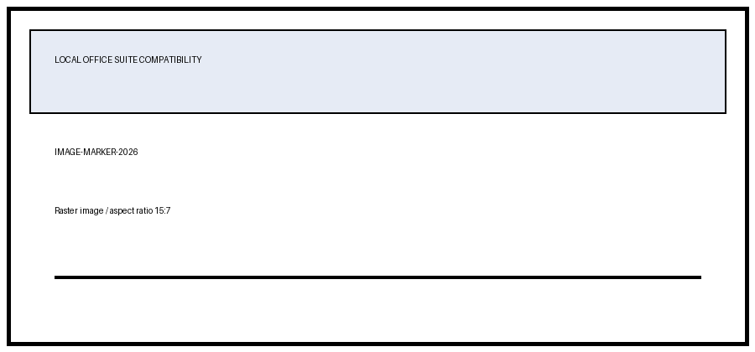

Landscape section
LANDSCAPE-SECTION-MARKER

