FicTabs — "Your world of dramas, all in one tab."
What is FicTabs ?

A streaming platform that provides Asian dramas (K-dramas, C-dramas, T-dramas, etc.) with multilingual subtitles, fewer ads, and global accessibility.
Problem It Solves
Drama fans often:
- Need multiple apps
- Face subscription costs
- Can't access content in some regions
- Struggle with subtitle availability

Value Proposition
"One platform for drama lovers to watch their favorite Asian dramas with subtitles, fewer ads, and no regional restrictions."
The 4 Ps of FicTabs
P | Details
Product | A mobile + desktop app for streaming Asian dramas (K, C, T, J) with multilingual subtitles, community forums, and a cross-platform watchlist tracker
Price | Free (ad-supported) + optional FicTabs Plus at ₹99/month for ad-free + early episode access
Place | Available on Android, iOS, Windows, Mac — accessible in all regions including India
Promotion | Instagram reels, YouTube drama edits, college ambassador program, Reddit drama communities

USER PERSONA :
1.Olivia,28
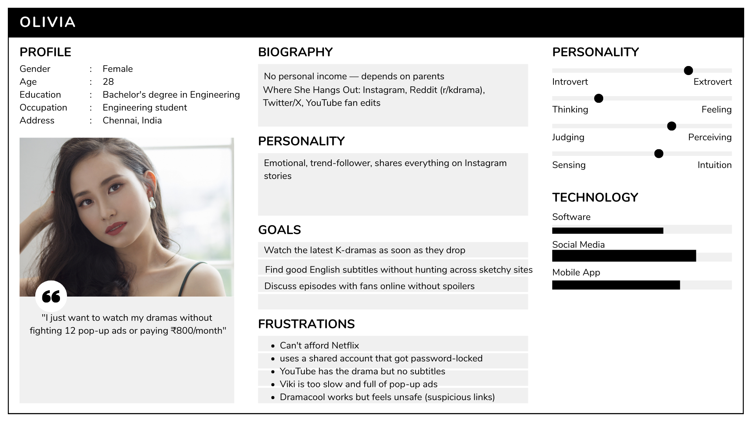
2.Meera,32
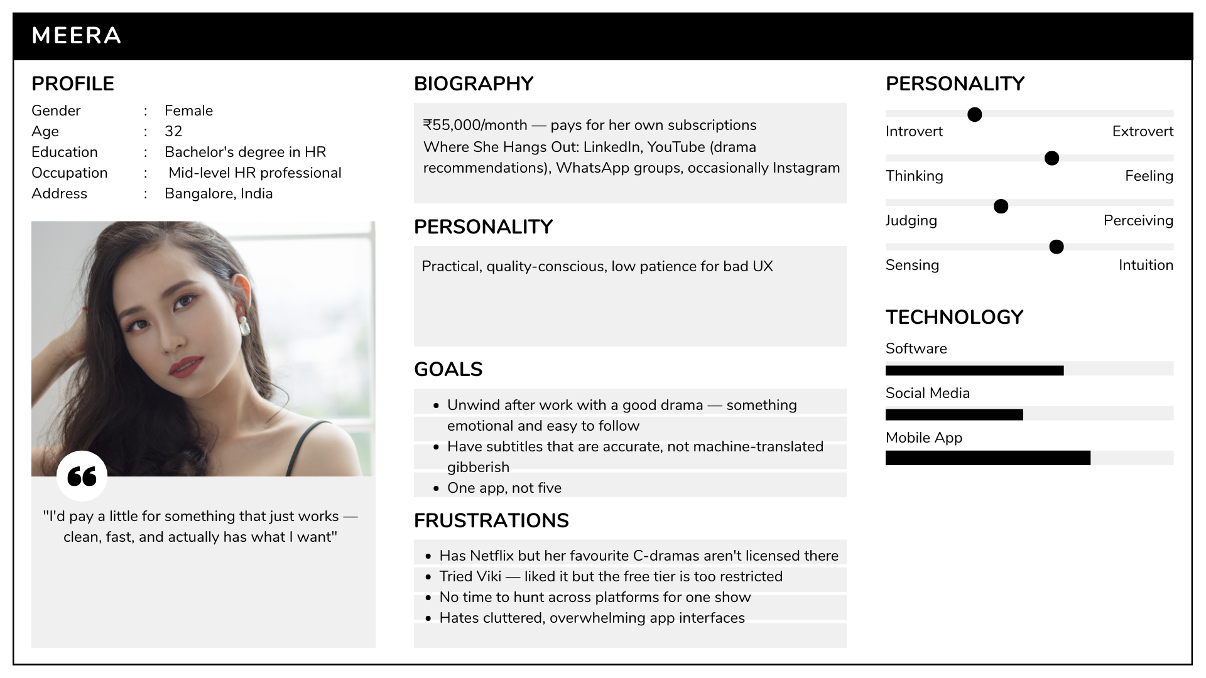

Competitor Analysis :
Factor | Youtube | Viki (by Rakuten) | Dramacool
Strength | Free, familiar interface, huge reach | Huge drama library, fan-subbed subtitles, strong community | Huge free library, fast uploads, works in all regions
Weakness | No subtitles for many dramas, content scattered across 50+ channels, no watchlist, constant algorithm interruptions | Free tier is heavily restricted (many episodes locked), UI feels outdated, slow load times | Illegal/grey-market content, full of malicious ads, no mobile app, feels unsafe, no community features
Pricing | Free / YouTube Premium ₹139/month | Free (limited) / Standard $4.99/month / Plus $9.99/month | Free (ad-heavy)
Region | Some videos are region-locked | Blocked or restricted in some countries | Works everywhere — but sketchy
Social Presence | Massive — but drama content is fragmented | Moderate — not great at engaging younger audiences | None — no official brand presence

Gaps FicTabs can fill:
1.YouTube is a chaos of channels. FicTabs is organised, subtitle-complete, and drama-only — a focused experience YouTube can never be.
2.Viki's free tier is practically unusable. FicTabs offers a genuinely free experience — that's a direct win.
3.Dramacool's biggest weakness is trust. FicTabs is the safe, legal, clean alternative that gives the same free access without the sketchiness

LOGO:
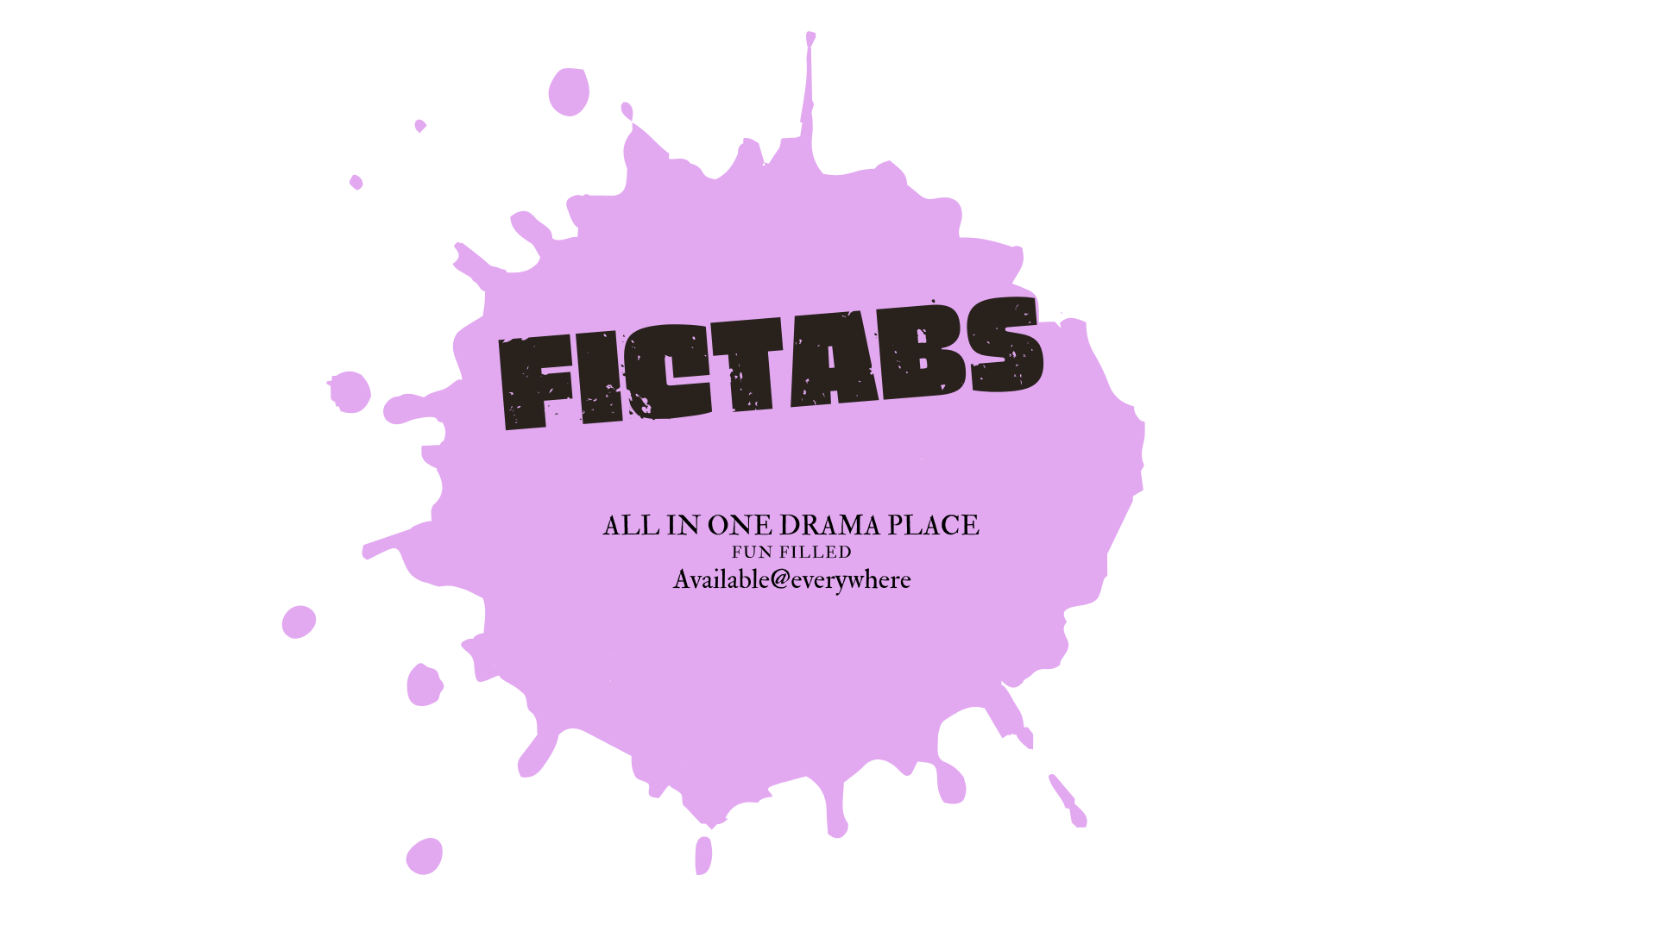

FicTabs Official Positioning Statement
"For young drama fans in India and Southeast Asia who are tired of paying too much, switching between sketchy sites, and missing subtitles — FicTabs is a free, all-in-one streaming and community app that delivers the biggest Asian drama library with accurate multilingual subtitles, safely and legally, in every region — unlike Viki, which locks most content behind a paywall, or Dramacool, which can't be trusted.""

Marketing Insights for FicTabs :

Insight 1 — "Trust is the real product gap, not content"
Observation: Dramacool already has the content. YouTube already has reach. Yet millions of fans still feel underserved.
The Insight:
Drama fans in India don't just want free content — they want free content they don't feel guilty or scared using. Sketchy ads, malware warnings, and piracy guilt are real emotional friction points.

Insight 2 — "Drama fans don't watch alone — they experience together"
Observation: Look at any K-drama subreddit, Twitter hashtag, or WhatsApp group during a popular drama season. The conversation is as big as the show itself.
The Insight:
For this audience, watching is only half the experience. Theorising, reacting, and discussing episodes is the entertainment. No current platform unifies watching + community in one clean space.

Insight 3 — "Your audience discovers content through emotion, not search"
Observation: Ananya (Persona 1) doesn't Google "best K-drama 2024." She sees a 30-second crying scene on Instagram Reels and immediately needs to know what show that is.
The Insight:
This audience is driven by emotional triggers — a beautiful OST clip, a heart-breaking scene edit, a "this show broke me" tweet. Discovery is emotional and social, not intentional.

Insight 4 — "Free means nothing if the experience feels cheap"
Observation: Many "free" drama apps exist — but users still go back to paid platforms or unsafe sites. Why? Because the free experience feels like a punishment — buffering, 5 ads per episode, locked episodes.
The Insight:
"Free" is not a differentiator on its own. The quality of free is what wins loyalty. Users will tolerate 1–2 ads per episode if the app is fast, clean, and reliable. They won't tolerate a bad experience even for ₹0.

Insight 5 — "Regional identity is an untapped emotional hook"
Observation: Most drama platforms are built with a Western or East Asian primary audience in mind. Indian and Southeast Asian fans are an afterthought — no regional language UI, no India-specific payment options, no culturally relevant promotions.
The Insight:
South Asian drama fans feel like second-class users on global platforms. A platform that says "we built this for you" will earn fierce loyalty — because nobody else has ever said that to them.

