Content Strategy & Calendar
Day | Format | Topic | Caption | Hashtags | Content Pillar
Day 1 | Reel | Introduce FicTabs | Tired of switching apps? Your dramas just found a home. 🎬 | #FicTabs #KDrama | Brand Awareness
Day 2 | Carousel | Streaming Problems | Too many subscriptions? Too many apps? We fixed that. | #DramaFans #FicTabs | Pain Points
Day 3 | Story | Poll | K-drama or C-drama? Vote now 👀 | #DramaPoll #FicTabs | Engagement
Day 4 | Reel | Safe Streaming | Stop risking your phone for "free" dramas. FicTabs = free AND safe. | #SafeStreaming #FicTabs | Trust & Safety
Day 5 | Carousel | Drama Recommendations | 5 underrated dramas you need this week 🍿 | #KDrama #DramaRecommendation | Drama Recommendations
Day 6 | Reel | Relatable Content | POV: You finished a 16-episode drama in 2 days 😭 | #DramaAddict #FicTabs | Emotional/Relatable
Day 7 | Twitter Post | Fan Culture | Second Lead Syndrome is real and I refuse to be normal about it. | #SecondLeadSyndrome | Community & Fan Culture
Day 8 | Reel | New Release Alert | New T-drama just dropped and we're already crying. | #TDrama #FicTabs | Drama Recommendations
Day 9 | Static Post | Feature Highlight | Never lose track of your shows — Watchlist syncs everywhere. | #FicTabs #AppFeatures | Behind the Feature
Day 10 | YouTube Short | App Comparison | I tried 5 "free" drama sites so you don't have to 💀 | #FicTabs #AppReview | Trust & Safety
Day 11 | Reel | Relatable Content | Me explaining why my friends NEED to watch this drama immediately. | #KDramaFan #Relatable | Emotional/Relatable
Day 12 | Story + Twitter | Fan Verdict | Friday Fan Verdict — what's your #1 drama of all time? | #FicTabsFanVerdict | Community & Fan Culture
Day 13 | Reel | Weekend Binge | Saturday = drama marathon day 🛋️ Start that drama everyone's talking about. | #SaturdayBinge #FicTabs | Drama Recommendations

FicTabs — Content Pillars Documentation

Pillar 1: Brand Awareness
Purpose: Introduce FicTabs, build recognition, and communicate what makes it different from existing platforms.

What is FicTabs?
FicTabs is a free, all-in-one streaming app built for K-drama, C-drama, and T-drama fans across India and Southeast Asia. It brings together a wide drama library, multilingual subtitles, and a fan community — all in one safe, legal platform, removing the need to juggle multiple unreliable apps.

Features
- Free streaming with minimal ads
- Multilingual subtitle support (English, Tamil, Hindi, and more)
- Cross-platform watchlist that syncs across mobile and desktop
- Built-in fan community for discussions and reactions
- Works reliably across regions, including India

Benefits
- Saves money — no expensive subscriptions needed
- Saves time — one app instead of five
- Saves trust — a safe alternative to sketchy free sites
- Connects fans — community features make watching more social
- Accessible — designed specifically for underserved regional audiences

Sample Content Angles
- "What is FicTabs?" explainer reel
- "5 reasons drama fans are switching to FicTabs" carousel
- Founder/brand story post — why FicTabs was built
- App walkthrough video (UI tour)
- "Before FicTabs vs After FicTabs" comparison post

Pillar 2: Entertainment
Purpose: Keep the audience engaged and entertained with content related to dramas themselves, not just the app.

Drama Recommendations
- Weekly "Hidden Gem" drama spotlight (lesser-known but high-quality shows)
- Genre-based recommendation lists (Romance, Thriller, Historical, Comedy)
- "If you liked [popular drama], watch this next" suggestion posts
- New release alerts and first-impression reactions

Weekend Watchlists
- "Your Weekend Binge List" curated every Friday
- Mood-based watchlists ("Feeling sad? Watch these" / "Need a laugh? Try these")
- Country-specific watchlists (Best of K-drama, Best of C-drama, Best of T-drama)
- Seasonal lists (Monsoon marathon, Festival special watchlist)

Drama Quizzes
- "Which drama character are you?" personality quiz
- "Guess the drama from this one screenshot" challenge
- "How well do you know K-dramas?" trivia post
- "Rate these drama tropes" interactive poll series

Sample Content Angles
- Carousel: "5 underrated C-dramas you need to watch"
- Reel: Quick-fire recommendations with trending audio
- Story quiz sticker: "Which drama trope are you?"
- Poll: "Romance or Thriller — what's your mood this weekend?"

Pillar 3: Community Engagement
Purpose: Build a sense of belonging and conversation, turning passive viewers into an active fan community.

Polls
- "K-drama or C-drama — which do you watch more?"
- "Subtitles on even when you understand the language — yes or no?"
- "Team Main Lead or Team Second Lead?"
- "Binge it all in one sitting or one episode a day?"

Questions
- "What's the one drama that broke your heart?"
- "Which drama do you recommend to EVERYONE you meet?"
- "What's a drama trope you secretly love?"
- "Tag a friend who needs to start watching dramas"

Discussions
- Weekly "Fan Verdict" — community votes on best drama of the week
- Comment-based theory threads for ongoing/trending dramas
- "Unpopular drama opinion" discussion prompts
- Fan art or fan edit reposts with credit (community spotlight)

Sample Content Angles
- Instagram Story poll stickers (quick, low-effort, high engagement)
- Twitter/X discussion threads with casual tone
- "Comment your answer below" carousel posts
- Weekly recurring series: "Friday Fan Verdict"

Pillar 4: Education
Purpose: Build trust and authority by helping the audience understand the platform and the drama-watching experience better.

Subtitle Benefits
- Why accurate subtitles matter (translation nuance, cultural context)
- How FicTabs supports multiple regional languages (Tamil, Hindi, Telugu, Bengali)
- Quick tutorial: "How to switch subtitle languages in 5 seconds"
- Behind-the-scenes: how community-contributed subtitles are moderated for quality

Streaming Tips
- "How to build the perfect watchlist" guide
- "How to avoid unsafe streaming sites" awareness post
- Tips for finding new dramas based on your taste
- How to use FicTabs' watchlist sync across devices

Genre Explanations
- "What is a K-drama, C-drama, and T-drama — what's the difference?"
- Breaking down popular genres (Historical/Sageuk, Office Romance, Revenge drama, Healing drama)
- "What does 'Second Lead Syndrome' mean?" — drama slang explained
- Introduction to drama tropes for new fans (e.g., "Why is everyone obsessed with amnesia plots?")

Sample Content Angles
- Carousel: "K-drama vs C-drama vs T-drama — explained simply"
- Reel: Quick tutorial on switching subtitle languages
- Educational post: "5 signs a streaming site isn't safe"
- Glossary-style post: "Drama terms every fan should know"

FicTabs — Platform-Specific Formatting Notes

Instagram
- Reels — best for reach and discovery; use trending audio, fast cuts, and hook viewers in the first 3 seconds (drama recommendations, relatable content)
- Stories — best for polls, questions, and quick engagement (community engagement pillar); use interactive stickers like polls and question boxes
- Carousels — best for educational content and structured information (genre explainers, app tutorials, multi-point lists); first slide should hook attention, last slide should have a clear CTA

LinkedIn
- Focus on storytelling rather than promotion — share the "why" behind FicTabs, founder insights, or the problem it solves
- Text-based posts perform better than heavy visuals; keep formatting simple with short paragraphs and line breaks for readability
- Best suited for Brand Awareness content — positioning FicTabs as a thoughtful solution to a real audience problem, rather than entertainment content

CONTENT CALENDER:
WEEK 1:
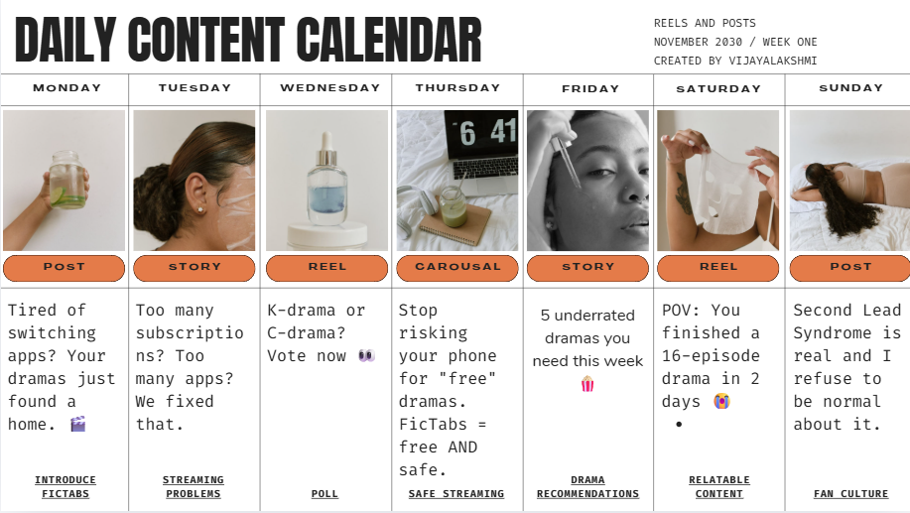

WEEK2:
