PrimeFinder

Basics

PrimeFinder is a RMI Server-Client system for calculating prime numbers. Clients connect to the server and get numbers to calculate prime numbers from, the resulting prime numbers are then sent back to the server.

Server

The server is a simple console program with no user interface, you just start the server with the command java prime.server.Server all server configuration is in the server.xml file in the root folder. The server saves all prime numbers that are found as the data type long in a binary file.

server.xml – Server configuration file located in the package root.

port – the port used for RMI connections.
name – the name used to connect to this RMI service.
interval-size – the nr of numbers to sent to the client every time he request a new interval to calculate.
timeout – the timeout in minutes for clients to calculate there interval.
state-file – file that holds information about the current state of the calculation, used to recover when restarting.
prime-log-file – all prime numbers that are found is saved to this file.

Client

The client has a simple layout that shows how many prime numbers it has found since the session started, how many prime numbers has been found since the client was first run, how many prime numbers has been found by all clients and the highest prime number found.
The client also have two buttons, pause and quit, the calculation can be paused at any moment.

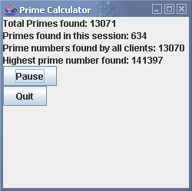
Client interface

client.xml – Client configuration file located in the package root.

server-url – the URL to the server.
stat-file – the path to the file where the total number of prime numbers found by the client is saved.

