API Integration Document

Purpose of API: Enable Customer Profile Management

Clients: Web and Mobile

High level API Flow

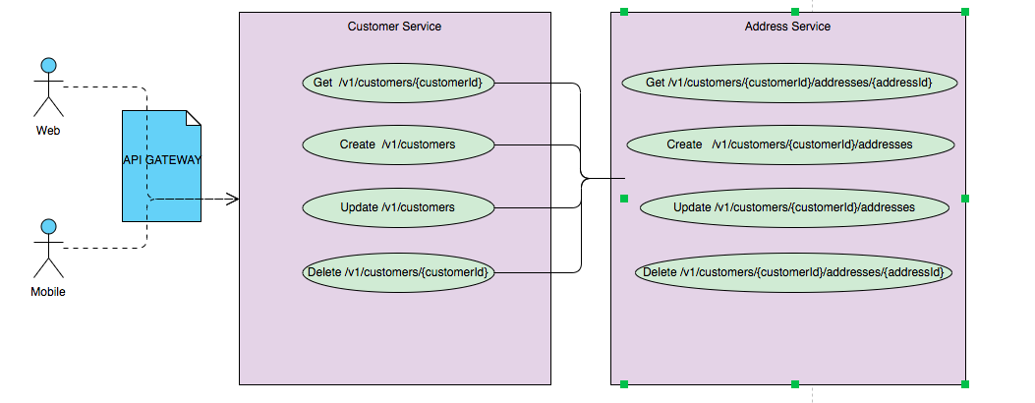

Include further details such as Base Path, HTTP Verbs, Versions, HTTP Response Codes, Associations, Security considerations, sample request/response, link to API Specification document etc in Integration document.