A WhatsApp-based case inquiry system with zero human intervention.
This system is an automated WhatsApp bot that:
- Listen to incoming WhatsApp messages via WhatsApp Web
- Identify the sender’s phone number
- Matches the sender against a case database
- Understands natural text queries like:
  - “Next hearing”
  - “Case history”
  - “Case 12345”
- Retrieves case & hearing information from a database
- Sends a real-time reply back to the user on WhatsApp

Technologies Involved
🔹 Programming Language
- Python
  - Core business logic
  - Text parsing
  - Database access
  - Automation orchestration

🔹 Automation / UI Control
- Selenium WebDriver
  - Controls browser interactions
  - Reads incoming messages
  - Sends replies automatically
- Chrome WebDriver
- WebDriver manager
  - Automatically downloads and manages Chromed River versions

🔹 Messaging Platform
- WhatsApp Web
  - Acts as the interface layer
  - No direct WhatsApp API usage (avoids paid API dependency)

🔹 Database
- SQLite
  - Lightweight, file-based relational database
  - Stores:
    - phone numbers
    - case IDs
    - hearing dates & times

🔹 Data Parsing & Utilities
- re – regex-based text parsing
- datetime – date comparison for upcoming hearings
- time – polling and wait logic

🔹 Browser
- Google Chrome
  - Used via Selenium for WhatsApp Web automation
- 3️⃣ Architecture Overview
- 🔷 Logical Architecture
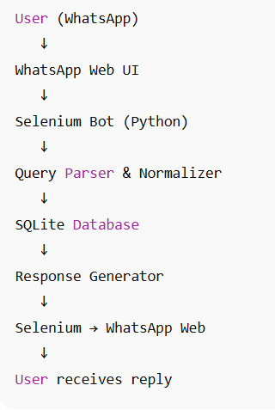
Runtime Architecture:

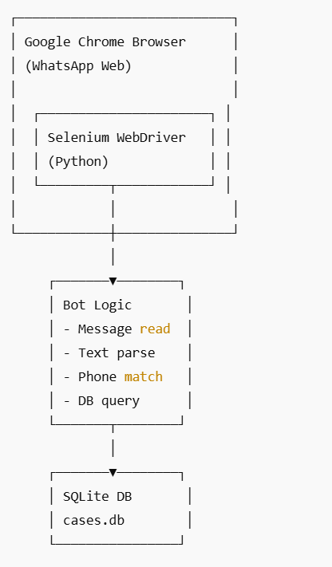
4️⃣ Component-by-Component Explanation

🔹 A. Phone Normalization (normalize phone)
Purpose
WhatsApp internally formats phone numbers with prefixes like:
false_919876543210@c.us
To ensure correct user matching, you:
- Strip non-numeric characters
- Match last 10 digits only
Why This Is Important
- Handles country codes
- Handles WhatsApp internal IDs
- Prevents duplicating user records
Logic Summary
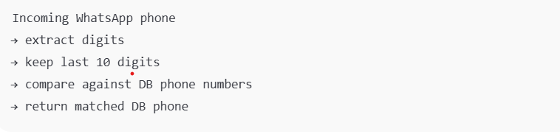
🔹 B. Query Understanding (search case)
This is the core intelligence layer.
Supported Query Types
User Message | Behavior
next hearing | Finds nearest future hearing
case history | Lists of all hearings
case 12345 | Fetches hearings for that case
Unknown text | Returns help message
Query Flow
- Normalize sender phone
- Check if phone exists in DB
- Extract case number (regex)
- Apply priority:
  - History queries first
  - Then next hearing
  - Then case look up
- 🔹 C. Database Layer (SQLite)
- Table Assumption
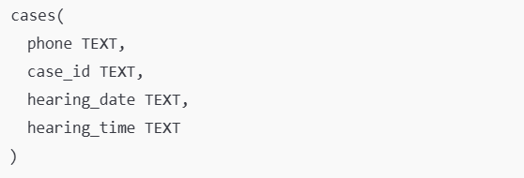
Why SQLite?
- No server setup
- Single-file portability
- Perfect for low–medium scale
- Easy to migrate later to PostgreSQL/MySQL

🔹 D. WhatsApp Message Listener (Selenium Loop)
Key Responsibilities
- Poll WhatsApp Web every ~1.5 seconds
- Identify latest incoming message
- Avoid duplicate processing
- Extract:
  - message text
  - Sender phone
DOM Strategy
You use:
- data-id attribute to extract phone
- message-in class to detect incoming messages
- XPath selectors for reliability

🔹 E. Reply Sender (Selenium)
Flow
- Find message input box
- Focus the box
- Send reply text
- Press ENTER
This simulates exactly what a human would do, making it very reliable.

5️⃣ End-to-End Request Flow (Step-by-Step)
Example: User sends “next hearing”
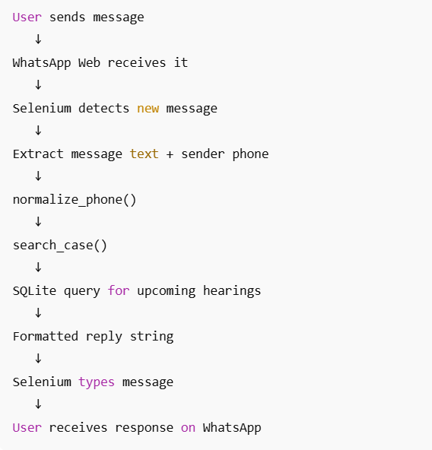
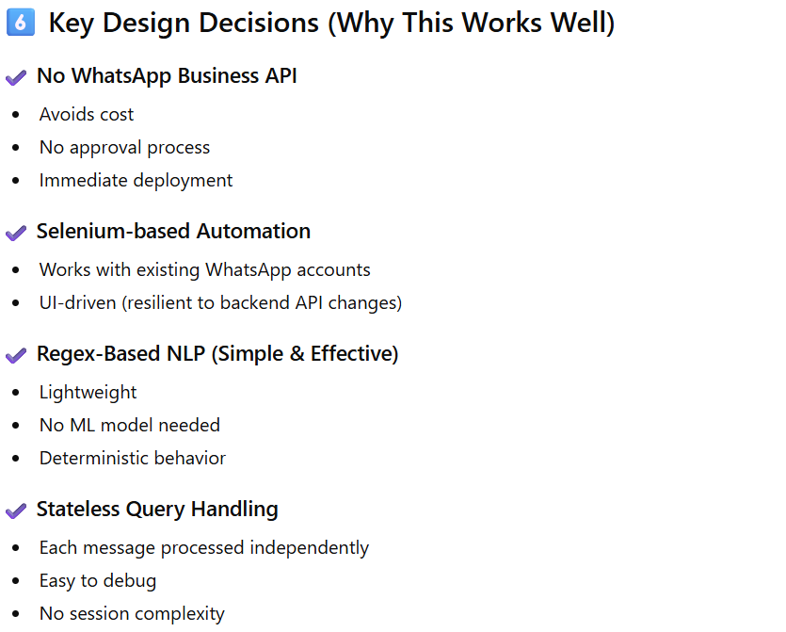
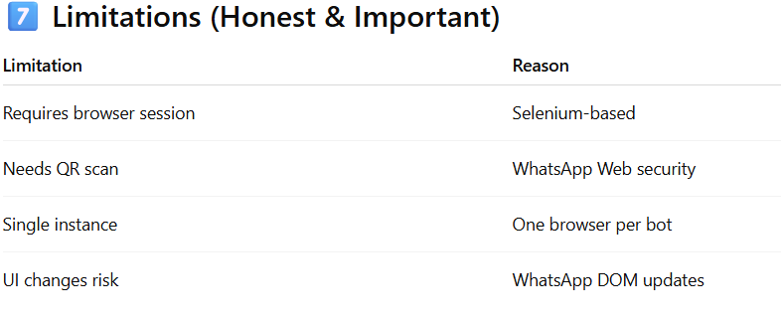
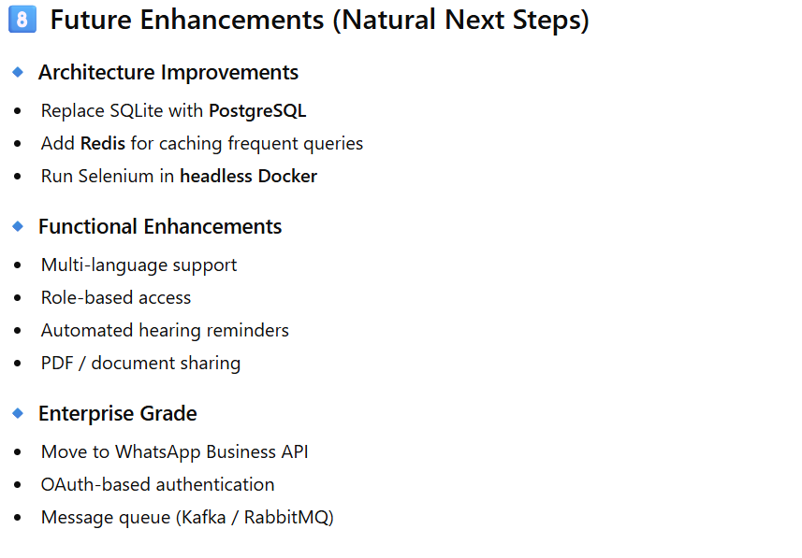
In Natural Language Processing (NLP), regex (regular expressions) is a foundational, rule-based technique used to identify and manipulate specific text patterns within large amounts of unstructured language data. It is a powerful tool for initial data handling and extraction tasks before more complex machine learning models are applied.
Meaning and Function
A regular expression is a specialized sequence of characters that defines a search pattern. By using regex in NLP, a computer can efficiently perform "find," "find and replace," and extraction operations on strings based on defined rules, rather than relying on statistical models or deep contextual understanding. It acts as a concise, algebraic notation for characterizing a set of strings.
Common Applications in NLP
Regex is highly effective for tasks where the target information follows a predictable or consistent format.
- Text Preprocessing and Cleaning: Removing unwanted characters, symbols, HTML tags, or excessive whitespace to prepare text data for analysis.
- Tokenization: Splitting sentences into words or phrases based on defined delimiters like spaces and punctuation.
- Information Extraction: Identifying and pulling out specific data types that have a fixed pattern, such as:
  - Email addresses (e.g., username@domain.com)
  - Phone numbers and dates
  - URLs and hashtags
- Rule-Based Entity Recognition: Creating simple rules to find specific types of information, like identifying all words that start with a capital letter as potential names or locations.
- Data Validation: Ensuring input data conforms to a required format (e.g., a valid date or ID number).
Key Limitations
While fast and efficient, regex has limitations because it is purely pattern-based and cannot interpret the meaning or context of human language. It works well for "regular languages" with predictable patterns but struggles with the inherent ambiguity and complexity of human communication, such as sarcasm, synonyms, or nuanced context, which are better handled by advanced machine learning and deep learning models.

