TECHNICAL PROPOSAL
RITES/ITES/APR/2026 · PARAKH — AI-Based DPR Appraisal Platform
Sections 3–8: Technical Approach

§3 | Understanding of Scope and Requirements

3.1 The Problem — DPR Appraisal Today at RITES
RITES produces and appraises Detailed Project Reports across eight infrastructure sectors. A typical DPR is 500–5,000 pages of mixed content: narrative text, structured engineering tables, scanned drawings, GIS overlays, and financial models — often digitised from paper originals at 100% scanned quality. Despite this scale and complexity, the current appraisal process is entirely manual:
- Reviewers work with ad-hoc checklists, Excel sheets, and handwritten comments — no structured validation system
- DMS tools (eOffice, SharePoint) route documents but provide zero technical validation or engineering logic
- Engineering tools (traffic modelling, geotechnical software, BIM) operate in discipline-specific silos — no cross-DPR consistency checking
- 1,000+ historical DPRs exist in the RITES repository — untapped for benchmarking
- No traceable audit trail of technical observations, scoring logic, or approval decisions

Seven Gaps That Exist Today
None of the following capabilities exist in RITES today: (1) automated completeness check of a DPR, (2) stakeholder input verification, (3) unrealistic technical input detection, (4) cross-section quantity and cost cross-checking, (5) automated appraisal summary generation, (6) audit trail of technical review, (7) benchmarking against historical DPRs. PARAKH addresses every one of these gaps within the 9-month delivery timeline.

3.2 PARAKH — Our Solution Vision
PARAKH is not an AI wrapper. It is a data-driven, rules-first, knowledge-graph-anchored decision-support platform where AI augments but never replaces deterministic engineering logic. The platform's primary reasoning engine is a multi-sector Knowledge Graph — the LLM is called only when the graph cannot answer a question deterministically. This architecture is what makes PARAKH low-compute, explainable, and fully traceable.
Human-in-the-loop is not a feature — it is an architectural constraint. No AI output is ever auto-accepted into the appraisal record. Every anomaly flag, every validation result, every appraisal summary draft requires explicit human reviewer confirmation before it is recorded. All final appraisal decisions remain with designated RITES authorities.

3.3 All 16 Modules — Full Scope Coverage
Module | Name | Our Approach
M1 | Admin, Users, Roles & Governance | Keycloak SSO + RBAC + ABAC; immutable audit trail streamed to OpenSearch SIEM
M2 | Master Data Management | 13 sectors; configurable Site & Context masters (terrain, soil, seismic, hydrology) feeding KG
M3 | DPR Template Creation Engine | 4-level hierarchy; conditional fields driven by site context; calculated cross-section columns
M4 | Role-to-DPR Mapping | Section-to-department mapping; Appraisal Readiness Indicator; configurable notifications
M5 | Dictionary & Standards Repository | IS/IRC/RDSO/CPWD/AAI/MoPSW library; controlled vocabulary; cost head hierarchy
M6 | Ontology & Dependency Framework | OWL/RDF KG; 8 sector ontologies; 100+ dependency rules at Go-Live; RITES SME sign-off per sector
M7 | Historical DPR Repository & Benchmarking | Cost/km benchmarks by terrain/geography; vector similarity search; pattern recognition
M8 | DPR Authoring / Submission Interface | Site context first; structured forms; inline benchmarks; version control; 4 scenario comparison
M9 | Completeness Validation Engine | 5 completeness check types; assisted computation; pre-appraisal gate
M10 | Technical Validation Engine | Range-based; contextual (soil/foundation, bridge/hydrology); standards-based; OOM detection
M11 | Consistency Engine | BOQ vs cost summary; design vs investigation alignment; NLP narrative cross-check
M12 | Anomaly Detection Engine | Statistical (IQR/Z-score); pattern-based; benchmark-comparative; AI-assisted for complex anomalies
M13 | Review Workflow & Scoring | Configurable state-machine; parallel review tracks; configurable scoring frameworks
M14 | Reporting & Appraisal Dashboard | DPR + portfolio dashboards; 5 report types; PDF/DOCX/XLSX export
M15 | Simulation & Sensitivity Analysis | Tornado charts; scenario modelling (4 scenarios); FIRR/EIRR sensitivity
M16 | Security, Audit & Monitoring | OWASP Web + API + LLM; 2× VAPT; SSDLC; SBOM; Zero Trust; sovereign AI boundary

3.4 Key RFP Challenges and Our Approach
Challenge | Our Specific Response
Sovereign AI — zero external LLM API calls in production (ATC2 Clause 5.18) | Hard architectural boundary in Staging/UAT/Production. LiteLLM Proxy blocks all non-whitelisted model endpoints. Gemma 4 + Sarvam-M self-hosted on vLLM. Verified in VAPT.
Scanned DPRs up to 5,000 pages | Docling + Granite-Docling-258M VLM: 30× faster than traditional OCR, native table/figure extraction. Accuracy targets progressively build from ≥85% (M2) to ≥95% (M4) per ATC2 SLA.
8-sector standards complexity (IRC, RDSO, IS, CPWD, AAI, MoPSW) | Separate KG ontology per sector; RITES SME sign-off per sector (10 working days SLA in M1 SRS). KG is the primary validation engine — not the LLM.
No vendor lock-in / DPI principles | 100% Apache 2.0/MIT/BSD stack. LLM-agnostic gateway (LiteLLM Proxy). Full source code handover at M4. Any model swappable via config change.
GPU must be justified — not assumed (ATC2 Section 3) | Gemma 4 26B MoE activates only 3.8B parameters per token — 8× compute saving over 31B Dense. 70–80% of validation runs as SPARQL + Drools (zero GPU). GPU called only for reasoning and generation tasks. Full benchmark in M1 SRS.
Nothing deployed without RITES sign-off (ATC2 Section 6.8) | All ontologies, rules, scoring frameworks, AI models submitted to RITES pre-deployment. Approval SLA written into M1 SRS. Delays against agreed SLA pause the LD clock.

§4 | Solution Architecture

4.1 The Eight-Layer Stack — Overall Architecture
The platform is organised as eight horizontal layers, each with a clearly defined responsibility, communicating only through well-defined API contracts. The diagram below shows the full stack with all component choices.

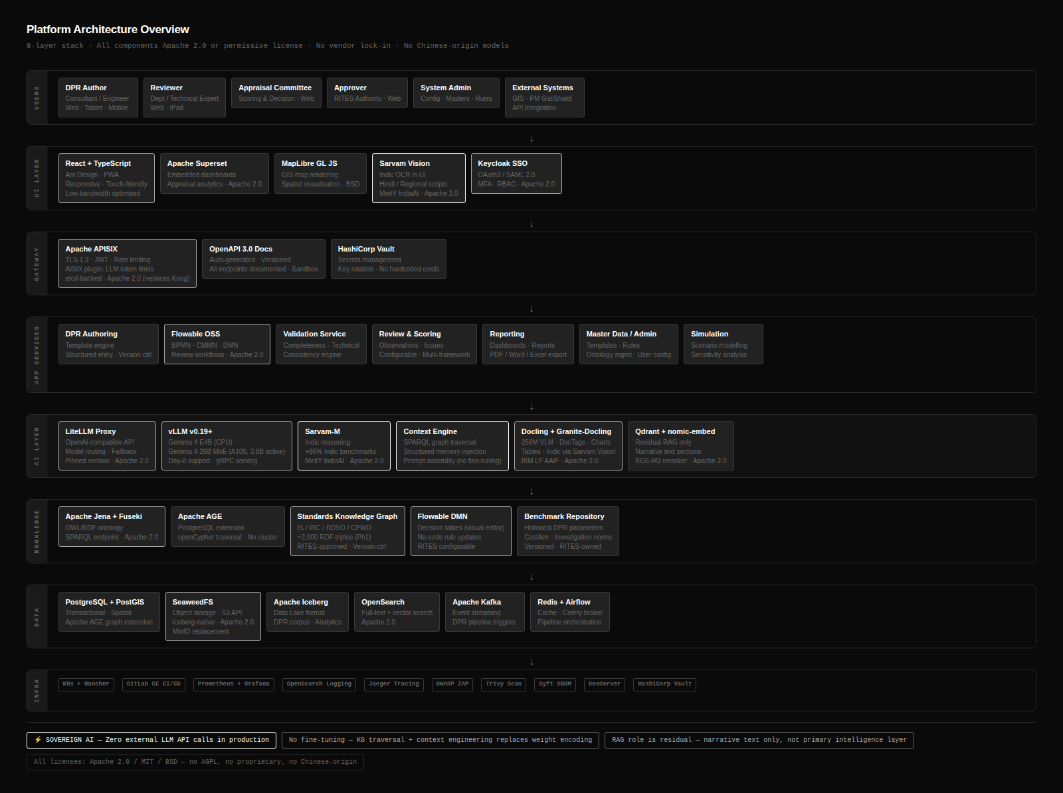
Figure 4.1 — PARAKH 8-Layer Architecture Stack (all components Apache 2.0 / permissive license, no vendor lock-in)

Layer-by-Layer Narrative
Layer | What It Does | Key Components | Why This Choice
1. User Interface | Role-based dashboards, DPR authoring forms, GIS map views, observation entry, approval workflows | React + TypeScript + Ant Design; Apache Superset (analytics); MapLibre GL JS (GIS) | React is the RFP-preferred stack. Ant Design provides enterprise-grade form components critical for structured DPR data entry. Superset embeds analytics without a separate BI tool licence.
2. API Gateway | Single entry point for all external and inter-service traffic. Authentication, rate limiting, logging, routing. | Apache APISIX (Apache 2.0) | APISIX chosen over Kong CE: native plugin ecosystem, hot-reload config without restart (critical for zero-downtime config changes in production), active Apache Foundation governance, identical Apache 2.0 licence.
3. Application Services | Business logic for all 16 modules. Async processing queue for heavy AI jobs. BPMN workflow engine for M13 review routing. | FastAPI (Python); Celery + Redis; Flowable OSS (BPMN + DMN) | FastAPI is RFP-preferred and the fastest Python API framework. Flowable OSS provides the configurable state-machine workflows required by M13 without code deployment — drag-and-drop BPMN diagrams.
4. AI / LLM Layer | Tiered model inference: small models for real-time tasks, large models only for complex reasoning. LLM-agnostic routing. All models self-hosted. | vLLM v0.19+; LiteLLM Proxy; Gemma 4 (E4B, 26B MoE); Sarvam-M; Granite-Docling-258M; Qdrant; nomic-embed-text / BGE-M3 | Detailed in §4.5. Key point: 70–80% of validation bypasses this layer entirely — handled by KG + rules engine below.
5. Rules & Knowledge Engine | Deterministic first-pass reasoning. SPARQL queries over KG answer most validation questions instantly. Drools DMN handles business rules. This layer runs before any LLM is invoked. | Apache Jena + Fuseki (OWL/RDF); Apache AGE (graph on PostgreSQL); Apache Drools OSS | KG-first is the fundamental compute reduction strategy. A SPARQL query answering "does this bridge design have hydrology inputs?" takes milliseconds and requires no GPU.
6. Data Layer | Transactional data, spatial data, document search, caching, object storage for DPR files and model weights. | PostgreSQL 15+ + PostGIS; OpenSearch 2.x; Redis 7+; SeaweedFS | PostgreSQL + PostGIS is the RFP-preferred stack. SeaweedFS replaces MinIO: identical S3-compatible API, Apache 2.0 licence (MinIO uses AGPL/SSPL, excluded per ATC2).
7. Streaming & Orchestration | Event-driven processing of document ingestion, validation triggers, AI job queuing, notification delivery. Scheduled batch jobs for model fine-tuning and benchmark updates. | Apache Kafka; Apache Airflow | Kafka provides fault-tolerant, scalable event bus. Schema registry (Apicurio, Apache 2.0) enforces message schema versioning. Airflow orchestrates the scheduled batch pipelines.
8. Infrastructure & Observability | Container runtime, orchestration, CI/CD pipeline, full-stack monitoring (metrics, tracing, logging), security scanning. | Docker + Kubernetes + Rancher; GitLab CE; Prometheus + Grafana; Jaeger; OpenSearch + Fluent Bit; Trivy; Syft/Grype | All Apache 2.0. Rancher provides the Kubernetes management UI needed by RITES IT team post-handover without additional licences.

4.2 Three-Layer Logical Architecture
Cutting across the 8 technical layers is a 3-layer logical architecture that maps directly to the DPR lifecycle:
Logical Layer | Modules | Technical Layers (from §4.1) | Key Data Flow
LAYER A  DPR Preparation | M1, M2, M3, M4, M8 | UI → API Gateway → App Services → Data Layer | Author enters DPR data → templates enforce structure → site context activates dependency rules → document stored in SeaweedFS → Kafka event triggers IDP pipeline
LAYER B  Appraisal & Evaluation | M5, M6, M9, M10, M11, M12, M13 | App Services → Rules & KG Engine → AI/LLM Layer (when needed) | Submitted DPR → KG dependency check (SPARQL, instant) → Drools rules validation (instant) → statistical anomaly detection → LLM reasoning only for complex multi-parameter anomalies → reviewer workflow
LAYER C  Knowledge & Decision Support | M7, M14, M15, M16 | Data Lake (Apache Iceberg on SeaweedFS) ← all layers | Historical DPR data flows into benchmarking engine; appraisal outcomes feed back into KG refinement; dashboards aggregate from PostgreSQL and OpenSearch; security audit trail streams to SIEM

Closed-Loop Design
PARAKH is designed as a closed-loop system: data captured during DPR preparation and appraisal is continuously leveraged for validation, benchmarking, and feedback — improving DPR quality over time. A highway DPR submitted in Year 2 benefits from all the validation outcomes and reviewer corrections collected in Year 1.

4.3 DPR Processing Pipeline
The pipeline below shows how a DPR flows from raw upload to structured appraisal output — across six swim lanes representing the major processing stages.

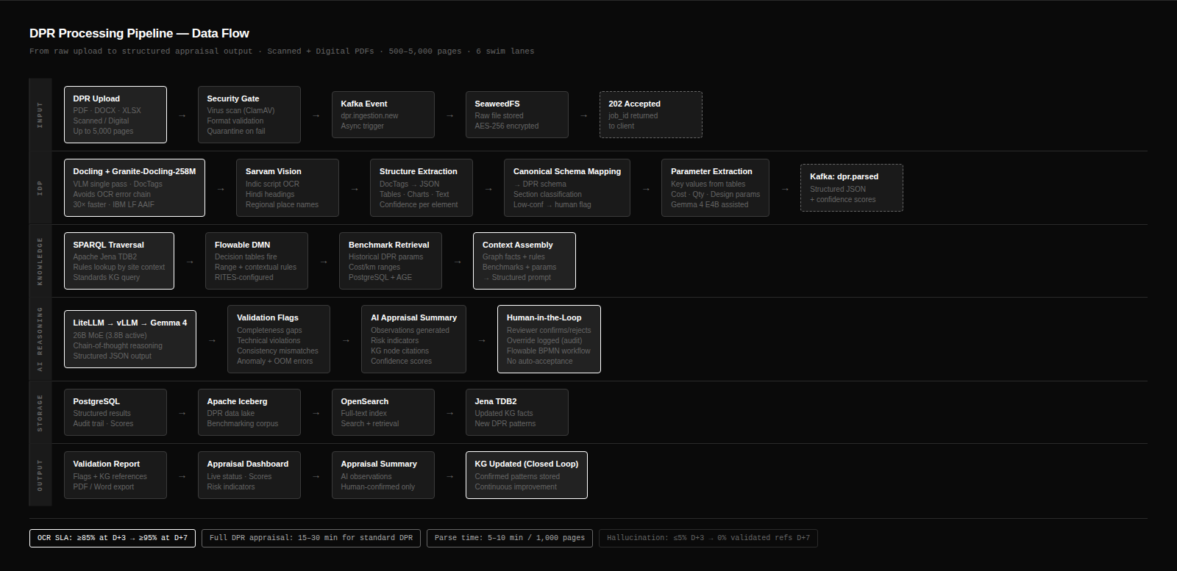
Figure 4.2 — DPR Processing Pipeline (6 swim lanes, from raw upload to structured appraisal output)

Pipeline Stage Narrative
Stage | Process | Technology | Compute Cost
Ingest | DPR uploaded via web UI. Virus scan. Format detection (digital PDF / scanned PDF / DOCX / XLSX). Queued to Kafka topic. | SeaweedFS, Kafka, ClamAV | Negligible — CPU only
IDP (Parse) | Granite-Docling-258M VLM processes each page: text extraction, table recognition, figure detection, drawing reference extraction. Structured JSON output per page with confidence scores and bounding boxes. | Granite-Docling-258M on CPU (258M params — no GPU needed for IDP stage) | Low — CPU inference, ~4–8 min per 200 pages
Structure & Map | spaCy NLP + rule engine maps extracted content to DPR canonical schema. Section identification. Low-confidence pages flagged for human review. | spaCy (NLP), LangChain (orchestration), Sarvam-M for Indic-language content | Low — CPU, sub-minute for 200 pages
Validate (KG + Rules) | Apache Jena SPARQL queries evaluate dependency rules. Drools DMN evaluates business rules. This is the primary validation pass — 70–80% of all validation issues identified here with zero LLM calls. | Jena/Fuseki (SPARQL), Apache Drools OSS (DMN) | Zero GPU — instant, millisecond-level per rule
Anomaly Detect | Statistical outlier detection (IQR, Z-score, percentile vs benchmark). Pattern-based checks. For complex cross-parameter anomalies only: Gemma 4 26B MoE called via LiteLLM Proxy. | XGBoost/LightGBM (statistical), Gemma 4 26B MoE (complex anomalies only, GPU) | Medium — GPU used only for LLM calls, typically <20% of DPRs trigger LLM anomaly analysis
Appraisal Assist | RAG retrieval (Qdrant) grounds the context. Gemma 4 26B MoE generates appraisal summary draft, prioritises issues, provides benchmark narrative. All outputs carry mandatory chain-of-thought + RAG citations. | Qdrant (vector retrieval), BGE-M3 (embeddings), Gemma 4 26B MoE (generation), LiteLLM Proxy | Highest GPU usage — but only once per DPR, not per validation check

4.4 Technology Choices Mapped to Functional Requirements
Every technology choice in PARAKH maps directly to a functional requirement in Annexure 12. The following table makes this mapping explicit, together with the rationale for each choice over the obvious alternatives.

Functional Requirement (Annexure 12) | Our Technology Choice | Why This Choice | Why Not the Alternative
M6: Ontology & dependency rules — inspectable, RITES-approved, version-controlled | Apache Jena + Fuseki (OWL/RDF + SPARQL) | Open W3C standards (OWL/RDF). Every triple is inspectable. RITES can view and approve the full graph before deployment. SPARQL queries are human-readable. Apache 2.0. | Neo4j (proprietary for enterprise). Graph databases without RDF lack the standards-compliance required for ontology-driven engineering validation.
M13: Configurable review workflows — state machines, no code deployment | Flowable OSS (BPMN + DMN) | BPMN diagrams are editable by RITES administrators without writing code. DMN decision tables provide the same drag-and-drop editability for validation rules. | Hardcoded workflow logic (fails the "configurable without code" principle). Activiti (Flowable is its fork with more active development).
M3/M9/M10: Rule engine — editable by RITES admin, RITES-approved before deployment | Apache Drools OSS (DRL + DMN) | Industry-standard Java rule engine. DRL rules are human-readable. Apache 2.0. Hot-deploy rules without service restart. | Custom Python rule logic (not editable by RITES admins without developer involvement).
M8: Structured DPR authoring — forms, tables, version control | FastAPI + React + Ant Design | FastAPI is RFP-preferred. Ant Design Form provides enterprise-grade structured form components (nested tables, conditional fields, calculated columns) that match DPR data entry patterns. | Django REST (slower, more opinionated). Material UI (less suited to data-dense government forms).
M7/M12: Similarity search and RAG over 1,000+ DPRs | Qdrant (vector store) | Apache 2.0. Metadata filtering by sector/terrain/geography as first-class feature — critical for returning benchmarks from comparable projects only. Sub-millisecond retrieval. | Weaviate (BSL licence, excluded). Chroma (not production-grade for 1,000+ DPR scale).
M16/M1: Event streaming for audit trail, AI job queuing, notifications | Apache Kafka | Apache 2.0. Fault-tolerant, durable message log. Exactly-once semantics for audit events. Schema registry enforces message versioning. | RabbitMQ (message broker, not a durable log — audit events could be lost).
Deployment: On-premise + NIC MeghRaj, RITES IT team must manage post-handover | Docker + Kubernetes + Rancher | Rancher provides a web-based K8s management UI that RITES IT staff can operate without deep K8s expertise. Apache 2.0. | OpenShift (Red Hat licence). Vanilla K8s without a management UI (too complex for RITES IT handover).
Security: Secrets management, encryption key rotation | HashiCorp Vault (BSL) or OpenBao (Apache 2.0 fork) | OpenBao is the Apache 2.0 fork of HashiCorp Vault created after the BSL licence change. Identical API. Fully RITES-manageable post-handover. | Kubernetes secrets (unencrypted at rest by default). HashiCorp Vault (BSL — excluded per ATC2 licence policy).

4.5 Compute Footprint Reduction — KG-First, Tiered LLM Strategy
The RFP (ATC2 Section 3) is explicit: GPU dependency shall be avoided unless specifically required and justified. This section shows exactly how we minimise compute at every stage of the PARAKH pipeline, and demonstrates that GPU is justified only for a small fraction of total operations.

4.5.1 The KG-First Principle — Most Validation Needs No LLM
The most important compute decision in PARAKH is architectural, not model-selection. By placing the Knowledge Graph as the primary reasoning engine for validation, we avoid the LLM entirely for 70–80% of all appraisal logic. A SPARQL query over the KG that answers 'Does this bridge design have hydrology inputs?' runs in milliseconds on a CPU and is fully traceable to a specific graph node. The LLM is only invoked when the graph cannot answer deterministically — typically complex cross-parameter reasoning or holistic document-level analysis.

Validation Type | Primary Engine | Compute Cost | LLM Involved? | Example
Dependency rule check (M6, M9) | Apache Jena SPARQL | < 10ms, CPU only | No | Bridge on river → hydrology section must be present
Business rule validation (M10) | Apache Drools OSS (DMN) | < 50ms, CPU only | No | Steel reinforcement diameter not in {8,10,12,16,20,25,32,40}mm per IS 1786
Cost cross-verification (M11) | PostgreSQL query | < 100ms, CPU only | No | BOQ total ≠ cost summary total beyond 1% tolerance
Narrative vs structured data (M11) | spaCy NLP + regex | < 200ms, CPU only | No | Project length "48 km" in narrative vs 52.3 km in alignment table
Statistical anomaly (M12) | XGBoost / IQR algorithm | < 500ms, CPU only | No | Cost/km is 2.8× P90 benchmark for highway in hilly terrain
Complex cross-parameter anomaly (M12) | Gemma 4 26B MoE (GPU) | ~ 30–90s per section, GPU | YES — sparingly | Foundation type inconsistent with soil classification given seismic zone and groundwater conditions combined
Full DPR appraisal summary (M14) | Gemma 4 26B MoE (GPU) + RAG | ~ 10–15 min per DPR, GPU | YES — once per DPR | Holistic appraisal summary with prioritised issues and benchmark narrative

Compute Budget Estimate
For a typical RITES review month (assume 20 DPRs processed): SPARQL/Drools/SQL validation: 0 GPU-hours (CPU only). Statistical anomaly detection: 0 GPU-hours. LLM complex anomaly calls (triggered for ~20% of DPRs): ~4 GPU-hours. LLM appraisal summaries (all 20 DPRs): ~5 GPU-hours. Total GPU: ~9 hours/month — well within a single A100's capacity. The other 23+ hours per day the GPU is idle or serving UI chatbot requests at negligible compute cost.

4.5.2 Tiered LLM Strategy — Right-Sized Model for Every Task
We deploy four model tiers, each matched to task complexity and latency requirements. The routing logic lives in the LiteLLM Proxy — the application layer never directly selects a model.

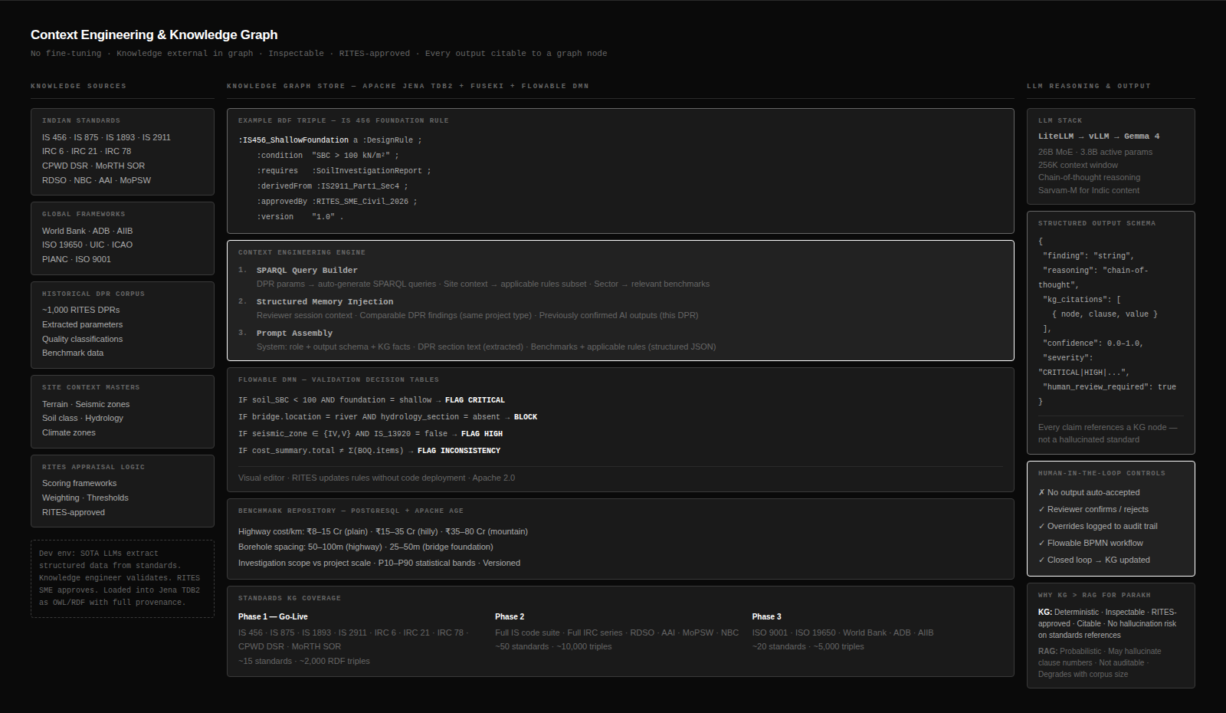
Figure 4.3 — Knowledge Graph Architecture and Context Engineering Layer

Tier | Model | Parameters (Active) | Hardware | Latency | Tasks in PARAKH
Tier 0  Basic NLP | Gemma 4 E2B | ~2.3B (CPU) | CPU only  (no GPU) | < 200ms | UI chatbot responses, form field auto-complete, section label detection, quick keyword extraction, search query expansion, notification text generation
Tier 1  Fast Reasoning | Gemma 4 E4B | ~4.5B (CPU) | CPU only  (no GPU) | 200ms–1s | Completeness pre-check (M9 first pass), structured data extraction from digital PDFs, RAG retrieval answer synthesis, unit mismatch detection, simple cross-field checks
Tier 2  Indic & Multilingual | Sarvam-M | ~7B (CPU or GPU) | CPU preferred  (GPU optional) | 1–5s | Hindi section headings, regional language place names, transliterated technical terms, multilingual DPR narrative extraction, Indic script OCR post-processing
Tier 3  Engineering Reasoning | Gemma 4 26B MoE | 3.8B active  of 26B total | 1× A100 GPU  (shared) | 30s–3 min | Complex dependency validation, multi-parameter anomaly analysis, engineering consistency reasoning, standards compliance checking with contextual explanation
Tier 4  Full Appraisal | Gemma 4 26B MoE  (extended context) | 3.8B active  of 26B total  (256K context) | 1× A100 GPU  (dedicated slot) | 10–30 min | Full DPR appraisal report generation, cross-chapter analysis, holistic benchmark narrative, executive summary with prioritised issues

Model | Benchmark (MMLU Pro) | Math (AIME) | Coding | Indic Language | License
Gemma 4 E2B | ~70% | Moderate | Moderate | Good (140+ languages) | Apache 2.0
Gemma 4 E4B | ~75% | Good | Good | Good (140+ languages) | Apache 2.0
Sarvam-M | ~75% | 88.3 Pass@1 | 92.1 HumanEval | +86% vs base (Indic) | Apache 2.0 — MeitY IndiaAI Mission
Gemma 4 26B MoE | 85.2% | 89.2% (AIME 2026) | 80% LiveCodeBench | Good (140+ languages) | Apache 2.0
Gemma 4 31B Dense | 85.2% | 89.2% | Similar to 26B | Good | Apache 2.0 — NOT used (8× higher compute)

Why Not Gemma 4 31B Dense?
The 31B Dense model has similar benchmark performance to the 26B MoE but activates all 31B parameters per token — approximately 8× the compute cost of the MoE model which activates only 3.8B parameters per token. For PARAKH, the 26B MoE delivers 97% of the 31B's quality at 8× lower GPU cost. This is the primary GPU justification per ATC2 Section 3.

4.5.3 LLM Routing Logic — When Each Tier Is Called
The LiteLLM Proxy implements a routing policy that selects the minimum-sufficient model tier for each request type. The policy is configuration-driven — no code change required to update routing rules.

Trigger Condition | Routed To | Rationale
Section label detection during IDP mapping | Tier 0 (E2B) | Fast classification task; no reasoning required; sub-200ms latency needed for user-facing IDP progress
User asks question in DPR authoring chatbot | Tier 0 (E2B) → escalate to Tier 1 (E4B) if answer requires retrieval | Conversational assist; most queries answered by Tier 0 + RAG context; Tier 1 only if multi-hop reasoning needed
Digital PDF section extraction (text-layer available) | Tier 1 (E4B) | Structured extraction from clean text; no complex reasoning; CPU-only keeps cost zero
Any Indic script detected in DPR content | Tier 2 (Sarvam-M) | +86% improvement on Indic language tasks; only tier with dedicated Indic training corpus
Ontology dependency rule triggered but pattern ambiguous | Tier 3 (26B MoE) | Engineering reasoning required; KG has flagged the issue but explanation requires domain understanding
Statistical anomaly threshold exceeded (IQR/Z-score) | Tier 3 (26B MoE) — only if anomaly score > 0.85 | High-confidence statistical anomalies explained without LLM; borderline cases sent to Tier 3 for contextualised explanation
Full DPR appraisal summary requested | Tier 4 (26B MoE extended context) | Requires 256K context window for large DPRs; cross-chapter analysis; holistic reasoning; GPU dedicated slot reserved
Scanned DPR — no text layer available | Granite-Docling-258M VLM (parallel to all tiers) | Specialised document VLM handles OCR + structure; output feeds the main pipeline; runs on CPU (258M params)

4.6 LLM-Agnostic Architecture — Future-Proofing the AI Stack
Between April and May 2026 alone, four major open-weight model families were released: Gemma 4, Sarvam 30B, Qwen 3.5, and Llama 4. The open-weight model landscape is moving faster than any 9-month project timeline. We design the AI layer so that swapping the underlying model requires a configuration change, never application code changes.

The Abstraction Architecture
Layer | Component | Responsibility | Interface
Application Layer | FastAPI services, Validation Engine, M12 Anomaly Detection, M14 Appraisal Assist | Calls the AI layer via a single standardised interface. Never imports a model library directly. | complete(prompt, tier, context) → AIOutput  embed(text) → vector  rerank(query, docs) → ranked_docs
LLM Gateway | LiteLLM Proxy (MIT licence) | Receives all AI requests. Routes to the correct model tier. Handles retries, fallbacks, load balancing, rate limiting. Enforces the sovereign AI boundary (blocks all non-whitelisted external endpoints in Staging+). | OpenAI-compatible REST API — identical interface regardless of underlying model
Model Registry | vLLM v0.19+ serving layer | Hosts Gemma 4 (E4B, 26B MoE) and Sarvam-M. Exposes OpenAI-compatible API. Hot-swap between model versions without service restart. | POST /v1/chat/completions (OpenAI spec)
CPU Inference | llama.cpp / Ollama | Serves Tier 0 (E2B) and Tier 1 (E4B) on CPU for latency-sensitive tasks. Zero GPU dependency for these tiers. | POST /api/generate (Ollama spec — LiteLLM translates)
Document VLM | Docling + Granite-Docling-258M | Separate pipeline for document parsing. Not routed through LiteLLM Proxy — dedicated Docling service. | POST /v1/parse (Docling REST API)

The application layer only knows the abstract interface: complete(), embed(), rerank(). Swapping Gemma 4 26B MoE for a future SOTA model — say Sarvam 30B for engineering reasoning tasks, or a Gemma 5 released during AMC — requires only:
- Update the model registry entry in LiteLLM Proxy config (YAML file)
- Run the validation suite against the new model (automated, part of CI/CD)
- Obtain RITES approval for the new model version (per ATC2 Section 6.8)
- Deploy — zero application code changes

Why This Matters for RITES
The open-weight model landscape will almost certainly shift during the 15-month AMC period. Without the LLM-agnostic layer, a model upgrade would require code changes, regression testing, and potentially a change request. With the abstraction layer, RITES IT staff can update the model configuration independently — it is a config file edit, not a software release. This directly satisfies the ATC2 requirement for "no vendor lock-in" and "vendor neutrality".

Sarvam-M — The Indic Intelligence Layer
Sarvam-M is not just "optics for a GoI client." It is a technically justified choice for RITES specifically:
- DPR multilingual content: RITES DPRs contain Hindi section headings, state-specific place names, transliterated engineering terms, and occasionally full sections in regional languages. Sarvam-M delivers +86% improvement on Indic language GSM-8K benchmarks over its base model — no Western model matches this on Indian-language numerical content.
- MeitY IndiaAI Mission backing: Sarvam AI was selected by MeitY in April 2025 for the IndiaAI Mission indigenous foundational model initiative. Sarvam-M (Apache 2.0) and Sarvam 30B (Apache 2.0) were released at Bharat Mandapam in February 2026. Citing a MeitY-backed Indian AI model in a GoI technical proposal carries evaluator credibility that no foreign model can match.
- Sarvam Vision for OCR: Sarvam has also developed a vision-language model specifically for document understanding and OCR in Indian scripts — a direct complement to Granite-Docling-258M for DPRs with regional language annotations.
- OpenAI-compatible via vLLM: Sarvam-M is deployable via vLLM serve sarvamai/sarvam-m with an OpenAI-compatible endpoint. It plugs into the LiteLLM Proxy as a Tier 2 model with zero application code changes.

4.7 Knowledge Graph — The Context Engineering Layer
The KG diagram below shows the three-column structure of the PARAKH knowledge layer: the sector-specific ontologies on the left, the cross-sector dependency rules in the centre, and the context engineering pipeline on the right.


Figure 4.4 — Knowledge Graph Architecture: Sector Ontologies, Dependency Rules, and Context Engineering

The Knowledge Graph is PARAKH's key architectural differentiator. It allows PARAKH to provide explainable, RITES-approved, deterministic validation for 70–80% of all appraisal logic — with zero LLM involvement. Every validation result traces to a specific graph triple and the standard that informed it.

Sector KG | Key Standards Encoded | Dependency Rule Examples | RITES Sign-off Constraint
Road / Highway | IRC 37/58/81, MoRTH SOR | Pavement design → traffic survey required; CBR test → soil classification required | 10 working days from draft KG submission
Bridge | IRC 6/21/78, IS 456, IS 2911, IRC 112 | Over-river → hydrology mandatory; High seismic zone → IS 13920 ductile detailing; Scour depth → foundation depth validation | 10 working days — highest complexity KG
Rail | RDSO standards, IRS codes, IS 1893 | Formation width → track category; Earthwork → soil investigation; Level crossing → traffic survey | 10 working days
Metro | RDSO Metro, NBC, fire codes | Viaduct → vibration analysis; Underground station → fire load calculation; Seismic zone → IRS B1 loading | 10 working days
Port / IWT | MoPSW, IS 4651, PIANC, IRC 5 | Berth design → tidal data; Dredging → hydrographic survey; Capital cost → cargo projection | 10 working days
Airport | AAI guidelines, ICAO Annex 14 | Pavement design → aircraft classification number; ILS → obstacle limitation surface survey | 10 working days
Urban Infrastructure | CPWD DSR, NBC, URDPFI | Building height → structural analysis; Fire exit → NBC compliance; Public space → URDPFI norms | 10 working days
Tunnel | IRC SP 91, NHAI, fire codes | Portal design → geological survey; Ventilation → traffic projections; Lining → geotechnical report | 10 working days

KG Bootstrap — GenAI Acceleration
In the development environment (where external LLM APIs are permitted), we use Claude API and GPT-4 to accelerate KG construction: ~80% saving on standards text extraction, ~60% on RDF triple generation, ~50% on DMN rule table creation. The binding constraint on each sector KG is RITES SME sign-off — not our preparation time. GenAI acceleration means we arrive at the RITES review gate faster, maximising the time available for RITES review within the milestone schedule.

4.8 Deployment Architecture
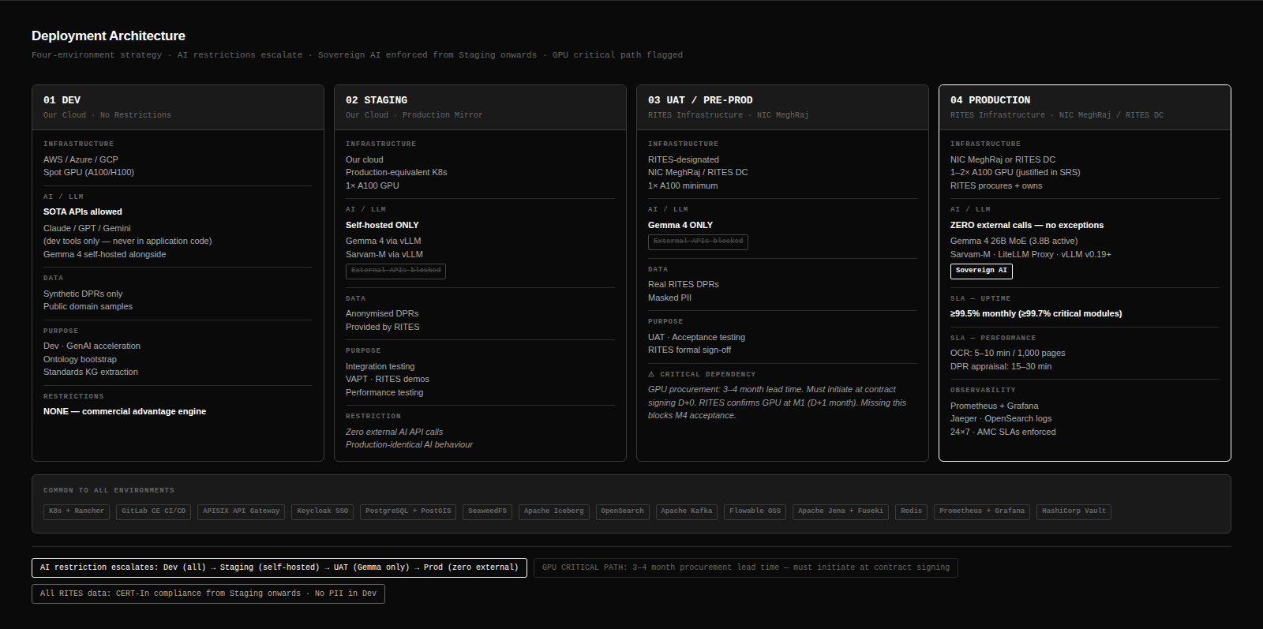
Figure 4.5 — Four-Environment Deployment Architecture (AI restrictions escalate from Dev to Production)
Four environments with escalating AI restrictions enforce the sovereign AI boundary as the platform progresses toward production. The critical path GPU dependency is explicitly flagged.

Environment | Owner | Infrastructure | AI/LLM | GPU | Key Constraint
Development | Our team | Any cloud (AWS/Azure/GCP) | Unrestricted — Claude API, GPT-4, Gemini permitted as developer tools | Spot A100/H100 for fine-tuning | None — this is the commercial advantage environment for GenAI-accelerated KG bootstrap
Staging | Our team | Our cloud — production-equivalent stack | Self-hosted Gemma 4 + Sarvam-M ONLY. All external LLM endpoints blocked at LiteLLM Proxy. | 1× A100 (our own) | No external LLM calls. Anonymised/synthetic DPR data only — no real RITES data.
UAT / Pre-Production | RITES | NIC MeghRaj or RITES DC | Fine-tuned Gemma 4 ONLY — zero external API calls | 1× A100 (RITES-procured)  CRITICAL PATH: 3–4 month lead time. Must procure at contract signing. | Full RITES data governance. CERT-In compliance. RITES UAT team participates.
Production | RITES | NIC MeghRaj or RITES DC | Fine-tuned Gemma 4 ONLY — ZERO external API calls | 1–2× A100 (RITES-procured) | ≥99.5% uptime SLA. 5–10 min/1,000 pages OCR. 15–30 min/DPR appraisal.

GPU Procurement Critical Path
NVIDIA A100 procurement lead time is typically 3–4 months in India. The UAT environment (D+5m) requires 1× A100 from RITES. This must be initiated at contract signing (Day 0) or the M3→M4 transition will be blocked. We will formally communicate this as a RITES dependency in the M1 SRS, with an agreed procurement timeline written into the dependency register.

4.9 Security Architecture — Defence in Depth
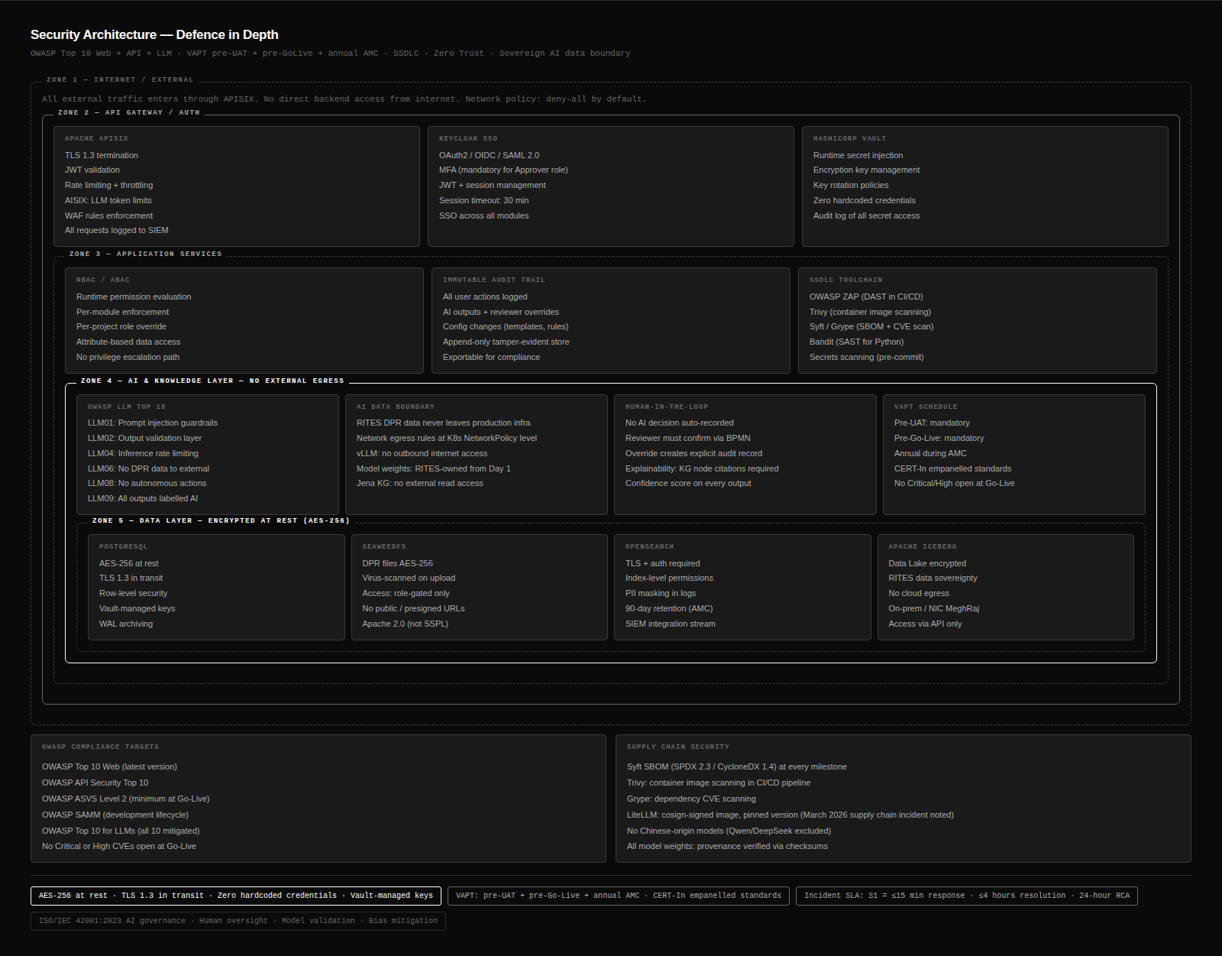
Figure 4.6 — Security Architecture: Concentric Zone Model, OWASP Compliance, Sovereign AI Data Boundary

Security Zone | Layer | Mechanisms | Standards
Perimeter | API Gateway (Apache APISIX) | Rate limiting, DDoS mitigation, geographic access controls, TLS termination (1.3), certificate management | OWASP API Security Top 10
Authentication | Keycloak (OAuth2/OIDC + SAML 2.0) | MFA for Approver/SysAdmin roles, JWT token rotation (15 min expiry), session timeout (30 min idle), RBAC + ABAC | OAuth2, SAML 2.0, PKCE
Application | FastAPI services | Input validation and sanitisation on all endpoints, CSRF protection, CSP headers, SQL injection prevention via ORM, XSS prevention via React templating | OWASP Top 10 Web
AI/LLM Boundary | LiteLLM Proxy | Sovereign AI enforcement: all external LLM endpoints blocked in Staging+. Prompt injection detection. Output validation before storage. Rate limiting on inference API. | OWASP Top 10 for LLMs
Data | PostgreSQL + SeaweedFS + Qdrant | AES-256 encryption at rest. TLS 1.3 in transit. Encryption keys in OpenBao (HashiCorp Vault Apache 2.0 fork). PII masking in non-production environments. Row-level security in PostgreSQL. | ISO 27001, AES-256
Audit | OpenSearch SIEM | Real-time streaming of all significant actions. Immutable audit log (no admin can delete). Anomaly detection on access patterns. Incident alerting within 15 minutes of Critical event. | ISO 27001

§5 | Module-Wise Solution Design

This section describes how each of the 16 modules in Annexure 12 is designed in PARAKH — covering purpose, key design decisions, inter-module dependencies, and how it addresses specific RITES appraisal challenges.

M1 — Admin, Users, Roles & Governance
Answers: "Who can do what, and who is accountable for which part of the appraisal?"
- Identity & SSO: Keycloak (Apache 2.0) with OAuth2/OIDC and SAML 2.0. MFA mandatory for Approver and System Admin roles. Bulk user import via CSV/Excel. Local fallback authentication.
- RBAC + ABAC: Nine pre-configured roles from dpr_author to approver. Roles assignable at platform, project, DPR, and section level. ABAC extensions for sector-specific data access. Permission changes take effect at runtime without service restart.
- Immutable Audit Trail: All significant actions logged with user ID, role at time of action, entity ID, before/after values, timestamp (UTC), IP address. Streamed in real time to OpenSearch SIEM. No administrator can modify or delete audit logs.

M2 — Master Data Management
Answers: "What are the standardised reference elements the platform uses across all modules?"
- 13 Sectors + 4 Project Types: Configurable without code. New sectors addable by administrators. Each sector links to applicable templates, validation rules, scoring frameworks.
- Site & Context Masters (key for KG integration): Terrain (Plain/Hilly/Mountainous/Coastal/Floodplain), Climate Zone (seismic, wind, rainfall, temperature), Soil & Geotechnical (SBC, N-value, liquefaction flag), Hydrology (scour risk, flood return period, river regime), Site Constraints. These masters are the input parameters that activate the Ontology dependency rules in M6.
- Standards Library: Each standard stored with code, issuing body, version, sector applicability, validity status. Used by M10 Technical Validation for standards-based checks.

M3 — DPR Template Creation Engine
Answers: "What should a DPR contain, and how should it be structured?"
- 4-Level Hierarchy: Template → Chapter → Section → Sub-section. Additional levels configurable. Conditional field visibility driven by Site Context master values — activates immediately on project creation.
- Calculated Columns & Cross-Section References: BOQ tables can auto-compute totals. Cost summary cells can reference BOQ totals across sections. Formula errors surfaced to author immediately.
- Attachment Requirements: Templates specify mandatory/conditional attachments per section. Completeness engine (M9) checks these before DPR proceeds to appraisal. Default formats: PDF, DOCX, XLSX, DWG, DXF, JPG, PNG, GeoTIFF, IFC, KML, GeoJSON, SHP.

M4 — Role-to-DPR Mapping
Answers: "Who is responsible for which part of the DPR?"
- Appraisal Readiness Indicator: Per-DPR metric showing: % mandatory sections submitted, % reviewed, number of open blocking issues. RITES PMU can view this for all active DPRs in the portfolio dashboard.
- Configurable Notification Triggers: Section assigned, deadline approaching (configurable lead time), section not submitted after deadline, section returned, issue raised, approval required. Email + in-platform. Templates configurable by administrators.

M5 — Dictionary & Standards Repository
Answers: "What do the terms and standards in this DPR mean, and what references should inputs comply with?"
- Inline Dictionary Lookup: During DPR authoring, hovering over flagged technical terms shows definition, applicability, and standard references. RITES-approved vocabulary only.
- Parameter Reference Ranges: IS reinforcement diameters, concrete grades M15–M80, pavement layer thickness ranges, foundation type applicability by SBC. Used by M10 Technical Validation.
- Cost Head Hierarchy: Major Head → Sub-Head → Line Item per sector, aligned with CPWD/MoRTH/Railway classification systems. Used for BOQ-to-summary cross-verification in M11.

M6 — Ontology & Dependency Framework
Answers: "How are different parameters in a DPR related to each other — and what does the presence or absence of one imply for others?"
This is the primary validation engine in PARAKH. Refer to §4.7 for the full KG architecture and §4.5.1 for the compute rationale. Key design points:
- OWL/RDF + Apache Jena: Open W3C standards. Every triple inspectable by RITES administrators. SPARQL queries human-readable. Version-controlled in GitLab CE.
- 8 Sector Ontologies, RITES SME sign-off per sector: See §4.7 table. Each sector KG is a separate approval exercise. Sign-off is the binding constraint, not our preparation.
- 100+ pre-configured dependency rules at Go-Live: Additional rules configurable by authorised administrators via admin web UI, expressed in Drools DRL or YAML/JSON rule schema. No code deployment required.

M7 — Historical DPR Repository & Benchmarking
Answers: "How does this DPR compare to past projects — and what can we learn from them?"
- DPR Classification & Tagging: Each historical DPR tagged with sector, project type, geography, scale (cost band, length, capacity), quality classification, and project outcome. These tags enable segmented benchmark computation.
- Benchmark Computation: Cost per unit by project type/terrain/geography. Configurable statistical methods: mean ± N std dev, P10–P90 percentile bands, IQR ranges. Overridable by RITES-approved manual values.
- Vector Similarity Search: Qdrant semantic search over structured DPR parameters — find DPRs with similar soil conditions, terrain, and project scale. Every benchmark comparison includes which projects form the benchmark group and what method was used.
- Pattern Recognition: Most frequently missing sections by sector, most common anomaly types, typical revision reasons. Surfaced as inline guidance during DPR authoring.

M8 — DPR Authoring / Submission Interface
Answers: "How is a DPR prepared and submitted — and how does the platform guide the author toward a complete, high-quality submission?"
- Site Context First: DPR authoring begins with a Site Context form. Values entered immediately activate the dependency framework — determining which sections are mandatory, optional, or conditional for this specific project. A bridge DPR on a river in Seismic Zone IV will have different mandatory sections than a bridge on a road in Zone II.
- Inline Benchmarks & Pattern Guidance: As the author enters values, benchmark ranges from comparable historical DPRs are shown inline (e.g., "Typical CBR for alluvial plains: 3–6%. Your value: 2.1% — below typical range").
- Version Control + Diff View: Every formal submission creates an immutable version. Side-by-side diff between versions at section and field level. Non-destructive restore of any previous version as a new draft.
- 4-Scenario Comparison: Design alternatives (alignment options, structural configurations) can be created and compared side-by-side with key parameter and cost differences highlighted.

M9 — Completeness Validation Engine
Answers: "Is this DPR complete — structurally, logically, and from all required stakeholders?"
Five types of completeness check, each targeting a different category of gap found in real-world DPR appraisal:
Check Type | What It Catches | Enabled By
Structural Completeness | Mandatory sections absent or empty | M3 Template Engine — mandatory field definitions
Field & Table Completeness | Partially filled tables; mandatory fields blank; calculated fields with null dependencies | M3 table schema definitions
Stakeholder Completeness | Assigned departments have not submitted their sections | M4 Role-to-DPR Mapping
Attachment Completeness | Required supporting documents not uploaded | M3 attachment requirements
Dependency-Based Completeness | Design section present but prerequisite survey data absent — logically incomplete even if structurally present | M6 Ontology — dependency rules evaluated via SPARQL

M10 — Technical Validation Engine
Answers: "Are the technical inputs reasonable, correct, and consistent with applicable engineering standards?"
Validation Type | Example | Technology | Compute
Range-Based | Steel reinforcement diameter outside IS 1786 standard series {8,10,12,16,20,25,32,40}mm | Drools DMN rules referencing M5 Parameter Ranges | CPU only
Unit & Format | Quantity entered in m² where mm² expected; mixing of incompatible units in cost calculation | Units master (M2) + field-level unit validation in React forms | CPU only
Contextual (Ontology-Driven) | Foundation type = Shallow Isolated + Soil SBC < 80 kN/m² → FLAG "Foundation inconsistent with SBC" | SPARQL query over M6 KG evaluating soil class + foundation type relationship | CPU only — SPARQL
Standards-Based | Design wind speed below IS 875 Part 3 basic wind speed for the declared wind zone | Drools rules referencing IS 875 Part 3 zone table in M5 Standards Library | CPU only
Order-of-Magnitude | Steel diameter entered as 200mm vs expected 20mm (10× error); cost 10× benchmark for project type | Statistical Z-score check + benchmark comparison via M7 | CPU only

M11 — Consistency Engine
Answers: "Do different parts of the DPR agree with each other?"
- Quantity & Cost Cross-Verification: BOQ line-item totals vs cost summary; section-wise quantities vs overall scope; unit rates consistent for the same item across sections. Flags exact mismatches and deviations beyond configurable tolerance.
- Design vs Investigation Alignment: Soil parameters in geotech report vs assumed values in structural design; river classification vs structural drawing span counts; traffic counts vs design-year traffic in pavement design.
- Narrative vs Structured Data (NLP-assisted): spaCy extracts numeric mentions from narrative text (project length, cost, capacity) and compares against structured fields. "Project length: 48 km" in narrative but 52.3 km in alignment data → FLAG.

M12 — Anomaly Detection Engine
Answers: "Does anything look suspicious — even if it doesn't strictly break a rule?"
This module layers three types of detection, escalating from fully deterministic to LLM-assisted only for the cases neither statistics nor rules can resolve:
- Statistical detection (IQR, Z-score, percentile vs benchmark) — CPU only, always runs
- Pattern-based detection (copy-paste errors, implausible distributions, round-number suspicion) — CPU only, always runs
- Contextual + comparative detection (benchmark deviation narrative, geotechnical parameter plausibility for stated soil class) — CPU + optional KG lookup, always runs
- AI-assisted detection (Gemma 4 26B MoE, for complex cross-parameter anomalies only) — GPU, triggered only for anomaly confidence score > 0.85

Human Confirmation Required
All AI-assisted anomaly flags (Tier 3/4 model outputs) require explicit reviewer confirmation before being recorded in the appraisal log. Reviewers can: Accept (with optional comment), Reject (with mandatory rejection reason), or Modify (creates override record). All override actions logged in audit trail with original AI output, reviewer action, and timestamp.

M13 — Review Workflow & Scoring
Answers: "How are reviewers' observations recorded, issues tracked, and DPR quality formally evaluated?"
- Configurable State Machine (Flowable OSS BPMN): DRAFT → SUBMITTED → UNDER_REVIEW → ADDITIONAL_INFO_REQUESTED → RESUBMITTED → FINAL_REVIEW → APPROVED / REJECTED / APPROVED_WITH_CONDITIONS. State machine definition editable by RITES administrators using drag-and-drop BPMN designer — no code deployment.
- Parallel Review Tracks: Multiple departments review simultaneously. Consolidation step merges parallel reviews. Critical path identification shows which department is the bottleneck.
- Issue Lifecycle: OPEN → ACKNOWLEDGED → IN_PROGRESS → RESOLVED_BY_AUTHOR → VERIFIED_BY_REVIEWER → CLOSED / DISPUTED. Resolution requires revision reference and optional attachment. Overdue issues trigger escalation notifications.
- Configurable Scoring Frameworks: Define scoring categories, weightages, and sub-criteria. Auto-scored from validation results (completeness score, technical pass rate, anomaly count). Human-scored criteria require mandatory justification. Multiple frameworks applicable simultaneously. All editable by administrators without code.

M14 — Reporting & Appraisal Dashboard
Answers: "What is the current status and quality of this DPR, and what needs attention?"
- DPR Dashboard: Completeness %, section status by department, current review stage, issues by severity and status, appraisal score, validation flag summary. Risk indicators red/amber/green, clickable to the specific finding.
- Portfolio Dashboard: All active DPRs with status, filter by sector/project type/stage, overdue reviews, reviewer workload.
- Five Report Types: Completeness Report, Validation Summary Report, Appraisal Score Report, Issue Status Report, Audit Trail Report. Exportable as PDF (formatted), Word (.docx), Excel (.xlsx).

M15 — Simulation & Sensitivity Analysis
Answers: "What happens to project cost, revenue, and feasibility if key assumptions change?"
- Parameter Sensitivity: Select parameters, define variation range (±X% or A to B), view effect on total cost / schedule / FIRR/EIRR. Tornado chart ranking parameters by impact. Sensitivity curve showing output vs input variation.
- Scenario Modelling: Up to 4 named scenarios with modified assumptions. Side-by-side comparison: cost breakdown, timeline Gantt, key parameter deviations. Scenarios stored linked to DPR, clearly marked as analysis constructs — never affecting submitted DPR data.

M16 — Security, Audit & Monitoring
Cross-cutting module applying to all 15 other modules. Full security architecture is described in §4.9. Key M16-specific capabilities:
- Real-Time Audit Trail: All actions streamed to OpenSearch SIEM. Immutable. Searchable and filterable by date range, user, action type, entity, project. Exportable to PDF/CSV. 2-year retention.
- User Activity Monitoring: Alerts on: >3 failed logins in 5 min, >10 project accesses in 1 min, unusual download volume, off-hours access. All alerts require human investigation before any action.
- SBOM: Syft/Grype generates SPDX 2.3 / CycloneDX 1.4 format at milestones M1, M2, M3, M4, and Go-Live. AI model weights included with provenance checksums. License register derived from SBOM.

§6 | AI/ML Approach

6.1 AI Architecture Principles
The PARAKH AI architecture follows five principles that together minimise compute cost, maximise explainability, and satisfy the ATC2 sovereign AI requirement:
Principle | What It Means | How We Implement It
KG-First | The Knowledge Graph answers validation questions before any LLM is considered | SPARQL + Drools DMN runs first on every validation request. LLM called only when graph returns no deterministic answer.
Tiered Models | Use the smallest sufficient model for every task | LiteLLM Proxy routes based on task type: E2B for NLP assist, E4B for extraction, Sarvam-M for Indic, 26B MoE for reasoning. See §4.5.2.
Sovereign AI Boundary | Zero external LLM API calls in Staging/UAT/Production | LiteLLM Proxy whitelist blocks all non-local model endpoints. Enforced in deployment config. Verified in VAPT.
Explainable by Design | Every AI output must be traceable to source data | Mandatory JSON schema: finding, reasoning (chain-of-thought), sources (RAG citations), confidence, severity. No output displayed without citations.
Human-in-the-Loop Enforced | No AI output auto-accepted | All AI outputs require explicit reviewer confirmation. Override logic logs original AI output + reviewer decision.

6.2 The DPR Appraisal Sequence — 5 Phases, 21 Steps
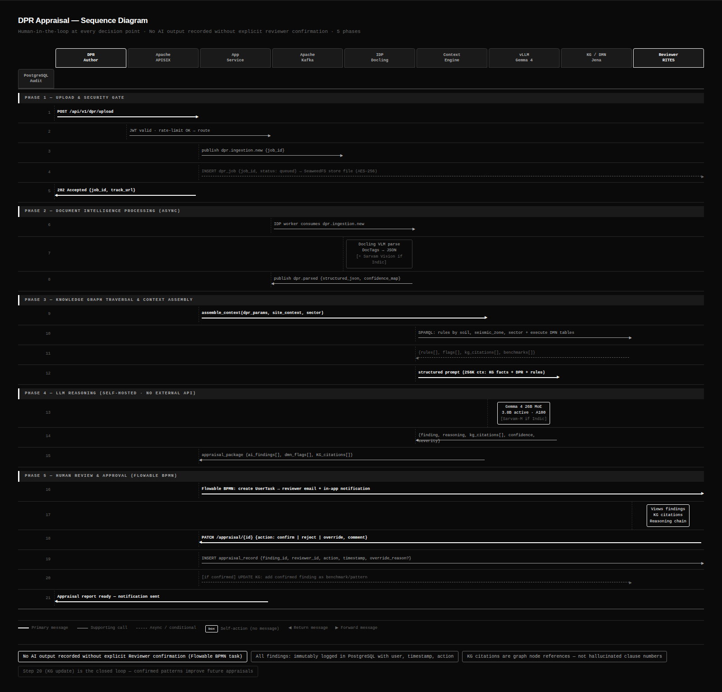
Figure 6.1 — DPR Appraisal Sequence: 5 Phases, 21 Steps, 10 Actors (Human-in-the-loop at every decision point)
The sequence diagram above shows every handoff in the PARAKH appraisal workflow — from DPR author submitting a section to the RITES approver signing off the final appraisal. Key points:
- Phases 1–3 (Ingest → Validate → Appraise) are system-automated and run without human involvement until the review stage
- Phase 4 (Review) is entirely human-driven — the system surfaces findings, the reviewer interprets and decides
- Phase 5 (Approve) is gated — the RITES approver can only approve when all Critical and High issues are CLOSED
- Every AI output in Phases 1–3 carries a "PENDING HUMAN CONFIRMATION" status until the reviewer acts in Phase 4

6.3 Document Parsing — Docling + Granite-Docling-258M
The IDP pipeline is the first and most critical AI stage — poor document parsing propagates errors through all downstream validation. We use Docling with the Granite-Docling-258M vision-language model (IBM Research, Apache 2.0, released January 2026).
Capability | Detail | Why It Matters for RITES DPRs
Native structure understanding | Granite-Docling-258M understands document structure without traditional OCR. IBM Research: "Avoiding OCR reduces errors and speeds up time-to-solution by 30×" | RITES DPRs contain complex table layouts (multiple nested headers, merged cells, rotated text) that traditional OCR misidentifies
Table extraction | DocTags markup separates table structure from content. Row/column recognition with nested header support. | BOQ tables, cost estimates, and engineering parameter tables are the primary input to M10/M11 validation — table accuracy is critical
Scanned document handling | VLM processes scanned pages directly. No intermediate OCR step. Confidence score per element. | NW-58 Kosi DPR sample: 203 pages, 100% scanned — Granite-Docling handles this without a preprocessing pipeline
Figure & drawing references | Figures detected with caption extraction. Drawing references (number + title) extracted. Full drawing interpretation is out of scope (flagged for human review). | RITES DPRs reference engineering drawings that must be manually reviewed — the system surfaces drawing references for reviewer attention
Indic script support | Sarvam Vision layer handles Hindi section headings, regional place names, transliterated terms | DPRs for state government projects often contain bilingual content — missed by Western VLMs

6.4 Worked Example — NW-58 Kosi River IWT DPR
To make the AI pipeline concrete, we trace the NW-58 Kosi River Inland Waterway DPR (203 pages, 100% scanned) through PARAKH end to end:
Step | What PARAKH Does | Technology | Time | GPU?
Upload | DPR uploaded. Format detected: scanned PDF, 203 pages, no text layer. Routed to IDP queue. | Kafka, SeaweedFS | < 10 sec | No
IDP Parsing | Granite-Docling-258M processes all 203 pages in parallel batches. Extracts: narrative sections (hydrological analysis, traffic projections, engineering design), tables (BOQ, cost estimates, hydrological data), drawing references. | Granite-Docling-258M (258M VLM, CPU) | ~ 6–10 min | No
Section Mapping | spaCy maps extracted content to IWT DPR template sections: Project Context, Survey Data, Hydrological Analysis, Traffic Projections, Engineering Design, Cost Estimates, Environmental Assessment. | spaCy + LangChain, Tier 1 E4B for ambiguous sections | ~ 2 min | No
Completeness Check (M9) | KG query: IWT sector → Hydrological Analysis mandatory. CHECK: present ✓. Environmental Clearance section: absent → FLAG (blocking). Geotechnical Investigation: 7 borehole locations required per IWT SOP; 4 present → FLAG (3 missing). | SPARQL over M6 KG + M3 template definitions | < 10 sec | No
Technical Validation (M10) | Design discharge: 5,800 cumecs. SPARQL query: IWT Kosi basin → typical discharge range P10–P90: 2,200–4,800 cumecs. 5,800 > P90 → FLAG "Design discharge above P90 benchmark — verify hydrological analysis." Foundation type: pile. SBC in geotech report: 85 kN/m². KG rule: SBC < 100 kN/m² AND site = alluvial → pile foundation expected → PASS. | Drools DMN + SPARQL, XGBoost benchmark comparison | < 30 sec | No
Consistency (M11) | BOQ total: ₹312.4 Cr. Cost summary: ₹315.1 Cr. Difference: 0.86% → within 1% tolerance → PASS. NLP extracts "project length: 48 km" from narrative. Alignment data: 51.3 km → MISMATCH → FLAG. | PostgreSQL query + spaCy NLP | < 60 sec | No
Anomaly (M12) | Cost/km: ₹312.4 Cr / 51.3 km = ₹6.1 Cr/km. IWT benchmark P90 for Bihar alluvial terrain: ₹4.8 Cr/km. Ratio: 1.27× P90 → anomaly score: 0.71 (< 0.85 threshold). Statistical flag only — no LLM called. | XGBoost + M7 benchmark data | < 30 sec | No
Appraisal Summary | Gemma 4 26B MoE reads: 3 critical flags, 2 high flags, 1 advisory. RAG retrieves 3 comparable IWT DPRs from benchmark database. Generates prioritised appraisal summary with: issue list, benchmark comparison table, recommended reviewer focus areas. All outputs carry chain-of-thought + RAG citations. | Gemma 4 26B MoE + Qdrant RAG | ~ 8–12 min | YES (1× A100)

Key Insight from this Example
7 of 8 pipeline stages ran with zero GPU usage. The GPU was used only once — for the final appraisal summary generation (8–12 min). The entire completeness, validation, consistency, and anomaly pipeline ran on CPU in under 3 minutes. This is the compute profile we commit to for all standard DPRs.

6.5 RAG Pipeline — Grounded Generation
All LLM text generation in PARAKH is grounded in retrieved context from Qdrant. The model never generates from weights alone for validation-related outputs.
RAG Component | Choice | Rationale
Vector Store | Qdrant (Apache 2.0) | Metadata filtering as first-class feature — essential for returning benchmarks from comparable projects only (same sector + terrain + geography). Sub-millisecond retrieval for real-time use.
Embeddings | nomic-embed-text / BGE-M3 (Apache 2.0) | Both models produce high-quality embeddings for technical engineering text. BGE-M3 also handles multilingual content — important for Indic DPR sections.
Orchestration | LangChain / LlamaIndex (MIT) | Handles context window management for large DPRs (up to 5,000 pages via multi-pass retrieval and recursive summarisation). Both Apache 2.0/MIT licenced.
Knowledge Base Segments | DPR content, Engineering standards, Benchmarks, Validation rule rationale | Segmented retrieval ensures the model receives contextually appropriate grounding for each query type — standards content for compliance checks, benchmark data for anomaly context.

Citation requirement (enforced at API level): Every RAG-assisted output includes structured citations — document name, section/page reference, text snippet. LiteLLM Proxy rejects outputs that do not include at least one citation. This is an API-level enforcement, not a prompt instruction.

6.6 Hallucination Control
Control Layer | Mechanism | ATC2 SLA Target
Validated Reference Library | All IS/IRC/RDSO/CPWD/AAI/MoPSW standard codes and clauses compiled into a verified lookup by M4 (D+7m). Every AI citation validated against this library before display. Citations not found flagged as "Unverified Reference — human confirmation required". | 0% fabricated standard references post D+7
RAG-Grounded Generation | All outputs grounded in retrieved context. Model cannot generate standards text not provided in context window. | Structural prevention — not dependent on model behaviour
Human Confirmation Gate | All AI-sourced outputs require explicit reviewer confirmation before recording. Reviewer responsible for verifying citation accuracy. | Human backstop for any slip-through
Monthly Hallucination Audit | Monthly AI Confidence and Hallucination Audit Report: counts of unverified citations, reviewer rejection rates, categories of corrections. Submitted to RITES within 5 working days of month end. | Ongoing monitoring throughout AMC

6.7 AI Accuracy Commitment — ATC2 SLA Targets
Metric | M2 (D+3m) | M3 (D+5m) | M4 (D+7m) | M5 (D+9m)
Document text extraction (OCR) | ≥85% | ≥90% | ≥95% | ≥95%
Tabular / financial data extraction | ≥90% | ≥95% | ≥98% | ≥99%
Section / clause identification | ≥80% | ≥85% | ≥90% | ≥95%
Rule-based validation accuracy | ≥85% | ≥90% | ≥95% | ≥95%
AI anomaly / red flag detection | ≥75% | ≥85% | ≥90% | ≥95%
Cross-reference checking | ≥75% | ≥85% | ≥90% | ≥90%
Appraisal summary quality | ≥75% | ≥80% | ≥85% | ≥90% (with human validation)
Engineering code hallucination rate | ≤5% | ≤2% | 0% (validated lib) | 0%

§7 | Implementation Methodology

7.1 Milestone-Anchored Agile
We deliver working software at every milestone — not documentation. Two-week Scrum sprints nested within the ATC2 milestone framework. RITES PMU receives: weekly written status report, fortnightly sprint demo, milestone gate review with formal sign-off required before proceeding.

Milestone | Timeline | Key Deliverables | Acceptance Gate
M1 — Inception & Architecture | D+1 month | SRS (all 16 modules), architecture document, Data Lake design, AI/ML strategy, GPU justification document, KG bootstrap plan (sector × SME assignments), RITES dependency SLA register, implementation roadmap | RITES written approval on SRS, architecture, and GPU procurement timeline
M2 — Draft Tool Version 1 | D+3 months | Core platform deployed to Staging: M8 (DPR authoring), M9 (completeness), M10 (rule-based validation), M1 RBAC, Data Lake ingestion pipeline, Docling IDP pipeline, API framework with OpenAPI docs, SBOM M2 | OCR ≥85% on scanned sample DPRs; completeness engine functional; API docs complete
M3 — Multi-Sector V2 | D+5 months | Phase 1 sector ontologies deployed (5 domains, RITES sign-off obtained), M6 dependency rules operational, M11 Consistency, M12 Anomaly Detection, M13 Workflow/Scoring, M14 Dashboard, GIS integration, full RBAC, audit trail, pre-UAT VAPT complete | All Critical/High VAPT findings remediated; 5 sector KGs RITES-approved; demo to evaluation committee
M4 — Production / UAT | D+7 months | All 16 modules UAT-accepted, all 8 sector KGs deployed, AI accuracy SLAs met (≥95% OCR, 0% hallucination), zero Critical/High VAPT, load test passed (20–50 concurrent users), source code + full documentation + SBOM handed over, runbook verified by RITES IT | Formal RITES UAT acceptance sign-off
M5 — Stabilisation | D+9 months | Issue resolution, AI fine-tuning on M4 reviewer feedback corpus, role-based training delivery (all role types), complete documentation set, 60-day KT to RITES IT team, operational readiness certificate | RITES IT team able to manage platform independently; training completion certificates
M6 — AMC (15 months) | D+10m to D+24m | Ongoing monitoring (24×7), incident response per SLA, monthly SLA + Hallucination Audit reports, security patches, bug fixes. Billed 2%/quarter × 5 quarters. | Monthly reports submitted on time; SLA targets maintained

7.2 RITES Dependencies — Formal Register
Dependency | Must Be Confirmed By | RITES Action Required | Impact if Delayed
GPU Infrastructure (UAT/Prod) | M1 sign-off — Day 0 procurement initiation | Procurement order for 1× NVIDIA A100 80GB. 3–4 month lead time. | M3→M4 transition blocked if GPU not available by D+5m. LD clock pauses.
Sector KG SME Sign-off × 8 | Staggered M2–M4 | Designated RITES SME per sector; 10 working days per sector from submission | Each sector KG unavailable in production until sign-off. Phased KG deployment planned.
UAT Environment Access | M3 completion (D+5m) | NIC MeghRaj or RITES DC environment provisioned with GPU | M4 UAT cannot begin without environment. LD clock pauses.
UAT Participation Team | M3 sign-off | Min 5 RITES staff across Author/Reviewer/Admin roles; 4-week UAT cycle | UAT sign-off delayed without adequate participation.
Architecture Document Approval | M1 | 15 working days review and approval after submission | Development of M2 features begins after M1 approval.
Pre-Bid Clarifications | Pre-submission | (1) Confirm GPU availability on NIC MeghRaj. (2) Confirm Go-Live definition (UAT acceptance vs production deployment). (3) Confirm RITES dependency SLA language acceptable. | Proposal assumptions subject to revision based on pre-bid responses.

7.3 Risk Register
Risk | Likelihood | Impact | Mitigation Strategy
GPU procurement delay (RITES-side) | Medium | High | Our Staging A100 available as fallback for extended demo/testing. Gemma 4 26B MoE tested on CPU for UAT (degraded latency acceptable). LD clock pauses per dependency SLA.
Sector KG sign-off bottleneck | Medium | Medium | GenAI acceleration shortens our preparation time, maximising RITES review window. Parallel sector KG development (all 8 started simultaneously). Staggered deployment — each signed-off KG goes live independently.
Scanned DPR accuracy below SLA at M2 | Low | Medium | Dual IDP pipeline (Granite-Docling-258M + Sarvam Vision for Indic). Human correction workflow for low-confidence pages. M2 target is ≥85% — conservative; Granite-Docling typically achieves ≥90% on clean scans.
Open-weight model landscape shifts during project | Very Low | Low | LLM-agnostic gateway (LiteLLM Proxy) means model upgrades are config changes, not code changes. Validated test suite ensures regression coverage for model updates.
Working capital (pre-payment gap) | Medium | Medium | ₹70L+ working capital provisioned for pre-M1 team ramp, Staging A100, and dev infrastructure. M2 payment (25%) arrives at D+3m.

§8 | Security, Compliance and Operations

8.1 Security Architecture — Full OWASP Compliance
OWASP Standard | Scope | Our Implementation
OWASP Top 10 (Web) | All React web interfaces | Input validation + sanitisation on all form fields; CSP headers; CSRF token on all state-changing requests; SQL injection prevention via SQLAlchemy ORM; XSS prevention via React's JSX auto-escaping; prepared statements in all raw queries
OWASP API Security Top 10 | All FastAPI endpoints exposed via APISIX | JWT authentication on every endpoint; RBAC enforced at APISIX plugin level before request reaches application; rate limiting configurable per endpoint per role; all inputs validated against Pydantic schemas; no sensitive data in error messages; API versioning with deprecation policy
OWASP Top 10 for LLMs | All LLM inference paths | LLM01 (Prompt Injection): input sanitisation + prompt structure hardening + output validation. LLM03 (Training Data Poisoning): controlled ingestion pipeline + data quality gates. LLM04 (Model DoS): rate limiting on inference API via LiteLLM Proxy. LLM06 (Sensitive Info Disclosure): DPR data never sent to external models. LLM08 (Excessive Agency): human confirmation gate on all AI outputs. LLM10 (Model Theft): self-hosted models with access controls on weight files.
OWASP ASVS Level 2 | Full platform | Compliance documented and verified before Go-Live. Compliance certificate submitted with M4 deliverables.

8.2 VAPT — Three Rounds
Round | Timing | Scope | Acceptance Criterion
Round 1 — Pre-UAT | Before M3 sign-off (D+5m) | Application layer, all APIs, data layer, containers, host OS, AI/ML inference paths | All Critical/High remediated before UAT commencement
Round 2 — Pre-Go-Live | Before M4 acceptance (D+7m) | Full scope including UAT environment. CERT-In aligned testing methodology. | Zero Critical or High vulnerabilities open at Go-Live. Compliance certificate submitted.
Round 3 — Annual AMC | Annually during 15-month AMC | Full production scope. Scheduled with RITES IT in advance. | Report submitted within 30 days of testing. Remediation plan with timelines.

8.3 Secure Development Lifecycle
SSDLC Control | Tool / Method | Gate
Static Analysis (SAST) | Bandit (Python) + SonarQube — integrated in GitLab CE CI pipeline | Every merge request — Critical findings block merge
Dependency Vulnerability Scanning | Trivy scans all container images and Python/Node dependency manifests | Daily automated scan — Critical/High CVEs alert within 24 hours, must be remediated within 30 days
Secrets Scanning | GitLeaks in CI pipeline + OpenBao (HashiCorp Vault Apache 2.0 fork) for runtime secrets | Every commit — no hardcoded credentials in any branch
Container Scanning | Trivy image scan in CI/CD before push to registry | Every container build — no Critical/High CVEs in production images
SBOM Generation | Syft/Grype — SPDX 2.3 / CycloneDX 1.4 format | Milestones M1, M2, M3, M4, Go-Live, and on any dependency change during AMC
AI Model Provenance | Model weight checksums verified against HuggingFace/AIKosh published hashes | Before each model deployment — included in SBOM

8.4 AMC — 15 Months from Go-Live
Severity | Description | Response | Resolution | RCA
S1 — Critical | Complete platform outage or AI generating materially incorrect financial data | ≤15 min | ≤4 hours | 24 hours after resolution
S2 — High | Major module unavailable, no workaround | ≤30 min | ≤8 hours | 48 hours after resolution
S3 — Medium | Partial degradation, workaround available | ≤2 hours | ≤2 working days | On request
S4 — Low | Minor defect, cosmetic issue | ≤6 hours | ≤5 working days | Not applicable

Monthly reporting: (1) SLA Performance Report — submitted within 5 working days of month end. (2) AI Confidence & Hallucination Audit Report — covering low-confidence outputs, reviewer corrections, false positives/negatives, hallucinated references, and corrective actions taken. (3) SBOM update when any dependency changes.

8.5 IP Ownership
IP Category | Ownership | Details
All custom-developed code, configs, AI models, model weights, documentation | RITES Ltd. exclusively | Full source code handover at M4 and project completion
Ontology structures, validation rules, benchmarking datasets, appraisal methodologies | RITES Ltd. exclusively | These are RITES institutional knowledge assets, not service provider deliverables
All patents arising from work under this contract | RITES Ltd. | Per ATC2 Section 6.7.11
Bidder's pre-existing IP | Bidder | RITES receives perpetual, irrevocable, royalty-free, non-exclusive, transferable licence to use within PARAKH
All DPR data, historical datasets, derived intelligence outputs | RITES Ltd. | Bidder shall not use RITES data for other clients, model training outside this project, or any purpose beyond this contract

8.6 Open-Source Licence Compliance
Category | Permitted | Prohibited in Staging/UAT/Production
Open-source licences | Apache 2.0, MIT, BSD (2-clause, 3-clause), MPL 2.0, EPL 2.0 | GPL (any version), AGPL (any version), SSPL, CC Non-Commercial
Object storage | SeaweedFS (Apache 2.0) | MinIO (AGPL/SSPL) — excluded per ATC2 licence policy
Secrets management | OpenBao (Apache 2.0 — HashiCorp Vault fork) | HashiCorp Vault commercial (BSL since 2023)
LLM Models | Gemma 4 (Apache 2.0), Sarvam-M (Apache 2.0) | Any model with data-use restrictions or closed-source licence
External LLM API calls | Dev environment only (Claude API, GPT-4, Gemini — developer tools) | PROHIBITED in Staging, UAT, Production — ATC2 Clause 5.18 disqualification risk

PARAKH Technical Proposal · RITES/ITES/APR/2026 · Sections 3–8 · CONFIDENTIAL

