PATHWAY AI
Product Design Document
Make the most of today. Build a better tomorrow.
An AI companion that helps high school students (grades 9–12) cut through the overwhelm, find what fits them, and build a path they’re proud of, with counselor-style guidance alongside school counselors.
Document control
Version | 2.0 · Final for submission
Date | October 11, 2026
Prepared by | Venkatesh (Venky) Gajula
Status | Approved prototype; Codex build kit available
Product name | Pathway AI (working name; “Pathwise” was an earlier name)

Contents

1. Executive summary
High school students juggle classes, activities, opportunities and big questions about their future, with information scattered across school portals, group chats, social feeds and program websites. What they lack is not information but personal guidance: someone who knows them, sees the whole picture and helps them decide. Too often that depends on access to a private counselor.
Pathway AI is one companion with three roles. A Buddy eases the overwhelm, an Organizer brings the scattered week together, and a Guide answers the unknowns: what fits me, what should I do next, am I on the right path. It is positioned as a student success companion, not a planner, and it works alongside school counselors rather than replacing them.
Its core promise is simple: Pathway suggests; the student decides. Nothing in a student’s calendar, goals or portfolio changes without a clear yes, every recommendation explains why, and nothing is invented.

What exists today
- A working prototype with the full experience: warm Today screen, News for you, Explore with transparent fit, Buddy with approvals, Grow with a grade path, and a labeled sample 10th-grade semester.
- A Codex build kit: a TypeScript codebase (React front end, Fastify API, Prisma database, provider-agnostic AI agent) with documentation, tests and step-by-step build prompts.
- Pitch materials: a 20-slide deck, pitch web page, talk track, 4-minute narrated demo video, architecture diagrams and a GitHub showcase.

What we are asking for
Pilot partners (schools, counselors or programs serving grades 9–12) and funding to run a student pilot, add verified news and opportunity sourcing, mobile apps and a privacy review. Amounts and targets are set with partners.

2. Problem and opportunity

2.1 It is not just a planning problem
Every student carries four questions, mostly alone:
Question | Underlying need | What it feels like
What should I do? | Uncertainty | Not knowing what matters or where to start
What fits me? | Discovery | Opportunities and trends scattered everywhere; hard to tell what suits them
How do I fit it all in? | Overwhelm | Too much at once, no time to step back and process
Am I on the right path? | The future | Worry about college readiness and “doing enough”

2.2 The guidance gap
Calendars hold time. Tutors explain subjects. Websites list programs. College platforms handle applications. None of them connect what a student wants, what they qualify for and what fits their week, and then help them follow through. One-on-one guidance does, but it is unevenly available.

2.3 Consequences
- Overcommit: everything lands in the same week, leading to cramming, stress and burnout.
- Underreach: opportunities they would have loved are missed because nobody connected the dots.

2.4 Reference scenario: Maya’s Sunday night
Maya, a 10th grader, has a biology test Friday with an essay due the same day. Debate just moved onto soccer practice. A friend mentioned an app competition, but she can’t remember the deadline. Her feed says everyone is doing AI research now. Underneath it all: “Am I doing enough for college? What should I even be doing?” Every piece is findable. Nothing connects them.

Interview evidence: [add findings from student and parent interviews].

3. Product vision and positioning

3.1 One companion, three roles
Role | Answers | What it does | Where it lives
Buddy | “This is too much.” | Eases overwhelm: someone to talk to, encouragement, help clearing their head | Buddy home, conversations, Today welcome
Organizer | “How do I fit it all in?” | Brings the scattered week into one calm view; plans that fit real free time | Today, timeline, rings, schedule scan
Guide | “What should I do? What fits me? Am I on the right path?” | Matches opportunities with reasons, suggests next steps, builds a path to college and beyond | Explore, News for you, Grow, grade path

3.2 Four outcomes (pillars)
Pillar | Outcome
Discover | Find relevant, eligible opportunities, each with a clear reason it fits
Simplify | Priorities, commitments and deadlines in one calm view, without overscheduling
Grow | Realistic next steps, learning that teaches, and reflection that builds skills
Prepare | A portfolio and growth story that link today’s work to future options

3.3 Positioning statements
- Pathway is a student success companion, not a planner; organization is an enabling capability.
- It provides counselor-style guidance every day, alongside school counselors, and points students back to their counselor for decisions about their situation.
- It frames college as readiness and a genuine story, never as “positioning to get in”, and never predicts admissions outcomes.
- The before-and-after promise: overwhelmed becomes one calm next step; unsure becomes matched with reasons; scattered becomes one view that fits real time; worried about college becomes a clear path and a story they own.

4. Users and personas
User | Role in product | Key needs | MVP access
Student (grades 9–12) | Primary user | Clarity, one next step, opportunities that fit, protected downtime, privacy, a sense of progress | Full
Parent or guardian | Secondary | Fewer surprises; visibility only into what the student shares | Shared items and calendar invites only
School counselor | Secondary, partner | Students who arrive organized, with goals and a record of experiences; no replacement of their role | Future: counselor views with student-controlled permissions
Trainer or reviewer | Evaluator | Run the app easily, test AI features, understand architecture | Codespaces or hosted link

4.1 Primary persona: Maya
- 10th grade; interests: AI, coding, robotics.
- Activities: soccer, debate, robotics club, food bank volunteering.
- Goal: build her first AI app; raise her biology grade.
- Pain points: clashes she discovers too late, half-remembered opportunities, worry about college, no time to think.

5. Goals, non-goals and success metrics

5.1 Goals
- Turn scattered information into one calm view and one meaningful next step each day.
- Match students to opportunities that genuinely fit, with transparent reasons.
- Help students follow through on plans they choose, without overscheduling.
- Build a four-year growth story the student owns.

5.2 Non-goals
- Predicting or promising admissions outcomes, or prescribing a “perfect résumé.”
- Doing graded schoolwork for students.
- Replacing school counselors, teachers or parents.
- Taking any external action (registering, emailing, submitting) on the student’s behalf.

5.3 Pilot success metrics
Outcome | Measure | Source
Less overwhelm | Student-reported stress and sense of control, before and after | Short survey
More of the right opportunities | Saved opportunities that become applications | Saved and status records
Better follow-through | Approved plans completed on time | Proposals, events and milestones
A story they own | Experiences captured and reflected on each term | Portfolio entries
Engagement | Weekly active use; time to first useful recommendation | Activity log

5.4 Guardrail metrics
False eligibility claims · stale or broken links · notification volume · any change made without approval (target: zero) · privacy incidents (target: zero). Numeric targets are set with pilot partners.

6. Experience principles
Principle | What it means in the product
Student-first and warm | Plain, kind language; greetings that fit the time of day; no pressure, guilt, streaks or rankings
One thing at a time | One primary action per card; one next best step per day; details in bottom sheets
Explainable | “Why this?” on suggestions; fit factors on opportunities; contributors behind every ring
Capacity-aware | Study only inside the student’s window and daily limit; protected downtime is never scheduled
Action with consent | Every change is proposed, reviewed and approved, then verified
Honest | Verified vs. unverified always visible; unknown deadlines stay unknown; sources always linked
Low friction | Works without connecting accounts; onboarding in about a minute; sample data to explore

7. Information architecture and navigation

7.1 Navigation model
A sticky top bar holds the Pathway brand, an appearance toggle (Dusk › Dark › Light › Match device) and the student’s avatar, with five section buttons beneath it. Details, forms and approvals open as bottom sheets. A floating “Talk to Buddy” orb sits on Today. On narrow phones the section buttons show text only so all five fit.
Section | Primary role | Contents
Today | Organizer + Buddy | Welcome card, Today’s spark (word of the day, News for you), next best step, day at a glance (rings), timeline, coming up, wrap-up
Explore | Guide | Opportunities with fit labels and factors; filters; compare; not a fit right now; detail sheet with prep reminder
Buddy | Buddy + Guide | Companion home (orb, starters, earlier chats) and conversation threads; mic input; inline proposals
Grow | Guide | Growth story, grade path, goals and steps, learning coach, portfolio
You | Trust | Student DNA with provenance, My Day settings, appearance, privacy, activity log, data controls

7.2 Onboarding flow
- Welcome: orb, promise, “Get started.”
- Your journey is yours: decide, private by default, delete anytime; AI consent switch.
- Name and grade.
- Interests (chips).
- Optional aspiration (with suggestion chips; skippable).
- Study window and protected downtime; optional labeled sample 10th-grade semester.

8. Core user journeys

8.1 Discover and act (demo spine)
- Explore lists opportunities that fit; ineligible items are set aside with the reason.
- Open an opportunity: why it fits, how it lines up (factors), what to check, official site, one next step.
- Tap “Set a prep reminder.” Pathway drafts a proposal: save the opportunity, a 15-minute reminder in the first free slot, a goal with two steps.
- Review: what will happen, information used, what changes.
- Approve › Approved › Saving › Verified. Optional “Add to my phone calendar” download.
- The reminder appears on Today; the goal and steps appear in Grow.

8.2 Simplify the week
- Scan a timetable photo or paste text.
- Review extracted events; fix anything flagged; nothing is saved until confirmed.
- Ask Buddy: “I have a biology exam Friday and soccer Wednesday.”
- Buddy checks the calendar and free time and proposes study sessions that avoid practice and downtime.
- Approve; sessions appear on the timeline and the Focus ring updates.

8.3 Clear my head
- Buddy home › “Clear my head.”
- Buddy asks for everything on the student’s mind in one message (typed or spoken).
- Buddy sorts it into Now, Later and Not my job, and suggests one small next step.

8.4 Growth story
- Finish a goal step or an experience.
- Capture it: what, kind, date, reflection, skills shown, share setting (private by default).
- The growth story and grade path update; “Explore related experiences” links back to Explore.

8.5 Stay curious
- Today shows the top story in the student’s news topics.
- “More for you” opens the feed; the student adjusts topic chips.
- “Explain it simply” asks Buddy to explain using only the story’s facts.

9. Functional requirements
Requirement IDs are referenced by the backlog and tests.

9.1 Onboarding and Student DNA
ID | Requirement
FR-ON-1 | Onboarding works without connecting a calendar or email and takes about a minute.
FR-ON-2 | Collect first name, grade (9–12), interests, optional aspiration, study window, maximum study minutes per day, protected downtime and AI consent.
FR-ON-3 | Every profile attribute stores its source and date (“You told me during setup”, “You edited”). No sensitive inferences; location stays broad.
FR-ON-4 | Offer an optional sample 10th-grade semester, clearly labeled and removable in one tap.

9.2 Today
ID | Element | Requirement
FR-TD-1 | Welcome card | Greeting and gradient by time of day (morning, afternoon, evening, night); one original encouraging line (rotates daily); one-line day summary; “Get today’s insight” (AI) when available.
FR-TD-2 | Word of the day | Word, part of speech, meaning, original example sentence; “Hear it” (speech); quick multiple-choice quiz. Can be turned off.
FR-TD-3 | News for you card | Newest story in the student’s topics with topic tag, source and date; More for you, Read, Explain it simply. Can be turned off.
FR-TD-4 | Next best step | One action with Do it, Later (snooze to tomorrow) and Why this? (source and data used). A pending approval takes this slot.
FR-TD-5 | Day at a glance | Rings: Focus (study minutes vs. limit), Free time (open study window plus downtime), Progress (goal steps done this week). Quantities, never scores; each opens a contributors sheet with plain explanations.
FR-TD-6 | Timeline | Today’s items with time, type, source tag (You added, Imported, Suggested and approved, Sample); overlaps flagged; flexible items can be marked done.
FR-TD-7 | Coming up | Exams, deadlines, competitions and reminders in the next 7 days.
FR-TD-8 | Wrap up | Evening reflection (finished, left, changed) that asks Buddy to propose tomorrow’s adjustments.

9.3 News for you
ID | Requirement
FR-NW-1 | Topics: Space, Science, AI & Tech, Health & Medicine, Climate & Nature, Arts & Culture, Sports.
FR-NW-2 | Default topics come from interests (for example AI and Coding › AI & Tech); the student can change them anytime; “Match my interests again” resets.
FR-NW-3 | Every story has a named source, URL and publish date; summaries are short neutral paraphrases. Pathway never generates news text.
FR-NW-4 | Topics with no stories are stated plainly; nothing is filled in.
FR-NW-5 | “Explain it simply” sends Buddy only the story’s headline, summary and source.

9.4 Explore (opportunities)
ID | Requirement
FR-EX-1 | Hard exclusions first: grade outside range or a passed deadline removes the item from recommendations; shown under “Not a fit right now” with the reason.
FR-EX-2 | Fit label (Strong fit, Good fit, Worth a look) plus factor states for Interests, Eligible, Time, Cost, Ready and Source. The numeric score is never shown as truth.
FR-EX-3 | Detail sheet: why it fits, how it lines up, what to check before committing, official site, one next step.
FR-EX-4 | Unverified records are labeled; unknown deadlines read “confirm on the official site.”
FR-EX-5 | Actions: Save, Compare (up to 3 side by side), Not for me (hide, reversible), Set a prep reminder, Plan with Buddy.
FR-EX-6 | Category filters: All, Competitions, Programs, Volunteering & clubs, Scholarships.

Fit scoring (transparent, weighted)
Factor | Weight | How it is judged
Interests | 30% | Overlap between the student’s interests and the opportunity’s tags
Goal alignment | 20% | Opportunity tags or skills appear in the student’s active goals
Time (schedule fit) | 15% | Free study time this week vs. commitment level (low, medium, high)
Cost | 15% | Free, or affordable within the student’s budget setting
Readiness | 10% | Required skills overlap the student’s listed skills
Source quality | 10% | Verified with a check date vs. unverified
Bands: 0.55 and above = Strong fit; 0.38 to 0.55 = Good fit; below = Worth a look.

9.5 Buddy
ID | Requirement
FR-BD-1 | Home: breathing orb, greeting, “Pick up where you left off”, starter questions (including Clear my head), earlier chats (up to 10).
FR-BD-2 | Conversations are threads: new topics start new threads; follow-ups continue the current one; “‹ Buddy” returns home; “New chat” archives and starts fresh.
FR-BD-3 | Behaviour: warm and brief (under about 150 words); uses tools for facts; never claims a change happened; asks one clarifying question when date, owner or intent is unclear.
FR-BD-4 | Proposals appear inline with Review & approve and Not now.
FR-BD-5 | Clear my head: collects everything on the student’s mind, sorts it into Now, Later and Not my job, and suggests one small step.
FR-BD-6 | Voice (option 1): mic button using the browser’s speech recognition; transcribed text goes into the message box for editing and is never sent automatically; optional “Read replies aloud”; Voice setting off by default; no audio stored; hidden where unsupported.

9.6 Schedule scan
ID | Requirement
FR-SC-1 | Input: a photo (PNG, JPG, WebP, GIF) or pasted text.
FR-SC-2 | AI extracts candidate events (title, type, date or weekdays, start, end, location, confidence, note); missing values stay empty, never guessed.
FR-SC-3 | Editable preview; rows missing a required field cannot be saved; low confidence is flagged.
FR-SC-4 | Nothing is saved until the student confirms; imported events are tagged “Imported.” Photos are not retained by default.

9.7 Approvals (the Action Agent)
Status | Meaning
Proposed | Created by Buddy (propose_actions) or by a student action such as “Set a prep reminder”
Awaiting approval | Shown with what will happen, information used and what changes; expires after 48 hours
Approved | The student said yes
Executing | Revalidating against the current calendar, then applying all actions in one transaction
Verified | Every change read back successfully; audit events written
Failed | Revalidation or verification failed; everything rolled back; reason shown with retry or “add it myself”
Rejected / Expired | Declined or timed out; nothing changed
Allowed action types: add_event, move_event (non-recurring), remove_event, add_goal, add_milestone, save_opportunity, add_portfolio_entry. Each proposal has an idempotency key so it can never run twice. External actions (phone calendar, registrations, email) are never automatic.

9.8 Grow
ID | Requirement
FR-GR-1 | Growth story: a month narrative (steps finished, experiences captured, opportunities saved). No competitive score.
FR-GR-2 | Grade path: four general focus areas for the student’s grade, each checked against their data, with a next action; labeled as guidance, not a checklist or admissions prediction.
FR-GR-3 | Goals and steps: progress ring, next step, effort estimates and target dates; “Break it into steps” and “Rethink my steps” use Buddy with approval; “I reached this goal” invites a capture.
FR-GR-4 | Learning coach: plain explanation, one worked example, two practice questions with answers; coaches the approach for graded work instead of answering it.
FR-GR-5 | Portfolio: capture what, kind, date, reflection, skills (chips), share setting; private by default; marked self-reported; exportable.

Grade path focus areas
Grade | Focus areas
9th | Explore what you enjoy · Build steady habits · Try one new club or activity · Capture what you do
10th | Explore what you enjoy · Build one real skill · Try a first competition or program · Reflect and capture
11th | Go deeper in one area · Take on responsibility or leadership · Do a bigger project or program · Tell your story clearly
12th | Finish strong in your classes · Apply with care, one deadline at a time · Lead or mentor in something you love · Put your portfolio together

9.9 You
ID | Requirement
FR-YO-1 | Student DNA view: interests, skills, goals, availability, each with provenance; edit sheet.
FR-YO-2 | My Day settings: word of the day, News for you, news topics.
FR-YO-3 | Appearance: Dusk (default), Dark, Light, Match device; also a one-tap toggle in the top bar.
FR-YO-4 | Privacy: AI help on or off, voice on or off, family sharing status, activity log.
FR-YO-5 | Data: export all data (JSON), remove sample data, delete everything (with confirmation).

9.10 Sample 10th-grade semester (demo data)
Area | Contents (all labeled “Sample”)
Schedule | School (weekdays 8–3), robotics club (Tue/Thu), soccer (Mon/Wed), debate (Wed, deliberately clashing with soccer), biology exam, English essay due, food bank volunteering, study blocks
Goals | “Build my first AI app” (2 of 4 steps done; linked to the Congressional App Challenge), “Raise my biology grade to an A-”, and a completed goal: first debate tournament
Opportunities | Saved: Congressional App Challenge, Hack Club, USACO
Portfolio | Food bank volunteering (shared), robotics drivetrain project, first debate tournament, each with reflection and skills
Buddy | Earlier chats: “How should I start learning Python?” and “I’m stressed about my bio test and soccer this week”

10. Non-functional requirements
Area | Requirement
Performance | Non-AI screens respond in under 1 second locally; AI replies show a progress state; local models may take up to a minute and say so
Availability | Every non-AI feature works with AI disabled; AI failures show clear messages, never silent errors
Accessibility | Labeled controls, keyboard reachable, 44-pixel touch targets, 4.5:1 contrast, status words alongside colors, reduced-motion support
Compatibility | Mobile-first web; current Chrome, Edge, Safari and Firefox (voice input where the browser supports it)
Security | Keys only in server environment; input validation on every route; least privilege; no secrets in GitHub
Privacy | Minimal data, private by default, export and delete, audit log, retention policy (see section 16)
Maintainability | TypeScript strict; deterministic logic unit-tested; docs updated when contracts change
Portability | SQLite for development, PostgreSQL for production with the same schema; AI provider selectable by configuration

11. Agentic architecture
Core idea: the AI reasons and proposes; plain code decides facts; the student approves; the approval service makes the change and proves it happened.
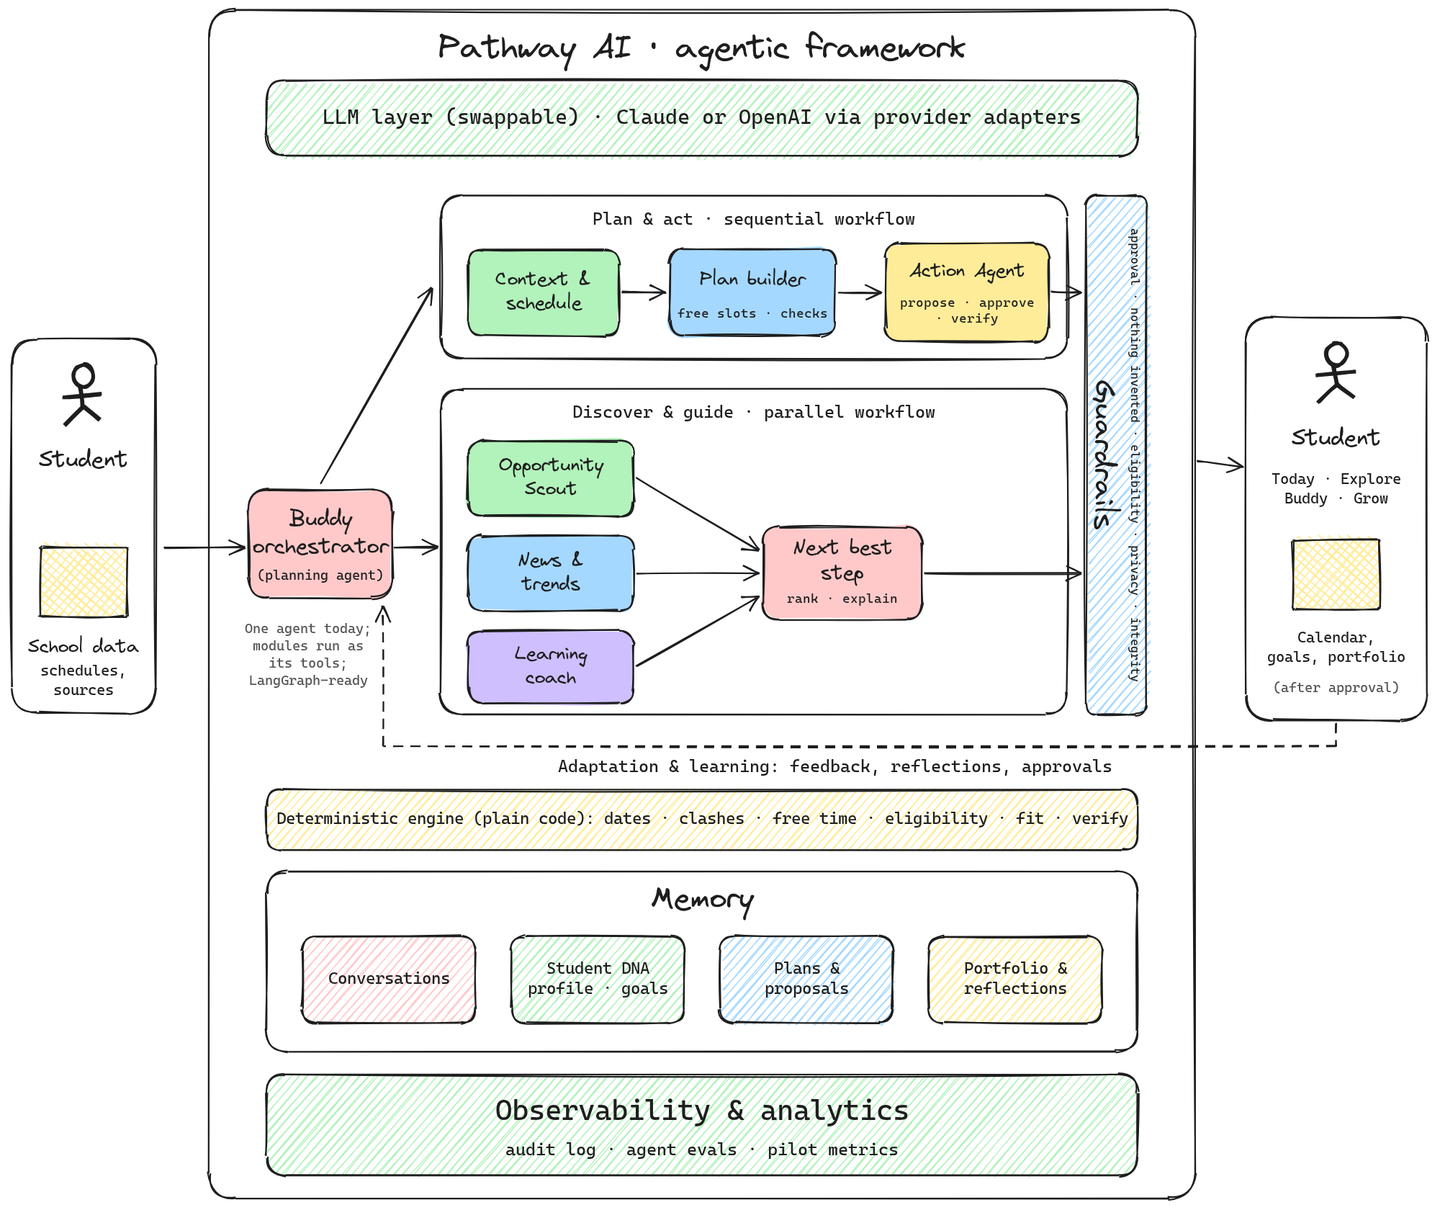
Figure 1. Pathway AI agentic framework (logical modules).

11.1 Request flow
- Ask: the student asks Buddy (or taps a button that asks for them).
- Think and call tools: Buddy sends the conversation to the LLM, runs the tools it requests, up to 6 rounds per message.
- Facts from code: tools read schedule, free time, eligibility and fit from the deterministic engine.
- Propose: propose_actions creates a proposal; nothing is saved yet.
- Approve: the student reviews and approves or declines.
- Execute and verify: recheck, one transaction, read back, audit; roll back on any failure.

11.2 Logical modules
Module | Workflow | Implemented today as
Buddy orchestrator (planning agent) | Entry point | Tool-use loop (agent/buddy.ts)
Context and schedule | Plan & act (sequential) | get_schedule tool
Plan builder | Plan & act | find_free_slots and check_plan tools
Action Agent | Plan & act | propose_actions tool + approval service (lib/proposals.ts)
Opportunity Scout | Discover & guide (parallel) | search_opportunities tool + scoring engine
News and trends | Discover & guide | News selection and News for you
Learning coach | Discover & guide | get_learning_resources tool + coach endpoint
Next best step | Decision | Today next action (rules + AI insight)
Guardrails | Across all | Tool validation, engine rules, approval gate, prompt policies
Memory | Across all | Conversations, Student DNA, proposals, portfolio and reflections in the database
Observability | Across all | Audit log; agent evals and pilot metrics (planned)

11.3 Agent tools
Tool | Input | Output | Notes
get_schedule | from, to (up to 21 days) | Events, conflicts, per-day capacity, rules | Recurrence expanded
find_free_slots | from, to, minutes, count | Open slots | Study window only; avoids commitments and downtime; max 2 per day; daily limit
check_plan | Proposed sessions | ok[], problems[] | Required before proposing calendar blocks
search_opportunities | Optional query | Results with factors and verified flag; excluded with reasons | Hard exclusions first
get_learning_resources | Topics | Curated resources | Only these links may be recommended
propose_actions | Summary, rationale, actions[] | Proposal id and status | The only write path; validated; calendar revalidated

11.4 Agent policies (system prompt)
- Use tools for facts; never compute dates, eligibility or free time in the model.
- Put every change into one propose_actions call; never say something was added, say it is waiting for approval.
- Protect downtime, respect the daily study limit, leave breathing room; reminders are 15-minute reminder events.
- Only use opportunity facts from tools; unknown deadlines stay unknown; tell the student what to verify.
- Explain why each recommendation fits and give one achievable next step.
- Coach learning; never complete graded work for submission.
- Never predict admissions, invent achievements or imply a universal ideal résumé.
- Ask one short clarifying question when a key detail is ambiguous; reply in under about 150 words.

11.5 LLM layer (provider-agnostic)
Provider | Setting | Notes
Claude (Anthropic) | LLM_PROVIDER=anthropic, ANTHROPIC_API_KEY, ANTHROPIC_MODEL | Default; Messages API with tool use and image input
OpenAI | LLM_PROVIDER=openai, OPENAI_API_KEY, OPENAI_MODEL | Kit adapter uses Chat Completions with function calling; newer models may require migrating the adapter to the Responses API
Ollama (local models) | LLM_PROVIDER=ollama, OLLAMA_BASE_URL, OLLAMA_MODEL | Free and private; runs where the server runs (for example inside each Codespace); slower and weaker at multi-step tool use
Only the adapter files import a vendor SDK; prompts, tools, guardrails and approvals are shared. The same golden conversations should pass on every provider.

11.6 Agent framework decision
Option | Adds | Decision
Custom thin loop (current) | Small, typed, auditable; no extra dependencies | MVP choice
LangGraph | Stateful graphs, checkpoints, approvals that pause and resume, parallel branches | Adopt when workflows become multi-agent or approvals must persist across sessions (Phase 2)
LangChain | Integrations, loaders, retrieval | Adopt for document-heavy sourcing if needed
Vercel AI SDK | Unified TypeScript API across providers, streaming | Option if more providers or streaming are needed quickly
Vendor agent SDKs | Vendor-native tooling | Only if committing to one vendor

12. System architecture

12.1 Layers
Layer | Technology | Responsibility
Front end | React + TypeScript (Vite) | Screens, sheets, themes; calls the API; no business rules
API server | Node.js + TypeScript (Fastify), zod | Routes, validation, engine, agent, approval service
Deterministic engine | TypeScript pure functions | Schedule, conflicts, capacity, eligibility, scoring, rings, news selection, action contracts
Agent | LLM interface + adapters | Buddy loop, insight, schedule extraction, coach
Data | Prisma ORM; SQLite (dev), PostgreSQL (prod) | Persistent storage; cascade delete per student
Jobs (planned) | Scheduled workers | News ingestion, opportunity verification, proposal expiry
Hosting (proposed) | Render or Fly.io (API), Vercel (web), managed Postgres | Public pilot deployment

12.2 Repository structure
Path | Contents
README.md, AGENTS.md, TRAINER-GUIDE.md | Overview, rules for coding agents, trainer instructions
package.json, .env.example, .gitignore | Workspace scripts (setup, dev, test, typecheck, build), settings template, upload exclusions
.devcontainer/ | GitHub Codespaces configuration (installs, sets up and forwards port 5173)
docs/ | PRD, UX flows, design system, architecture, data model, API (+ openapi.yaml), agent and tools, sourcing, privacy, backlog, traceability, Codex playbook
apps/web/src/pages/ | Onboarding, Today, Explore, Buddy, Grow, You, ScanSheet
apps/web/src/components/ | Rings and sheets (ui), approval review, News for you sheet
apps/web/src/lib/ | API client, types, formatting, themes
apps/api/prisma/ | Database schema and seed (opportunities, news)
apps/api/src/routes/ | students, events, today, opportunities, proposals, growth, news, ai
apps/api/src/domain/ | time, types, schedule, scoring, metrics, actions, news
apps/api/src/agent/ | buddy (loop), tools, prompts, llm/ (types, anthropic, openai, index)
apps/api/src/lib/ | proposals (approval service), audit, auth (dev only), context, db, env, sample
apps/api/test/ | Unit tests: schedule, scoring, actions, news, llm

12.3 Request lifecycle
Student taps › front end calls the API › input validated › engine or Buddy computes › any change becomes a proposal › student approves › one transaction, verified › audit log › screen refreshes.

12.4 Environments
Environment | Purpose | Data | AI
Claude prototype | Demos and user testing | Claude artifact storage (per viewer) | Viewer’s Claude account
Local / Codespaces | Development, trainers | SQLite file | Off by default; own key or Ollama
Hosted pilot | Real students | Managed PostgreSQL | Server-side key with usage limits

13. Data model
Entity | Purpose | Key fields
Student | Student DNA | name, grade, timezone, broad location, interests[], skills[], aiConsent, budget, format, settings (showWord, showNews, theme, newsTopics, voice), provenance
Availability | Capacity rules | studyStart, studyEnd, maxStudyMin, downtimeStart, downtimeEnd, source, lastVerified
Event | Calendar items | title, type, start/end (local), recurDays[], recurUntil, location, source, confidence, done, proposalId
Goal / Milestone | Growth journey | title, category, priority, targetDate, opportunityId, status; steps with effortMin, targetDate, status, doneAt
Opportunity | Normalized listing | name, organizer, url, category, gradeMin/Max, minAge, format, cost, commitment, skills[], tags[], checks[], deadline, sourceCheckedAt, isSample
SavedOpportunity | Student status | saved, dismissed, preparing, applied, done
PortfolioEntry | Achievements | type, title, date, reflection, skills[], evidence, visibility, verification
AgentAction | Proposal | origin, summary, rationale, actions[], dataUsed[], effect, status, idemKey, result, createdIds[], log[], expiresAt
AuditEvent | Activity log | actor (student, pathway, system), event, record, at
Conversation / ChatMessage | Buddy threads | title, updatedAt; role, content, meta (tool events, proposal ids)
NewsStory | Sourced news | topic, headline, summary, source, url, publishedAt, checkedAt
DailyBrief | Cached AI insight | studentId + date › JSON
Conventions: local datetimes as “YYYY-MM-DDTHH:MM” plus the student’s timezone; JSON fields stored as strings for SQLite/PostgreSQL portability; deleting a student cascades to all linked records; never store exact home addresses, health data or sensitive inferences.

14. API reference
REST over JSON. Development identity uses the x-student-id header and must be replaced by real authentication before any real student uses the product.
Method | Path | Purpose
POST | /api/students | Onboard (Student DNA, availability, optional goal and sample semester)
GET / PATCH / DELETE | /api/me | Read, edit (records provenance), delete everything
GET | /api/me/export | Full data export (JSON)
GET / POST | /api/today, /api/today/insight | Today snapshot; AI insight (cached daily)
GET / POST | /api/events | Occurrences with clash flags; add event (409 warning on conflict unless forced)
POST | /api/events/bulk | Save events the student confirmed from a scan
PATCH / DELETE | /api/events/:id | Mark done; delete
GET | /api/events/:id/ics | Calendar file (student-initiated download)
GET | /api/opportunities, /api/opportunities/:id | Recommendations with factors; excluded with reasons; one opportunity
POST | /api/opportunities/:id/status | Save, dismiss or clear
POST | /api/opportunities/:id/prep | Create a prep proposal
GET / POST | /api/proposals, /:id, /:id/approve, /:id/reject | List, read, approve (execute and verify), decline
GET / POST / PATCH / DELETE | /api/goals, /api/milestones/:id | Goals and steps
GET / POST / PATCH / DELETE | /api/portfolio | Portfolio entries and visibility
GET | /api/news | Stories filtered by the student’s topics
GET / DELETE | /api/buddy/conversations(/:id/messages) | Threads for Buddy home; read or delete a thread
POST | /api/buddy/messages | {text, conversationId?}; new thread when no id; returns conversationId
POST | /api/extract | Candidate events from an image or text (not saved)
POST | /api/coach | Learning explanation
GET | /api/audit, /api/resources, /api/health | Activity log; curated resources; health with AI provider

15. Deterministic engine rules
Rule | Definition
Recurrence | Weekly events expand by weekday between start and recurUntil
Conflicts | Overlapping occurrences; exams and deadlines inside class time are not conflicts; flexible items inside protected downtime are conflicts
Day capacity | Free minutes inside the study window minus busy time; study minutes planned; remaining budget = daily limit minus planned study
Free slots | Never in the past or in downtime; inside the study window; at most 2 per day; respects the remaining budget; 30-minute spacing
Check plan | Each proposed block is checked against events, downtime, other proposed blocks and the daily limit
Focus ring | Study minutes today ÷ daily limit; status Open, On track or Too much
Free time ring | (Free study-window minutes + downtime) ÷ (window + downtime); status Plenty (3h+), Some (1.5h+) or Tight
Progress ring | Goal steps done ÷ steps planned or completed this week; status No steps yet, Building or Moving (60%+)
Eligibility | Grade range and passed deadlines exclude; minimum age, cost (if budget is free only), format and program-specific checks become “check details”
Prep proposal | Save opportunity + 15-minute reminder in the first free slot in the next 1–4 days + goal with two steps (confirm details in 3 days; first prep session in 7 days)

16. Trust, safety and privacy

16.1 Trust promises
Promise | How it is enforced
Students decide | The agent’s only write path is a proposal; the approval service executes after a yes
Nothing invented | Facts from code and sources; unverified data labeled; deadlines unknown unless verified; news always sourced
Private by default | Minimal data; portfolio items private unless shared; export and delete anytime; visible activity log
Learning, not shortcuts | The coach explains and practices; graded work gets coaching, not answers
Room to breathe | Study only inside the student’s window and limit; downtime never scheduled

16.2 Agent safety behaviours
No admissions predictions; no invented achievements; ask instead of guessing; non-judgmental tone; no pressure, streaks or rankings; limited nudges; point students to their counselor for decisions about their situation.

16.3 Privacy for minors: launch blockers
- Real authentication and an age gate; verifiable parental consent where required.
- Legal review covering COPPA, FERPA and applicable state student-privacy laws.
- Encryption in transit and at rest; secrets in a vault; least-privilege service accounts.
- Data retention policy (for example, schedule photos not kept; chat retention limits).
- Content moderation and crisis-language handling with appropriate resources.
- Student-controlled permissions for parent and counselor views.
- Review of each AI provider’s data-handling settings; local models (Ollama) as a privacy option.

16.4 Voice privacy
Voice is off by default. Speech is transcribed by the browser and shown for editing before sending; no audio is recorded or stored by Pathway. Students are told that the browser’s speech service may process audio.

17. Design system

17.1 Direction
Calm companion, inspired by the Oura app: soft dark backgrounds with a gentle glow, rings with contributors, editorial serif for warmth, one action at a time.
Token / theme | Dusk (default) | Dark | Light
Background | #161A2C | #080A13 | #F3F2F8
Text / secondary | #EEF0F8 / #B2B8D0 | #ECEEF7 / #A0A6BE | #16152A / #5D5B73
Periwinkle (Focus, links) | #A9B9FF | #9DAFFF | #4E62D6
Teal (Free time, success) | #7FDDCB | #6FD8C4 | #13897A
Peach (Progress, attention) | #F7C79B | #F5BE8C | #B8641F
Rose (overlaps, destructive) | #FF9DB0 | #FF8FA3 | #C2405A

17.2 Typography and signature elements
- Fraunces (soft serif) for greetings, headlines and insights; Instrument Sans for interface text; system fallbacks.
- Sky card: time-of-day gradients (morning peach to rose, afternoon sky to periwinkle, evening peach to violet, night indigo).
- Orb: Buddy’s identity; radial white to periwinkle to teal with a glow; breathes gently unless reduced motion is on.
- Rings: thin glowing strokes, centered value, status word below; tap for contributors.
- Cards and sheets: translucent cards; bottom sheets with grabber, Cancel/Done.

17.3 Rules
- One primary action per card; 44-pixel minimum targets; 4.5:1 text contrast; color never the only signal.
- Motion under 400 ms; disabled when reduced motion is requested.
- Copy: second person, warm and short; avoid pressure and admissions talk.

18. Data sourcing
Data | Today | Target pipeline
Opportunities | Curated sample of 14 well-known programs with official URLs; deadlines unknown; labeled unverified | Allow-listed official sources › fetch and snapshot › AI extraction to a strict schema › normalize and de-duplicate › verify (link works, deadline in future, eligibility present) › check date › weekly re-checks; expired hidden
News | Real, sourced starter set (October 2026) across five topics | Daily job per topic from licensed or allow-listed reputable sources › student-appropriate filtering › one-sentence neutral summary › 30-day retention
Learning resources | Curated list (Python tutorial, CS50, Khan Academy, Kaggle Learn and others) | Reviewed additions; the agent may only recommend listed links
Words of the day | 12+ words with original example sentences | Expanded list by grade

19. Testing and quality
Level | Coverage today | Next
Unit tests | 16 tests: schedule (recurrence, conflicts, capacity, free slots, plan checks), scoring (exclusions, factors, unverified source), action contracts, news selection, LLM JSON parsing | Grow with every domain change
Integration tests | Codex verified the approval journey in its environment | Fastify inject tests for Discover-and-act, including FAILED with rollback
Agent evals | Manual checks | 20 golden conversations across providers (no scheduling over practice; ineligible not recommended; unknown deadline stated; homework coached; no claims without approval)
Accessibility | Labels and contrast by design | Automated audit plus keyboard-only journey
Pilot measures | Defined (section 5) | Instrumented dashboards

19.1 Acceptance criteria (non-negotiable)
- Onboarding works without calendar or email connections.
- No opportunity is shown as verified without a source and check date.
- Ineligible or expired opportunities are excluded or prominently flagged.
- No change happens without a clear, specific approval.
- Every action reports its real outcome; no premature success.
- Students can inspect, correct, export and delete their data.
- Recommendations include plain-language rationale and realistic time expectations.
- Works on common phone widths with keyboard navigation and accessible labels.
- Missing integrations or unavailable sources never fail silently.

20. Build and delivery approach

20.1 Prototype vs. production app
 | Claude-built prototype | Codex-built application
What it is | One self-contained page published in Claude | Full repository: web app, API server, database
Where it runs | Claude’s viewer, from a shared link | Local machines, Codespaces, or cloud hosting
AI | Viewer’s Claude account, in the browser | Server-side: Claude, OpenAI or Ollama
Data | Claude artifact storage per viewer | Your own database (SQLite or PostgreSQL)
Purpose | Demos, user testing, submission | Pilot and growth

20.2 Building with Codex
- Codex build kit (recommended): working foundation plus AGENTS.md rules, docs and a 14-prompt playbook; small reviewable tasks.
- Standalone build prompt: rebuilds from this document in seven milestones (M0 foundation › M6 hardening); useful as a clean-room build.
- Environment: GitHub repository connected to Codex; internet access allow-listing registry.npmjs.org, binaries.prisma.sh and api.github.com; install skill runs setup, tests and builds; AI disabled by default.

20.3 Trainer and tester access
Option | How | Notes
GitHub Codespaces | Code › Codespaces › Create; npm run dev; open port 5173 | No installs; each trainer has a private copy; free monthly hours
Laptop | Install Node.js and Git; npm run setup; npm run dev | See TRAINER-GUIDE.md
Public test link | Set port 5173 to Public in Codespaces | Temporary; uses the owner’s hours and AI key
Hosted pilot | Deploy API, web and PostgreSQL to free or low-cost tiers with an access code | Permanent link; recommended for multi-day testing

20.4 Costs
Item | Cost
GitHub (free account, private repo) | Free
Node.js, SQLite, Ollama | Free
Codex | Included in eligible ChatGPT plans
AI API (Claude or OpenAI) | Pay-as-you-go, billed separately from ChatGPT subscriptions; set usage limits
Hosting | Free starter tiers available; scale with the pilot

21. Roadmap
Phase | Focus | Exit criteria
Now: prototype | One connected journey end to end; sample semester; News for you; Buddy home; voice; provider choice | Demo journeys work; materials match the product
Next: MVP and pilot | Real sign-in and consent; verified sourcing jobs; reminders; PostgreSQL and CI; agent evals; hosted pilot | Real students discover and follow through safely
Phase 2: Grow | Learning paths; learn from feedback (“Not for me” reasons); week-ahead check-in; growth insights; calendar integrations; LangGraph if needed | Retention and progress signals in the pilot
Exploration | Opportunity gap finder; opportunity creator; parent and counselor views; school partnerships | Validated with partners

22. Risks and mitigations
Risk | Impact | Mitigation
Wrong or stale opportunity data | Student misses or misreads a deadline | Verification pipeline, check dates, “confirm on site” for unknowns, weekly re-checks
AI makes unsafe or wrong suggestions | Trust loss | Facts from code, approval gate, prompt policies, evals across providers
Over-reliance or pressure | Stress increases | Protected downtime, no streaks or scores, limited nudges, counselor referral
Privacy breach involving minors | Severe | Minimal data, encryption, legal review, retention policy, audit log
Academic integrity | Cheating concerns | Coach explains and practices; refuses to complete graded work
Provider dependency or cost | Outages or budget overrun | Provider-agnostic layer, usage limits, Ollama option
Adoption by schools | Slow pilot | Position as counselor complement; clear privacy story; sample data demos

23. Open decisions
Decision | Options | Owner / timing
Final product name | Pathway AI or Pathwise | Before pilot materials
Age coverage and consent model | By region; 13+ default with consent flows | With legal review
Default AI provider for pilot | Claude, OpenAI or local (Ollama) | Before hosted pilot
News and opportunity sources | Licensed APIs or allow-listed publishers | MVP
Parent and counselor permissions | Read-only shares, student-controlled | Phase 2
Pricing and distribution | Free student core; paid family and school plans (to validate) | Pilot learnings

Appendix A. Screens
Prototype screens in the default Dusk theme, with the labeled sample 10th-grade semester.
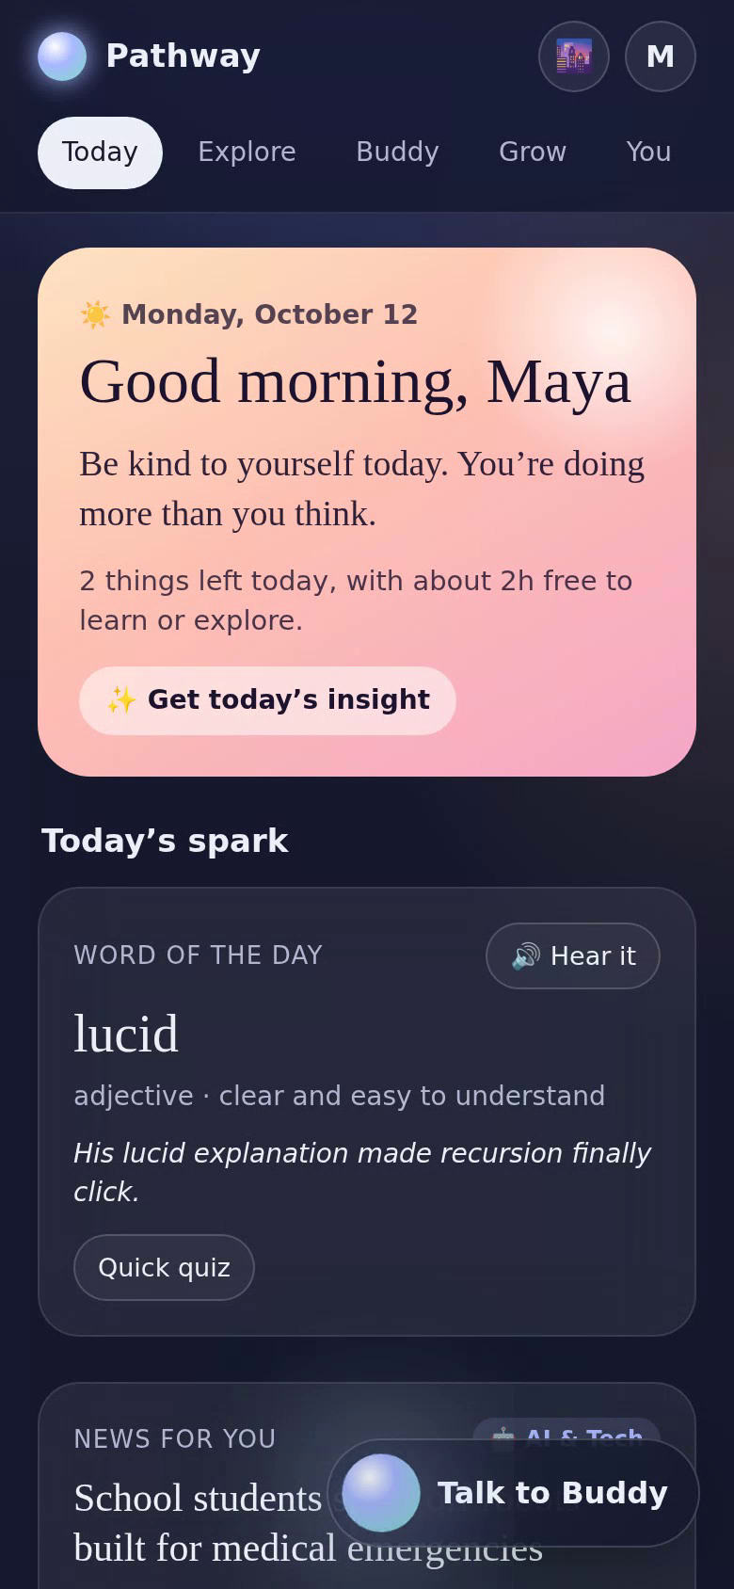  Today | 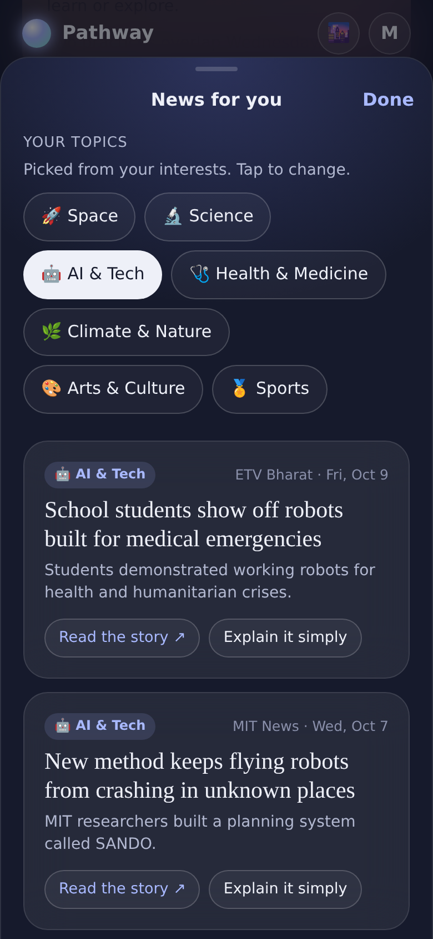  News for you | 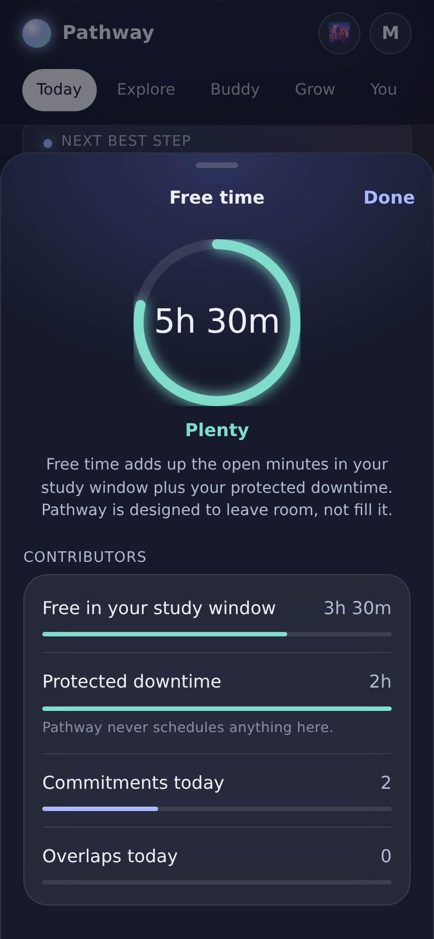  Ring contributors
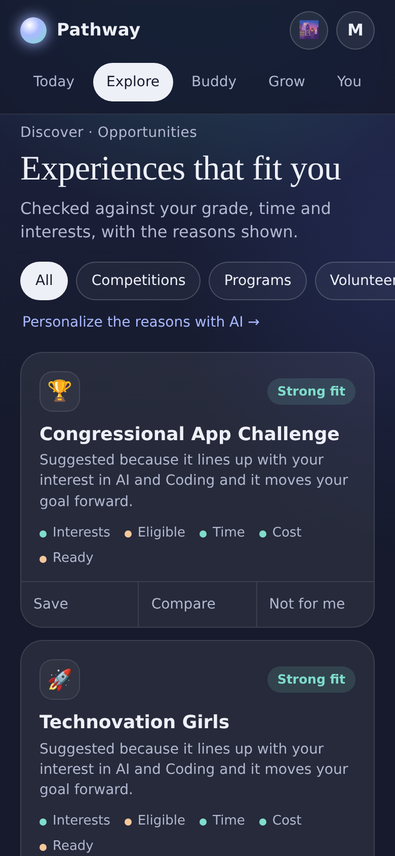  Explore | 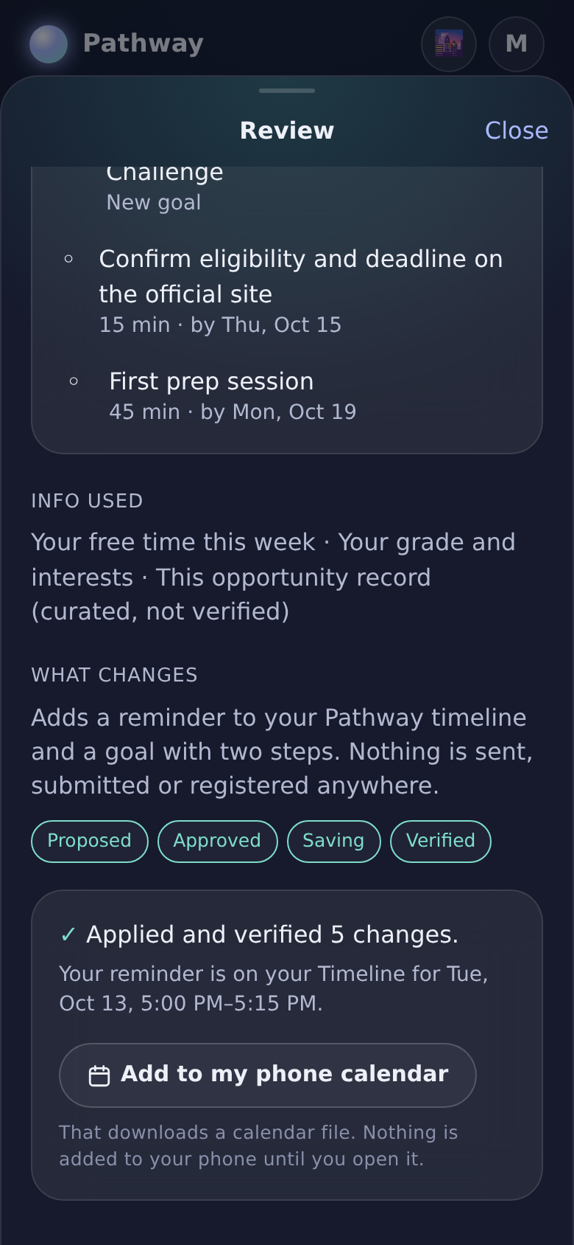  Approval verified | 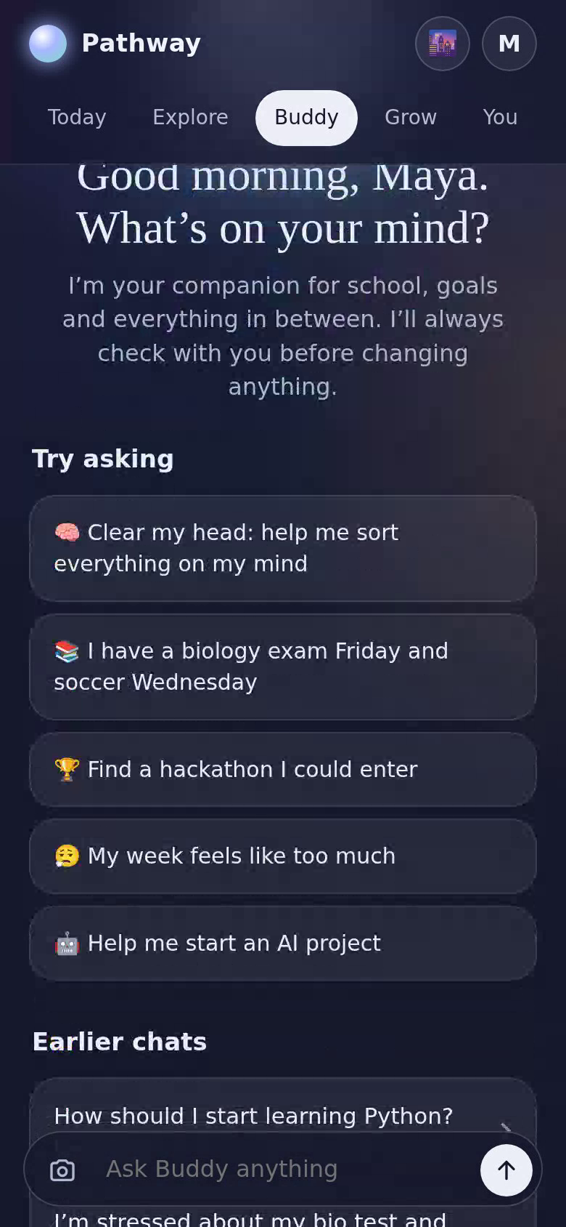  Buddy home
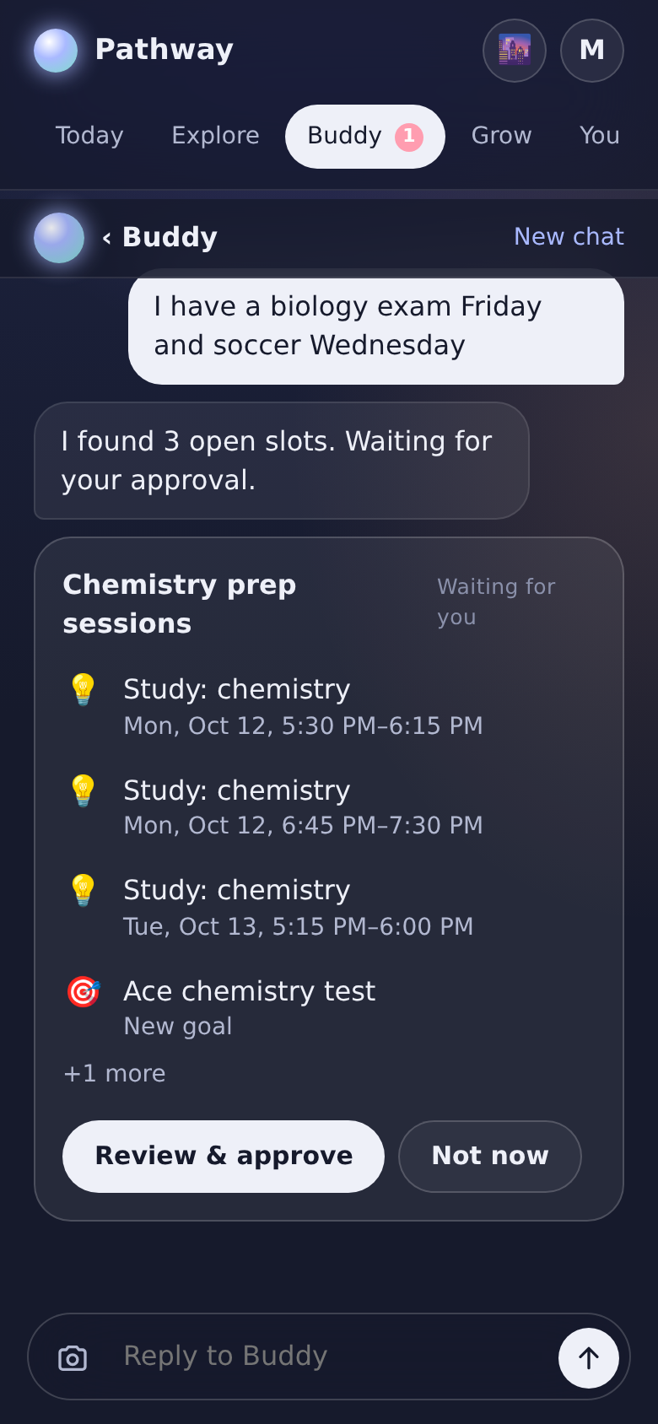  Buddy proposal | 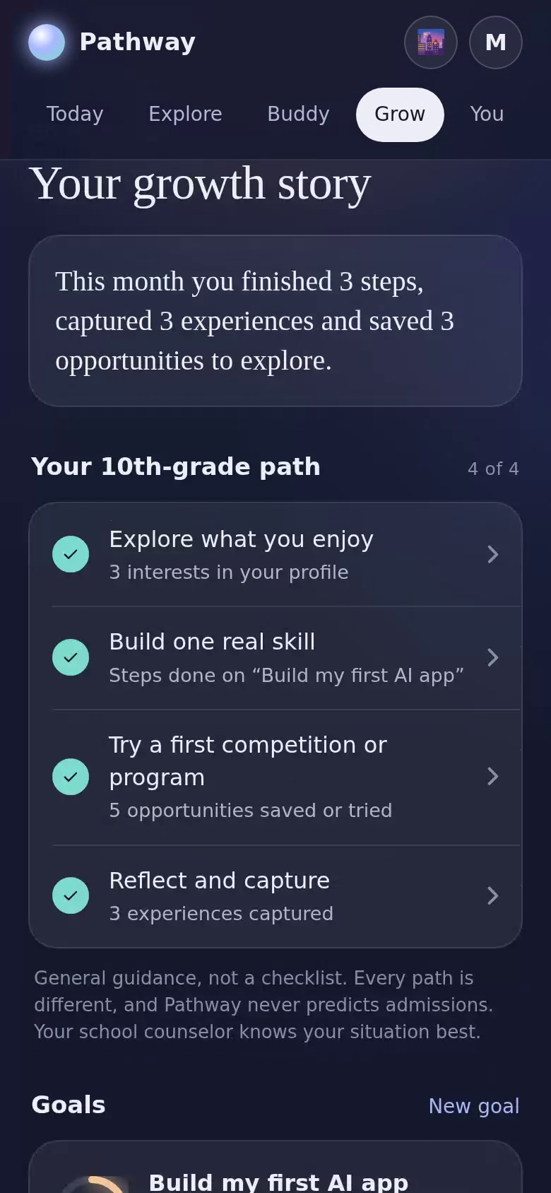  Grow and grade path | 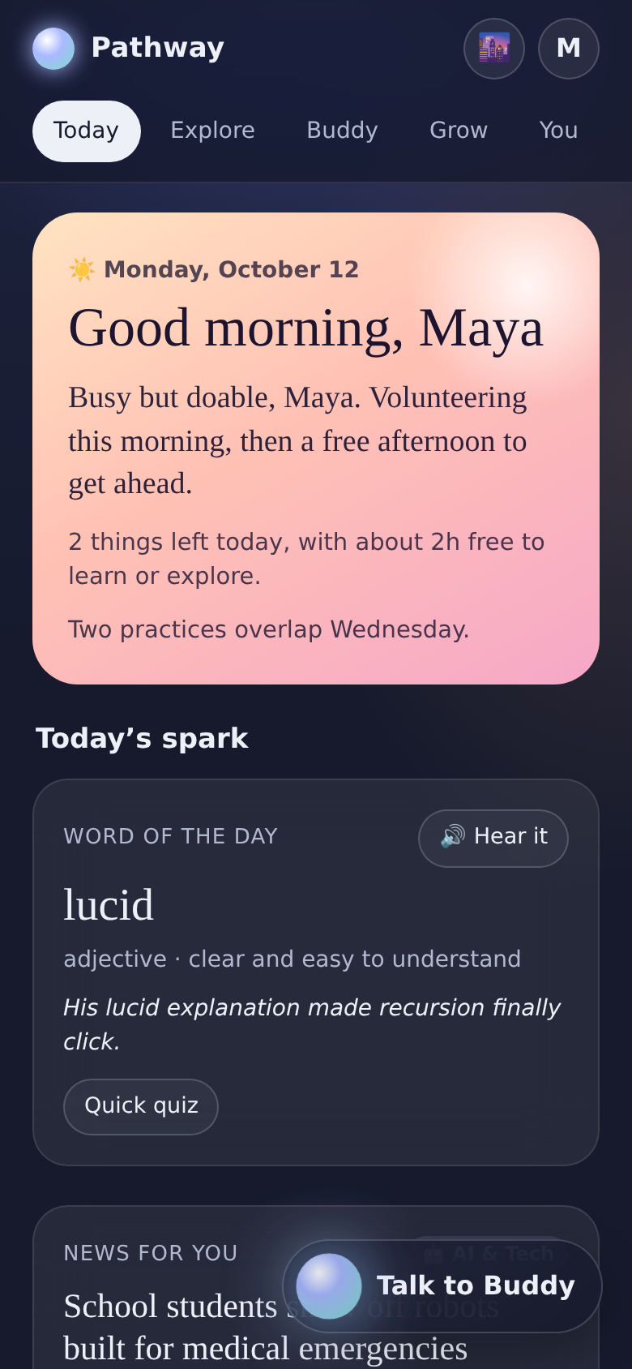  Today (morning)

Appendix B. Glossary
Term | Meaning
Agent / orchestrator | The AI component (Buddy) that decides which tools to use to answer a request
Tool | A function written in plain code that the agent may call (for example find_free_slots)
Proposal | A set of changes the agent or a student action suggests; nothing is saved until approved
Deterministic engine | Plain, tested code that computes facts (dates, conflicts, eligibility) the same way every time
LLM | Large language model, the AI that writes language (Claude, OpenAI models or local models)
Student DNA | The student’s profile: interests, skills, goals, availability, with the source of each
Provenance | Where a piece of profile data came from and when
Codespaces | GitHub’s browser-based development computers
Codex | OpenAI’s coding agent that works in the GitHub repository
Ollama | Free software that runs open AI models on a computer
SQLite / PostgreSQL | Databases: SQLite is a single local file; PostgreSQL is a production database server

Appendix C. Related materials
Material | Description
Working prototype | Live Pathway AI app published in Claude (share before distributing)
Pitch deck (20 slides) and pitch web page | Story: Maya, four questions, Buddy / Organizer / Guide, product walkthrough, trust, impact, ask
Talk track | Ten-minute presentation script with Q&A and a one-minute version
Demo video | 4-minute narrated walkthrough with original music
Architecture diagrams | Agentic framework (sketch style) and system architecture
Codex build kit and Build Guide | Repository, docs, playbook prompts, trainer guide
Standalone Codex build prompt | Milestone-based clean-room build from this document
GitHub showcase | One-pager README, HTML page, video and diagram for the repository

