**RETO 1: DESARROLLO DE UN API REST CON DJANGO Y DJANGO REST FRAMEWORK**

**VICTOR GALINDO CAVERO**

1. Configura un entorno de desarrollo utilizando Django y Django REST Framework. Cliente. **(5 puntos)**

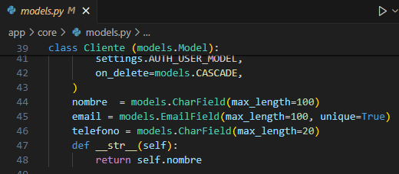

1. **API REST:**

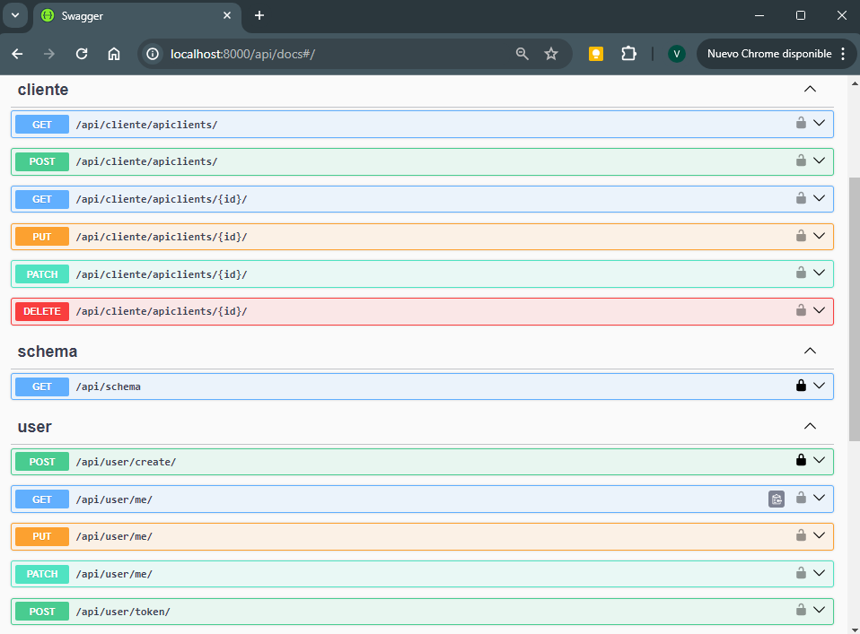

1. **Contenedor Docker:**

**Dockerfile:**

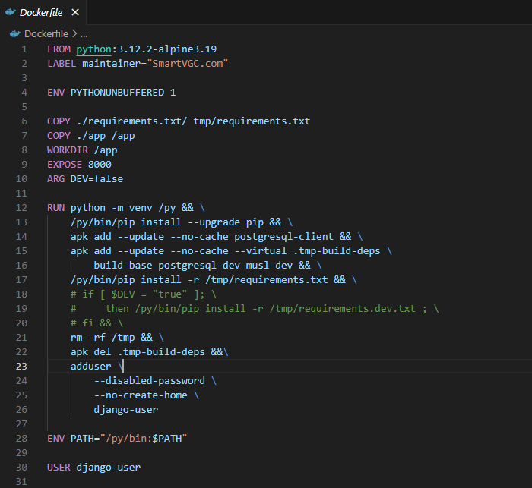

**Docker-Compose: Port mapping**

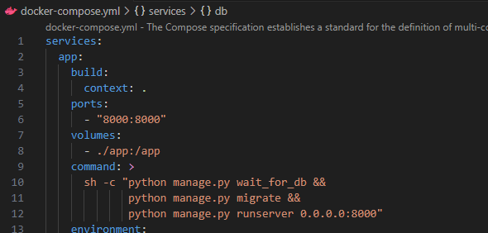

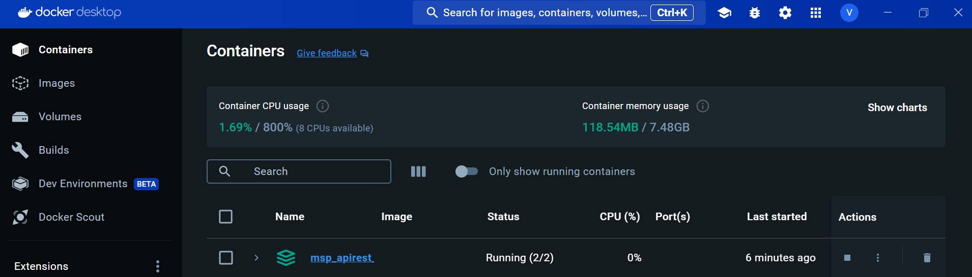

1. **Implementa las vistas y serializadores**



1. **Prueba cada de las operaciones CRUD haciendo uso de Postman**

**GET**

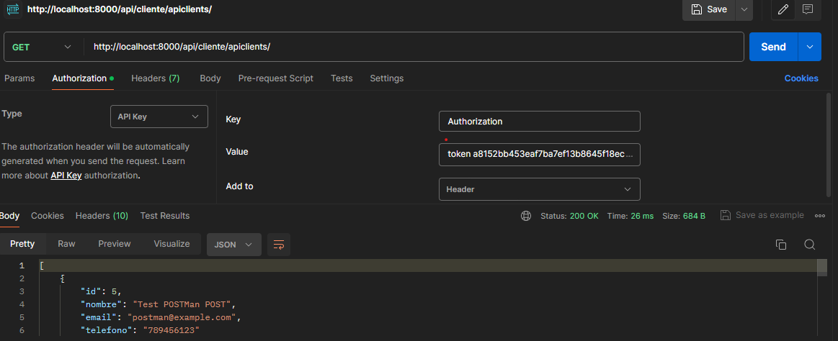

**POST**

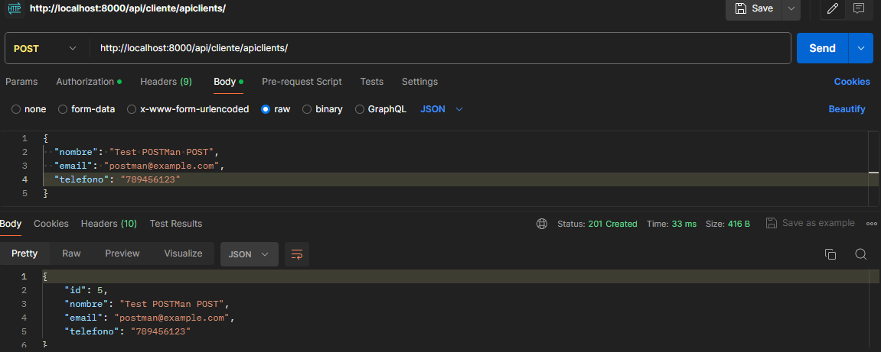

**GET BY ID**

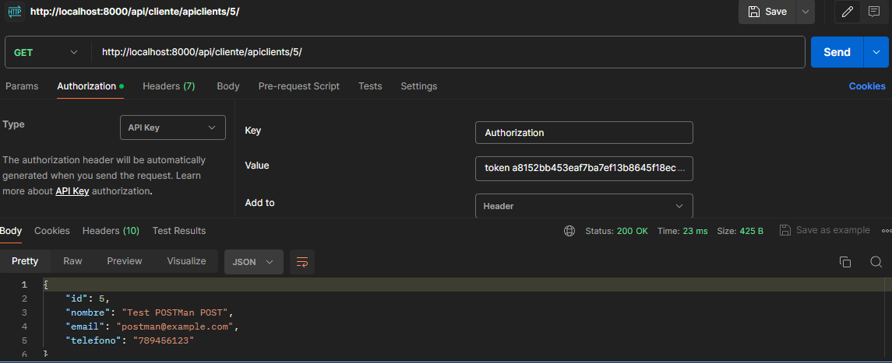

**PUT**

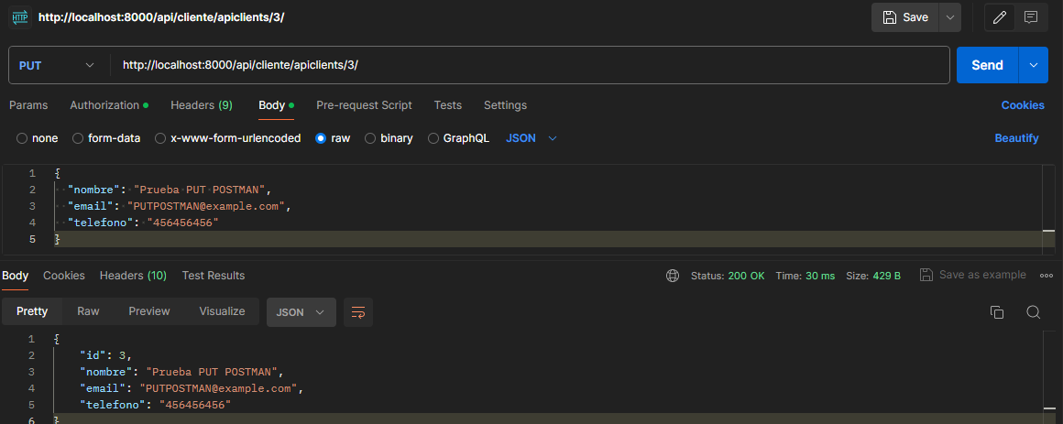

**PATCH**

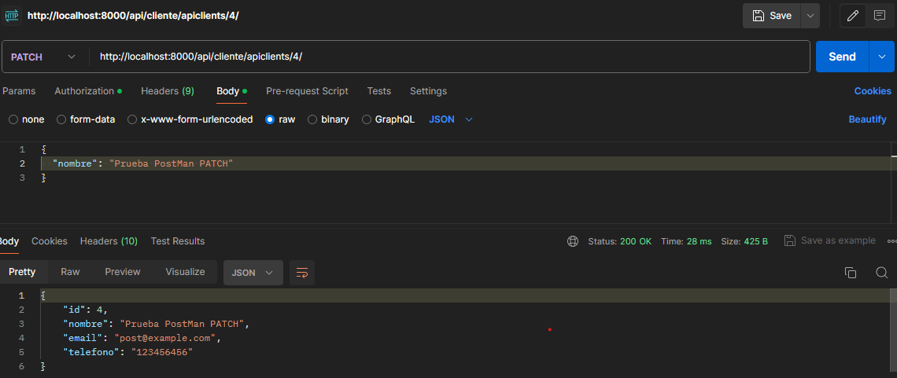

**DELETE**

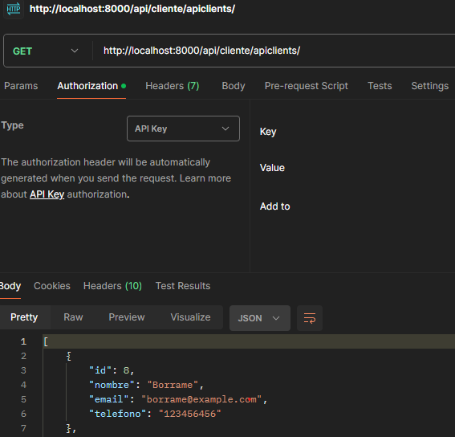

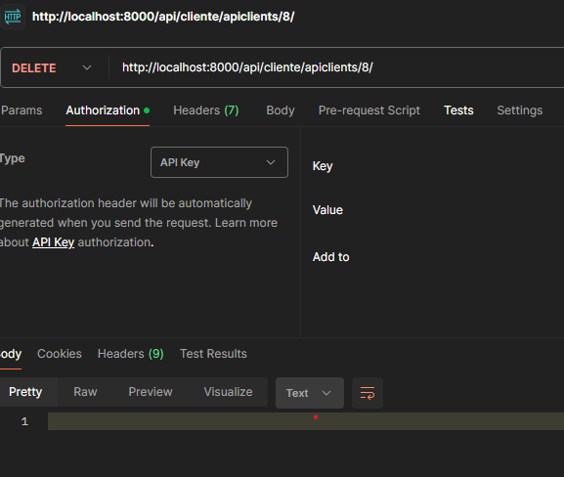

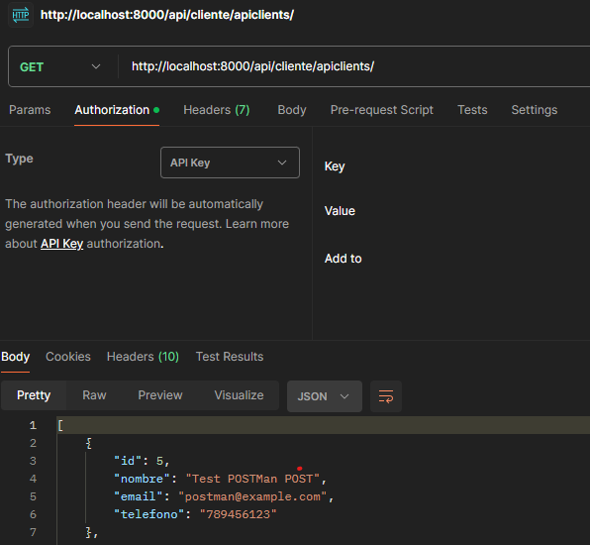

**Documenta TU API**

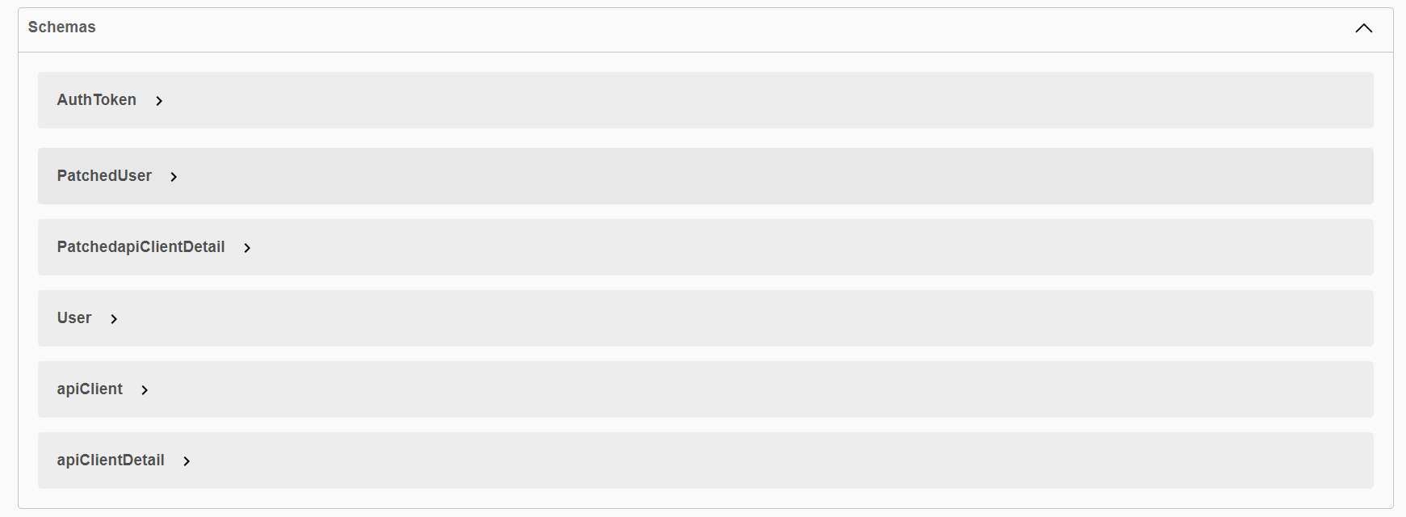

**Realiza un unit_test de nombre cliente_test.py (test_cliente_test) para validar la API**

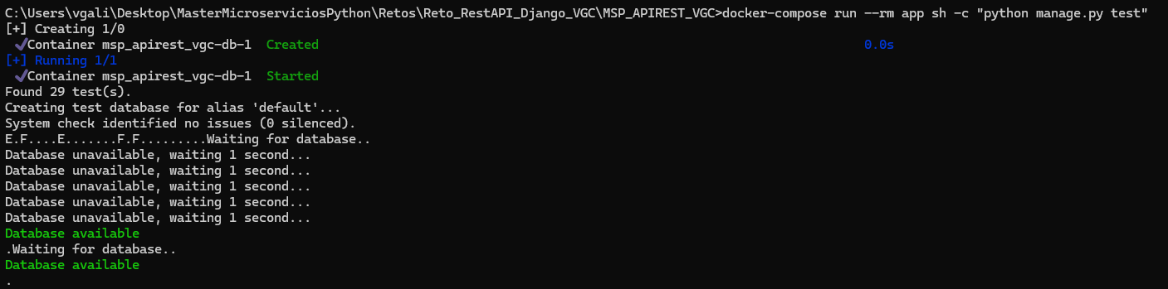

**Found 29 test(s).**

**Creating test database for alias 'default'...**

**System check identified no issues (0 silenced).**

**E.F....E.......F.F.........Waiting for database..**

**Database unavailable, waiting 1 second...**

**Database unavailable, waiting 1 second...**

**Database unavailable, waiting 1 second...**

**Database unavailable, waiting 1 second...**

**Database unavailable, waiting 1 second...**

**Database available**

**.Waiting for database..**

**Database available**

**.**

**======================================================================**

**ERROR: test_client_list_limited_to_user (apiclient.test.test_client_test.PrivateClientpiTests.test_client_list_limited_to_user)**

**Test list of clients is limited to authenticated user.**

**----------------------------------------------------------------------**

**Traceback (most recent call last):**

**File "/py/lib/python3.12/site-packages/django/db/backends/utils.py", line 105, in _execute**

**return self.cursor.execute(sql, params)**

**^^^^^^^^^^^^^^^^^^^^^^^^^^^^^^^^**

**psycopg2.errors.UniqueViolation: duplicate key value violates unique constraint "core_cliente_email_key"**

**DETAIL: Key (email)=(Sample@gmail.com) already exists.**

**The above exception was the direct cause of the following exception:**

**Traceback (most recent call last):**

**File "/app/apiclient/test/test_client_test.py", line 80, in test_client_list_limited_to_user**

**create_client(user=self.user)**

**File "/app/apiclient/test/test_client_test.py", line 34, in create_client**

**client = Cliente.objects.create(user=user, **defaults)**

**^^^^^^^^^^^^^^^^^^^^^^^^^^^^^^^^^^^^^^^^^^^^^**

**File "/py/lib/python3.12/site-packages/django/db/models/manager.py", line 87, in manager_method**

**return getattr(self.get_queryset(), name)(*args, **kwargs)**

**^^^^^^^^^^^^^^^^^^^^^^^^^^^^^^^^^^^^^^^^^^^^^^^^^^^**

**File "/py/lib/python3.12/site-packages/django/db/models/query.py", line 679, in create**

**obj.save(force_insert=True, using=self.db)**

**File "/py/lib/python3.12/site-packages/django/db/models/base.py", line 822, in save**

**self.save_base(**

**File "/py/lib/python3.12/site-packages/django/db/models/base.py", line 909, in save_base**

**updated = self._save_table(**

**^^^^^^^^^^^^^^^^^**

**File "/py/lib/python3.12/site-packages/django/db/models/base.py", line 1067, in _save_table**

**results = self._do_insert(**

**^^^^^^^^^^^^^^^^**

**File "/py/lib/python3.12/site-packages/django/db/models/base.py", line 1108, in _do_insert**

**return manager._insert(**

**^^^^^^^^^^^^^^^^**

**File "/py/lib/python3.12/site-packages/django/db/models/manager.py", line 87, in manager_method**

**return getattr(self.get_queryset(), name)(*args, **kwargs)**

**^^^^^^^^^^^^^^^^^^^^^^^^^^^^^^^^^^^^^^^^^^^^^^^^^^^**

**File "/py/lib/python3.12/site-packages/django/db/models/query.py", line 1847, in _insert**

**return query.get_compiler(using=using).execute_sql(returning_fields)**

**^^^^^^^^^^^^^^^^^^^^^^^^^^^^^^^^^^^^^^^^^^^^^^^^^^^^^^^^^^^^^**

**File "/py/lib/python3.12/site-packages/django/db/models/sql/compiler.py", line 1823, in execute_sql**

**cursor.execute(sql, params)**

**File "/py/lib/python3.12/site-packages/django/db/backends/utils.py", line 79, in execute**

**return self._execute_with_wrappers(**

**^^^^^^^^^^^^^^^^^^^^^^^^^^^^**

**File "/py/lib/python3.12/site-packages/django/db/backends/utils.py", line 92, in _execute_with_wrappers**

**return executor(sql, params, many, context)**

**^^^^^^^^^^^^^^^^^^^^^^^^^^^^^^^^^^^^**

**File "/py/lib/python3.12/site-packages/django/db/backends/utils.py", line 100, in _execute**

**with self.db.wrap_database_errors:**

**File "/py/lib/python3.12/site-packages/django/db/utils.py", line 91, in __exit__**

**raise dj_exc_value.with_traceback(traceback) from exc_value**

**File "/py/lib/python3.12/site-packages/django/db/backends/utils.py", line 105, in _execute**

**return self.cursor.execute(sql, params)**

**^^^^^^^^^^^^^^^^^^^^^^^^^^^^^^^^**

**django.db.utils.IntegrityError: duplicate key value violates unique constraint "core_cliente_email_key"**

**DETAIL: Key (email)=(Sample@gmail.com) already exists.**

**======================================================================**

**ERROR: test_retrieve_clients (apiclient.test.test_client_test.PrivateClientpiTests.test_retrieve_clients)**

**Test retrieving a list of clients.**

**----------------------------------------------------------------------**

**Traceback (most recent call last):**

**File "/py/lib/python3.12/site-packages/django/db/backends/utils.py", line 105, in _execute**

**return self.cursor.execute(sql, params)**

**^^^^^^^^^^^^^^^^^^^^^^^^^^^^^^^^**

**psycopg2.errors.UniqueViolation: duplicate key value violates unique constraint "core_cliente_email_key"**

**DETAIL: Key (email)=(Sample@gmail.com) already exists.**

**The above exception was the direct cause of the following exception:**

**Traceback (most recent call last):**

**File "/app/apiclient/test/test_client_test.py", line 67, in test_retrieve_clients**

**create_client(user=self.user)**

**File "/app/apiclient/test/test_client_test.py", line 34, in create_client**

**client = Cliente.objects.create(user=user, **defaults)**

**^^^^^^^^^^^^^^^^^^^^^^^^^^^^^^^^^^^^^^^^^^^^^**

**File "/py/lib/python3.12/site-packages/django/db/models/manager.py", line 87, in manager_method**

**return getattr(self.get_queryset(), name)(*args, **kwargs)**

**^^^^^^^^^^^^^^^^^^^^^^^^^^^^^^^^^^^^^^^^^^^^^^^^^^^**

**File "/py/lib/python3.12/site-packages/django/db/models/query.py", line 679, in create**

**obj.save(force_insert=True, using=self.db)**

**File "/py/lib/python3.12/site-packages/django/db/models/base.py", line 822, in save**

**self.save_base(**

**File "/py/lib/python3.12/site-packages/django/db/models/base.py", line 909, in save_base**

**updated = self._save_table(**

**^^^^^^^^^^^^^^^^^**

**File "/py/lib/python3.12/site-packages/django/db/models/base.py", line 1067, in _save_table**

**results = self._do_insert(**

**^^^^^^^^^^^^^^^^**

**File "/py/lib/python3.12/site-packages/django/db/models/base.py", line 1108, in _do_insert**

**return manager._insert(**

**^^^^^^^^^^^^^^^^**

**File "/py/lib/python3.12/site-packages/django/db/models/manager.py", line 87, in manager_method**

**return getattr(self.get_queryset(), name)(*args, **kwargs)**

**^^^^^^^^^^^^^^^^^^^^^^^^^^^^^^^^^^^^^^^^^^^^^^^^^^^**

**File "/py/lib/python3.12/site-packages/django/db/models/query.py", line 1847, in _insert**

**return query.get_compiler(using=using).execute_sql(returning_fields)**

**^^^^^^^^^^^^^^^^^^^^^^^^^^^^^^^^^^^^^^^^^^^^^^^^^^^^^^^^^^^^^**

**File "/py/lib/python3.12/site-packages/django/db/models/sql/compiler.py", line 1823, in execute_sql**

**cursor.execute(sql, params)**

**File "/py/lib/python3.12/site-packages/django/db/backends/utils.py", line 79, in execute**

**return self._execute_with_wrappers(**

**^^^^^^^^^^^^^^^^^^^^^^^^^^^^**

**File "/py/lib/python3.12/site-packages/django/db/backends/utils.py", line 92, in _execute_with_wrappers**

**return executor(sql, params, many, context)**

**^^^^^^^^^^^^^^^^^^^^^^^^^^^^^^^^^^^^**

**File "/py/lib/python3.12/site-packages/django/db/backends/utils.py", line 100, in _execute**

**with self.db.wrap_database_errors:**

**File "/py/lib/python3.12/site-packages/django/db/utils.py", line 91, in __exit__**

**raise dj_exc_value.with_traceback(traceback) from exc_value**

**File "/py/lib/python3.12/site-packages/django/db/backends/utils.py", line 105, in _execute**

**return self.cursor.execute(sql, params)**

**^^^^^^^^^^^^^^^^^^^^^^^^^^^^^^^^**

**django.db.utils.IntegrityError: duplicate key value violates unique constraint "core_cliente_email_key"**

**DETAIL: Key (email)=(Sample@gmail.com) already exists.**

**=============================================================**

**FAIL:test_create_client (apiclient.test.test_client_test.PrivateClientpiTests.test_create_client)**

**Test creating a client.**

**----------------------------------------------------------------------**

**Traceback (most recent call last):**

**File "/app/apiclient/test/test_client_test.py", line 108, in test_create_client**

**self.assertEqual(res.status_code, status.HTTP_201_CREATED)**

**AssertionError: 400 != 201**

**=============================================================**

**FAIL: test_new_user_email_normalized (core.test.test_models.ModelTests.test_new_user_email_normalized)**

**----------------------------------------------------------------------**

**Traceback (most recent call last):**

**File "/app/core/test/test_models.py", line 24, in test_new_user_email_normalized**

**self.assertEqual(user.email, expected)**

**AssertionError: 'VgalindoC@email.com' != 'vgalindoc@email.com'**

**- VgalindoC@email.com**

**? ^ ^**

**+ vgalindoc@email.com**

**? ^ ^**

**=============================================================**

**FAIL: test_post_me_not_allowed (user.test.test_user_api.PrivateUserApiTests.test_post_me_not_allowed)**

**----------------------------------------------------------------------**

**Traceback (most recent call last):**

**File "/app/user/test/test_user_api.py", line 118, in test_post_me_not_allowed**

**self.assertEqual(res.status_code, status.HTTP_405_METHOD_NOT_ALLOWED)**

**AssertionError: 200 != 405**

**----------------------------------------------------------------------**

**Ran 29 tests in 19.719s**

**FAILED (failures=3, errors=2)**

**Destroying test database for alias 'default'...**