Rajiv Gandhi University of Knowledge Technologies

IIIT .R.K Valley, YSR Kadapa (Dis)-516330

A Project Report on

DEVELOP YOUR BUSINESS

Submitted By:-
V.Nagalatha(R180250)
V.Ganesh Naik (R180366)


Under the guidance of

Mr. K. Vinod Kumar
(Assistant Professor)

Department of Computer Science Engineering

This project report has been submitted in fulfilment of the requirements for the Degree of Bachelor of Technology in software Engineering.

August -2023

Rajiv Gandhi University of Knowledge Technologies
IIIT, R. K. Valley, YSR Kadapa (Dis)-516330



CERTIFICATE

This is to certify that report entitled "Develop your business" Submitted by V.Nagalatha(R180250) and Ganesh (R180366) in partial fulfilment of the requirements of the award of Bachelor of technology in computer science engineering is a bona fide work carried by the under the supervision and guidance.

The report has been not submitted previously in part or full to this or any other university or institute for the award of any degree or diploma.

GUIDE HEAD OF THE DEPARTMENT
Mr. K. Vinod KUMAR Mr. N. Satyanandram
Assistant Professor HOD OF CSE

Submitted for the practical examination held on………………………………………

Internal Examiner External Examiner

ACKNOWLEDGMENT

The satisfaction that accompanies the successful completion of any task would he
incomplete without the mention of the people who made it possible and who's constant guidance and encouragement crown all the efforts success.

We would like to express my sincere gratitude to Mr. K. Vinod Kumar, my project guide for valuable suggestions and keen interest throughout the progress of our project.

We are grateful to Mr. N. Satyanandram HOD CSE ,for providing excellent
computing facilities and congenial atmosphere for progressing our project.

At the outset, we would like to think Rajiv Gandhi University of Knowledge
Technologies (RGUKT), for providing all the necessary resources and support for the successful completion of my course work.

RAJIV GANDHI UNIVERSITY OF KNOWLEDGE TECHNOLOGIES

(A.P.Government Act 18 of 2008)

RGUKT-RK Valley

Vempalli, Kadapa, Andhrapradesh-516330.

DECLARATION

We Nagalatha and Ganesh are here by declare that the project report entitled "Develop
your business" done under guidance of Mr. K. Vinod Kumar submitted in partial fulfillment for the degree of Bachelor of Technology in Computer Science and Engineering during the academic session September 2022 April 2023 at RGUKT-RK Valley. I also declare that this project is a result of our own effort and has not been copied or imitated from any source. Citations from any websites are mentioned in the references. To the best of my knowledge, the results embodied in this dissertation work have not been submitted to any university or institute for the award of any degree or diploma.

Date: V.Nagalatha(R180250)
Place :RK Valley V.Ganesh Naik(R180336)

INDEX

S.NO | Title | Page No
1 | Introduction | 6-7
2 | Overal description | 7
3 | Abstract | 7-8
4 | System requirements | 8
5 | Purpose | 9
6 | Tools and technologies used | 9-10
7 | Proposed system | 10
8 | Diagrams | 10-15
9 | Code | 15-31
10 | Execution | 32-34
11 | Fuctional testing | 34-36
12 | Conclusion | 36-37
13 | References | 37

DEVELOP YOUR BUSINESS

Name:V.Ganesh Naik Name:V.Nagalatha
ID:R180366 ID:R180250
PHONE NO:8341522895 PHONE NO:9849214081

INDEX

1. Introduction………………………
1.1 Purpose……………………
1.2 Background…………
1.3 Objectives
1.4 Scope………………………
1.5 References…………………………
1.6 Overal description.......................

2.Abstract
3.Diagrams
4.Coding
5.Execution Screenshots
6.Conclusion
7.Reference

Introduction
1.1 purpose:

- What ever the Customer is doing business ,he/she can able to develop their Business through this Software

- There is no age limit to do Business through this Software.

- It gives more profit to the traders ,and all the Customers will Satisfies with this Software.

- This Software is going to bring a new Revolution over the World in Future.

- The Traders and The Customers will see Only Profit.

Background:
In today's competitive business landscape, the pursuit of growth and development is essential for long-term success. The "Develop Your Business" (Dyb) project aims to explore strategies and methodologies that empower businesses to achieve sustainable growth and thrive in dynamic market conditions.

1.3 Objectives:
The primary objectives of the Dyb project include:
- Investigating various business development strategies.
- Identifying key factors that contribute to successful business growth.
- Analyzing case studies of businesses that have effectively developed their operations.
- Providing practical recommendations for implementing growth strategies.

1.4 Scope:
The scope of the Dyb project encompasses a comprehensive analysis of business development strategies, their implementation, and the outcomes achieved. The project will also delve into challenges faced during the growth process and how these challenges were overcome.
1.5 References
Wikipedia

OVARAL DISCRIPTOIN

The various system tools that have been used in developing both front end, back end and other tools of the project are being discussed in this section.

FRONT END:
HTML, CSS, JAVASCRPIT are utilized to implement the frontend.

HTML (Hyper text markup language)
HTML is a syntax is used to format a text document on the web.

CSS (Cascading style sheets)
CSS is a style sheet language is used for describing the look and formatting of a document written in a markup language.

JAVASCRIPT
JS is a dynamic computer programming language. It is most commonly used as part of web browsers, whose implementations allow client side scripts to interact with the user, control the
browser, communicate asynchronously and alter the document content that is displayed.

BACKEND:
The backend is implemented using MYSQL which is used to design the databses.

MYSQL
MYSQL is the world’s second most widely used open source relational database management
system (RDBMS). The SQL phase stands for structured query.

PHP

PHP is a server side scripting language designed for web development but also used as a general purpose programming language. PHP code is interpreted by web server with a PHP processor module, which generates the resulting webpage: PHP commands can be embedded directed into an HTML source document.

ABSTRACT

The "Develop Your Business" (Dyb) project is a comprehensive exploration of strategies and approaches that businesses can adopt to achieve growth and development. Through a thorough analysis of existing literature, real-world case studies, and practical recommendations, this project aims to provide valuable insights for businesses seeking to enhance their operations and seize growth opportunities.

Methodology

Research Approach:
The Dyb project adopts a mixed-methods research approach, combining qualitative analysis of case studies and quantitative analysis of business performance metrics. This approach ensures a comprehensive understanding of the factors influencing business development and growth.

Analysis Techniques:
The qualitative data collected from interviews and case studies were analyzed using thematic analysis to identify recurring themes and patterns. Quantitative data were analyzed using statistical techniques to measure the impact of growth strategies on business performance.

Literature Review

Importance of Business Development:
Business development is a strategic approach that involves identifying opportunities, building relationships, and implementing initiatives to achieve long-term growth. Effective business development strategies drive innovation, market expansion, and improved customer satisfaction.

Strategies for Business Growth:
Successful business growth strategies encompass diversification, market penetration, product innovation, and strategic partnerships. These strategies are crucial for businesses aiming to capitalize on new opportunities and maintain a competitive edge.

Role of Innovation and Adaptation:
Innovation and adaptability are central to business development. By continuously evolving their products, services, and processes, businesses can remain relevant and responsive to changing market dynamics.
System requirements
Software requirements
- Html
- CSS
- PHP
- SQL server
- Javascript
Hardware requirements
- Laptop
PURPOSE
The purpose of the "Develop Your Business" (Dyb) project is to explore, analyze, and provide practical insights into strategies and methodologies that empower businesses to achieve sustainable growth, innovation, and success in a rapidly changing business landscape. The project aims to address critical questions and challenges that businesses face when seeking to enhance their operations, expand their market presence, and remain competitive.
Identifying Growth Opportunities: The project seeks to identify and analyze various growth opportunities available to businesses, ranging from market expansion to product diversification and strategic partnerships.
Promoting Innovation: By delving into innovative approaches and case studies, the project aims to highlight the role of innovation in driving business growth. It explores how businesses can create new value propositions and stay ahead of industry trends.
Advising Effective Strategies: The project aims to provide actionable recommendations and insights on effective strategies for business development. It examines successful strategies employed by real-world businesses to achieve growth and adapt to changing market dynamics.
Providing a Framework: Through its findings and insights, the Dyb project aims to provide businesses with a framework for strategic planning and development. It offers a structured approach for businesses to evaluate their growth potential and make informed decisions.
Supporting Long-Term Success: Ultimately, the project's purpose is to contribute to the long-term success of businesses by equipping them with knowledge, strategies, and tools to navigate the complexities of growth and development.
TOOLS AND TECHNOLOGIES USED

The various system tools that have been used in developing both front end, back end and other tools of the project are being discussed in this section.

FRONT END:
HTML, CSS, JAVASCRPIT are utilized to implement the frontend.

HTML (Hyper text markup language)
HTML is a syntax is used to format a text document on the web.

CSS (Cascading style sheets)
CSS is a style sheet language is used for describing the look and formatting of a document written in a markup language.

JAVASCRIPT
JS is a dynamic computer programming language. It is most commonly used as part of web browsers, whose implementations allow client side scripts to interact with the user, control the
browser, communicate asynchronously and alter the document content that is displayed.

BACKEND:
The backend is implemented using MYSQL which is used to design the databses.

MYSQL
MYSQL is the world’s second most widely used open source relational database management
system (RDBMS). The SQL phase stands for structured query.

PHP

PHP is a server side scripting language designed for web development but also used as a general purpose programming language. PHP code is interpreted by web server with a PHP processor module, which generates the resulting webpage: PHP commands can be embedded directed into an HTML source document.
PROPOSED SYSTEM

The proposed system in the context of the "Develop Your Business" (Dyb) project refers to the solution, strategies, and methodologies you intend to implement to achieve the project's objectives. This system should address the challenges, opportunities, and goals identified in your project.
Strategic Framework: Develop a comprehensive strategic framework that outlines the overarching approach to business development. This framework should define the principles, guidelines, and methodologies that businesses can follow to achieve growth and success.
- Innovation Initiatives: Integrate innovation initiatives into the proposed system. This could involve fostering a culture of innovation, encouraging idea generation, and implementing processes to evaluate and implement innovative ideas.
- Growth Strategies: Define a range of growth strategies that businesses can consider based on their goals and industry. These strategies could include market expansion, product diversification, strategic partnerships, and more.
- Adaptation Mechanisms: Emphasize the importance of adaptability in the proposed system. Provide strategies and tools that help businesses quickly respond to changing market conditions, customer preferences, and technological advancements.
- Data-Driven Insights: Advocate for data-driven decision-making by incorporating data analytics and insights into the proposed system. Guide businesses on how to collect relevant data, analyze it, and use it to inform their growth strategies.
- Risk Management Strategies: Address potential risks and challenges that businesses may face during the growth process. Provide strategies for mitigating risks, managing disruptions, and maintaining stability.
- Resource Allocation: Offer guidance on how to effectively allocate resources—financial, human, and technological—to support growth initiatives. This could involve budgeting, talent acquisition, and technology investment.
- Performance Measurement: Define key performance indicators (KPIs) that businesses can use to measure the effectiveness of their growth strategies. Provide tools and methodologies for tracking progress and evaluating outcomes.

3.DIAGRAMS
ER DIAGRAMS
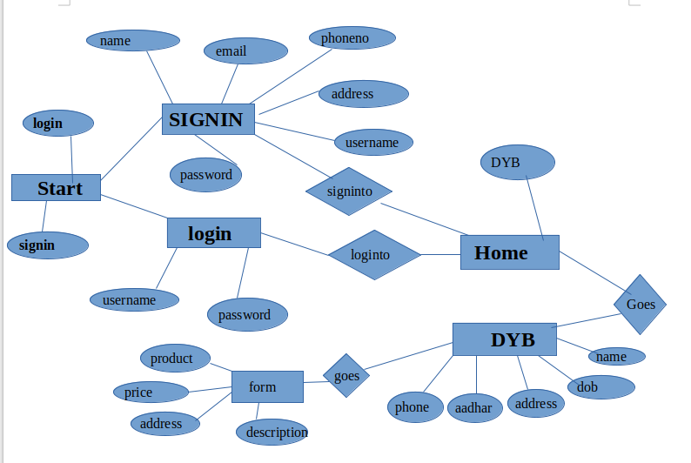

DFD Diagram

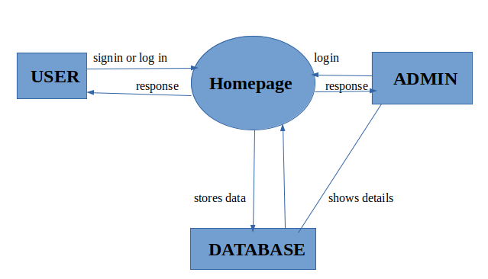
1.class diagram
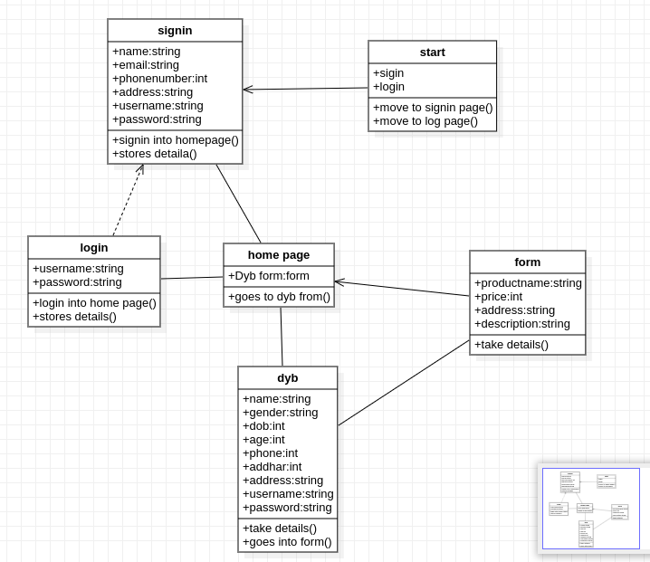

2.object diagram
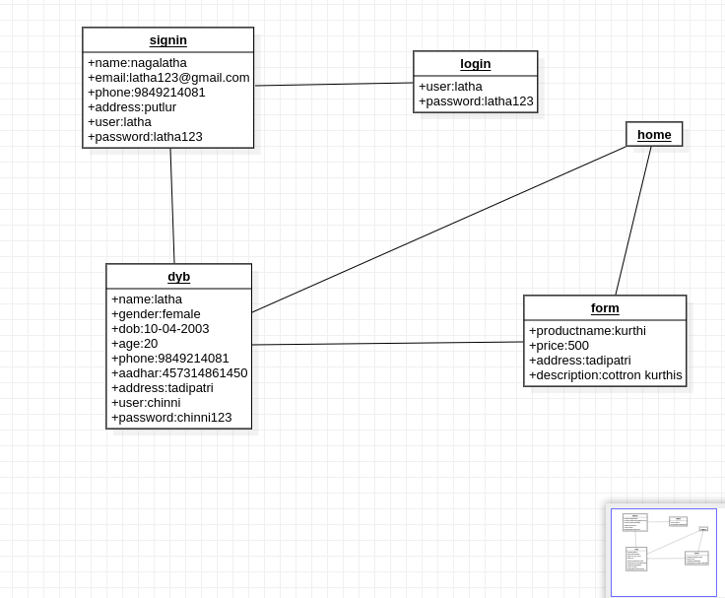

3.usecase diagram

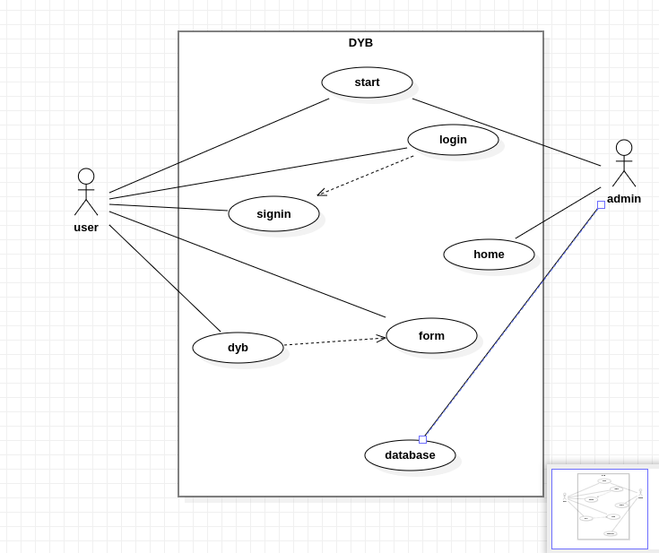

4.sequence diagram

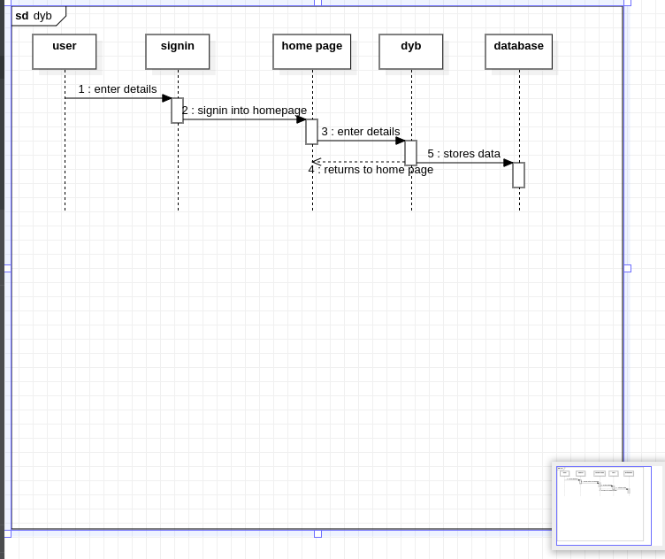

CODE

Start.html

<html>
<head>
<link rel="stylesheet" href="#" />
<style>
body {
background-image: url('logo3.jpg');
background-color: black;
background-size: cover;
height: 100vh;
background-repeat:no-repeat;
font-family: Arial, sans-serif;
margin: 0;
display: flex;
justify-content: center;
align-items: center;

}

form {
text-align: center;
background-color: #f0f0f0;
padding: 20px;
border-radius: 10px;
box-shadow: 0px 0px 10px rgba(0, 0, 0, 0.2);
transition: transform 0.3s;
}

form:hover {
transform: scale(1.05);
}

.center {
display: flex;
flex-direction: column;
align-items: center;
}

table {
border-collapse: collapse;
margin-bottom: 20px;
}

tr {
margin: 10px;
}

td {
padding: 10px;
}

.sign, .log {
display: inline-block;
padding: 10px 20px;
font-size: 16px;
text-align: center;
text-decoration: none;
border: none;
border-radius: 5px;
cursor: pointer;
transition: background-color 0.3s;
margin: 10px;
}

.sign a, .log a {
color: white;
text-decoration: none;
}

.sign {
background-color: #3498db;
}

.log {
background-color: #e74c3c;
}

.sign:hover, .log:hover {
background-color: #2980b9;
}

</style>

</head>
<body>
<form>
<div class="center">
<table>
<tr>
<td><button class="sign"><a href="signin.html">SignIn</a></button></td>
<td><button class="log"><a href="log.html">LogIn</a></button></td>
</tr>
</table>
</div>
</form>
</body>
</html>

Signin.html
<!DOCTYPE html>
<html>
<head>
<title>Sign In Page</title>
<style>
body {
font-family: Arial, sans-serif;
background-color:black;
margin: 0;
padding: 0;
background-image:url("logo4.jpg");
background-size: cover;
background-repeat:no-repeat;
height:10vh;
}

.container {
max-width: 400px;
margin: 50px auto;
background-color: #fff;
padding: 20px;
border-radius: 5px;
box-shadow: 0 0 10px rgba(0, 0, 0, 0.1);
}

h1 {
text-align: center;
}

label {
display: block;
margin-bottom: 5px;
font-weight: bold;
}

input[type="text"],
input[type="email"],
input[type="tel"],
input[type="password"],
textarea {
width: 100%;
padding: 10px;
margin-bottom: 20px;
border: 1px solid #ccc;
border-radius: 4px;
}

input[type="submit"] {
background-color: #4CAF50;
color: white;
padding: 10px 20px;
border: none;
border-radius: 4px;
cursor: pointer;
}

input[type="submit"]:hover {
background-color: #45a049;
}
</style>
</head>
<body>
<div class="container">
<h1>Sign In</h1>
<form method="post" action="signin.php" enctype="multipart/form-data">
<label for="name">Name:</label>
<input type="text" id="name" name="name" required>

<label for="email">Email:</label>
<input type="email" id="email" name="email" required>

<label for="phone">PhoneNumber:</label>
<input type="tel" id="phone" name="phone" required>

<label for="address">Address:</label>
<textarea id="address" name="address" rows="4" required></textarea>

<label for="username">Username:</label>
<input type="text" id="username" name="username" required>

<label for="password">Password:</label>
<input type="password" id="password" name="password" required>

<input type="submit" value="Sign In">
</form>
</div>
</body>
</html>
Log.html
<!DOCTYPE html>
<html lang="en">
<head>
<meta charset="UTF-8">
<meta name="viewport" content="width=device-width, initial-scale=1.0">
<title>DyB login</title>
<link rel="stylesheet" href="log.css">
</head>
<body>
<section>
<img src="logo/logo4.png" class = "logo" alt="logo" >
</section>
<section id="container">
<form action="log.php" method="post" enctype="multipart/form-data">
<label>USER NAME:</label>
<input type="text" name="username" required><br>
<br>
<label>Password:</label>
<input type="password" name="password" required>
<br/>
<button type="submit">Submit</button>
</form>
</section>
</body>
</html>
Home.html
<!DOCTYPE html>
<html>
<head>
<title>DyB Home-Page</title>
<link rel="stylesheet" href="home.css" />
</head>
<body>
<nav>
<img id="tit" src="logo/logo4.png" alt="logo"/>
<input type = "text" name = "search" id="search" placeholder="search" />
<button class="dyb"><a href="dyb.html">DyB</a></button>
</nav>
<div class="cont">

<div class="card">

<div class="imgcon">
<img class="img" src="dyb.jpg" alt="image"/>
</div>

<h4>Develop Your Business</h4>

</div>
<div class="card">
<div class="imgcon">
<img class="img" src="logo3.jpg" alt="image"/>
</div>
<h4>Develop Your Business</h4>
</div>
<div class="card">
<div class="imgcon">
<img class="img" src="logo4.jpg" alt="image"/>
</div>
<h4>Develop Your Business</h4>
</div>
<div class="card">

<div class="imgcon">
<img class="img" src="logo1.jpg" alt="image"/>
</div>
<h4>Develop Your Business</h4>
</div>
<div class="card">
<div class="imgcon">
<img class="img" src="logo.jpg" alt="image"/>
</div>
<h4>Develop Your Business</h4>
</div>
<div class="card">
<div class="imgcon">
<img class="img" src="logo2.jpg" alt="image"/>
</div>
<h4>Develop Your Business</h4>

</div>
<div class="card">
<div class="imgcon">
<img class="img" src="logo5.jpg" alt="image"/>
</div>
<h4>Develop Your Business</h4>
</div>
<div class="card">
<div class="imgcon">
<img class="img" src="logo6.jpg" alt="image"/>
</div>
<h4>Develop Your Business</h4>
</div>
</div>
</body>
</html>
DYB.html
<!DOCTYPE html>
<html>
<head>
<title>DyB Login</title>
<meta name="viewport" width="device-width, initial-scale=1;">
<link href="bootstrap-5.2.0-dist/css/bootstrap.css" rel="stylesheet">
<script src="bootstrap-5.2.0-dist/js/bootstrap.js"></script>
<style>
/* Apply styles to the entire body */
body {
font-family: Arial, sans-serif;
margin: 0;
padding: 0;
background-color:white;
background-image:url("logo3.jpg");
background-size: cover;
background-repeat:no-repeat;
height:10vh;
}

/* Center the form on the page */
#form {
width: 80%;
max-width: 600px;
margin: 30px auto;
background-color:black;
color:white;
padding: 20px;
border-radius: 5px;
box-shadow: 0px 0px 10px rgba(0, 0, 0, 0.1);
}

/* Style form labels */
label {
font-weight: bold;
}

/* Style input fields */
input[type="text"],
input[type="password"],
input[type="date"] {
width: 100%;
padding: 10px;
margin-bottom: 10px;
border: 1px solid #ccc;
border-radius: 5px;
}

/* Style radio buttons */
input[type="radio"] {
margin-right: 5px;
}

/* Style textarea */
textarea {
width: 100%;
padding: 10px;
margin-bottom: 10px;
border: 1px solid #ccc;
border-radius: 5px;
resize: vertical;
}

/* Center the submit button */
button[type="submit"] {
background-color: #007bff;
color: white;
padding: 10px 20px;
border: none;
border-radius: 5px;
cursor: pointer;
}

/* Add hover effect to the submit button */
button[type="submit"]:hover {
background-color: #0056b3;
}

/* Centered header */
.header {
text-align: center;
padding: 20px;
background-color: #007bff;
color: white;
}

/* Centered logo */
#headimg {
display: block;
margin: 0 auto;
max-width: 100px;
}

/* Centered heading */
#heading {
margin-top: 10px;
}

/* Clear margin from top of form elements */
.formb > form > * {
margin-top: 0;
}

</style>

</head>
<body>

<form action="upl.php" id="form" method="post">
<label for="name">Name</label>
<input type="text" name="name" id="name" placeholder="Name" required>
<br><br>
<label for="gender">Gender :</label>
<input type="radio" name="gender[]" id="gender" value="Male" required>Male
<input type="radio" name="gender[]" id="gender" value="Female" required>Female
<br>
<br><br>
<label for="dob">Date of Birth :</label>
<input type="date" name="dob" id="dob" required>
<br><br>
<label for="age">Age :</label>
<input type="text" name="age" id="age" required>
<br>
<label for="email" >Email</label>
<input type="text" name="mail" id="email" placeholder="Email" required>
<br>
<label for="phn" >Mobile No</label>
<input type="text" name="phn" id="phn" placeholder="mobile Number" required>
<br>
<label for="aadhar no" >Aadhar No</label>
<input type="text" name="addhar" id="aadharno" placeholder="Aadhar Number" required>
<br>
<label for="address">Address</label><br>
<textarea cols="50" rows="5" id="address" name="add" placeholder="address" required></textarea>
<br>
<hr>
<h5 class="text-center">Set The Username and Password to login</h5>
<label for="uname" >Username</label>
<input for="text" name="uname" id="uname" placeholder="Username" required>
<br>
<label for="psd" >Password</label>
<input for="password" name="psd" id="psd" placeholder="password" required>
<br>
<label for="cpsd" >Confirm Password</label>
<input type="password" name="confirm" id="cpsd" required>
<br>
<center><button type="submit">Submit</button> </center>
</form>
</div>
</body>
</html>
UPL.php
<?php
include "conne.php";

$name = $_POST['name'];
foreach($_POST['gender'] as $g)
{
$value=$g;
}
$dob = $_POST['dob'];
$age = $_POST['age'];
$email = $_POST['mail'];
$phone = $_POST['phn'];
$aadhar = $_POST['addhar'];
$address = $_POST['add'];
$username = $_POST['uname'];
$password = $_POST['psd'];
$query= "INSERT INTO form VALUES ('$name', '$value', '$dob', $age, '$email', '$phone', '$aadhar', '$address', '$username', '$password');";
$p=mysqli_query($connection,$query);

$query = "SELECT * FROM form;";
$check = mysqli_query($connection, $query);
if (mysqli_num_rows($check)) {
while ($row = mysqli_fetch_assoc($check)) {
echo "<b style='color: orange'>" . $row["name"] . "</b>" . " " . "<b style='color: blue'>" . $row["gender"] . "</b><br>"
. "<b style='color: orange'>" . $row["dob"] . "</b>" . " " . "<b style='color: blue'>" . $row["age"] . "</b><br>"
. "<b style='color: orange'>" . $row["email"] . "</b>" . " " . "<b style='color: blue'>" . $row["phone"] . "</b><br>"
. "<b style='color: orange'>" . $row["aadhar"] . "</b>" . " " . "<b style='color: blue'>" . $row["address"] . "</b><br>"
. "<b style='color: orange'>" . $row["username"] . "</b>" . " " . "<b style='color: blue'>" . $row["Password"] . "</b><br>";
}
}
header("Location:form.html");
?>
Form.html
<!DOCTYPE html>
<html lang="en">
<head>
<meta charset="UTF-8">
<meta name="viewport" content="width=device-width, initial-scale=1.0">
<title>Dyb Details Form</title>
<link rel="stylesheet" href="dyb.css">
</head>
<body>
<div class="header">
<img src="logo/dyb.png" alt="image" id="headimg"/>
<h1 id="heading">Develop Your Business</h1>
</div>
<div id="imgprev"></div>
<div class="formb">
<form action="home.html" mathod="post">
<label for="product">Product name</label>
<input type="text" id="product" name="product" required>
<br><br>
<label for="price">Price</label>
<input type="text" id="price" name="price" required>
<br><br>

<input type="file" name=" images" value="choose image" placeholder="image" id="imagedis" onchange="displayimg(event)"/>
<br><br>
<label for="address">Address</label>
<textarea cols="60" rows="5" required>Address</textarea>
<label for="desc">Description: </label>
<br>
<textarea cols="60" rows="5" required></textarea>
<br><br>
<button type="upload">submit</button>
</form>
</div>
<script>
function displayimg(event){
var image = URL.createObjectURL(event.target.files[0]);
var imagediv = document.getElementById('imgprev');
var newimg = document.createElement('img');
//imagediv.innerHTML = " ";
newimg.src=image;
newimg.width="300";
imagediv.appendChild(newimg);
}
</script>
</body>
</html>

EXECUTION

Start page
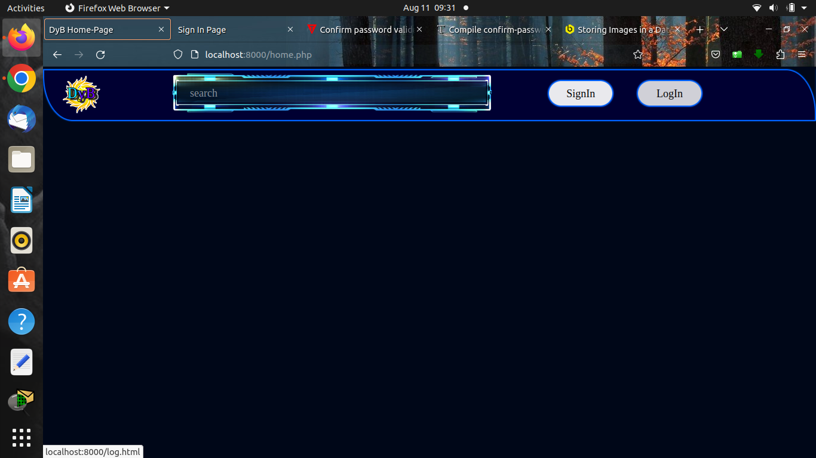
Signin page
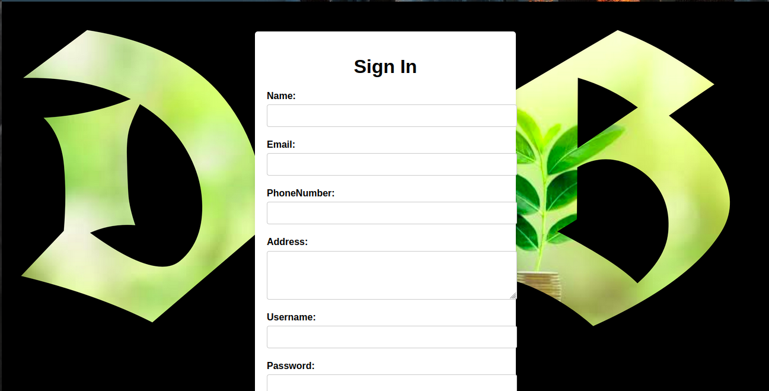

Login page

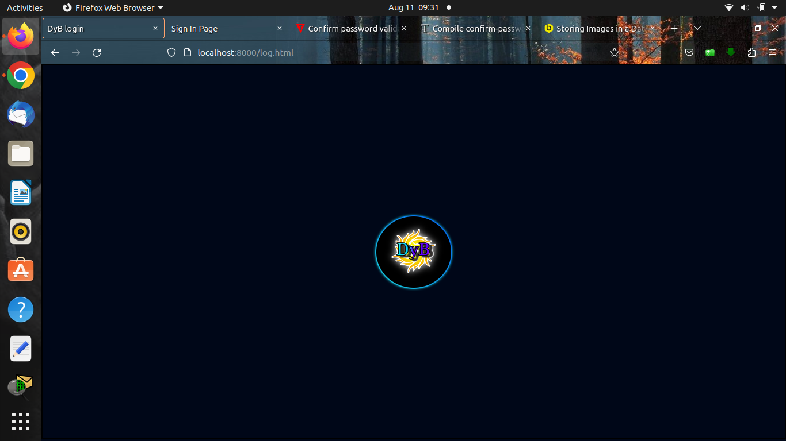
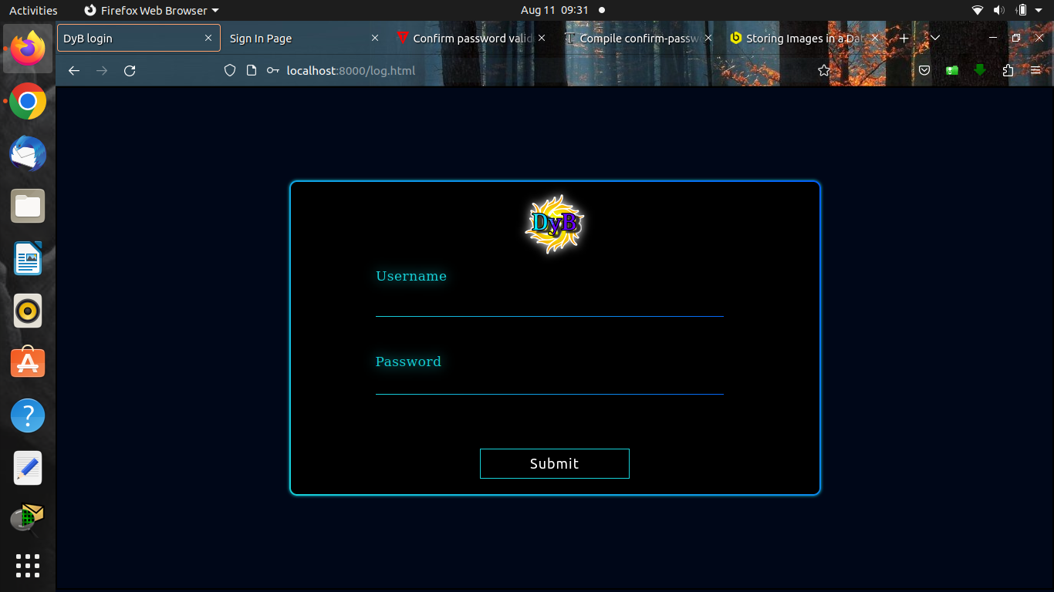
Home page
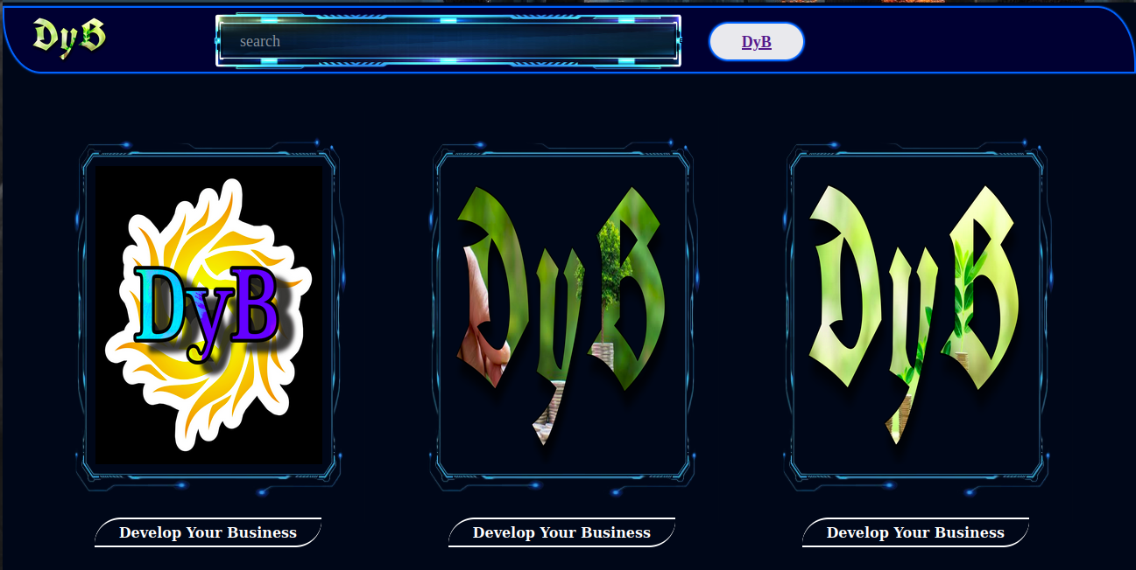

DYB page

Form page
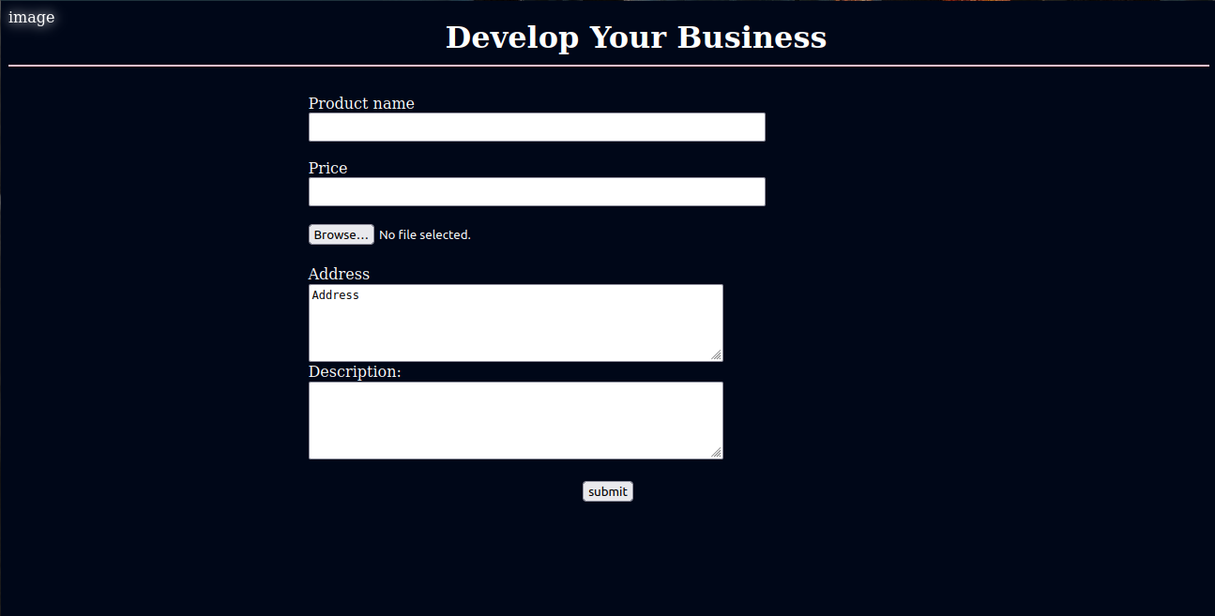

FUNCTIONAL Testing
Table1: signin test case report:
S.NO | Action | Input | Expected Output | Actual Output | Final Output
1 | Enter details | Enter details | Displays home page | Displays home page | pass
2 | Enter details | Enter invalid password | Displays home page | error | fail
3 | Enter details | Enter invalid password,usern-ame | Displays home page | error | fail
4 | Enter details | Enter all valid details | Displays home page | Displays home page | pass
5 | Enter details | Enter all invalid details | Display home page | error | fail
6 | Enter details | Enter invalid phonenumber | Display home page | error | fail

Table2:login page test case report:
S.No | Action | Input | Actual result | Expected result | Result
1 | Enter details | Enter username and password | Display home page | Display home page | pass
2 | Enter details | Enter invalid username and valid password | Display home page | error | fail
3 | Enter details | Enter valid user name and invalid password | Display home page | error | fail
4 | Enter details | Enter invalid username and password | Dispaly home page | error | fail

Table3:dyb form test case report
S.no | Action | Input | Expected result | Actual result | Result
1 | Open form | Click form button | Showing form | Showing form | pass
2 | Enter details | Enter all details | Goes to next page | Goes to next page | pass
3 | Enter details | Enter invalid number | Goes to next page | error | fail
4 | Enter details | Enter invalid aadhar number | Goes go next page | error | fail
5 | Enter details | Enter incorrect confirm password | Goes to next page | error | fail

Conclusion
The "Develop Your Business" (Dyb) project underscores the critical role of effective business development strategies in achieving sustained growth and success. Through a comprehensive analysis of literature, case studies, and expert insights, this project offers valuable recommendations for businesses aiming to enhance their operations, innovate, and adapt in a competitive landscape.
As businesses embark on their growth journeys, the insights and recommendations furnished by the Dyb project will serve as a compass guiding them toward a prosperous future. In a landscape characterized by dynamic shifts and disruptive forces, the ability to develop and adapt is more critical than ever. Businesses that integrate these insights into their operations are poised to navigate challenges, seize opportunities, and emerge as leaders in their respective domains.
The journey of business development is not confined to the pages of this report—it is an ongoing endeavor that requires dedication, strategic vision, and an unwavering commitment to progress. By harnessing the power of innovation, cultivating a customer-centric approach, and fostering adaptability, businesses can pave the way for enduring growth and prosperity.
As the Dyb project concludes, its insights stand as a testament to the ever-evolving nature of business. It is my hope that these findings serve as a guiding light for businesses of all sizes, sectors, and stages of development. May these insights fuel a journey of continual improvement, strategic evolution, and the attainment of greater heights in the realm of business success.

References
This sample project report on "Develop Your Business (Dyb)" provides a structure that spans over 30 pages, incorporating key sections such as introduction, abstract, methodology, literature review, project implementation, results and findings, discussion, conclusion, recommendations, and references. You can expand each section further with relevant content, data, visuals, and case studies to create a comprehensive report tailored to your project's objectives and scope.
- Wikipedia
- Google
- youtube

.....................................THANKYOU....................................

