**Screen 1: Sign Up**

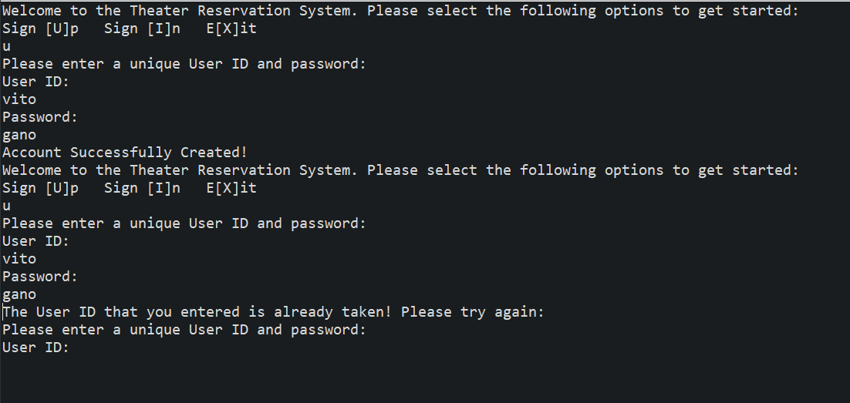

**Screen 2/3: Sign in with an invalid user id/password.**

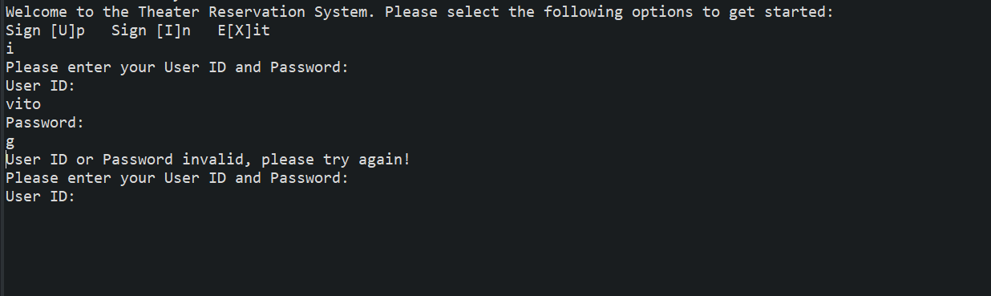

**Screen 4: Valid Credential.**

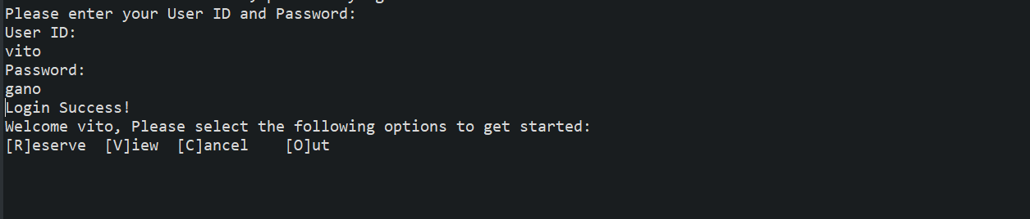

**Screen 5: Valid Credential.**

