DSA

Assignment-1

1) Develop a Menu driven program to demonstrate the following operations of Arrays ——MENU——- 1.CREATE 2. DISPLAY 3. INSERT 4. DELETE 5. LINEAR SEARCH 6. EXIT

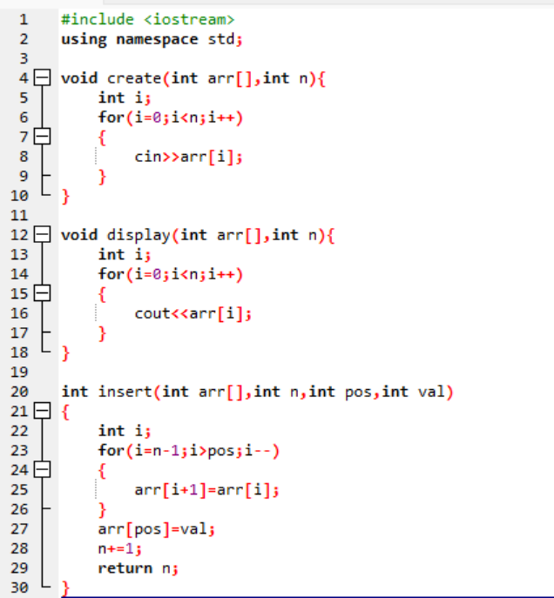

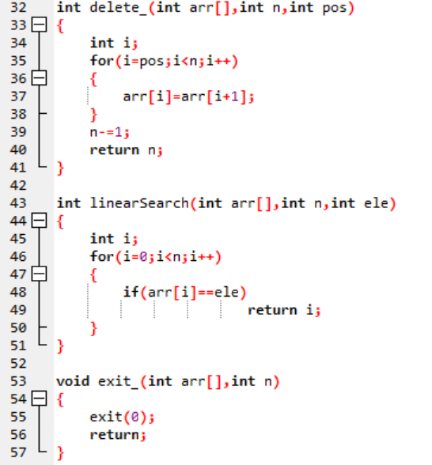

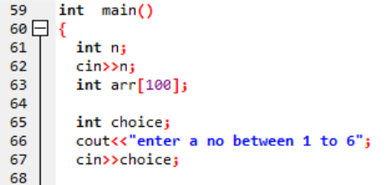

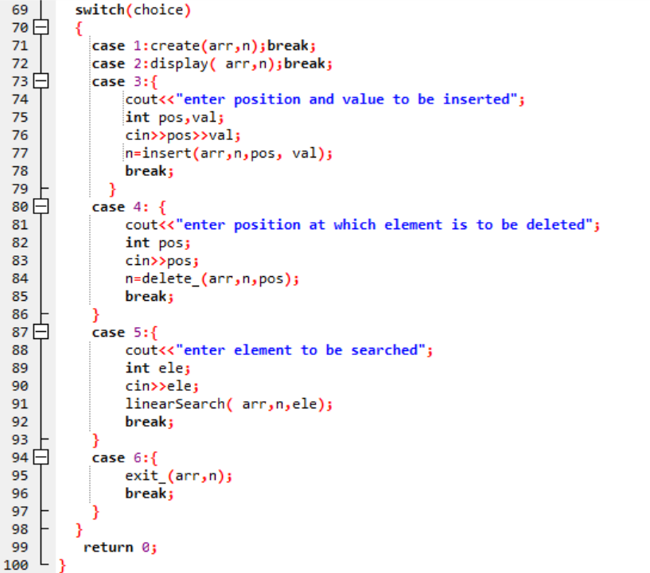

2) Design the logic to remove the duplicate elements from an Array and after the deletion the array should contain the unique elements.

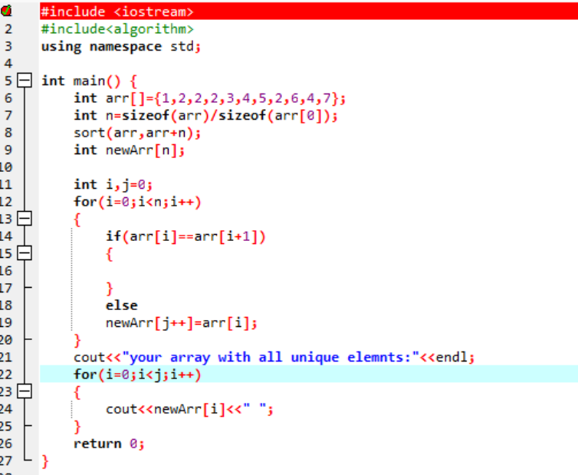

3) Predict the Output of the following program

int main()

{ int i;

int arr[5] = {1};

for (i = 0; i < 5; i++)

printf("%d",arr[i]);

return 0; } // 10000

4) Implement the logic to

a. Reverse the elements of an array

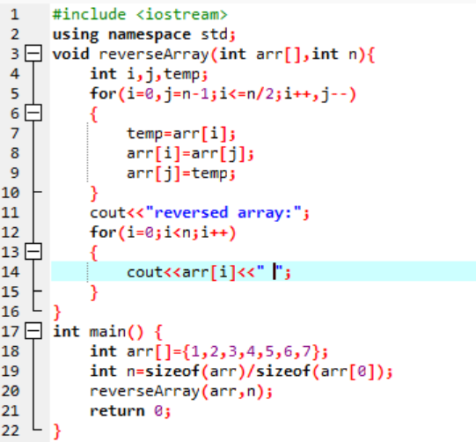

b. Find the matrix multiplication

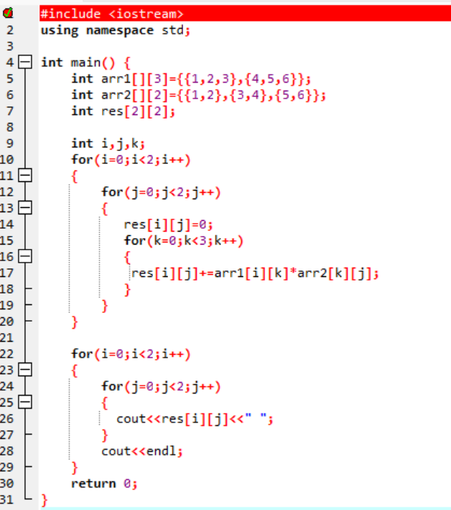

c. Find the Transpose of a Matrix

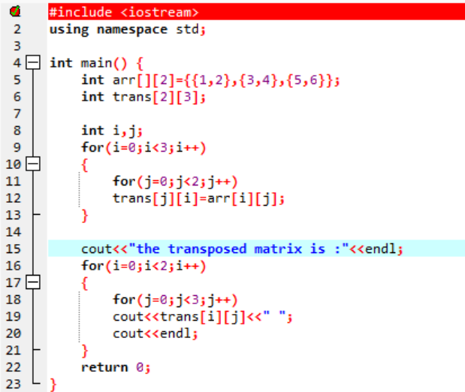

5) Write a program to find sum of every row and every column in a two-dimensional array.

