Note: I used Claude Opus 4.6 and GTP 5.5 Thinking (enterprise) to support storyboard organization, manuscript drafting, data analysis planning, statistical interpretation, figure caption development, and R code generation/troubleshooting. These tools were also used to help evaluate whether interpretations of MicroResp trajectory clustering, MEFISTO latent factors, factor-specific reconstructed trajectories, feature weights, and pathway enrichment results were consistent with the underlying outputs.
Potential Journals: SBB?
Team members: Vanessa Garayburu-Caruso, David Degnan, Sheryl Bell, Evan Warburton, Sharon Zhao, Regan McDearis, Josue Rodriguez-Ramos, Amy Zimmerman, Kirsten Hofmockel
Acknowledgements: Gregory, Kali Cornwell, Mischelle
GitHub link with code: vgc40/Soil_time_series_data
Title (working):
Seasonal soil substrate-use phenotypes are partly reflected in expressed microbial function across an annual cycle
Seasonal soil microbial substrate use is partially reflected in gene expression across an annual cycle
Soil microbial substrate use varies seasonally and is poorly reflected in transcriptional profiles
Substrate use patterns vary across an annual cycle but are only partially reflected in gene expression

Terms to use: Activity potential, potential metabolic or enzymatic activity

Be precise as possible: call respiration or enzyme activity where appropriate

Highlight (citation) points:
2 clusters of temporal dynamics, but neither has clear unifying features (one is broad and include glucose and methyl oleate)
Winter metabolism matters!
Low variance explained by measured factors

Abstract (~250 words)
Soil microbial communities express substrate-use phenotypes that respond to environmental conditions and substrate availability, yet how these phenotypes vary across full annual cycles and whether they correspond to shifts in gene expression remains poorly resolved. We paired monthly field environmental measurements with laboratory assays of substrate-induced respiration, extracellular enzyme activities, microbial biomass, and metatranscriptomes over 13 months in an irrigated tall wheatgrass system. Across 31 substrates, substrate-induced respiration exhibited significant temporal structure and resolved into two trajectory groups: a small group of organic acids and amino-acid-related substrates peaking in fall, and a larger group of chemically diverse substrates with lowest respiration in mid-summer and highest respiration in late winter and early spring. Broad substrate chemical class did not consistently predict trajectory membership, suggesting that seasonal context could shape substrate-use capacity alongside substrate identity. Integrating substrate-induced respiration, enzyme activity, biomass, and metatranscriptomes through time recovered the winter/early-spring phenotype as a partially shared signal across substrate use, enzyme activity, and a subset of transcripts, although this factor explained only modest variance within each data type (3.5–6.7%). In contrast, the transient fall pulse was not recovered as a strong shared signal. These results show that longer-duration seasonal phenotypes can be partially reflected across phenotypic, enzymatic, and molecular measurements, while shorter-lived substrate-use pulses may remain assay-specific or require denser temporal sampling to resolve. Pairing substrate-use assays with molecular measurements provides a more complete view of annual microbial functional dynamics than either approach alone.
Introduction
P1: Microbial phenotypes connect molecular potential and ecosystem function
Connect genomic potential (microbial genomes are metabolically versatile) à expressed traits (but the subset of that genetic potential which is actually expressed is strongly influence by the environment (both biotic and abiotic factors))
Clarify that phenotypes – expressed traits (functions?) that are quantifiable – can be measured at different scales (organism vs community; gene expression vs rate measurements)
- Soil microbial communities express diverse phenotypes, including substrate preferences, enzyme activity profiles, and growth efficiencies, that reflect their physiological state and ecological strategies under given environmental conditions.
- These phenotypes provide a community-level perspective on microbial function, integrating the combined effects of gene expression, enzyme production, and environmental constraints into observable activity.
  - Community-level phenotypic measurements represent an aggregated view of microbial contributions to broader ecosystem-level processes
- Understanding observable phenotypes and how they shift through time is central to understanding microbial contributions to ecosystem processes. (+1)
  - But this is complicated by measurements at different scales
- To interpret these shifts mechanistically, we need to understand whether changes in gene expression correspond to altered metabolic activity, or whether environmental constraints decouple molecular signals from phenotypic outcomes.
  - This is about connecting across scales of expression (the different levels at which one could measure a phenotype)
- Sequencing-based approaches, including amplicon surveys and metatranscriptomics, provide powerful insight into community composition and active gene expression, while phenotype-based assays offer complementary information on realized metabolic responses under specific environmental conditions
- However, studies that explicitly couple phenotypic and sequencing-based measurements across temporal gradients remain rare, leaving open the question of whether these complementary data streams tell coherent stories about microbial metabolic dynamics through time.
P2: Temporal dynamics of metabolic phenotypes are poorly resolved (knowledge gap)
And that knowledge gap is a problem because…we don’t know what we don’t sample, and if microbial phenotypes are dynamics, we can’t extrapolate to forecasting
- Temporal dynamics of soil microbial metabolic phenotypes remain poorly resolved, despite multiple factors that influence microbial activity changing across an annual cycle. For example, plant phenology drives seasonal shifts in rhizosphere inputs, from active root exudation during growth to litter and root turnover during senescence, altering the substrate landscape that microbes encounter.
- Temperature and moisture further modulate substrate accessibility, microbial mobility, reaction kinetics and diffusion rates.
- Together, these seasonal changes are expected to influence microbial substrate preferences, enzyme investment, and catabolic activity.
- Evidence from individual studies supports this expectation: substrate-induced respiration profiles in dryland soils shift with season, microbial biomass C peaks in winter in some systems, and extracellular enzyme investment shifts between C, N, and P acquisition depending on plant activity and resource stoichiometry
- However, many temporal studies of soil microbial function focus primarily on the growing season, leaving non-growing season dynamics comparatively uncharacterized despite evidence of significant microbial activity during winter in soils that do not fully freeze
- Moreover, studies that span full annual cycles rarely combine phenotypic, enzymatic, and molecular measurements needed to distinguish whether observed shifts reflect changes in substrate supply, environmental regulation of activity, transcriptional reallocation, or some combination of these processes.
P3: Our work
- To address this, we conducted monthly soil sampling over 13 months (June 2023 to June 2024) in an irrigated tall wheatgrass system under contrasting soil moisture conditions. We paired monthly field environmental measurements (temperature, moisture, extractable resource pools) with laboratory characterization of microbial resource use phenotypes at distinct levels along the continuum of genomic potential to expressed function – molecular (gene expression), enzymatic (activity rates), and physiological (respiration rates as a proxy for active microbial biomass… growth or metabolism?) (MicroResp, 31 substrates), extracellular enzyme activities, and field metatranscriptomes to capture microbial function across phenotypic, enzymatic, and molecular scales.
- We treat the full dataset as a continuous time series and ask: (1) How do substrate-use phenotypes change through time, and how much of this temporal variation is explained by temperature, moisture, and resource availability? (2) Do temporal shifts in phenotype measurements covary across scales (from molecular, to enzymatic, to metabolic) metatranscriptomic profiles covary with substrate-use phenotypes and enzyme activities, indicating coordinated regulation across these measurement scales, or do they diverge under certain seasonal conditions? In essence, how/does the scale of measurement influence interpretation of temporal dynamics?
Research questions and hypotheses
Q1: How does microbial substrate-induced respiration (metabolic phenotype) change through time, and what environmental gradients are associated with temporal variation?
- H1a: Multivariate temporal variation in substrate-use phenotypes will be significantly associated with soil temperature, moisture, and salt extractable resource pools.
  - Rationale: These factors serve as master controls on microbial activity.
- H1b: Soil microbial substrate-use phenotypes will show structured temporal dynamics across the annual cycle, with distinct substrate groups following different temporal trajectories.
  - Rationale: Set up predictions for different compound classes – microbes likely to constitutively metabolize simpler compounds that require less investment to deconstruct while metabolism of more complex compounds may be more dynamic if tightly regulated to availability (although documentation of temporal dynamics of soil metabolites is poor and we didn’t actually do metabolomics to test this underlying mechanism)

Q2: Do temporal shifts in metatranscriptomic profiles (molecular phenotypes) covary with substrate-induced respiration rates (metabolic phenotypes) and enzyme activities, indicating coordinated regulation across these phenotypic measurement scales, or do they diverge under certain seasonal conditions?
  - H2: Metatranscriptomic profiles, extracellular enzyme activities, and substrate-use phenotypes will show partially shared temporal structure across the annual cycle, reflecting coordinated seasonal changes in microbial function, while also retaining data-type-specific variation because each measurement captures a distinct layer of microbial activity.

Methods
2.1 Site Description
Prosser, WA tall wheatgrass site; Jose cultivar; irrigation treatments (25% and 100% FWC); Warden series Aridisol
2.2 Sampling Design
Monthly, June 2023–June/July 2024 (13–14 months); 0–15 cm; 6 plots × 2 irrigation = 12 composite samples/month; ~156 total samples
2.3 Environmental and Biogeochemical Measurements
- In situ temperature (continuous sensors, 18 cm depth)
- Gravimetric water content
- Salt-extractable OC/TN (SEOC, SETN)
- Microbial biomass C, N, P (fumigation-extraction)
- pH
- Root biomass (from cores)

2.4 Substrate-Induced Respiration (MicroResp)
31 substrates + water control; 5-hour incubation; C-normalized (ng CO₂-C mg⁻¹ substrate-C h⁻¹); standardized temperature and moisture (60% WHC)
Note the interpretive caveat: respiration is indirect measure; some substrates may be incorporated rather than respired; proxy for active microbial biomass pool
2.5 Extracellular Enzyme Activities
7 enzymes (BG, CB, BX, NAG, Leu, Ala, AP); fluorometric; 1h and 3h timepoints. Report as nmol g⁻¹ dry weight h⁻¹.
2.6 Metatranscriptomics
100% irrigation plots only; monthly RNA extraction; annotation to KEGG KOs → summarized at pathway and module levels. Describe library prep, sequencing, QC, and annotation pipeline.
2.7 Statistical Analysis
Q1 Analyses (all samples, both irrigation treatments):
- Data cleaning:
  - Outlier samples (SM1082, SM1085, SM1087, and SM1088) were removed prior to analysis based on exploratory screening that identified extreme values in soil C/N/P measurements.
  - Zero values in selected C, N, P, and microbial biomass variables were treated as below-detection-limit values. These zeros were replaced using a half-minimum detected value approach, where each zero was replaced with one-half of the minimum non-zero value observed for that variable.
  - Negative field respiration values were assumed as low respiration (below detection) and were replaced with one-half of the minimum non-negative respiration value.
- Multivariate temporal structure (to uncover relationships/structure in measured phenotypes across experiment parameters): NMDS (Bray-Curtis) of MicroResp profiles with envfit of environmental variables
  - MicroResp substrate-induced respiration profiles were analyzed using 5-hour carbon-normalized substrate-induced respiration rates (ng CO2-C mg substrate-C⁻¹ h⁻¹). Water-only controls were excluded prior to analysis, leaving the substrate response matrix for downstream multivariate analyses.
  - Non-metric multidimensional scaling (NMDS) was performed using Bray-Curtis dissimilarities on the carbon-normalized substrate-use matrix. NMDS was run with two dimensions, 200 random starts, and no automatic data transformation because the response values were already normalized rates.
  - NMDS ordination quality was evaluated using the final stress value and a Shepard diagram. If two-dimensional stress exceeded 0.20, a three-dimensional NMDS was also evaluated as a diagnostic comparison.
  - Environmental associations with NMDS structure were assessed using vector fitting (envfit) with 999 permutations. Continuous variables tested included soil temperature, gravimetric water content, soluble organic carbon, soluble total nitrogen, SEOC:SETN, microbial biomass carbon, microbial biomass nitrogen, and pH.
  - Irrigation treatment was fit separately as a categorical variable using envfit to evaluate whether treatment categories were associated with ordination structure. PERMANOVA was used to test whether substrate-use profiles varied with time and irrigation treatment. Bray-Curtis distances were modeled using continuous time and irrigation treatment as predictors, with marginal tests based on 999 permutations.
  - A second PERMANOVA model treated sampling month as a categorical factor to assess whether temporal inference was robust to representing time discretely rather than continuously.
  - Homogeneity of multivariate dispersion was evaluated using betadisper for irrigation treatment and seasonal groupings. Significant dispersion differences were noted as a caveat for interpreting PERMANOVA results.
From this analysis, we will understand something about how substrate induced respiration varies across the dataset, whether time or irrigation treatment are major explanatory variables, and which other measured environmental parameters are associated.
- To decompose the multivariate temporal structure into individual substrate behaviors, we fit generalized additive mixed models (GAMMs) separately for each of the 31 MicroResp substrates using the gamm function in R (mgcv package). Each model took the form:
SIR ~ s(time_numeric, k=7) + Irrigation_factor, random = list(Plot = ~1)
where SIR is the carbon-normalized substrate-induced respiration rate (ng CO₂-C per mg substrate-C per hour) at the 5-hour timepoint, time_numeric is a continuous variable representing days since the first sampling date, and the smooth term s(time_numeric) uses a non-cyclic thin plate regression spline. For each substrate, we used a GAM smooth to allow respiration rates to change nonlinearly through time, rather than forcing a straight-line trend. The smooth was limited to moderate complexity (k = 7) because there were only 13 monthly sampling dates. This allowed the model to capture broad seasonal peaks and troughs without fitting every small month-to-month fluctuation. We used a non-cyclic smooth, meaning the curve was not forced to match between June 2023 and June 2024. This was appropriate because the two June sampling dates may reflect different antecedent conditions rather than identical points in a repeating annual cycle. Irrigation treatment (25% vs. 100% field water capacity) was included as a parametric fixed effect, representing an average shift between irrigation treatments after accounting for temporal dynamics. Plot was specified as a random intercept to account for repeated monthly sampling of the same plots. Models were fit using restricted maximum likelihood (REML).
Significance of temporal trends was assessed from the approximate p-value of the smooth term, with false discovery rate (FDR) correction applied across all 31 tests using the Benjamini-Hochberg method. Effective degrees of freedom (EDF) quantify the complexity of each fitted curve: values near 1 indicate nearly linear temporal trends, while higher values indicate more complex nonlinear trajectories with multiple peaks or inflections.
From this analysis, we will understand something about the temporal complexity of substrate-induced respiration across the substrates tested. It enables clustering while reducing noise.
- Clustering based on substrate-specific temporal trends:
Which substrates change through time in similar ways? We cluster substrates by the shape of the fitted temporal trajectory, not by absolute respiration rate.
Extract fitted values from GAMs trajectories, this ensures the use of smooth data rather than the more noisy observations. The trajectories within each substrate were z-score normalized to remove magnitude differences. Further a correlation-based distance matrix was calculated and hierarchical clustering (Ward's D2) was used to group substrates with similar temporal shapes.
Q2 Analyses (100% irrigation only):
To test whether the MicroResp temporal phenotypes identified in Q1 were reflected in field-expressed function, we integrated substrate-induced respiration, extracellular enzyme activity, microbial biomass C and N, and metatranscriptomic profiles using MEFISTO. This analysis focused on the 100% irrigation subset, where metatranscriptomic data were available, and modeled time as a continuous covariate across the annual cycle.
- Data cleaning
  - 4.28Tb of metagenomic reads were assembled using MEGAHIT using default settings in order to generate DNA scaffolds, generating a total of 382,038,085 scaffolds. Of these, we selected scaffolds that were at least 2.5kb in length for subsequent functional annotation (n = 1,206,272 scaffolds). Those scaffolds were then annotated using eggnog (emapper-2.1.13 / Expected eggNOG DB version: 5.0.2 / Installed eggNOG DB version: unknown / Diamond version found: diamond version 2.0.15 / MMseqs2 version found: 16.747c6 / Compatible novel families DB version: 1.0.1). Metatranscriptomic reads were then mapped to these same >2.5kb scaffolds using bbmap and reads were assigned to specific coding sequences using featureCounts. Results were then geTMM normalized in R and subsequently used.
- MOFA/MEFISTO integration: Four views (MicroResp, EEA, MBC/MBN, transcripts at KO level); time as continuous covariate; extract latent factors and top-weighted features
  - MEFISTO was used to identify latent temporal factors shared across MicroResp, extracellular enzyme activity, microbial biomass, and metatranscriptomic data in the 100% irrigation subset. Each factor captures a major axis of variation (may be shared across data views/types/modalities or specific to one data type).
  - Input features were organized into separate data views before model fitting. MicroResp features represented C-normalized substrate-induced respiration responses, extracellular enzyme features represented enzyme activity measurements, microbial biomass features represented MBC and MBN, and transcriptomic features represented normalized functional gene or pathway abundances.
  - Time was included as a continuous covariate so that MEFISTO could estimate smooth temporal structure in each latent factor.
  - For each latent factor, MEFISTO estimates two linked quantities: sample-level factor values, which describe the temporal activity of the factor across samples, and feature weights, which describe how strongly each measured variable contributes to that factor.
  - Factor-specific reconstructed trajectories were generated by combining the sample-level factor values for a given factor with the corresponding feature weights for each feature. Conceptually, the reconstructed contribution of Factor k to feature j in sample i is:
reconstructed value = factor score for sample i × feature weight for feature j
  - To visualize Factor 1-associated temporal structure, we reconstructed the contribution of Factor 1 to selected features from each data view. Because positive and negative weights represent opposing sides of the same MEFISTO factor, features were interpreted by signed weight rather than averaged across signs. The negative-weight side of Factor 1 was anchored by MicroResp substrates from the Q1 Cluster 2 winter/rebound group, so we used this side of the factor to evaluate cross-view coordination associated with the dominant Q1 substrate-use phenotype.
  - For each selected negative-weight feature, reconstructed contributions were calculated as the sample-level Factor 1 score multiplied by the feature-specific Factor 1 weight. Contributions were averaged within each feature group and sampling date, then standardized within group for visualization. These trajectories represent Factor 1-specific contributions to each feature group, not raw measured values or full reconstructed trajectories across all MEFISTO factors.
  - 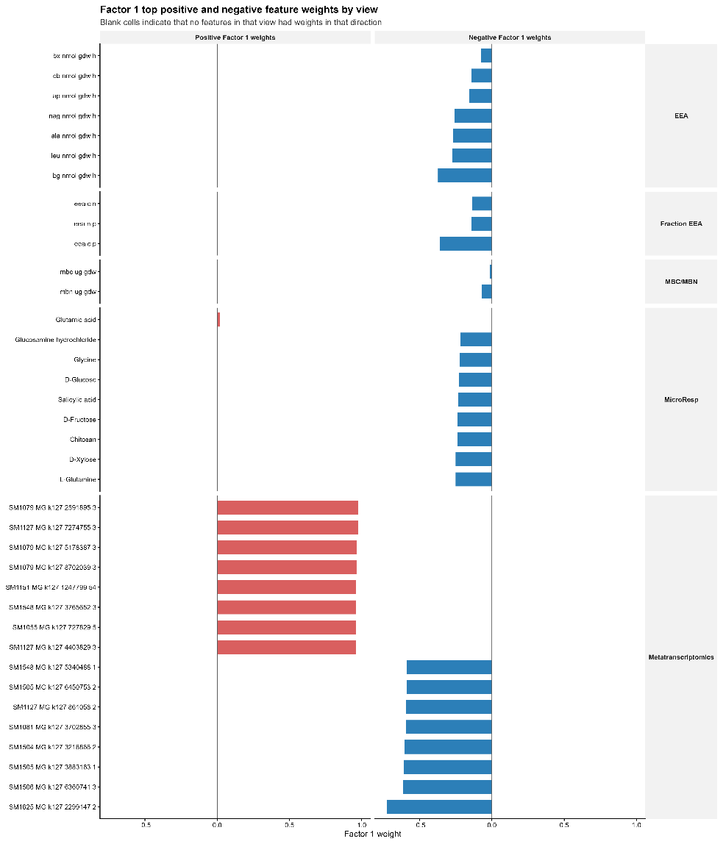
- Supplementary Non-integrative benchmarks: Mantel tests and Procrustes analysis on raw dissimilarity matrices (no temporal structure learned) — compare to MEFISTO results
- Pathway enrichment: Map top transcript features from each factor to KEGG pathways; test for enrichment relative to the MicroResp-linked pathway set
- Temporal trajectory comparison: Plot aggregated temporal profiles by view for each latent factor to visualize coordination or divergence across data streams

Results
  - Temporal structure in substrate-use phenotypes (Q1)

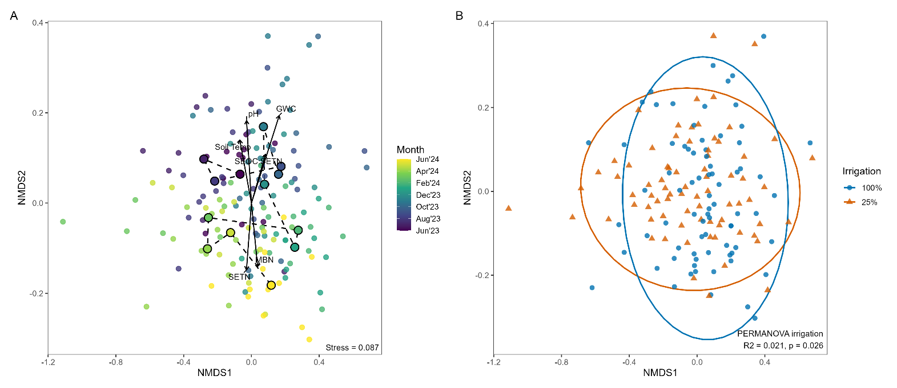
Figure 1. Temporal and irrigation-related structure in microbial substrate-use phenotypes. Non-metric multidimensional scaling (NMDS) of Bray-Curtis dissimilarities calculated from 5-hour C-normalized MicroResp responses across 31 substrates. Each point represents one sample (n=?). (A) Samples colored by month show temporal structure in substrate-use phenotype composition across the 13-month sampling period. Black arrows show significant environmental vectors fit to the ordination, and connected monthly centroids summarize the temporal trajectory through the annual cycle. (B) The same ordination colored by irrigation treatment shows partial separation between 25% and 100% field water capacity treatments. Ellipses show treatment-level dispersion. PERMANOVA indicated a small but significant irrigation effect on overall substrate-use composition (R² = 0.021, p = 0.026). Stress = 0.087.
Take-Home: Figure 1A Substrate-use phenotypes exhibited significant temporal structure across the 13-month sampling period (PERMANOVA: R² = 0.055, p = 0.002; Figure 1A). Six environmental variables were significantly associated with ordination space (envfit, p < 0.05; Figure 1A). Gravimetric water content showed the strongest association (R² = 0.179, p = 0.001), followed by pH (R² = 0.095, p = 0.002), soil temperature (R² = 0.067, p = 0.007), salt-extractable total nitrogen (R² = 0.063, p = 0.007), microbial biomass nitrogen (R² = 0.059, p = 0.006), and the SEOC:SETN ratio (R² = 0.052, p = 0.017). Notably, the stoichiometric ratio of extractable carbon to nitrogen was significantly associated with phenotypic variation, while absolute extractable organic carbon concentration (SEOC) was not, suggesting that resource balance rather than carbon availability alone influenced substrate-use profiles.
Figure 1B: Irrigation treatment explained minimal multivariate variation in substrate-use phenotypes (PERMANOVA: R² = 0.021, p = 0.026; Figure 1B). Although statistically detectable, the irrigation effect was less than half the magnitude of the temporal effect, and 95% confidence ellipses for the two treatments overlapped substantially in ordination space (Figure 1B). This indicates that temporal dynamics in substrate-use phenotypes are robust across contrasting moisture regimes and are not driven by the irrigation treatment imposed during the growing season
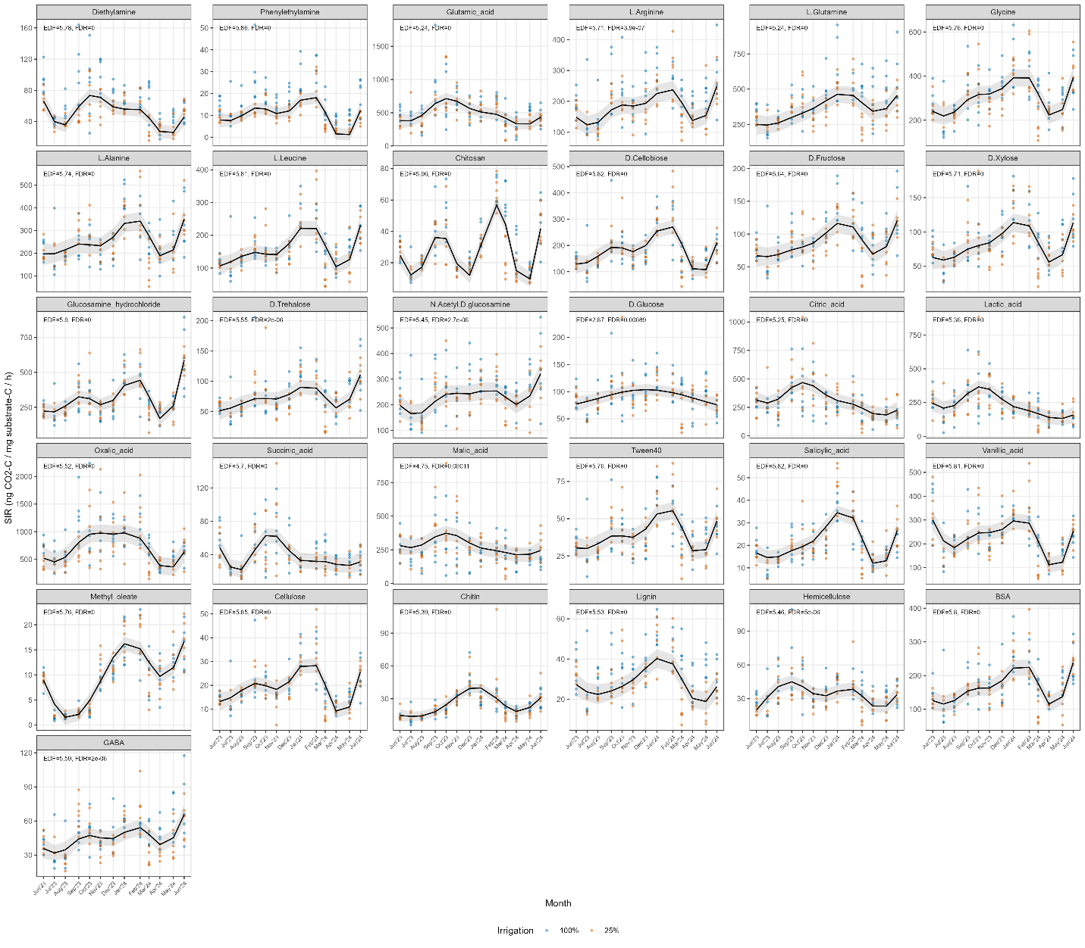
Figure S1. Substrate-specific temporal trajectories in microbial substrate-use phenotypes. Generalized additive mixed models (GAMMs) were fit separately for each substrate using 5-hour C-normalized MicroResp rates. Time was modeled as a non-cyclic smooth term, irrigation treatment was included as a fixed effect, and plot was included as a random intercept. Lines show fitted temporal trajectories for each irrigation treatment, and shaded ribbons indicate 95% confidence intervals. Each panel shows one substrate, with effective degrees of freedom (EDF) and FDR-adjusted p-values for the temporal smooth reported in the panel label. Higher EDF values indicate more nonlinear temporal structure. All substrates exhibited significant temporal dynamics after FDR correction, indicating widespread annual variation in microbial substrate-use phenotypes.
Results: All 31 substrates exhibited significant temporal trends across the 13-month sampling period (FDR-adjusted p < 0.05 for all substrates; Figure S1, Table S1). Despite all substrates showing significant temporal trends, the strength and complexity of the temporal patterns varied significantly across substrates. Deviance explained by the full model ranged from 12.2% (D-glucose) to 71.9% (methyl oleate), indicating that temporal dynamics capture the majority of variation for some substrates while explaining only modest fractions for others. Effective degrees of freedom ranged from 2.87 (D-glucose, indicating a nearly linear or simple unimodal trend) to 5.96 (chitosan, indicating a highly nonlinear trajectory with multiple temporal peaks and troughs). The median EDF across all substrates was 5.71, indicating that most substrates followed complex, multi-modal temporal trajectories that would not be captured by simple linear or seasonal-categorical approaches.
Take home: The substrates with the strongest temporal structure (highest deviance explained) were methyl oleate (71.9%), chitosan (64.9%), phenylethylamine (54.3%), glucosamine hydrochloride (54.6%), salicylic acid (52.3%), and diethylamine (47.8%) (Table S1). Visual inspection (subsequently confirmed by cluster analysis) of fitted trajectories (Figure S1) reveals that many of these substrates share a pronounced elevation in respiration during winter months (approximately December through March), when field temperatures are lowest and plant root activity is minimal. Methyl oleate, a fatty acid ester representative of plant cuticle waxes, displayed the most distinctive temporal signal with a clear winter peak and summer depression. Chitosan and glucosamine hydrochloride, both chitin-derived substrates associated with fungal cell wall turnover, showed similarly strong winter/early spring peaks. In contrast, D-glucose showed the weakest temporal structure (12.2% deviance explained, EDF = 2.87), suggesting that the capacity to metabolize this accessible monosaccharide remains relatively stable across the annual cycle. This is consistent with glucose being a constitutively metabolized substrate that does not require specialized enzymatic machinery or community compositional shifts for catabolism.
Irrigation treatment, included as a parametric covariate in all models, showed significant effects for only 8 of 31 substrates (p < 0.05 for the irrigation coefficient): chitosan (p < 0.001), diethylamine (p < 0.001), phenylethylamine (p < 0.001), lignin (p < 0.001), L-arginine (p = 0.001), L-glutamine (p = 0.024), hemicellulose (p = 0.030), and N-acetyl-D-glucosamine (p = 0.044) (Table S1). For these substrates, the irrigation effect represents a consistent vertical shift in the temporal trajectory (higher or lower mean SIR across the entire year) rather than a change in temporal shape. The majority of substrates (23 of 31) showed no significant irrigation effect on mean respiration rates, in agreement with Figure 1 findings that temporal dynamics dominate over treatment effects in structuring substrate-use phenotypes.

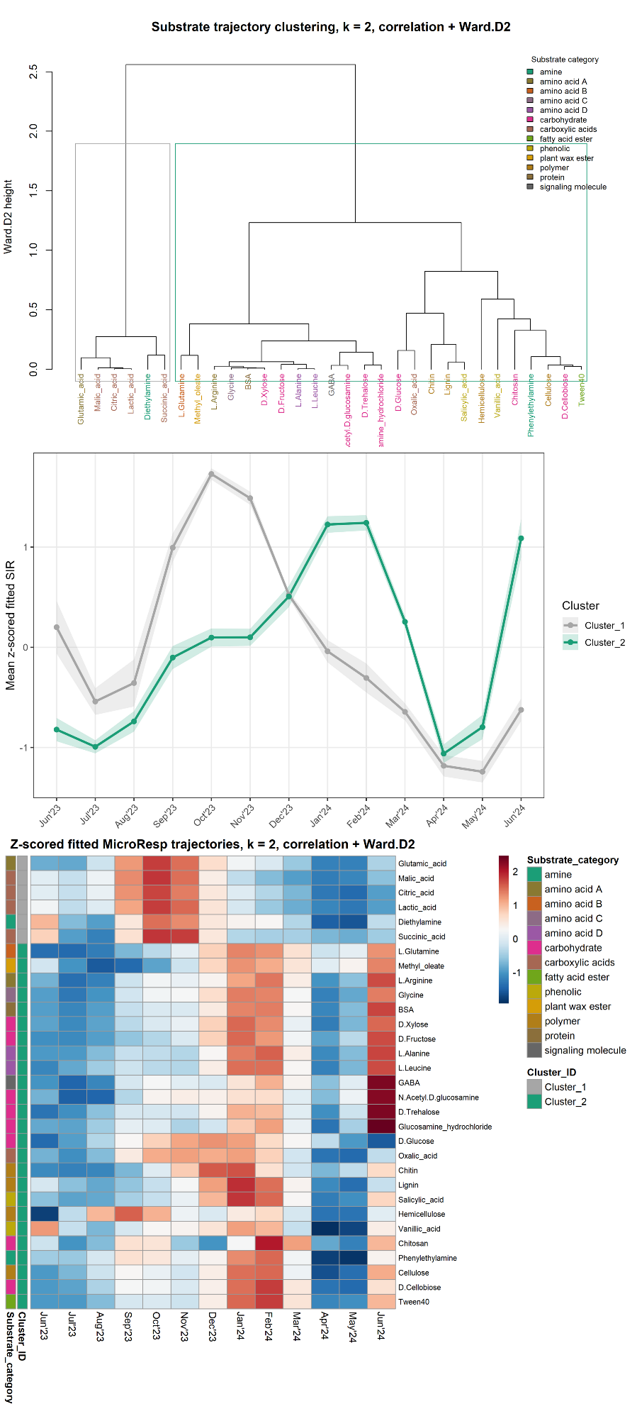

Figure 2. Clustering of substrate-specific temporal trajectories. Substrate trajectories were derived from GAM-fitted values (Figure S1, Table S1), z-scored within substrate to compare temporal shape rather than absolute respiration magnitude, and clustered using correlation-based distance and hierarchical clustering. The dendrogram shows substrate similarity based on fitted temporal trajectories, with colors indicating substrate category. The two-cluster solution was selected based on clustering diagnostics, including the highest average silhouette width. The middle panel shows mean z-scored fitted MicroResp trajectories for each cluster, with ribbons showing among-substrate variation. The heatmap shows z-scored fitted trajectories for individual substrates across the 13-month sampling period. Cluster 1 was enriched in carboxylic acids and showed an earlier fall peak followed by decline through spring. Cluster 2 contained most substrates and was characterized by a winter peak, spring decline, and June rebound.
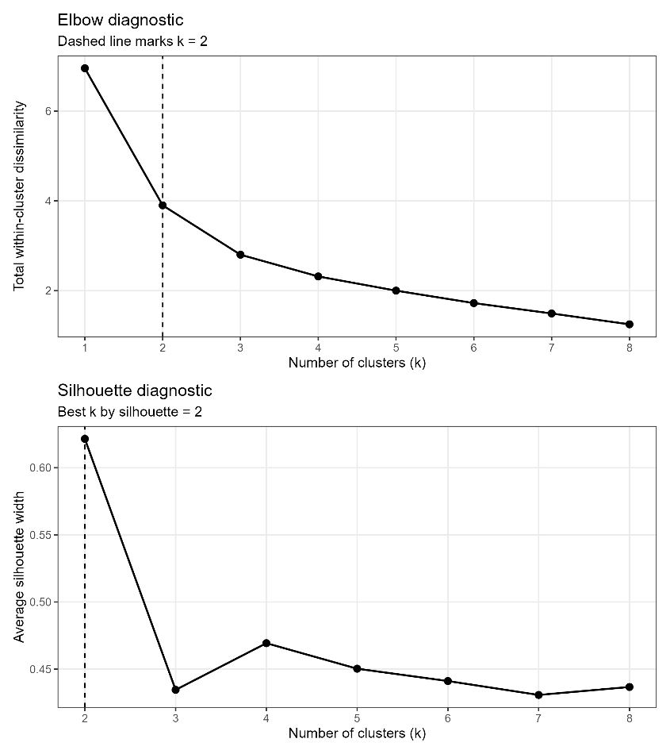
Take-home: Hierarchical clustering of z-scored GAM-fitted trajectories (correlation distance, Ward.D2 linkage) identified two temporal trend groups (k = 2, average silhouette width = 0.62, Figure 2). A three-cluster solution was evaluated, but it reduced average silhouette width to 0.43 and subdivided the dominant winter/rebound pattern rather than identifying a clearly distinct third temporal phenotype. Cluster 1 (6 substrates: citric acid, lactic acid, malic acid, succinic acid, glutamic acid, and diethylamine; silhouette range 0.73-0.91) showed peak substrate-induced respiration in September-October, coinciding with the late growing season when root exudation is expected to be high. These substrates are low-molecular-weight organic acids and amino acids characteristic of root exudates and rhizosphere metabolism. Cluster 2 (25 substrates spanning amino acids, carbohydrates, polymers, phenolics, lipids, and N-acetylated compounds; silhouette range -0.28 to 0.81) showed minimum activity in mid-summer (July-August) and peak activity in late winter through early spring (January-April) (Figure 2). Within Cluster 2, most substrates showed strong temporal coherence, though D-Glucose (-0.25), Oxalic acid (-0.28), and Hemicellulose (-0.20) had low or negative silhouette widths, indicating weak temporal structure consistent with relatively constant metabolic accessibility regardless of season.
The heatmap confirms at least two distinct temporal strategies separated by timing of peak metabolic capacity. Cluster 1, top 6 rows: organic acids show concentrated positive z-scores (red) in September-October, while the majority of Cluster 2 (bottom rows) show positive z-scores shifted toward January-April.
The rows immediately after the Cluster 1 (L-Glutamine, Methyl oleate, L-Arginine, Glycine, BSA, D-Xylose, D-Fructose, L-Alanine, L-Leucine, GABA, N-Acetyl-D-glucosamine, D-Trehalose, Glucosamine hydrochloride) display a stronger negative-to-positive (blue-to-red) transitions from summer to winter. The lower rows within Cluster 2 (D-Glucose, Oxalic acid, Chitin, Lignin, Salicylic acid, Hemicellulose, Vanillic acid through Tween40) show weaker, more diffuse color patterns, consistent with their low or negative silhouette values. Mid-summer (July-August), corresponding to the period of maximum plant biomass aboveground, represents the annual minimum for metabolic capacity across nearly all substrates. Both clusters show their most negative z-scores (deepest blue) during July-August 2023. The organic acid cluster (Cluster 1) shows the sharpest temporal concentration of any group. That is, their positive z-scores are confined to approximately a two-month window (September-October), producing the tightest temporal peak observed across all 31 substrates. The winter peak in Cluster 2 is broad (December through March), not a single spike. Substrate chemical class alone does not seem to predict temporal cluster membership. Within Cluster 2, amino acids, carbohydrates, a lipid ester (methyl oleate), a protein (BSA), and a signaling molecule (GABA) all share the same winter-peak trajectory. Thus, the temporal strategy could be more strongly influenced by shared environmental or biological regulation rather than by substrate chemistry, which challenges simple predictions that "labile substrates peak in growing season" and "complex substrates peak in dormancy.
Our first set of analyses showed that microbial substrate-induced respiration (a proxy of metabolic activity) followed substrate-specific temporal patterns that fell into two general trend groups: a broad winter-peaking group spanning chemically diverse substrates (Cluster 2) a large group of chemically varied substrates that were used least in mid-summer and most in winter and early spring, and a small group of organic acids and amino acids that peaked sharply in September and October, when root activity is high (Cluster 1).
The temporal patterns of substrate-induced respiration represent potential metabolic capacity (measured under standardized lab conditions), and not direct measurements of in situ microbial activity. Establishing connections (or lack thereof) between such phenotypic measurements and other field-based proxies of microbial phenotypes (e.g., molecular phenotypes like functional gene expression) is important for understanding the limitations of generalizing (dynamics of) microbial phenotypes across data types. To determine whether these laboratory-based phenotypes (SIR and EEA) correspond to in-field functional gene expression, specifically whether extracellular enzyme activities and , we tested whether metatranscriptomic profiles track the same temporal patterns or whether each measurement scale (molecules, enzymes, respiration) captures distinct aspects of microbial activity. Because moisture treatment didn’t provide much explanatory power, we focused the integrated analysis on the 100% irrigation plots and months where metatranscriptomes were available, while retaining the temporal signal of interest. We applied MEFISTO (Multiple Explanatory Factor Integration applied to Spatio-Temporal Omics), a variation of multi-omic factor analysis method, which identifies shared temporal patterns across data types measured through time sensitively by accounting for temporal noise, enabling us to test whether the phenotypic trends identified in the SIR data alone reflect coordinated regulation across phenotypic scales.
MEFISTO identified a latent factor that partially recovered the dominant winter-active substrate-use pattern (Factor 1), which linked Cluster 2 SIR substrates with extracellular enzyme activity and a subset of transcriptomic features, collectively explaining 3.5–6.7% variance per view (data type or data modality). Although Factor 1 accounted for only 4.1% of transcriptome variance, this was the largest transcriptome contribution to any multi-view factor. A second factor (Factor 4) showed transcriptome-led enrichment for amino acid metabolism with weaker, more selective respiration contributions. In contrast, the sharp September–October amino acid/organic-acid pulse (Cluster 1) was not recovered as a major shared factor; these substrates grouped modestly on Factor 3 but showed a broad summer-to-fall pattern rather than the distinct autumn peak. This may reflect insufficient temporal resolution (only one September and one October transcriptome sample) to capture transient pulses, or genuine phenotype-specificity of short-lived rhizosphere signals. Together, these results support our hypothesis that microbial functions show partially shared temporal structure across phenotypic scales (respiration, enzymes, and gene expression), with transient or specialized signals remaining measurement-specific.

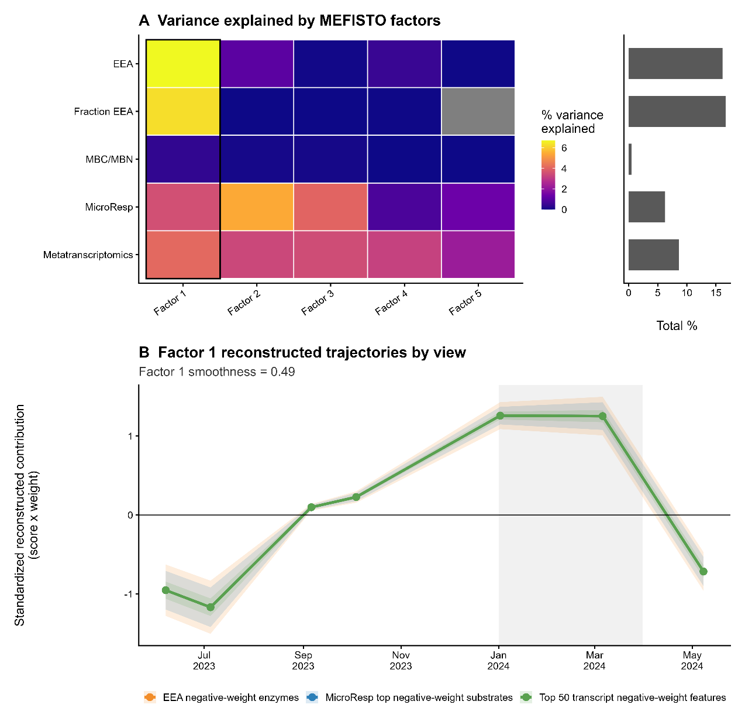
Figure 3: MEFISTO identifies a temporal signal shared across phenotypic scales (substrate-induced respiration, extracellular enzyme activity, and metatranscriptomes). (A) Percent variance explained by each MEFISTO factor across data views. Rows represent data views and columns represent identified latent factors. Factor 1 explained variance across multiple views, including extracellular enzyme activity (EEA), fraction EEA, MicroResp, and metatranscriptomics, but explained little variance in microbial biomass C and N (MBC/MBN). (B) Factor 1 reconstructed temporal trajectories for negative-weight feature sets from EEA, MicroResp, and metatranscriptomics. Reconstructed values were calculated as the sample-level Factor 1 score multiplied by the feature-specific Factor 1 weight (loading?), then averaged within feature group and standardized for visualization. These trajectories represent the Factor 1-specific contribution to each feature group, not raw measured MicroResp rates, enzyme activities, or transcript abundances. The shared increase during winter/early spring indicates coordinated temporal structure across phenotypic, enzymatic, and molecular measurements.
Take-Home: Temporally-sensitive multi-omics integration identified partially shared temporal structure across measured microbial phenotypes (substrate-induced respiration, extracellular enzyme activity, and gene expression). Factor 1 was the clearest multi-data signal, explaining moderate variance in EEA, Fraction EEA, MicroResp, and metatranscriptomics, but little variance in MBC/MBN. Reconstructed Factor 1 trajectories for negative-weight MicroResp, EEA, and transcript features showed a coordinated winter/early-spring pattern, indicating that the dominant winter/rebound MicroResp phenotype identified in Q1 is detectable to some degree across other phenotypic (enzymatic- and molecular-scale) measurements. This supports partial cross-scale coordination in seasonal microbial function, while also showing that biomass pools contributed little to the shared temporal signal.

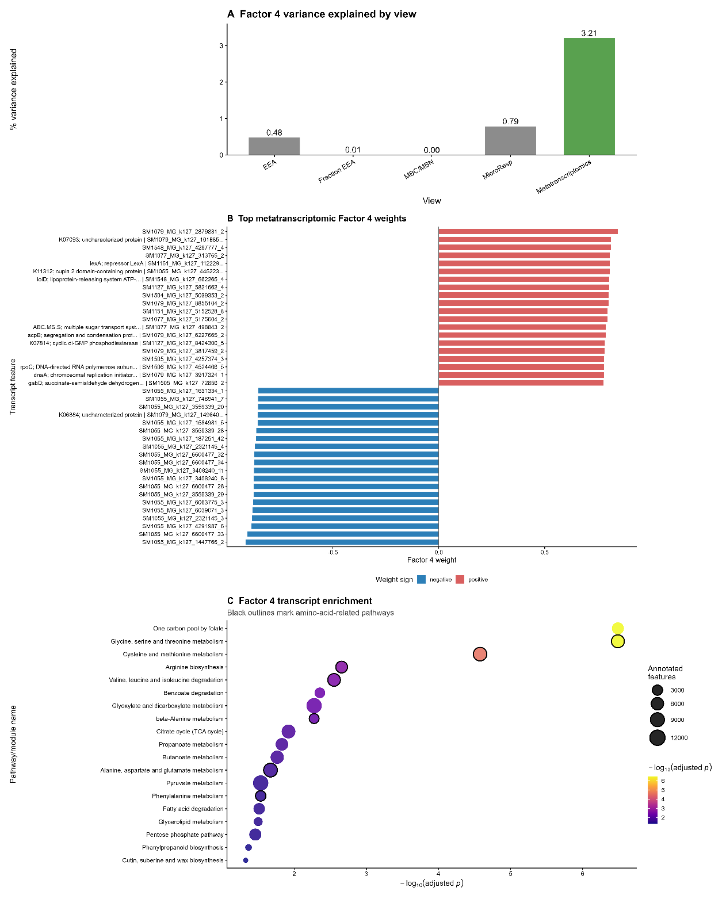
Figure S2. Factor 4 captures predominantly transcriptomic data signals. (A) Percent variance explained by MEFISTO Factor 4 across data views. Factor 4 explained the most variance in the gene expression (metatranscriptomic) data, with weaker contributions from respiration and extracellular enzyme activity and near-zero contribution from microbial biomass C and N. (B) Top positive and negative metatranscriptomic feature weights for Factor 4. Bars show signed Factor 4 weights, with positive and negative weights representing opposing sides of the same latent factor. (C) KEGG pathway/module enrichment among Factor 4-associated transcript features. Point color indicates statistical significance as -log10(adjusted p), point size indicates the number of annotated features, and black outlines mark amino-acid-related pathways. Enriched terms included multiple amino-acid and one-carbon metabolic pathways, supporting interpretation of Factor 4 as a transcriptome-led metabolic signal.
Take-home: Factor 4 was primarily transcriptome-led. It explained substantially more variance in metatranscriptomics than in MicroResp, EEA, Fraction EEA, or microbial biomass, and its associated transcript features were enriched for amino-acid and central-carbon metabolic pathways. This indicates that some seasonal transcriptomic programs were not strongly reflected in substrate-induced respiration, extracellular enzyme activity, or biomass pools.

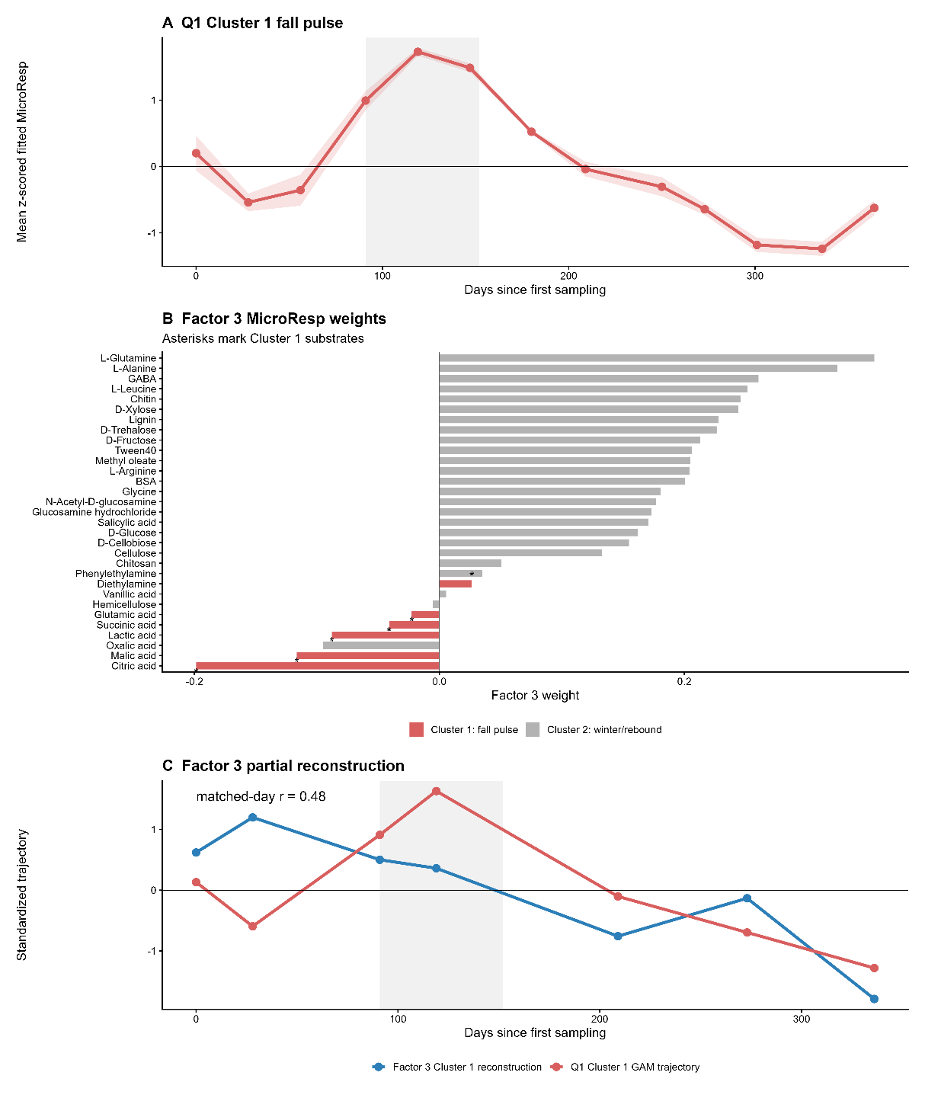
Figure S3. The Q1 Cluster 1 fall pulse was only weakly recovered by MEFISTO Factor 3.
(A) Mean z-scored GAM-fitted MicroResp trajectory for Q1 Cluster 1 substrates, consisting of citric acid, lactic acid, malic acid, succinic acid, glutamic acid, and diethylamine. The group showed a concentrated fall pulse centered in September-October. (B) MicroResp feature weights for MEFISTO Factor 3, colored by Q1 cluster. Cluster 1 substrates were highlighted to evaluate whether the fall pulse group loaded coherently on Factor 3. (C) Factor 3 reconstructed trajectory for Cluster 1 substrates compared with the Q1 Cluster 1 fitted trajectory at matched or nearest sampling dates. Reconstructed values were calculated as sample-level Factor 3 scores multiplied by feature-specific Factor 3 weights and averaged across Cluster 1 substrates. The comparison shows that Factor 3 captured only a weak or broadened version of the Cluster 1 fall pulse rather than a strong shared reconstruction of the Q1 pattern.
Take-home: The Cluster 1 fall pulse was clear in Q1 but was not strongly recovered as a shared MEFISTO factor. Factor 3 captured only partial or broadened MicroResp structure for this group, suggesting that the fall pulse may be transient, substrate-specific, or less synchronized with enzyme and transcriptomic dynamics than the Cluster 2 winter/rebound phenotype.
Additional results
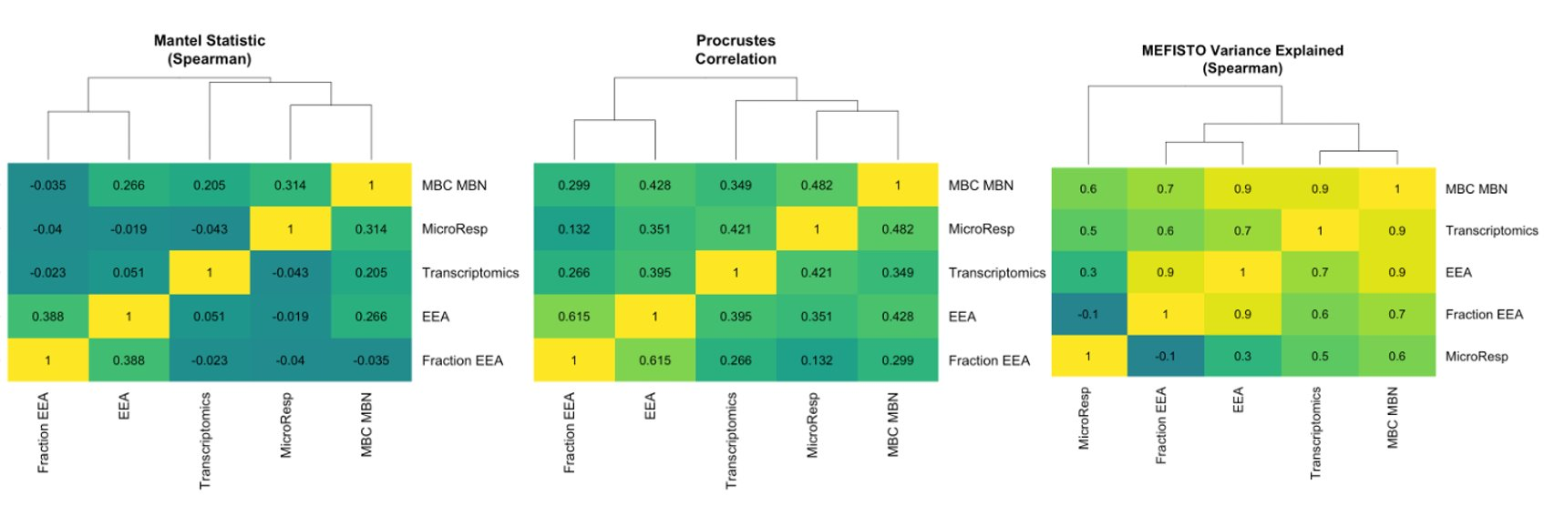
Identification of latent factors while accounting for temporal noise uncovered shared temporal trajectories across data types. Comparison of associations across data types using dimensionality reduction methods that are (MEFISTO) or are not (Mantel, Procrustes) aware of temporal scale. Both Mantel and Procrustes, which do not account for time or learn shared latent structure, identify transcriptomics data as the outlier – its expression profile doesn't match the other types in raw data space. ​The time-aware approach (MEFISTO), however, identifies latent factors that weight specific subsets of transcripts sharing temporal trajectories with the other types, effectively stripping away some of the noise. Under this temporal latent factor model, transcriptomics clusters with EEA and MBC/MBN, while MicroResp becomes the most distinct data type. MEFISTO still indicates that transcriptomics and respiration covary (variance-explained correlation of 0.5), though the magnitude is weaker than the other pairings. ​Notably, correlation scores across these three methods are not directly comparable. They measure fundamentally different quantities (Spearman correlation of variance explained, Mantel's distance-matrix correlation, and Procrustes' rotational fit), so the rank ordering agreement (ρ = 0.71–0.84) is the more meaningful validation. ​

Plotting actual raw data for different data types, subset to features significantly associated with a latent factor. [You kind of do this for Figure S3C above… but let’s talk about elaborating]
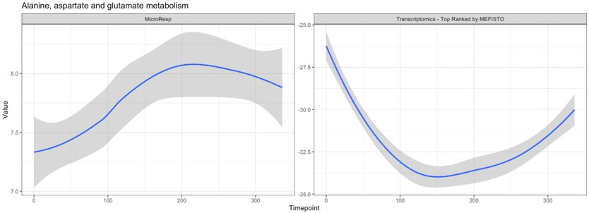
Average expression of MicroResp: "BSA”, "GABA”, "Glutamic_acid”, "Glycine”, "L.Alanine”, "L.Arginine”, "L.Glutamine”, "L.Leucine” (pathways?)​

Conclusions
Substrate-use phenotypes change through time in structured ways, and temporal trajectory was not primarily explained by broad substrate chemistry (class).
Across 13 months, respiration of all 31 substrates showed significant temporal trends. These trends separated into two main groups: a small group of organic acids and amino-acid-related substrates that peaked in September–October, and a larger group of chemically diverse substrates with lowest substrate-induced respiration in mid-summer and highest respiration in late winter and early spring. Broad substrate class did not cleanly predict cluster membership, because amino acids, carbohydrates, a lipid ester, a protein, and a signaling molecule all followed the same winter-peaking pattern. [Another layer is chemical complexity – labile and more structurally complex molecules fell into each broad class] This pattern suggests that shared seasonal context, including moisture, temperature, and extractable resource stoichiometry, may influence substrate-use capacity alongside substrate identity.
These phenotypic patterns are partly, but not fully, reflected in enzyme activity and gene expression. [and we can highlight the specific points/features where these cross-data associations hold true and where they don’t apply, which is extremely valuable to the field to understand when results of a specific measurement can be generalized or not]
When substrate-induced respiration, enzyme activity, biomass, and gene expression were integrated through time, the broad winter/early-spring pattern was partly recovered as a shared signal across substrate-use capacity, enzymes, and a subset of transcripts. However, this shared signal explained only a modest share of variance within each measurement type, approximately 3.5–6.7%. The sharper September–October pulse was not recovered as a strong shared factor. This may reflect limited temporal resolution for transcriptomes during a short-lived transition, or it may indicate that the fall pulse was specific to substrate-induced respiration and not tightly synchronized with enzyme activity or transcript abundance. In this dataset, the longer winter/early-spring phenotype was more visible across measurement types than the shorter fall phenotype.
Phenotypic assays add information that molecular data alone do not capture.
Together, these results show that substrate-induced respiration assays and molecular measurements capture overlapping but distinct aspects of microbial function through time. Two points are especially important. First, potential substrate-use capacity was often highest in winter and early spring, a period that is frequently under-sampled in studies focused on the growing season. Second, cross-scale correspondence was only partial, meaning that any single measurement type could miss important seasonal dynamics. Pairing phenotypic assays with enzyme and molecular measurements, especially with denser sampling around short seasonal transitions, will provide a more complete picture of how microbial function changes across the year.

Potential Discussion points
- TBD
- TBD
- TBD

Relevant references
https://journals.asm.org/doi/full/10.1128/msystems.00112-25

https://academic.oup.com/femsre/article/33/1/191/2683778
https://academic.oup.com/femsre/article/47/4/fuad030/7191836 “The phenotype of a microbe can be viewed as any observable characteristic of that organism, such as morphology, the consumption or production of certain metabolites, or the capability of growth in an environmental niche.”
Ontology of microbial phenotypes: https://link.springer.com/article/10.1186/s12866-014-0294-3
2020 review on microbial phenomics: https://doi.org/10.1016/j.csbj.2020.08.010

