Adding files up to 100 MB to GitHub
Step 1: Cloning repository
1) Open the repository in a browser
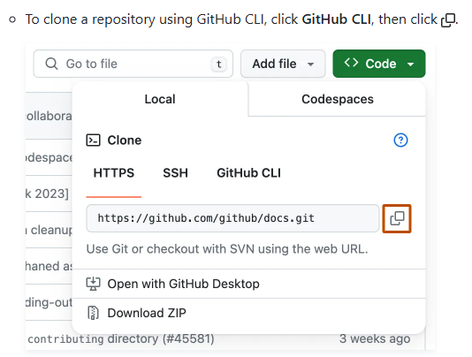
2) In GitBash
git clone link
Step 2: Adding files
3) In the folder created in the PC, copy and paste the desired files
4) In GitBash
cd folder
git add --all
git commit -m “new changes”
git push

Adding files bigger than 100 MB
1) Clone the repository and copy and paste the desired file (see steps above)
2) Open GitBash
git lfs install
git lfs track “file_name”
Obs: we can use git lfs track “*.file_type” to add all files with the same ending
git lfs push --all origin main
git add --all
git commit -m “new changes”
git push -u origin main

