

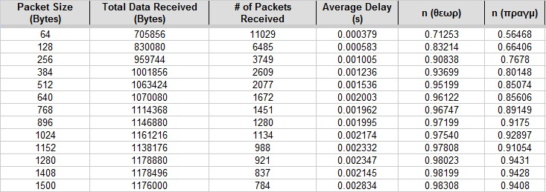
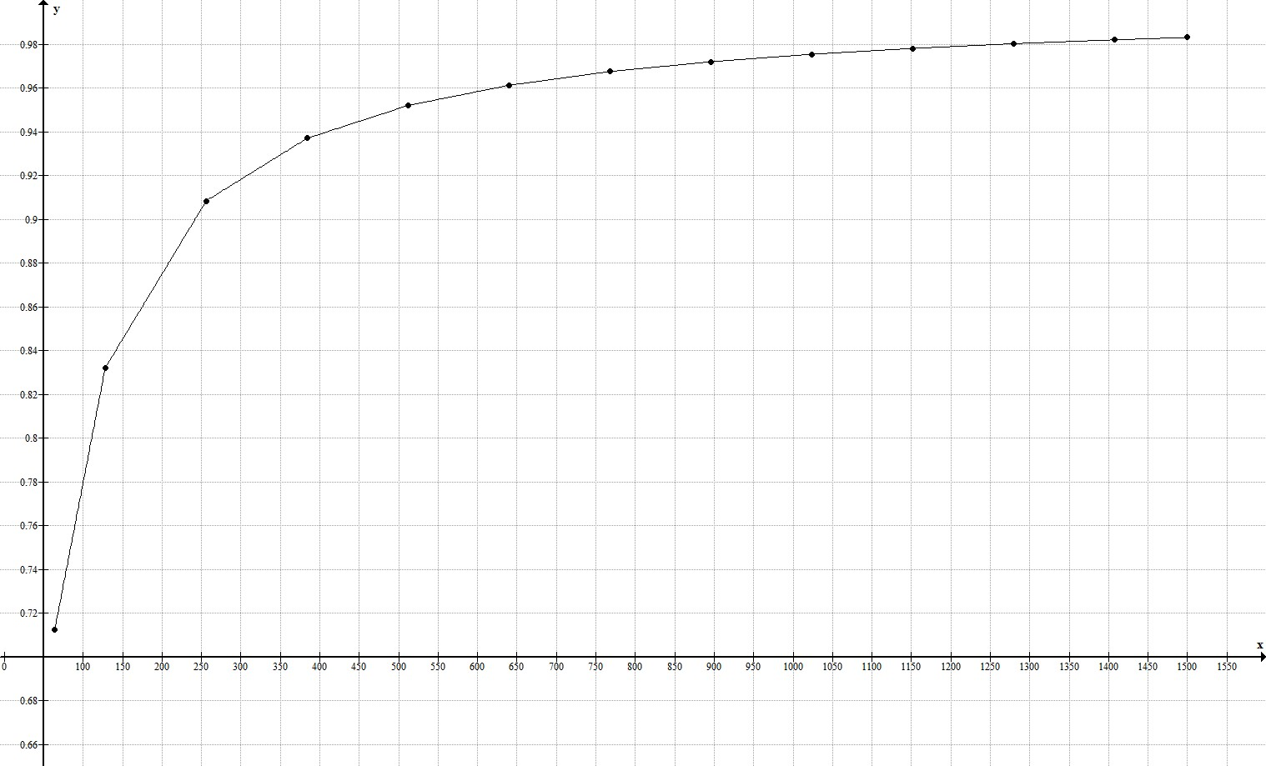
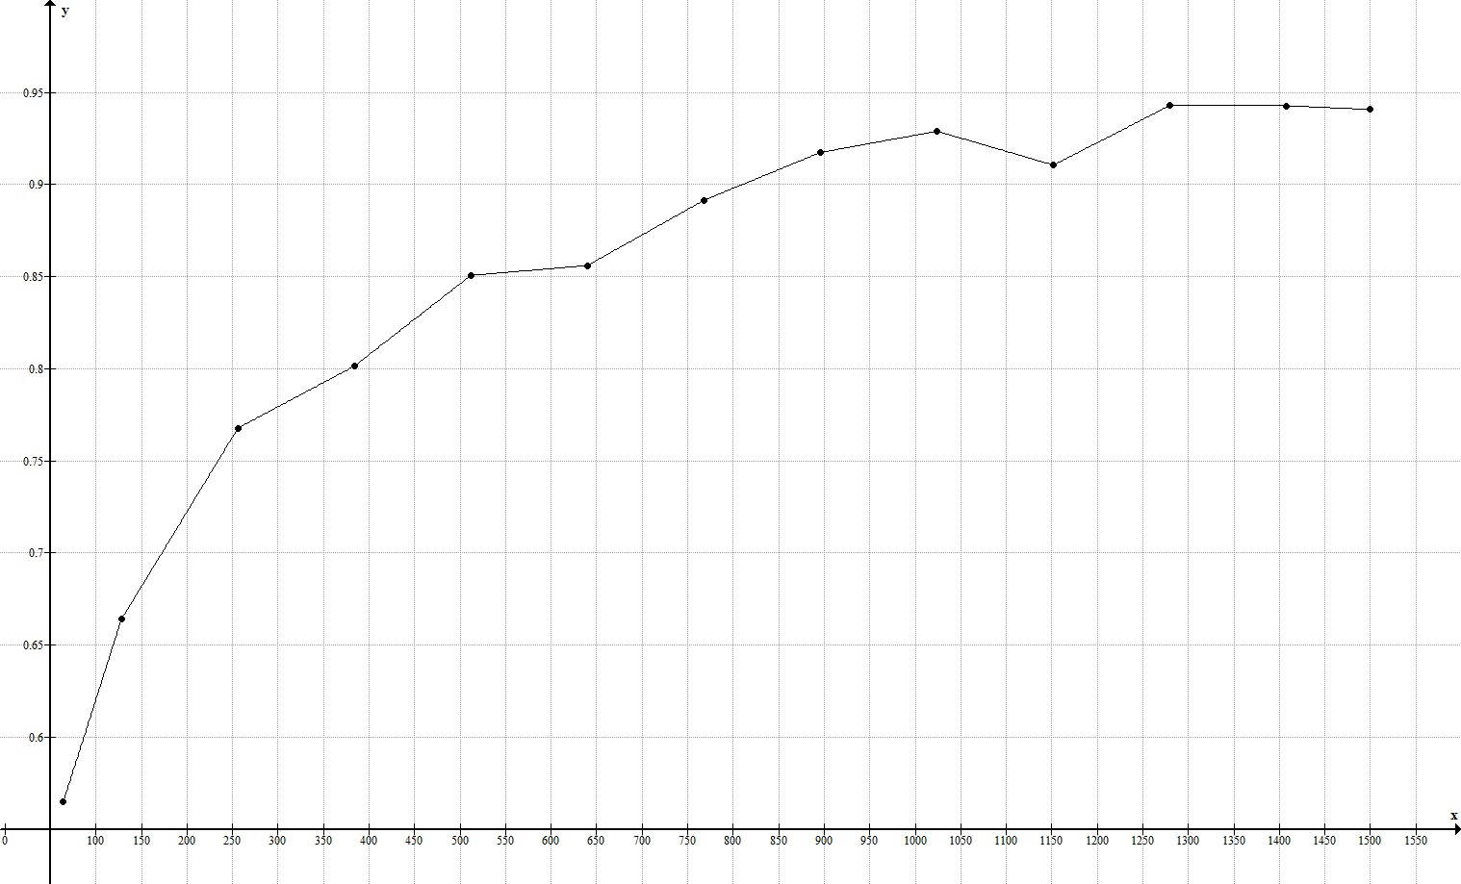
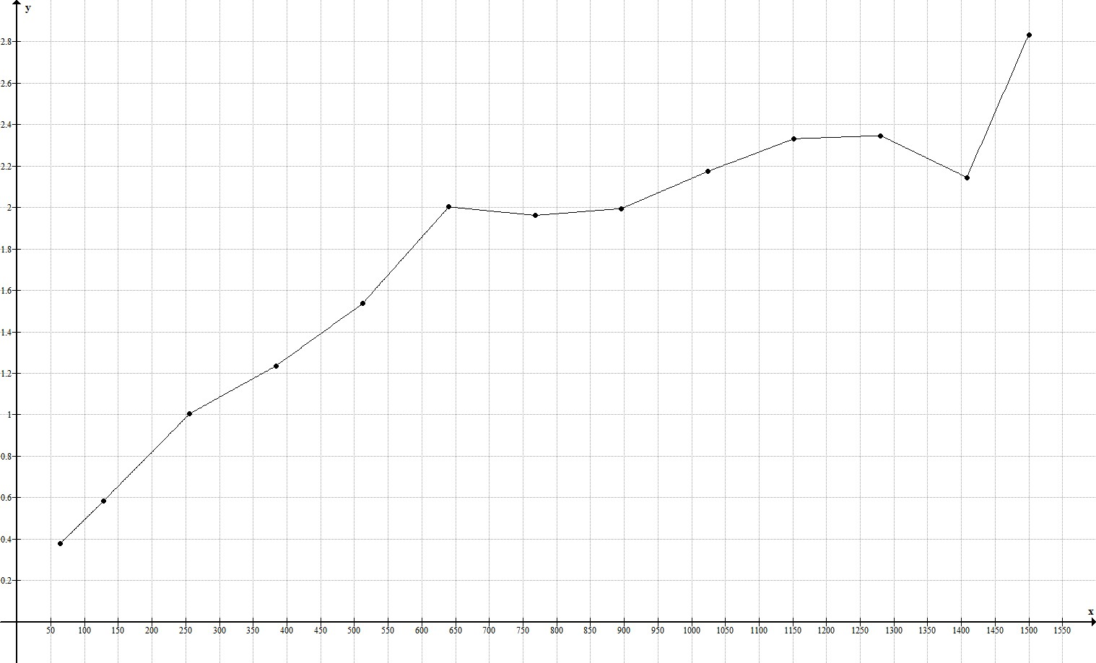
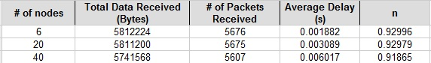
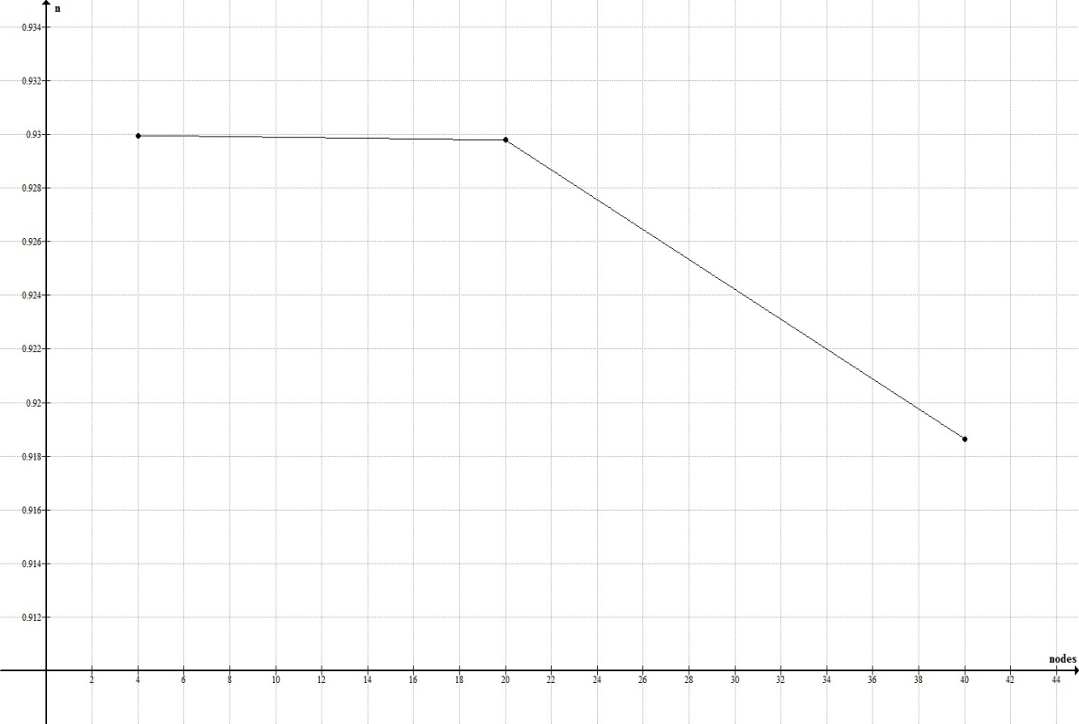
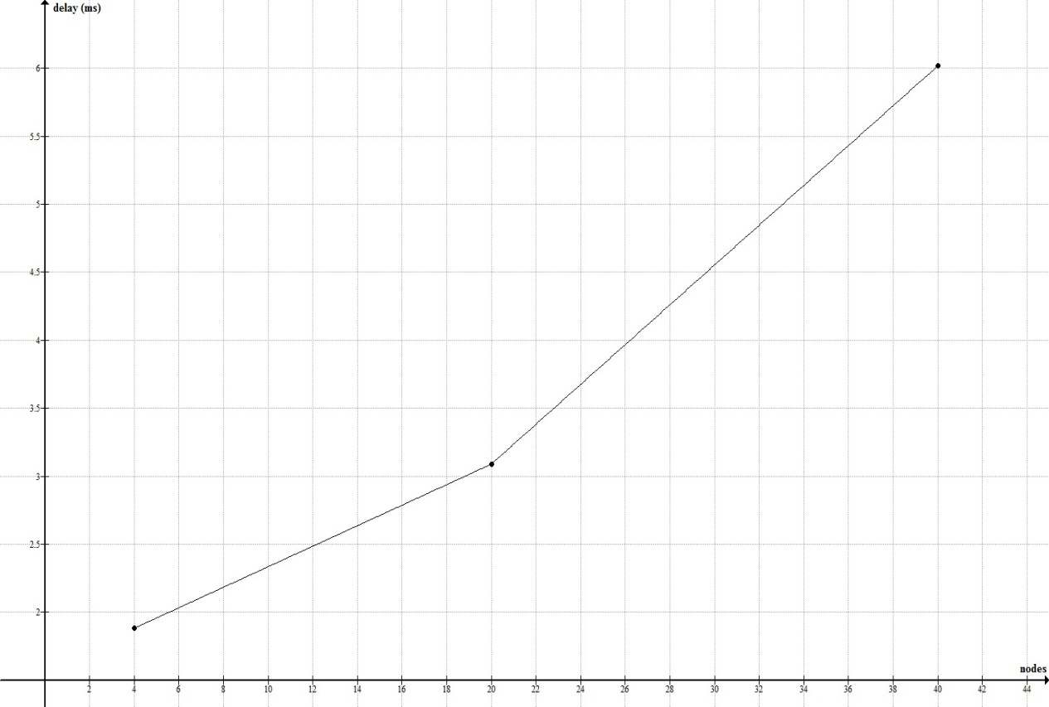
Εθνικό Μετσόβιο Πολυτεχνείο
Σχολή Ηλεκτρολόγων Μηχ. Και Μηχ. Υπολογιστών
Διαδίκτυο & εφαρμογές
8ο εξάμηνο, Ροή Δ
Ακαδημαϊκή Περίοδος : 2011-2012

1^{η} Εργαστηριακή Άσκηση

Γερακάρης Βασίλης
<vgerak@gmail.com>
Α.Μ. :03108092

- Εισαγωγικά:

Σε αυτή την εργαστηριακή άσκηση κληθήκαμε να γράψουμε μια web εφαρμογή με Java Server-Side Scripting, η οποία θα έκανε χρήση cookies για την εξυπηρέτηση των clients.

Για την ανάπτυξη αυτής της εφαρμογής χρησιμοποιήθηκε το IDE Eclipse Java EE Indigo για τη συγγραφή του κώδικα, ο Apache Tomcat 6.0.35 web server και ο περιηγητής ιστού Google Chrome 18.0.1025.165 (από τον οποίο προέρχονται και τα screenshots), πάνω σε λειτουργικό MacOS X.

Εκτός της Java, χρειάστηκαν θεμελιώδεις γνώσεις HTML, ενώ έγινε και συγγραφή 2 αρχείων CSS, για βελτίωση του αισθητικού αποτελέσματος της ιστοσελίδας. Τέλος, επιλέχθηκε χρήση JSP αντί servlets για την εφαρμογή αυτή, μιας και το μεγαλύτερο μέρος της αποτελείται απο HTML κώδικα, και οι λειτουργικότητες που ζητούνταν από την εκφώνηση καλύπτονται από λίγες γραμμές εμβόλιμου κώδικα Java.

Screenshots:

Ακολουθούν μερικά χαρακτηριστικά στιγμιότυπα οθονών από την εκτέλεση της εφαρμογής:

Εισαγωγική φόρμα (1):

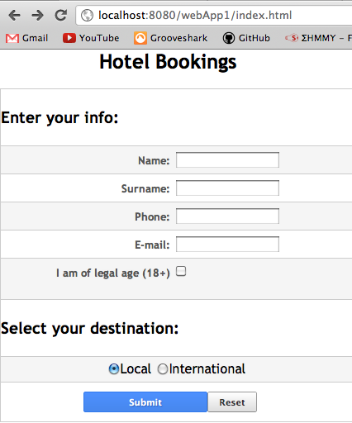

Πάτημα Reset σε συμπληρωμένη φόρμα:

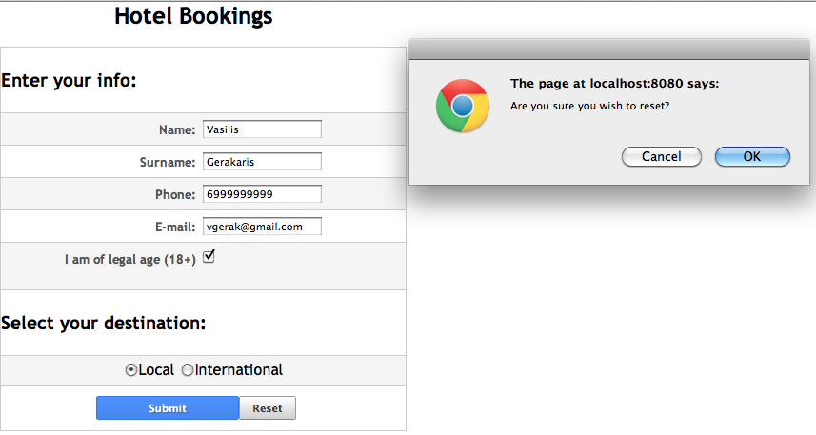

- Επιλογή Local (2a):

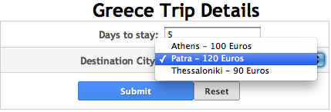

- Κόστος και επιβεβαίωση (3a):

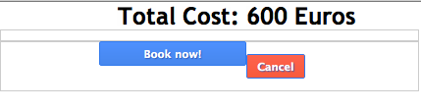

- Επιλογή International (2b):

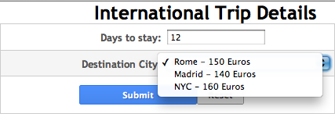

- Κόστος και επιβεβαίωση (3b):

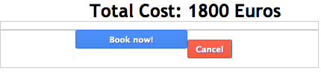

- Τελική φόρμα – Απόδειξη (4):

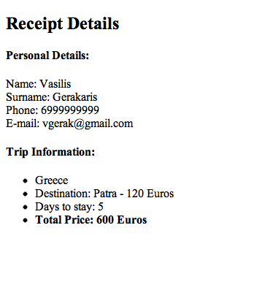

Source Code:

Παρατίθενται τα αρχεία του πηγαίου κώδικα που συγγράφηκαν για τις ανάγκες της άσκησης.

index.html

- <!DOCTYPE html PUBLIC "-//W3C//DTD HTML 4.01 Transitional//EN" "http://www.w3.org/TR/html4/loose.dtd">
- <html>
- <head>
- <meta http-equiv="Content-Type" content="text/html; charset=UTF-8">
- <link rel="stylesheet" href="css/style.css" />
- <link rel="stylesheet" href="css/form.css" />
- <title>Hotels</title>
- </head>
- <body>
- <h2>Hotel Bookings</h2><br>
- <form method="post" action="home.jsp">
- <div>
- <h3>Enter your info:</h3>
- </div>
- <div>
- <label>Name:</label>
- <input type="text" name="name">
- </div>
- <div>
- <label>Surname:</label>
- <input type="text" name="surname">
- </div>
- <div>
- <label>Phone:</label>
- <input type="text" name="phone">
- </div>
- <div>
- <label>E-mail:</label>
- <input type="text" name="email">
- </div>
- <div>
- <label>I am of legal age (18+)</label>
- <input type="checkbox" name="check"> <br><br>
- </div>
- <div>
- <h3>Select your destination:</h3>
- </div>
- <div class="label_radio">
- <input type="radio" name="local" value="Greece" checked>Local
- <input type="radio" name="local" value="International">International<br>
- </div>
- <div class="actions">
- <input type="submit" value="Submit">
- <input type="reset" value="Reset" onclick="return confirm('Are you sure you wish to reset?')">
- </div>
- </form>
- </body>
- </html>

home.jsp

- <%@ page language="java" contentType="text/html; charset=UTF-8"
- pageEncoding="UTF-8"%>
- <%!public String[] getTowns(String country) {
- String grTowns[] = {"Athens - 100 Euros", "Patra - 120 Euros", "Thessaloniki - 90 Euros"};
- String intTowns[] = {"Rome - 150 Euros", "Madrid - 140 Euros", "NYC - 160 Euros"};
- if (country.equals("Greece")) {
- return grTowns;
- } else {
- return intTowns;
- }

- }%>

- <!DOCTYPE html PUBLIC "-//W3C//DTD HTML 4.01 Transitional//EN" "http://www.w3.org/TR/html4/loose.dtd">
- <html>
- <head>
- <meta http-equiv="Content-Type" content="text/html; charset=UTF-8">
- <link rel="stylesheet" href="css/style.css" />
- <link rel="stylesheet" href="css/form.css" />
- <title>City Selection</title>
- </head>
- <body>
- <%
- Cookie cookies[] = request.getCookies();
- String re[];

- String name = request.getParameter("name");
- String surname = request.getParameter("surname");
- String email = request.getParameter("email");
- String check = request.getParameter("check");
- String phone = request.getParameter("phone");
- String local = request.getParameter("local");

- //Redirect if age < 18
- if (check == null) {
- String redirectURL = "http://localhost:8080/webApp1/index.html";
- response.sendRedirect(redirectURL);
- }

- if (name == null || surname == null || email == null || phone == null || local == null) {
- for( int i = 0 ; i < cookies.length ; ++i ) {
- if (name == null && cookies[i].getName().equals("name")) {
- name = cookies[i].getValue();
- }
- else if (surname == null && cookies[i].getName().equals("surname")) {
- surname = cookies[i].getValue();
- }
- else if (email == null && cookies[i].getName().equals("email")) {
- email = cookies[i].getValue();
- }
- else if (phone == null && cookies[i].getName().equals("phone")) {
- phone = cookies[i].getValue();
- }
- else if (local == null && cookies[i].getName().equals("local")) {
- local = cookies[i].getValue();
- }
- }

- }
- Cookie c1 = new Cookie("name", name);
- Cookie c2 = new Cookie("surname", surname);
- Cookie c3 = new Cookie("email", email);
- Cookie c4 = new Cookie("phone", phone);
- Cookie c5 = new Cookie("local", local);
- c1.setMaxAge(120);
- c2.setMaxAge(120);
- c3.setMaxAge(120);
- c4.setMaxAge(120);
- c5.setMaxAge(120);

- response.addCookie(c1);
- response.addCookie(c2);
- response.addCookie(c3);
- response.addCookie(c4);
- response.addCookie(c5);

- re = getTowns(local);
- %>
- <h2><%=local%> Trip Details</h2>
- <form method="post" action="book.jsp">
- <div>
- <label>Days to stay:</label>
- <input type = "text" name="days">
- </div>
- <div>
- <label>Destination City:</label>
- <select name="destination">
- <option selected="selected">
- <%=re[0]%></option>
- <option>
- <%=re[1]%></option>
- <option>
- <%=re[2]%></option>
- </select>
- </div>
- <div class="actions">
- <input type="submit" value="Submit">
- <input type="reset" value="Reset" onclick="return confirm('Are you sure you wish to reset?')">
- </div>
- </form>
- </body>
- </html>

book.jsp

- <%@ page language="java" contentType="text/html; charset=UTF-8"
- pageEncoding="UTF-8"%>
- <%! public int calcPrice(String select, String days) {
- int d = Integer.parseInt(days);
- if(select.equals("Athens - 100 Euros")) {
- return 100*d;
- }
- else if (select.equals("Patra - 120 Euros")) {
- return 120*d;
- }
- else if(select.equals("Thessaloniki - 90 Euros")) {
- return 90*d;
- }
- else if(select.equals("Rome - 150 Euros")) {
- return 150*d;
- }
- else if(select.equals("Madrid - 140 Euros")) {
- return 140*d;
- }
- else if(select.equals("NYC - 160 Euros")) {
- return 160*d;
- }
- return 0;
- }
- %>
- <!DOCTYPE html PUBLIC "-//W3C//DTD HTML 4.01 Transitional//EN" "http -//www.w3.org/TR/html4/loose.dtd">
- <html>
- <head>
- <meta http-equiv="Content-Type" content="text/html; charset=UTF-8">
- <link rel="stylesheet" href="css/style.css" />
- <link rel="stylesheet" href="css/form.css" />
- <title>Booking Details</title>
- </head>
- <body>
- <%
- Cookie cookies[] = request.getCookies();
- String dest= request.getParameter("destination");
- Cookie c1 = new Cookie("destination",dest);
- response.addCookie(c1);
- String days = request.getParameter("days");
- Cookie c2 = new Cookie("days",days);
- response.addCookie(c2);
- Cookie c3 = new Cookie("price",""+calcPrice(dest, days));
- response.addCookie(c3);
- %>

- <div><h2>Total Cost: <%=calcPrice(dest, days) %> Euros</h2></div>
- <form method="post" action="receipt.jsp">
- <div class="actions">
- <input type="submit" value="Book now!">
- </div>
- </form>
- <form method="post" action="home.jsp">
- <div class="actions">
- <input type="submit" value="Cancel">
- </div>
- </form>
- </body>
- </html>

book.jsp

- <%@ page language="java" contentType="text/html; charset=UTF-8"
- pageEncoding="UTF-8"%>
- <!DOCTYPE html PUBLIC "-//W3C//DTD HTML 4.01 Transitional//EN" "http://www.w3.org/TR/html4/loose.dtd">
- <html>
- <head>
- <meta http-equiv="Content-Type" content="text/html; charset=UTF-8">

- <title>Receipt</title>
- </head>
- <body>

- <%
- Cookie cookies[] = request.getCookies();
- String name, surname, phone, email, check, local, days, destination, price;
- name = "";
- surname = "";
- phone = "";
- email = "";
- check = "";
- local = "";

- days = "";
- destination = "";
- price = "";

- for (int i = 0; i < cookies.length; ++i) {
- if (cookies[i].getName().equals("name")) {
- name = cookies[i].getValue();
- } else if (cookies[i].getName().equals("surname")) {
- surname = cookies[i].getValue();
- } else if (cookies[i].getName().equals("phone")) {
- phone = cookies[i].getValue();
- } else if (cookies[i].getName().equals("email")) {
- email = cookies[i].getValue();
- } else if (cookies[i].getName().equals("local")) {
- local = cookies[i].getValue();
- } else if (cookies[i].getName().equals("days")) {
- days = cookies[i].getValue();
- } else if (cookies[i].getName().equals("destination")) {
- destination = cookies[i].getValue();
- } else if (cookies[i].getName().equals("price")) {
- price = cookies[i].getValue();
- }
- }
- %>
- <div><h2> Receipt Details </h2></div>
- <div><h4>Personal Details:</h4>
- <div>
- <label>Name: </label>
- <%=name%>
- </div>
- <div>
- <label>Surname: </label>
- <%=surname%>
- </div>
- <div>
- <label>Phone: </label>
- <%=phone%>
- </div>
- <div>
- <label>E-mail: </label>
- <%=email%>
- </div>
- </div>
- <div><h4>Trip Information:</h4></div>
- <ul>
- <li>
- <div>
- <%=local%>
- </div>
- </li><li>
- <div>
- <label>Destination: </label>
- <%=destination%>
- </div>
- </li><li>
- <div>
- <label>Days to stay: </label>
- <%=days%>
- </div>
- </li><li>
- <div>
- <strong>
- <label>Total Price: </label>
- <%=price%> Euros
- </strong>
- </div>
- </li>
- </ul>

- </body>
- </html>

form.css

- form input[type='text'].error, form select.error {
- color: red;
- font-weight: bold;
- border: 2px solid red;}
- form .actions input[type=reset] {
- float: none;
- display: block;
- border: 1px solid #999;
- border-bottom-color: #888;
- color: #333;
- background-color: #eee;
- font-size: 70%;
- padding: 5px;
- border-radius: 2px;
- margin: 6px 0;
- width: 60px;
- text-align: center;
- font-weight: bold;
- background-image: -webkit-linear-gradient(top, #fff, #ddd);
- background-image: -moz-linear-gradient(top, #fff, #ddd);
- background-image: linear-gradient(top, #fff, #ddd);
- }
- a.reset:hover {
- text-decoration: none;
- }
- form select {
- width: 210px;
- }
- form div.actions:nth-child(even), form div.actions:nth-child(odd) {
- border-bottom: none;
- background-color: white;
- }
- form div.eof {
- border-bottom: none;
- }
- label {
- float: left;
- display: block;
- width: 200px;
- padding: 5px 5px;
- text-align: right;
- font-size: 80%;
- font-weight: bold;
- color: #555;
- }
- form {
- border: 1px solid #ccc;
- width: 425px;
- }
- form.delete {
- border: none;
- width: auto;
- }
- form div {
- padding: 5px 0;
- border-bottom: 1px solid #ccc;
- }
- form div:nth-child(even) {
- background-color: #f5f5f5;
- }
- form .actions {
- margin: 0 100px;
- }
- form .actions input[type=submit] {
- margin: 6px auto;
- display: block;
- width: 150px;
- padding: 5px;
- background-color: #4d90fe;
- color: white;
- border: 1px solid #3079ED;
- background-image: -webkit-linear-gradient(top, #4d90fe, #4787ed);
- background-image: -moz-linear-gradient(top, #4d90fe, #4787ed);
- background-image: linear-gradient(top, #4d90fe, #4787ed);
- border-radius: 2px;
- cursor: pointer;
- font-weight: bold;
- font-size: 70%;
- text-shadow: 1px 1px 1px #2f5bb7;
- float: left;
- }
- form .actions input[value=Cancel] {
- margin: 7px 0;
- display: block;
- width: 60px;
- padding: 5px;
- background-color: #fe634d;
- color: white;
- border: 1px solid #3079ED;
- background-image: -webkit-linear-gradient(top, #fe634d, #f85a3c);
- background-image: -moz-linear-gradient(top, #fe634d, #f85a3c);
- background-image: linear-gradient(top, #fe634d, #f85a3c);
- border-radius: 2px;
- cursor: pointer;
- font-weight: bold;
- font-size: 70%;
- text-shadow: 1px 1px 1px #2f5bb7;
- float: none;
- }
- form .actions input[type=submit]:hover {
- background-image: -webkit-linear-gradient(top, #4d90fe, #357ae8);
- background-image: -moz-linear-gradient(top, #4d90fe, #357ae8);
- background-image: linear-gradient(top, #4d90fe, #357ae8);
- border: 1px solid #2f5bb7;
- }
- form .actions input[value=Cancel]:hover {
- background-image: -webkit-linear-gradient(top, #fff, #d0d0d0);
- background-image: -moz-linear-gradient(top, #fff, #d0d0d0);
- background-image: linear-gradient(top, #fff, #d0d0d0);
- }
- form .actions input[type=reset]:hover {
- background-image: -webkit-linear-gradient(top, #fff, #d0d0d0);
- background-image: -moz-linear-gradient(top, #fff, #d0d0d0);
- background-image: linear-gradient(top, #fff, #d0d0d0);
- }
- form .label_radio input[type=radio]{
- position: relative;
- float: none;
- }
- form .label_radio{
- text-align: center;
- position: relative;
- }

style.css

- body {
- font-family: 'Trebuchet MS', Verdana, sans-serif;
- margin: 0;
- }
- #universe {
- clear: both;
- margin: 5px;
- }
- h2 {
- margin: 0;
- float: center;
- position: relative;
- left: 120px;
- }
- h4 {
- margin: 0;
- float: center;
- font-family: Verdana;
- font-size: 1.5em;
- text-align: center;
- text-decoration: underline;
- center: 0px;
- }
- ul#navigation {
- float: right;
- padding: 5px;
- margin: 0;
- list-style: none;
- }
- ul#navigation li {
- float: left;
- }
- a {
- color: #3b5998;
- text-decoration: none;
- }
- a:hover {
- text-decoration: underline;
- }
- #copy {
- color: #555;
- font-size: 80%;
- padding: 20px 5px;
- text-align: center;
- }
- #navigation a {
- padding: 5px;
- }
- #navigation a:hover {
- background-color: #e5e5ff;
- }
- div.eof {
- clear: both;
- margin: 0;
- padding: 0;
- }

