Εθνικό Μετσόβιο Πολυτεχνείο
Σχολή Ηλεκτρολόγων Μηχ. Και Μηχ. Υπολογιστών
Διαδίκτυο & Εφαρμογές
8ο εξάμηνο, Ροή Δ

Ακαδημαϊκή Περίοδος : 2011-2012

2η Εργαστηριακή Άσκηση

Γερακάρης Βασίλης
<vgerak@gmail.com>
Α.Μ. :03108092

18/05/2012
Εισαγωγικά:

Σε αυτή την εργαστηριακή άσκηση κληθήκαμε να γράψουμε μια web εφαρμογή με χρήση ενός servlet , η οποία μετασχηματίζει αρχεία .xml προκαθορισμένης μορφής με χρήση ενός .xsl αρχείου ως DOMSource.

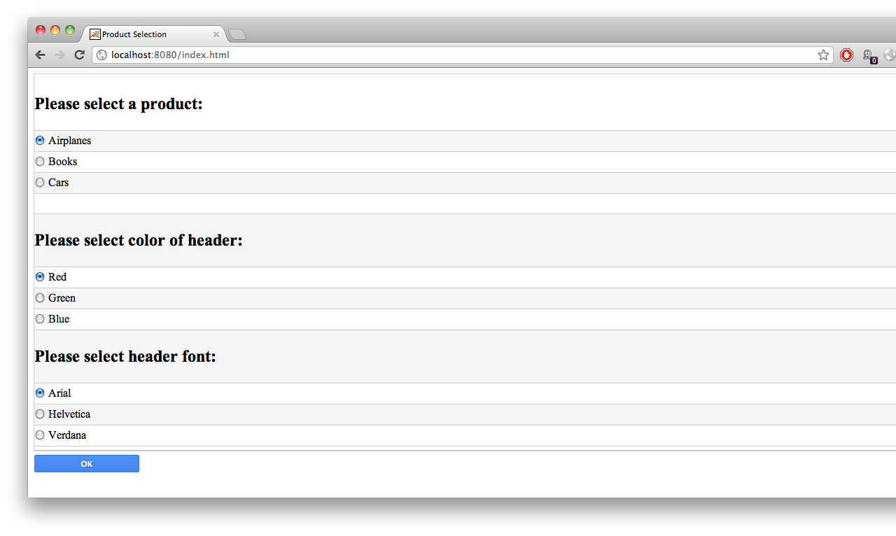
Για την ανάπτυξη αυτής της εφαρμογής χρησιμοποιήθηκε το IDE Eclipse Java EE Indigo για τη συγγραφή του κώδικα, ο Apache Tomcat 6.0.35 web server και ο περιηγητής ιστού Google Chrome 18.0.1025.165 (από τον οποίο προέρχονται και τα screenshots), πάνω σε λειτουργικό MacOS X.

Εκτός το κομμάτι της Java, χρειάστηκαν γνώσεις XML, XLS και XPATH, ενώ έγινε και συγγραφή δύο αρχείων CSS, για βελτίωση του αισθητικού αποτελέσματος της ιστοσελίδας.

Screenshots:

Ακολουθούν χαρακτηριστικά στιγμιότυπα οθονών από την εκτέλεση της εφαρμογής:

Αρχική σελίδα - επιλογές

Επιλογή: Airplanes – Red - Arial

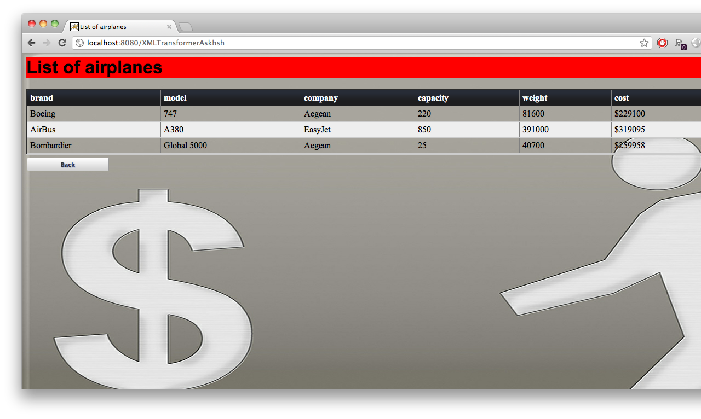
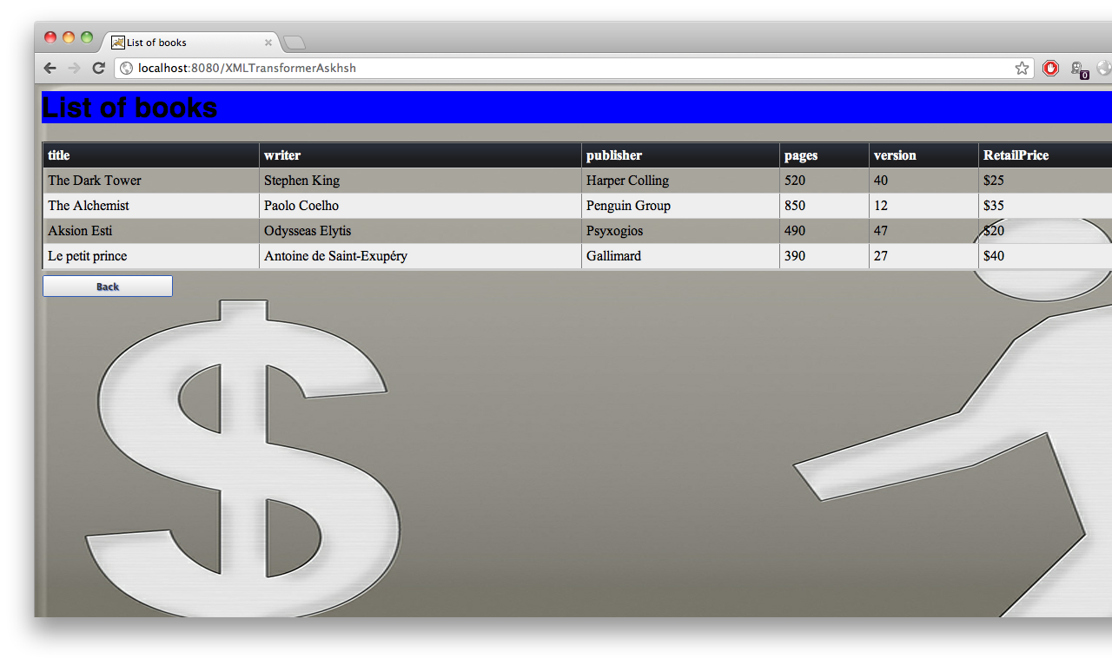
Επιλογή: Books – Blue – Helvetica

Επιλογή: Cars – Green – Verdana

Source Code:

Παρατίθενται τα αρχεία του πηγαίου κώδικα που συγγράφηκαν για τις ανάγκες της άσκησης.

index.html

1 <!DOCtype html PUBLIC "-//W3C//DTD HTML 4.01 Transitional//EN" "http://www.w3.org/TR/html4/loose.dtd">
2 <html>
3 <head>
4 <meta http-equiv="Content-Type" content="text/html; charset=UTF-8">
5 <link rel="stylesheet" href="css/form.css">
6 <title>Product Selection</title>
7 </head>
8
9 <body>
10 <form ACTION="http://localhost:8080/XMLTransformerAskhsh" method="POST">
11 <div>
12 <div>
13 <h2>Please select a product:</h2>
14 </div>
15 <div>
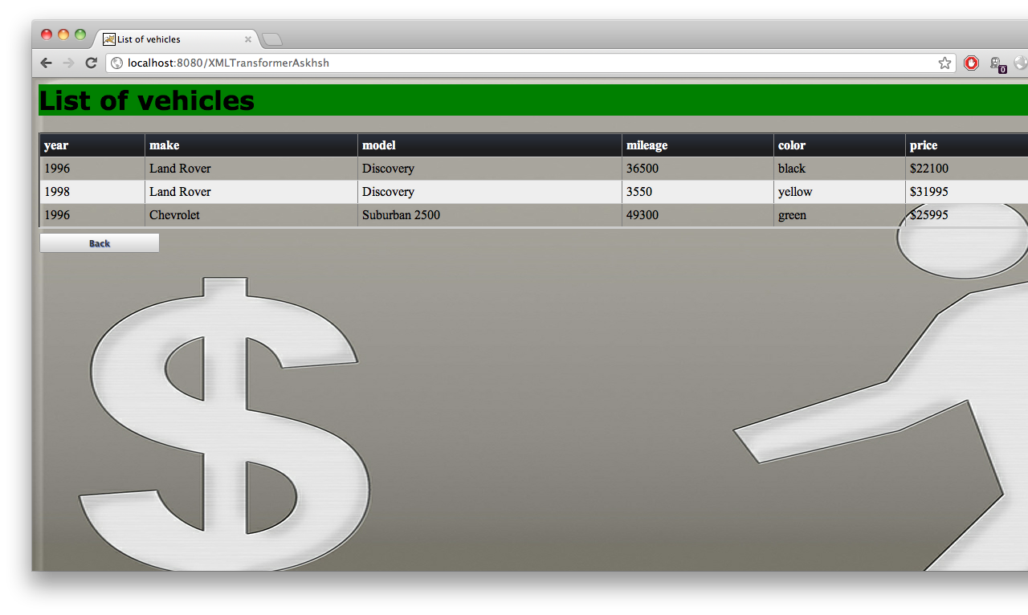
16 <input type='radio' name='type' value="/WEB-INF/Airplanes.xml" checked> Airplanes
17 </div>
18 <div>
19 <input type='radio' name='type' value="/WEB-INF/Books.xml"> Books
20 </div>
21 <div>
22 <input type='radio' name='type' value="/WEB-INF/Cars.xml"> Cars
23 </div>
24 <div><br></div>
25 <div>
26 <h2>Please select color of header:</h2>
27 </div>
28 <div>
29 <input type='radio' name='color' value="red" checked> Red
30 </div>
31 <div>
32 <input type='radio' name='color' value="green"> Green
33 </div>
34 <div>
35 <input type='radio' name='color' value="blue"> Blue
36 </div>
37 <div>
38 <h2>Please select header font:</h2>
39 </div>
40 <div>
41 <input type='radio' name='font' value="Arial" checked> Arial
42 </div>
43 <div>
44 <input type='radio' name='font' value="Helvetica"> Helvetica
45 </div>
46 <div>
47 <input type='radio' name='font' value="Verdana"> Verdana
48 </div>
49 </div>
50 <input type='submit' value='OK'>
51 </form>
52 </body>
53 </html>

XMLTransformerAskhsh.java

1 import java.io.*;
2 //import javax.xml.transform.stream.*;
3 import javax.xml.transform.*;
4 import javax.xml.transform.sax.SAXSource;
5 import javax.xml.transform.stream.StreamSource;
6 import javax.xml.transform.stream.StreamResult;
7 import org.xml.sax.*;
8 // for servlet:
9 import javax.servlet.*;
10 import javax.servlet.http.*;
11
12 import org.w3c.dom.*; // for DOM (Java DOM)
13 import javax.xml.parsers.*;
14
15 import javax.xml.transform.dom.*;// for transformations
16
17 public class XMLTransformerAskhsh extends HttpServlet {
18 /**
19 *
20 */
21 private static final long serialVersionUID = 1L;
22 ServletContext ctx;
23 String absPath; //absolute path to our files - see below
24 SAXSource xsltDoc; TransformerFactory tF;
25 Transformer myTransformer;// will be built at init, will be used by doGet
26 Document doc;
27
28 public void init(ServletConfig config) throws UnavailableException {
29 System.out.println("Init start");
30 try {
31 ctx = config.getServletContext(); // we will use the 'contex' below
32 absPath = ctx.getRealPath("WEB-INF/Presentor.xsl");
33 xsltDoc = new SAXSource(new InputSource(absPath));
34 tF = TransformerFactory.newInstance();
35 DocumentBuilderFactory fact = DocumentBuilderFactory.newInstance();
36 // absolutely important, to understand the meaning of prefix 'xslt' !!!!
37 fact.setNamespaceAware(true);
38 DocumentBuilder builder = fact.newDocumentBuilder();
39 doc = builder.parse(absPath);
40 System.out.println("Name of document element is " + doc.getDocumentElement().getNodeName());
41 } catch (Exception e) { e.printStackTrace(); }
42 System.out.println("Init end");
43 }
44 private void changeDomByColor(Document doc, String color) {
45 NodeList nl = doc.getElementsByTagName("h1");
46 Attr a = doc.createAttribute("style");
47 a.setValue("background-color: "+color);
48 nl.item(0).getAttributes().setNamedItem(a);
49 }
50 private void changeDomByFont(Document doc, String font) {
51 NodeList nl = doc.getElementsByTagName("font");
52 Attr a = doc.createAttribute("face");
53 a.setValue(font);
54 nl.item(0).getAttributes().setNamedItem(a);
55 }
56
57 @Override
58 public void doPost(HttpServletRequest request, HttpServletResponse response) throws ServletException, IOException {
59 System.out.println("dopost start");
60 System.out.println("Name of document element (at the post) is " + doc.getDocumentElement().getNodeName());
61 String color = request.getParameter("color");
62 String font = request.getParameter("font");
63 String myXML = request.getParameter("type");
64 System.out.println("You selected the color " + color);
65 System.out.println("You selected the font " + font);
66 System.out.println("You selected the XML file: " + myXML);
67 changeDomByColor(doc, color);
68 changeDomByFont(doc, font);
69 PrintWriter pwr = response.getWriter();
70 try {
71 DOMSource ds = new DOMSource(doc) ;
72 System.out.println( ((Document)ds.getNode()).getDocumentElement().getNodeName() +" " +((Document)ds.getNode()).getDocumentElement().getNodeValue() ) ;
73 myTransformer = tF.newTransformer(new DOMSource(doc));
74 myTransformer = tF.newTransformer(xsltDoc);
75 myTransformer = tF.newTransformer(ds);
76
77 StreamSource xmlSource = new StreamSource(ctx.getResourceAsStream(myXML));
78 System.out.println("Sending back the xml tranformed into html");
79 response.setContentType("text/html"); //in order to put in http body
80 myTransformer.transform(xmlSource, new StreamResult(pwr));
81 //pwr.println("End of list, thanks for viewing!");
82 pwr.close();
83 }
84 catch (Exception e)
85 {
86 e.printStackTrace();
87 }
88 System.out.println("dopost stop");
89 }
90
91 }

Presentor.xsl

1 <?xml version="1.0"?>
2 <xsl:stylesheet version="1.0"
3 xmlns:xsl="http://www.w3.org/1999/XSL/Transform">
4 <xsl:template match="/">
5 <html>
6 <head>
7 <link rel="stylesheet" href="css/table.css" />
8 <link rel="stylesheet" href="css/form.css" />
9 <title>
10 List of <xsl:value-of select="name(*/*)" />s
11 </title>
12 </head>
13 <body background="Money.jpg">
14 <h1 style="font-size: 20pt; text-align: center; letter-spacing: 1.0em">
15 <font>List of <xsl:value-of select="name(*/*)" />s</font>
16 </h1>
17 <table align="center" border="2">
18 <thead>
19 <tr bgcolor="#446600">
20 <th>
21 <xsl:value-of select="name(*/*/@*[1])" />
22 </th>
23 <th>
24 <xsl:value-of select="name(*/*/@*[2])" />
25 </th>
26 <th>
27 <xsl:value-of select="name(*/*/@*[3])" />
28 </th>
29 <th>
30 <xsl:value-of select="name(*/*/*[1])" />
31 </th>
32 <th>
33 <xsl:value-of select="name(*/*/*[2])" />
34 </th>
35 <th>
36 <xsl:value-of select="name(*/*/*[3])" />
37 </th>
38 </tr>
39 </thead>
40 <tbody>
41 <xsl:apply-templates />
42 </tbody>
43 </table>
44 <form method="post" action="index.html">
45 <input type="submit" value="Back"/>
46 </form>
47 </body>
48 </html>
49 </xsl:template>
50
51 <xsl:template match="/*/*">
52 <tr>
53 <td>
54 <xsl:value-of select="@*[1]" />
55 </td>
56 <td>
57 <xsl:value-of select="@*[2]" />
58 </td>
59 <td>
60 <xsl:value-of select="@*[3]" />
61 </td>
62 <td>
63 <xsl:value-of select="*[1]" />
64 </td>
65 <td>
66 <xsl:value-of select="*[2]" />
67 </td>
68 <td>
69 <xsl:value-of select="*[3]" />
70 </td>
71 </tr>
72
73 </xsl:template>
74 </xsl:stylesheet>

Airplanes.xml

1 <?xml version="1.0"?>
2 <!-- REFERENCE TO THE STYLESHEET: -->
3 <!-- not present here, is programmatically arranged -->
4 <airplanes>
5 <airplane brand="Boeing" model="747" company="Aegean">
6 <capacity>220</capacity>
7 <weight>81600</weight>
8 <cost>$229100</cost>
9 </airplane>
10 <airplane brand="AirBus" model="A380" company="EasyJet">
11 <capacity>850</capacity>
12 <weight>391000</weight>
13 <cost>$319095</cost>
14 </airplane>
15 <airplane brand="Bombardier" model="Global 5000" company="Aegean">
16 <capacity>25</capacity>
17 <weight>40700</weight>
18 <cost>$259958</cost>
19 </airplane>
20 </airplanes>

Books.xml

1 <?xml version="1.0"?>
2 <!-- REFERENCE TO THE STYLESHEET: -->
3 <!-- not present here, is programmatically arranged -->
4 <books>
5 <book title="The Dark Tower" writer="Stephen King" publisher="Harper Colling">
6 <pages>520</pages>
7 <version>40</version>
8 <RetailPrice>$25</RetailPrice>
9 </book>
10 <book title="The Alchemist" writer="Paolo Coelho" publisher="Penguin Group">
11 <pages>850</pages>
12 <version>12</version>
13 <RetailPrice>$35</RetailPrice>
14 </book>
15 <book title="Aksion Esti" writer="Odysseas Elytis" publisher="Psyxogios">
16 <pages>490</pages>
17 <version>47</version>
18 <RetailPrice>$20</RetailPrice>
19 </book>
20 <book title="Le petit prince" writer="Antoine de Saint-Exupéry" publisher="Gallimard">
21 <pages>390</pages>
22 <version>27</version>
23 <RetailPrice>$40</RetailPrice>
24 </book>
25 </books>

Cars.xml

1 <?xml version="1.0"?>
2 <!-- REFERENCE TO THE STYLESHEET: -->
3 <!-- not present here, is programmatically arranged -->
4 <vehicles>
5 <vehicle year="1996" make="Land Rover" model="Discovery">
6 <mileage>36500</mileage>
7 <color>black</color>
8 <price>$22100</price>
9 </vehicle>
10 <vehicle year="1998" make="Land Rover" model="Discovery">
11 <mileage>3550</mileage>
12 <color>yellow</color>
13 <price>$31995</price>
14 </vehicle>
15 <vehicle year="1996" make="Chevrolet" model="Suburban 2500">
16 <mileage>49300</mileage>
17 <color>green</color>
18 <price>$25995</price>
19 </vehicle>
20 </vehicles>

form.css

1 form select {
2 width: 210px;
3 }
4 form div.actions:nth-child(even), form div.actions:nth-child(odd) {
5 border-bottom: none;
6 background-color: white;
7 }
8 form div.eof {
9 border-bottom: none;
10 }
11
12 label {
13 float: left;
14 display: block;
15 width: 200px;
16 padding: 5px 5px;
17 text-align: right;
18 font-size: 80%;
19 font-weight: bold;
20 color: #555;
21 }
22 form {
23 border: 1px solid #ccc;
24 /*width: 425px; */
25 }
26
27 form div {
28 padding: 5px 0;
29 border-bottom: 1px solid #ccc;
30 }
31 form div:nth-child(even) {
32 background-color: #f5f5f5;
33 }
34 form .actions {
35 margin: 0 100px;
36 }
37 form input[type=submit] {
38 margin: 6px auto;
39 display: block;
40 width: 150px;
41 padding: 5px;
42 background-color: #4d90fe;
43 color: white;
44 border: 1px solid #3079ED;
45 background-image: -webkit-linear-gradient(top, #4d90fe, #4787ed);
46 background-image: -moz-linear-gradient(top, #4d90fe, #4787ed);
47 background-image: linear-gradient(top, #4d90fe, #4787ed);
48 border-radius: 2px;
49 cursor: pointer;
50 font-weight: bold;
51 font-size: 70%;
52 text-shadow: 1px 1px 1px #2f5bb7;
53 float: left;
54 }
55
56 form input[type=submit]:hover {
57 background-image: -webkit-linear-gradient(top, #4d90fe, #357ae8);
58 background-image: -moz-linear-gradient(top, #4d90fe, #357ae8);
59 background-image: linear-gradient(top, #4d90fe, #357ae8);
60 border: 1px solid #2f5bb7;
61 }
62 form input[value=Back] {
63 margin: 6px auto;
64 display: block;
65 width: 150px;
66 padding: 5px;
67 background-color: #4d90fe;
68 color: #333;
69 border: 1px solid #999;
70 border-bottom-color: #888;
71 background-image: -webkit-linear-gradient(top, #fff, #d0d0d0);
72 background-image: -moz-linear-gradient(top, #fff, #d0d0d0);
73 background-image: linear-gradient(top, #fff, #d0d0d0);
74 border-radius: 2px;
75 cursor: pointer;
76 font-weight: bold;
77 font-size: 70%;
78 text-shadow: 1px 1px 1px #2f5bb7;
79 float: left;
80 }
81
82 form input[value=Back]:hover {
83
84 background-image: -webkit-linear-gradient(top, #fff, #ddd);
85 background-image: -moz-linear-gradient(top, #fff, #ddd);
86 background-image: linear-gradient(top, #fff, #ddd);
87 border: 1px solid #2f5bb7;
88 }
89
90 form .label_radio input[type=radio]{
91 position: relative;
92 float: none;
93 }
94
95 form .label_radio{
96 text-align: center;
97 position: relative;
98 }

table.css

1 table {
2 border-collapse: collapse;
3 width: 100%;
4 border-bottom: 1px solid #ccc;
5 }
6 tbody tr {
7 border-left: 1px solid #ccc;
8 }
9 tbody tr td:last-child {
10 border-right: 1px solid #ccc;
11 }
12 th {
13 color: white;
14 text-align: left;
15 background-color: #333;
16 background-image: linear-gradient(bottom, rgb(29,29,31) 32%, rgb(39,44,54) 83%);
17 background-image: -o-linear-gradient(bottom, rgb(29,29,31) 32%, rgb(39,44,54) 83%);
18 background-image: -moz-linear-gradient(bottom, rgb(29,29,31) 32%, rgb(39,44,54) 83%);
19 background-image: -webkit-linear-gradient(bottom, rgb(29,29,31) 32%, rgb(39,44,54) 83%);
20 background-image: -ms-linear-gradient(bottom, rgb(29,29,31) 32%, rgb(39,44,54) 83%);
21
22 background-image: -webkit-gradient(
23 linear,
24 left bottom,
25 left top,
26 color-stop(0.32, rgb(29,29,31)),
27 color-stop(0.83, rgb(39,44,54))
28 );
29 }
30 tr th:first-child {
31 border-top-left-radius: 5px;
32 }
33 tr th:last-child {
34 border-top-right-radius: 5px;
35 }
36 tr:nth-child(even) {
37 background-color: #eee;;
38 border-top: 1px solid #ccc;
39 border-bottom: 1px solid #ccc;
40 }
41 th.icon, th.update {
42 color: transparent;
43 width: 50px;
44 font-size: 0;
45 overflow: hidden;
46 }
47 th, td {
48 padding: 5px;
49 }

