So you are an Oracle Forms Developer, but have you ever had to create a Form using a data block that wasn’t based on a Table or a View? If you have been in the situation where a table or a view wouldn’t quite work and you found yourself asking how to use the data block options available in Oracle Forms and the overwhelming lack of documentation frustrating, then you are not alone. As a review, Forms allows you to base a data block on the following: Table, View, From Clause Query and Database Stored Procedures. From Clause queries have been covered fairly well by Oracle and other authors, however, Procedure based blocks documentation fairly lacking. Yes, Oracle has produced a document on how to do this (see My Oracle Support [formerly Metalink] Document ID: 66887.1), but this document only covers how to use Transactional Triggers. What if you need to use the Advanced Database options and use the Insert/Update/Delete/Lock Procedure Name properties? There is little or no documentation on this process – until now. The purpose of this document is to give you detailed instructions on the use of a procedure based data block using DML Data Target Type = Procedure.

This document uses the well established SCOTT schema. If you are using a database installation that exclusively uses the new HR (among others) schema and does not have the SCOTT schema, please make the necessary changes to the following described methods.

Note: all of the following code samples are included in the accompanying compressed archive file (Procedure.Based.Block.w.Adv.DB.zip).

Objects used in this document are:
- SCOTT.EMP and SCOTT.DEPT tables
- EMPLOYEE package
- BASE_ON_PROC.dml.fmb

SETUP:
The basic set up is essentially the same and Oracle’s published document. The difference comes into the play in the design of the transactional triggers procedures. In order to use the Advanced Database procedure properties, the Insert, Update, Delete, and Lock procedures must use and IN OUT parameter of type: TABLE. The first element of this process I’ll describe is the SCOTT.EMP and DEPT tables.

TABLES:

SCOTT.EMP
CREATE TABLE "SCOTT"."EMP"
( "EMPNO" NUMBER(4,0),
"ENAME" VARCHAR2(10),
"JOB" VARCHAR2(9),
"MGR" NUMBER(4,0),
"HIREDATE" DATE,
"SAL" NUMBER(7,2),
"COMM" NUMBER(7,2),
"DEPTNO" NUMBER(2,0));

SCOTT.DEPT
CREATE TABLE "SCOTT"."DEPT"
( "DEPTNO" NUMBER(2,0),
"DNAME" VARCHAR2(14),
"LOC" VARCHAR2(13));

EMPLOYEE Package:

Package Specification:

CREATE OR REPLACE PACKAGE SCOTT.EMPLOYEE
AS
TYPE emp_t IS RECORD(
empno emp.empno%TYPE,
ename emp.ename%TYPE,
JOB emp.JOB%TYPE,
mgr emp.mgr%TYPE,
hiredate emp.hiredate%TYPE,
SAL emp.sal%TYPE,
comm emp.comm%TYPE,
deptno emp.deptno%TYPE
);

-- For SELECT
TYPE rc_employee IS REF CURSOR
RETURN emp_t;
-- For the DML - a table of records
TYPE t_employee
IS TABLE OF emp_t
INDEX BY BINARY_INTEGER;

PROCEDURE emp_select( p_employee IN OUT rc_employee);
PROCEDURE emp_insert( p_employee IN OUT t_employee);
PROCEDURE emp_update( p_employee IN OUT t_employee);
PROCEDURE emp_delete( p_employee IN OUT t_employee);
PROCEDURE emp_lock( p_employee IN OUT t_employee);
END;

Package Specification:

CREATE OR REPLACE PACKAGE BODY SCOTT.employee AS

PROCEDURE emp_select( p_employee IN OUT rc_employee) IS
BEGIN
-- This can be more complex and include conditional
-- logic to select from one source or another.
OPEN p_employee
FOR
SELECT empno,
ename,
JOB,
mgr,
hiredate,
sal,
comm,
deptno
FROM scott.emp;
END emp_select;

PROCEDURE emp_insert( p_employee IN OUT t_employee) IS

BEGIN
FOR i IN 1 .. p_employee.count
LOOP
-- Straight INSERT - No pre checks.
-- If duplicates, the standard DUP_VAL_ON_INDEX exception
-- will automatically be raised.
INSERT INTO scott.emp (
empno
,ename
,JOB
,mgr
,hiredate
,sal
,comm
,deptno)
VALUES (
p_employee(i).empno
,p_employee(i).ename
,p_employee(i).JOB
,p_employee(i).mgr
,p_employee(i).hiredate
,p_employee(i).sal
,p_employee(i).comm
,p_employee(i).deptno
);
END LOOP;
END emp_insert;

PROCEDURE emp_update ( p_employee IN OUT t_employee ) IS
BEGIN
FOR i IN 1..p_employee.count LOOP
-- Again, no prechecks are done here.
-- All unhandled errors will propogate.
UPDATE scott.emp
SET ename = p_employee(i).ename
,JOB = p_employee(i).JOB
,mgr = p_employee(i).mgr
,hiredate = p_employee(i).hiredate
,sal = p_employee(i).sal
,comm = p_employee(i).comm
,deptno = p_employee(i).deptno
WHERE empno = p_employee(i).empno;

END LOOP;
END emp_update;

PROCEDURE emp_delete ( p_employee IN OUT t_employee ) IS
BEGIN
FOR i IN 1..p_employee.count LOOP
-- Again, no prechecks are done here.
-- All unhandled errors will propogate.
DELETE FROM scott.emp
WHERE empno = p_employee(i).empno;

END LOOP;
END emp_delete;

PROCEDURE emp_lock( p_employee IN OUT t_employee) IS
v_empno emp.empno%TYPE;
BEGIN
FOR v_ct IN 1 .. p_employee.count
LOOP
SELECT empno
INTO v_empno
FROM scott.emp
WHERE empno = p_employee(v_ct).empno
FOR UPDATE;
END LOOP;
END emp_lock;

END employee;

Form: BASE_ON_PROC.dml.fmb

- Start by creating a new Form and save it as: BASE_ON_PROC.dml.fmb.
- Now create a new data block using the “Data Block Wizard”. It is always a good idea to use the Data Block Wizard when creating a block based on a procedure so all of the underlying block properties are set correctly.
  - Select the “Stored Procedure” radio button and click “Next”.
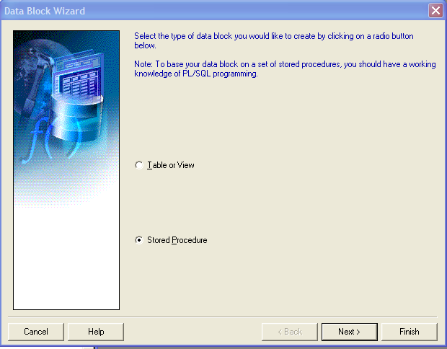
  - Enter: SCOTT.EMPLOYEE.EMP_SELECT in the Procedure field and click on the Refresh button.
    - Click the “Select All” button to select and move all of the columns listed in the “Available Columns” section to the “Database Items” section.
    - Click the Next button.
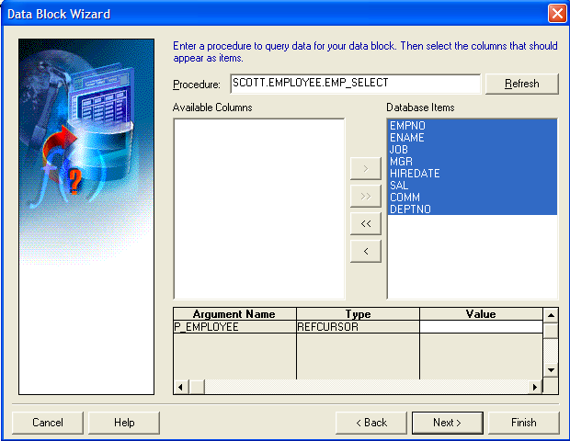

  - In the “Insert” screen, enter “SCOTT.EMPLOYEE.EMP_INSERT” in the Procedure field and click the “Refresh” button. Then Click Next.
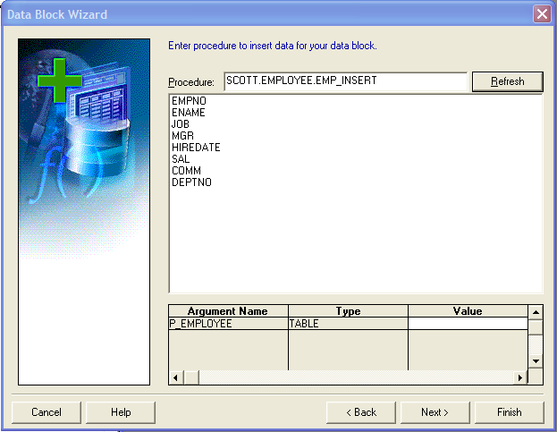
  - Enter “SCOTT.EMPLOYEE.EMP_UPDATE”, “SCOTT.EMPLOYEE.EMP_DELETE” and “SCOTT.EMPLOYEE.EMP_LOCK” in the following wizard screens.
  - In the Data Block Name: Field enter “EMPLOYEE” and click next.
  - Leave the “Create the data block, then call the Layout Wizard” option selected and then click on Finish.
  - Now you are in the Layout Wizard.
    - Leave the Canvas and Type properties at their default value and click on Next.
    - Select all items in the Data Block – Available Items screen by clicking on the “Select All” button and click Next.
    - For the purposes of this demo, leave the default Prompt, Width and Height values and click Next.
    - Select the “Tabular” radio button and click Next.
    - Enter “Employee” in the Frame Title, 5 in the Records Displayed and check the “Display Scrollbar” checkbox and click Next.
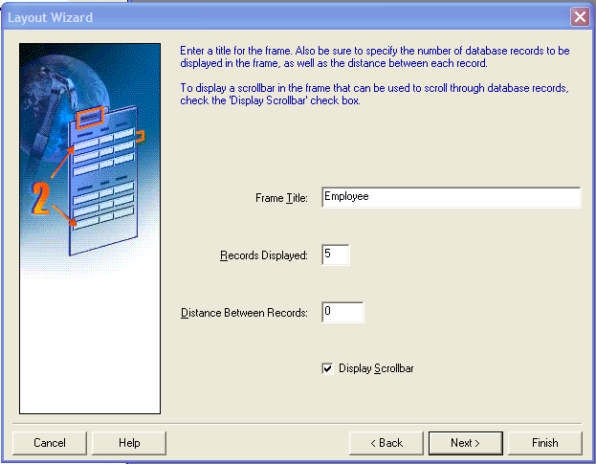
    - Click “Finished” and you are done!
    - This process will have created the following objects in the Forms Object Navigator.
      - EMPLOYEE Block
        - BLOCK triggers:
          - INSERT-PROCEDURE
          - UPDATE-PROCEDURE
          - DELETE-PROCEDURE
          - LOCK-PROCEDURE
        - BLOCK ITEMS:
          - EMPNO
          - ENAME
          - JOB
          - MGR
          - HIREDATE
          - SAL
          - COMM
          - DEPTNO

      - CANVAS and related FRAME graphic.
  - Lastly, we need to create a Form Level On-Error trigger to capture any potential database errors during Insert, Update and Delete processing. Because these processes are handled in the database and not in the form, if an error occurs it will be reported through the DBMS_ERROR_CODE and DBMS_ERROR_TEXT variables instead of the default ERROR_CODE and ERROR_TEXT variables. Forms will not display the DBMS_ERROR_CODE or TEXT messages by default so we have to ensure the On-Error trigger will.
    - Click on the Form level Triggers node and click on the Add (+) button.
      - Select On-Error from the list of triggers
      - Add the following ‘Basic” code.

BEGIN
IF ( ERROR_CODE = 40735 ) THEN
Message(DBMS_ERROR_TEXT);
Message(DBMS_ERROR_TEXT);
ELSE
Message(ERROR_TEXT);
Message(ERROR_TEXT);
END IF;
END;

The key to this whole process is the database stored procedure. This method requires the use of a PL/SQL table of records to work. The second key process is the use of the data block wizard. By using the wizard, you ensure all of the required properties are configured correctly.

