Author: Craig J. Butts

Title: Record Group Processing in Oracle Forms

Version: 2.0

Forms Versions: 6i and higher

The purpose of this document and the accompanying Forms Program Unit (package) is to provide Forms developers an easy to use API to the Record Group Built-ins supplied with Oracle Forms.

Why would you use Forms Record Groups? There are many reasons; multiple selections in a Forms list, in-form duplicate record checking (no trip to the database to check for duplicates), and the list goes on.

The example listed later demonstrates duplicate record checking and should give you the basics you need to expand the use of these methods to perform multiple selections or any other action where you need to track the rows in a multi-record block.

The following Forms package contains a collection of methods designed to quickly add, remove, find and update data in a multi-record data block.

Package Name: Rec_Group
Package Members: rg_name (package variable)
prev_value (package variable)
initialize (function)
add_value (function)
get_value (function)
get_number (function)
get_count (function)
delete_value (function)
remove_group (procedure)
add_rg (function)

Methods Descriptions
Variables
- rg_name – package variable used to store the name of the Record Group.
- prev_value – package variable used to store each item’s previous value. Used for comparison or duplicate checking.

Functions
- initialize - This FUNCTION initializes a Forms Record Group (the equivalent of creating an empty array) so it is ready to store values
- add_value – This FUNCITON adds a value to the Record Group at the specified row number and returns a Boolean TRUE or FALSE if the Add was successful
- get_value - This FUNCTION returns the value in the record specified
- get_number – This FUNCTION returns the number where a specified value was found in the record group
- get_count – This FUNCTION returns the number of records in the record group
- delete_value – This FUNCTION returns the record number where the specified value was found and deleted or returns zero (0) if the value was not found

Procedures
- remove_group – this PROCEDURE simply removes the specified record group from memory

It should be noted that it is assumed that you will also have a densely populated record group versus a sparsely populated record group. In other words, there will be no blank or null elements in your record group. For example:

Densely Populated |  | Sparsely Populated
Element 1 | Value 1 | Element 1 | Value 1
Element 2 | Value 2 | Element 2 | NULL
Element 3 | Value 3 | Element 3 | Value 2
Element 4 | Value 4 | Element 4 | Value 3

Example of Duplicate Record checking with record groups

The following example will demonstrate how you can check for duplicate records in a multi-record data block. This method is helpful when you have uncommitted rows displayed in a multi-record data block and you need to ensure there are no duplicates. This method is the equivalent of looping through the data block and comparing each value – which can be extremely slow if you have a lot of records in your block.

This example tracks entries in a table to Reports that are available in an application. Each report must have a unique id (REPORT_ID).

I have included all of the code in the zip file to create all of the objects used in this example. For this example, I have created the table: REPORTS_LIST (see “cr8_ins_reports_list.sql” script) which is described as:
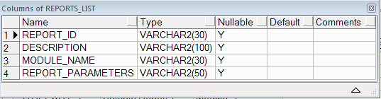

This table contains a list of Report IDs, a description of the report, the report module the report is assigned too (allows grouping of like reports) and any parameters associated with the report file.

The REC_GROUP.fmb Form has all of the objects needed to implement this example. I will walk you through creating all of the necessary objects used in this example.

First, create the REPORTS_LIST table in the schema of your choice. You can use the table description above to create your own CREATE TABLE script or you can use the provided “cr8_ins_reports_list.sql” script file which will create the table and populate it with 140 sample records. The schema is not defined in this script so ensure you are logged in as the user who will own this object or modify the script to specify the owner/schema.

Next, I’ll walk you through creating the form and all of it’s objects.

Forms Objects
- Open Oracle Forms Builder.
- Create a new form and save it as “REC_GROUP.fmb”
- Create a Canvas and rename it to “MAIN”.
- Create a Data Block using the data block wizard and select the REPORTS_LIST table.
  - Let the data block wizard call the layout wizard and select a tabular layout. We will use most of the default properties set by the wizard.
  - The Layout Wizard will enclose the REPORTS_LIST items in a Frame object. Open the Property Pallet for the frame and change the following properties:
    - Update Layout = Manually
    - X Position = 8
    - Y Position = 72
    - Width = 542
    - Height = 237
    - Frame Title = Report List
  - Open the Property Pallet for the REPORTS_LIST block and set the following properties for the items listed:
    - REPORT_ID
      - X Position = 16
      - Y Position = 90
      - Width = 75
    - DESCRIPTION
      - X Position = 91
      - Y Position = 90
      - Width = 180
    - MODULE_NAME
      - X Position = 271
      - Y Position = 90
      - Width = 75
    - REPORT_PARAMETERS
      - X Position = 346
      - Y Position = 90
      - Width = 180
- Create a second data block. This will be a Control Block that will hold the non-base table objects.
  - Click on the Data Blocks node of the navigator and click the Add button (the green plus button in the navigator tools pallet) and select the “Build a new data block manually” option.
  - Set the following properties of the Control block.
    - Name = CONTROL
    - Database Data Block = NO
  - Now click on the “Items” node in the CONTROL block and click the Add button to add 6 Text-Items to the Control block. Change the text-item Properties as follows:
    - Item 1
      - NAME = RG_SEARCH
      - Maximum Length = 50
      - Database Item = NO
      - Canvas = MAIN
      - X Position = 64
      - Y Position = 15
      - Width = 125
      - Height = 14
      - Prompt = RG Search
    - Item 2
      - Name = BTN_RG_SEARCH
      - Item Type = Push Button
      - Label = GO
      - Canvas = MAIN
      - X Position = 190
      - Y Position = 15
      - Width = 25
      - Height = 14
    - Item 3
      - Name = ROW_SEARCH
      - Maximum Length = 50
      - Database Item = No
      - Canvas = MAIN
      - X Position = 64
      - Y Position = 31
      - Width = 125
      - Height = 14
    - Item 4
      - Name = BTN_ROW_SEARCH
      - Item Type = Push Button
      - Label = Go
      - Canvas = MAIN
      - X Position = 190
      - Y Position = 31
      - Width = 25
      - Height = 14
    - Item 5
      - Name = RG_COUNT
      - Data Type = Number
      - Database Item = NO
      - Canvas = MAIN
      - X Position = 312
      - Y Position = 48
      - Width = 68
      - Height = 14
    - Item 6
      - Name = BTN_GET_RG_COUNT
      - Item Type = Push Button
      - Label = Get RG Count
      - Canvas = MAIN
      - X Position = 190
      - Y Position = 46
      - Width = 82
      - Height = 16
- Click on the Program Units node of the Navigator and then click on the Green Plus/Add button to add a new program unit.
  - Select “Package Spec” and name the object “REC_GROUP”.
  - Copy the Package Specification code from the “rec_group.pks” file and paste it into the Package Spec editor.
  - Compile and close the editor.
- Now create the corresponding Package Body.
  - Name the object “REC_GROUP”
  - Copy the Package Body code from the “rec_group.pkb” file and paste in into the Package Body editor.

Now that all of the primary objects are created we need to add the code.

1. Form Level – When-New-Form-Instance
The purpose of this trigger is simply to name the record group (RG) and create it in memory so it can be used. This does not have to occur in this trigger, you simply need to ensure you have created the RG before you try to assign a value to the RG or you will receive an error.

DECLARE
bIgnore BOOLEAN := FALSE;
BEGIN
--Name the Record Group.
Rec_Group.rg_name := 'RPT_LIST';

--Initialize the RG. No harm is done if the RG already exists.
bIgnore := rec_group.initialize(Rec_Group.rg_name);

Go_Block('REPORTS_LIST');
execute_query;
END;

These next triggers must occur at the data block where values will be assigned to the RG.

REPORTS_LIST Block
When-Remove-Record – This trigger ensures any row removed from the data block is also removed from the RG.

DECLARE
ignore NUMBER;
BEGIN
-- Remove the Current Record from the Record Group (No DML occurs).
ignore := rec_group.delete_value(Rec_Group.rg_name,
:reports_list.report_id);
END;

Post-Query – This trigger ensures each row displayed in the data block as the result of an Execute_Query is added to the RG.
Note: I use “Named Notation” in this example. This is not required, but helps to self-document the code.

DECLARE
bIgnore BOOLEAN := FALSE;
BEGIN
--Add a record to the Record Group.
bIgnore := rec_group.add_value(p_name=>Rec_Group.rg_name,
p_value=>:reports_list.report_id, p_record=>:system.trigger_record);
END;

Now we move the Item-Level triggers. This code needs to be added to each Item that will be checked for duplicates. In this example, the REPORT_ID column is the key column so all records must be unique.

REPORT_ID Text-Item

When-New-Item-Instance – records the current value of the item before any change is made. This value will be used for comparison in the When-Validate-Item trigger later.

BEGIN
-- Records the previous value of the item so we can
-- Easily check to see if the value has been changed.
Rec_Group.Prev_Value := :DETAIL.Key;
END;

When-Validate-Item – this is the primary work horse of this method. In this trigger you will compare the current value with the previous value, check for and report any if a duplicate value is found, update the record group if the value has changed and add a value if there was no previous value.

DECLARE
ignore NUMBER;
bIgnore BOOLEAN;
BEGIN
IF ( :REPORTS_LIST.report_id IS NOT NULL ) THEN
-- Check for Duplicates first
ignore := Rec_Group.Get_Number(Rec_Group.rg_name,
:REPORTS_LIST.report_id);

IF ( ignore > 0 ) THEN
-- Duplicate found!
Message('Value: '||:REPORTS_LIST.report_id
||' already exists!',ACKNOWLEDGE);
RAISE Form_Trigger_Failure;
ELSE
-- Check if the value has changed
IF ( Rec_Group.Prev_Value != :REPORTS_LIST.report_id ) THEN

-- The value of the KEY has changed so we
-- need to delete the old value
-- before we insert the new value
ignore := 0; -- reset our variable.
ignore := Rec_Group.Delete_Value(Rec_Group.rg_name,
Rec_Group.Prev_value);
END IF;

bIgnore := Rec_Group.Add_Value(Rec_Group.rg_name,
:REPORTS_LIST.report_id,
:SYSTEM.Trigger_Record);
END IF;
END IF;
END;

Now we’ll add the Search and count items to the Control Block. Click on the Control Block in the object navigator and add 6 Text-Items to the block. Select each item and change their properties as follows:

Item 1
- Name = RG_SEARCH
- Maximum Length = 50
- Database Item = No
- Canvas = Main
- X Position = 64
- Y Position = 15
- Width = 125
- Height = 14
- Prompt = RG Search

Item 2
- Name = BTN_RG_SEARCH
- Item Type = Push Button
- Label = GO
- Canvas = MAIN
- X Position = 190
- Y Position = 15
- Width = 25
- Height = 14

Item 3
- Name = ROW_SEARCH
- Maximum Length = 50
- Database Column = NO
- Canvas = MAIN
- X Position = 64
- Y Position = 31
- Width = 125
- Height = 14
- Prompt = Row Search

Item 4
- Name = BTN_ROW_SEARCH
- Item Type = Push Button
- Canvas = MAIN
- X Position = 190
- Y Position = 31
- Width = 25
- Height = 14

Item 5
- Name = RG_COUNT
- Data Type = Number
- Canvas = MAIN
- X Position = 312
- Y Position = 48
- Width = 68
- Height = 14

Item 6
- Name = BTN_GET_RG_COUNT
- Label = Get RG Count
- Canvas = MAIN
- X Position = 190
- Y Position = 46
- Width = 82
- Height = 16

Now let’s add the code for the buttons and you will be ready to run your form for the first time.

BTN_RG_SEARCH
DECLARE
nRec NUMBER;
BEGIN
IF (:control.rg_search IS NOT NULL ) THEN
nRec := rec_group.get_number(Rec_Group.rg_name,
:control.rg_search);
IF ( nRec > 0 ) THEN
GO_BLOCK('REPORTS_LIST');
go_record(nRec);
ELSE -- Not Found
Message('The entered value "'||:control.rg_search
||'" was not found.',ACKNOWLEDGE);
END IF;
END IF;
END;
BTN_ROW_SEARCH
BEGIN
IF ( :control.row_search IS NOT NULL ) THEN
GO_BLOCK('REPORTS_LIST');
First_Record;
WHILE ( :system.last_record != 'TRUE' ) LOOP
IF (:reports_list.report_id = :control.row_search ) THEN
EXIT;
ELSE
NEXT_RECORD;
END IF;
END LOOP;
END IF;
END;

BTN_GET_RG_COUNT
DECLARE
row_count NUMBER;
BEGIN
Message('RG_NAME = '||Rec_Group.rg_name,ACKNOWLEDGE);
row_count := Rec_Group.get_count(Rec_Group.rg_name);
:control.rg_count := row_count;
END;

When you are finished, here is what the Object Navigator should look like.

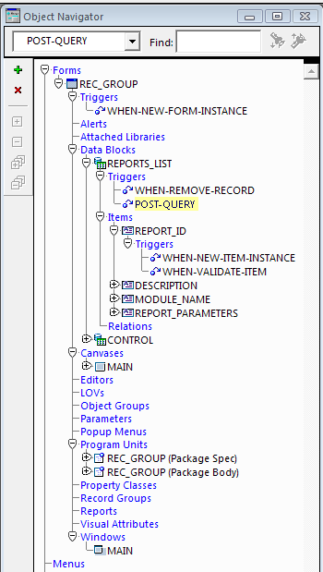

Here is a screen shot of the Canvas editor and a brief description of a few items:

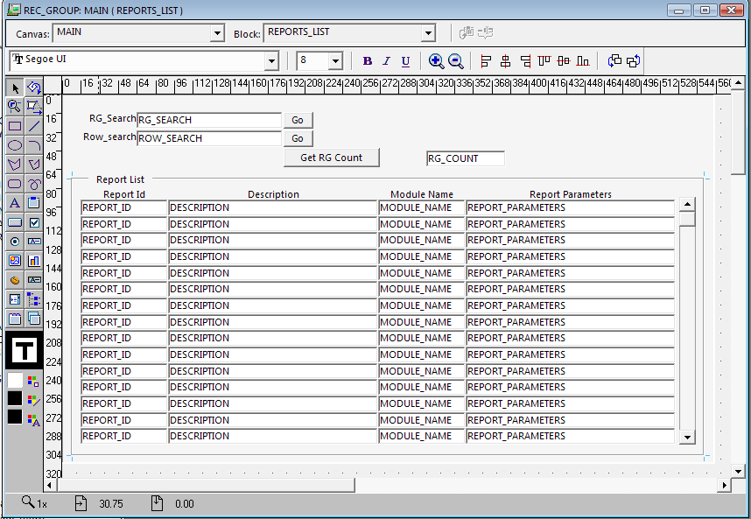

RG_Search – This item allows a user to Search the Record Group for a given Report_ID when the adjacent “GO” button is clicked. This is the fastest search option as the code in the GO button makes a simple call to the Rec_Group.

Row_Search – This item allows a user to Search the multi-record block for a given Report_ID when the adjacent “GO” button is clicked.

Here is a screen shot of what the Form looks like when run:

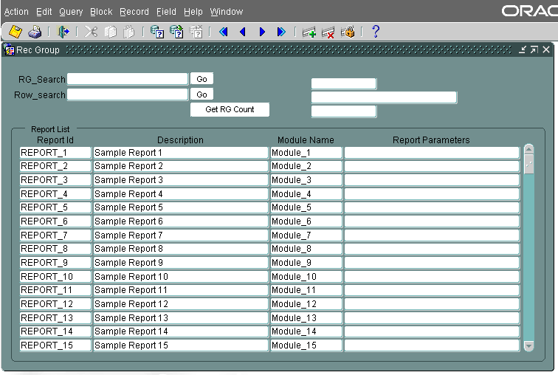

In this screen shot, notice that I have attempted to add a new record by pressing the “Ctrl + Down Arrow” to insert a new row and I am attempting to add the new value “REPORT_2.” Notice the error message listed in the Status Bar.

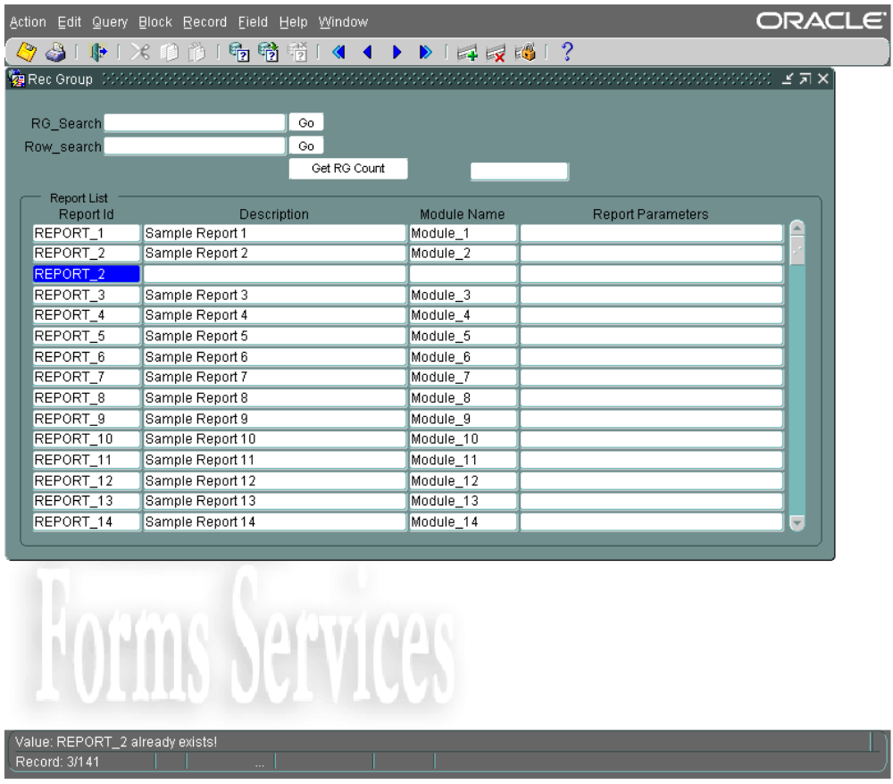

This next example demonstrates the Search feature of the Form. The screen shot displays the Record Group search. By entering the criteria in the RG_Search field and clicking on the GO button, the code in the When-Button-Pressed trigger will search the record group and immediately move the cursor to the record found by the call to the Rec_Group.Find_Number package function. Due to the number of records in this example, this search appears to be just as fast as the Row Search option, which starts at the first record of the REPORTS_LIST block and navigates one-by-one to each record until a match is found. On a smaller data set, there is no performance gain by using a Record Group for searching a block for a key value, but when the data set is large (more than 1000 rows) the benefits are substantial.

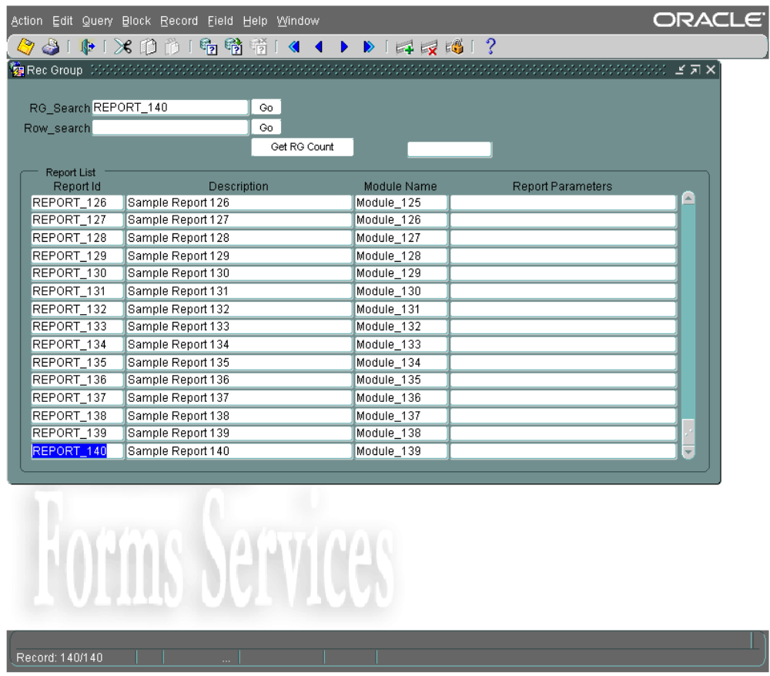

This is a very basic example of how to use a Record Group to test for duplicate records. Record Groups are also useful for implementing multiple selections in a List Item or multi-record block.

