**Saving On Device**

**How saving works ?**

SaveManager has a SavableAsset array where I put all the ScriptableObjects which has any data to save (as PlayerData or any Data derived from SavableAsset). StringHolder has the Key-JSons of the assets. When I request saving from SaveManager it saves the Stringholders JSon.

StringHolders List has only assets which has been modified.You dont need to save all SavableAssets if they have default values.

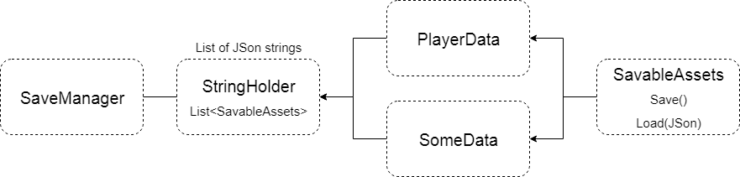

Windows saving directory:

C:\Users\YourPcName\AppData\LocalLow\DefaultCompany\ProjectName

This saves a Binary formatted file which is not that easy to modify as text files.

**How it works in our Scene ?**

When we click the "++" or "--" buttons we update the PlayerDatas health variable and then we request saving from SaveManager which saves every savable asset as JSon. SaveManager has a list of all savable assets (like PlayerData or any asset which has something to save).

