**System Requirements Statement (SRS) –**

**E-Car Rental System**

Doc. Ref. :

Version : 0.4

Status : Drafted

Created by : Kenji Tanaka

Date : 02-Dec-2020

1. Introduction 3

2. Functional Requirements Error! Bookmark not defined.

2.1 Customer Module 5

2.2 Car Owner Module 11

2.3 admin Module 17

2.4 message acknoeledgement Module 21

2.5 Use Case Diagram.............................................................................................................................22

* **Introduction**

This document explains the system requirements and scope for developing e-Car Rental System.

Car Rental System could divide the four main parts, Customer part, Car Owner part, Admin part and the Acknowledgement part.

This document describes the system requirement of the Account part.

**Functional Requirements**

The Account part of E-Car Rental System has three modules which are divided into processes described as below.

|  |  |  |
| --- | --- | --- |
| **No** | **BRS requirement ID** | **Description** |
| **2.1** | **Customer Module** | |
| **2.1.1** | **F1** | **Account Creation Process** |
| **2.1.2** | **F2** | **Login Process** |
| **2.1.3** | **F3** | **Forgot Password Process** |
| **2.1.4** | **F4** | **Change Password Process** |
| **2.1.5** | **F5** | **Update Account Process** |
| **2.1.6** | **F6** | **Number of Persons** |
| **2.1.7** | **F7** | **Search Cars** |
| **2.1.8** | **F8** | **Pick up point and Destination** |
| **2.1.9** | **F9** | **Payment, Promo code and Referral code** |
| **2.1.10** | **F10** | **History of Bookings** |
| **2.1.11** | **F11** | **Cancel Trip** |
| **2.2** | **Car Owner Module** | |
| **2.2.1** | **F12** | **Account Creation Process** |
| **2.2.2** | **F13** | **Login Process** |
| **2.2.3** | **F14** | **Forgot Password Process** |
| **2.2.4** | **F15** | **Change Password Process** |
| **2.2.5** | **F16** | **Update Account Process** |
| **2.2.6** | **F17** | **Car History** |
| **2.2.7** | **F18** | **Number of Trips and Kilometres Travelled** |
| **2.2.8** | **F19** | **Any Damage** |
| **2.2.9** | **F20** | **Upcoming Trips** |
| **2.3 Admin Module** | | |
| **2.3.1** | **F21** | **Login Process** |
| **2.3.2** | **F22** | **Forgot Password Process** |
| **2.3.3** | **F23** | **Change Password Process** |
| **2.3.4** | **F24** | **Update Account Process** |
| **2.3.5** | **F25** | **Report Generation** |
| **2.3.6** | **F26** | **Account Management** |
| **2.4 Message Acknowledgement Module** | | |
| **2.4.1** | **F27** | **Sends Messages of Acknowledgement** |

* 1. **Customer Module**
* Customer is the user of system who wants to rent the car.
* Customer is also able to view the car which are available for renting.

**2.1.1 Account Creation Process**

* E-Car Rental System compels to create the account before using it. So, E-Car Rental System should provide the function which makes customer creates new account.
* When customer creates new account, the function demands two

information described as below.

* Login information
* Contact Details
* The Login information

The Login information consists of some items described as below.

* UserID
* Password
* First Name
* Last Name
* E-mail address
* User Type
* All items are compulsory demanded.
* UserID
* The UserID should be unique. If the UserID correspond with not case-sensitive to other which is previously registered, the UserID should not be registered as an account.
* Password
* The Password has constrains which makes the Password consists of more than or equal 8 and less than or equal 16 characteristics including characters described as below.
* Numeric figure (at least one)
* Capital alphabet (A-Z)(at least one)
* Small alphabet (a-z)(at least one)
* Special character (#, $, %, &, etc.) (at least one)
* The Password is masked by dummy characters. The re-entering Password is demanded.
* The Password must be encrypted in E-Car rental System.
* User Type

The User Type falls into three categories described as below.

* Customer
* Car Rental Owner
* Administrator
* The User Type defines also three types of user; "Customer user", "Car Rental user", and "Administrator user”.
* In an Account Creation Process, the user can select Customer.
* No one could select The Administrator, because Administrator is implemented to e- Car Rental System in advance.
* Contact Details
* The Contact Detail consists of some items described as below.
* Permanent Address
* Contact Phone No
* All items are compulsory demanded.
* Permanent Address
* Permanent Address should be filled.
* But only the state should be selected from options.
* The Security Question information

The Security Question information is needed when customer lost their Password. This information consists of two items described as below.

* Selected Question
* Answer
* All items are compulsory demanded.
* Some questions which are difficult to answer for anyone else are prepared in advance.

E.g. which color do you like most?

* A question should be selected from options by the customer, and the Answer is registered by the Customer.
* Login information should be entered on one screen, and then customer information and Security Question information should be entered on another screen.

**2.1.2 Login Process**

* E-Car Rental System always compels user authentication before using itself except when a new account is successfully created.
* The user authentication demands UserID and Password. The UserID and the Password should be checked in three ways.
* First, The UserID and the Password should be existed and correct.
* If The UserID and the Password are not equal to what the user has registered, the user authentication cannot be provided.
* Second, the User Type linked to the UserID should be "Customer".
* When the User Type is "Customer", then user can be placed on “Customer Home”.
* Finally, UserID should be available.
* The Administrator can decide whether the UserID is available or suspended – Refer to the SRS of the Admin part.
* If customer is rejected, user authentication is not provided for system user.
* The Customer account should alive for so long as the duration decided by Admin.
* Only when the three checks are successfully completed, customr can be placed on respected page.
* The “Customer Home” provides some items described as below.
* A trigger to logout
* A trigger to update Account
* A trigger to Change Password
* A trigger to Search car
* A trigger to Pick up point and Destination
* A trigger to Payment, Promo code and Referral code
* A trigger to history of Booking
* A trigger to cancel trip

**2.1.3 Forgot Password Process**

* When system user lost their Password, the recovery method should be provided by e- Car Rental system.

The recovery method is described as below.

* First, system user enters their UserID for e-Car Rental System.
* Next, E- Car Rental System demands the Answer which has been registered since when the Account was created.
* Only when the Answer is correct, customer get the new password by E-mail which also has been registered since when the Account was created.
* The new password is automatically generated by e- Car Rental System.
* Of course, the new password should consist of more than or equal 8 and less than or equal 16 characteristics including at least a numeric figure, a capital alphabet, a small alphabet, and a special character.
* As a consequence, The Customer could get the customer authentication using the new password.
* Then, the customer had better change the new password manually.
* If the Answer is not correct, otherwise, the correct Answer is demanded for user again.
* In that case, Of course, customer couldn’t get the new password.

**2.1.4 Change Password Process**

* When customer wants to change their Password, the measure should be provided by e- Car Rental System.
* Therefore, E- Car Rental System should provide the function which is available after getting the customer authentication.
* The function demands the current password and the new password.
* Of course, the new password should consist of more than or equal 8 and less than or equal 16 characteristics including at least a numeric figure, a capital alphabet, a small alphabet, and a special character.
* The current password and the new password are masked by using dummy characters.
* The new password is demanded to enter twice to avoid a typing error.
* Only when the current password is correct, customer could change their Password.
* When the current password is changed into new password, E-Car Rental System compels user authentication again.

**2.1.5 Update Account Process**

* E- Car Rental System should provide the function which makes the account updated for customer.
* The information customer could update is described below.
* Login information
* User information
* Security Question Information
* The Login information

The updatable items as described below.

* First Name
* Last Name
* E-mail address
* All items are compulsory demanded, but updating is optional.
* The User information

The updatable items as described below.

* User Name
* User Phone No
* E-mail address
* Permanent address
* All items are compulsory demanded, but updating is optional.
* The Security Question information

The updatable items as described below.

* Selected Question
* Answer
* All items are compulsory demanded, but updating is optional

**2.1.6 Number of Person**

* Number of people are described as below
* How many person

**2.1.7 Search Car**

* Search conditions are described as below.
* View the car
* Price range
* Popular car
* Car Brand

**2.1.8 Rent Car**

* Rent Car are described as below.
* The car
* Price
* Car Brand
* Photo
* Pickup point
* Destination point
* Date and time

**2.1.9 Payment, Promo code and Referral code**

* Select the preferred payment method and receive a confirmation email.

**2.1.10 History of Booking**

* Customer could see the information of existing products.

**2.1.11 Cancel Order**

* After ordering if customer wants to cancel the order then he can cancel the order.

#### Car Owner Module

### 2.2.1 Account Creation Process

* E-Car Rental System compels to create the account before using it. So, E-Car Rental System should provide the function which makes car owner creates new account.
* When car owner creates new account, the function demands four information described as below.

1. Login information

2. Contact Details

3. Security Question Information

4. Payment information.

* The Login information

The Login information consists of some items described as below.

1. User ID

2. Password

3. First Name

4. Last Name

5. E-mail address

6. User Type

* + All items are compulsory demanded.
  + User ID
* The User ID should be unique. If the User ID correspond with not case-sensitive to other which is previously registered, the User ID should not be registered as an account.
  + Password
* The Password has constraints which makes the Password consists of more than or equal 8 and less than or equal 16 characteristics including characters described as below.

1.Numeric figure (at least one)

2.Capital alphabet (A-Z)(at least one)

3.Small alphabet (a-z)(at least one)

4.Special character (#, $, %, &, etc.) (at least one)

* The Password is masked by dummy characters. The re-entering Password is demanded.
* The Password must be encrypted in e-rental car System.
  + User Type

The User Type falls into three categories described as below.

1.Customer

2.Car Rental Owner

3.Administrator

* The User Type defines also three types of user; " Customer user", "Car Rental user", and "Administrator user”.
* In an Account Creation Process, the user can select Rented Cars.
* No one could select The Administrator, because Administrator is implemented to e-Car Rental System in advance.
* Contact Details
* The Contact Detail consists of some items described as below.

1.Permanent Address

2.Contact Phone No

* + All items are compulsory demanded.
  + Permanent Address
* Permanent Address should be filled.
* But only the state should be selected from options.
* The Security Question information

The Security Question information is needed when Wholesaler lost their Password. This information consists of two items described as below.

1. Selected Question
2. Answer
   * All items are compulsory demanded.
   * Some questions which are difficult to answer for anyone else are prepared in advance.

E.g. which color do you like most?

* + A question should be selected from options by the Car Renter, and the Answer is registered by the Car Renter.
* Login information should be entered on one screen, and then car owner information and Security Question information should be entered on another screen.

### Login Process

* E-rental car System always compels owner authentication before using itself except when a new account is successfully created.
* The user authentication demands UserID and Password. The UserID and the Password should be checked in three ways.
  + First, The UserID and the Password should be existed and correct.
* If The UserID and the Password are not equal to what the user has registered, the user authentication cannot be provided.
  + Second, the User Type linked to the UserID should be "user".
* When the User Type is " owner ", user can be placed on “owner’s Homepage”.
  + Finally, UserID should be available.
* The Administrator can decide whether the UserID is available or suspended – Refer to the SRS of the Admin part.
* If user is rejected, user authentication is not provided for car owner.
* The owner’s account should alive for so long as the duration decided by Admin.
* Only when the three checks are successfully completed, owner can be placed on respected page.
* The “owner’s Homepage” provides the some items described as below.

1. A trigger to logout
2. A trigger to update Account
3. A trigger to Change Password
4. A trigger to Search Product
5. A trigger to Publish Product for sale
6. A trigger to Update Product Information
7. A trigger to Delete Product
8. A trigger to Browse existing Market price

### Forgot Password Process

* When owner lost their Password, the recovery method should be provided by e-rental car system.

The recovery method is described as below.

* + First, owner enters their User ID for e-rental car System.
  + Next, E-rental car System demands the Answer which has been registered since when the Account was created.
  + Only when the Answer is correct, owner get the new password by E-mail which also has been registered since when the Account was created.
  + The new password is automatically generated by e-rental car System.
* Of course, the new password should consist of more than or equal 8 and less than or equal 16 characteristics including at least a numeric figure, a capital alphabet, a small alphabet, and a special character.
* As a consequence, the owner could get the user authentication using the new password.
  + Then, the owner had better change the new password manually.
* If the Answer is not correct, otherwise, the correct Answer is demanded for owner again.
  + In that case, Of course, owner couldn’t get the new password.

### Change Password Process

* When owner wants to change their Password, the measure should be provided by e-rental car System.
* Therefore, E-rental car System should provide the function which is available after getting the owner authentication.
* The function demands the current password and the new password.
  + Of course, the new password should consist of more than or equal 8 and less than or equal 16 characteristics including at least a numeric figure, a capital alphabet, a small alphabet, and a special character.
  + The current password and the new password are masked by using dummy characters.
  + The new password is demanded to enter twice to avoid a typing error.
* Only when the current password is correct, owner could change their Password.
* When the current password is changed into new password, E-rental car System compels owner authentication again.

### Update Account Process

* E-rental car System should provide the function which makes the account updated for owner.
* The information owner could update is described below.

1. Login information

2. User information

3. Security Question Information

* The Login information

The updatable items as described below.

1. First Name
2. Last Name
3. E-mail address
   * All items are compulsory demanded, but updating is optional.

* The User information

The updatable items as described below.

1. User Name
2. User Phone No
3. E-mail address
4. Permanent address
   * All items are compulsory demanded, but updating is optional.

* The Security Question information

The updatable items as described below.

1. Selected Question
2. Answer
   * All items are compulsory demanded, but updating is optional.

### Car History

It contains all travel history of the car like at which city it stays for how much time, which area it takes more rounds and also how much time use the application.

It contains traffic fines and amount of money spent on the car.

This module represents ratings and queries about the car and car owner simultaneously.

Customer can give ratings about the time management, safety and also about cleanliness of the car.

### Number of Trips and Kilometres Travelled

This module contains the capacity of the car per hour or per day and also, we take the mileage limit of the car etc.

### Any Damage

We take this module as a mandatory about the car.

If there is any accident history, Damage history, parts changed history.

also, about servicing history by renowned cleaning garages for background verification.

### Upcoming Trips

It is about feature plans of the car.

If the car owner is planning to car state permit or national permit for travelling.

**2.3 Admin Module**

**•** Administratorshould be responsible for following activities**,**

* + 1. **Login Process**
* E-Car Rental System always compels user authentication before using itself except when a new account is successfully created.
* The user authentication demands UserID and Password. The UserID and the Password should be checked in three ways.
* First, The UserID and the Password should be existed and correct.
* If The UserID and the Password are not equal to what the admin has registered, the Admin authentication cannot be provided.
* Second, the User Type linked to the UserID should be "Admin".
* When the User Type is "Admin", user can be placed on “Admin Home”.
* Finally, UserID should be available.
* The Administrator can decide whether the UserID is available or suspended – Refer to t
* .0he SRS of the Admin part.
* If user is rejected, user authentication is not provided for system user.
* The Admin account should alive for so long as the duration decided by Admin.
* Only when the three checks are successfully completed, Admin can be placed on respected page.
* The “Admin Home” provides the some items described as below.
* A trigger to logout
* A trigger to update Account
* A trigger to Change Password
* A trigger to Search available Cars
* A trigger to Publish cars for rent
* A trigger to Update Car Information
* A trigger to remove cars
* A trigger to Browse existing car price
  + 1. **Forgot Password Process**
* When Admin lost their Password, the recovery method should be provided by e-car rental system.

The recovery method is described as below.

* First, Admin enters their UserID for e-Car Rental System.
* He will enter the E-mail id since when the Account was created.
* Only when the E-mail Id is correct, Admin get the new password by E-mail which also has been registered since when the Account was created.
* The new password is automatically generated by e- Car Rental System.
* Of course, the new password should consist of more than or equal 8 and less than or equal 16 characteristics including at least a numeric figure, a capital alphabet, a small alphabet, and a special character.
* As a consequence, The Admin could get the Admin authentication using the new password.
* Then, the Admin had better change the new password manually.
  + 1. **Change Password Process**
* When Admin wants to change his Password, the measure should be provided by e- Car Rental System.
* Therefore, E- Car Rental System should provide the function which is available after getting the Admin authentication.
* The function demands the current password and the new password.
* Of course, the new password should consist of more than or equal 8 and less than or equal 16 characteristics including at least a numeric figure, a capital alphabet, a small alphabet, and a special character.
* The current password and the new password are masked by using dummy characters.
* The new password is demanded to enter twice to avoid a typing error.
* Only when the current password is correct, Admin could change his Password.
* When the current password is changed into new password, E- Car Rental System compels user authentication again.
  + 1. **Update Account Process**
* E- Car Rental System should provide the function which makes the account updated for Admin.
* The information Admin could update is described below.
* Login information
* User information
* Security Question Information
* The Login information

The updatable items as described below.

* First Name
* Last Name
* E-mail address
* All items are compulsory demanded, but updating is optional.
* The User information

The updatable items as described below.

* User Name
* User Phone No
* E-mail address
* Permanent address
* All items are compulsory demanded, but updating is optional.
* The Security Question information

The updatable items as described below.

* Selected Question
* Answer
* All items are compulsory demanded, but updating is optional.
  + 1. **Record Generation**

• Admin should able to see all the records from any users.

• Daily report of enrolment to admin.

• Monthly report of enrolment as per the states to admin.

* + 1. **Accounts Management**

• Admin should able to manage all the accounts with following activities,

1. Enable accounts

2. Disable accounts

**2.4 Message Acknowledgement Module**

• In following conditions acknowledgement to be send

* After completion of successful registration.
* After every successful transaction (buy, sale).
* Now the messages are being sent by using email but in future we can have mobile sms.
* **2.5 Use Case Diagram**

**Admin:**

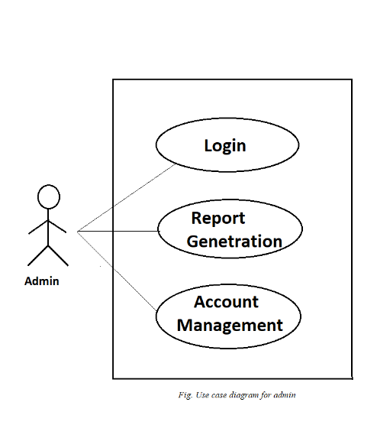

*Fig. Use case diagram for admin*

* In Admin use case diagram Admin is the Actor.
* Admin can handle following use cases:
* Login
* Report Generation
* Controls account

**Customer:**

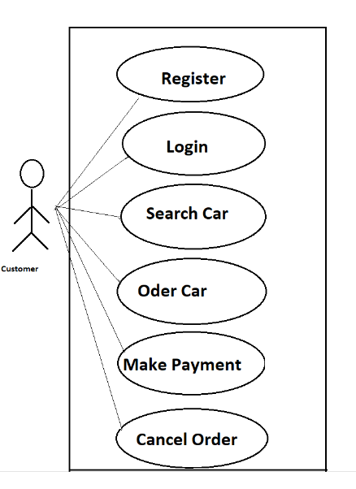

*Fig. Use case diagram for customer*

* In customer use case diagram customer is the Actor.
* Customer can handle following use cases:
* Register
* Login
* Search car
* Book car
* Make payments
* Cancel order

**Car owner:**

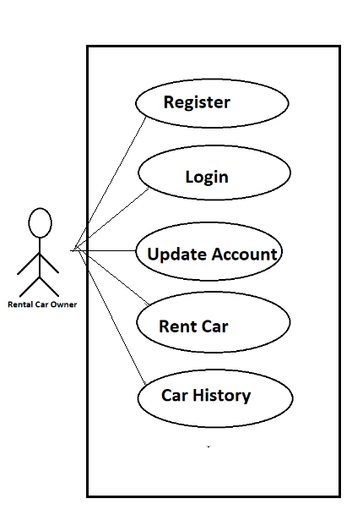

*Fig. Use case diagram for car owner*

* In car owner use case diagram car owner is the Actor**.**
* Car owner can handle following use cases:
* Register
* Login
* Update account
* Rent car
* Car history