|  |  |
| --- | --- |
| High School of Coding and Innovations | |
| **Theme:** String Program – Editing Text | |
| **Our Team:**  Пламен Петков 9г  Петър Стоев 9а  Вектор Кавалджиев 9в  Колян Йорданов 9б |

# Our Team

Name: Пламен Петков

Е-mail: PCPetkov18@codingburgas.bg

Name: Петър Стоев

Е-mail: PKStoev18@codingburgas.bg

Name: Виктор Кавалджиев

Е-mail: VGKavaldzhiev18@codingburgas.bg

Name: Калоян Йорданов

Е-mail: KYAYordanov18@codingburgas.bg

1. Table

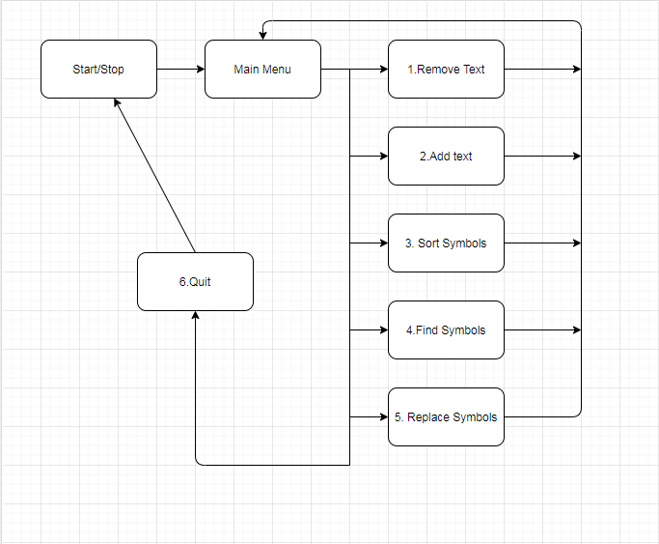

1. Table content
   1. Main Menu
      1. Remove Text
      2. Add Text
      3. Sort Symbols
      4. Find Symbols
      5. Replace Symbols
      6. Quit
2. About Us

We try to be as productive as possible we can to make the best program. We are trying to give everything we can from us. We are working hard to be the best.

1. 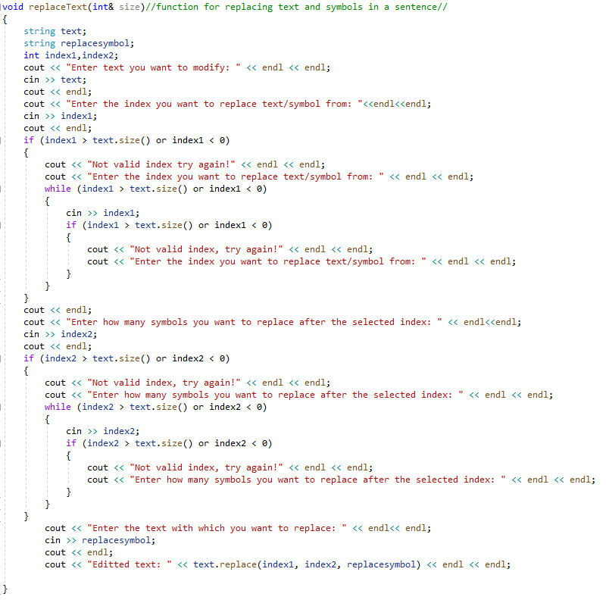void ReplaceText

This program is finding the sentence that you want by id. Then ask you “What do you want to change?” and when you type this what you want to replace it just replace it. Also it can replace text, symbols or letters. Everything you want to.

1. 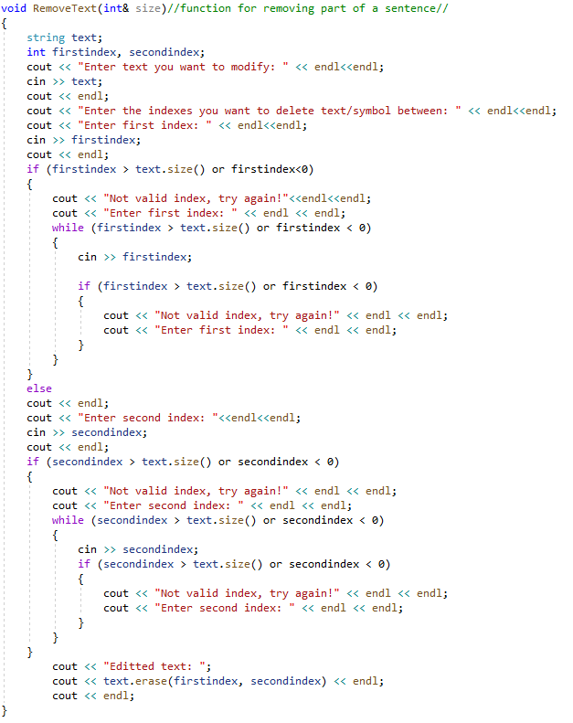void RemoveText

The “void RemoveText” program is removing text, letters, sentences or symbols that want to remove. You just have to write down the id in front of the text or sentence that you want to delete and the program is finding it by its ID.

1. 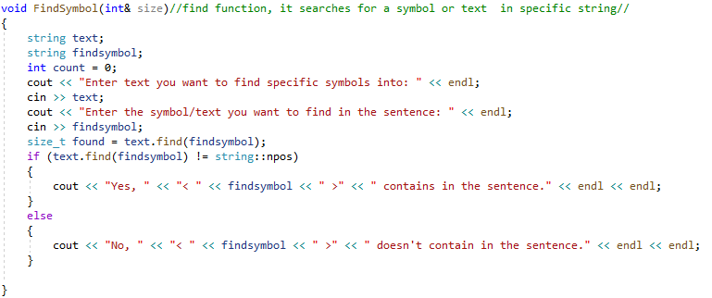void FindSymbol

This program is searching symbols or text by ID. Also it searching it by specific symbols. You just have to write down the id in front of the text.

1. 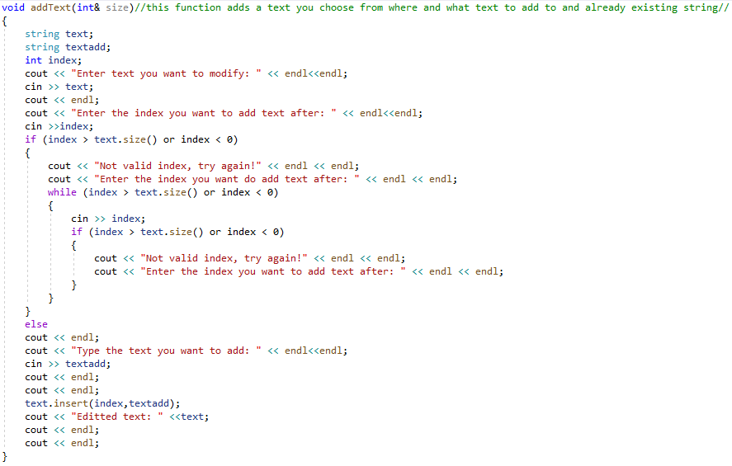void addText

This program is adding text just by the oldest one. Firstly the program is finding the text by ID then ask you “What do you want to add?” and then just added.

1. 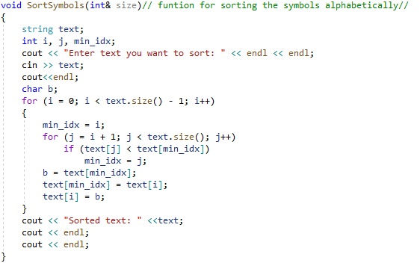 void SortSymbols

The “void SortSymbols” program is sorting text or symbols that you want. Firstly it just ask you to write the text that want to sort. Then just check the condition of the task and complete it. After that It just sort alphabetically.

1. 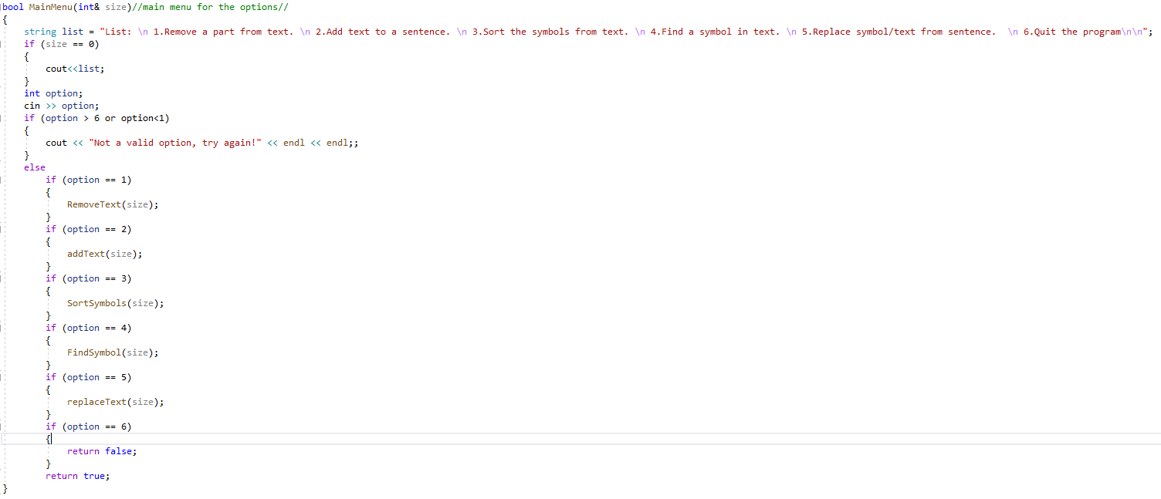bool MainMenu

This is the main menu which contain and display the main functions. Also all functions that we have got.