Data Engineer Application Assessment

Business Case:

Your exercise is to write a Python application that is capable of reading this hit level
data file and answer the client's question. Ideally the expectation is for the candidate
to use their own free tier AWS account to build and deploy this python code and
deployment scripts, additional documentation and results within a public Github
repository that needs to be shared as part of the exercise.

The Client's Question (Business problem):

How much revenue is the client getting from external Search Engines, such as Google, Yahoo and
MSN, and which keywords are performing the best based on revenue?

Development Requirements
1. Create a Python application that needs to be deployed and executed within AWS
2. The Python application needs to contain at least one class
3. The Python application needs to accept a single argument, which is the file that needs to be
processed.
Bonus Points: Unit test cases, serverless deployment scripts, Business problem presentation

Deliverable Requirements
The final output needs to be a tab delimited file with the following data points:
• Search Engine Domain (i.e. google.com)
• Search Keyword (i.e. "Laffy Taffy")
• Revenue (i.e. 12.95)

The final output also has the following requirements:
• A header row needs to be included. Use the above bulleted items for each column header,
minus the example.
• Sorted by revenue, descending, so the client can easily review which keyword is performing the
best.
• The output file should have the following naming convention:
[Date]_SearchKeywordPerformance.tab
[Date] corresponds to the date the application executed for
The format should be YYYY-mm-dd (i.e. 2009-10-08)

Approach:

1. Using AWS Lambda which gets triggered by S3 file drop event.

Architecture
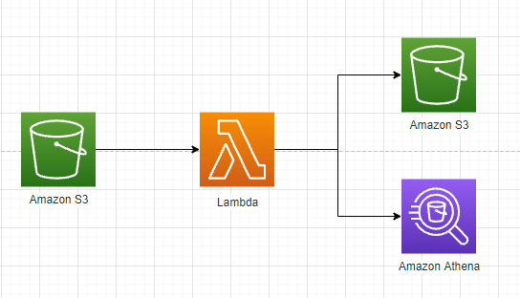

Description:

The above architecture depicts that once the file lands in S3 bucket, the AWS lambda would get triggered. The lambda reads the file from S3 bucket based on the context and event information from S3 event. It processes the data based on the business requirement, cleans, wrangles and converts into readable information in tab delimited format. The file would be written back to S3 bucket in tab delimited format and can also be exposed to Athena for querying.

Advantages:
1. Fast processing and event driven pipeline.
2. Suitable for near real time data processing of the file from S3.
3. Highly scalable and concurrent executions can be triggered. (1000)
4. Memory upto 10GB

Disadvantages:
1. Has a compute time limit of 15 min.
2. If size of the data is very huge, then it might timeout.
3. Not a service for ETL processing.

Approach 2:

2. Using Pyspark AWS Glue which reads data from the S3 bucket and processes the data using Spark on Aws Cluster and writes it back to S3 or expose it to Athena
Glue can be scheduled based on the need.

Architecture
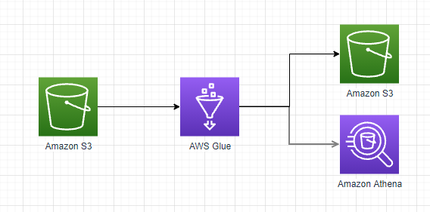

Description:
The above architecture depicts that AWS Glue, an ETL service provided by AWS reads the data from the S3 bucket and creates a table and database based on the data source. This process is called crawling. Here in this use case, the data source is the S3 bucket. Once the data store is created, based the Pyspark script, the data compute happens on Spark Cluster. The configurations can be changed based on the size of the input source. The script reads the data from the data store and does all the business logic to finally write the data back to S3 bucket which can be exposed to Athena for querying.

Advantages:
1. ETL processing capability.
2. Can scale based on the data size.
3. Can handle heavy data in Tbs or Petabytes.

Disadvantages:
1. Not as fast as Lambda
2. Can’t be used for near real time processing
3. Can’t be triggered directly from S3 event but using services like Lambda, can be triggered based on event
4. Spark script is required for processing.

Approach 3:
3. Using AWS EMR service similar to AWS Glue, reads the data from S3 and processes the data using Pyspark and writes the data back to S3.

Architecture

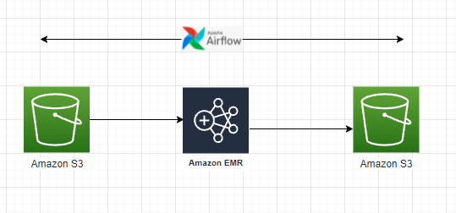
Description:
This is another approach similar to the AWS Glue. Here we use AWS EMR instead of Glue. EMR provides more flexibility in terms of Cluster configurations, cost control, data security, IAM role options, VPC options. These options provide more control on the data processing capability and along with the power of native spark compute. EMR reads data from S3 and does all the compute within Pyspark program in the cluster and finally lands the data to S3 bucket which can be exposed to Athena for querying. Airflow can be used to orchestrate the whole process in terms of spinning up and tearing down the cluster.

Advantages:

1. ETL capability
2. Can scale based on the size of the compute.
3. Better control in terms of Cluster configurations, cost control, data security, IAM role options, VPC options.
4. Can be orchestrated with open source technologies like airflow.

Disadvantages:
1. Not as fast as Lambda
2. Can’t be used for near real time processing
3. Can’t be triggered directly from S3 event but using services like Lambda, can be triggered based on event
4. Spark script is required for processing.

Implementation :

Implemented the first two approach as part of this assessment. The github link is the below:
https://github.com/vgnsh15/

There are two repos:

1 https://github.com/vgnsh15/github-actions-with-aws-sam : This repo contains the script for development of the first approach – Lambda function triggered based on S3 file drop event. It also contains all the deployment script based on SAM – Serverless Application Model for deploying the Lambda functions to production.

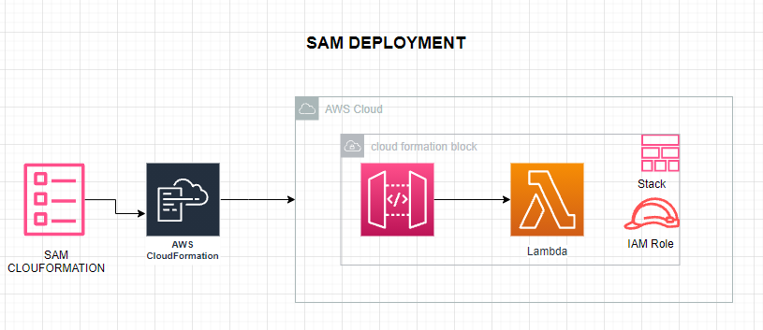

This location https://github.com/vgnsh15/github-actions-with-aws-sam/blob/main/data_file_processing/app.py
has the source lambda execution code.

- This location
- https://github.com/vgnsh15/github-actions-with-aws-sam/tree/main/.github/workflows
has the SAM yaml file for serverless deployment.

- Any changes commited to the Github, will trigger the Github Actions which eventually triggers the deployment script based on the yaml file. Ultimately, SAM creates a cloudformation template, which is being used to provision the services.

2. https://github.com/vgnsh15/adobe-assessment : This repo contains just the source code for all approaches:

- AWS-glue: The Pyspark script which can be executed in AWS glue service

- Lambda-function: The python script which can be executed in the Lambda service

- Python: Native Python program to execute it on EC2 instance or from the local machine

- How to execute from EC2 with file in S3 – Python3 purchase_transaction.py s3://bucket/keyname True

- How to execute from EC2 with file in local directory --- Python3 purchase_transaction.py <local directory where the file is> False

- How to execute from Local Machine --- Python3 purchase_transaction.py <local directory where the file is> False

