Implementation of Real World Modern Football Tactics in RoboCup Soccer Simulator
A dissertation submitted in partial fulfilment of
the requirements for the degree of
BACHELOR OF SCIENCE in Computer Science
in
The Queen's University of Belfast
by
James Young
28/04/2025

SCHOOL OF ELECTRONICS, ELECTRICAL ENGINEERING and COMPUTER SCIENCE
CSC3002 – COMPUTER SCIENCE PROJECT
Dissertation Cover Sheet

Student Name: | James Young | Student Number: | 40296786
Project Title: | Implementation of Real World Modern football Tactics in RoboCup Soccer Simulator
Supervisor: | Dr Vahid Garousi
Declaration of Academic Integrity
Before submitting your dissertation please check that the submission:

- Has a full bibliography attached laid out according to the guidelines specified in the Student Project Handbook
- Contains full acknowledgement of all secondary sources used (paper-based and electronic)
- Does not exceed the specified page limit
- Is clearly presented and proof-read
- Is submitted on, or before, the specified or agreed due date. Late submissions will only be accepted in exceptional circumstances or where a deferment has been granted in advance.

By submitting your dissertation you declare that you have completed the tutorial on plagiarism at http://www.qub.ac.uk/cite2write/introduction5.html and are aware that it is an academic offence to plagiarise. You declare that the submission is your own original work. No part of it has been submitted for any other assignment and you have acknowledged all written and electronic sources used.
- If selected as an exemplar, I agree to allow my dissertation to be used as a sample for future students. (Please delete this if you do not agree.)

Student’s signature | James Young | Date of submission | 28/04/2025

Acknowledgements
First and foremost I would like to give my thanks to my project supervisor, Dr Vahid Garousi. He has been incredibly helpful throughout this project, giving advice and insight during several meetings over the development period. I would also like to extend thanks to the developers of HELIOS-BASE as well, without their existing to codebase to work off this project simply would not have been possible. Finally, I’d like to thank the RoboCup SoccerSim team and the community. This project allowed me to combine one of my passions into my University Work and the RoboCup initiative is brilliant work that I’m honoured to be able to work within. The community were also incredibly helpful, assisting me several times when I was struggling with technical difficulties both with the RoboCup framework and with my own system.

Abstract
This project looks into an implementation of real-world modern football tactics into the RoboCup 2D Soccer Simulator, using the open source team HELIOS as a base. The project looked into adding new formations, player roles and new behaviour, as well as a machine learning-driven xG model using XGBoost to inform decision making and aide in statistical evaluation. The project was evaluated through a combination of statistics and watching simulated games from a 20 game sample. Although the changes did not improve the performance of the team, deeper analysis revealed that the team improved in specific metrics and showed potential for modern tactics inside the soccer simulator, as well as its limitations.

Contents
Acknowledgements 3
Abstract 3
Contents 4
The Main Text 5
1.0 Introduction and Problem Area 5
1.1 Background 5
1.2 Problem Area 5
2.0 System Requirements and Specification 7
2.1 Functional Requirements 9
2.2 Non-Functional Requirements 9
2.3 Software Environments 10
3.0 Design 11
3.1 UML Sequence Diagrams 11
3.2 Use Case Descriptions 17
3.3 Class Diagrams 20
4.0 Implementation 22
4.1 HELIOS Existing Codebase 22
4.2 XGBoost Library 22
4.3 Implementation of New Formations 23
4.4 Implementation of Updated Decision Making Logic 24
5.0 Testing 26
5.1 Test Plan 26
5.2 Test Results 26
6.0 System Evaluation and Experimental Results 30
6.1 Has there been an Improvement? 31
6.2 Human vs Computer Differences 33
6.3 Future Improvements 34
6.4 xG Model Accuracy 34
6.5 Development Process 35
7.0 Appendices 36
7.1 Links to games played 36
References 37

The Main Text
- Introduction and Problem Area
  - Background
RoboCup is an initiative that began in 1997, with the objective “By the middle of the 21st century, a team of fully autonomous humanoid robot soccer players shall win a soccer game, complying with the official rules of FIFA, against the winner of the most recent World Cup” [1]. The project runs several leagues, these include both simulated soccer and also soccer player by real robots.

This project is focused on the 2D Simulation League, in which “2 Teams of 11 autonomous software programs (called agents) play soccer in a two-dimensional virtual soccer stadium”[2]. There is an annual competition played, with teams being entered from all over the globe in an attempt to be crowned ‘RoboCup World Champions’. Some of these teams release versions of their code in open source libraries. HELIOS is one of these teams, and this was the starting point for the development in this project.

  - Problem Area
The project combines this existing team with an insight into modern football tactics. The first ideology that was chosen to implement was the concept of xG. In basic terms, xG or ‘Expected Goals’ is a metric which assigns a probability value to every shot taken on a football pitch. The higher the number, the greater the likelihood of the shot going into the goal. The term was coined in a 1993 paper which was reviewing the difference between grass and artificial pitches in football [3]. It was first used as a metric for analysis in 2012 by Opta, who describe the metric like this, “xG measures the quality of a chance by calculating the likelihood that it will be scored by using information on similar shots in the past. We use nearly one million shots from Opta’s historical database to measure xG on a scale between zero and one, where zero represents a chance that is impossible to score, and one represents a chance that a player would be expected to score every single time” [4]. A number of factors are considered when calculating this value, including the distance from goal, the angle at which the shot is taken, the part of the body used to shoot and the position of the defence around the player taking the shot.
This metric has widely been adopted within football, its very useful to measure the overall ability of a team to create chances, but it also measures whether an individual is a good finisher, i.e. are they scoring as many goals as expected from the opportunities they get. Football is quite a low scoring game, so goals become even more valuable to a team than in other sports. Being able to measure not only how many goals you scored, but how many goals you expect to score is very important for any modern coach or analyst. The applications for this to the simulated game are very apparent. We can use this purely as a metric to gauge the performance of the team, and as part of the logic for players decision-making when it comes to taking shots at goal.

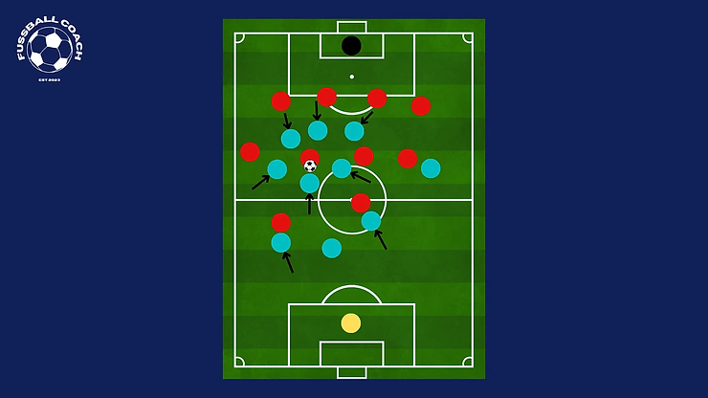
Another area of football that was deemed appropriate for integration to the simulated game were modernised formations, especially out of possession. OOP Structures have been one of the most rapidly evolving aspects of football over the last decade. Tactician Jon Mackenzie on Twitter studies OOP structures at length, and he has said “Almost all the modern tactical evolution has been OOP development”[5]. Many of the different formations and new age tactical ideas were considered for implementation into the simulated system. Ultimately two different ideologies were chosen for their effectiveness and simplicity. Firstly, a 442 block was chosen for out of possession structure when the team is winning. This formation involves falling into compact rows of players, offering best coverage of the pitch and occupying the central areas of the pitch which are the most important areas to defend and where most goals and chances come from. The other modern setup that was chosen for the simulation was the implementation of a 433 High Press. Pressing in football is the idea of being proactive without the ball. Instead of allowing the opposition team to control the ball easily, the team instead hassles them even high up the pitch. Jurgen Klopp, former Liverpool and Borussia Dortmund Manager, has said “Counter-pressing is the best playmaker” [6]. The idea is that winning the ball high up the pitch near the opposition’s goal is a form of chance creation, and it is more valuable to try and win the ball in the attacking third than to win it back further from goal, as you then have to go through the process of bringing it back up the pitch.

The graphic here [6] highlights how a team without the ball, the blue team here, might work together to “collectively apply pressure on the opponent”. The important factors are how quickly they are ready to close the space and how the defenders are able to cut off any potential passes to teammates.

The evolution in football tactics also brought new player roles to the spotlight. One of these is the concept of a “False 9”. This is a playing style for the centre forward, named as he is not performing the standard duties of the position, and the position tends to wear the number 9 on his back. “A false nine is a centre-forward who repeatedly moves towards the ball in deeper positions from a high starting position, often dropping to receive centrally. The main intention is to get on the ball away from the opposition centre-backs – and, in doing so, to draw players out of position and disrupt the defence” [7]. This role could be particularly beneficial in simulated games as they tend to follow rigid structures and repeatable patterns of play, and a false 9 dropping back can create chaos and unique angles of attack that can take advantage of a slower defence.

The other positional roles selected to be implemented both relate to the full-back position. Firstly is the Overlapping Full-Back, which was nearly universally adopted in the 1990s and early 2000s by the best teams in Europe. “An overlapping fullback contributes to attacking play by providing width, creating overloads in wide areas, and delivering crosses into the box. By overlapping the winger or midfielder, they stretch the opposition’s defence, open up space for teammates, and can generate scoring opportunities from out wide” [8]. This role requires a high level of fitness, with the players tasked with covering up and down the full length of the pitch for long periods of the game. The opposite idea to this are Inverted Full-Backs. These players “move inside into central spaces when their team has possession” [9] and this allows them to gain numerical superiority in midfield. By having extra players in the centre of the park, an attacking team is able to play passes much easier and in turn bypass the opposition midfield and move the ball up the pitch efficiently. This role is demanding on a technical level, however it suits the simulated game perfectly as the difficulties human players might face in this role (such as making poor touches under pressure or being unable to adapt to playing centrally) are not issues that a programmed player can run into.

It is hoped that with the implementation of these modern ideas into a simulated team, we can see an improvement in performance for our team, as well as open the door for other teams to attempt to incorporate real world football tactics into their simulated teams.

- System Requirements and Specification
As stated in the previous section, The RoboCup 2D Soccer Simulator will be the primary element that this project revolves around. Use of this software requires a few pre requisites before use. Firstly, the simulator requires a Linux environment to run. Initially for development the Windows Subsystem for Linux (WSL) was used. However during the second half of development there were some errors and difficulties with this system, and development was then transferred to a virtual machine. This was done using Oracle VirtualBox, running Ubuntu 24.04. This would be the recommended environment for use of the system, once this was set up and running then there were no problems with the environment. To run the simulator, one needs to install several pieces of software developed by the RoboCup Team. Firstly, The RoboCup Soccer Simulator Server (rcssserver) is used to host the virtual games and actually run the simulations. This connects to the RoboCup Soccer Simulator Monitor (rcssmonitor), which is the visualiser for the server. This is the software that allows us to watch the games, giving visual representations of the players, the pitch and the ball. Both these essential pieces of software can be found on the RoboCup Soccer Simulator GitHub Page (Appendix 1) and full Installation Instructions can also be found there. It is also recommended that if readers want to further familiarise themselves with how the simulator works, they should consult the RoboCup Soccer Simulator User’s Manual (Appendix 2). This is a really great resource that can serve as a basis for anyone wanting to learn more about the RoboCup initiative.

Another large part of this project that must be acknowledged is the RoboCup team “HELIOS”. (REFERENCE 3 IN JAN REPORT). This is a project developed by a joint team from Fukuoka University and Osaka Prefecture University which have been competing in RoboCup competitions since 2000, claiming victory in 2010 and 2012, as well as finishing 2nd twice [10]. This team is available in an open source context and has been used as the starting point, upon which the new features developed in this project have been placed. The HELIOS team works by having a series of predetermined scenarios and then programming behaviour for the players. Each player on the pitch has a role, and each role is tied to certain behaviours and positions within different formations. The formation that is used is dependent on the game situation, as well as the location of the ball relative to the pitch.
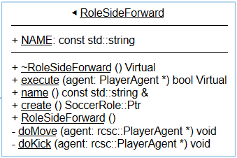
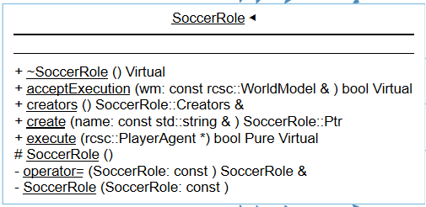
The roles work by all inheriting from a class “SoccerRole” which defines each role and the specific actions that belong to each one. Below you can see the class diagram for the “SoccerRole” class (Fig 1) and a sample role, “RoleSideForward” (Fig 2).
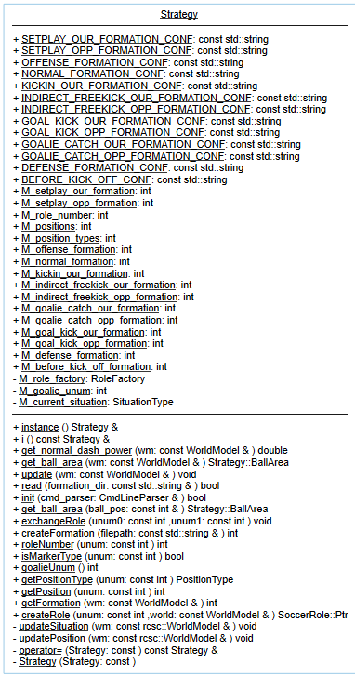
The roles are assigned to each player on the pitch in the formation configuration files. Which formation file is used is determined by the “situation”. There are a lot of situations but the main ones are offense and defence. Below is the class diagram for the Strategy Class (Fig 3). This class is responsible for determining the situation at any given time, and then selecting which formation is to be followed.

There is one final prerequisite that must be discussed in this section. The machine learning algorithm “Extreme Gradient Boosting” , also known as “XGBoost” has been used in this project. This is an algorithm that is designed specifically for speed and performance, and it used in this project to aide in the calculation of xG values on shots taken. “It utilizes decision trees as base learners and employs regularization techniques to enhance model generalization” and this has allowed it to become “famous for its computational efficiency” which is incredibly important given that multiple predictions need to be made in real time during the simulation [11]. Again, a fuller understanding and installation guide can be found through reading the documentation, and this will be needed to run the final project (Appendix 3).
  - Functional Requirements
- The team should display improved performance over the original HELIOS base team.
- The new behaviour of the team should adhere to the new specifications outlined in the Use Case Descriptions, including both team structure and individual player behaviour.
  - Non-Functional Requirements
- The system’s code and documentation should be clear and concise.
- The finished project should be of high quality and professional standard.
- The Implementation should follow the Design specifications.
- The project should be completed efficiently and in a timely manner that aligns with the planned timeline.
  - Software Environments
- RoboCup SoccerSim
- HELIOS-BASE Team
- SoccerWindow2
- C++
- Git and GitLab
- Visual Studio 2022
- Pheonix Code
- Ubuntu 24.04
- Oracle VirtualBox
- SciTools Understand
- Microsoft Excel and Word
- OBS Recording Software

From an overall perspective, this system will take the existing HELIOS system and upgrade the structures and decision making to see how the modern tactics mentioned previously can impact the team, hopefully in a positive direction. This analysis will be performed using a collection of footballing metrics, and will hopefully prove that changes in tactics can make a marked difference on the performance of a team as well as its potential.

- Design
The design stage of a project is crucial for ensuring that the developed software and the final project and clearly thought out and well engineered. A system with good design has far greater maintainability and also makes the development and testing phases much more straightforward.
This section highlights the design of each of the new features using different design techniques and diagrams, shown and explained below.
  - UML Sequence Diagrams
These Sequence Diagrams display the newly implemented behaviour logic for the three new player roles. Also shown here are the files involved in the xG prediction process, and the changes in strategy that implement the new formations and how they are selected depending on the different situation.

Inverted Full-Back
The role of the Inverted Full-Back is to tuck into midfield to give numerical superiority and aide in build up play from the back in possession. This was reflected in the new behaviour for the role, which describes upgraded movement patterns for the player. If they do not have the ball, (kickable is false) then they are instructed to move into a position that will create a triangle with their teammates. These triangle situations are a key tactical idea in football that allows for easy space creation and quick passing, they originated in the 1970s with the Dutch National Team and their style of “Total Football” [12]. 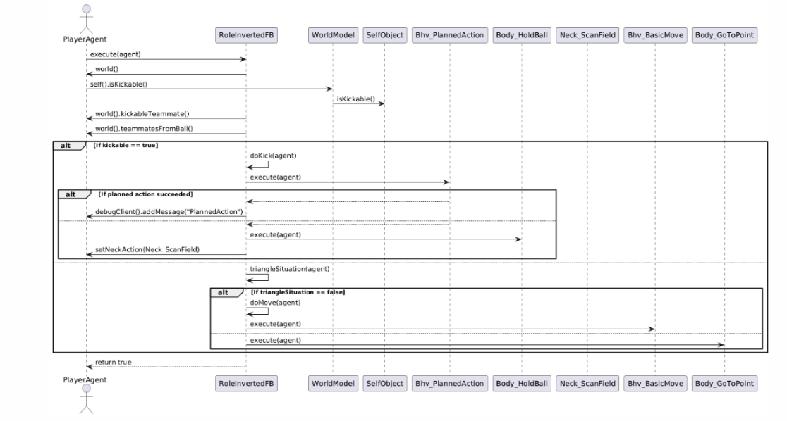

Overlapping Full-Back
The Overlapping Full-back role is essentially the opposite of inverting. These players are keen to run down the wing and join the attack from defence. Their new behaviour focused on what happens when they have joined the attack, namely delivering crosses into the box. If they have the ball they will check if a cross is on, this involves checking what part of the pitch the player currently occupies and if there are suitable targets for a cross in the box. If the scenario meets this criteria then a cross will be delivered, otherwise the player falls back to the previous default behaviour.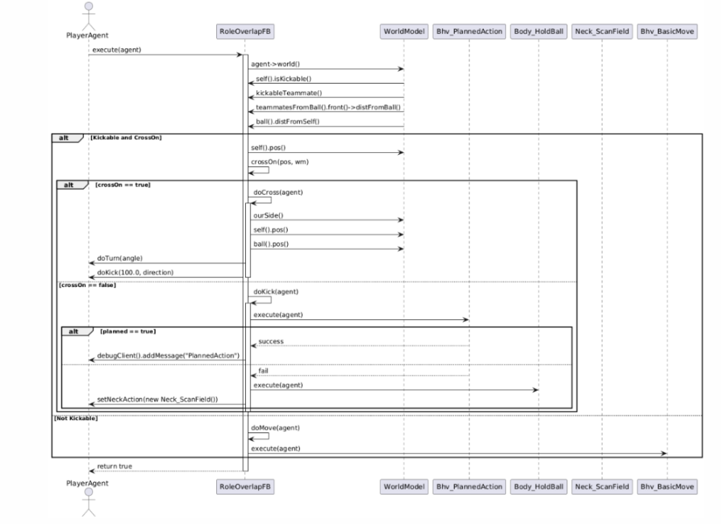

False 9
The False 9 often will find itself in large pockets of space between the midfield and defence of the opposition. The upgraded behaviour seeks to take advantage of this space and encourage the player to dribble more rather than a ‘pass first’ mentality. If the player has the ball and finds enough space it will always take the opportunity to dribble at the defenders and towards the goal, potentially creating chances from which to shoot.
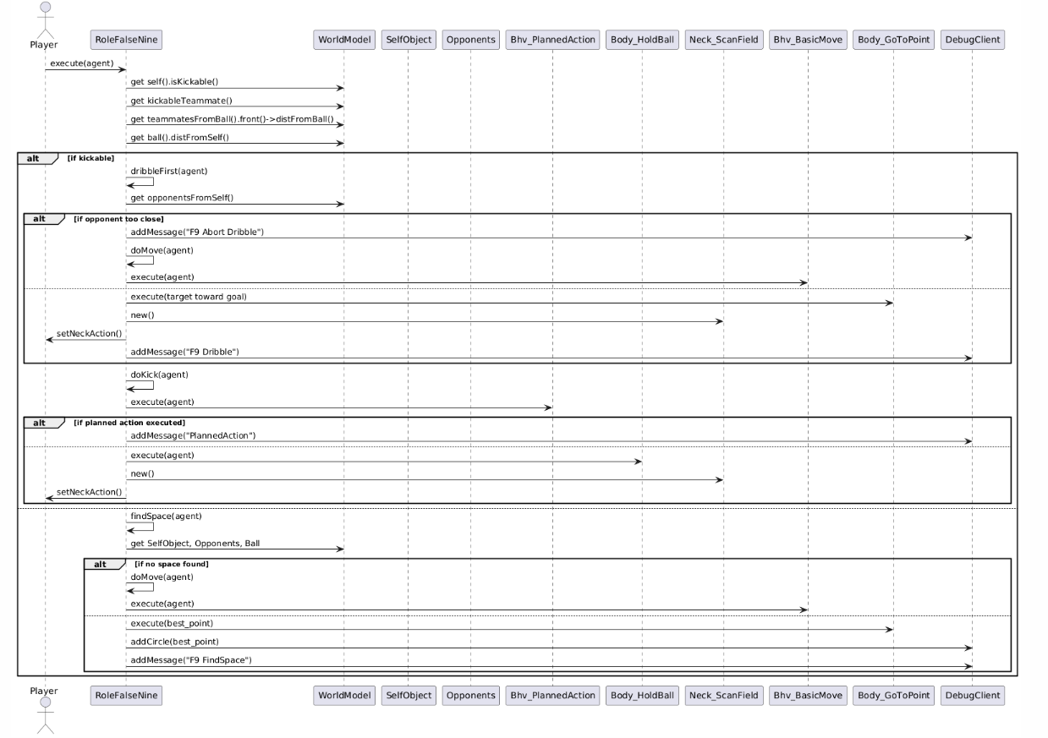

Read Files and Transform Coordinates
This code is part of the xG model developed for the project. It takes in real world shot data from StatsBomb (Appendix 4) and then converts from their coordinate system to that of the soccer simulator. It then writes this shot data (the converted coordinates of each shot and its xG) to a file called “transformed_shots.json”. 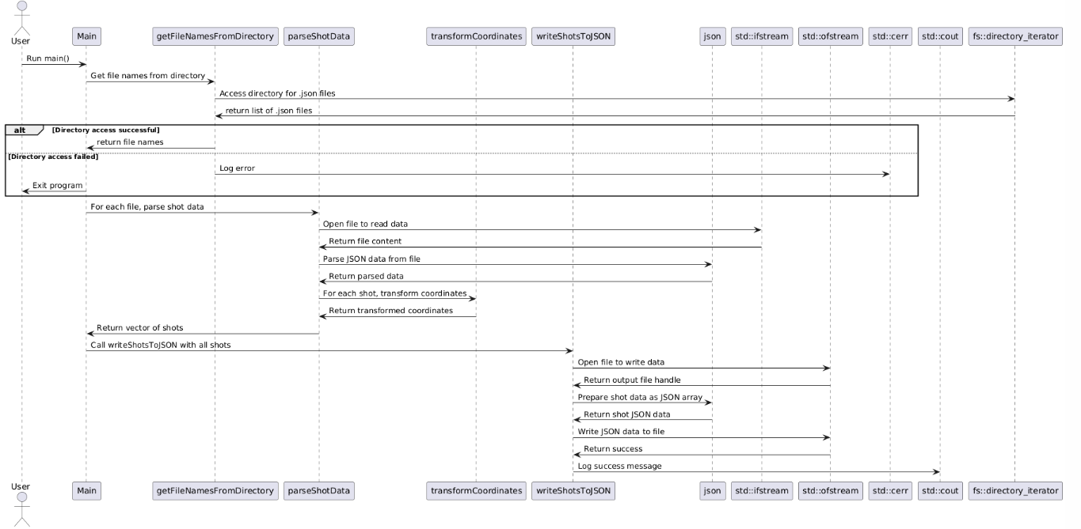

xG Algorithm – Model Training
The training of the xG Model involved reading the shot data that has been pre-processed and then using the xgboost algorithm to perform 200 rounds of training which then creates the final model.
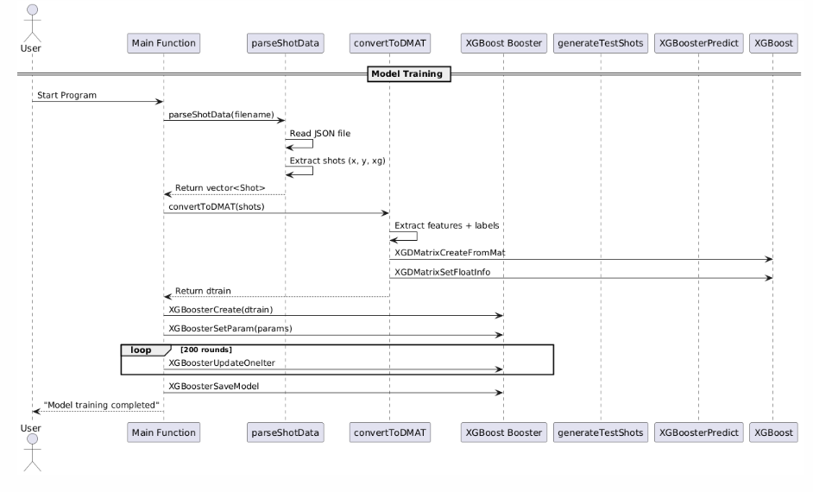

xG Algorithm – Shot Prediction
The final part of the xG algorithm is shown here, where the trained model is used to predict a shots xG based on the location from which it has been taken. 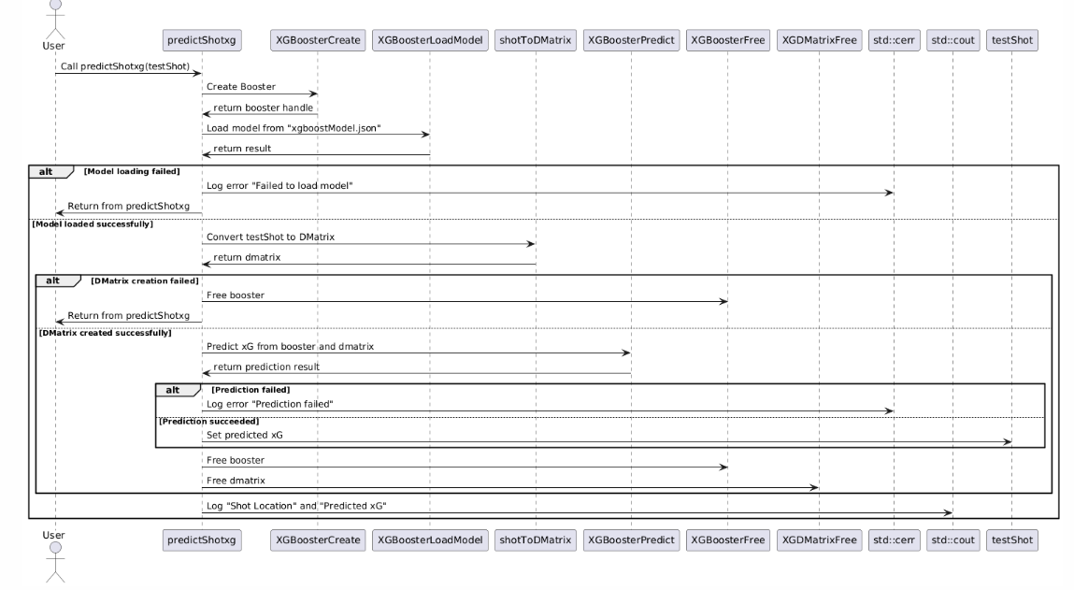

Strategy – Upgraded Situation Logic
The newly implemented situation logic dictates at what points in the game the new formations will be used by the team. Under the previous system there was just one offensive formation and one defensive formation, making choosing which one to use purely a matter of which team had the ball. The new logic instead uses the state of the game (winning, losing or drawing) to pick from a larger choice of formations, giving more tactical depth. 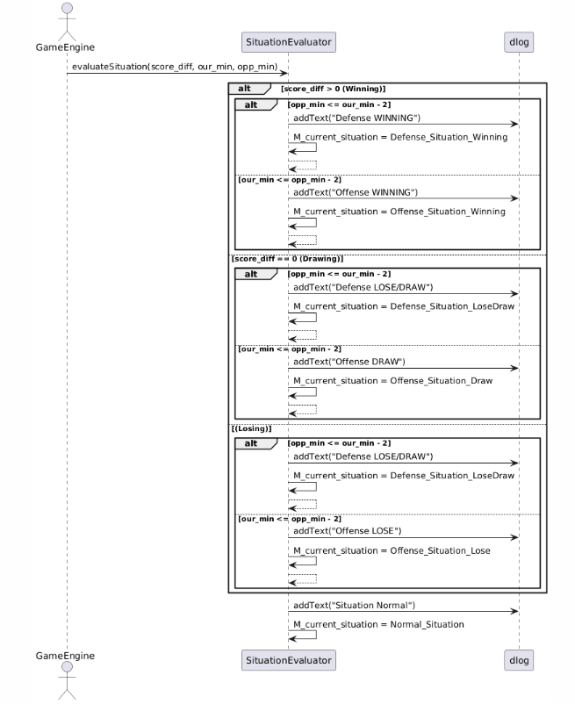

Upgraded Shooting Logic
This diagram shows the new and improved flow of the shooting logic which takes advantage of the developed xG model. Before a shot is taken the player checks the xG value of the shot and the xG values of locations around it. If the nearby locations have higher probability of a goal (higher xG) then the player will move towards those locations before shooting, which is more statistically efficient behaviour.
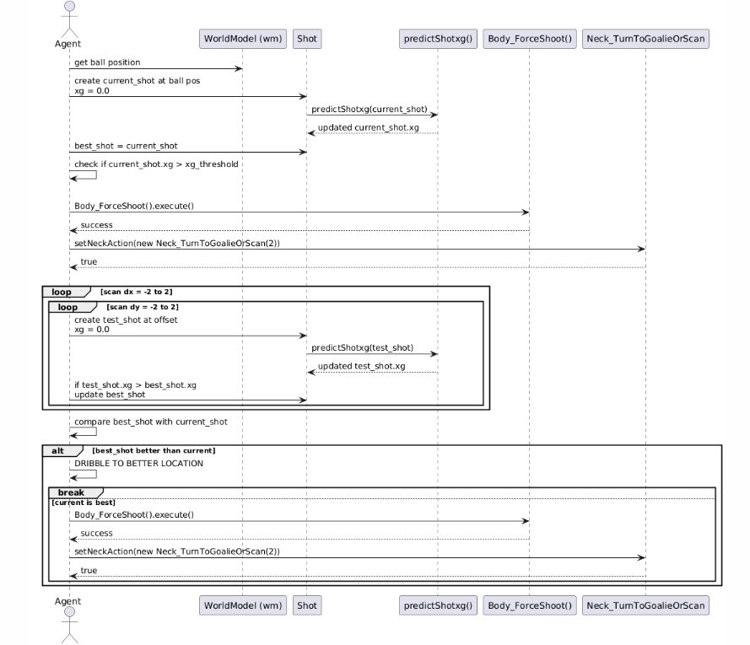

  - Use Case Descriptions
Use Case Descriptions were also produced for each new feature and behaviour, this helped create a clear picture of what each would look like and how they would come together as part of the full system.
- Overlapping Full-Back Role
Preconditions: Simulated Match is Playing
Objective: Full-Backs are able to join the attack when their team has the ball and deliver crosses into the box
Actors: Person running simulated match
Trigger: Team has possession of the ball in the opposition’s final third or near the touchline in the opposing half.
Postconditions: Full-Back has joined the attack and advanced further up the field, has had the option to deliver a cross into the box
Main Flow:
- The system recognises the situation as Offense
- The overlapping full back formation is used
- The ball progresses into the final third
- The Full-Back advances up the field
- Player checks if a crossing opportunity is present
- Player decides either to make a cross or not
Alternative Flow:
- The situation changes to something other than Offense
- The Full-Back’s Role reverts to the standard “SideBack”
- Full-Back reverts to normal behaviour and positioning

- False 9 Role
Preconditions: Simulated Match is Playing
Objective: Central Striker is able to drop into midfield
Actors: Person running simulated match
Trigger: Team has possession of the ball in the middle of the pitch
Postconditions: Striker has dropped back to join the midfield
Main Flow:
- The system recognises the situation as Offense
- The False 9 formation is used
- The Striker has dropped back into the midfield
- The player chooses to dribble more often if space allows
Alternative Flow:
- The situation changes to something other than Offense
- The Striker’s Role reverts to the standard “CenterForward”
- Striker reverts to normal behaviour and positioning

- Inverted Full-Back Role
Preconditions: Simulated Match is Playing
Objective: Full Back is able to tuck into midfield
Actors: Person running simulated match
Trigger: Team has possession of the ball in buildup or during an attack
Postconditions: Full-Back has tucked in to join the midfield
Main Flow:
- The system recognises the situation as Offense
- The Inverted Full-back formation is used
- The ball is in the middle third of the pitch, the offensive third of the pitch or in central zones in the defensive zoneF
- The Full-Back joins the midfield, sitting next to the defensive midfielder
- Player is able to move into beneficial positions to receive the ball
Alternative Flow:
- The situation changes to something other than Offense
- The Full-Back’s Role reverts to the standard “SideBack”
- Full-Back reverts to normal behaviour and positioning

- 442 Out of Possession (OOP) Structure
Preconditions: Simulated Match is Playing
Objective: Change standard 433 defensive structure into 442 shape
Actors: Person running simulated match
Trigger: Team does not have possession of the ball
Postconditions: Team formation has changed
Main Flow:
- The system recognises the situation as Defence
- The 442 block formation is used
- The ball is in the defensive half of the pitch
- The defensive midfielder joins the striker in a front 2, and the wingers drop back to aid the defence
Alternative Flow:
- The situation changes to something other than Defence
- The formation reverts to standard 433

- 443 High Press Structure
Preconditions: Simulated Match is Playing
Objective: Change standard 433 defensive structure into a High Press
Actors: Person running simulated match
Trigger: Team does not have possession of the ball, the ball is in the opposition’s half
Postconditions: Team formation has changed, players attempt to smother the player with the ball
Main Flow:
- The system recognises the situation as Defence
- The 433 press formation is used
- The ball is in the opposition’s half of the pitch
- The forwards and midfielders push higher up the pitch towards the ball
Alternative Flow:
- The situation changes to something other than Defence
- The formation reverts to standard roles and positions

- xG Model Cross-Validation
Preconditions: User wants to train the xG Model
Objective: Train xG Model to give predictions of Shot xG
Actors: User training the Model
Trigger: User begins training, with cross-validation active
Postconditions: Updated Model is written to file
Main Flow:
- The program loads in the shot data from file
- XGBoost algorithm parameters are set
- Data is split into k folds for training and testing
- Model is trained and written to file, once for each fold
- Evaluation Metrics are calculated and written to command line – Accuracy, Recall and Precision
Alternative Flow:
- Cross-Validation isn’t chosen as the training method
- Normal Training is performed
- Model is trained to a lower standard

- xG Model Shot Prediction
Preconditions: Simulated Match is Playing
Objective: xG Value is output to command line after every shot and xG values are used in the decision making process of when and where to shoot from.
Actors: Person Running the Match
Trigger: In-Game Player decides to take a shot
Postconditions: xG Value is printed and the shot is taken from an optimal location
Main Flow:
- A shot is about to be taken
- The player gets the xG value of the current location
- The player gets the xG values for nearby locations
- If the current location is optimal, the shot is taken. If nearby locations are better then the player moves there and shoots.
- Shot is taken
- Value is output to command line with the location of the shot

  - Class Diagrams
The following Class Diagrams were generated using the software “Understand” by SciTools (https://scitools.com/ ), which is a tool used in assessing existing and legacy code. It made the process of analysing the HELIOS model much easier and was also able to help design the new classes that were implemented for this project. Highlighted in yellow are the new additions to the HELIOS existing system that are the key aspects of this project.

Inverted Full Back

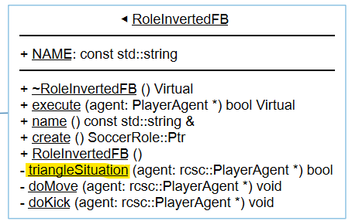

Overlapping Full Back

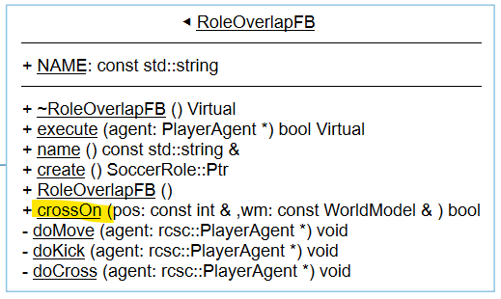

False 9

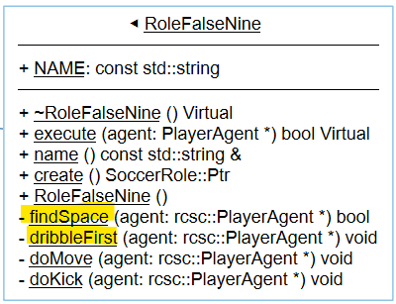

Strategy

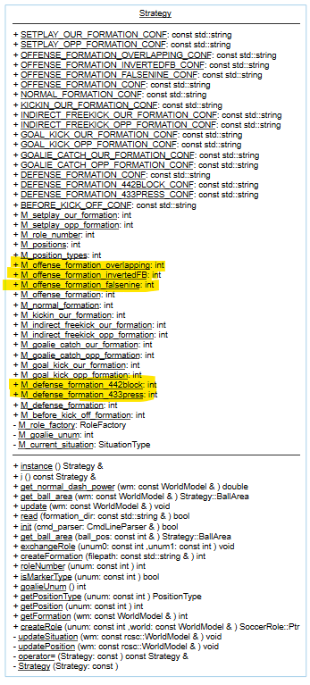
- Implementation
  - HELIOS Existing Codebase
The first task of the Implementation section of the project was working out how to integrate the new work that was to be completed into the existing codebase that was to be used as a starting point. HELIOS was written in C++ and this is a language that I was already familiar with from previous university work. Initially when adding new code to the existing system there were errors getting the program to even compile. This was because the HELIOS team uses “MAKEFILEs” to build the program, and when new files were added such as the new roles or formations they had to be included in the proper MAKEFILEs so that they could be included in the program while it runs.
  - XGBoost Library
Developing the xG prediction model was one of the most important features to get correct early on in the project, as it would serve as a key factor in the new team and would be referenced many times during each game. The XGBoost algorithm was selected for this process primarily because of its high predictive power and fast processing speed, as well as its suitability to the dataset that was available.

The first stage of implementation was to convert the data from StatsBomb (Appendix 4) into usable data for this project. The data used was from hundreds of a real world games of football and included lots of different data points stored in json files. For this project we are interested in shots taken, their location and the xG value associated with them. Once these were found the coordinates of the location had to be converted to the system used by the RoboCup Simulator. The StatsBomb data had pitches set to 120x80 units but the Soccer Simulator pitch is 104x66 units. There was also a difference in where the coordinates counted from, with the StatsBomb data starting with one of the corner flags being (0,0) but the Soccer Simulator uses the centre of the pitch as (0,0). Once these coordinates were scaled and transformed to fit the new system then they could be saved and were now ready to be used to train the model.

When training the model the first thing to do was to convert the data to a DMatrix, this is the data format that XGBoost works in. After this then the model was trained using K-fold cross validation and then also evaluated for testing and parameter tuning. The model was evaluated by comparing to the real world ground truth values and then these comparisons were used to calculate Type 1 and Type 2 errors which were able to give an idea of the overall performance of the model and which specific kinds of shots it was struggling with. There were several different parameters that were experimented with in order to find the optimal results, this process can be seen in the spreadsheet on the GitLab page (Appendix 5) It was found that the model particularly struggled with predicting shots from wide angles and wasn’t giving high enough predictions for shots around the edge of the box, so these areas were given weights to help the model come to more accurate predictions.
  - Implementation of New Formations
The way HELIOS handles formations is by using a “Delaunay triangulation constructed from recorded data” (reference is that helios paper you know the main one). The recorded data involves using the position of the ball at 114 unique locations on the field and then giving each player a specific coordinate that they should aim to be at when the ball is at a certain location. These are stored as shown below.
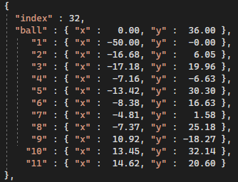
This project developed 5 new formations for the new team to use, meaning that over 500 new ball indexes had to be set and with 11 players per index it means over 5,000 new points of data had to be set. Luckily, these did not have to be manually typed and edited within the configuration files. The HELIOS team developed an upgraded version of the RoboCup Monitor, called SoccerWindow2 (Appendix 1). This has the functionality of a “formation editor” which allows players to be dragged around on the field using a GUI. This allows for an easier visualisation of the positions players will take up on the pitch and mirrors tactics boards used by real football coaches and managers.
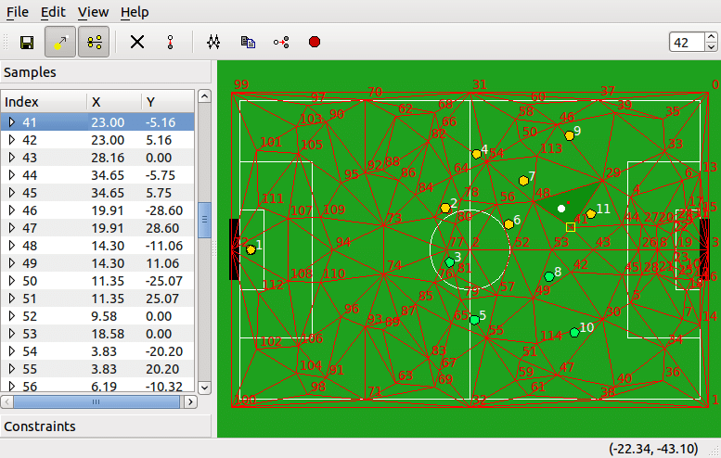
  - Implementation of Updated Decision Making Logic
The majority of the new decision making logic came through the implementation of new player roles. Within the HELIOS system every player in the team is assigned a role which then dictates the behaviour they show on the pitch. The implementation of the new roles comes with new functions that give the players new abilities, such as overlapping full-backs gaining the ability to cross the ball. Analysis of the existing behaviour of players on the ball in wide spaces gave the impression that there was something missing in this area of the pitch, and players having the ability to cross would add more threat and dynamism to an attack. This action was broken down into two functions, firstly checking the location of the full-back in possession of the ball to ensure he is in the right place to perform the cross. If this returned true, then a pass will be delivered in towards the penalty spot that will test the defence of the opposition team.

Another notable feature was developed for the false 9 role. Because of the new formation developed the player should find itself in space more often, meaning that there will be more opportunities to dribble with the ball. The function “dribbleFirst” takes advantage of this, instructing the player to check if it has space and if so, dribble towards the opposition goal directly, which allows the player to progress the ball up the field and get into positions to create chances for team mates. If the player is not in possession of the ball then it will be aiming to move into space at all times thanks to the function “findSpace”, which checks the area around the player and scans for opposition players to see where the most space available is. Once this location has been identified the player can move there, making it a better option to be passed to or to drag defenders away from where they should be.

When updating the shooting logic to include the xG analysis, a new function was not created. Instead an existing function was altered, namely “Bhv_PlannedAction”. This is because previously new behaviour was only being used on the specific roles of players, however the new shooting applies universally to all players on the team so it needs to be one layer further in the system.

- Testing
  - Test Plan
The testing for this project was undertaken through visual analysis of simulated games being played. With the Soccer Simulator it is not possible to set up specific scenarios so the process of ensuring correct behaviour was displayed involved running full simulated matches and observing the team and player behaviour to see if it matched what would be expected. There were also safety checks put into place during development, with output to the command line to ensure that each section of the code was reached and executed at least once under supervision. Once the development of the team was finished 10 official simulated games were played, which will be shown as examples of the successful tests in the results section, and analysed further in the evaluation section.
  - Test Results
Feature Under Test | Outcome | Description | Output
442 Formation OOP | PASS | Once the formation was implemented, the team was easily able to take up a 442 formation out of possession | 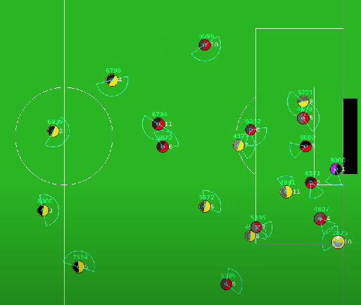  From this game: https://www.youtube.com/watch?v=M_e5idIrOZE at 6:27
433 High Press Formation OOP | PASS | Once formation was implemented, the team followed the correct formation and pressed high on the ball | 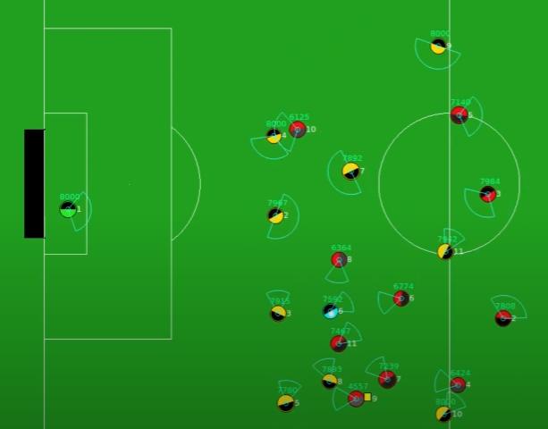
False 9 Formation | PASS | The formation with the false 9 dropping into midfield was visible during games | 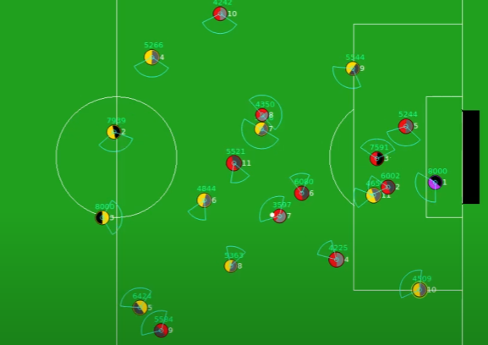  From this game: https://www.youtube.com/watch?v=M_e5idIrOZE at 7:54
Overlapping Full-Back Formation | PASS | Overlapping Full-Back joined the attack and was in correct position | 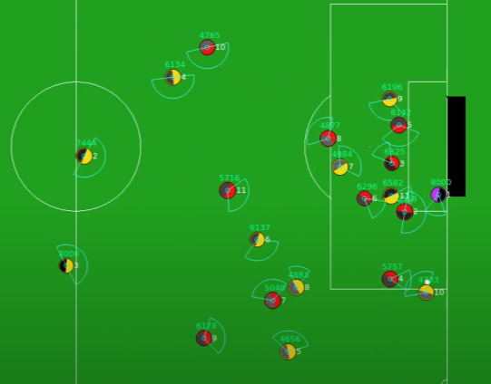  From this game: https://www.youtube.com/watch?v=Z1xtyqKLUbE&t=46s at 0:52
Inverted Full-Back Formation | PASS | Inverted Full-Back joined midfield and was in correct position to form the “box midfield” | 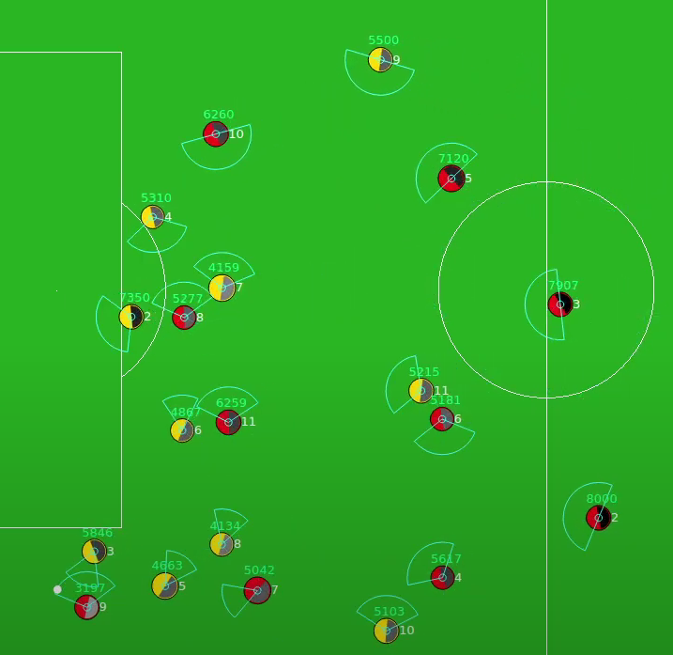  From this game: https://www.youtube.com/watch?v=AJzHT5HAVTc at 0:29
Shot data is transformed and converted to correct coordinates system | FAIL | Initially, the conversion of coordinates was incorrect because the pitch was measured incorrectly | N/A
Shot data is transformed and converted to correct coordinates system | PASS | Shot data now converts correctly with updated measurements | N/A
xG Model Training | FAIL | Model was not predicting to a high enough degree of accuracy | N/A
xG Model Training | PASS | After weight adjustment and Parameter Tuning, the Model was predicting to a satisfactory level. | 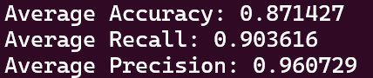
xG prediction | PASS | Before Shot is taken, xG and Shot Location are printed to the console | 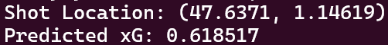
xG based Shooting Behaviour | PASS | Players check xG before taking shots, and this process is output to the console. | (show console output)
Overlapping Full-Back Crossing | FAIL | The player was able to perform crosses however this would also happen in the defensive third because the code did not check which goal was being attacked | N/A
Overlapping Full-Back Crossing | PASS | The cross is now performed only in attacking situations, and is output to the console. | 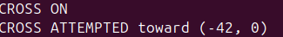
False 9 dribbles at opposition | PASS | The false 9 chooses to dribble first, and runs towards the goal, printing this to the console.
False 9 cancels dribble if players are too close | PASS | If players are too close, the dribble is cancelled and the player reverts to normal behaviour | 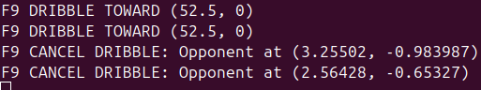

- System Evaluation and Experimental Results
In order to evaluate the performance of the newly developed team for this project (named “Donny Dynamos”) there had to be some further basis and more concrete evidence than just the eye test. For this reason, 20 simulated games were run and recorded so that the team’s performance could be evaluated and have statistics tracked. 10 games were played between HELIOS and itself, as a baseline to compare, the other 10 games were HELIOS vs the new Donny Dynamos. These can be found uploaded to YouTube, and linked in Appendices 6 and 7. These games were then reviewed and had several statistics counted for each of them, which were then compiled into a spreadsheet (Appendix 8). The statistics that were chosen were:
- Goals
  - The amount of goals scored by that team in the match
- Shots
  - The amount of total shots taken by that team in the match
- Shots on Target
  - The amount of total shots that were going towards the goal, or “on target”
- Chances Created
  - The amount of times the team created a situation where a shooting chance was possible in the match
- Dribbles
  - The number of successful dribbles completed in the match by the team, a successful dribble means dribbling past an opposition player to gain ground up the field
- Total xG Created
  - The total xG created in the match by a team, this was only available for the Donny Dynamos team.
- xG per Shot
  - Total xG Created / Shots
- Corners
  - The amount of corners won by a team in a match
- Attacking Free Kicks
  - The amount of free kicks won by a team in the attacking third of the pitch in a match
- Entries to Opposition Box
  - The number of times a team had possession of the ball inside the opponent’s box during the match.
These statistics were chosen because they give a good overview of a team’s performance, they are widely used in real world football analysis and each individual stat allows for further analysis on certain aspects of the game.
  - Has there been an Improvement?
Here, we can see the results tables of the 20 simulated games that were played:
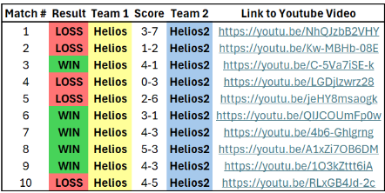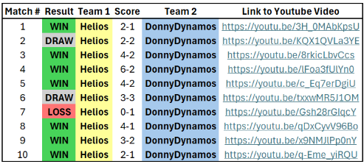
As we can see, unfortunately Donny Dynamos were not particularly successful, only winning 1 game out of 10 and drawing twice. When HELIOS played vs itself there was, predictably, a 50% win split. A surface level analysis here would show that the changes made to the existing team only served to make it worse. This is undoubtedly hard to argue with, a 10% win ratio on a 1-2-7 record is a significant downgrade, but we can take a look at the average statistics for each set of matches to see that there may me more to it.
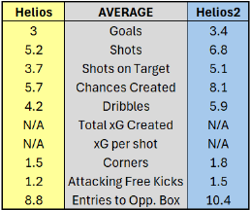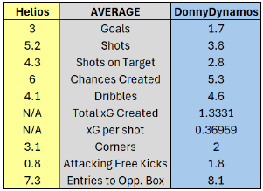
These statistics show that in the key areas Donny Dynamos were just a step behind the opposition, averaging fewer goals, shots and chances created. However the team was able to generate more successful dribbles, more touches in the opposition box and win more attacking free kicks. In the following sections these factors will be addressed and possible methods for improvement will be discussed.

Gamestate Differences
Because a key component of the strategy for Donny Dynamos revolves around the gamestate (which team is winning), it is worth taking a look at the goals scored in each of these three states so that they can be evaluated independently. The table below shows how many goals were scored at each state:
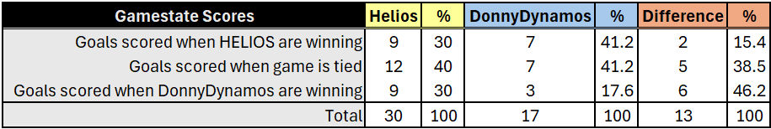
The results from this show a clear discrepancy between the game states for Donny Dynamos. Helios spreads its goals scored fairly evenly (slightly more scored when the game is level, likely due to the fact that every game begins level and it is the most common game state). However, Donny Dynamos score only 17% of their goals when leading the game, just 3 over the course of 10 games. The other 2 game states had an equal 7 games scored each. Goals scored when Donny Dynamos were leading count for nearly half of the total difference between the teams total goal tallies. If we remove this gamestate, then the difference between the teams is only 7 goals and it is highly likely that a couple of the matches that finished with close scores could have had different results without this large weakness.

This section of the system would be the first thing addressed in further changes, either reworking the logic to use less of this system and more of the other two, or a total revamp of the tactics employed when winning.

Further Investigation into statistics
Some of the statistics outside of goals scored are able to give us deeper insight into the strengths and weaknesses of this team and allow further analysis. For example, taking a look at the entries to the opposition box we can see that Donny Dynamos actually made more per game than the Helios team, however they actually ended up creating fewer chances per game and taking fewer shots. This shows that the Dynamos were actually often equally if not more dominant in terms of possession and field territory, however they were unable to convert these opportunities into high quality shooting opportunities. The overall gameplan in the first phase of the game leads to chances to launch attacks but the attacks are not ending up with final output of shots on goal. Further tactical development of attacking patterns and encouraging the players to shoot more frequently would potentially give this team the boost it needs to be winning games.

The stats also show that that Donny Dynamos are completing more successful dribbles per game than Helios, likely caused by the new emphasis put on dribbling through the False 9 role. This could also be caused by the overlapping full-backs joining the attack, which gives the wingers more opportunities to run at defenders 1v1 with other defenders busy worrying about the overlapping player. These higher dribble numbers also could be the reason why the Dynamos are significantly ahead in terms of Attacking Free Kicks won. These attacking free kicks present great opportunities for goals however the team converts from these situations surprisingly infrequently. If more efficient and more manually structured free kick routines were implemented, then this high volume of attacking free kicks could turn into an extra goal a game.
  - Human vs Computer Differences
One noticeable aspect of these tactics that may be affecting their effectiveness in the simulated games is the fact that there are significant differences between the programmed agents and the human players that these tactics were designed for. Programmed agents do not have the ability to make their own decisions and are wholly reliant on their programming. This can give advantages to a strictly structured tactical system as the agents will follow instructions to exact specifics, rather than human players who will follow their tactical system but can inject their own ideas into it on the fly. This is neither strictly an advantage nor a disadvantage for the agents, it merely suggests that real life tactics need to be adjusted slightly and implemented with high degrees of detail to succeed in the simulated world.

Programmed agents also do not possess athleticism in the way real players do. This means that rather than some players being faster than others and other players being stronger, all players possess the same base skillset. This means that tactics can be less individual player driven, allow for more player rotation and more consistency across the team. The experience working on this project and this team leads me to believe that the future of these simulated teams will be “positionless”, and can be even more tactically advanced as a result. The end goal of the RoboCup initiative as a whole will be with real three dimensional robots playing real football against human players, and whether they use 11 identical robots or robots with differing sizes, shapes and abilities will massively dictate the tactical element of this initiative as a whole.

The other major difference with the programmed players that changes from real life, is the shooting. The computer agents display much more clinical finishing than real life players. We can see this through the xG stats from Donny Dynamos, on average scoring 0.4 more goals per game than expected over the 10 sample games. This is likely because they simply do not have the human error that real players possess, the simulated players are incredibly accurate with their shooting, putting it on target 74% of the time. Because of this extra accuracy in shooting it would definitely be advisable to take more shots in the simulated game than in real life.

  - Future Improvements
There are many areas of the team that I would like to work on in improvements going forwards. Firstly, as mentioned previously, it would be really effective to develop more complex set piece routines, namely from free kicks and corners. Both these situations should yield more goals than they do currently. Set pieces are becoming more and more advanced in the modern era of football and there are many teams to take inspiration from to bring into the simulated game. This could be especially fruitful when the game is brought from the 2D space to 3D, and passes can be played through the air rather than just on the ground.

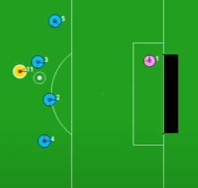
One major aspect of the team that is at fault for a significant amount of goals being conceded is the behaviour of the goalkeeper. The goalkeeper is often not very mobile, does not come out of goal to cut down angles for the shooter and often leaves large sections of the goal wide open for easy shots. For example, look at this situation that occurs often from Game 3 of Helios vs Donny Dynamos:
The keeper is totally off to the side and its positioning leaves so much space for the yellow attacker to shoot from far out and score an easy goal, which in this example it does.

Another aspect of the game to consider is the stamina mechanism in the simulation. Each player has stamina that gets used up by sprinting, and if they lose all their stamina they move significantly slower and are essentially unable to keep up with the pace of the game. This happens frequently towards the end of each half, and a further look into the stamina aspect could pay dividends for a team if they can take advantage. Possible solutions could be to ask more of the defenders, as it is mostly the midfield and forwards that run out of stamina, or to implement a more conservative passing based style for the start of the game to tire the opponent out, and then start to run faster and harder later once the opposition have run out of stamina.
  - xG Model Accuracy
Overall the xG Model predicts to a high degree of accuracy and encourages the shot takers to take high value shots from good positions. It slightly underpredicts because of the clinical shooting from agent players mentioned previously. This could be fixed if there were a dataset of shots taken in the game to review. This could be generated by running a large amount of simulated games and creating a dataset but was out of scope for this project and its timescale.

  - Development Process
I believe that the process I took while developing this project worked fairly well. All the work was completed to a timely manner and allowed me to learn and complete other university work alongside the completion of the project. The design documents and lots of planning and note taking made the implementation significantly easier. I also worked closely with my supervisor at the beginning of the project, attending biweekly meetings to ensure that things were moving at an appropriate pace and along the right lines.

If I were to think about areas of improvement for the project work, I would say that I would like to have more games recorded during the process so that it would be easier to get an overview of the progress over time. I would also like to implemented more through mechanical testing or be able to run certain training situations in the simulator if possible.

- Appendices
Appendix 1: RoboCup Soccer Simulator GitHub Page https://github.com/rcsoccersim
Appendix 2: RoboCup Soccer Simulator User’s Manual https://rcsoccersim.readthedocs.io/en/latest
Appendix 3: XGBoost Documentation https://xgboost.readthedocs.io/en/release_3.0.0/
Appendix 4: StatsBomb Open Data: https://github.com/statsbomb/open-data
Appendix 5: GitLab for this Project: https://gitlab.eeecs.qub.ac.uk/40296786/james-young-football-simulator-sw-for-robocup/-/tree/master
  - Links to games played
Appendix 6: Helios Games vs Itself Playlist: https://www.youtube.com/playlist?list=PLj1ZEcCeAxhxm7RlRFxdblSqVUrh5v_C-
Appendix 7: Helios Games vs DonnyDynamos Playlist: https://www.youtube.com/playlist?list=PLj1ZEcCeAxhxo-Csmc_pajDe-cvNHI_rI
Appendix 8: Results and Stats sheet for all simulated games: https://gitlab.eeecs.qub.ac.uk/40296786/james-young-football-simulator-sw-for-robocup/-/blob/master/simulated_games.xlsx

References
[1] RoboCup, "RoboCup Objective," RoboCup.org, 1997. [Online]. Available: https://www.robocup.org/objective. [Accessed: Apr. 20, 2025].
[2] RoboCup, "2D Simulation League," RoboCup.org, 2025. [Online]. Available: https://www.robocup.org/leagues/24. [Accessed: Apr. 20, 2025].
[3] V. Barnett and S. Hilditch, "The effect of an artificial pitch surface on home team performance in football (soccer)," Journal of the Royal Statistical Society. Series A (Statistics in Society), vol. 156, no. 1, pp. 39–50, 1993. [Online]. Available: https://www.jstor.org/stable/2982859. [Accessed: Apr. 20, 2025].
[4] Opta, "What is Expected Goals (xG)?," The Analyst, Aug. 2023. [Online]. Available: https://theanalyst.com/2023/08/what-is-expected-goals-xg. [Accessed: Apr. 20, 2025].
[5] J. Mackenzie, "Almost all the modern tactical evolution has been OOP development," X (formerly Twitter), Mar. 2025. [Online]. Available: https://x.com/Jon_Mackenzie/status/1899797652968993184. [Accessed: Apr. 20, 2025].
[6] J. Klopp, "Counter-pressing is the best playmaker," Fussball Coaches, Nov. 2023. [Online]. Available: https://www.fussballcoaches.com/en/post/counter-pressing-is-the-best-playmaker-j%C3%BCrgen-klopp. [Accessed: Apr. 20, 2025].
[7] A. Tweedale, "The false nine: explained," Coaches’ Voice, May 2022. [Online]. Available: https://learning.coachesvoice.com/cv/what-is-a-false-nine-explained-messi-kane-firmino-fabregas/. [Accessed: Apr. 20, 2025].
[8] Titans Football Academy, "Overlapping Fullback Mastery: Techniques for Success," Titans FA, Mar. 2024. [Online]. Available: https://thetitansfa.com/overlapping-fullback-mastery-techniques-for-success/. [Accessed: Apr. 20, 2025].
[9] J. Lacey-Hatton, "The inverted full-back: football tactics explained," FourFourTwo, Feb. 2025. [Online]. Available: https://www.fourfourtwo.com/features/the-inverted-full-back-football-tactics-explained. [Accessed: Apr. 20, 2025].
[10] H. Akiyama and T. Nakashima, "HELIOS-BASE," GitHub, 2025. [Online]. Available: https://github.com/helios-base/helios-base. [Accessed: Apr. 20, 2025].
[11] A. Tyagi, "What is XGBoost Algorithm," Analytics Vidhya, Apr. 2018. [Online]. Available: https://www.analyticsvidhya.com/blog/2018/09/an-end-to-end-guide-to-understand-the-math-behind-xgboost/. [Accessed: Apr. 20, 2025].
[12] Wikipedia, "Total Football," Wikipedia, 2025. [Online]. Available: https://en.wikipedia.org/wiki/Total_Football. [Accessed: Apr. 20, 2025].

