Hello there, welcome to the 1DEV documentation. You will find below the reasons for our choices concerning our Pinball project.

The game engine: Why choose Unity?

Unity is an amazingly convenient game engine. Unity enabled us to build a reliable Pinball alongside the ability to relay the troubles we encountered to a comprehensive support centre team. Being able to code alongside add physics was so appealing we just could not resist.

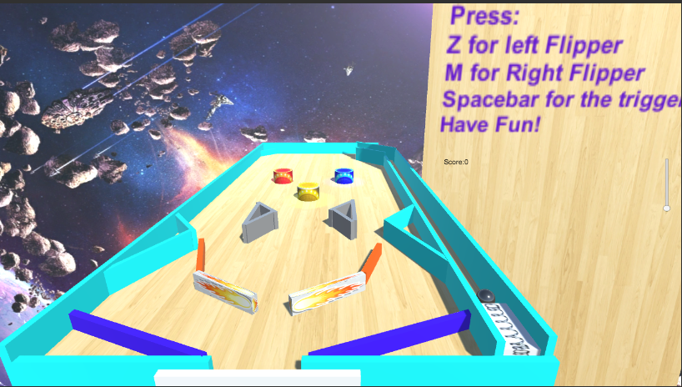

The algorithm: Why choose C++?

Here’s a secret: C++ was intimidating at first. But on the long run we discovered it was just so convenient, that we used it over Javascript. The flexibility in the engine and the compatibility to implement physics modules made it significantly easier to code and provide a beautiful output.

And speaking of ball physics… Those were quite the challenge in themselves.

First the ball movement was already implemented thanks to Unity. Some coding was required but we were still able to perform a satisfactory code.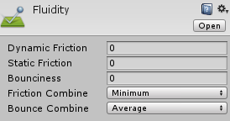

This allowed movement across the board to appear as the ball was sliding

The ball speed was also heavily dependent on collisions and gravity. Unity had already a gravity option to act as a real life pinball and our collisions were coded as such.

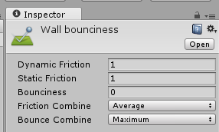

The ball rebound was decided by the walls and collisions were quite effective.

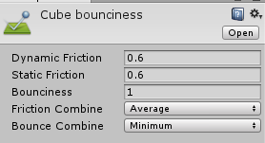

The walls themselves contributed to this rebound and controllably threw the ball. Just like the flippers.

The flippers themselves had to be coded using C++ using various technical terms:

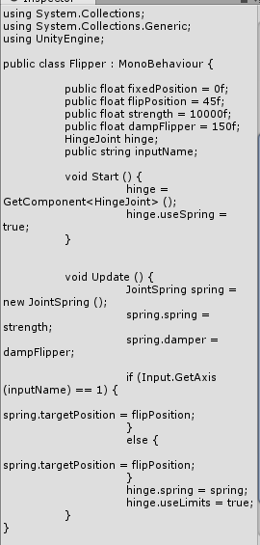

As for the scoreboard, when the ball collides with the triangles, the score increases by 2 points and when the ball collides with the bumbers, the score increases by 5.

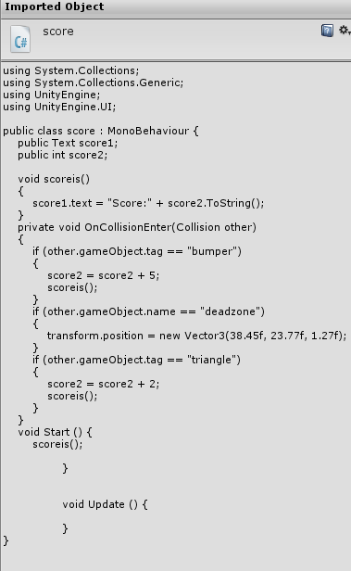

Also, the above script includes the function to respawn the ball to it’s initial location, that is 38.45f,23.77f,1.27f; this area is called deadzone.

In addition, a background music was included to render the game an exciting atmosphere. We gave the game a classical arcade look and style, trying to give the player a feeling of nostalgia.