CardDemo Modernized Application – Using Agentic AI
Screens and Functional Overview

1. Authentication 3
Figure 1: Login Page 3
2. Main Navigation 3
Figure 2: Main Menu 3
3. Account Management 4
Figure 3: Account List View 4
Figure 4: Account Details View 4
Figure 5: Account Update Page 5
4. Card Management 5
Figure 6: Card List Page 5
5. Transactions 6
Figure 7: Transaction Details 6
6. Bill Payments 7
Figure 8: Bill Payment Page 7
7. Reporting and Batch Processing 8
Figure 9: Transaction Reports Submission 8
Figure 10: Batch Job Submission 8
Figure 11: Job Run Details 8
Figure 12: Job Artifacts 9

1. Authentication

Figure 1: Login Page
This screen provides secure access to the application. Users authenticate using valid credentials before accessing system functions.

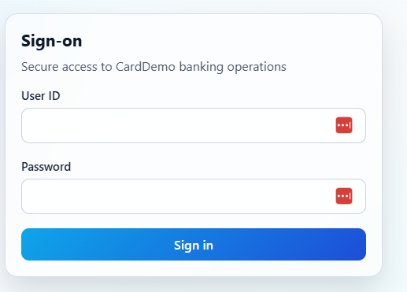

2. Main Navigation

Figure 2: Main Menu
The main menu serves as the central navigation hub. It provides access to account management, card services, transactions, reports, and batch operations.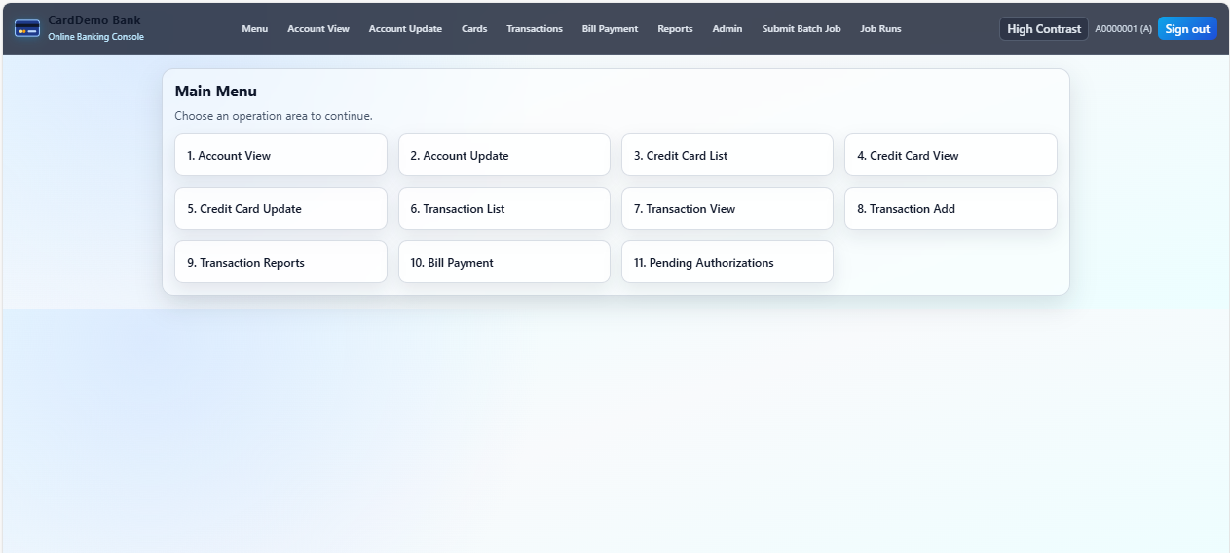

3. Account Management

Figure 3: Account List View
Accounts are displayed in a searchable and paginated table. Administrative users can view all accounts, while standard users can search for specific accounts.

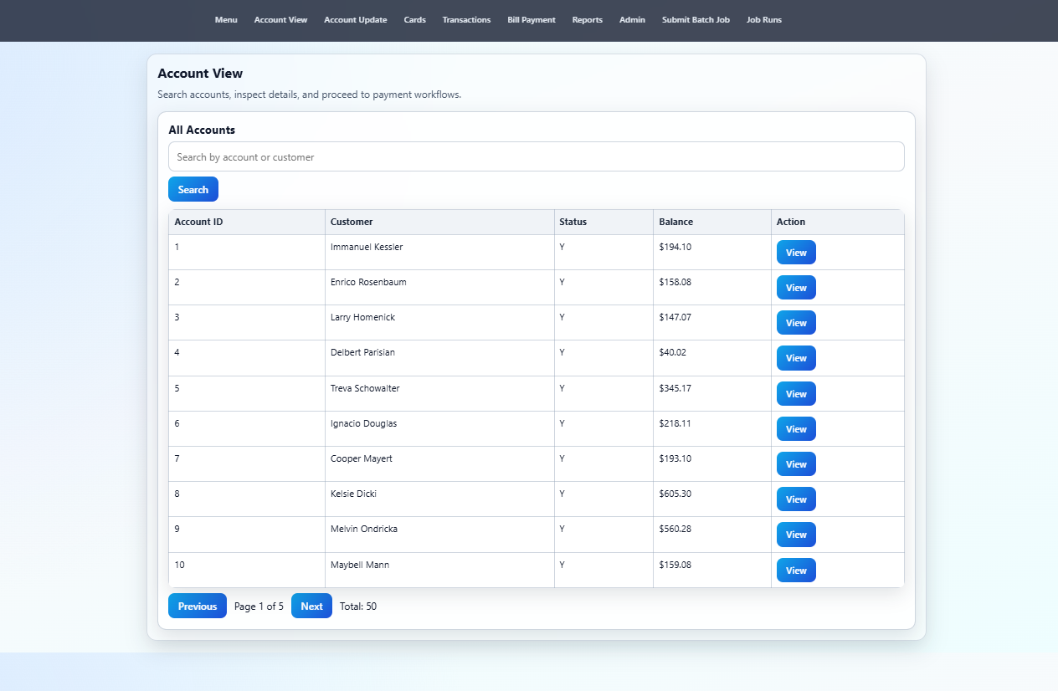

Figure 4: Account Details View
This view displays account and customer details on a single page. Users can initiate payments or edit customer information directly.

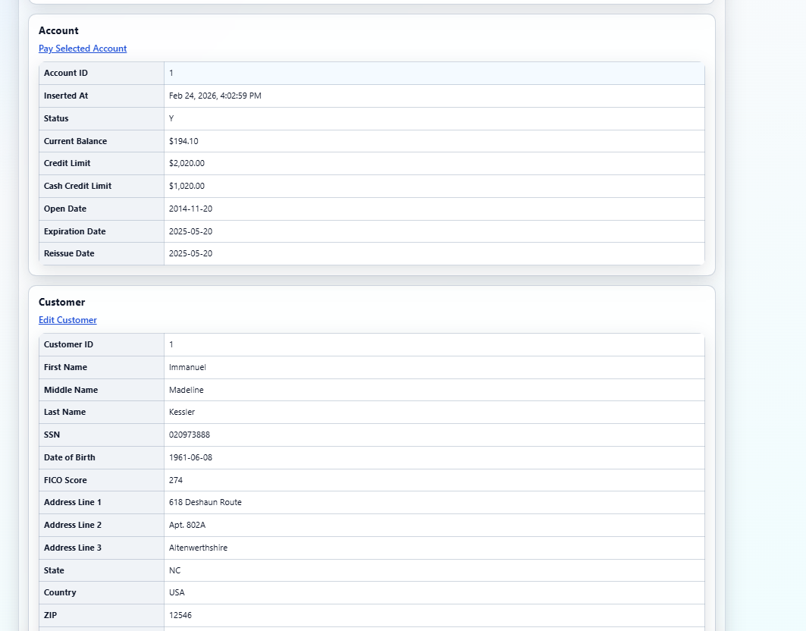

Figure 5: Account Update Page
Authorized users can update account and customer details. Date fields use calendar controls and input is validated before submission. 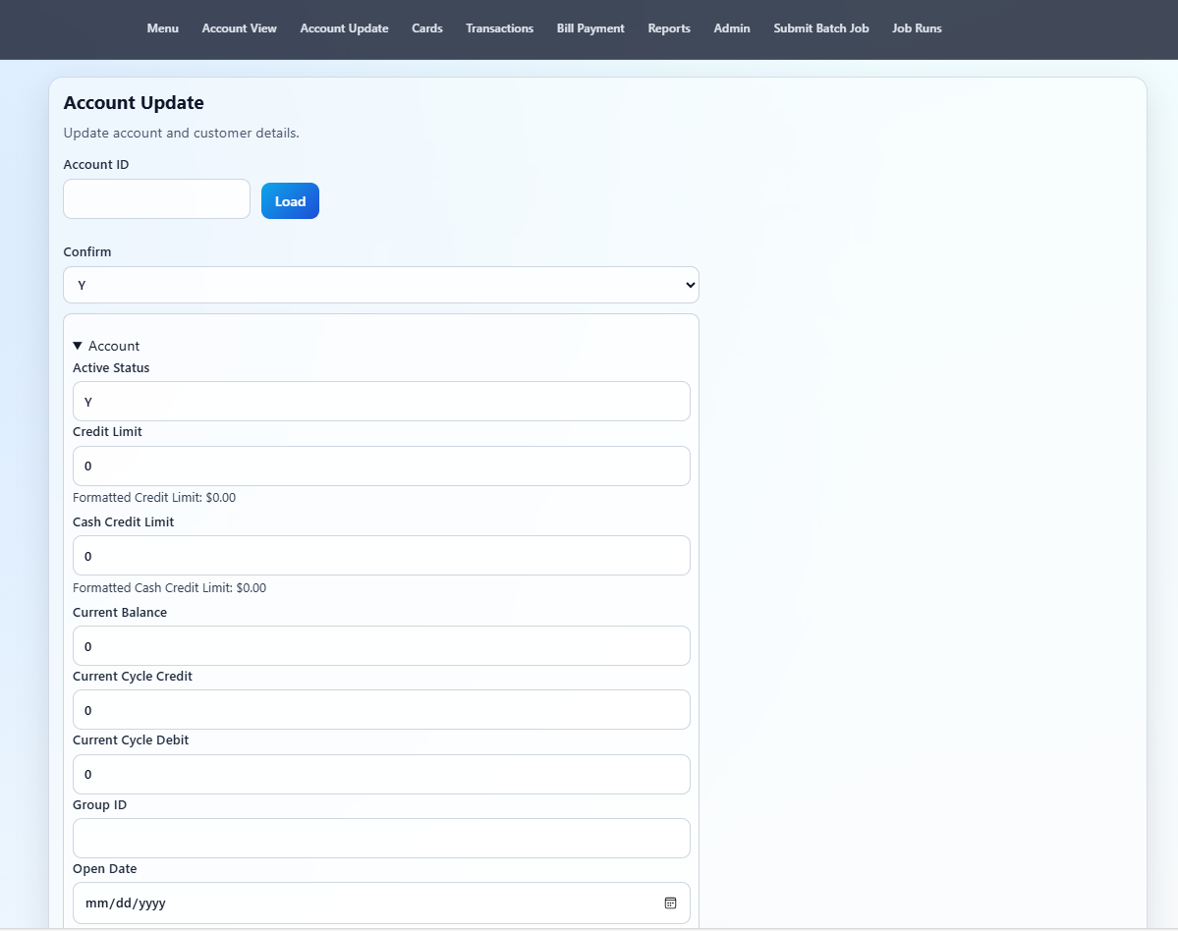

4. Card Management

Figure 6: Card List Page
This page lists all credit cards with pagination and search by account ID. Users can view or edit card details.

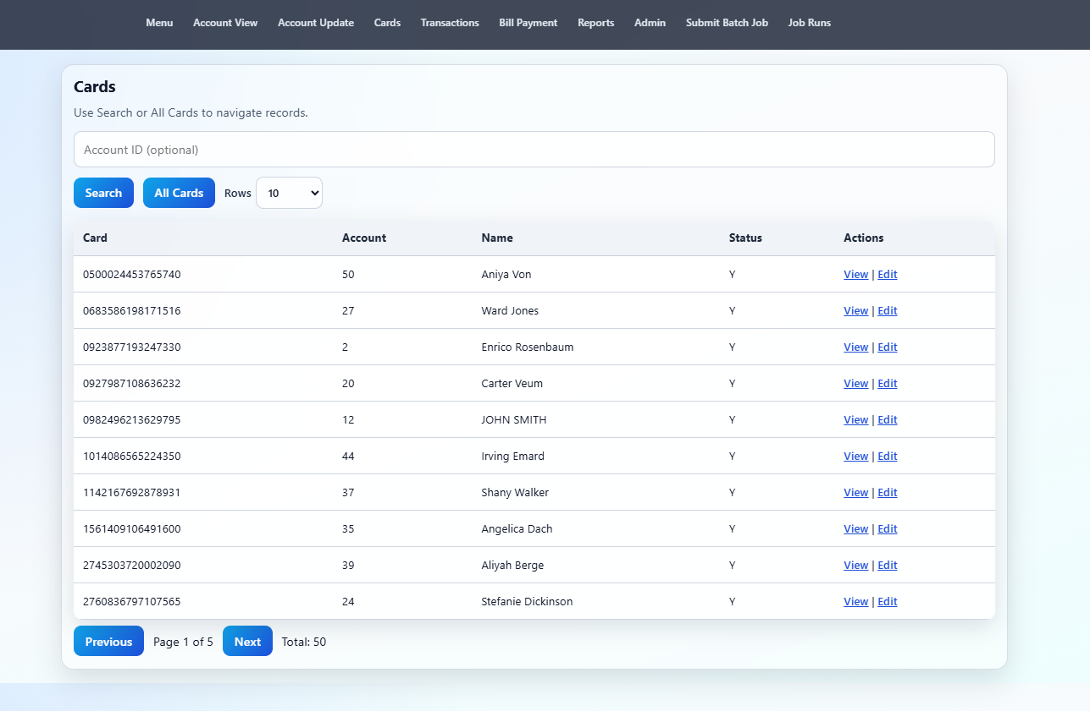

5. Transactions

Figure 7: Transaction Details
Transactions are presented in a consistent table layout, supporting review and navigation across records.

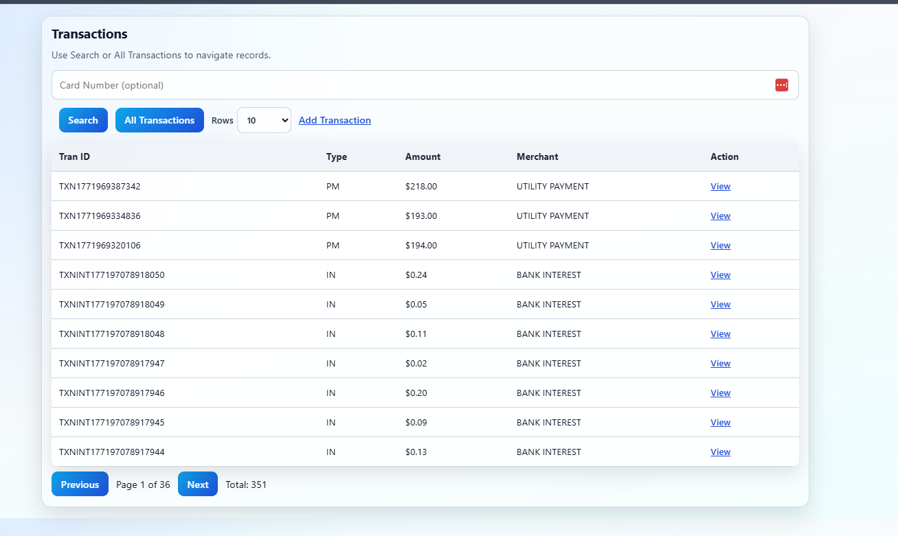

6. Bill Payments

Figure 8: Bill Payment Page
This screen retrieves account balance and card details automatically. If no card exists, users can add and save a new card. 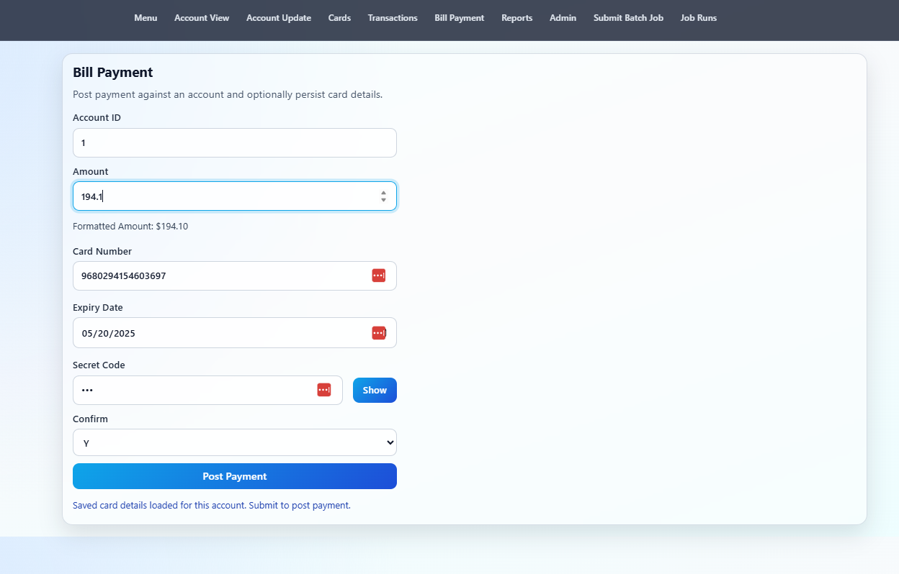

7. Reporting and Batch Processing

Figure 9: Transaction Reports Submission
Users can initiate batch report generation directly from the web interface.

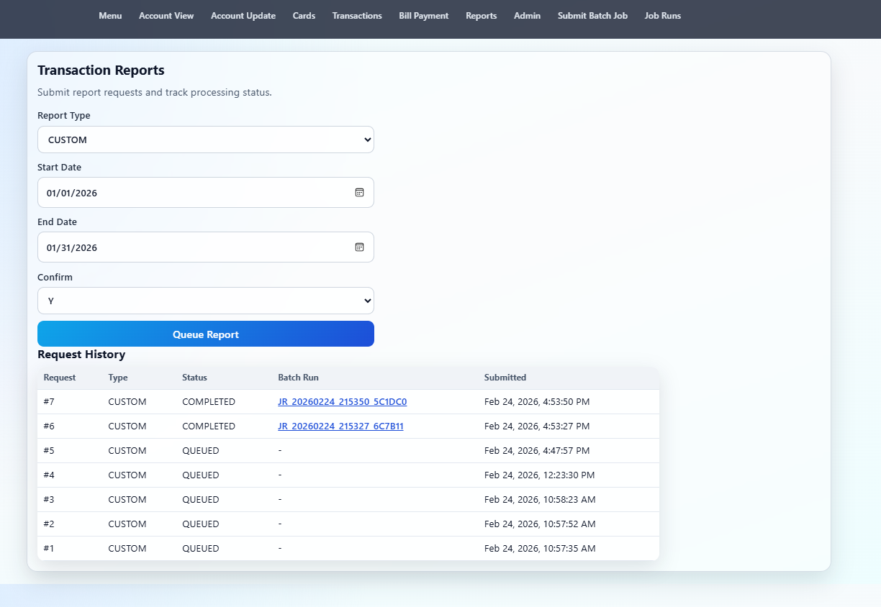

Figure 10: Batch Job Submission
This page allows users to trigger batch jobs manually and view job run history.

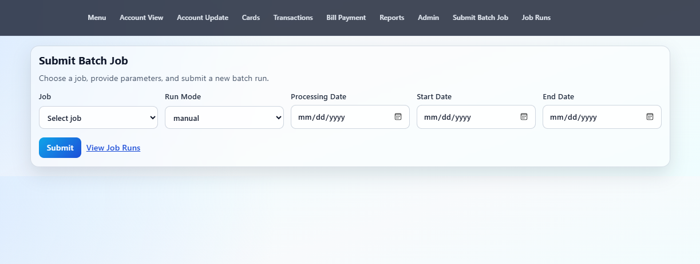

Figure 11: Job Run Details
Detailed execution information is shown, including step status, logs, and generated artifacts.

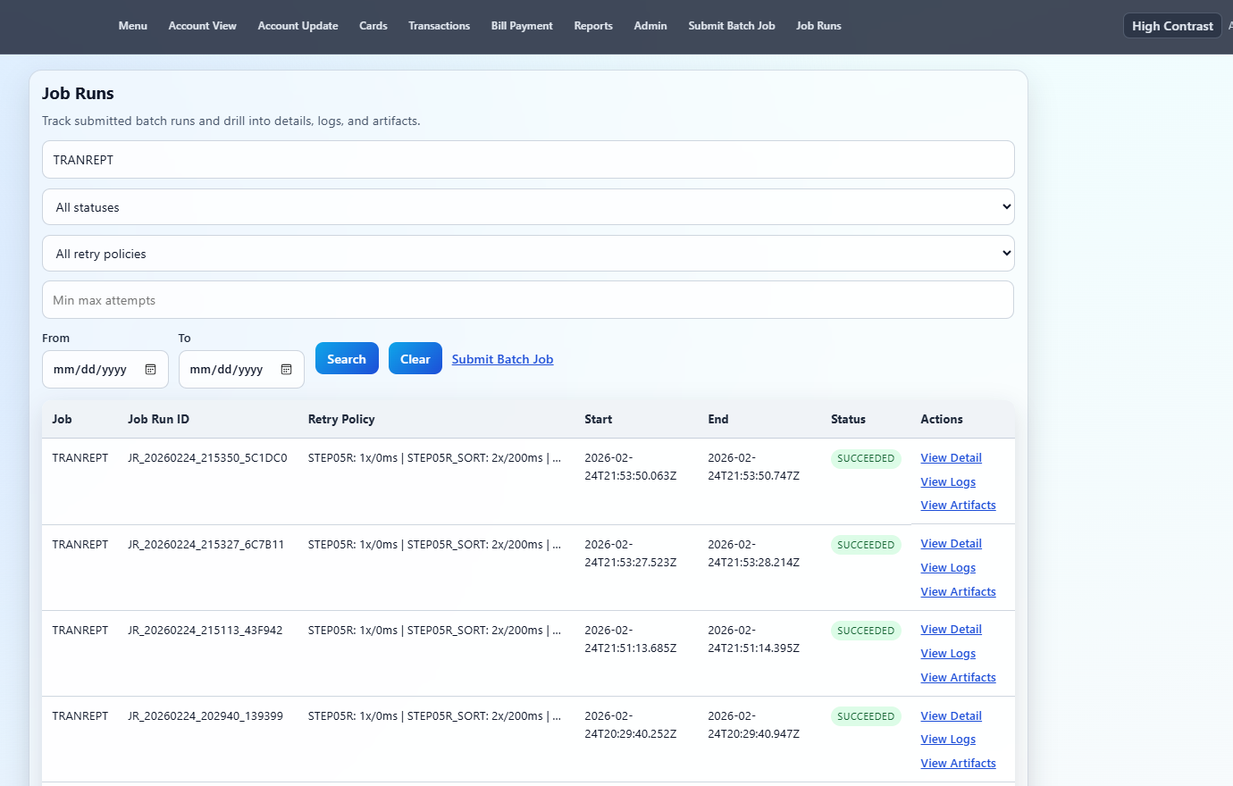

Figure 12: Job Artifacts
Generated reports and output files can be downloaded from this page.
