# INDEX

|  |  |  |  |
| --- | --- | --- | --- |
| Sr. No. | Description | Page  No | Sign |
| 1. | Install Selenium IDE; Write a test suite containing a minimum of 4 test cases for different formats. | 4 |  |
| 2. | Conduct a test suite for any two web sites. | 8 |  |
| 3. | Install the Selenium server (Selenium RC) and demonstrate it using a script in Java/PHP. | 10 |  |
| 4. | Write and test a program to login a specific web page. | 12 |  |
| 5. | Write and Test a program to update 10 student record excel sheets. | 14 |  |
| 6. | Write and test a program to select the no. of students who have scored more than 60 in anyone subject. | 17 |  |
| 7. | Write and test a program to provide the total number of objects present/available on the page. | 20 |  |
| 8. | Write and test a program to get the number of items in a list/combo box. | 22 |  |
| 9. | Write and test a program to count the number of checkboxes on the page checked and unchecked count. | 24 |  |

**Practical No 1**

Aim: Install Selenium IDE; Write a test suite containing a minimum of 4 test cases for different formats

**TEST-1:**

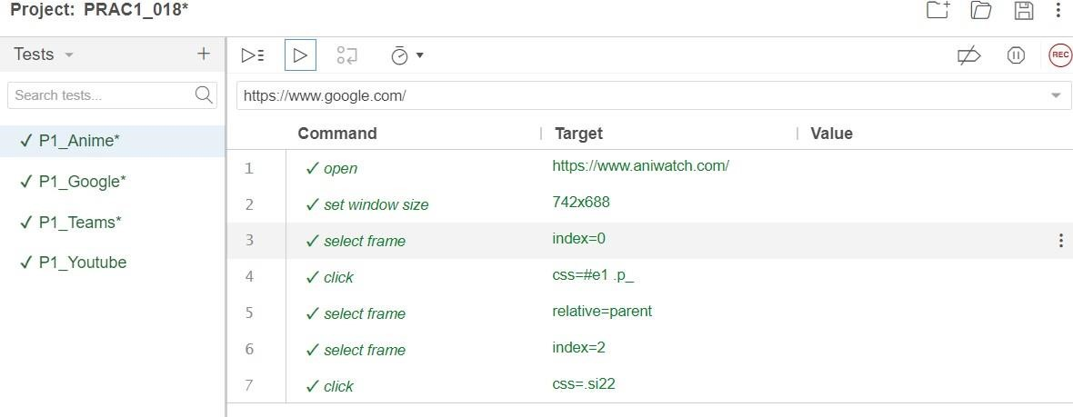

**TEST-2:**

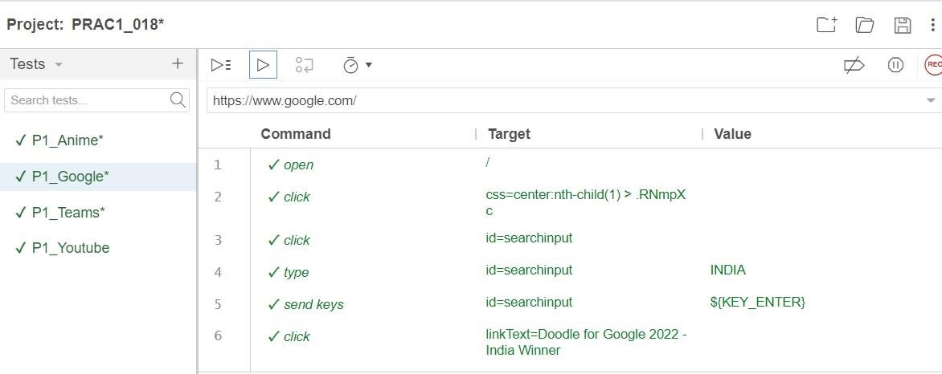

**TEST-3:**

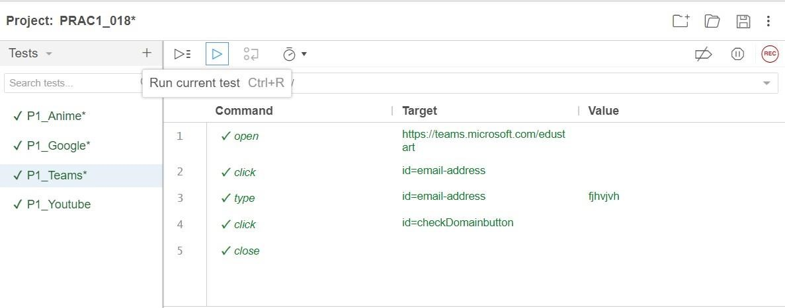

**TEST-4:**

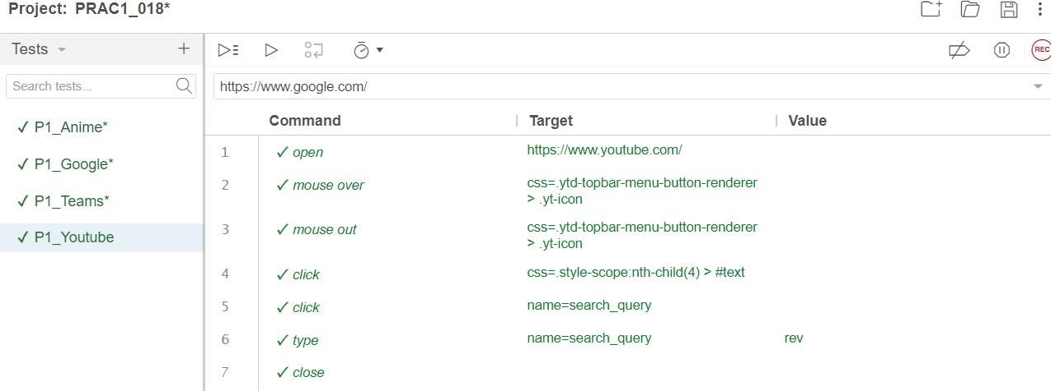

**2**

Conduct a test suite for any two web sites.

**Test 1:**

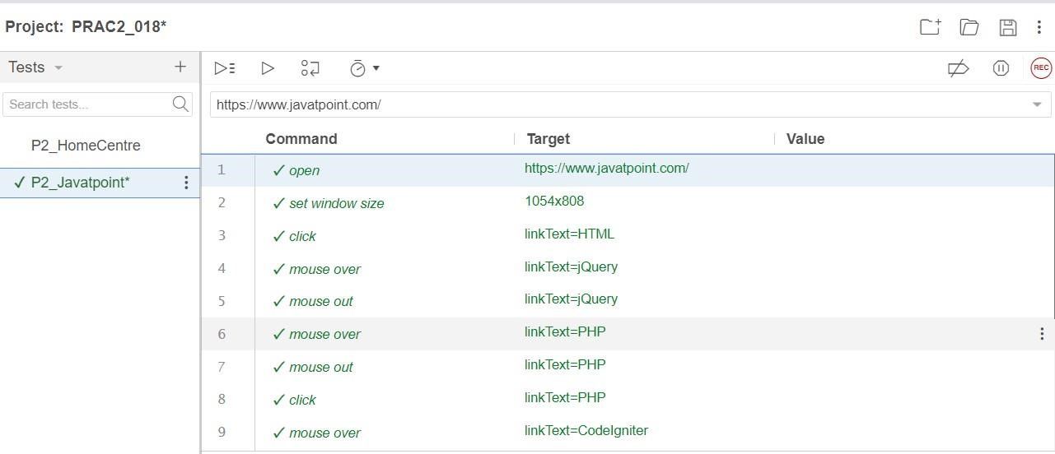

**Test 2:**

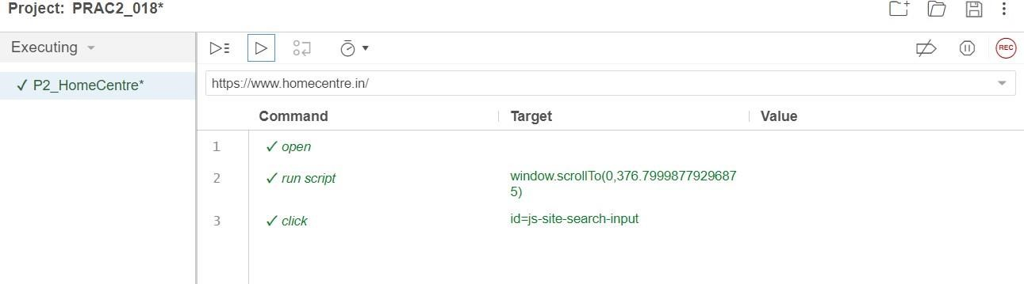

**3**

Install the Selenium server (Selenium RC) and demonstrate it using a script in Java/PHP.

**Code:**

package stqa_prac3;

import java.util.List;

import org.openqa.selenium.By; import org.openqa.selenium.WebDriver;

import org.openqa.selenium.chrome.ChromeDriver;

public class STQA_PRAC3 {

public static void main(String[] args) {

System.setProperty("webdriver.chrome.driver","C:\\Users\\LENOVO\\Downloads\\chromed river-win32_1\\chromedriver-win32\\chromedriver.exe"); WebDriver driver = new ChromeDriver(); driver.get("https://[www.google.com"](http://www.google.com/)); driver.manage().window().maximize();

List lists = driver.findElements(By.xpath("//select/option")); System.out.println("Total no. of lists: " + lists.size());

} }

**4)** Write and test a program to login a specific web page.

**Code:**

package stqa_prac4;

import org.openqa.selenium.By; import org.openqa.selenium.WebDriver;

import org.openqa.selenium.chrome.ChromeDriver;

public class STQA_PRAC4 {

public static void main(String[] args) {

System.setProperty("webdriver.chrome.driver","C:\\Users\\LENOVO\\Downloads\\chromed river-win32_1\\chromedriver-win32\\chromedriver.exe"); WebDriver driver = new ChromeDriver(); driver.get("[http://localhost/login_net.php"](http://localhost/login_net.php)); driver.manage().window().maximize(); driver.findElement(By.id("user")).sendKeys("user"); driver.findElement(By.id("pass")).sendKeys("1234"); driver.findElement(By.id("login")).click(); if(driver.getTitle().contains("welcome")){

System.out.print("Login Successful!");

}

else{

System.out.print("Login Failed!");

}

}

}

**login_net.php :**

**<?php**

**if (isset($_POST['login'])) {**

**$user = $_POST['user'];**

**$pass = $_POST['pass'];**

**if ($user == "User" && $pass == "1234") {**

**echo "<h1>Welcome User</h1>";**

**} else {**

**echo "<h1>Invalid username or password</h1>";**

**}**

**}**

**?>**

**<!DOCTYPE html>**

**<html>**

**<head>**

**<title>Login Page</title>**

**</head>**

**<body>**

**<br><br>**

**<form method="POST">**

**<label for="user">Enter username:</label>**

**<input type="text" name="user" id="user" placeholder="Username" required><br>**

**<label for="pass">Enter password:</label>**

**<input type="password" name="pass" id="pass" placeholder="Password" required><br>**

**<button name="login" id="login" type="submit">Login</button>**

**</form>**

**</body>**

**</html>**

**Output:**

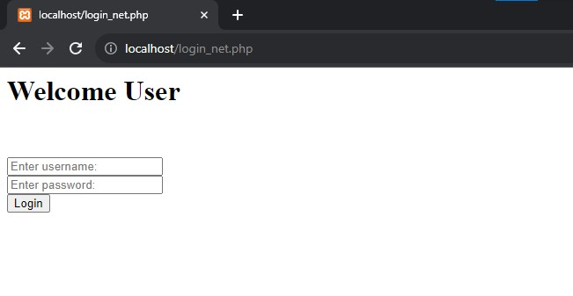

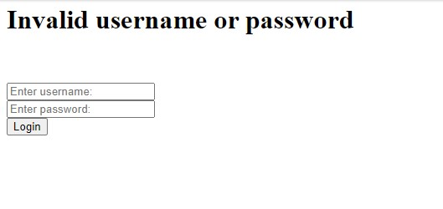

**5**

Write and Test a program to update 10 student record excel sheets.

**Code:**

package stqa_prac5; import java.io.FileInputStream; import java.io.FileNotFoundException; import java.io.FileOutputStream; import java.io.IOException; import jxl.Workbook; import jxl.Sheet;

import jxl.read.biff.BiffException; import jxl.write.Label; import jxl.write.WritableSheet; import jxl.write.WritableWorkbook;

import jxl.write.WriteException;

public class STQA_PRAC5 {

public static void main(String[] args) throws FileNotFoundException, IOException,

BiffException, WriteException {

FileInputStream fi=new FileInputStream("E:\\SEM-5\\STQA\\Student1.xls");

Workbook w= Workbook.getWorkbook(fi);

Sheet s=w.getSheet(0);

String a[][]=new String[s.getRows()][s.getColumns()];

FileOutputStream to=new FileOutputStream("E:\\SEM-5\\STQA\\Student2.xls");

WritableWorkbook wwb=Workbook.createWorkbook(to); WritableSheet ws=wwb.createSheet("result1",0);

for (int i=0;i<s.getRows();i++) {

for (int j=0;j<s.getColumns();j++) { a[i][j]=s.getCell(j,i).getContents(); Label l=new Label(j,i,a[i][j]); ws.addCell(l);

}

}

Label l=new Label(6,0,"Result"); ws.addCell(l); for (int i=1;i<s.getRows();i++){ for (int j=5; j<s.getColumns(); j++ ){ a[i][j]=s.getCell(j,i).getContents(); int x=Integer.parseInt(a[i][j]); if (x/3>35){

Label l1=new Label(6,i,"pass"); ws.addCell(l1);

}

else{

Label l1=new Label(6,i,"fail"); ws.addCell(l1);

break;

}

}

}

wwb.write(); wwb.close();

}

}

**Output:**

**Student1.xls :**

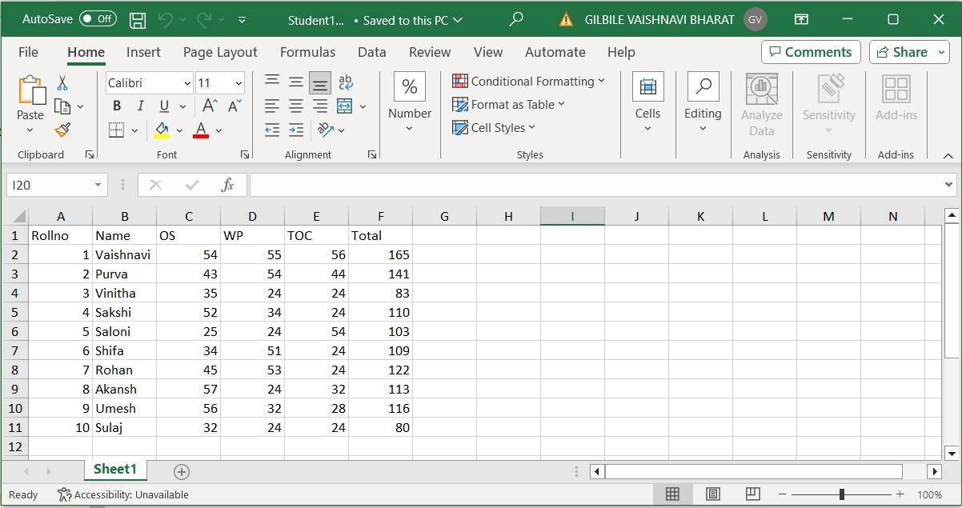

**Student2.xls with pass or fail result :**

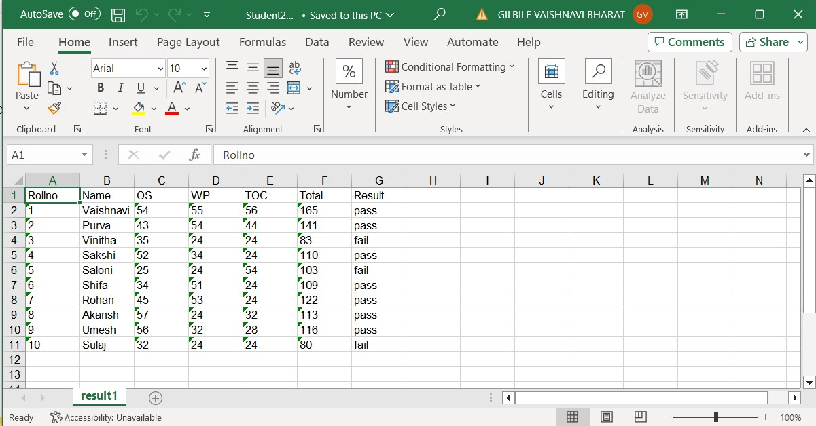

**Practical No 6**

Aim : Write and test a program to select the no. of students who have scored more than 60 in anyone subject.

**Code:**

package stqa_prac6; import java.io.FileInputStream; import java.io.FileNotFoundException; import java.io.FileOutputStream; import java.io.IOException; import jxl.Sheet; import jxl.Workbook; import jxl.read.biff.BiffException; import jxl.write.Label; import jxl.write.WritableSheet; import jxl.write.WritableWorkbook;

import jxl.write.WriteException;

public class STQA_PRAC6 {

public static void main(String[] args) throws FileNotFoundException, IOException,

BiffException, WriteException {

// TODO code application logic here

FileInputStream fi = new FileInputStream("E:\\SEM-5\\STQA\\Marks1.xls");

Workbook w = Workbook.getWorkbook(fi);

Sheet s = w.getSheet(0);

String a[][]= new String[s.getRows()][s.getColumns()];

FileOutputStream fo = new FileOutputStream("E:\\SEM-5\\STQA\\Marks2.xls");

WritableWorkbook wwb = Workbook.createWorkbook(fo);

WritableSheet ws = wwb.createSheet("result1", 0);

System.out.println(); for (int i=0; i<s.getRows(); i++){

String temp[] = new String[s.getColumns()]; boolean flag = false; for(int j=0; j<s.getColumns(); j++){ temp[j] = s.getCell(j,i).getContents(); if(i >= 1 && j>=2 && j<=4){ if(Integer.parseInt(temp[j]) >= 60){ flag = true;

}

}

}

if(flag){

for(int k=0; k<temp.length;k++){ Label l2 = new Label(k,i,temp[k]); ws.addCell(l2);

} }

}

wwb.write(); wwb.close();

}

}

**Marks1.xsl :**

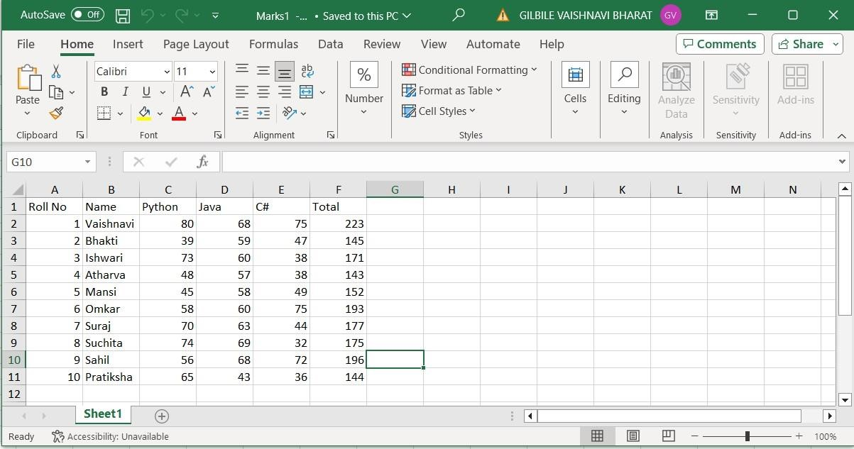

**Marks2.xsl with only 60 marks and above in any one subject :**

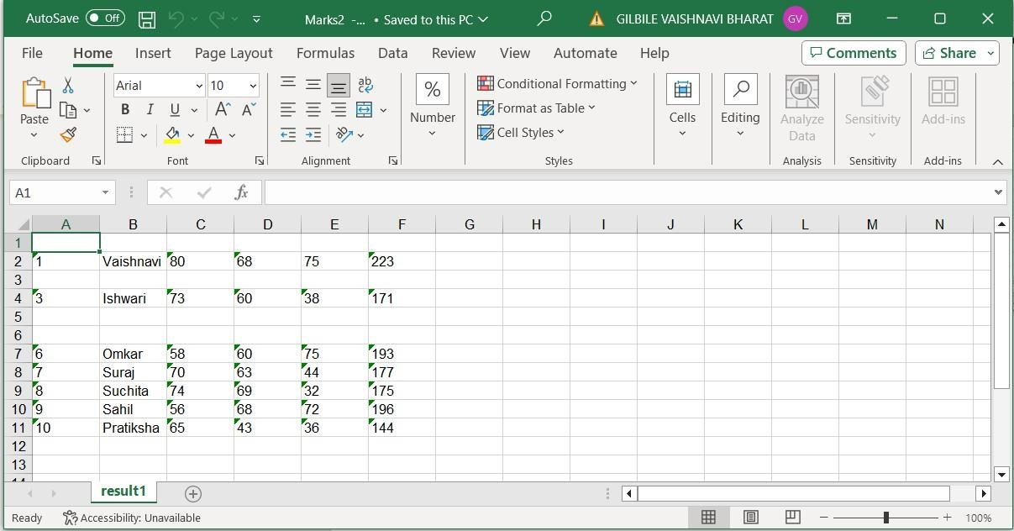

**7**

provide the total number of

objects present/available on the page.

**Code:**

package stqa_prac7;

import java.util.List;

import org.openqa.selenium.By; import org.openqa.selenium.WebDriver; import org.openqa.selenium.WebElement;

import org.openqa.selenium.chrome.ChromeDriver;

public class STQA_PRAC7 {

public static void main(String[] args) {

System.setProperty("webdriver.chrome.driver","C:\\Users\\LENOVO\\Downloads\\chromed river-win32_1\\chromedriver-win32\\chromedriver.exe"); WebDriver driver = new ChromeDriver(); driver.get("[http://www.google.com"](http://www.google.com/)); driver.manage().window().maximize();

List<WebElement> links = driver.findElements(By.tagName("a"));

List<WebElement> buttons = driver.findElements(By.tagName("button"));

List<WebElement> fields = driver.findElements(By.tagName("input"));

System.out.println("Total No. of links = " +links.size());

System.out.println("Total No. of buttons = " +buttons.size()); System.out.println("Total No. of fields = " +fields.size());

driver.quit();

}

}

**8**

get the number of items in a

list/combo box

**Code:**

package stqa_prac8;

import java.util.List;

import org.openqa.selenium.By; import org.openqa.selenium.WebDriver;

import org.openqa.selenium.chrome.ChromeDriver;

public class STQA_PRAC8 {

public static void main(String[] args) {

// TODO code application logic here

System.setProperty("webdriver.chrome.driver","C:\\Users\\LENOVO\\Downloads\\chromed river-win32_1\\chromedriver-win32\\chromedriver.exe"); WebDriver driver = new ChromeDriver(); driver.get("E:\\SEM-5\\STQA\\index.html"); driver.manage().window().maximize();

List list1 = driver.findElements(By.xpath("//select/option"));

List list2 = driver.findElements(By.xpath("//ul/li"));

System.out.println("Total no. of Subjects: " +list2.size());

System.out.println("Total no. of Characters: " +list1.size());

}

**Index.html:**

<!DOCTYPE html>

<html>

<head>

<title>Subjects</title>

</head>

<body>

<h1>Subjects</h1>

<ul>

<li>os</li>

<li>Linux</li>

<li>Python</li>

<li>Java</li>

<li>C++</li>

<li>.NET</li>

</ul>

Choose a Character:

<select>

<option>Nobita</option>

<option>Doraemon</option>

<option>Shizuka</option>

<option>Dorami</option>

<option>Sunio</option>

</select>

</body>

</html>

**9**

count the number of checkboxes

on the page checked and unchecked count

**Code:**

package stqa_prac9;

import java.util.List;

import org.openqa.selenium.By; import org.openqa.selenium.WebDriver;

import org.openqa.selenium.WebElement;

public class STQA_PRAC9 {

public static void main(String[] args) {

// TODO code application logic here]

System.setProperty("webdriver.chrome.driver","C:\\Users\\LENOVO\\Downloads\\chromed river-win32_1\\chromedriver-win32\\chromedriver.exe");

WebDriver driver = new org.openqa.selenium.chrome.ChromeDriver(); driver.get("E:\\SEM-5\\STQA\\PRAC_9.html"); driver.manage().window().maximize();

List<WebElement> check = driver.findElements(By.xpath("//input[@type='checkbox']")); System.out.println("Total no of checkboxes : " + check.size());

int checked_Count=0,unchecked_Count=0;

for(int i=0;i<check.size();i++)

{

if(check.get(i).isSelected())

{

checked_Count++;

}

else

{

unchecked_Count++;

}

}

System.out.println("Number of selected checkboxes are : "+checked_Count);

System.out.println("Number of unselected checkboxes are : "+unchecked_Count);

}

}

**PRAC_9.html:**

<!DOCTYPE html>

<html>

<body>

<input type="checkbox" checked>BMM<br>

<input type="checkbox">IT<br>

<input type="checkbox">MBA<br>

<input type="checkbox" checked>CS<br>

<input type="checkbox">BMS<br>

<input type="checkbox" checked>MCA<br>

</body>

</html>