**CS434 Fall 2023**

**HOMEWORK 3**

General Instructions.

Read this carefully.

This is more important than the individual questions.

There are NO GROUP HOMEWORKS IN THIS CLASS. YOU NEED TO WORK ALONE.

1) Do not copy code from any other person. You can ask questions and get answers, but NEVER copy code. Also do not copy and paste English text unless I specifically permit it. NEVER.

2) Save this file. All questions will be in boxes like this. Put your answer to every question into the space AFTER and OUTSIDE of the box. Then submit the whole file.

3) SHOW EVERYTHING. **Anything you don't show will be automatically assumed as not done.** Don't logically argue that "of course you must have done it." If we don't see it, then it is not done.

4) The whole homework is worth 50 points.

Points will appear in [ ] brackets.

If you miss the due date by up to one week, there will be a late penalty of 8 points subtracted.

If you miss the due date by MORE than a week you will get ZERO points.

The due date is  **Tuesday, November 20 at 4:00 PM.**

**Your file name must have the format:**

**LASTNAME_firstname_HWK3.doc (or .docx)**

1-a) Go to: <https://ephtracking.cdc.gov/>

Click on Explore Data

**STEP 1: CONTENT**

Click on “Select Content Area” so that you get “Chronic Obstructive Pulmonary Disease (COPD)”.

Choose “Mortality from COPD” on the second drop-down menu.

Choose “Crude Death Rate from COPD among people >= 25 years of age per 100,000 population” on the third drop-down menu.

**STEP 2: GEOGRAPHY TYPE**

National by State

**STEP 3: GEOGRAPHY**

All States.

**STEP 4: TIME**

Choose all these 4 years:

2017, 2018, 2019, 2020

**STEP 5: ADVANCED OPTIONS**

Race Ethnicity

All 4 Choices for Race

Then download the data and save it as a COPD4YEARS.CSV file [1 point].

Replace all “Suppressed” values in the VALUE column to NULL.

**b)** Load the Cleaned Data into an Oracle Table COPD4YEARS using SQL Developer.   
Write an SQL statement to display the COPD4YEARS table.

► SELECT * FROM COPD4YEARS

After the first red arrow below, show a screen dump that shows the select statement and at least the first 20 lines for the table. [2]

► 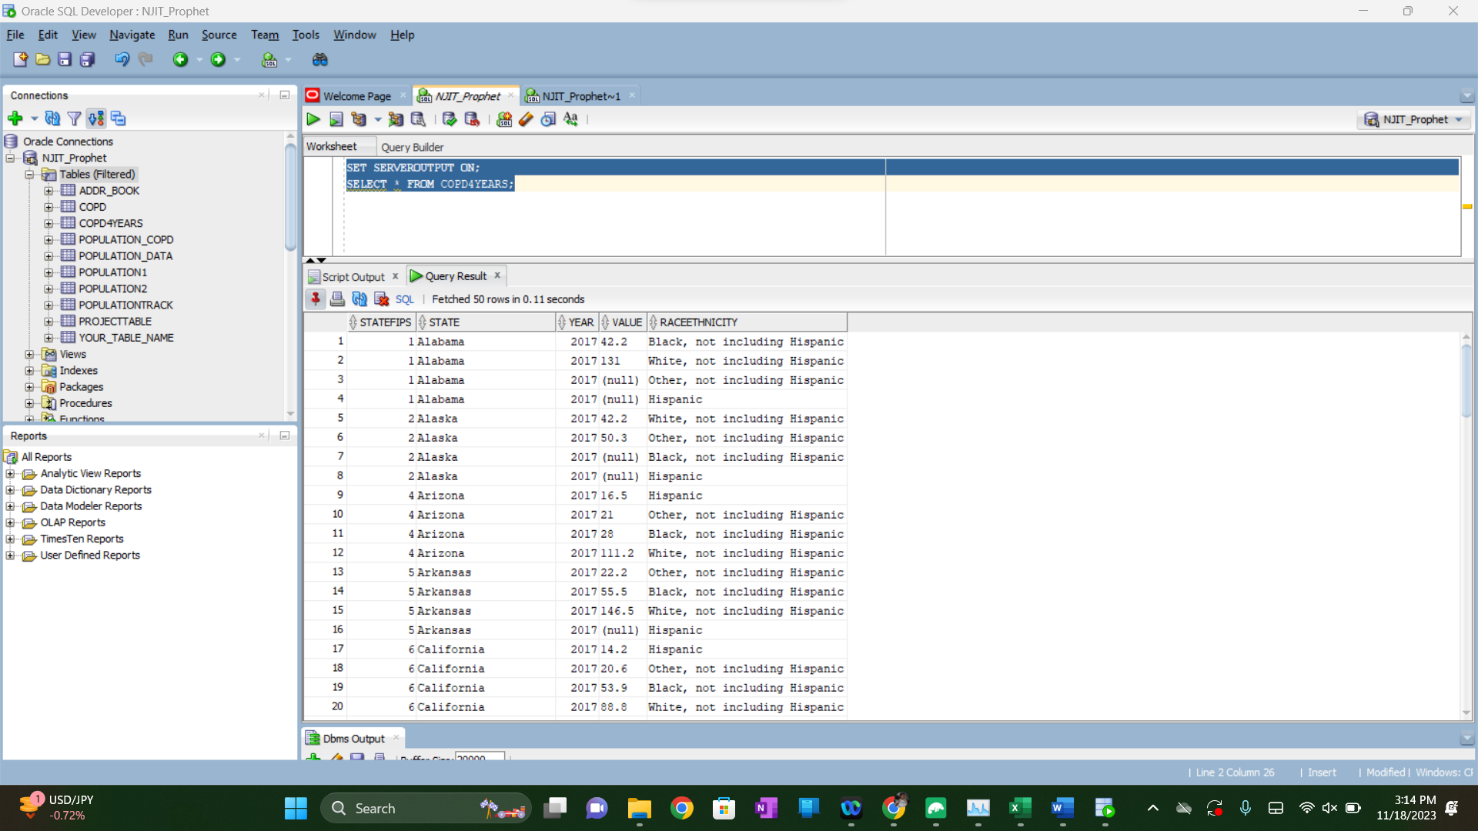

**c)** Create an Oracle Class **race_o** from the COPD4YEARS table with the following attributes; White, Black, Hispanic, and Others

Show the code for the types after the second red arrow. [1]

► CREATE OR REPLACE TYPE race_o AS OBJECT (

White NUMBER,

Black NUMBER,

Hispanic NUMBER,

Others NUMBER

);

►

**d)** Create a table **COPDobject** with **State** attribute data type of VARCHAR2(26) and four attributes with (data type of race_o) named Year2017, Year2018, year2019, and Year2020 respectively.

Show the code for the table after the third red arrow [1].

► CREATE TABLE COPDobject (

State VARCHAR2(26),

Year2017 race_o,

Year2018 race_o,

Year2019 race_o,

Year2020 race_o

);

**2) a)** Write a PL/SQL program using an **implicit** cursor that inserts into a **COPDobject** table all states’ names and each year all race data.

Show the program after the first red arrow.

► DECLARE

v_year_2017 race_o;

v_year_2018 race_o;

v_year_2019 race_o;

v_year_2020 race_o;

v_current_state VARCHAR2(100);

v_previous_state VARCHAR2(100) := NULL;

FUNCTION reset_race_o RETURN race_o IS

BEGIN

RETURN race_o(0, 0, 0, 0);

END reset_race_o;

BEGIN

FOR rec IN (SELECT State, Year, Value, RACEETHNICITY FROM COPD4YEARS ORDER BY State, Year, RACEETHNICITY) LOOP

v_current_state := rec.State;

IF v_current_state != v_previous_state AND v_previous_state IS NOT NULL THEN

INSERT INTO COPDobject (State, Year2017, Year2018, Year2019, Year2020)

VALUES (v_previous_state, v_year_2017, v_year_2018, v_year_2019, v_year_2020);

v_year_2017 := reset_race_o;

v_year_2018 := reset_race_o;

v_year_2019 := reset_race_o;

v_year_2020 := reset_race_o;

END IF;

IF rec.Year = 2017 THEN

v_year_2017 := race_o(

CASE WHEN rec.RACEETHNICITY = 'White, not including Hispanic' THEN NVL(rec.Value, 0) ELSE v_year_2017.White END,

CASE WHEN rec.RACEETHNICITY = 'Black, not including Hispanic' THEN NVL(rec.Value, 0) ELSE v_year_2017.Black END,

CASE WHEN rec.RACEETHNICITY = 'Hispanic' THEN NVL(rec.Value, 0) ELSE v_year_2017.Hispanic END,

CASE WHEN rec.RACEETHNICITY = 'Other, not including Hispanic' THEN NVL(rec.Value, 0) ELSE v_year_2017.Others END

);

ELSIF rec.Year = 2018 THEN

v_year_2018 := race_o(

CASE WHEN rec.RACEETHNICITY = 'White, not including Hispanic' THEN NVL(rec.Value, 0) ELSE v_year_2018.White END,

CASE WHEN rec.RACEETHNICITY = 'Black, not including Hispanic' THEN NVL(rec.Value, 0) ELSE v_year_2018.Black END,

CASE WHEN rec.RACEETHNICITY = 'Hispanic' THEN NVL(rec.Value, 0) ELSE v_year_2018.Hispanic END,

CASE WHEN rec.RACEETHNICITY = 'Other, not including Hispanic' THEN NVL(rec.Value, 0) ELSE v_year_2018.Others END

);

ELSIF rec.Year = 2019 THEN

v_year_2019 := race_o(

CASE WHEN rec.RACEETHNICITY = 'White, not including Hispanic' THEN NVL(rec.Value, 0) ELSE v_year_2019.White END,

CASE WHEN rec.RACEETHNICITY = 'Black, not including Hispanic' THEN NVL(rec.Value, 0) ELSE v_year_2019.Black END,

CASE WHEN rec.RACEETHNICITY = 'Hispanic' THEN NVL(rec.Value, 0) ELSE v_year_2019.Hispanic END,

CASE WHEN rec.RACEETHNICITY = 'Other, not including Hispanic' THEN NVL(rec.Value, 0) ELSE v_year_2019.Others END

);

ELSIF rec.Year = 2020 THEN

v_year_2020 := race_o(

CASE WHEN rec.RACEETHNICITY = 'White, not including Hispanic' THEN NVL(rec.Value, 0) ELSE v_year_2020.White END,

CASE WHEN rec.RACEETHNICITY = 'Black, not including Hispanic' THEN NVL(rec.Value, 0) ELSE v_year_2020.Black END,

CASE WHEN rec.RACEETHNICITY = 'Hispanic' THEN NVL(rec.Value, 0) ELSE v_year_2020.Hispanic END,

CASE WHEN rec.RACEETHNICITY = 'Other, not including Hispanic' THEN NVL(rec.Value, 0) ELSE v_year_2020.Others END

);

END IF;

v_previous_state := v_current_state;

END LOOP;

IF v_previous_state IS NOT NULL THEN

INSERT INTO COPDobject (State, Year2017, Year2018, Year2019, Year2020)

VALUES (v_previous_state, v_year_2017, v_year_2018, v_year_2019, v_year_2020);

END IF;

END;

Show the first 10 rows of the result at the second red arrow by snipping them. [10]

► Output after iterating each race_o object:

And ouput as table itself (but sqldeveloper didn’t let me display race_o object in its format. Rather it used my accountName.race_o as:

b) Write a PL/SQL program using an **implicit** cursor that displays information about all states in the table **COPDobject** in a nice format. Use rpad().

Your output should look like this:

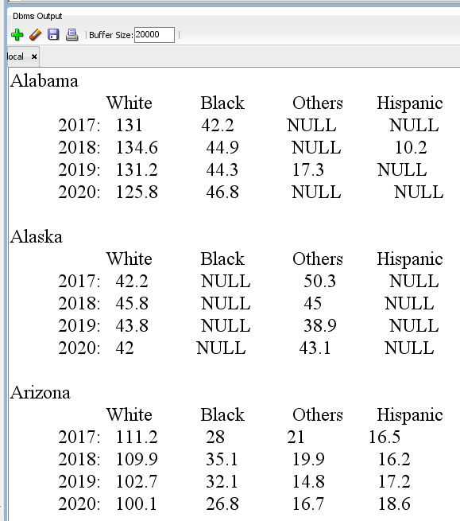

Show the program at the third red arrow.

Show the output of the first three state data **COPDobject** table at the fourth red arrow, the last three state data at the fifth red arrow by snipping them [10].

► DECLARE

CURSOR copd_cursor IS

SELECT State,

Year2017, Year2018, Year2019, Year2020

FROM COPDobject;

rec copd_cursor%ROWTYPE;

FUNCTION zero_to_null(p_value IN NUMBER) RETURN VARCHAR2 IS

BEGIN

IF p_value = 0 THEN

RETURN 'NULL';

ELSE

RETURN TO_CHAR(p_value);

END IF;

END zero_to_null;

BEGIN

FOR rec IN copd_cursor LOOP

DBMS_OUTPUT.PUT_LINE(rec.State);

DBMS_OUTPUT.PUT_LINE(RPAD(' ', 5) || 'White' || RPAD(' ', 4) || 'Black' || RPAD(' ', 4) || 'Others' || RPAD(' ', 4) || 'Hispanic');

DBMS_OUTPUT.PUT_LINE('2017: ' || RPAD(zero_to_null(rec.Year2017.White), 10) || RPAD(zero_to_null(rec.Year2017.Black), 10) || RPAD(zero_to_null(rec.Year2017.Others), 10) || RPAD(zero_to_null(rec.Year2017.Hispanic), 10));

DBMS_OUTPUT.PUT_LINE('2018: ' || RPAD(zero_to_null(rec.Year2018.White), 10) || RPAD(zero_to_null(rec.Year2018.Black), 10) || RPAD(zero_to_null(rec.Year2018.Others), 10) || RPAD(zero_to_null(rec.Year2018.Hispanic), 10));

DBMS_OUTPUT.PUT_LINE('2019: ' || RPAD(zero_to_null(rec.Year2019.White), 10) || RPAD(zero_to_null(rec.Year2019.Black), 10) || RPAD(zero_to_null(rec.Year2019.Others), 10) || RPAD(zero_to_null(rec.Year2019.Hispanic), 10));

DBMS_OUTPUT.PUT_LINE('2020: ' || RPAD(zero_to_null(rec.Year2020.White), 10) || RPAD(zero_to_null(rec.Year2020.Black), 10) || RPAD(zero_to_null(rec.Year2020.Others), 10) || RPAD(zero_to_null(rec.Year2020.Hispanic), 10));

DBMS_OUTPUT.PUT_LINE('-------------------------------------------');

END LOOP;

END;

SET SERVEROUTPUT ON;

**3**- Write a PL/SQL program using an **implicit cursor** that loads all the data from the POPULATION2 (from Homework1) table into the POPULATIONXML table.

To clarify: POPULATIONXML has to have all rows with the following information from POPULATION2, but in a single column, as XML expressions.

STATE, WHITE, AFRICANAMERICAN, MULTIRACIAL, OTHER for

WHITE>1,000,000 and AFRICANAMERICAN >10,000 and MULTIRACIAL>50,000

HINTS: Students usually have a really hard time with this.

You need to construct the XML expression from strings with lots of concatenation (||) operators.

'<population>

<STATE>' || variablefromcursorwithSTATEinit || '</STATE>

<WHITE>' || variablefromcursorwithWHITEinit || </WHITE>'

Etc. etc.

Show the POPULATIONXML table creation statement at the first red arrow below [1 point].

Show the INDENTED program to insert data with cursor at the second red arrow below [6].

► DECLARE

CURSOR pop_cursor IS

SELECT STATE,

WHITE,

BLACK_OR_AFRICAN_AMERICAN,

MIXED_RACE_MULTI_RACIAL,

OTHER2

FROM POPULATION2

WHERE WHITE > 1000000

AND BLACK_OR_AFRICAN_AMERICAN > 10000

AND MIXED_RACE_MULTI_RACIAL > 50000;

v_xml_expression VARCHAR2(4000);

BEGIN

FOR rec IN pop_cursor LOOP

v_xml_expression :=

'<population>' ||

'<STATE>' || rec.STATE || '</STATE>' ||

'<WHITE>' || rec.WHITE || '</WHITE>' ||

'<AFRICANAMERICAN>' || rec.BLACK_OR_AFRICAN_AMERICAN || '</AFRICANAMERICAN>' ||

'<MULTIRACIAL>' || rec.MIXED_RACE_MULTI_RACIAL || '</MULTIRACIAL>' ||

'<OTHER>' || rec.OTHER2 || '</OTHER>' ||

'</population>';

INSERT INTO POPULATIONXML (PopulationData)

VALUES (v_xml_expression);

END LOOP;

END;

**4**- Write a PL/SQL program that uses ONLY the table POPULATIONXML and does NOT use the table POPULATION2 or any other table or any other view. Zero points if you do not follow these rules.

This program should send the complete table POPULATIONXML to the screen in the following format:

STATE : Alabama

White : 3171351

African American : 1288159

Multiracial : 184618

Others : 116104

STATE : Arizona

White : 3816547

African American : 317161

Multiracial : 266840

Others : 558701

STATE : Arkansas

White : 2063550

African American : 449884

Multiracial : 147157

Others : 94086

STATE : California

Etc. etc.

Note the empty line. There has to be an empty line after every new table row. Every table row becomes 5 lines + 1 empty line after.

Note that all the ":" are lined up in the same column. It has to be that way.

Show the program at the first red arrow below.

Show the first 12 lines of the result at the second red arrow below [6 points].

► DECLARE

CURSOR xml_cursor IS

SELECT PopulationData

FROM POPULATIONXML;

v_xml CLOB;

v_state VARCHAR2(100);

v_white NUMBER;

v_african_american NUMBER;

v_multiracial NUMBER;

v_others NUMBER;

BEGIN

FOR rec IN xml_cursor LOOP

v_xml := rec.PopulationData;

SELECT EXTRACTVALUE(XMLTYPE(v_xml), '/population/STATE') INTO v_state FROM DUAL;

SELECT EXTRACTVALUE(XMLTYPE(v_xml), '/population/WHITE') INTO v_white FROM DUAL;

SELECT EXTRACTVALUE(XMLTYPE(v_xml), '/population/AFRICANAMERICAN') INTO v_african_american FROM DUAL;

SELECT EXTRACTVALUE(XMLTYPE(v_xml), '/population/MULTIRACIAL') INTO v_multiracial FROM DUAL;

SELECT EXTRACTVALUE(XMLTYPE(v_xml), '/population/OTHER') INTO v_others FROM DUAL;

DBMS_OUTPUT.PUT_LINE('STATE : ' || RPAD(v_state, 20));

DBMS_OUTPUT.PUT_LINE(RPAD('White', 25) || ': ' || v_white);

DBMS_OUTPUT.PUT_LINE(RPAD('African American', 25) || ': ' || v_african_american);

DBMS_OUTPUT.PUT_LINE(RPAD('Multiracial', 25) || ': ' || v_multiracial);

DBMS_OUTPUT.PUT_LINE(RPAD('Others', 25) || ': ' || v_others);

DBMS_OUTPUT.PUT_LINE('');

END LOOP;

END;

**5-** Create a table POPULATION_JSON in Oracle. It should contain a single column POPULATION that contains STATE, WHITE, AFRICANAMERICAN, MULTIRACIAL, OTHER attributes of POPULATION2.

Then, write a PL/SQL program using an **implicit cursor** that loads all the data from the POPULATION2 table into the POPULATION_JSON.

Show the POPULATION_JSON table creation statement at the first red arrow below [1 point].

Show the INDENTED program to insert data with cursor at the second red arrow below [5].

► DECLARE

CURSOR pop_cursor IS

SELECT STATE,

WHITE,

BLACK_OR_AFRICAN_AMERICAN,

MIXED_RACE_MULTI_RACIAL,

OTHER2

FROM POPULATION2;

v_json CLOB;

BEGIN

FOR rec IN pop_cursor LOOP

v_json :=

'{' ||

'"state": "' || rec.STATE || '",' ||

'"white": ' || rec.WHITE || ',' ||

'"africanAmerican": ' || rec.BLACK_OR_AFRICAN_AMERICAN || ',' ||

'"multiracial": ' || rec.MIXED_RACE_MULTI_RACIAL || ',' ||

'"other": ' || rec.OTHER2 ||

'}';

INSERT INTO POPULATION_JSON (Population)

VALUES (v_json);

END LOOP;

END;

**6-** Write a program **using a cursor** that displays the complete table POPULATION_JSON on the screen in the following format. NOTE THE NEWLINES.

STATE : Alabama

White : 3171351

African American : 1288159

Multiracial : 184618

Others : 116104

STATE : Arizona

White : 3816547

African American : 317161

Multiracial : 266840

Others : 558701

Etc…etc….

Every table row (i.e., JSON expression) becomes five rows followed by an empty row.

Show the program at the first red arrow below.

Show the first 12 lines of the result at the second red arrow below [6 points]

► DECLARE

CURSOR json_cursor IS

SELECT Population

FROM POPULATION_JSON;

v_state VARCHAR2(100);

v_white VARCHAR2(100);

v_african_american VARCHAR2(100);

v_multiracial VARCHAR2(100);

v_others VARCHAR2(100);

FUNCTION get_json_value(json_data IN CLOB, key IN VARCHAR2) RETURN VARCHAR2 IS

v_start_pos PLS_INTEGER;

v_end_pos PLS_INTEGER;

BEGIN

v_start_pos := INSTR(json_data, '"' || key || '": ') + LENGTH(key) + 4;

IF v_start_pos > LENGTH(key) + 4 THEN

v_end_pos := INSTR(json_data, ',', v_start_pos);

IF v_end_pos = 0 THEN

v_end_pos := INSTR(json_data, '}', v_start_pos);

END IF;

RETURN TRIM(BOTH '"' FROM SUBSTR(json_data, v_start_pos, v_end_pos - v_start_pos));

ELSE

RETURN NULL;

END IF;

END get_json_value;

BEGIN

FOR rec IN json_cursor LOOP

v_state := get_json_value(rec.Population, 'state');

v_white := get_json_value(rec.Population, 'white');

v_african_american := get_json_value(rec.Population, 'africanAmerican');

v_multiracial := get_json_value(rec.Population, 'multiracial');

v_others := get_json_value(rec.Population, 'other');

DBMS_OUTPUT.PUT_LINE('STATE : ' || v_state);

DBMS_OUTPUT.PUT_LINE(RPAD('White', 25) || ': ' || v_white);

DBMS_OUTPUT.PUT_LINE(RPAD('African American', 25) || ': ' || v_african_american);

DBMS_OUTPUT.PUT_LINE(RPAD('Multiracial', 25) || ': ' || v_multiracial);

DBMS_OUTPUT.PUT_LINE(RPAD('Others', 25) || ': ' || v_others);

DBMS_OUTPUT.PUT_LINE('');

END LOOP;

END;

►