Hospital Readmission Risk Prediction Using Explainable Machine Learning

Hospital Readmission Risk Prediction Using Explainable Machine Learning
V.G.PRAKUL
23BCE1548

Project aim
I built this project to explore whether the details available at hospital discharge after a clinic visit, could help identify whether the patient will be admitted again to the hospital within 30 days. The work uses a public dataset of encounters involving patients with diabetes. After applying the project's discharge rules, 99,319 encounters remained. I kept each patient's records in one data partition, compared several models, and saved the selected pipeline for use in a Streamlit app.
Among the models tested, Histogram Gradient Boosting achieved the highest average precision in the training comparison. On the separate test set, it reached ROC-AUC of 0.671, recall of 69.58%, and precision of 15.89%. It flagged almost half of the encounters. This result is central to the project: the model finds useful patterns, but the number of false alarms limits what can be concluded about practical and clinical use. The app lets a user enter encounter details, see the prediction, and understand the features that contributed to it.
The aim was to complete and understand the whole workflow, from checking hospital records to publishing a working prediction tool. I wanted to see which of the tested models performed best, how the threshold affected its decisions, and whether the result could be explained clearly. The app is an educational demonstration and has not been validated for medical decisions.
Live application: https://prakul-readmission-explorer.streamlit.app/
Source code: https://github.com/vgprakul/hospital-readmission-prediction

Abstract
This project examines whether information available at discharge can help predict early hospital readmission among patients with diabetes. It uses the UCI Diabetes 130-US Hospitals dataset, which contains 101,766 encounters recorded between 1999 and 2008. An encounter represents one hospitalization, and a patient may have several encounters. After excluding death, hospice, and records with an unclear completed discharge, 99,319 encounters from 69,980 patients remained. Early readmission occurred in about 11% of eligible encounters, making the positive outcome much less common than the negative outcome making this a very imbalanced dataset.
Patients were divided into training, validation, and test sets, with all records for a patient kept together to avoid data leakage. Missing values, categorical encoding, and numerical scaling were handled within each training fold. Additional features summarized previous visits and diabetes medication use, while diagnosis codes were grouped into broader categories. Dummy and logistic-regression baselines provided a starting point. Weight-Based Logistic regression, Random Forest, and Histogram Gradient Boosting were then compared using three folds grouped by patient. Gradient boosting achieved the highest mean average precision. Sigmoid calibration did not improve both validation Brier score and log loss, so the original probability estimates were retained.
The selected model and threshold were fixed before evaluation on 14,862 test encounters from 10,497 patients. Test ROC-AUC was 0.6705, average precision was 0.2291, and Brier score was 0.09536. Recall reached 69.58%, but precision was only 15.89%. At the validation-selected threshold of 0.09737941008039629, the model flagged 49.52% of test encounters. Tree SHAP highlighted previous inpatient use and discharge destination as important influences on predictions. The published Streamlit app allows users to enter encounter details, inspect a prediction, and view its explanation alongside the evaluation results.
The results also show the limits of this approach: discrimination is moderate, many flags are false positives, and the data are historical. Newer independent data and a prospective assessment of usefulness would be needed before considering clinical use.
Keywords: hospital readmission; diabetes; patient-grouped validation; gradient boosting; calibration; SHAP; Streamlit.
Contents
Abstract 2
1 Introduction 5
Scope 5
Objectives 5
Methodology and model 5
Expected outcome 5
Introduction conclusion 5
2 Literature Review 6
Readmission prediction studies and reviews 6
Evaluation explainability and reporting 7
Literature synthesis and project contribution 8
3 Methods and Models 9
Prediction task and outcome 9
Workflow and leakage prevention 9
Preprocessing and engineered features 9
Models and fixed configurations 10
Metrics calibration and threshold policy 10
Explainability uncertainty and implementation 11
4 Datasets and Exploratory Data Analysis 12
Dataset provenance and cohort 12
Sample dataset 12
Data quality and missingness 13
EDA interpretation rules 13
Age and readmission 14
Length of stay and readmission 15
Medication count and readmission 16
Previous inpatient visits and readmission 17
Previous emergency visits and readmission 18
5 Results and Discussion 19
Baseline performance on validation data 19
Training cross validation model comparison 19
Calibration candidate assessment 19
Validation threshold tradeoffs 20
Final held out test results 21
Discrimination calibration and uncertainty 22
Model explanations and demographic performance 23
Demographic audit and practical interpretation 24
Published application and software checks 24
6 Conclusion and Future Improvements 25
Conclusion 25
Future improvements 25
7 References 26
Appendix 28
Project links 28
Repository organization 28
Runtime and reproduction 28
Run the published code locally 28
Cohort target and patient grouped partitioning 29
Fold specific preprocessing pipeline 29
Selected gradient boosting configuration 29
Validation recall constrained threshold selection 30
Frozen pipeline inference 30
Explanation consistency check 30
Supporting Evaluation Figures 31

1 Introduction
An early return to hospital can reflect return of illness, failure in properly following the post-cure care, or the ineffectiveness of the medication. Routine records capture only part of this picture. Reviews report modest predictive performance and frequent gaps in social and functional information [2, 10]. A model therefore needs evaluation in relation to the outcome it predicts and the action that follows a flag.
This project asks whether discharge information can help estimate recorded readmission before 30 days. Each eligible hospitalization receives a probability and a threshold-based flag. Since one person may contribute several records, patients are kept together when dividing the data. Their identifiers are then excluded from the predictors.

Scope
This is a retrospective study of the historical UCI dataset, supported by a web application that demonstrates the completed model. The target follows the source label for readmission before 30 days. It does not identify why a patient returns or whether that return could have been prevented. Follow-up across different hospitals may be incomplete. The app therefore serves as an educational tool and does not connect to live health records or recommend treatment.
The implemented models are a prior-probability dummy, ordinary and class-weighted logistic regression, Random Forest, and Histogram Gradient boosting. The final comparison uses engineered features and patient-grouped training folds.

Objectives
- Build a repeatable pipeline that converts encounter details into an estimated probability of recorded early readmission.
- Keep patients separate across data partitions and learn preprocessing steps only from the relevant training data.
- Compare baseline and nonlinear models using average precision, ROC-AUC, and measures of probability error.
- Examine calibration and show how the chosen threshold changes precision, recall, and the number of flags.
- Explain individual predictions and describe performance across demographic groups.
- Publish the model in Streamlit with accessible source code, software checks, and clearly stated limitations.

Methodology and model
After checking the data and defining the cohort, patients were assigned to separate partitions. Each model pipeline handled feature engineering and preprocessing within the same grouped training folds. Mean average precision favored histogram gradient boosting. Validation data informed calibration and threshold choices, which were fixed before test evaluation. The app reuses the resulting saved pipeline.

Expected outcome
The intended outcome was a working application backed by an evaluation that a reader could follow and reproduce. The project produces EDA charts, model comparisons, calibration plots, SHAP explanations, and demographic summaries. These outputs help explain both the predictions and their limitations.
The model can rank encounters better than a constant baseline within this dataset. Its large alert volume, however, raises questions about practical use.
Project Architecture
The project has two connected parts. Model development uses the historical records to fit, compare, and evaluate a pipeline. The app then loads that saved pipeline to process a new encounter. The diagram follows those two paths.
The top row shows the work completed before deployment. Training data fit the candidate models. Validation data guide the calibration choice and threshold. The test set stays separate until the model and threshold are fixed.
The lower row shows what happens when someone uses the app. Streamlit checks the entered values and sends them through the saved feature engineering, preprocessing, and model. The user receives a probability and a threshold flag. Tree SHAP explains the submitted score. The saved model connection is important: submitting an encounter does not retrain the model.
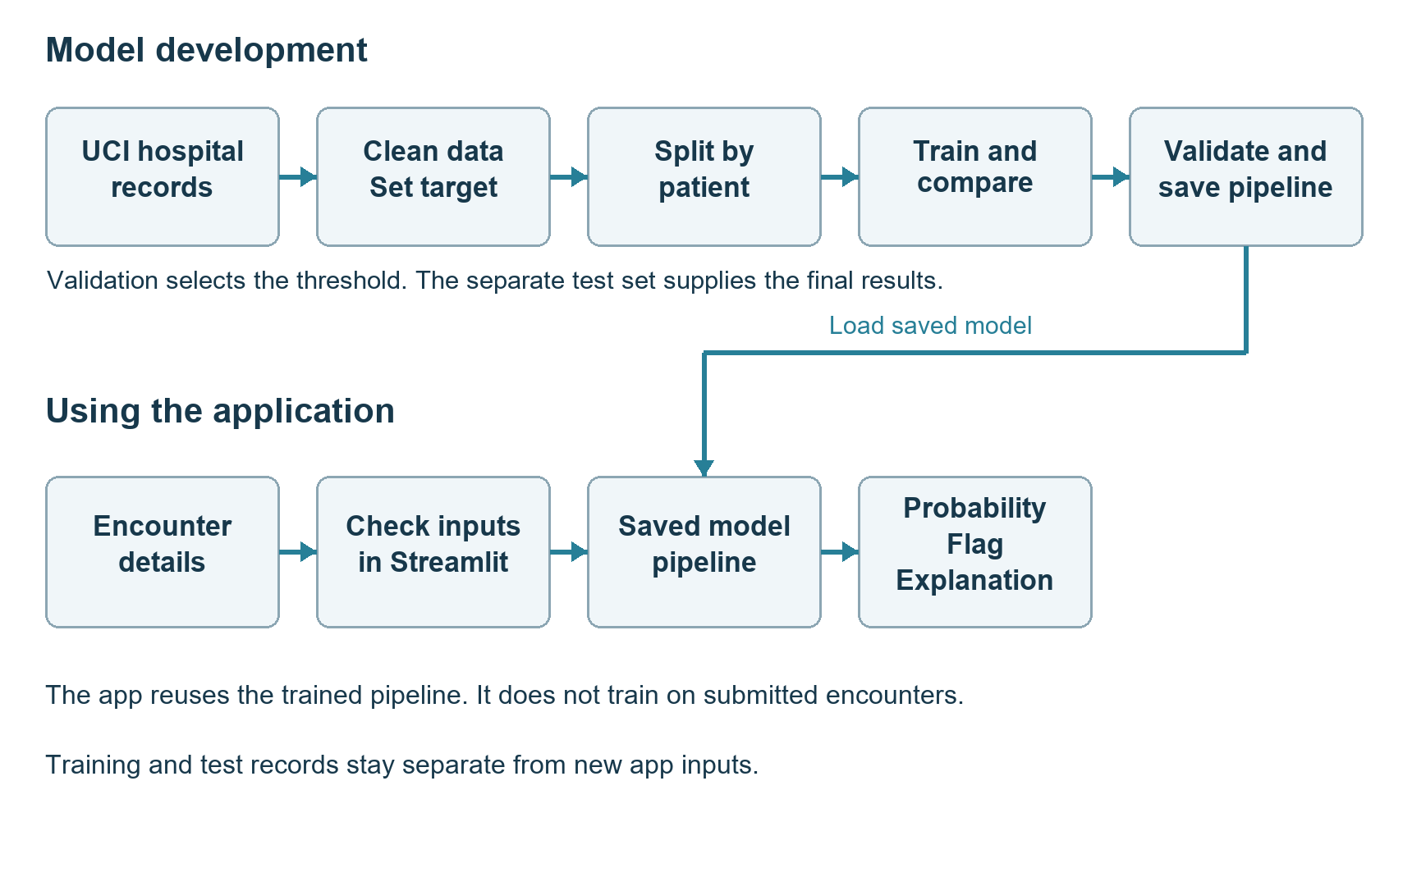

2 Literature Review
The following review covers 15 journal articles relevant to readmission prediction and its evaluation. It includes empirical studies, validation work, systematic reviews, and papers on methods or reporting.

Readmission prediction studies and reviews

Study 1 Strack B 2014
Strack and colleagues studied almost 70,000 diabetes encounters using multivariable logistic regression in BioMed Research International. They examined the association between HbA1c measurement and early readmission after accounting for demographic and clinical variables. The association differed by primary diagnosis. This paper gives the UCI dataset its clinical context, but its findings do not show that ordering a test prevents a return to hospital. The current project uses the larger released encounter file and applies different eligibility rules, so it should not be read as a replication of their analysis [1].

Study 2 Kansagara D 2011
Kansagara and colleagues reviewed 30 studies covering 26 validated readmission models in JAMA. Models based on administrative records often had limited ability to distinguish patients who would return from those who would not. Studies also differed in their prediction time and the clinical information available. The review identified gaps in functional status, illness severity, and social factors. For this project, those findings support a clearly defined prediction time and realistic expectations about performance. They also make a single benchmark AUC difficult to justify across such different studies [2].

Study 3 van Walraven C 2010
The LACE index, published by van Walraven and colleagues in CMAJ, uses length of stay, admission acuity, comorbidity, and previous emergency-department use. The study derived and validated it in 4,812 participants and examined it further in administrative records from Ontario. The derivation-study C statistic was 0.684. Its choice of variables supports examining prior use and hospitalization duration here. Its outcome, however, combines death and unplanned readmission. This project excludes death-coded index discharges and predicts the released readmission label, so the two AUC values would not provide a like-for-like comparison [3].

Study 4 Donze J 2013
Donze and colleagues introduced the HOSPITAL score in JAMA Internal Medicine using seven predictors available around discharge. These included previous admissions and length of stay. The score targeted potentially avoidable readmission and achieved validation discrimination of approximately 0.71. The study supports using discharge information and earlier hospital use in prediction. Its outcome definition and laboratory measurements differ from those available in this project. For that reason, the application developed here neither reproduces the HOSPITAL score nor estimates whether a readmission is preventable [4].

Study 5 Donze JD 2016
An international validation by Donze and colleagues tested the HOSPITAL score among 117,065 adults discharged from nine hospitals in four countries. Published in JAMA Internal Medicine, it reported a C statistic of 0.72 for potentially avoidable readmission, with agreement across predicted and observed risk categories. The study illustrates the importance of testing a score beyond its development setting. The current test set contains different patients but still comes from the same historical source. It therefore provides internal validation. Another difference is that the international study excluded acute-care transfers, whereas this project retains transfers under its cohort rules [5].

Study 6 Futoma J 2015
Futoma and colleagues compared several approaches to predicting early readmission in the Journal of Biomedical Informatics. Their work considered methods beyond conventional regression, including deep-learning approaches for specific conditions, and related targeting decisions to costs. This supports comparing algorithms under the same evaluation conditions rather than choosing one because it is more complex. Here, logistic regression, Random Forest, and histogram gradient boosting use identical grouped folds. The paper also raises an issue that remains open in this project: choosing a useful intervention policy requires cost and benefit information that the dataset does not provide [6].

Study 7 Frizzell JD 2017
Frizzell and colleagues compared machine-learning methods with conventional statistical approaches in 56,477 patients hospitalized for heart failure. The JAMA Cardiology study found similar validation C statistics and no overall advantage for the more flexible methods. This is a reason to retain logistic regression as a serious comparator. Greater complexity does not automatically improve readmission prediction. The population also differs from the one used here: the study concerned Medicare heart-failure patients and had a 21.2% readmission prevalence. Its results help frame the model comparison, but cannot serve as a direct target for this diabetes cohort [7].

Study 8 Rajkomar A 2018
Rajkomar and colleagues used longitudinal electronic health records from two medical centers for several prediction tasks. Their npj Digital Medicine paper reported AUROC values of 0.75-0.76 for 30-day unplanned readmission. Detailed records, clinical notes, and information collected throughout hospitalization gave those models a richer input than the tabular UCI file used here. The study shows what may be possible with more extensive data. It does not establish that changing the algorithm alone would bring the current project to the same performance, since outcome definitions, patient selection, and validation methods also differ [8].

Study 9 Artetxe A 2018
Artetxe and colleagues reviewed 77 studies in Computer Methods and Programs in Biomedicine. They found considerable variation in study populations, algorithms, feature selection, outcome prevalence, and performance reporting. Regression was common, while explicit handling of class imbalance was less frequent. Their review explains why results from different datasets are difficult to rank fairly. In the present project, all final candidates share a cohort and grouped folds, and a dummy model provides a reference. Multiple evaluation measures help show what each model achieves. The review offers no basis for assuming that one algorithm will always perform best [9].

Study 10 Mahmoudi E 2020
Mahmoudi and colleagues reviewed 41 studies using electronic medical records to predict readmission within 28 or 30 days. The BMJ review found modest improvements over earlier administrative-data approaches, together with gaps in calibration, diagnostic testing, socioeconomic variables, and assessment of clinical impact. These gaps influenced the evaluation in this project: probability error and alert volume are reported alongside ranking measures. Functional and social information remains limited in the available data. Even a favorable retrospective result would therefore leave unanswered whether an intervention based on the model would help patients [10].

Evaluation explainability and reporting

Study 11 Saito T 2015
Saito and Rehmsmeier explain in PLOS ONE why precision-recall plots are useful when positive cases are uncommon. They show the relationship between finding positive cases and the proportion of predictions that are correct. That relationship matters here because only about 11% of eligible encounters have an early readmission. The project therefore reports average precision and the precision-recall curve alongside ROC-AUC. Average precision uses a different calculation from trapezoidal PR-AUC, and the terms are kept distinct. This approach also makes the false-positive burden easier to see than accuracy alone would [11].

Study 12 Van Calster B 2019
Van Calster and colleagues discuss calibration in BMC Medicine: a model may rank cases reasonably well while assigning probabilities that do not match observed outcomes. The paper covers calibration assessment, sample-size considerations, and updating models. It provides the reason for examining reliability plots and comparing original probabilities with a sigmoid-calibrated candidate here. The candidate did not improve both validation scoring measures and was not retained. A small gap between the average prediction and the outcome rate still leaves room for errors within particular risk ranges or populations [12].

Study 13 Lundberg SM 2020
Lundberg and colleagues describe efficient explanations for tree models in Nature Machine Intelligence. Their method connects contributions for individual predictions with summaries of overall model behavior. This journal paper provides the basis for the Tree SHAP analysis used here. Contributions from encoded columns are added back to their originating feature, and the baseline plus contributions is checked against the model output in log-odds before conversion to probability. This checks the arithmetic of the explanation. It does not make the explanation causal, and related features may share the influence attributed to them [13].

Study 14 Wolff RF 2019
Wolff and colleagues present PROBAST in Annals of Internal Medicine as a way to assess bias and applicability in prediction-model studies. It asks structured questions about participants, predictors, outcomes, and analysis. For this project, the relevant concerns include historical patient selection, missing information, incomplete follow-up, and validation within one source. The report describes these limitations without claiming to have completed a formal PROBAST assessment. Keeping patients separate and fixing the model before testing address specific evaluation risks, but neither step removes every source of bias or establishes suitability for clinical use [14].

Study 15 Collins GS 2024
The TRIPOD+AI statement by Collins and colleagues, published in BMJ, updates guidance for reporting prediction models developed with regression or machine learning. Its 27-item checklist asks authors to explain the task, data, methods, evaluation, and interpretation clearly enough for readers to assess the work. This report draws on those principles by documenting the prediction time, outcome mapping, cohort exclusions, patient grouping, model settings, and threshold choice. No claim of audited checklist compliance is made. Clear reporting helps readers judge a study, while evidence of model quality and clinical benefit still has to come from evaluation [15].

Literature synthesis and project contribution
Together, these papers support studying discharge information and previous hospital use, while keeping algorithm comparisons fair [3,8]. They also show why evaluation should include precision-recall behavior, probability calibration, and explanations [11,13]. The current project brings these elements into one reproducible workflow. Its test results still describe one historical data source.
Table 1. Connections between the journal literature and this implementation
Theme | Journal references | Implemented response
Discharge-time prediction and utilization | 3, 4, 5 | Use discharge-available features and previous visits
Comparable model evaluation | 6, 7, 9 | Shared three-fold patient-grouped training splits
Imbalance and probability quality | 10, 11, 12 | Average precision, Brier score, reliability bins
Transparent explanations | 13 | Tree SHAP with prediction reconstruction checks
Bias and reproducible reporting | 14, 15 | Cohort rules, frozen artifacts, subgroup tables and limits

3 Methods and Models

Prediction task and outcome
The model makes its prediction at discharge. The binary target equals 1 when the source field readmitted is <30, and 0 when it is >30 or NO. Each score estimates the probability of that recorded outcome given the input fields. Throughout the report, 30-day readmission refers to this source definition of a return before 30 days. The label NO means that no readmission is recorded in the source outcome; it does not confirm complete observation of every later episode of care.
Table 2. Outcome mapping used consistently throughout the project
Source value | Binary target | Interpretation
<30 | 1 | Recorded readmission before 30 days
>30 | 0 | Recorded later readmission
NO | 0 | No recorded readmission in the source label

Workflow and leakage prevention
Table 3. Data boundaries across the end-to-end workflow
Stage | Data used | Purpose
Cohort definition | Raw source and code mappings | Apply explicit discharge eligibility rules
Outer partitioning | Patient identifiers | Reserve train, validation, and test patients
Model comparison | Training only | Fit preprocessing and models in each grouped fold
Calibration fitting | Training-only out-of-fold scores | Fit a sigmoid probability mapping
Development decisions | Validation | Compare calibration and select operating threshold
Frozen evaluation | Test once | Estimate final internal held-out performance
Presentation EDA | All eligible encounters after evaluation | Describe patterns without further tuning
Web application | Frozen artifact and new input values | Serve scores and explanations without retraining

The encounter and patient identifiers are used to match records and keep patients together, then removed from the predictors. The original outcome and partition label are also excluded. Each fitting subset supplies its own imputation, scaling, and encoding estimates. No learned preprocessing or feature selection is fitted to the complete cohort before the split. The later EDA of all eligible encounters serves a descriptive purpose and does not alter model selection or the threshold.

Preprocessing and engineered features
Some of the columns contain Question mark (‘?’) in place of missing value. Data loading treats the Question Mark as missing and also preserves the laboratory category ‘None’ which means no data was recorded. Numeric predictors receive median imputation and standard scaling. Missing categorical values receive the label ‘Missing’ before one-hot encoding. Admission and discharge codes are treated as categories because their numerical codes do not represent increasing quantities. The encoder ignores unsupported columns when a previously unseen category appears.
Table 4. Deterministic feature engineering applied within every pipeline
Feature change | Definition | Reason
total_previous_visits | Outpatient + emergency + inpatient visits in the preceding year | Summarize recent utilization
active_diabetes_medications | Count medication fields marked Steady, Up, or Down | Proxy for active medication breadth
changed_diabetes_medications | Count medication fields marked Up or Down | Summarize recorded dose changes
diag_1_group to diag_3_group | Replace each diagnosis code with a broad project-defined group | Reduce sparse diagnosis categories

Diagnosis codes are grouped using numeric ICD-9 ranges for circulatory, respiratory, digestive, genitourinary, musculoskeletal, injury, neoplasm, and diabetes categories. Codes outside these ranges, including V and E prefixes, map to Other. Missing diagnosis values remain separate. These are broad project-defined groups rather than a complete clinical classification. After engineering, the 47 input predictors become 50 fields before encoding. Weight and detailed medication categories are retained despite sparse information. No feature-selection experiment or controlled test of each engineered feature was carried out.

Models and fixed configurations
Table 5. Algorithms actually trained and their fixed parameters
Model | Role | Key settings
Prior dummy | No-learning ranking reference | Training positive prevalence
Logistic regression | Linear probabilistic comparator | liblinear; C=1; max_iter=2000; seed=42
Balanced logistic regression | Baseline imbalance experiment | Same settings; class_weight=balanced
Random Forest | Nonlinear bagged trees | 120 trees; depth 14; min leaf 15; sqrt features; seed=42
Histogram gradient boosting | Final selected model family | 150 iterations; learning rate 0.07; 15 leaves; min leaf 30; L2=5; no early stopping; seed=42

All three engineered candidates use the same shuffled, three-fold Stratified Group K-Fold split with seed 42. Mean average precision across the folds determines model selection. The settings in Table 5 define a limited set of experiments, not an exhaustive hyperparameter search. Random Forest and gradient boosting use no class weights in this comparison. Scaling remains in the shared preprocessing pipeline even though tree models do not need it.

Metrics calibration and threshold policy
ROC-AUC describes how well the model ranks positive encounters above negative ones. Average precision summarizes precision over changes in recall and differs from trapezoidal PR-AUC.
Precision = TP/(TP+FP), and
Recall = TP/(TP+FN), and
F1 = 2 * (Precision * Recall)/(Precision + Recall)
Brier score measures squared probability error, while log loss penalizes confident errors more strongly. Lower Brier score and log loss indicate better probability predictions, although either measure alone is insufficient to establish calibration [11, 12].
The sigmoid calibration candidate uses pooled out-of-fold predictions from three grouped training folds. With ensemble=False, the base estimator is subsequently refitted on all training rows. The candidate is retained only if both Brier score and log loss improve on validation data. Otherwise, the original probabilities are used. Reliability plots compare predictions and outcome frequencies in bins with approximately equal counts, keeping tied predictions together.
The chosen operating objective is to identify at least 70% of positive validation encounters. Among thresholds meeting that objective, the highest is selected to reduce the number flagged. Equal scores receive the same decision, and a score exactly at the threshold is flagged. The saved value is 0.09737941008039629. This objective illustrates a recall-workload tradeoff. It does not establish a clinical cutoff because the project has no information on intervention capacity, costs, or expected benefit.

Explainability uncertainty and implementation
Tree SHAP explains the selected gradient boosting model using its training tree-path background. Contributions from one-hot columns are combined under the original engineered feature. Adding all contributions to the baseline gives the prediction in log-odds, and applying the logistic function returns its probability. Numerical checks confirm this agreement. Global importance uses a fixed random sample of 1,000 validation encounters. Six individual examples were chosen at evenly spaced score ranks without consulting their outcomes [13].
To estimate uncertainty on the test set, 300 bootstrap samples were drawn by patient with seed 42. All encounters for a sampled patient move together. The resulting percentile intervals describe sampling variation in this test population. They do not measure how performance might change in a different hospital or period, or account for every modeling choice. Demographic summaries use the same threshold for all groups. Groups with fewer than 100 encounters, or fewer than 30 positive or negative outcomes, are flagged as small.
The application loads the trusted joblib pipeline and its saved decision policy. Input options and example encounters come from training data. SHA-256 checks verify the model and feature-code files. Pinned dependencies for Python 3.13, an isolated runtime package, interaction checks, and Ubuntu CI help reproduce the software behavior. These checks support implementation reliability but do not evaluate clinical effectiveness [14, 15].

4 Datasets and Exploratory Data Analysis

Dataset provenance and cohort
The dataset is Diabetes 130-US Hospitals for Years 1999-2008, available from the UCI Machine Learning Repository under CC BY 4.0 [16]. It contains 101,766 encounter records from 71,518 distinct patients. Its 50 columns comprise 47 predictors, two identifiers, and the outcome. Records describe inpatient encounters involving diabetes, stays of 1-14 days, and recorded laboratory and medication activity. The age of the data and its US setting limit how far the findings can be generalized.
Table 6. Cohort construction and denominator accounting
Cohort step | Encounters | Explanation
Raw source | 101,766 | All released encounter records
Death-coded discharges | 1,652 excluded | Codes 11, 19, 20, 21
Hospice discharges | 771 excluded | Codes 13 and 14
Unclear completed discharge | 24 excluded | Codes 9 and 12
Eligible cohort | 99,319 | 69,980 unique patients; transfers retained
Eligible positive outcomes | 11,303 | 11.38% recorded early readmission

The exclusion for code 12 needs particular care because its description combines still-patient and expected-outpatient-return wording. Removing it is a conservative choice for this project. Hospice records are excluded to keep the cohort outside end-of-life discharge pathways. Other transfers, rehabilitation and nursing-facility destinations, and unknown categories remain. The cohort therefore includes more than community discharges, and its outcome should not be described as exclusively unplanned readmission. Encounter IDs are unique, but repeated encounters for the same patient are retained.
Table 7. Reserved patient-disjoint partitions
Partition | Encounters | Patients | Positive outcomes | Positive rate
Train | 69,651 | 48,986 | 7,973 | 11.45%
Validation | 14,806 | 10,497 | 1,650 | 11.14%
Test | 14,862 | 10,497 | 1,680 | 11.30%

A two-stage Group Shuffle Split with seed 42 assigns patients to the outer partitions. The 70/15/15 allocation refers to patients. Encounter percentages differ slightly because patients contribute different numbers of records. Checks confirm zero patient overlap across the sets. Cross-validation within training also groups by patient. These addresses overlap between patients in fitting and evaluation data, while leaving temporal and hospital-level external validation for future work.

Sample dataset
Table 8. Selected fields from three actual training encounters
Field | Encounter A | Encounter B | Encounter C
Age band | [20-30) | [10-20) | [60-70)
Gender | Female | Female | Male
Length of stay in days | 2 | 3 | 7
Number of medications | 13 | 18 | 11
Previous inpatient visits | 1 | 0 | 0
Previous emergency visits | 0 | 0 | 0
Number of diagnoses | 6 | 9 | 7
Primary diagnosis code | 648 | 276 | 157
HbA1c category | None | None | None
Source readmission label | NO | >30 | <30
Binary target | 0 | 0 | 1

The three training examples show how the source labels map to the binary target. They were selected for illustration and do not represent the cohort as a whole. Patient and encounter identifiers are omitted. Only selected fields appear in the table, although the model accepts all 47 inputs. A source question mark indicates missingness. For laboratory variables, ‘None’ retains its separate meaning of no result recorded.

Data quality and missingness
Table 9. Largest training-partition missing-value proportions
Predictor | Missing in training | Treatment
weight | 96.87% | Retained; explicit categorical missing category
medical_specialty | 48.83% | Retained; explicit categorical missing category
payer_code | 39.64% | Retained; explicit categorical missing category
race | 2.27% | Retained; explicit categorical missing category
diag_3 | 1.50% | Retained; explicit categorical missing category
diag_2 | 0.36% | Retained; explicit categorical missing category
diag_1 | 0.02% | Retained; explicit categorical missing category

Weight has the greatest missingness, at approximately 97% of training encounters. Admitting specialty and payer code also have substantial missing information. These predictors were retained as a baseline choice; their inclusion does not establish that they improve predictions. A feature-selection study based on missingness was not performed. Unknown admission and discharge codes remain categorical, and rare or missing demographic categories are kept visible for reporting.

EDA interpretation rules
The next five charts describe the full eligible cohort of 99,319 encounters. Each percentage divides positive outcomes by all eligible encounters within that group. A patient can contribute several records, so the counts represent hospitalizations rather than independent people. These charts were produced after final evaluation and were not used to revise the model or threshold. They show unadjusted associations without uncertainty intervals, so they cannot establish causal effects or statistical significance.

Age and readmission
Readmission varies across the ten-year age bands, but does not rise steadily with age. The 20-29 group has the highest displayed percentage, while the youngest groups have much lower rates. The 50-59 group falls below the overall cohort rate, and several older groups lie above it. This uneven pattern makes age alone a limited explanation of readmission in these records.
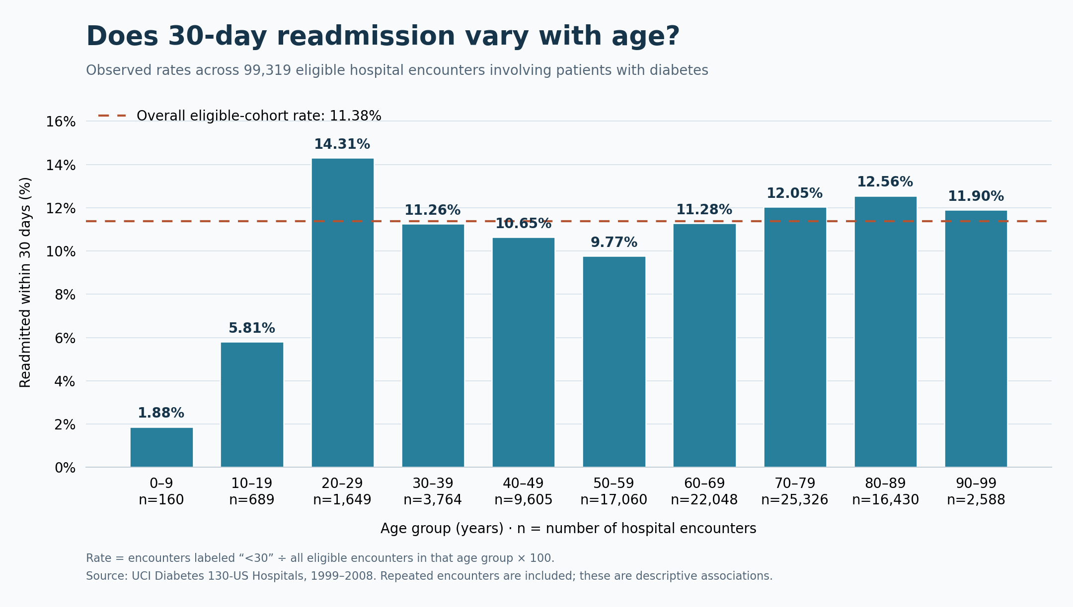
Figure 1. Age and readmission in the complete eligible cohort with group encounter counts
Group size matters when interpreting the age chart. There are 1,649 encounters in the 20-29 band, compared with 25,326 in the 70-79 band. Differences in illness burden, previous use, and repeated hospitalizations may contribute to their rates. The youngest group contains only three early readmissions among 160 encounters. That low percentage warrants caution rather than a broad conclusion about all children.
Table 10. Selected descriptive values for age and readmission
Selected group | Encounters | Readmission rate
0–9 years | 160 | 1.88%
20–29 years | 1,649 | 14.31%
70–79 years | 25,326 | 12.05%
80–89 years | 16,430 | 12.56%

Length of stay and readmission
Readmission generally becomes more common as stays increase from one day to around eight or ten days. The rate is 8.39% after a one-day stay and 14.81% after ten days. It then falls at eleven days and fluctuates over the remaining durations. Longer stays are therefore associated with higher rates across part of the range, but the relationship is not consistently increasing.
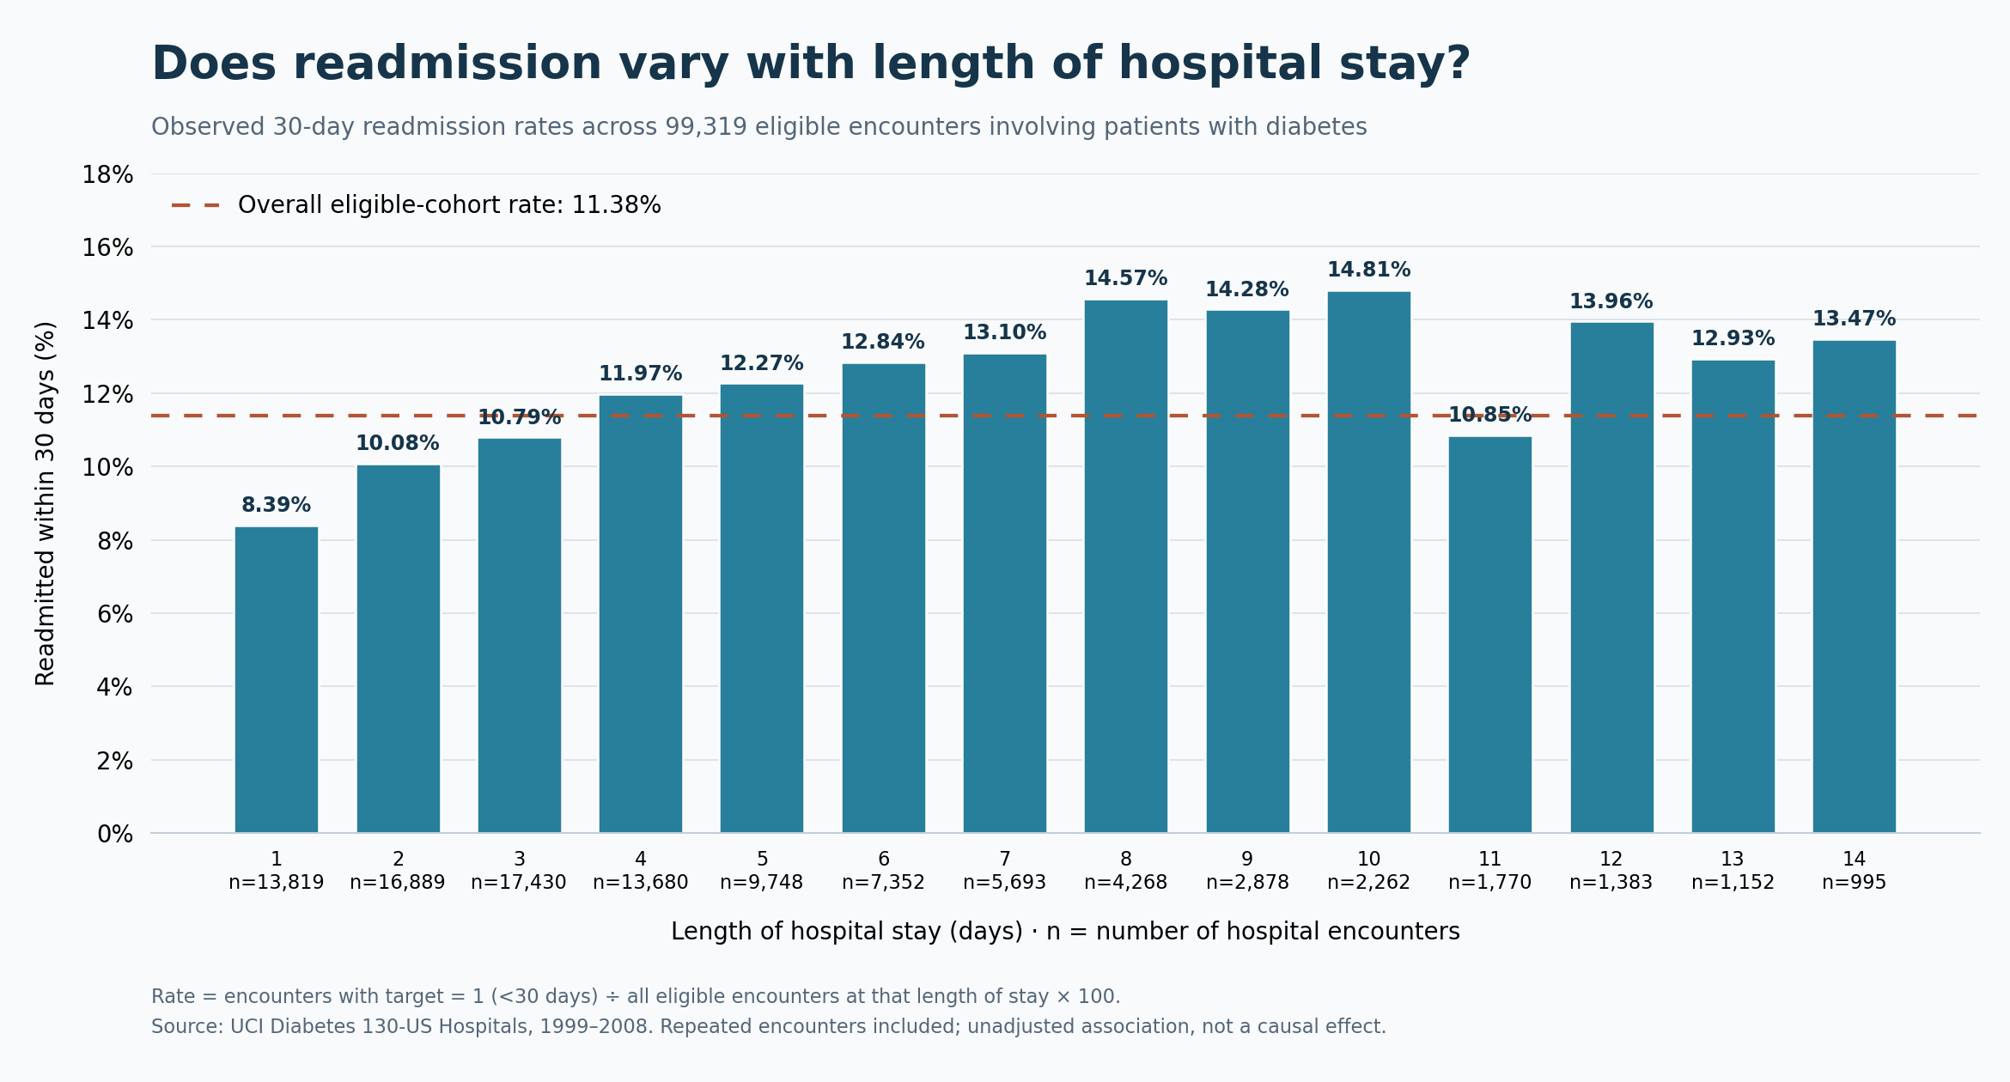
Figure 2. Length of stay and readmission in the complete eligible cohort with group encounter counts
A long stay may reflect more serious illness or complications that also make a later return more likely. But it does not automatically mean that extra days in hospital lead to readmission. The longer-stay groups are also smaller: the data contain 13,819 one-day encounters and 995 fourteen-day encounters. This chart describes observed outcomes at each duration. It cannot show what would happen if an individual patient were discharged earlier or kept longer.
Table 11. Selected descriptive values for length of stay and readmission
Selected group | Encounters | Readmission rate
1 day | 13,819 | 8.39%
8 days | 4,268 | 14.57%
10 days | 2,262 | 14.81%
14 days | 995 | 13.47%

Medication count and readmission
Medication count provides a rough indication of treatment complexity. It does not directly measure drug interactions, doses, or whether medication is taken as prescribed. Readmission rises from 7.62% in the 1-5 medication group to around 13% in several higher-count groups. The rate then falls to 11.65% for 41 or more medications. The association is therefore noticeable but uneven.
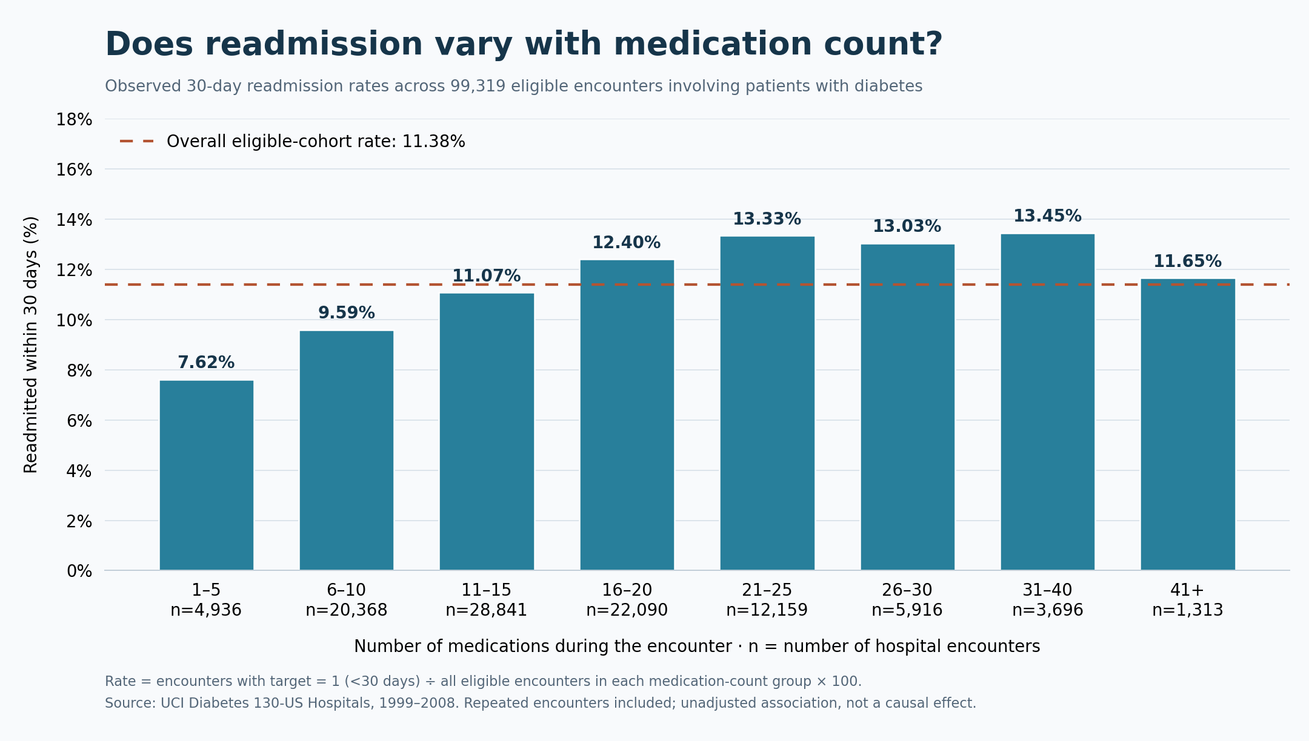
Figure 3. Medication count and readmission in the complete eligible cohort with group encounter counts
Recorded counts range from 1 to 81 medications. Wider upper groups keep the chart readable and avoid many categories with very few encounters. The median is 16 medications for readmitted encounters and 15 for the others, with considerable overlap. A difference of this size offers limited separation on its own. Illness severity, stay duration, and previous hospital use may help explain the observed pattern.
Table 12. Selected descriptive values for medication count and readmission
Selected group | Encounters | Readmission rate
1–5 medications | 4,936 | 7.62%
16–20 medications | 22,090 | 12.40%
31–40 medications | 3,696 | 13.45%
41+ medications | 1,313 | 11.65%

Previous inpatient visits and readmission
Previous inpatient use shows a clearer pattern than age or medication count. Readmission increases from 8.59% with no inpatient visits in the preceding year to 13.23% with one, 24.16% with four, and 40.48% with six or more. Patients returning repeatedly to hospital may have continuing care needs, making this history useful for prediction.
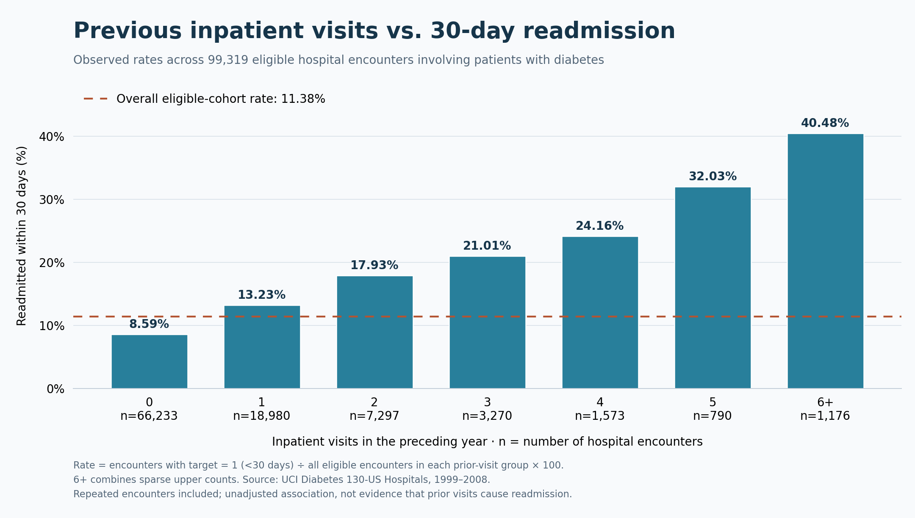
Figure 4. Previous inpatient visits and readmission in the complete eligible cohort with group encounter counts
The 6+ group combines sparse upper counts. It contains 1,176 encounters from 483 patients, which shows how repeated admissions affect an encounter-based chart. The high rate could reflect persistent illness, severity, access to care, or other unmeasured factors. It should not be interpreted as evidence that previous admissions themselves cause a subsequent return.
Table 13. Selected descriptive values for previous inpatient visits and readmission
Selected group | Encounters | Readmission rate
0 prior visits | 66,233 | 8.59%
1 prior visit | 18,980 | 13.23%
4 prior visits | 1,573 | 24.16%
6+ prior visits | 1,176 | 40.48%

Previous emergency visits and readmission
The percentage also rises with previous emergency visits: 10.68% for none, 14.66% for one, 18.68% for two, 20.82% for three, and 28.74% for four or more. However, most encounters belong to the group with no prior emergency visits. The rate within a group and the total number of readmissions in that group answer different questions.
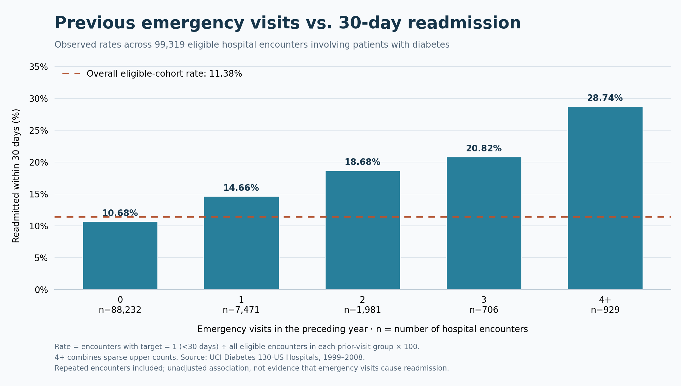
Figure 5. Previous emergency visits and readmission in the complete eligible cohort with group encounter counts
The pooled 4+ group contains 929 encounters from 413 patients. By comparison, the zero-visit group contains 88,232 encounters and 9,424 early readmissions. A small group can have a high percentage while accounting for fewer events overall. This helps explain why emergency-use history can be informative without making it easy to identify most readmissions with few false positives.
Table 14. Selected descriptive values for previous emergency visits and readmission
Selected group | Encounters | Readmission rate
0 prior visits | 88,232 | 10.68%
1 prior visit | 7,471 | 14.66%
3 prior visits | 706 | 20.82%
4+ prior visits | 929 | 28.74%

5 Results and Discussion

Baseline performance on validation data
Table 15. Raw-feature validation baselines at the default 0.5 threshold
Model | AP | ROC AUC | Precision | Recall | Brier
Prior dummy | 0.111 | 0.500 | 0.00% | 0.00% | 0.09903
Logistic regression | 0.214 | 0.647 | 50.51% | 3.03% | 0.09547
Balanced logistic regression | 0.210 | 0.642 | 16.93% | 53.52% | 0.22021

The dummy assigns the same score to every encounter. Its ROC-AUC is 0.5, and average precision equals validation prevalence. Ordinary logistic regression improves ranking but identifies only 3.03% of positives at the default threshold. Class weighting raises recall to 53.52%, with precision of 16.93% and a worse Brier score. These differences show why the algorithm and its operating threshold must be considered together. In the baseline table, precision is recorded as zero when no positive cases are predicted, following the experiment convention.

Training cross validation model comparison
Table 16. Three-fold patient grouped training results
Engineered model | Mean AP | AP SD | Mean ROC AUC | Mean Brier
Histogram gradient boosting | 0.2321 | 0.0093 | 0.6753 | 0.09625
Random Forest | 0.2183 | 0.0118 | 0.6722 | 0.09745
Logistic regression | 0.2150 | 0.0155 | 0.6607 | 0.09740

Gradient boosting has the highest mean average precision, 0.2321, and is selected using the stated ranking rule. The standard deviations show variation across three folds; they are not confidence intervals or proof that one model is statistically superior. The raw-input baselines and engineered models belong to different comparison stages. Without a controlled ablation, their differences cannot be attributed entirely to feature engineering.

Calibration candidate assessment
Table 17. Probability quality before and after training only sigmoid calibration
Probability output | Validation Brier | Validation log loss | AP
Uncalibrated | 0.093989 | 0.329039 | 0.2315
Sigmoid | 0.094002 | 0.329090 | 0.2315

Sigmoid calibration slightly increases both validation Brier score and log loss, so the original probabilities are kept. The differences are small. Ranking metrics remain the same for the two versions, as expected from a monotone probability transformation. Because validation data informed this choice, the comparison forms part of model development rather than an independent final test of calibration.

Validation threshold tradeoffs
Table 18. Validation tradeoffs under alternative recall objectives
Recall objective | Threshold | Precision | Flagged | False positives | Missed outcomes
50% | 0.127321 | 19.21% | 29.00% | 3,469 | 825
60% | 0.111099 | 17.28% | 38.69% | 4,738 | 660
70% | 0.097379 | 15.93% | 48.97% | 6,096 | 495
80% | 0.081934 | 14.47% | 61.60% | 7,800 | 330
90% | 0.064189 | 12.74% | 78.70% | 10,167 | 165

Meeting the 70% validation-recall objective gives a threshold of 0.09737941008039629 and flags 7,251 of 14,806 encounters. The alternative objectives make the workload tradeoff clear: 50% recall flags about 29% of encounters, while 90% recall flags almost 79%. Finding more positive outcomes comes with many more flags. The selected objective is illustrative because the project has no documented intervention capacity, cost of missed outcomes, or expected clinical benefit to optimize.
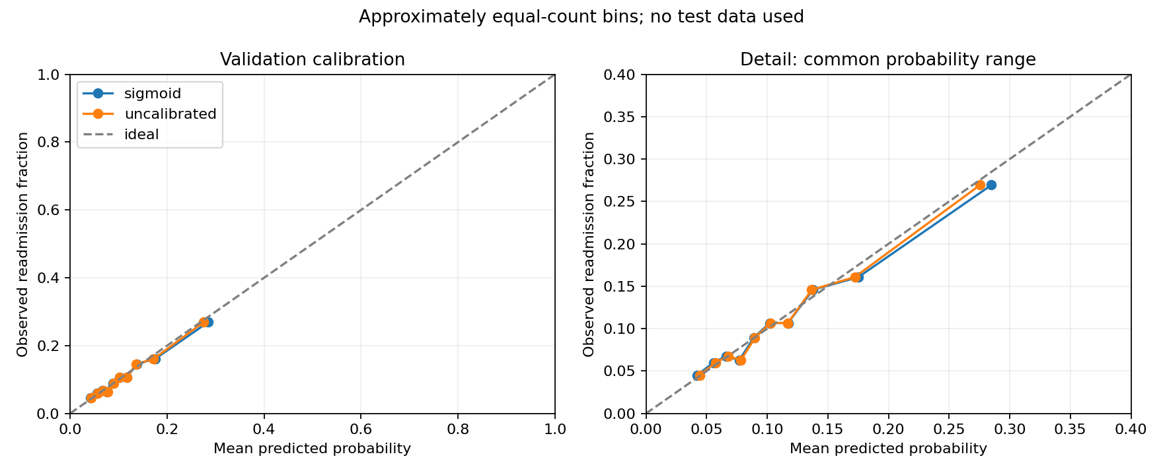
Figure 6. Validation reliability curves for original and sigmoid calibrated probability outputs
The reliability plots compare average predictions with observed outcome frequencies within approximately equal-count bins. Close agreement is encouraging at that level of aggregation, but errors may remain within a risk range or subgroup. The figure includes no uncertainty interval for each bin. These are validation results used during development, so they should not be treated as external evidence of calibration.

Final held out test results
Table 19. Final held out results from one frozen policy scoring pass
Metric | Final test result
Encounters / patients | 14,862 / 10,497
Readmission prevalence | 11.30%
ROC-AUC | 0.6705
Average precision | 0.2291
Recall | 69.58%
Precision | 15.89%
F1 | 0.2587
Brier score | 0.09536
Log loss | 0.33221
Encounters flagged | 49.52%
Frozen threshold | 0.09737941008039629

At the fixed threshold, the test set contains 1,169 detected early readmissions out of 1,680, giving recall of 69.58%. The model flags 7,359 encounters, or 49.52% of the test set. Precision is 15.89%, which means that most flags do not correspond to a recorded early readmission. Test recall is close to the 70% validation objective, but there is no guarantee of achieving that level in new data. The threshold was left unchanged after viewing these results.
Table 20. Confusion matrix at the frozen operating threshold
Actual outcome | Below threshold | Above threshold
No early readmission | 6,992 true negatives | 6,190 false positives
Early readmission | 511 false negatives | 1,169 true positives

Average precision is 0.2291, roughly twice the test positive prevalence of 0.1130. This supports the presence of useful ranking information in the model. The operational picture is less favorable: about 6.3 encounters are flagged for each detected early readmission, and approximately 84% of flags are false positives under the source labels. Precision would also change with the outcome prevalence and chosen threshold. Before acting on flags, a service would need to define the follow-up response and assess whether it could manage that workload.

Discrimination calibration and uncertainty
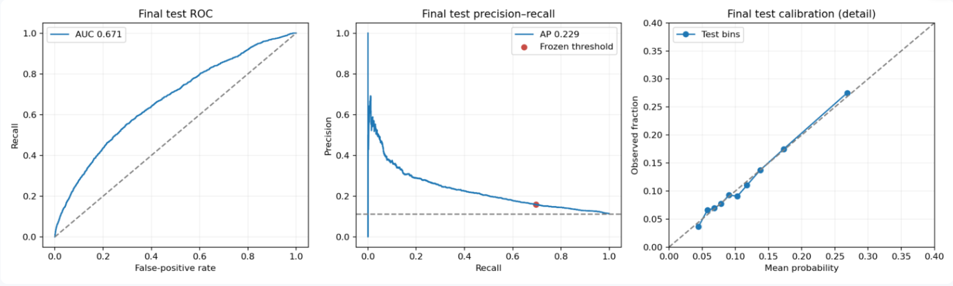
Figure 7. Final test ROC precision recall and calibration curves with the frozen threshold marked
The ROC curve shows moderate separation between positive and negative encounters. The precision-recall plot makes the low precision at the selected recall more apparent. The calibration panel enlarges the range containing common predicted probabilities rather than examining the full 0-1 range equally closely. Average predicted probability is 11.39%, compared with an observed test rate of 11.30%. Those averages are close, but can conceal errors in particular parts of the score range.
Table 21. Approximate patient cluster bootstrap percentile intervals from 300 draws
Metric | Estimate | Lower 95 percent | Upper 95 percent
Average precision | 0.2291 | 0.2051 | 0.2491
ROC-AUC | 0.6705 | 0.6532 | 0.6851
Recall | 0.6958 | 0.6716 | 0.7170
Precision | 0.1589 | 0.1491 | 0.1677
Brier score | 0.0954 | 0.0912 | 0.0993
Flagged fraction | 0.4952 | 0.4865 | 0.5050

Resampling patients keeps their repeated encounters together when estimating the test intervals. The intervals describe sampling variation under the observed patient distribution. They do not predict uncertainty for a future hospital or calendar period, and they cannot account for every design choice made earlier. The model and threshold had been selected before test access. As elsewhere in the report, average precision means the non-interpolated scikit-learn measure rather than trapezoidal PR-AUC.

Model explanations and demographic performance
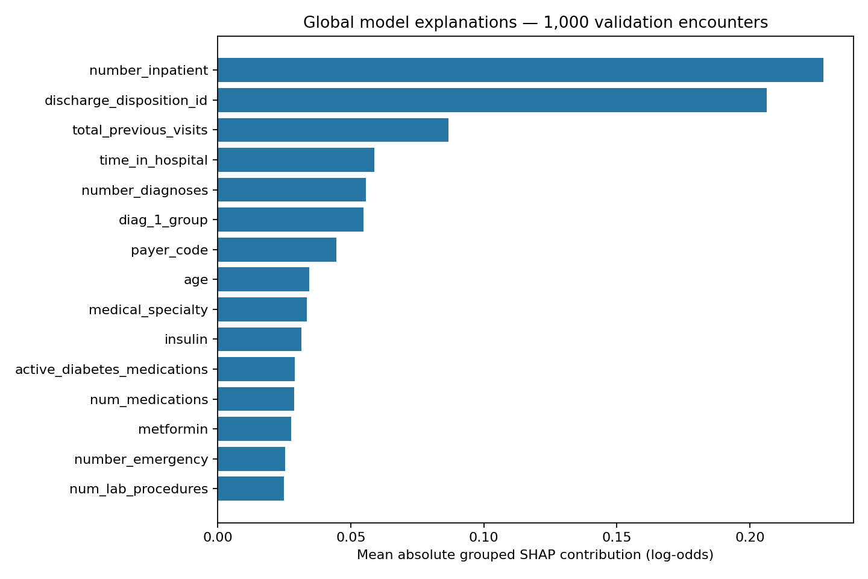
Figure 8. Global grouped Tree SHAP importance from a fixed sample of 1000 validation encounters
Previous inpatient visits and discharge destination have the largest average absolute SHAP contributions. Total previous visits, length of stay, and number of diagnoses also influence predictions. This broadly agrees with the utilization patterns seen in the EDA. SHAP, however, describes how the fitted model uses these variables. It does not isolate independent effects, and related raw and engineered features can share attribution.
The SHAP values are in log-odds relative to the model baseline. They should not be read as percentage-point changes in a patient's risk. Reconstruction checks confirm that the baseline and contributions reproduce the predicted score. They do not establish that every clinical factor has been captured or that changing one attributed feature would change the outcome.

Demographic audit and practical interpretation
Table 22. Final test gender and race metrics at the same global threshold
Attribute and group | Encounters | Positives | Recall | Precision | Small group
Gender / Female | 8,004 | 902 | 70.84% | 15.52% | No
Gender / Male | 6,857 | 778 | 68.12% | 16.35% | No
Gender / Unknown/Invalid | 1 | 0 | Undefined | 0.00% | Yes
Race / African-American | 2,785 | 330 | 71.52% | 17.25% | No
Race / Asian | 99 | 7 | 57.14% | 12.90% | Yes
Race / Caucasian | 11,183 | 1,273 | 70.31% | 15.75% | No
Race / Hispanic | 276 | 21 | 61.90% | 11.82% | Yes
Race / Missing | 309 | 28 | 42.86% | 13.04% | Yes
Race / Other | 210 | 21 | 42.86% | 12.16% | Yes

Recall is 70.84% for female test encounters and 68.12% for male encounters. Several race groups contain too few positive outcomes for stable comparisons under the project rule. Missing race remains a separate category. These estimates have no subgroup-specific uncertainty intervals, so the observed differences are insufficient to establish fairness, equal benefit, or discrimination. Age-group results are also available in the app and saved subgroup table.
All three partitions have an outcome prevalence near 11%, but this alone does not show that their patients have the same clinical characteristics. The results cannot be assumed to apply to present-day hospitals, populations outside the US, or patients without diabetes. Social support, functional limitations, and access to follow-up may be missing or only partly represented. The outcome also does not reliably separate every planned return from an avoidable one.

Published application and software checks
The app has three pages: an encounter predictor, an explanation of the last submitted prediction, and model performance. Users can edit all 47 inputs or load one of three training examples without patient identifiers. The app applies the saved threshold exactly and shows the probability and resulting flag. It also presents the observed precision and alert workload. It avoids assigning medical risk bands that the study has not validated.
Software checks covered input validation, missing values, prediction consistency, SHAP reconstruction, navigation, demographic filters, and the integrity of the frozen files. A runtime-only ZIP was tested separately without the raw dataset, and the Ubuntu CI workflow passed. Deployment checks also exercised prediction, live explanations, and the performance page. An anonymous HTTP session returned status 200. These checks establish that the application works as implemented; they do not show that its use improves patient outcomes.
Open the published Streamlit application
Open the source code and documentation

6 Conclusion and Future Improvements

Conclusion
This project connects data preparation, model evaluation, explanations, and deployment in a single reproducible workflow. Keeping patients separate and fitting preprocessing within training folds reduces specific leakage risks. The cohort rules, saved model, threshold policy, and final evaluation record make the main choices traceable. Histogram gradient boosting achieved the highest mean training-fold average precision among the engineered candidates. On the held-out test patients, ROC-AUC was 0.671 and average precision was 0.229.
The most important result is the tradeoff at the selected threshold. Recall reaches 69.58%, but precision is 15.89% and almost half of encounters are flagged. That volume would be difficult to justify without knowing the capacity and benefit of a follow-up intervention. Previous hospital use shows clear descriptive patterns, while age, stay duration, and medication count are less consistent. Tree SHAP helps explain the model's calculations without establishing medical causes. The app makes these findings accessible as an educational demonstration; clinical use remains unsupported by the present evaluation.

Future improvements
External and temporal validation. Test the fixed model on newer records from independent hospitals, with clear eligibility and follow-up rules. The current test set has already informed the reported evaluation and should not be reused as an untouched tuning benchmark.
Better outcome information. Where reliable data are available, link returns across facilities and distinguish planned, potentially preventable, and competing outcomes. Reconsider transfer and discharge eligibility rules before evaluating a new cohort.
Clinical and social context. Examine whether functional status, follow-up access, or longitudinal records add useful information. Any added predictor must be available at the time of prediction and evaluated for its contribution.
Further modeling experiments. Compare additional settings, imbalance methods, and individual feature-engineering choices within grouped training folds. Keep the final test results out of this tuning process.
Alert capacity and benefit. Define what happens after a flag, how many encounters staff can review, and the costs or harms of correct and incorrect decisions. Those details would support a more practical threshold than a recall target alone.
Calibration and subgroup uncertainty. Estimate reliability and uncertainty in groups large enough for meaningful analysis, then repeat this assessment in external data. Monitor changes in the data and use new development records for recalibration.
Prospective evaluation and maintenance. Study the model in a future workflow before considering clinical adoption. Assess usability, oversight, and effects on care, while maintaining the software and preserving the evaluated model's provenance.

7 References
References 1-15 are the journal articles discussed in the literature review. Reference 16 identifies the dataset. The appendix provides the repository and application links.
[1] Strack B, DeShazo JP, Gennings C, et al. Impact of HbA1c Measurement on Hospital Readmission Rates: Analysis of 70,000 Clinical Database Patient Records. BioMed Research International. 2014;2014:781670. doi:10.1155/2014/781670
Publisher or PubMed record
[2] Kansagara D, Englander H, Salanitro A, et al. Risk prediction models for hospital readmission: a systematic review. JAMA. 2011;306(15):1688-1698. doi:10.1001/jama.2011.1515
Publisher or PubMed record
[3] van Walraven C, Dhalla IA, Bell C, et al. Derivation and validation of an index to predict early death or unplanned readmission after discharge from hospital to the community. CMAJ. 2010;182(6):551-557. doi:10.1503/cmaj.091117
Publisher or PubMed record
[4] Donze J, Aujesky D, Williams D, Schnipper JL. Potentially avoidable 30-day hospital readmissions in medical patients: derivation and validation of a prediction model. JAMA Internal Medicine. 2013;173(8):632-638. doi:10.1001/jamainternmed.2013.3023
Publisher or PubMed record
[5] Donze JD, Williams MV, Robinson EJ, et al. International Validity of the HOSPITAL Score to Predict 30-Day Potentially Avoidable Hospital Readmissions. JAMA Internal Medicine. 2016;176(4):496-502. doi:10.1001/jamainternmed.2015.8462
Publisher or PubMed record
[6] Futoma J, Morris J, Lucas J. A comparison of models for predicting early hospital readmissions. Journal of Biomedical Informatics. 2015;56:229-238. doi:10.1016/j.jbi.2015.05.016
Publisher or PubMed record
[7] Frizzell JD, Liang L, Schulte PJ, et al. Prediction of 30-Day All-Cause Readmissions in Patients Hospitalized for Heart Failure: Comparison of Machine Learning and Other Statistical Approaches. JAMA Cardiology. 2017;2(2):204-209. doi:10.1001/jamacardio.2016.3956
Publisher or PubMed record
[8] Rajkomar A, Oren E, Chen K, et al. Scalable and accurate deep learning with electronic health records. npj Digital Medicine. 2018;1:18. doi:10.1038/s41746-018-0029-1
Publisher or PubMed record
[9] Artetxe A, Beristain A, Grana M. Predictive models for hospital readmission risk: A systematic review of methods. Computer Methods and Programs in Biomedicine. 2018;164:49-64. doi:10.1016/j.cmpb.2018.06.006
Publisher or PubMed record
[10] Mahmoudi E, Kamdar N, Kim N, et al. Use of electronic medical records in development and validation of risk prediction models of hospital readmission: systematic review. BMJ. 2020;369:m958. doi:10.1136/bmj.m958
Publisher or PubMed record
[11] Saito T, Rehmsmeier M. The precision-recall plot is more informative than the ROC plot when evaluating binary classifiers on imbalanced datasets. PLOS ONE. 2015;10(3):e0118432. doi:10.1371/journal.pone.0118432
Publisher or PubMed record
[12] Van Calster B, McLernon DJ, van Smeden M, et al. Calibration: the Achilles heel of predictive analytics. BMC Medicine. 2019;17:230. doi:10.1186/s12916-019-1466-7
Publisher or PubMed record
[13] Lundberg SM, Erion G, Chen H, et al. From local explanations to global understanding with explainable AI for trees. Nature Machine Intelligence. 2020;2(1):56-67. doi:10.1038/s42256-019-0138-9
Publisher or PubMed record
[14] Wolff RF, Moons KGM, Riley RD, et al. PROBAST: A Tool to Assess the Risk of Bias and Applicability of Prediction Model Studies. Annals of Internal Medicine. 2019;170(1):51-58. doi:10.7326/M18-1376
Publisher or PubMed record
[15] Collins GS, Moons KGM, Dhiman P, et al. TRIPOD+AI statement: updated guidance for reporting clinical prediction models that use regression or machine learning methods. BMJ. 2024;385:e078378. doi:10.1136/bmj-2023-078378
Publisher or PubMed record
[16] Clore J, Cios K, DeShazo J, Strack B. Diabetes 130-US Hospitals for Years 1999–2008 [dataset]. UCI Machine Learning Repository; 2014. CC BY 4.0. doi:10.24432/C5230J
Bibliographic records and dataset documentation accessed 2 November 2026.

Appendix

Project links
Published application
https://prakul-readmission-explorer.streamlit.app/
GitHub source repository
https://github.com/vgprakul/hospital-readmission-prediction
UCI source dataset
https://archive.ics.uci.edu/dataset/296/diabetes+130+us+hospitals+for+years+1999+2008

Repository organization
Table 23. Files supporting the implementation and report
Location | Contents
scripts/ | Data audit, cohort splitting, baseline training, grouped comparison, calibration, freezing, final evaluation and EDA scripts
src/features.py | Deterministic encounter feature transformer
models/ | Selected trusted pipeline, operating policy and frozen manifest
app/ | Streamlit pages, inference helpers, training-derived input schema and pinned runtime dependencies
reports/ | Aggregate experiments, EDA figures, explanation records and final test evaluation
deployment/ | Runtime packaging guide and publication status

Runtime and reproduction
The hosted app uses Python 3.13 and the pinned dependencies in app/requirements.txt. The evaluated environment records scikit-learn 1.6.1, pandas 2.2.3, NumPy 2.2.6, joblib 1.5.1, and SHAP 0.50.0. App checks used Streamlit 1.50.0. Once packaged, the app can serve predictions without the raw data. Only trusted joblib artifacts should be loaded.

Run the published code locally
python -m venv .venv
# Windows PowerShell
.venv/Scripts/python -m pip install -r app/requirements.txt
.venv/Scripts/python -m streamlit run app/app.py

# Linux and macOS use .venv/bin/python instead.

The frozen manifest records the training requirements, model, feature code, decision policy, and checksums for the data and partition files. The final evaluation script reuses saved results, so rerunning it does not create a new untouched holdout. Further experiments require a separate evaluation plan.

Code Snippets
These excerpts show the main implementation steps. They are selected fragments, with the full imports, validation checks, and runnable scripts available in the repository.

Cohort target and patient grouped partitioning
reason = df.discharge_disposition_id.map(EXCLUSIONS)
cohort = df.loc[reason.isna()].copy()
cohort['target'] = cohort.readmitted.eq('<30').astype('int8')
first = GroupShuffleSplit(n_splits=1, test_size=0.30, random_state=SEED)
train_idx, held_idx = next(first.split(cohort, groups=cohort.patient_nbr))
held = cohort.iloc[held_idx]
second = GroupShuffleSplit(n_splits=1, test_size=0.5, random_state=SEED)
val_idx, test_idx = next(second.split(held, groups=held.patient_nbr))

Fold specific preprocessing pipeline
preprocessing = ColumnTransformer([
('numeric', Pipeline([('imputer', SimpleImputer(strategy='median')),
('scaler', StandardScaler())]), numeric),
('categorical', Pipeline([('imputer', SimpleImputer(strategy='constant', fill_value='Missing')),
('encoder', OneHotEncoder(handle_unknown='ignore', dtype=np.float32))]), categorical),
('codes', OneHotEncoder(handle_unknown='ignore', dtype=np.float32), CODE_COLUMNS),
], sparse_threshold=1.0)

Selected gradient boosting configuration
'hist_gradient_boosting_engineered': HistGradientBoostingClassifier(max_iter=150, learning_rate=0.07,
max_leaf_nodes=15, min_samples_leaf=30, l2_regularization=5,
early_stopping=False, random_state=42),
}

Every candidate uses the same grouped fold indices. A fresh copy of its pipeline fits the relevant training subset before predicting the held-out fold, keeping learned transformations within the fitting data.

Validation recall constrained threshold selection
def choose_threshold(y, p, target):
"""Highest score threshold achieving target recall (fewest flagged encounters)."""
if not 0 < target <= 1 or np.asarray(y).sum() == 0:
raise ValueError('Need a positive recall target and positive outcomes')
_, recall, thresholds = precision_recall_curve(y, p)
return float(thresholds[recall[:-1] >= target].max())

Frozen pipeline inference
def predict(model, policy, schema, values):
frame = make_frame(values, policy, schema)
with threadpool_limits(limits=2):
probability = float(model.predict_proba(frame)[0, 1])
if not np.isfinite(probability) or not 0 <= probability <= 1:
raise ValueError('Invalid model probability')
return {'probability': probability, 'flagged': probability >= policy['threshold'],
'threshold': policy['threshold']}

Explanation consistency check
# Grouped SHAP reconstruction used by the application
base = float(np.asarray(explainer.expected_value).reshape(-1)[0])
log_odds = base + grouped.sum()
reconstructed = float(1 / (1 + np.exp(-log_odds)))
np.testing.assert_allclose(
reconstructed, result['probability'], atol=1e-7
)

The model loader converts Windows path separators for Linux hosting and verifies the model and feature-code checksums. It restores the expected input column order and applies the exact saved threshold. A prediction request neither retrains the model nor accesses the test records.

Supporting Evaluation Figures
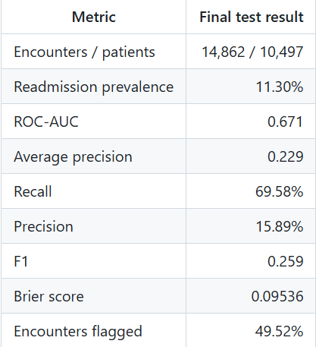
Figure 9. Archived final test metric snapshot matching the editable results table in Chapter 5
Figure 10. Reference copy of the inpatient utilization chart with the same values as the corresponding EDA figure
The screenshot rounds the metrics for display. Saved evaluation files retain the full-precision scores and exact threshold. The second inpatient chart repeats the earlier EDA figure for reference and does not represent another analysis.

