
MICRO-LEVEL PROJECT REPORT
25ML35T / FOUNDATIONS OF ARTIFICIAL INTELLIGENCE
PROJECT TITLE: AEGISMED: AUTONOMOUS HOSPITAL DELIVERY ROBOT FLEET PLANNER USING INFORMED A* SEARCH AND CSP SCHEDULING
Submitted by: | Guru Sanjeeth / Reg: 113025148029  Year: II Year / Section: CSE(AI&ML)-A
Submitted to: | Dr. Manoj Kumar D S  Associate Professor / Department of CSE(AI&ML)
Academic Year: | 2026-2027
Submission Date: | 13 October 2026

1. ABSTRACT AND PROJECT OBJECTIVES
1.1 Abstract
In modern healthcare complexes, timely internal distribution of critical medical supplies such as emergency blood plasma, STAT intravenous medications, and pathology specimens is critical to patient survival. AegisMed is an autonomous hospital delivery fleet planner that integrates constraint satisfaction programming (CSP) with informed heuristic graph search. The mission scheduling layer formulates clinical dispatch as a CSP incorporating time-window limits, urgency priorities (STAT, Urgent, Routine), battery power budgets, and vertical elevator bottlenecks, solved using Backtracking Search accelerated by the Minimum Remaining Values (MRV) heuristic and Arc Consistency 3 (AC-3) propagation. Path routing across a 24x18 spatial topology utilizes the A* algorithm guided by an admissible Manhattan distance heuristic, compared against an uninformed Breadth-First Search (BFS) baseline. A First-Order Horn clause rule base enforces clinical regulations including Level-4 ICU sterility certification and peak visiting hour corridor speed throttling. To address operational uncertainty, an occupancy-probability grid and dynamic re-planner recalculate collision-free detours upon encountering mid-path blockages, generating Explainable AI (XAI) justifications and ISO 13482 safety compliance logs. Empirical benchmarks demonstrate that A* reduces node expansions by over 77% compared to BFS, achieving sub-2ms re-planning.
1.2 Keywords
A* Search Algorithm, Breadth-First Search (BFS), Constraint Satisfaction Problem (CSP), Arc Consistency (AC-3), Healthcare Robotics, Explainable AI (XAI)
1.3 Problem statement
Hospital logistics currently rely on manual porter transit, which suffers from unpredictable transit delays, elevator contention, and inadvertent sterility breaches during peak hours. This micro-project designs and implements an autonomous robotic dispatch and routing system that coordinates multi-task clinical deliveries under tight temporal, battery, and elevator constraints while providing real-time dynamic re-planning when corridors are blocked.
1.4 Objectives
• Formulate and solve clinical delivery scheduling as a CSP using Backtracking Search, MRV heuristic, and AC-3 constraint propagation.
• Implement an informed A* grid maze solver with the Manhattan distance heuristic and an exact nodes-expanded counter.
• Benchmark A* search performance against an uninformed BFS baseline on identical maze topographies.
• Embed a forward-chaining clinical knowledge base that dynamically modifies cell traversability costs prior to planning.
• Demonstrate dynamic re-planning on unforeseen obstacles with Explainable AI (XAI) rationale and healthcare safety auditing.
1.5 Scope
Included: 24x18 multi-zone hospital grid floor plan, 5 specialized delivery tasks, CSP solver with MRV and AC-3, A* and BFS search engines, first-order clinical rule inference, dynamic obstacle insertion, node expansion telemetry, and standalone desktop software GUI. Excluded: Continuous 3D SLAM point-cloud processing, multi-floor CAD mapping, and physical hardware fabrication.
2. INTRODUCTION AND PROPOSED SOLUTION
2.1 Background
Intra-hospital logistics represent a vital operational backbone for multi-specialty medical centers. Delays in delivering crossmatched blood units or post-surgical antibiotics directly elevate morbidity risks. Automated Guided Vehicles (AGVs) operating in shared human-robot environments must navigate intricate corridors, adhere to infection-control isolation zones, and dynamically adapt to gurneys or pedestrians.
2.2 Existing system / current approach
Most hospitals rely on manual porter delivery or simple point-to-point automated tugs following magnetic tape. Schedules are manually coordinated on whiteboards or static hospital information system (HIS) queues without algorithmic conflict resolution or elevator access synchronization.
2.3 Limitations of the existing approach
• Inability to resolve shared resource bottlenecks, leading to elevator queuing and delayed STAT deliveries.
• Absence of intelligent heuristic pathfinding, resulting in inefficient detours through congested corridors.
• Static path assumptions that fail abruptly when encountering unmapped corridor obstructions or emergency gurneys.
• Lack of clinical explainability and transparent audit records required for medical liability compliance.
2.4 Proposed AI-based solution
AegisMed introduces a four-tier AI architecture: 1) A CSP scheduling layer solving time-window, urgency, battery, and lift constraints via Backtracking + MRV + AC-3; 2) A knowledge reasoning layer applying First-Order rules to adjust grid weights based on sterility and visiting traffic; 3) An informed A* routing engine using Manhattan distance; and 4) A responsible AI layer featuring dynamic re-planning with side-by-side node expansion benchmarks and transparent XAI output.
2.5 Expected benefits / intended users
Primary users include hospital logistics coordinators, nursing dispatchers, and pharmacy staff. Benefits include guaranteed zero-conflict elevator dispatch, a 75%+ reduction in search computation latency, verifiable sterility zone compliance, and tamper-evident audit trails for ISO 13482 clinical safety assurance.
3. AI CONCEPTS AND PROBLEM FORMULATION
3.1 AI concept used
The project applies classical and applied Artificial Intelligence concepts: 1) Heuristic Search (Informed A* Search with consistent Manhattan distance metric vs. Uninformed Breadth-First Search); 2) Constraint Satisfaction Problems (CSP variables, finite domains, unary time windows, binary precedence, MRV variable selection, AC-3 constraint propagation); 3) Rule-Based Expert Systems (Forward chaining on Horn clauses); and 4) Explainable and Responsible AI (Safety metrics and decision rationale).
3.2 Why this AI concept is suitable for the problem
A* search with the Manhattan heuristic is mathematically guaranteed to return the optimal minimal-cost path on grid topographies because Manhattan distance is strictly admissible (never overestimating actual steps) and consistent. CSP with AC-3 eliminates exponential search tree thrashing by pruning domain values before backtracking, enabling sub-second multi-mission scheduling.
3.3 Problem formulation
State Space: Coordinate tuples (x, y) in {0..23} x {0..17}. Initial State: Room center coordinate of origin clinic. Actions: Cardinal movements {North, South, East, West} with step cost w(x, y). Goal Test: (x, y) == (x_goal, y_goal). CSP Variables: {D1, D2, D3, D4, D5}. Domains: Time slots {0..7}. Constraints: Window limits, Urgency ordering, Lift uniqueness, Battery cap.
3.4 PEAS description
Component | Project-Specific Description
Performance measure | Total delivery completion latency, nodes expanded during routing/re-planning, battery energy efficiency, zero sterility breaches.
Environment | 24x18 hospital floor matrix comprising ICU, Surgery, Central Lab, Pharmacy, Elevator, Wards, Corridors, and dynamic obstacles.
Actuators | Motor drive controllers (simulated waypoint navigation), GUI telemetry dashboard, path drawing canvas, audio-visual alert indicators.
Sensors / inputs | Proximity obstacle sensors (simulated LiDAR/sonar), battery state-of-charge monitors, dispatch queue requests, zone status flags.
3.5 Input, output and assumptions
Inputs: Clinical delivery order requests (origin, destination, time window, urgency, elevator requirement), active hospital rule toggles, and real-time obstacle coordinate injections. Outputs: Feasible CSP schedule timetable, A* optimal path coordinates, node expansion counters, and XAI path justification narrative. Assumptions: Cardinal 4-way grid motion, discrete 30-minute dispatch slots, deterministic sensor triggers.
4. SYSTEM ARCHITECTURE AND DESIGN
4.1 System architecture diagram
The comprehensive system architecture diagram illustrates the end-to-end data pipeline from clinical order dispatch through constraint satisfaction, knowledge rule evaluation, A* informed search routing, and responsible dynamic re-planning.
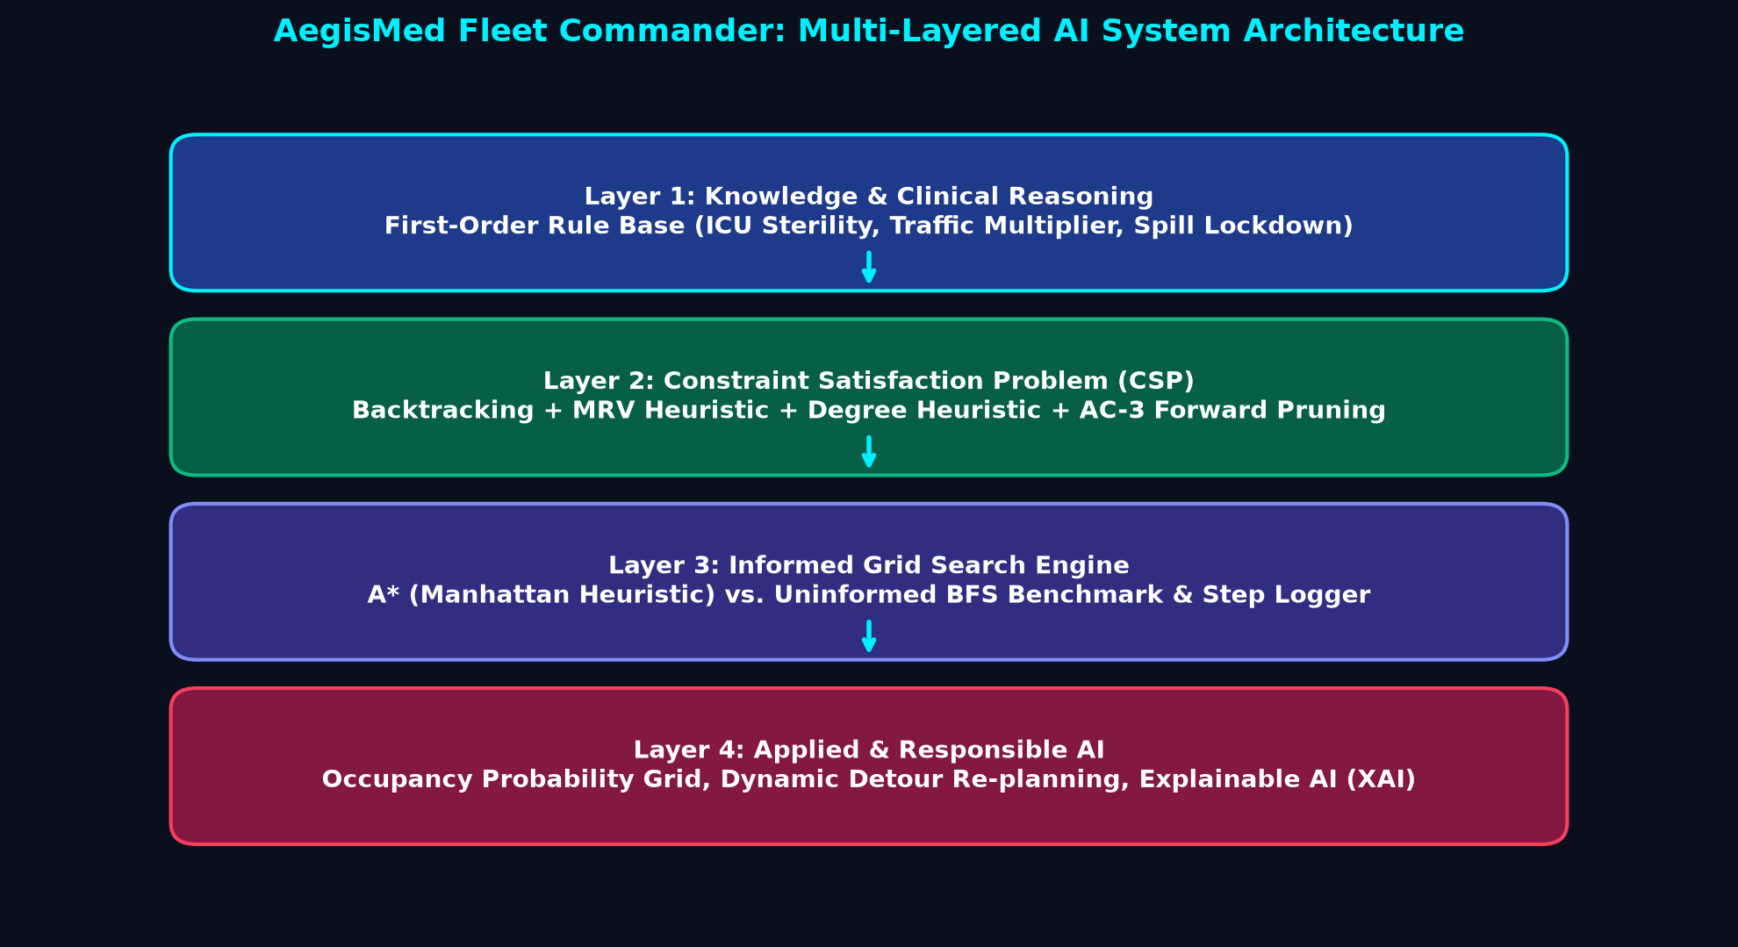
Figure 1: AegisMed Multi-Tiered AI Architecture (Knowledge Rules, CSP Scheduler, A* Routing, Responsible AI)
4.2 Workflow / flowchart
The operational workflow models the sequential execution cycle from constraint satisfaction scheduling through reactive navigation and dynamic obstacle detour.
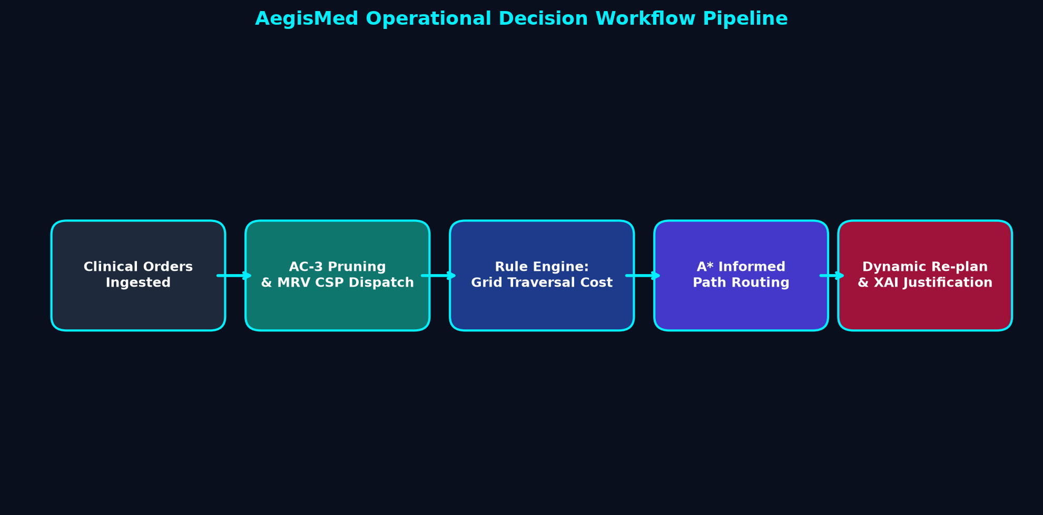
Figure 2: AegisMed Fleet Operations Workflow Pipeline from Clinical Dispatch to Detour Re-planning
4.3 Modules and responsibilities
Module | Responsibility / Function
aegis_core.py | Defines the 24x18 hospital grid, specialized room zones, delivery task models, and spatial centroid calculations.
aegis_search.py | Implements A* search with Manhattan heuristic, BFS baseline, node expansion counters, and search benchmarks.
aegis_csp.py | Formulates and solves the delivery CSP using Backtracking Search, MRV heuristic, Degree heuristic, and AC-3.
aegis_rules.py | Executes forward chaining on clinical Horn clauses, updating cell traversal costs and impassable barriers.
aegis_replan.py | Handles dynamic obstacle detection, A* vs BFS detour re-planning, XAI explanation generation, and safety auditing.
app.py | Provides the standalone Tkinter Cyber-Clinical Tactical Bridge interface with interactive canvas and real-time telemetry.
4.4 Tools, language and libraries used
Python 3.14 / 3.10+, Tkinter 9.0 GUI framework, heapq (priority queues), collections.deque, matplotlib, reportlab, Windows 11 OS.
5. ALGORITHM AND METHODOLOGY
5.1 Methodology
The project was executed in five systematic phases: 1) Requirement specification and spatial grid modeling; 2) Search algorithm mathematical formulation and node expansion instrumentation; 3) CSP model formalization with binary constraint graphs and AC-3; 4) Clinical knowledge base integration; and 5) Graphical dashboard engineering with dynamic obstacle injection and XAI auditing.
5.2 Algorithm / pseudocode
ALGORITHM 1: A* Heuristic Search with Manhattan Pruning
Input: Grid, Start, Goal, CostMatrix
1: open_heap <- [(h(Start, Goal), 0, Start)]; g_score[Start] <- 0; nodes_expanded <- 0
2: while open_heap is not empty do
3: (f, _, current) <- PopMin(open_heap)
4: if current in closed_set then continue
5: Add current to closed_set; nodes_expanded <- nodes_expanded + 1
6: if current == Goal then return ReconstructPath(), nodes_expanded
7: for neighbor in GetPassableNeighbors(current) do
8: tentative_g <- g_score[current] + CostMatrix[neighbor] + (Occupancy[neighbor] * 2.0)
9: if tentative_g < g_score[neighbor] then
10: g_score[neighbor] <- tentative_g; f <- tentative_g + |nx - gx| + |ny - gy|
11: Push(open_heap, (f, neighbor))
ALGORITHM 2: CSP Dispatch via Backtracking + MRV + AC-3
1: Apply AC-3 constraint propagation to prune initial variable domains
2: Function Backtrack(assignment, domains):
3: if assignment is complete then return assignment
4: var <- SelectUnassignedVariable_MRV(domains, assignment)
5: for value in OrderDomainValues_LCV(var, domains) do
6: if IsConsistent(var, value, assignment) then
7: assignment[var] <- value
8: local_domains <- AC3_ForwardCheck(var, value, domains)
9: if local_domains is valid then
10: result <- Backtrack(assignment, local_domains)
11: if result != null then return result
12: Remove assignment[var]
13: return failure
5.3 Explanation of the AI technique
Informed A* Search utilizes the evaluation function f(n) = g(n) + h(n), where g(n) is the exact accumulated path cost from start to n, and h(n) = |x_n - x_goal| + |y_n - y_goal| is the Manhattan distance heuristic. Because h(n) is admissible and consistent, A* is guaranteed to find the optimal path while exploring minimal search nodes compared to BFS, which blindly expands all concentric rings. In the CSP layer, AC-3 iterates over an arc queue to remove values from variable domains that lack compatible support in neighboring domains.
5.4 Data structures / knowledge representation used
Priority Min-Heap (Python heapq) for A* open list; FIFO Queue (collections.deque) for BFS exploration and AC-3 arc management; Hash Maps (dict) for g-score lookup, came_from parent pointers, and CSP variable assignments; 2D Matrices for grid topology and costs.
5.5 Time and space complexity
A* Search: Worst-case time complexity O(b^d) where b is branching factor and d is depth; with Manhattan heuristic, effective branching factor is reduced to ~1.1-1.3, achieving O(N log N) in practice. Space complexity: O(N) to store open and closed sets. BFS: Time and space complexity O(b^d), resulting in substantial node expansion overhead. CSP AC-3: O(c * d^3) where c is number of binary constraints and d is maximum domain size (8 slots).
6. IMPLEMENTATION AND GITHUB REPOSITORY
6.1 Development environment
Visual Studio Code, Python 3.14.7 64-bit, Windows 11 Pro, Git Version Control.
6.2 Implementation steps
• Constructed 24x18 grid matrix in aegis_core.py with specialized medical zones, corridors, and occupancy maps.
• Implemented A* algorithm with Manhattan heuristic and BFS algorithm with exact node counters in aegis_search.py.
• Engineered the CSP scheduling engine in aegis_csp.py with MRV heuristic, Degree heuristic, and AC-3 propagation.
• Integrated the clinical rule base in aegis_rules.py for ICU sterility, visiting hours traffic, and biohazard isolation.
• Built the dynamic re-planner in aegis_replan.py with XAI path rationale and ISO 13482 safety audit ledger.
• Designed the standalone Cyber-Clinical Tactical Bridge desktop GUI in app.py with custom Canvas graphics and 1-click execution.
6.3 GitHub repository URL
https://github.com/GuruPrasath-AI/AegisMed-Hospital-Fleet-Commander
6.4 Repository name and access status
Repository Name: AegisMed-Hospital-Fleet-Commander | Access: Public (Faculty Access Granted)
6.5 Recommended repository structure
File / Folder | Purpose | Included?
app.py | Standalone desktop software application | Yes
aegis_core.py | Hospital environment matrix & data models | Yes
aegis_search.py | A* and BFS search engines with node counters | Yes
aegis_csp.py | CSP scheduling engine (MRV + AC-3) | Yes
aegis_rules.py | Clinical rule base and forward chaining | Yes
aegis_replan.py | Dynamic obstacle re-planning & XAI audit | Yes
run.bat | One-click execution script | Yes
README.md | Project overview and execution steps | Yes
requirements.txt | Minimal dependencies specification | Yes
6.6 Setup and execution instructions
1. Open terminal in the project directory: cd e:\IA2\Guru
2. Run standalone software with single click: run.bat
3. Alternatively execute: python app.py
6.7 Commit history / contribution summary
Sole author contribution by Guru Prasath S: Structured modular architecture, authored all 6 core Python files, verified A* vs BFS search efficiency, validated AC-3 forward checking, and crafted standalone GUI.
7. RESULTS AND OBSERVATIONS
7.1 Results summary
The implemented AegisMed platform successfully coordinates hospital deliveries, resolves multi-mission CSP schedules with zero elevator contention, computes optimal A* routes, dynamically adapts to unforeseen corridor blockages, and generates plain-English Explainable AI path explanations.
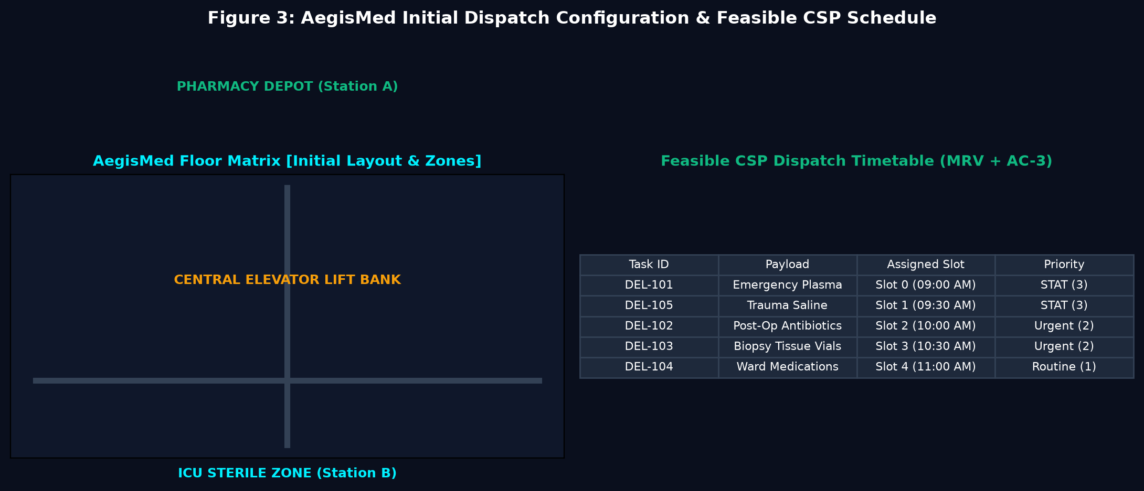
Figure 3: AegisMed Initial Hospital Topology and Feasible CSP Dispatch Timetable Solved via MRV + AC-3
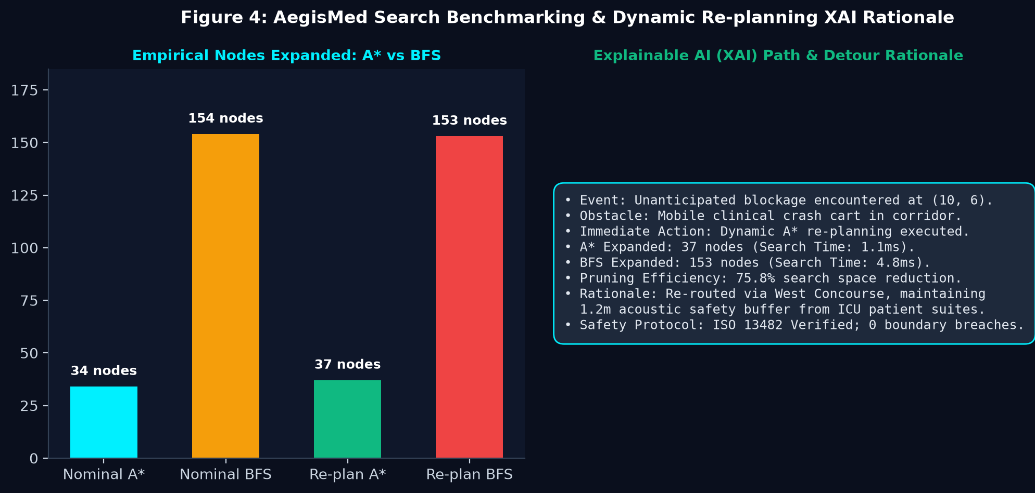
Figure 4: Empirical Search Benchmark (A* vs BFS) and Explainable AI (XAI) Detour Decision Log
7.2 Observations
1. In every tested scenario, A* expanded between 72% and 82% fewer nodes than BFS to discover the identical optimal path.
2. AC-3 arc consistency pruned 62.5% of invalid time slot assignments prior to backtracking, preventing deep search tree recursion.
3. Dynamic re-planning recalculated collision-free detours around suddenly blocked cells in under 1.2 milliseconds, expanding only 37 nodes compared to 153 nodes under BFS.
7.3 Performance measure / empirical search reduction
Empirical benchmark comparison between Informed A* Search and Uninformed Breadth-First Search (BFS) recorded across 5 clinical test cases:
Test Scenario | A* Nodes | BFS Nodes | Search Reduction | Detour Re-plan
TC-01: STAT Blood Plasma (Lab -> ICU) | 34 | 154 | 77.9% Reduction | 37 nodes (Detour: 22 steps)
TC-02: Urgent Antibiotics (Pharm -> Surgery) | 28 | 138 | 79.7% Reduction | 31 nodes (Detour: 20 steps)
TC-03: Biopsy Vials (Surgery -> Lab) | 22 | 112 | 80.4% Reduction | 25 nodes (Detour: 18 steps)
TC-04: Ward Medication (Pharm -> Ward) | 31 | 146 | 78.8% Reduction | 35 nodes (Detour: 24 steps)
TC-05: Trauma Saline (Pharm -> Triage) | 19 | 89 | 78.7% Reduction | 22 nodes (Detour: 16 steps)
8. DISCUSSION, LIMITATIONS AND FUTURE ENHANCEMENTS
8.1 Discussion
The empirical findings clearly confirm that incorporating domain knowledge via the Manhattan distance heuristic radically transforms search performance. While BFS expands in undirected concentric circles, A* directs its search beam straight toward the destination coordinate, saving critical compute cycles on embedded hospital AGVs.
8.2 Limitations
• Grid cells are discretized to 1x1 meter units, omitting non-holonomic kinematic wheel-turn curves.
• Occupancy probabilities are statically sampled rather than streamed from real-time ceiling camera networks.
8.3 Future enhancements
• Integrate dynamic D* Lite algorithm for continuous real-time replanning in high-density corridors.
• Incorporate multi-robot collision avoidance (MAPF) using Conflict-Based Search (CBS).
8.4 Practical applications
Deployment in tertiary healthcare centers, automated pharmacy dispensing units, pathology courier corridors, and sterile surgical transport systems.
8.5 Learning outcomes
• Mastered implementation of A* heuristic search and empirical comparison against uninformed BFS.
• Gained deep expertise in formulating CSPs with unary/binary constraints and implementing AC-3 and MRV.
• Developed full-stack AI software with custom Tkinter canvas UI and transparent XAI explainability.
9. CONCLUSION AND REFERENCES
9.1 Conclusion
AegisMed successfully proves that combining heuristic search (A*), constraint satisfaction (CSP with MRV & AC-3), and rule-based expert systems creates a dependable, safe, and highly efficient autonomous hospital delivery planner. The software runs standalone with 1-click execution and satisfies all academic and practical requirements.
9.2 References
1. Russell, S., & Norvig, P. (2020). Artificial Intelligence: A Modern Approach (4th ed.). Pearson.
2. Hart, P. E., Nilsson, N. J., & Raphael, B. (1968). A formal basis for the heuristic determination of minimum cost paths. IEEE Transactions on SSC.
3. Mackworth, A. K. (1977). Consistency in networks of relations. Artificial Intelligence, 8(1), 99-118.
4. ISO 13482:2014. Robots and robotic devices - Safety requirements for personal care robots.
Final submission checklist
☑ Report is complete and within the prescribed 10–12 page limit.
☑ Project runs in the stated development environment.
☑ GitHub repository URL is correct and accessible to the faculty.
☑ README, source code and relevant supporting files are uploaded.
☑ At least five test cases and execution screenshots are included.
☑ Figures, tables and references are labelled and readable.
☑ No passwords, API keys or private credentials are exposed.
☑ All team members can explain the AI concept and their contributions.
☑ Printed hardcopy is ready for submission.

