WEEK 4
Tokenizer Comparison:
BPE, WordPiece and SentencePiece

Project Overview
The objective of Week 4 is to understand how Large Language Models split text into tokens. The program loads three pretrained tokenizers from Hugging Face, each based on a different algorithm, and applies them to the same sentence written in English, Telugu and Hindi. For every tokenizer and language it prints the tokens, the token IDs and the token count, so the results can be compared side by side.

Objectives
- Understand what tokenization is and why LLMs work with tokens instead of characters or words.
- Compare three tokenization algorithms: Byte-Pair Encoding (BPE), WordPiece and SentencePiece.
- Load pretrained tokenizers with the Hugging Face AutoTokenizer class.
- Observe how the same meaning produces different token counts in English, Telugu and Hindi.
- Display Telugu and Hindi text correctly in a Windows terminal by switching the output to UTF-8.

Tools and technologies
Tool / Library | Purpose
Python 3 | Programming language (pyproject.toml requires 3.14 or newer)
PyCharm | Code editor and integrated terminal
uv | Creates the project virtual environment (pyproject.toml, uv.lock)
transformers | Hugging Face library that provides AutoTokenizer
sentencepiece | Backend needed by SentencePiece-based tokenizers
protobuf | Dependency used when loading SentencePiece tokenizer files
tiktoken | OpenAI tokenizer library, listed in requirements
Hugging Face Hub | Hosts the tokenizer files, which are downloaded on the first run

Project Folder Structure
The project folder is named week-4. It contains the following files and folders:
week-4/ ├── .venv/ # Python virtual environment
├── main.py # Default PyCharm sample script
├── pyproject.toml # Project metadata
├── requirements.txt # Python dependencies
├── tokenizer_comparison.py # Tokenizer comparison program
└── uv.lock # Locked dependency versions
PyCharm also creates an .idea folder for its project settings, and Python may create a __pycache__ folder. Neither needs to be edited. This project does not call a paid API, so no .env file or API key is needed.
[ Insert screenshot: week-4 project folder in PyCharm ]
Figure 1. week-4 project folder and files in PyCharm.

Environment Setup on Windows
- Open the week-4 folder in PyCharm.
- Open the integrated terminal (View > Tool Windows > Terminal).
- Create a virtual environment (if it has not already been created): uv venv or python -m venv .venv
- Activate it: .venv\Scripts\activate. The terminal should show (.venv).
- Install dependencies: pip install -r requirements.txt (with uv: uv pip install -r requirements.txt). The dependencies are listed in requirements.txt; the dependencies list in pyproject.toml is empty.
- Make sure the computer is connected to the internet. The first run downloads the three tokenizers fromHugging Face and stores them in a local cache.

Configuration: Tokenizers and Texts
Instead of an API key, this project is configured by two dictionaries at the top of tokenizer_comparison.py. The TOKENIZERS dictionary maps a display name to a Hugging Face model ID:
Display name | Model ID | Algorithm
BPE - GPT-2 | gpt2 | Byte-Pair Encoding
WordPiece - Multilingual BERT | bert-base-multilingual-cased | WordPiece
SentencePiece - XLM-R | xlm-roberta-base | SentencePiece
The TEXTS dictionary holds the same sentence, “Artificial intelligence is changing the world.”, in three languages: English, Telugu and Hindi. To test other sentences or tokenizers, edit these two dictionaries.

Dependencies: requirements.txt
Install all listed packages from the project terminal with:
transformers sentencepiece protobuf tiktoken pip install -r requirements.txt

Source Code

tokenizer_comparison.py
The program disables a Hugging Face symlink warning and switches the console output to UTF-8 so that
Telugu and Hindi print correctly on Windows. load_tokenizers() downloads each tokenizer with AutoTokenizer. compare_tokenizers() encodes every text with every tokenizer, converts the token IDs back to token strings, and prints the tokens, the token IDs and the token count. Special tokens are included in the IDs and the count (add_special_tokens=True).
import sys import os os.environ["HF_HUB_DISABLE_SYMLINKS_WARNING"] = "1" from transformers import AutoTokenizer
# Allow Telugu/Hindi output on Windows consoles try:
sys.stdout.reconfigure(encoding="utf-8") except Exception: pass
TOKENIZERS = {
"BPE - GPT-2": "gpt2",
"WordPiece - Multilingual BERT": "bert-base-multilingual-cased",
"SentencePiece - XLM-R": "xlm-roberta-base",
}
TEXTS = { "English": "Artificial intelligence is changing the world.",
}
def load_tokenizers():
loaded = {} for display_name, model_name in TOKENIZERS.items():
print(f"Loading {display_name}...")
loaded[display_name] = AutoTokenizer.from_pretrained(model_name) return loaded
def compare_tokenizers(loaded_tokenizers):
for language, text in TEXTS.items(): print("\n" + "=" * 75) print(f"LANGUAGE: {language}") print(f"INPUT TEXT: {text}") print("=" * 75)
for tokenizer_name, tokenizer in loaded_tokenizers.items():
encoded = tokenizer(text, add_special_tokens=True, truncation=False) token_ids = encoded["input_ids"] tokens = tokenizer.convert_ids_to_tokens(token_ids)
print(f"\n{tokenizer_name}") print("Tokens :", tokens) print("Token IDs :", token_ids) print("Token count:", len(token_ids))
def main():
tokenizers = load_tokenizers() compare_tokenizers(tokenizers)
if __name__ == "__main__": main()

main.py
This is the default sample script that PyCharm creates for a new project. It only prints a greeting and is not used by the tokenizer comparison.
# This is a sample Python script.
# Press Ctrl+F5 to execute it or replace it with your code. # Press Double Shift to search everywhere for classes, files, tool windows, actions, and settings.
def print_hi(name): # Use a breakpoint in the code line below to debug your script. print(f'Hi, {name}') # Press F9 to toggle the breakpoint.
# Press the green button in the gutter to run the script. if __name__ == '__main__': print_hi('PyCharm') # See PyCharm help at https://www.jetbrains.com/help/pycharm/

Running the Application
Run these commands in the PyCharm terminal from inside the week-4 folder:
.venv\Scripts\activate python tokenizer_comparison.py
The program prints a Loading message for each tokenizer. Then, for English, Telugu and Hindi, it prints the input text followed by the Tokens, Token IDs and Token count of each tokenizer.
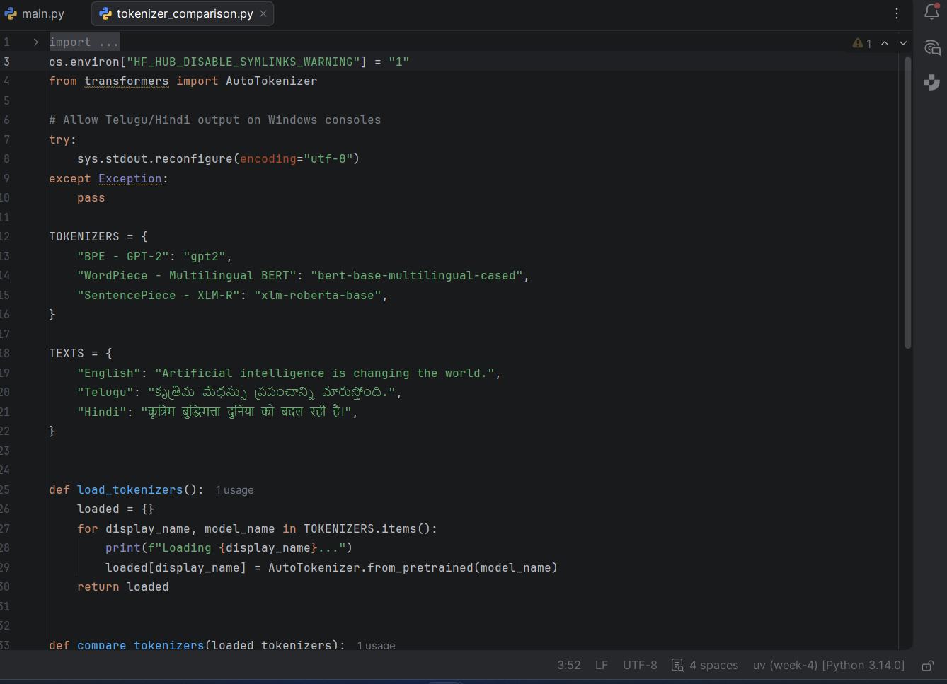
Figure 2. Output of tokenizer_comparison.py.

Token counts
Copy the Token count values from your run into this table. Remember that the counts include the special tokens added by each tokenizer.
E8
Language
BPE (GPT-2)
WordPiece (mBERT)
SentencePiece (XLM-R)
English
Telugu
Hindi

Result
A program was implemented that compares three tokenization algorithms (BPE, WordPiece and SentencePiece) on the same sentence in English, Telugu and Hindi. For each combination it shows the tokens, the token IDs and the total number of tokens, which makes the differences between the algorithms and between the languages visible.

Conclusion
This project shows that a tokenizer decides how text is split before a model ever sees it, and that different algorithms split the same sentence into different tokens. Comparing token counts across English, Telugu and Hindi gives a practical view of how well each tokenizer represents each language. This understanding is useful when working with LLM APIs, where input and output are measured in tokens.


