WEEK 3
LLM Monitoring with MongoDB Logging

Project Overview
Week 3 extends the provider-agnostic LLM client from Week 2 with monitoring. The application sends a prompt to either a cloud-based Gemini model or a local Llama 3.2 model running in Ollama. For every call, the common client measures latency, records token usage, estimates the cost, retries temporary failures, and saves a log document in a MongoDB database. The provider can still be changed without rewriting the application logic.

Objectives
- Extend the common LLM provider interface so every provider returns the response together with tokencounts.
- Measure the total latency of each request, including retries.
- Calculate the cost of each call from token usage and per-model pricing.
- Retry only temporary failures (timeouts, connection errors, HTTP 429 and 5xx) with exponentialbackoff.
- Store each successful or failed call as a document in MongoDB using PyMongo.
- Keep logging errors separate so that a MongoDB failure never repeats a successful model request.
- Load API credentials securely from a .env file.

Tools and technologies
Tool / Library | Purpose
Python 3 | Programming language (pyproject.toml requires 3.14 or newer)
PyCharm | Code editor and integrated terminal
uv | Dependency and virtual-environment manager (uv.lock, pyproject.toml)
Google Gemini API | Cloud-based LLM provider
google-genai | Python SDK for Gemini
Ollama | Runs the Llama 3.2 model locally
requests | Sends HTTP requests to Ollama
MongoDB | Database that stores the call logs (localhost:27017)
pymongo | Python driver for MongoDB
python-dotenv | Loads environment variables from .env
pytest | Testing tool listed in requirements

Project Folder Structure
The project folder is named week-3. It contains the following files and folders:
week-3/ ├── .venv/ # Python virtual environment
├── .env # Gemini API key (kept private)
├── cost_calculator.py # Per-model pricing and cost calculation
├── llm_client.py # Provider classes and common client
├── main.py # Program entry point
├── mongo_logger.py # MongoDB logging class
├── pyproject.toml # Project metadata and dependencies
├── requirements.txt # Python dependencies
└── uv.lock # Locked dependency versions
The __pycache__ folder may also appear automatically after Python runs, and PyCharm creates the .idea folder. Neither needs to be edited.
[ Insert screenshot: week-3 project folder in PyCharm ]
Figure 1. week-3 project folder and files in PyCharm.

Environment Setup on Windows
- Open the week-3 folder in PyCharm.
- Open the integrated terminal (View > Tool Windows > Terminal).
- Install dependencies with uv: uv sync
- Or create a virtual environment manually: python -m venv .venv and activate it with .venv\Scripts\activate.
- Install dependencies: pip install -r requirements.txt and also pip install requests, which llm_client.py imports and which is listed in pyproject.toml.
- Install and start MongoDB so that it listens on mongodb://localhost:27017/. The logger writes to thellm_monitoring database, in the call_logs collection.
- Install Ollama and download the model: ollama pull llama3.2. The Ollama service listens on http://localhost:11434.

Configuration: .env
The Gemini API key is stored in a .env file so that it is not hard-coded into the Python source. Replace the placeholder below with the API key created for your Google AI Studio project. The .env file must never be uploaded to GitHub or shown in screenshots.
GEMINI_API_KEY=YOUR_GEMINI_API_KEY

Dependencies: requirements.txt
Install all listed packages from the project terminal with:
pytest google-genai python-dotenv pymongo pip install -r requirements.txt

Source Code

cost_calculator.py
This file stores the price per one million input and output tokens for each model and calculates the cost of a call. Ollama runs locally, so its cost is always 0.0. The rates are sample values and must be replaced with the current prices of the selected model. A model without a pricing entry returns None.
# cost_calculator.py # Example rates per 1 million tokens.
# IMPORTANT: These are sample values, not verified current Gemini prices.
# Replace them with the actual rates for your selected model.
PRICING = {
"gemini-3.8-flash": {
"input": 0.50, "output": 2.00
} }
def calculate_cost(provider, model, input_tokens, output_tokens): # Ollama runs locally and does not charge a per-token API fee. if provider == "OllamaProvider":
return 0.0 rates = PRICING.get(model) if rates is None: return None input_cost = ( input_tokens * rates["input"] ) / 1_000_000 output_cost = ( output_tokens * rates["output"] ) / 1_000_000 total_cost = input_cost + output_cost return round(total_cost, 10)

llm_client.py
This file defines the abstract provider interface, the Gemini and Ollama implementations, and the common LLMClient. Both providers return the response text with the input and output token counts. LLMClient measures latency, calculates cost, retries temporary errors with exponential backoff (1 s, then 2 s), and logs every successful or failed call.
# llm_client.py
from abc import ABC, abstractmethod from google import genai from google.genai import types import requests import time from cost_calculator import calculate_cost
# --------------------------------
# 1. Common LLM Provider Interface # -------------------------------class LLMProvider(ABC): @abstractmethod def generate(self, prompt): pass
# --------------------------------
# 2. Gemini Provider # -------------------------------class GeminiProvider(LLMProvider): def __init__(self, api_key):
self.client = genai.Client( api_key=api_key, http_options=types.HttpOptions(timeout=600000) ) self.model = "gemini-3.8-flash" def generate(self, prompt):
response = self.client.models.generate_content( model=self.model, contents=prompt ) usage = response.usage_metadata
input_tokens = ( usage.prompt_token_count if usage else 0 )
output_tokens = ( usage.candidates_token_count if usage else 0 )
return { "response": response.text,
"input_tokens": input_tokens,
"output_tokens": output_tokens
}
# --------------------------------
# 3. Ollama Provider # -------------------------------class OllamaProvider(LLMProvider): def __init__(self, model="llama3.2"):
self.model = model self.url = "http://localhost:11434/api/generate" def generate(self, prompt):
response = requests.post( self.url, json={ "model": self.model,
"prompt": prompt,
"stream": False
},
timeout=180 ) response.raise_for_status() data = response.json()
return { "response": data["response"],
"input_tokens": data.get("prompt_eval_count", 0),
"output_tokens": data.get("eval_count", 0)
}
# --------------------------------
# 4. Common LLM Client # -------------------------------class LLMClient:
def __init__(self, provider, logger):
self.provider = provider self.logger = logger def generate(self, prompt):
max_attempts = 3 start_time = time.perf_counter() last_error = None for attempt in range(1, max_attempts + 1): try:
# Generate AI response result = self.provider.generate(prompt)
# Calculate total elapsed time, including retries latency = round( (time.perf_counter() - start_time) * 1000,
2 ) input_tokens = result["input_tokens"] output_tokens = result["output_tokens"] model = self.provider.model provider_name = type(self.provider).__name__
cost = calculate_cost( provider_name, model, input_tokens, output_tokens )
# Prepare MongoDB document log_data = {
"provider": provider_name,
"model": model,
"prompt": prompt,
"input_tokens": input_tokens,
"output_tokens": output_tokens,
"total_tokens": input_tokens + output_tokens,
"latency_ms": latency,
"cost": cost,
"attempts": attempt,
"status": "success",
"error": None
}
# Log separately: a MongoDB error must not repeat # an already successful model request. try:
self.logger.log_call(log_data) except Exception as log_error: print("MongoDB logging error:", log_error) return result["response"] except Exception as error: last_error = error
# Retry only likely temporary failures status_code = getattr(error, "status_code", None)
retryable = ( isinstance( error, ( requests.exceptions.Timeout, requests.exceptions.ConnectionError ) ) or status_code == 429 or ( isinstance(status_code, int) and status_code >= 500 ) or ( isinstance(error, requests.exceptions.HTTPError) and error.response is not None and (
error.response.status_code == 429 or error.response.status_code >= 500 )
) )
if not retryable or attempt == max_attempts: break wait_time = 2 ** (attempt - 1)
print( f"Attempt {attempt} failed. " f"Retrying in {wait_time} seconds..." ) time.sleep(wait_time)
# All attempts failed, or the error was not retryable latency = round(
(time.perf_counter() - start_time) * 1000,
2 )
failed_log = { "provider": type(self.provider).__name__,
"model": self.provider.model,
"prompt": prompt,
"latency_ms": latency,
"attempts": attempt,
"status": "failed",
"error": str(last_error) }
try:
self.logger.log_call(failed_log) except Exception as log_error: print("MongoDB logging error:", log_error) raise last_error

mongo_logger.py
This file connects to the local MongoDB server, adds a UTC timestamp to each log document, and inserts it into the call_logs collection of the llm_monitoring database. from pymongo import MongoClient from datetime import datetime, timezone
class MongoLogger:
def __init__(self):
self.client = MongoClient( "mongodb://localhost:27017/" ) self.db = self.client["llm_monitoring"] self.collection = self.db["call_logs"] def log_call(self, log_data):
log_data["timestamp"] = datetime.now(timezone.utc) self.collection.insert_one(log_data) print("Call details saved in MongoDB!") def close(self): self.client.close()

main.py
The main program loads the .env file, connects to MongoDB, asks the user to select a provider, creates the common LLMClient with the logger, sends the prompt, prints the answer, and closes the database connection.
# main.py
import os from dotenv import load_dotenv
from llm_client import ( GeminiProvider,
OllamaProvider,
LLMClient ) from mongo_logger import MongoLogger
# Load environment variables load_dotenv(override=True)
print("================================") print(" WEEK 3: LLM MONITORING") print("================================")
print("1. Gemini") print("2. Ollama") choice = input("\nSelect provider (1/2): ").strip() logger = None try:
# Connect to MongoDB logger = MongoLogger()
# Select AI provider if choice == "1":
api_key = os.getenv("GEMINI_API_KEY")
if not api_key: raise ValueError("Gemini API key not found in .env") provider = GeminiProvider(api_key)
elif choice == "2": provider = OllamaProvider("llama3.2") else:
raise ValueError("Invalid selection. Choose 1 or 2.")
# Create common client client = LLMClient(provider, logger)
# Get user prompt
prompt = input("\nEnter your question: ")
# Generate response answer = client.generate(prompt) print("\n========== AI RESPONSE ==========") print(answer) print("\n========== COMPLETED ==========") except Exception as error:
print("\nApplication error:", error) finally:
if logger is not None: logger.close()

Running the Application
Make sure MongoDB is running (and Ollama, if you plan to use it). Then run these commands in the PyCharm terminal from inside the week-3 folder:
.venv\Scripts\activate python main.py
Or, with uv: uv run python main.py
When prompted, enter one of the following provider choices:
- 1 – uses the Gemini cloud API and the key stored in .env.
- 2 – uses the local Llama 3.2 model through Ollama.
Then type a question at the Enter your question prompt. The answer is displayed under AI RESPONSE, and the message “Call details saved in MongoDB!” confirms that the call was l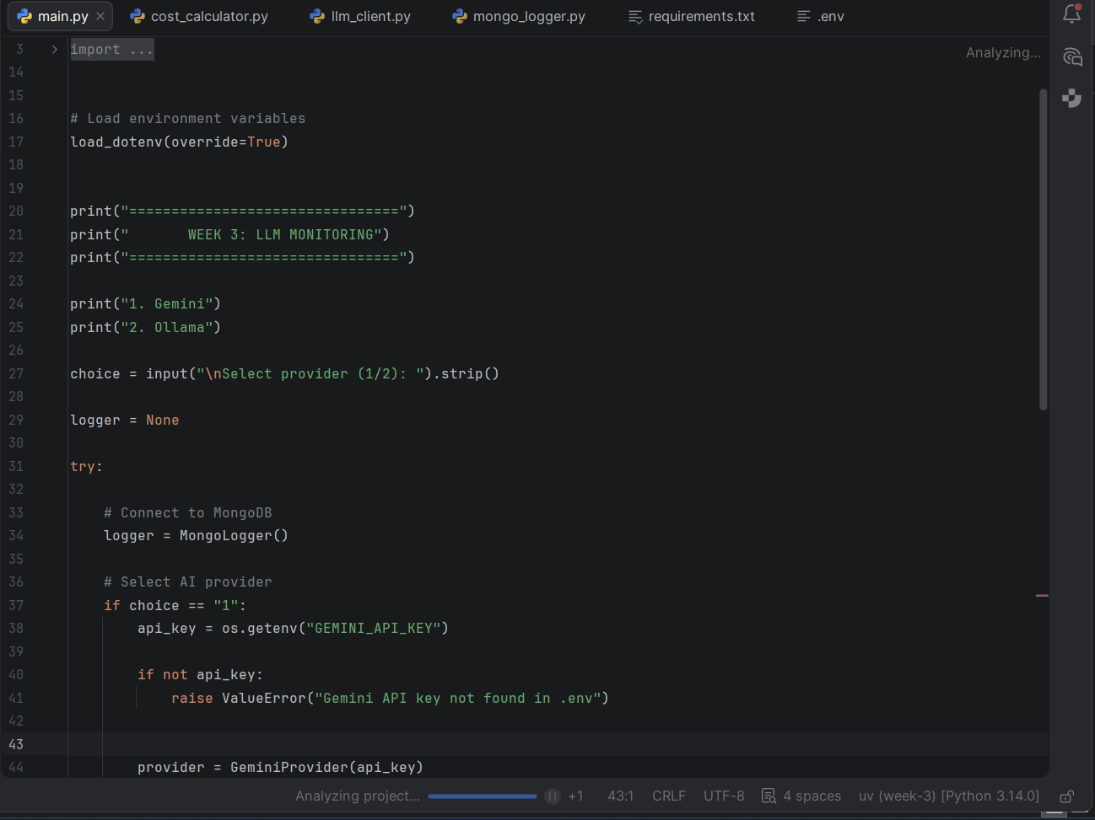
Figure 2. Running main.py with a selected provider.

Logged data
Each call is stored as one document in MongoDB with these fields:
Field | Meaning
provider / model | Provider class name and model ID used for the call
prompt | The question sent to the model
input_tokens / output_tokens / total_tokens | Token usage reported by the provider
latency_ms | Total elapsed time in milliseconds, including retries
cost | Estimated cost in dollars (0.0 for Ollama, None if no price is configured)
attempts | Number of attempts that were made
status / error | success or failed, with the error message for failed calls
timestamp | UTC time when the log was saved
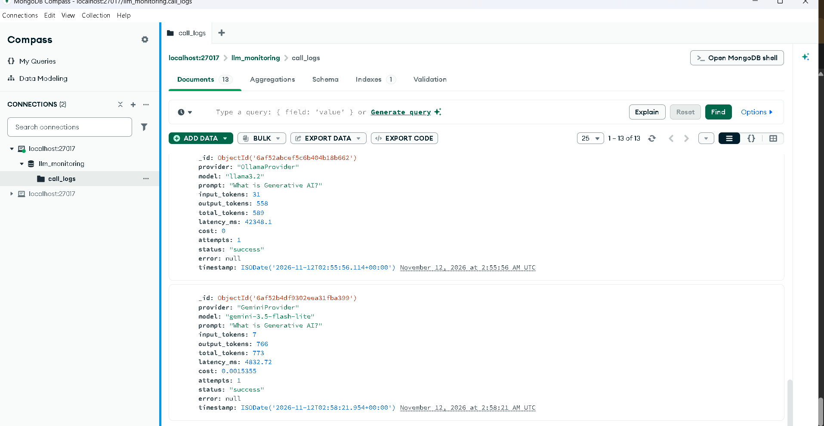
Figure 3. A saved call log in MongoDB.

Result
The provider-agnostic LLM client was extended with monitoring. Each call made through the common LLMClient is timed, its token usage and estimated cost are recorded, temporary failures are retried automatically, and the outcome is saved as a document in the llm_monitoring database in MongoDB. Failed calls are logged as well, with the error message and the number of attempts.

Conclusion
This project shows how monitoring can be added in one place, the common client, without changing the provider classes beyond returning token counts. Because logging, retry, latency and cost are handled by LLMClient, any new provider that implements the LLMProvider interface is monitored automatically.

