NC State University
Department of Electrical and Computer Engineering
ECE 463/563: Fall 2018 (Rotenberg)
Project #2: Branch Prediction

by

Vishal Ganesh Shitole
200258381
vgshitol

NCSU Honor Pledge: "I have neither given nor received unauthorized aid on this test or assignment."

Student’s electronic signature: Vishal Ganesh Shitole

Course number: ECE 563

BIMODAL PREDICTOR

- Graphs

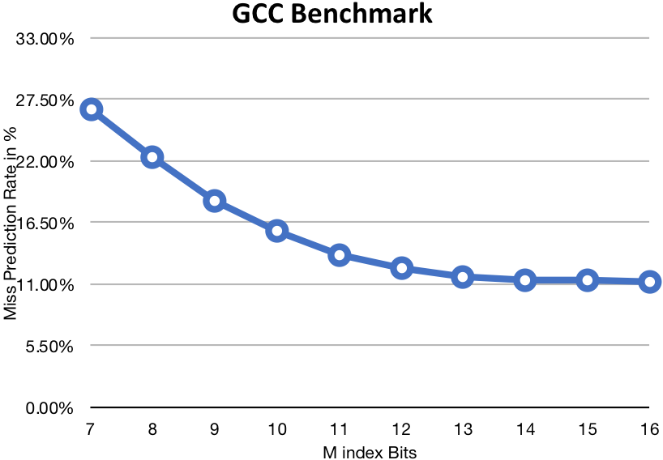
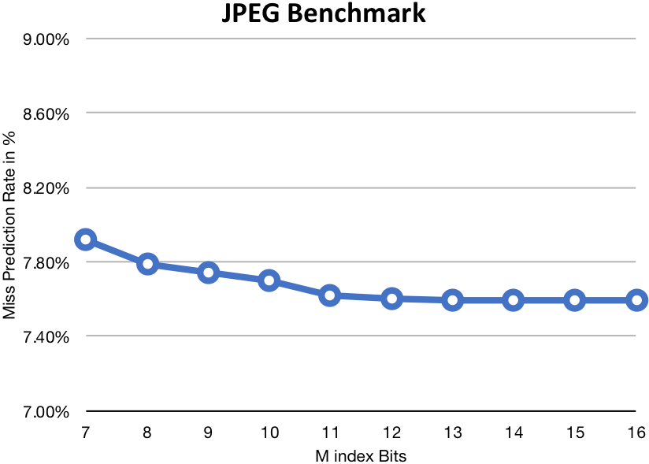
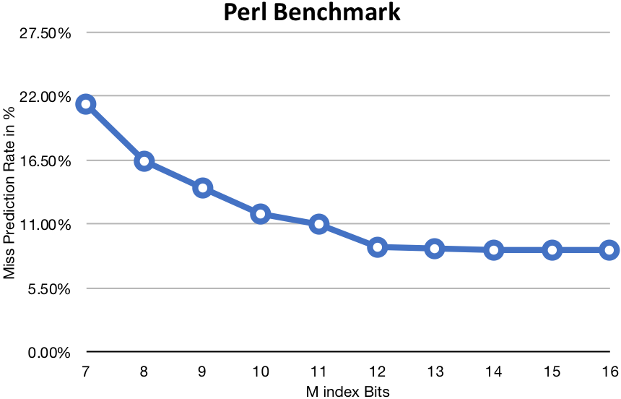

- Analysis

We see that with the increase in number of index bits the misprediction rate is decreased until a point of saturation. However, the rate of change of misprediction rate differs from benchmark to benchmark. This is evident from the varying range of misprediction rate among the 3 graphs.

Hence, we can conclude that more the index bits, irrespective of the benchmark the misprediction rate is reduced and saturates at some instance. Point of Saturation varies from benchmark to benchmark.

- Design

We see that Benchmark JPEG saturates at M = 12, Benchmark GCC Saturates at M = 14 and Benchmark PERL Saturates at M = 12.

Now,

With the constraint of 16KB we can choose a maximum M = 16.

Thus, for M = 14 we see saturation of all the benchmarks and can optimize the design area without affecting our performance by choosing M =14. The Misprediction Rates for the benchmarks at M = 14 are 11.37% (GCC), 7.59%(JPEG) and 8.82(PERL). With this our area for Branch Predictor would be 2^{M+1} bits = 2¹⁵ bits = 2¹² Bytes = 4KB

GSHARE PREDICTOR

- Graphs

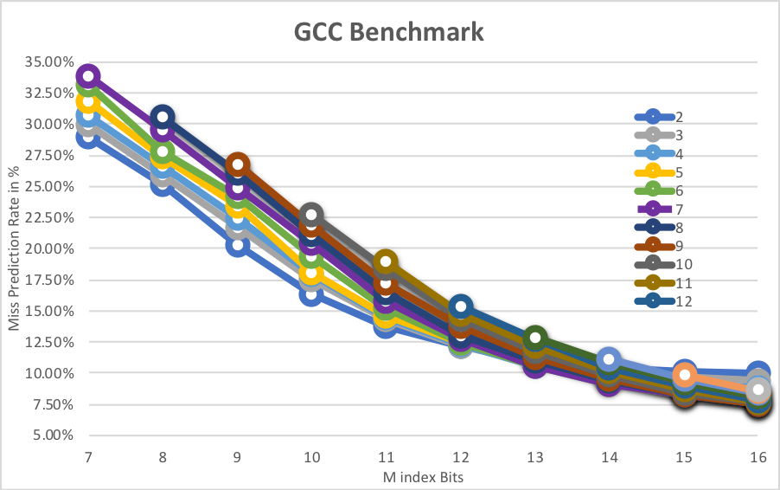

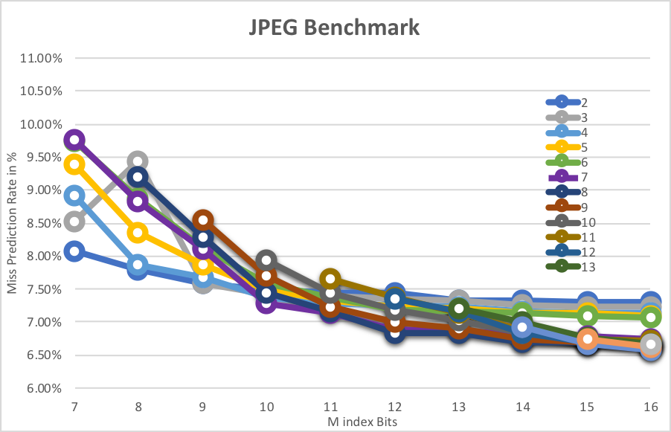
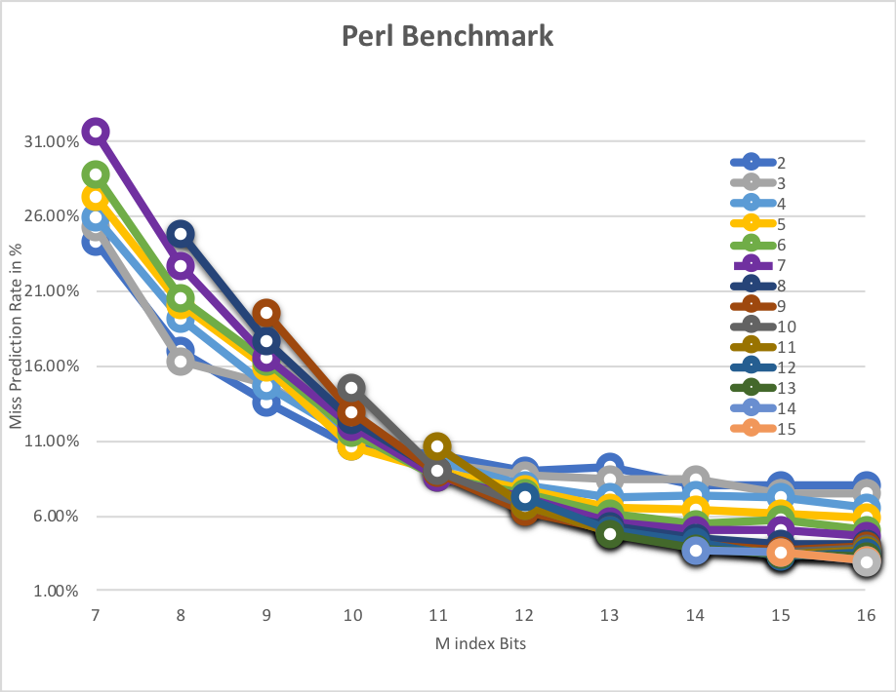

- Analysis

We see that with the increase in number of M index bits, the misprediction rate is decreased drastically. However, the rate of change of misprediction rate differs from benchmark to benchmark. This is evident from the varying range of misprediction rate among the 3 graphs.

We also see that the increase in BHR Index Bits (n), increases the misprediction rate for smaller M. However, as M increases the increase in BHR index bits leads to smaller misprediction rates for all the benchmarks.

Hence, we can conclude that more the M index bits and more/optimal BHR index bits (n < m) can give better misprediction rate.

- Design

We see that Benchmark JPEG saturates at M = 14, Benchmark GCC Saturates at M = 15 and Benchmark PERL Saturates at M = 14.

Importantly, we see that for every M there exists N for which the misprediction rate is lowest. This value is not the lowest N or the Highest N but some median N for every M. This N varies from Benchmark to Benchmark. With increase in M higher N (Not highest) values give lower misprediction results.

Now,

With the constraint of 16KB we can choose a maximum M = 16.

Thus, for M = 15, if we choose N = 9 we get misprediction rates as 8.23% (GCC), 6.69% (JPEG), 3.72%(PERL). We see saturation of all the benchmarks and can optimize the design area without affecting our performance by choosing M =15 and N = 9. With this our area for Branch Predictor would be 2^{M+1} bits = 2¹⁶ bits = 2¹³ Bytes = 8KB

