NC State University
Department of Electrical and Computer Engineering
ECE 463/563: Fall 2018 (Rotenberg)
Project #2: Branch Prediction

by

Vishal Ganesh Shitole

NCSU Honor Pledge: "I have neither given nor received unauthorized aid on this test or assignment."

Student’s electronic signature: Vishal Ganesh Shitole

Course number: ECE 563

BIMODAL PREDICTOR

- Graphs
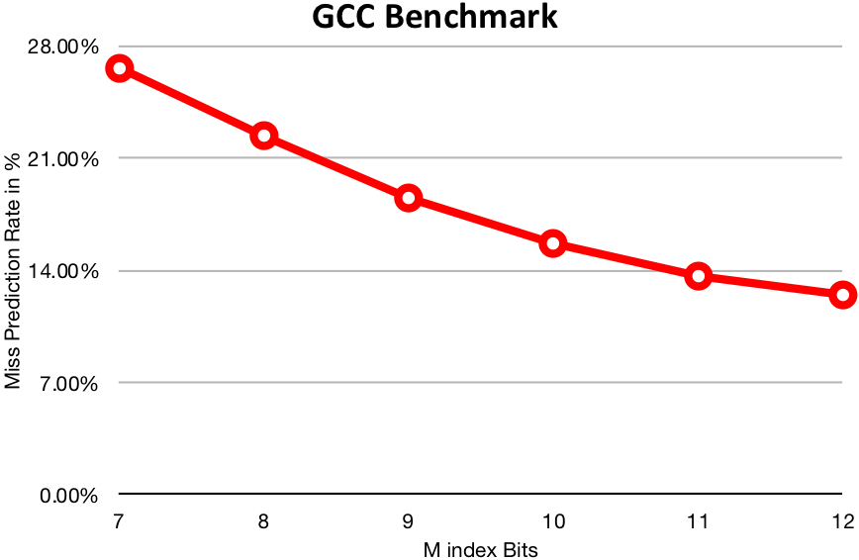

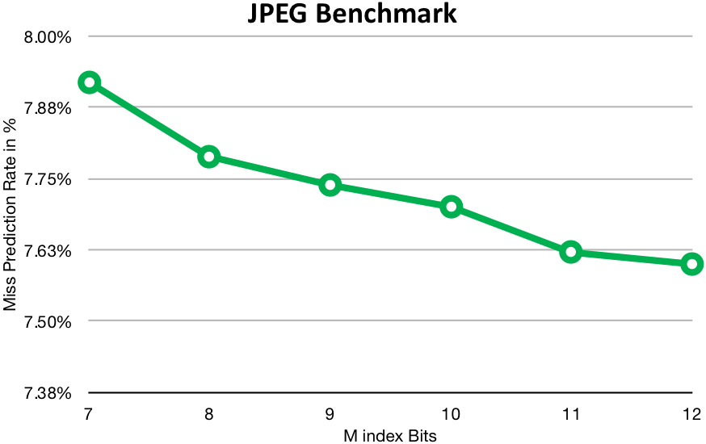

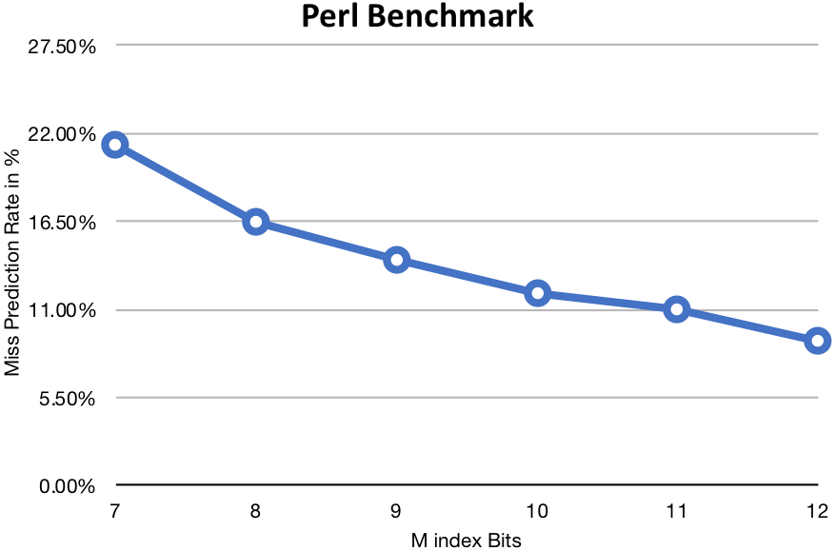

- Analysis

We see that with the increase in number of index bits the misprediction rate is decreased. However, the rate of change of misprediction rate differs from benchmark to benchmark. This is evident from the varying range of misprediction rate among the 3 graphs.

Hence, we can conclude that more the index bits, irrespective of the benchmark the misprediction rate is reduced.

- Design

We can see that optimal bimodal predictor design suitable for the above three benchmarks considering the cost efficiency would be with M = 10. Benchmark JPEG is not affected majorly by increasing the M index bit. It changes only 0.5% for 1 bit increase in M index bits. Benchmark Perl shows decrease in misprediction rate by 3% per bit increase in M until M=10. Likewise, Benchmark GCC also shows decrease in misprediction rate by 2% per bit increase in M.

The storage capacity required for holding the predictor would be 2^{M}.2 = 2Kb = 256B which is in the budget constraint. We can choose a higher M which might give better results. Thus, with the constraint of 16KB we can choose M = 16. Simulating result for M = 16 the misprediction rate = 11.21% which is 1% better than Miss prediction rate at M = 12.

GSHARE PREDICTOR

- Graphs

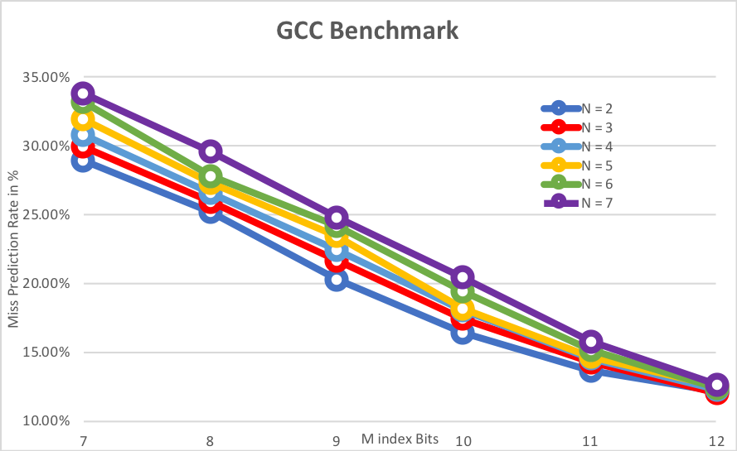

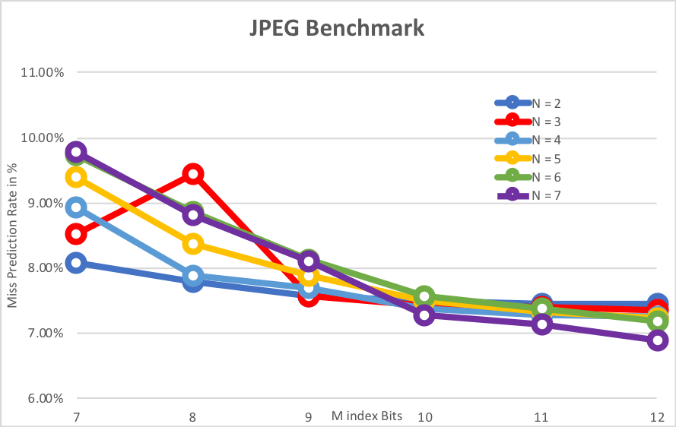

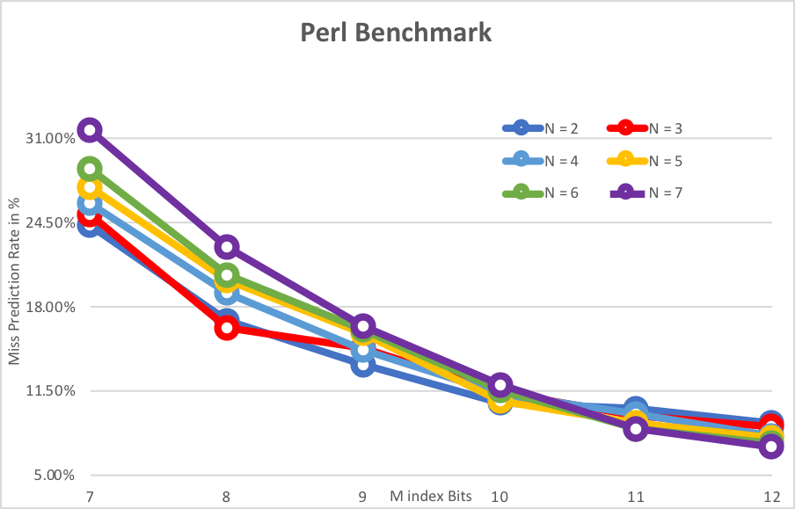

- Analysis

We see that with the increase in number of M index bits, the misprediction rate is decreased drastically. However, the rate of change of misprediction rate differs from benchmark to benchmark. This is evident from the varying range of misprediction rate among the 3 graphs.

With also see that the increase in BHR Index Bits (n), increases the misprediction rate for smaller M. However, as M increases the increase in BHR index bits leads to smaller misprediction rate of Benchmarks Perl and JPEG but not for Benchmark GCC. Maybe, extending the graph can give a better idea and benchmark GCC can also resemble with trends seen in the other two benchmarks.

Hence, we can conclude that more the M index bits and more/optimal BHR index bits (n < m) can give better misprediction rate.

- Design

We can see that optimal bimodal predictor design suitable for the above three benchmarks considering the cost efficiency would be with M = 12 and N = 7. Benchmark JPEG is not affected majorly by increasing the M index bit. It changes only 0.5% for 1 bit increase in M index bits. Benchmark GCC shows decrease in misprediction rate by 3% per bit increase in M until M=12. Likewise, Benchmark Perl also shows decrease in misprediction rate by 2% per bit increase in M.

Importantly, we see that for lower N values the misprediction rate is higher when M is lower. However, with increase in M higher N values give lower misprediction results.

The storage capacity required for holding the predictor would be 2^{M}.2 = 1KB which is in the budget constraint.

However, for our budget constraint maximum M can be 16. The best design for the model would be determined by N and M. The Configuration M = 16 and N = 9 gives best design with misprediction rate 7.49 for GCC trace. 6.77 for JPEG and 3.99 for Perl. Increasing or decreasing the value of N increases the misprediction rate.

