**Cohesion**

In computer programming, **cohesion** refers to the *degree to which the elements of a module belong together*. Thus, it is a measure of how strongly related each piece of functionality expressed by the source code of a software module is.

P = Number of pairs of methods that do **not** share attributes

Q = Number of pairs of methods that share attributes

$$LCOM= \left\{\begin{aligned}P-Q, if P-Q≥0 \\ 0, otherwise\end{aligned}\right.$$

**Example:**

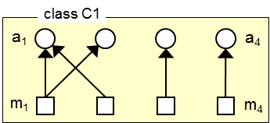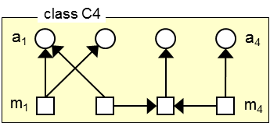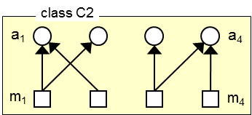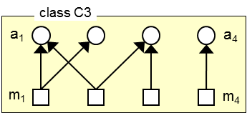

LCOM (C1) = 5-1=4; LCOM (C2) = 2

LCOM (C3) = 2; LCOM (C4) = 4

**Problem**

Write a java program which will take java file/files as input and will calculate LCOM of different classes and also print the argument list in each method and method invocation.

The input file will maintain standard java syntax.

**Sample Input file:-**

class test {

int a, b, x, y;

public void fun1()

{

int c = a + b;

}

public void fun2(int a1)

{

int e = a + 4;

}

private void fun3(int x1)

{

x = x1 + 4;

}

protected void fun4(int y1)

{

y = y1 + 4;

}

}

class test1{

int a, b, x, y;

public void fun1(int a1, int b1)

{

int c = a + b;

}

public void fun2(int a1)

{

a = fun3(a1);

x = a;

}

private int fun3(int x1)

{

x = x1;

return x;

}

protected void fun4(int y1)

{

y = y1;

int z = fun3(y);

}

}

class Main {

public static void main()

{

int a1, b1, x1, y1;

x1 = 5;

b1 = 5;

a1 = 10;

y1 = 11;

test1 t1 = new test1();

t1.fun1();

t1.fun2(a1);

t1.fun3(x1);

t1.fun4(y1);

test t2 = new test();

t2.fun1(a1, b1);

t2.fun2(a1);

t2.fun3(x1);

t2.fun4(y1);

}

}

**Sample output:-**

LCOM of test = 4

LCOM of test1 = 2

Class test

fun1 – argument list:-null; method invocation:- null

fun2 – argument list:- a1.; method invocation:- null

fun3 – argument list:- x1; method invocation:- null

fun4 – argument list:- y1; method invocation:- null

Class test1

fun1 – argument list:- a1,b1; method invocation:- null

fun2 – argument list:- a1.; method invocation:- fun3

fun3 – argument list:- x1; method invocation:- null

fun4 – argument list:- y1; method invocation:- fun3

Class Main

Main - argument list

**Hints**:-

You can use the previous code developed for cohesion and coupling for reference that can be used to extract the classes and the methods in each class. Only the argument list of the methods must to be found.