Tonal components:

* Pure tones
* Narrowband noises with bandwidth less than the critical bandwidth

Critical bandwidth = 100 Hz up to 400Hz and CBW (Hz) is bandwidth

First step:

* Identify pure tones
* Identify narrowband noises with bandwidth less than the critical bandwidth
  + 7dB above the levels of all neighboring narrowband samples

Second step:

* Identify SPL excess (deltaLi) of each tonal component
  + Consider tones that are aurally relevant for tonality calculation
  + Terhardt (Perceived virtual pitch of tonal sounds)
* First part:

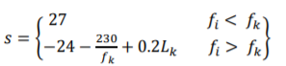





* Second part:

Masking intensity of broadband noise surrounding tone (EGr) = Broadband noise intensities surround tone in range (zi-0.5 bark: zi-+0.5 bark)

* Third part:





Third step:

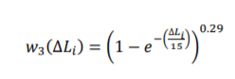

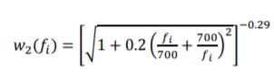









Step 4:

 🡪 c = 1.09