ITMD455/555/855 Android App Development

HW6 Due date: Before class on 10/30/2017.

Please send one Word or PDF file that contains the necessary XML files, Java code and screenshots to phuang9@iit.edu Please create an App that uses Bound Service to simulate a Stop Watch.

1. Button “Start Services” is used to start the background services.
2. Button “Stop Services” is used to stop the background services.
3. Button “Start” is used to start the stop watch.
4. Button “stop” is used to stop the stop watch.
5. Button “Reset” is used to reset the stop watch.

Solution:

Layout

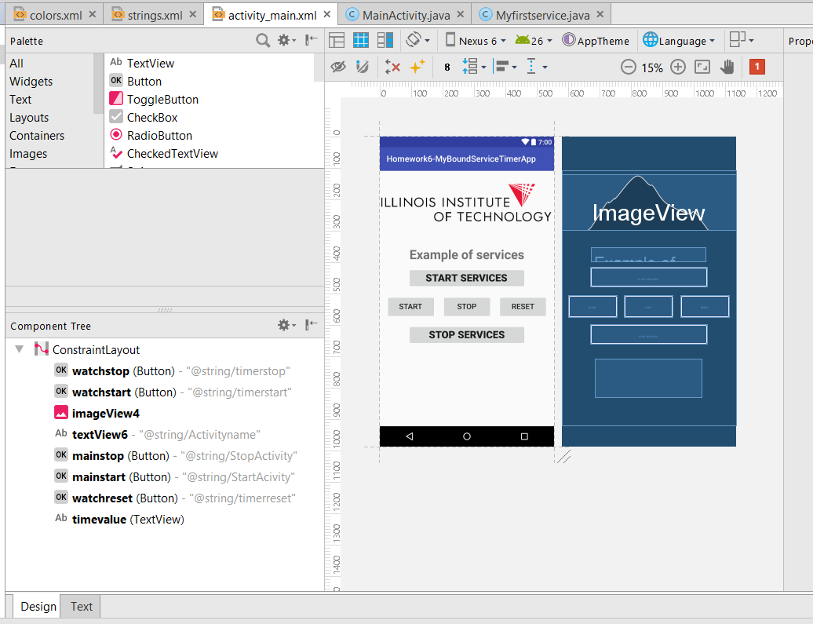

Activity_main.xml

*<?***xml version="1.0" encoding="utf-8"***?>*<**android.support.constraint.ConstraintLayout xmlns:android="http://schemas.android.com/apk/res/android"  
 xmlns:app="http://schemas.android.com/apk/res-auto"  
 xmlns:tools="http://schemas.android.com/tools"  
 android:layout_width="match_parent"  
 android:layout_height="match_parent"  
 tools:context="com.example.vasugupta.homework6_myboundservicetimerapp.MainActivity"**>  
  
 <**Button  
 android:id="@+id/watchstop"  
 android:layout_width="115dp"  
 android:layout_height="53dp"  
 android:layout_marginBottom="64dp"  
 android:layout_marginTop="65dp"  
 android:onClick="ClickStop"  
 android:text="@string/timerstop"  
 android:textSize="18sp"  
 app:layout_constraintBottom_toBottomOf="@+id/mainstop"  
 app:layout_constraintLeft_toLeftOf="parent"  
 app:layout_constraintRight_toRightOf="parent"  
 app:layout_constraintTop_toTopOf="@+id/mainstart"  
 tools:layout_constraintBottom_creator="1"  
 tools:layout_constraintLeft_creator="1"  
 tools:layout_constraintRight_creator="1"  
 tools:layout_constraintTop_creator="1"** />  
  
 <**Button  
 android:id="@+id/watchstart"  
 android:layout_width="0dp"  
 android:layout_height="53dp"  
 android:text="@string/timerstart"  
 android:textSize="18sp"  
 app:layout_constraintRight_toLeftOf="@+id/watchstop"  
 tools:layout_constraintRight_creator="1"  
 android:layout_marginStart="16dp"  
 android:layout_marginEnd="17dp"  
 app:layout_constraintBaseline_toBaselineOf="@+id/watchstop"  
 tools:layout_constraintBaseline_creator="1"  
 tools:layout_constraintLeft_creator="1"  
 app:layout_constraintLeft_toLeftOf="parent"** />  
  
 <**ImageView  
 android:id="@+id/imageView4"  
 android:layout_width="wrap_content"  
 android:layout_height="wrap_content"  
 app:srcCompat="@drawable/illinoistech"  
 tools:layout_constraintTop_creator="1"  
 android:layout_marginTop="8dp"  
 tools:layout_constraintLeft_creator="1"  
 app:layout_constraintLeft_toLeftOf="parent"  
 app:layout_constraintTop_toTopOf="parent"** />  
  
 <**TextView  
 android:id="@+id/textView6"  
 android:layout_width="0dp"  
 android:layout_height="35dp"  
 android:text="@string/Activityname"  
 android:textSize="30sp"  
 android:textStyle="bold"  
 tools:layout_constraintRight_creator="1"  
 tools:layout_constraintBottom_creator="1"  
 app:layout_constraintBottom_toTopOf="@+id/mainstart"  
 android:layout_marginStart="70dp"  
 android:layout_marginEnd="70dp"  
 app:layout_constraintRight_toRightOf="parent"  
 tools:layout_constraintLeft_creator="1"  
 android:layout_marginBottom="13dp"  
 app:layout_constraintLeft_toLeftOf="parent"** />  
  
 <**Button  
 android:id="@+id/mainstop"  
 android:layout_width="0dp"  
 android:layout_height="48dp"  
 android:text="@string/StopActivity"  
 android:textSize="24sp"  
 android:textStyle="bold"  
 tools:layout_constraintRight_creator="1"  
 tools:layout_constraintBottom_creator="1"  
 app:layout_constraintBottom_toBottomOf="parent"  
 app:layout_constraintRight_toRightOf="@+id/mainstart"  
 tools:layout_constraintLeft_creator="1"  
 android:layout_marginBottom="192dp"  
 app:layout_constraintLeft_toLeftOf="@+id/mainstart"** />  
  
 <**Button  
 android:id="@+id/mainstart"  
 android:layout_width="0dp"  
 android:layout_height="48dp"  
 android:elevation="3dp"  
 android:text="@string/StartAcivity"  
 android:textSize="24sp"  
 android:textStyle="bold"  
 tools:layout_constraintRight_creator="1"  
 tools:layout_constraintBottom_creator="1"  
 app:layout_constraintBottom_toTopOf="@+id/mainstop"  
 android:layout_marginStart="67dp"  
 android:layout_marginEnd="67dp"  
 app:layout_constraintRight_toRightOf="parent"  
 tools:layout_constraintLeft_creator="1"  
 android:layout_marginBottom="86dp"  
 app:layout_constraintLeft_toLeftOf="parent"** />  
  
 <**Button  
 android:id="@+id/watchreset"  
 android:layout_width="0dp"  
 android:layout_height="53dp"  
 android:layout_marginEnd="16dp"  
 android:layout_marginStart="17dp"  
 android:text="@string/timerreset"  
 android:textSize="18sp"  
 app:layout_constraintBaseline_toBaselineOf="@+id/watchstop"  
 app:layout_constraintLeft_toRightOf="@+id/watchstop"  
 app:layout_constraintRight_toRightOf="parent"  
 tools:layout_constraintBaseline_creator="1"  
 tools:layout_constraintLeft_creator="1"  
 tools:layout_constraintRight_creator="1"** />  
  
 <**TextView  
 android:id="@+id/timevalue"  
 android:layout_width="253dp"  
 android:layout_height="92dp"  
 android:layout_marginBottom="98dp"  
 android:layout_marginTop="97dp"  
 android:textAlignment="center"  
 android:textColor="@color/timercolor"  
 android:textSize="30sp"  
 app:layout_constraintBottom_toBottomOf="parent"  
 app:layout_constraintLeft_toLeftOf="parent"  
 app:layout_constraintRight_toRightOf="parent"  
 app:layout_constraintTop_toBottomOf="@+id/watchstart"  
 tools:layout_constraintBottom_creator="1"  
 tools:layout_constraintLeft_creator="1"  
 tools:layout_constraintRight_creator="1"  
 tools:layout_constraintTop_creator="1"  
 app:layout_constraintVertical_bias="0.0"** />  
  
</**android.support.constraint.ConstraintLayout**>

Myfirstservice.java

**package** com.example.vasugupta.homework6_myboundservicetimerapp;  
  
**import** android.app.Service;  
**import** android.content.Intent;  
**import** android.os.Handler;  
**import** android.os.IBinder;  
**import** android.widget.Toast;  
  
**import** java.util.Timer;  
**import** java.util.TimerTask;  
  
**public class** Myfirstservice **extends** Service {  
 **int counter**=0;  
 Timer **timer** = **new** Timer();  
 TimerTask **timerTask**;  
 **final** Handler **handler** = **new** Handler();  
  
 @Override  
 **public void** onCreate() {  
 }  
 @Override  
 **public** IBinder onBind(Intent arg0) {  
 **return null**;  
 }  
 @Override  
 **public int** onStartCommand(Intent intent, **int** flags, **int** startId) {  
 *// Let it continue running until it is stopped.* **final** Handler handler = **new** Handler();  
 *// final Timer timer = new Timer();* **timerTask** = **new** TimerTask() {  
 @Override  
 **public void** run() {  
 handler.post(**new** Runnable() {  
 **public void** run() {  
 ++**counter**;  
 Toast.*makeText*(getApplicationContext(),  
 **"Counter=:"**+**counter**, Toast.***LENGTH_SHORT***).show();  
 *// Log.d("test", "run: ------> "+counter);* }  
 });  
 };  
 };  
 **timer**.schedule(**timerTask**, 1000, 3000);  
 Toast.*makeText*(**this**, **"Service Started"**, Toast.***LENGTH_LONG***).show();  
 **return *START_STICKY***;  
 }  
 @Override **public void** onDestroy() {  
 **super**.onDestroy();  
 **timerTask**.cancel();  
 **timer**.cancel();  
 Toast.*makeText*(**this**, **"Service Destroyed"**, Toast.***LENGTH_LONG***).show();  
 }  
}

MainActivity.java

**package** com.example.vasugupta.homework6_myboundservicetimerapp;  
  
**import** android.content.Intent;  
**import** android.os.Bundle;  
**import** android.os.Handler;  
**import** android.os.SystemClock;  
**import** android.support.v7.app.AppCompatActivity;  
**import** android.view.View;  
**import** android.widget.Button;  
**import** android.widget.TextView;  
  
**public class** MainActivity **extends** AppCompatActivity {  
  
 Button **strservbtn**, **stpservbtn**, **tstartbtn**, **tstopbtn**, **tresetbtn**;  
 TextView **tvalue**;  
  
 **long MillisecondTime**, **StartTime**, **TimeBuff**, **UpdateTime** = 0L ;  
  
 Handler **handler**;  
  
 **int Seconds**, **Minutes**, **MilliSeconds** ;  
 Runnable **runnable** = **new** Runnable() {  
 **public void** run() {  
 **MillisecondTime** = SystemClock.*uptimeMillis*() - **StartTime**;  
 **UpdateTime** = **TimeBuff** + **MillisecondTime**;  
 **Seconds** = (**int**) (**UpdateTime** / 1000);  
 **Minutes** = **Seconds** / 60;  
 **Seconds** = **Seconds** % 60;  
 **MilliSeconds** = (**int**) (**UpdateTime** % 1000);  
 **tvalue**.setText(**""** + **Minutes** + **":"** + String.*format*(**"%02d"**, **Seconds**) + **":"** + String.*format*(**"%03d"**, **MilliSeconds**));  
 **handler**.postDelayed(**this**, 0);  
 }  
 };  
 @Override  
 **protected void** onCreate(Bundle savedInstanceState) {  
 **super**.onCreate(savedInstanceState);  
 setContentView(R.layout.***activity_main***);  
 **strservbtn** = (Button) findViewById(R.id.***mainstart***);  
 **stpservbtn** = (Button) findViewById(R.id.***mainstop***);  
 **tstartbtn** = (Button) findViewById(R.id.***watchstart***);  
 **tresetbtn** = (Button) findViewById(R.id.***watchreset***);  
 **tstopbtn** = (Button) findViewById(R.id.***watchstop***);  
 **tvalue** = (TextView) findViewById(R.id.***timevalue***);  
 **handler** = **new** Handler() ;  
 **tstartbtn**.setEnabled(**false**);  
 **tstopbtn**.setEnabled(**false**);  
 **tresetbtn**.setEnabled(**false**);  
  
 **strservbtn**.setOnClickListener(**new** View.OnClickListener() {  
 @Override  
 **public void** onClick(View v) {  
 startService(**new** Intent(getBaseContext(), Myfirstservice.**class**));  
 **tvalue**.setVisibility(View.***VISIBLE***);  
  
 *// Myfirstservice helloService = new Myfirstservice();* **tstartbtn**.setEnabled(**true**);  
 **tstopbtn**.setEnabled(**true**);  
  
 *// Toast.makeText(getApplicationContext(),"Start server btn", Toast.LENGTH_SHORT).show();* }});  
 **stpservbtn**.setOnClickListener(**new** View.OnClickListener() {  
 @Override  
 **public void** onClick(View v) {  
 stopService(**new** Intent(getBaseContext(), Myfirstservice.**class**));  
  
 *// Toast.makeText(getApplicationContext(),"Stop server btn", Toast.LENGTH_SHORT).show();* **tstartbtn**.setEnabled(**false**);  
 **tstopbtn**.setEnabled(**false**);  
 **tresetbtn**.setEnabled(**false**);  
 **tvalue**.setVisibility(View.***INVISIBLE***);  
 }  
 });  
 **tstartbtn**.setOnClickListener(**new** View.OnClickListener() {  
 @Override  
 **public void** onClick(View v) {  
 **StartTime** = SystemClock.*uptimeMillis*();  
 **handler**.postDelayed(**runnable**, 0);  
 **tresetbtn**.setEnabled(**false**);  
 *// Toast.makeText(getApplicationContext(),"Clock Start", Toast.LENGTH_SHORT).show();* }});  
 **tstopbtn**.setOnClickListener(**new** View.OnClickListener() {  
 @Override  
 **public void** onClick(View v) {  
 **TimeBuff** += **MillisecondTime**;  
 **handler**.removeCallbacks(**runnable**);  
 **tresetbtn**.setEnabled(**true**);  
 *// Toast.makeText(getApplicationContext(),"Clock Stop", Toast.LENGTH_SHORT).show();* }});  
 **tresetbtn**.setOnClickListener(**new** View.OnClickListener() {  
 @Override  
 **public void** onClick(View v) {  
 **MillisecondTime** = 0L ;  
 **StartTime** = 0L ;  
 **TimeBuff** = 0L ;  
 **UpdateTime** = 0L ;  
 **Seconds** = 0 ;  
 **Minutes** = 0 ;  
 **MilliSeconds** = 0 ;  
 **tvalue**.setText(**"00:00:00"**);  
 *// Toast.makeText(getApplicationContext(),"Clock reset", Toast.LENGTH_SHORT).show();* }});}}

Working Screenshots

Service Start

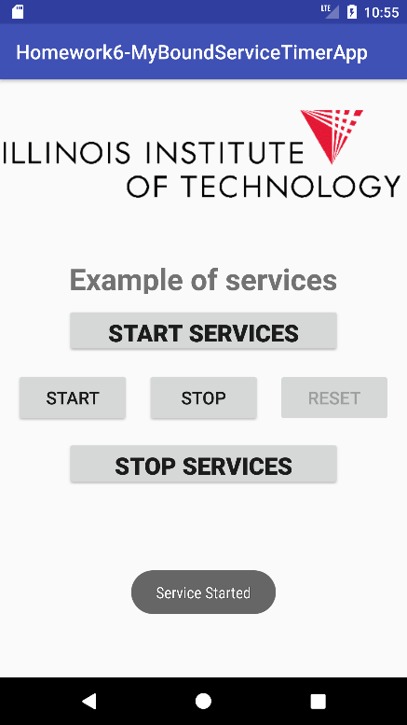

Timer Start

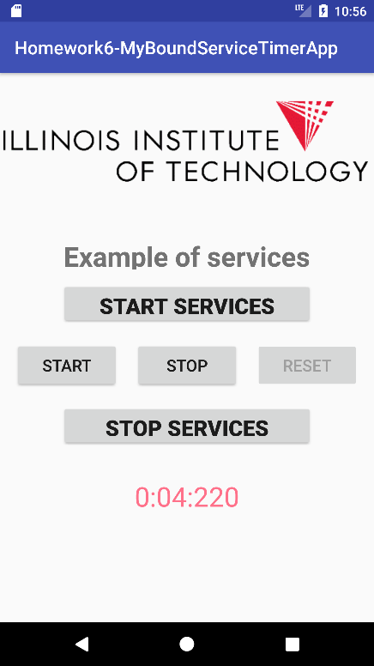

Timer Stop

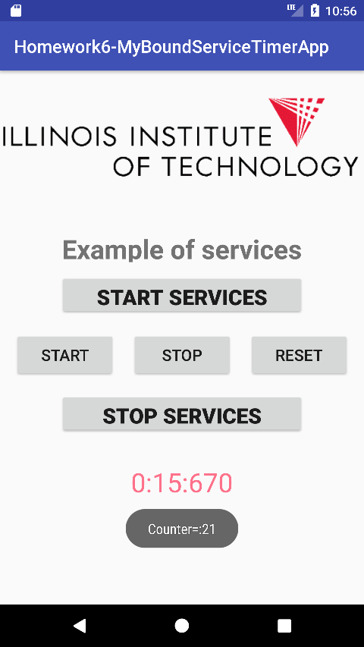

Timer Reset

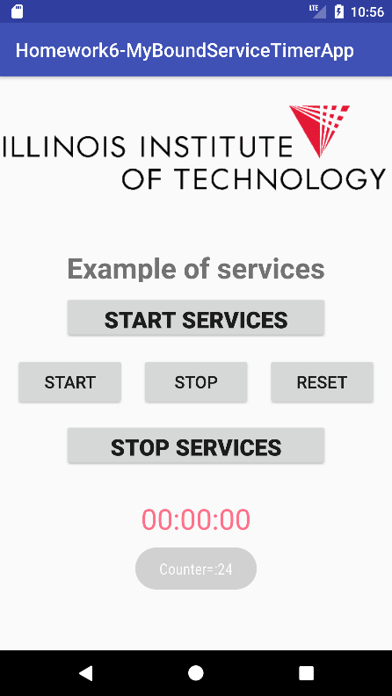

Service Stop

