MAE 674 Final Project (Due Tuesday, May 4)

Contents

- Introduction
- Starter code descriptions
- Getting oriented (quick tutorial)
- Data structure descriptions
- Basic modeling background information
- Project ideas

1. Introduction

The goal of the final project is to create a 3-5 minute simulation movie of a specific complex decision problem being solved in the “Trapeze Blocks” world that you saw in the case study example. Recall that this domain is a combination of the “Blocks world” prototype problem in AI planning and the pendulum-on-a-cart prototype problem in control theory. Your movie should be a series of frames like this one.
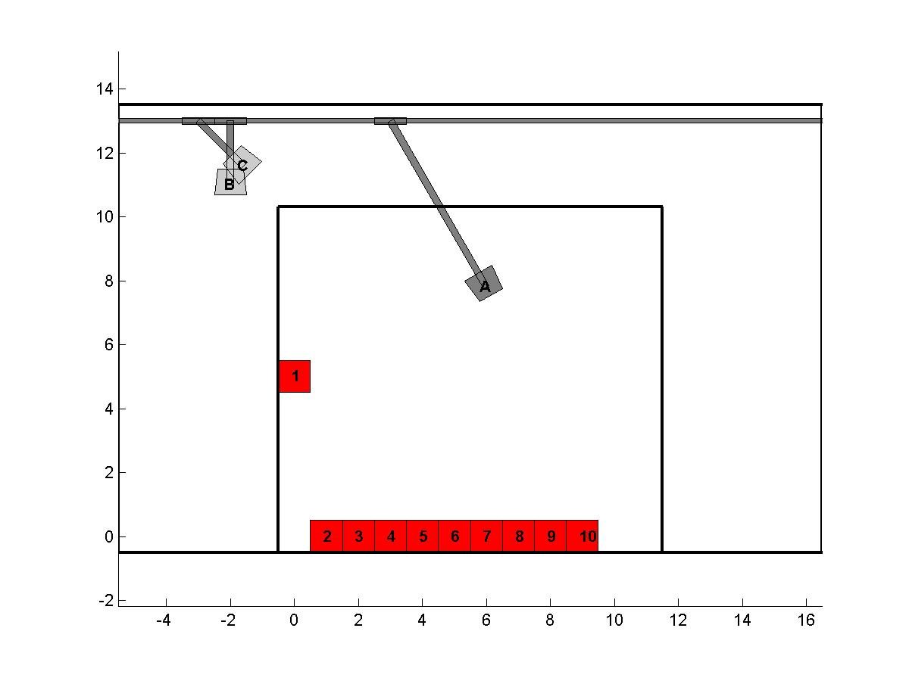
You will use the starter code and design and code the solution to your chosen complex decision problem. Try your best to cross at least 1 disciplinary boundary. Several project suggestions are appended at the end. Pick one that allows you to use your existing skills/knowledge for about 70% of the thinking required, and forces you to apply a new technique that you’ve just learned, for the remaining 30% of the thinking.

Deliverables:

- A 3-5 minute movie created by your problem-solving logic code using the visualization code, along with NO MORE THAN 5 PPT slides describing your project. You will make an 8-10 minute presentation of your work which includes movie run time.
- A concise write-up of your project, with a clear statement of the problem being solved, underlying model (described with data structures, if you change the data structure design – not recommended) and pseudocode for the main parts of your solution code. A log-file view of your movie capturing the main events should be included, along with a 2-3 freeze frames if appropriate. A log-file viewer program is not necessary (you can hand-create the plot), but would be nice to have one.
- A zip of all code with a readme. Make sure your code is adequately commented.

2. Starter Code

The main programs are:

- trapblocksinit.m: this file creates initial configuration data files (.mat) containing the tbw structure. The program will pop up a menu allowing you to choose from 4 different world types. The first three, stacked, unstacked and occupancy, create default patterns of stacked blocks automatically. The fourth allows you to create a world interactively by specifying the number of grippers and blocks, values of various parameters and block locations. You will need to modify this code only if none of these 4 options creates the kinds of worlds you want to work with. This file would correspond to a constructor method in an object oriented implementation. If you change this data structure design by adding fields to it, things should continue to work (though worlds created with the basic version will be incompatible with your new worlds, so delete the contents of the worlds directory first).
- loadworld.m: This function loads a configuration file created with (1) into memory and returns it.
- blocksdraw.m: this file draws a configuration, as defined by the tbw data structure, on the screen. It is in function form, and returns handles to all graphic objects. You can use these to manipulate the visualization, but it is probably best to leave it as is.

Auxiliary programs that you can modify to suit your particular project are the following.

- trivialdemo.m: play with this file to get a feel for how visualization is done.
- basicdyn.m: this file provides an example of how to use the scripts 1 and 2 to simulate and animate a highly dynamic situation. It uses ode45 to integrate the standard pendulum-on-a-cart equations (non-inverted) and calls blocksdraw to animate the result. Use this file as your starting point if you want to investigate a problem with a lot of dynamics.
- basicplan.m: this demo file provides an example of how to restack the blocks using purely non-dynamic moves, as in classical AI planning. The grippers move in an inertia free manner to grip and reposition blocks. This file is called by makeplan.m, which implements a very primitive planning language. It can also be called directly to simulate an existing plan.
- makeplan.m: This is a very trivial plan creation file that allows you to hand code plans in a primitive language. The language is the primitive action set: {NULL, Left, Right, Up, Down, Gripper Toggle, EOQ}. These are encoded as {0, 1, 2, 3, 4, 5, -1}. There is an inline plan and an interactive input mode. Comment out the one you don’t want to use. The interactive mode is best for playing.
- padops.m: A helper program that will do matrix/vector padding/unpadding operations for you.

3. Getting Oriented/Tutorial

It should only take you a half hour or so to get familiar with running the code, using the following tutorial steps. Understanding the code is a different matter. I have commented as much as I could, see me if you have trouble understanding any bits of logic.

- Run trivialdemo.m to watch some basic things happening in the ‘occ1.mat’ world.
- Run basicdyn (you can change the world it loads if you want by editing the script). Try changing parameter values directly in tbw.pend(.) to see how the pendulum dynamics behave.
- Run trapblocksinit.m four times, and try out all four world creation options. Positioning blocks individually is fairly tedious, but if you need specific world configurations for your code to run, it is easiest to hand-create them this way rather than trying to make the placement code smarter. Not worth the trouble unless you need more than 4-5 worlds to play with.
- Run basicplan.m. You can either give it the filename as an input parameter (basicplan(‘test1’)) or enter the file name when prompted for a call without a parameter. Enter test1 (without quotes) for the latter.
- Run makeplan.m and try out several new plans (as we did in class). You can comment out the interactive part and uncomment the inline plan definition if you like to edit the plan directly.

3.1 Code Reading

Reading code written by someone else is probably the hardest engineering skill to acquire. Use the following hints:

- It is known that programmers can generally look at no more than 14-15 lines of code at once. Print out the code, and decompose the code into logical modules with a marker, trying to get down to 14-line chunks.
- Identify and track the main data structure being manipulated.
- Change variable values to see what happens. We are often unconsciously intimidated by glaring red error messages, so best to blunt your senses early
- I find that being playful is the easiest frame of mind with which to read code. For an hour or so, just tinker with the code with no objective in mind. When you feel comfortable with the starter code, you are ready to start coding your own project.
- Keep the air-traffic control analogy in mind. You will usually need to stare at code for a while (even your own) before you “get in the zone.” Try running through the tutorial exercises as a warm up at the beginning of each session.
- It is usually MUCH easier to write thinking heavy kernel code in one long sitting, since you can stay in the zone
- Come ask me if you absolutely must. I am not the world’s most readable programmer, but I am not the worst either, so if you can’t read my code, you are probably in some trouble as an engineer!

4. Data structures

4.1 Worlds

The tbw structure contains all the parameters for a world. Sample worlds are created, automatically stored and loaded from the worlds/ directory.

>> tbw

tbw =
gripOpenColor: [0.8000 0.8000 0.8000]
gripClosedColor: [0.5000 0.5000 0.5000]
colorVec: [3x1 char]
rodCartColor: [0.5000 0.5000 0.5000]
numBlocks: 10
numGrips: 3
xc: [1x78 double]
% The continuous states in the normal controls sense
% There are 6 states per block: x, y, θ and their derivatives. These are followed by 6 states per gripper, where x is the cart position, y is the rod length and θ is the swing angle. To extract the k^{th} block’s state, jump 6*(k-1) into this vector. To extract the k^{th} gripper, jump 6*numBlocks+6*(k-1).
blockCols: [1 1 1 1 1 1 1 1 1 1]
% Index into the colorVec
Pend: [1x3 struct]
% Pendulum substructure, see separate description
mB: [2.5000 2.5000 2.5000 2.5000 2.5000 2.5000 2.5000 2.5000 2.5000 2.5000] % block masses
g: 9.8000 % gravity
xd: [1 0 0 0 0 0 0 0 0]
% discrete states, 3 per gripper: gripper open/closed, cart brake on/off, pendulum joint brake on/off
holdState: [3x10 double]
% holdstate(row,column)set to 1 if gripper ‘row’ is gripping block ‘column’
blockX: [-0.5000 -0.5000 0.5000 0.5000 -0.5000]
blockY: [-0.5000 0.5000 0.5000 -0.5000 -0.5000]
gripOpenX: [-0.5000 -0.4000 0.4000 0.5000 -0.5000]
gripOpenY: [-0.3000 0.5000 0.5000 -0.3000 -0.3000]
gripClosedX: [-0.4000 -0.5000 0.5000 0.4000 -0.4000]
gripClosedY: [-0.3000 0.5000 0.5000 -0.3000 -0.3000]
% All the above are polygons about the origin. These are translated and rotated appropriately for plotting.
roomWidth: 22
roomHeight: 14
cartX: [-0.5000 -0.5000 0.5000 0.5000 -0.5000]
cartY: [-0.1000 0.1000 0.1000 -0.1000 -0.1000]
cartHeight: 13
% Height of the overhead rail on which cranes travel
gripBarX: [-0.1000 -0.1000 0.1000 0.1000 -0.1000]
gripNames: [6x1 char]
worldname: 'test'

The tbw.pend substructure. This is an array of substructures, one per gripper. Each is modeled as a non-inverted pendulum on a cart.

>> tbw.Pend(1)

ans =

m: 5 % (gripper mass)
M: 2 % (cart mass)
d: 1 % (damping without brakes)
dB: 10 % (damping with brakes)
b: 1 % (angular damping without brakes)
bB: 10 % (angular damping with brakes)

4.2 Raw Plans

Raw plans use the language: {NULL, Left, Right, Up, Down, Gripper Toggle, EOQ} (end of queue), encoded as {0, 1, 2, 3, 4, 5, -1}. makeplan.m creates plans as a set of variables stored in a .mat file in the rawplans/ directory.

commQueues: a matrix of command queues, each row being the commands for one gripper.
planname : obvious
qLen : commQueues is 100 steps long, qLen specifies the actual length of the plan. worldname: the name of the underlying world (in the worlds/ directory) where the plan will operate. Trying to execute a plan in the wrong world will lead to unpredictable results.

I did not have time to struct-ize raw plans neatly, and makeplan.m is fairly crude. But this should work as a raw language. If you want a better raw language, you will need to substantially rewrite basicplan.m, so I don’t recommend it. Compile your language to the raw language instead.

5. Basic Modeling Background Information

Here is some background information for you to use. What you use depends on whether you pick a dynamic modeling and decision-making problem or a purely non-dynamic one, or a hybrid one.

5.1 Continuous Dynamic Modeling

The equations of motion for the (noninverted) pendulum on a cart are:

x'= | v
θ' = | ω
v' = | m R ω² sin θ + m g sin θ cos θ − k x − d v + ^{b}⁄_{R} ω cos θ  M + m sin²θ
ω' = | −m R ω² sin θ cos θ − (m+M)g sin θ + k x cos θ + d v cos θ − (1 + ^{M}⁄_{m})^{b}⁄_{R} ω  R (M + m sin²θ)

Check out http://www.myphysicslab.com/pendulum_cart.html for a java simulation that will give you a feel for how the system behaves with various parameters.

In the basicdyn.m code, the spring stiffness term is replaced by an artificial spring that acts as a proportional control to the desired cart position, regPos. Each gripper is modeled by an element of the substructure array tbw.Pend, an example of which is shown below:

The simple demo does very little with the dynamics. If you want to use it, you will need to make decisions regarding the following:

- Model gripper raising/lowering with full nonlinear dynamics of real-time pendulum shortening OR fix pendulum length while swinging, and throw away dynamics while raising/lowering (with appropriate switching with thresholds)
- These are continuous ODEs, so they will not converge in finite time to the discretized block-position grid. You can either “snap” to the discrete world after sufficient settling (say 1%) or try a more realistic model
- You can model the starting and stopping of the cart and pendulum swinging using the braking/nonbraking damping values OR just regulate to desired positions and wait for sufficient convergence.

A nonlinear systems book, like Khalil, will give you plenty of control ideas for the pendulum on a cart. Come talk to me if you want specific ones – I have a whole bunch filed away from when I took nonlinear control back in graduate school.

5.2 Non-Dynamic Discrete Modeling

If you decide to focus on a non-dynamic discrete model (~ highly damped pendulum dynamics + powerful cart motors with feed-forward motion control to achieve uniform velocity transfers), then you don’t need the basicdyn.m code. You can start with basicplan.m and makeplan.m as an example. Use the following hints to stay safe:

- Try and make your code dump plans that are either directly in the planning language of makeplan.m OR in a language that compiles to it. This way you will be able to use basicplan.m with almost no modifications to visualize what is going on and create your movie.
- The very FIRST thing you probably want to do is code a version of the MOV command that allows a SINGLE gripper to transfer a clear block from start to finish.
- If you want to do interference checking between polygons (i.e. do 2 polygons intersect), ask me for code, I have some that I haven’t included from another project.
- The inpolygon MATLAB command will do basic point-in-polygon testing if you need to do that.
- If you need graph search code ask me; I have an A* m-file and a depth-first-search script. These are for path planning, however, and you’ll need to modify.

If you are interested in planning, the best resource is probably Russell and Norvig for the basic planning algorithms in pseudocode form. The Ghallab, book will give you all you need to know about planning, and the Pinedo book will give you all you need on scheduling. With these 3 books, you should have all you need to create a good project.

5.3 Hybrid Models

These will be the most challenging. Talk to me before taking on a hybrid model project.

Cramped Space for mini Mind Maps (sketch while watching the movie)
Dynamics version
Non-Dynamics version

6. PROJECT IDEAS

Be careful, some of these problems are MUCH harder than others. I have put my own ratings on a scale of 1-5. This represents the amount of thinking and design you will need to do. The code itself might well turn out to be fairly short and elegant. My ratings could be WAY off.

- Using only 1 gripper (either create a 1-gripper world, or park extra grippers on the side in a multi-gripper world), code a simple planning algorithm that can rearrange blocks from any start state to any end state (be careful, this is a computationally intractable problem: STRIPS planning is PSPACE hard, which is a worse category than NP Complete. So make some careful simplifying assumptions. ) 2
- Using at least 2 grippers, and assigning a single MOV task to each, demonstrate a deconfliction algorithm that will make sure the grippers do not interfere. 1
- Code a simple “dynamic move” where the pendulum dynamics are present, and the primitive action is to move a block from one location to another. 2
- Write an algorithm that implements a cooperative move: a single MOV task is decomposed into two MOVs. 1
- Write an assignment algorithm that takes a set of nonconflicting MOV tasks, and assigns each to a gripper using an appropriate partitioning technique. A trivial example is to assign each gripper a “zone” of responsibility. More complex strategies will do some optimization to minimize total schedule lengths. 2
- Try 5, but with conflicting MOVs. 3
- Try 4, but with dynamics included, and an in-air block transfer, as in a bucket brigade. 4
- Try 4, but with blocks being thrown from one gripper to another – you will have a free flight mode, and “throw” and “catch” modes. 5
- The simplest MOV implementation (which I have provided) operates by positioning the gripper over the target object, lowering it, raising it all the way to the ceiling, moving to the new position and lowering all the way. This avoids collisions in a trivial way. Try to optimize this in the grid-motion (non dynamic) case. 2
- Try 9, but optimizing with continuous motion instead. 5
- Modify the block dimensions appropriately to make it horizontally long, and code a “SimMOV” primitive that allows TWO grippers to pick up a block. 5
- Can you model falling blocks under gravity? 3
- Can you use this world to simulate a scheduling program where the task is to move all blocks from one end to the other in minimum time without conflict? 5
- Can you use this world to write a program that will write number or letter sequences using the blocks (you’ll need to map numbers to letters in the visualization) 5
- Can you model an overhead throw using a pendulum swing-up controller? 10/5
- Can you model toppling in the block stacks? This is a very difficult research problem, I’d give it a 30 on a scale of 5!

