Table of Contents
Hershey’s NPI + Agents — Talking Points 2
The Opening — Set the Frame 2
The Process Today — Three Things That Are True 2
The Agents 2
DEMO Click-Guidance Step One (Differentiator) : The Orchestration Layer 3
What an Agent Actually Is — Two Moments 3
The People Story — Say It Plainly 3

Hershey’s NPI + Agents — Talking Points
Accenture Confidential · MD to Senior Executive

The Opening — Set the Frame
- Hershey runs Kinaxis, SAP S/4HANA, and Aera. The question is whether these systems connected enough to launch a new product the way a modern consumer goods company must.
- NPI is the one process these systems were never designed to handle together. Kinaxis was built for existing SKUs. SAP executes against Kinaxis. Aera has three live optimization skills in production. But when a new product enters the picture, the coordination that ties all of that together happens in email.

The Process Today — Three Things That Are True
- Eight steps. Five teams. Dozens of handoffs. Brand, supply planning, logistics, customer service, and S&OP each own a piece — and none of them have a shared view of where the plan stands.
- The problem isn’t a better pipeline. It’s judgment. Every step needs someone to pull numbers, reconcile them across systems, make a call, and pass it forward. NPI cycles are getting shorter. The people and time to do that aren’t growing with them.
- Right now: in most cases we’ve seen, a static 12-week forecast loaded into Kinaxis once and rarely touched. Launch quantities set by planner intuition. DC allocation based on historical regional patterns and customer asks. There can be more than 25 manual coordination touchpoints before a product ships.

The Agents
Five reasoning agents sit between the systems Hershey already runs. They don’t replace Kinaxis, SAP, or Aera. They do the judgment work that today requires a meeting. . Each has full click through discussion (see Appendix) and a process flow
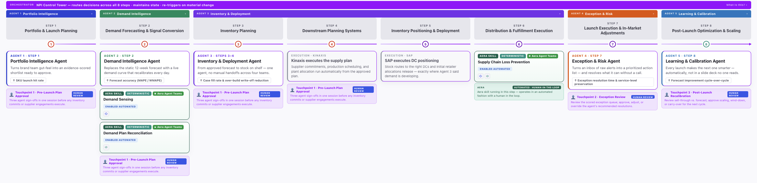

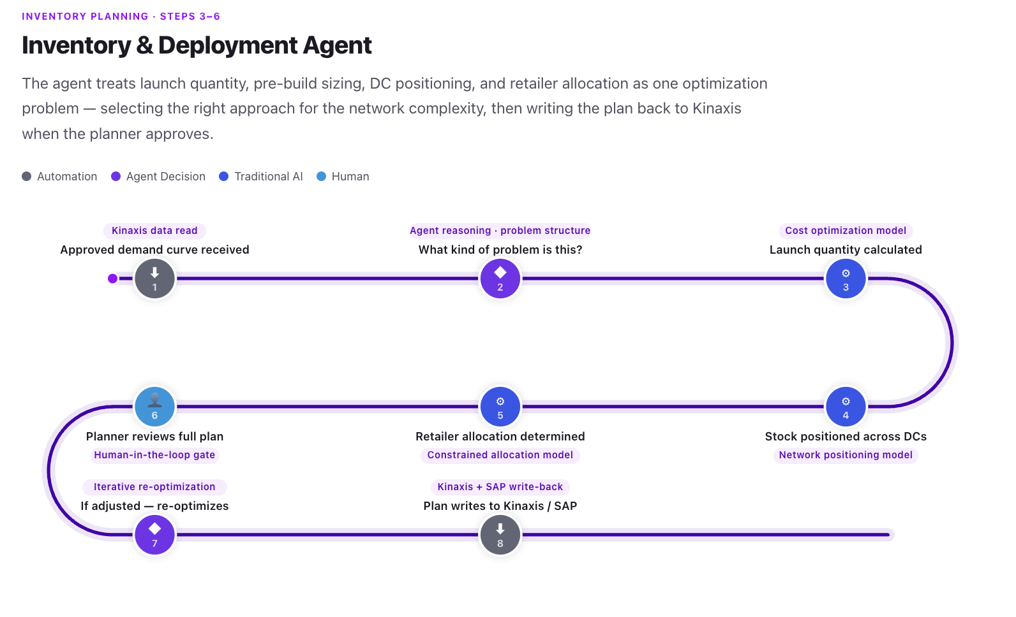
Agent | Decision it owns | Systems it works with
Portfolio Intelligence | Which SKUs advance, in what channel sequence | NPI SaaS tool · Snowflake · SAP
Demand Intelligence | What the demand curve is, and when it needs to change | Kinaxis · Aera Demand Sensing · PlanX
Inventory & Deployment | How much to build, where to position it, how to allocate | Kinaxis · SAP · Aera SCLP
Exception & Risk | Which exceptions to resolve automatically, which need a human | Kinaxis · SAP · Aera SCLP
Learning & Calibration | What this launch teaches us and how it changes the next one | SAP · Kinaxis · Snowflake

Aera Scope
Three Aera skills are already running in production today — Demand Sensing, Demand Plan Reconciliation, and Supply Chain Loss Prevention. The agents would read their outputs and apply its reasoning “on top.” Existing tech does the deterministic work; agents handle the reasoning.

DEMO
Click-Guidance Step One (Differentiator) : The Orchestration Layer
Spend real time here. See Appendix for a preview of some of what it shows. It’s a nice discussion piece on how Agents are Orchestrated.
- There is one layer above the five agents — the NPI Control Tower. It holds the live state of every decision across all eight steps. It doesn’t do the analytical work; it decides what runs next and whether the answer was good enough to move forward.
- This is not a pipeline. A pipeline runs the same steps in the same order regardless of what came back. This is a decision graph — the path forward depends on the answer at every node.
- Three routing examples that land the concept:
- Forecast too uncertain: Agent 2 returns a wide confidence interval. Instead of passing an unreliable number downstream, the orchestrator routes back to Agent 1 — narrow the SKU list, then re-forecast.
- Mid-launch demand spike: Week 2 post-launch, live POS data shows demand tracking 35% above plan. Threshold crossed. The orchestrator re-triggers Agent 3 automatically. DC positions update before launch week is lost. No meeting.
- Large expedite decision: Agent 4 flags a $420K air freight resolution. That’s above the auto-resolve limit. The orchestrator holds the plan — nothing moves until a planner explicitly signs off.

What an Agent Actually Is — Two Moments
These are the two places in the demo where the concept becomes concrete. Use them.
Moment 1 — Inventory & Deployment Agent (Step 3 in the graphic)
“A straightforward buy gets a cost model to generate an answer. Alternatively, a complex multi-DC network gets a network-wide solver that optimizes across all distribution points simultaneously to generate its answer. The agent reasons about which approach fits before running anything.”
This is where an agent decides how to solve the problem and then solves it.
Moment 2 — Exception & Risk Agent (Step 7 in the graphic)
“The boundary between act and escalate is dynamic based on magnitude and risk type, not a hardcoded rule.”
- In the case of 200-unit DC reallocation: the agent handles it and logs the action (low-mid consequence).
- At a higher consequence action (e.g., $420K expedite fee) the agent stops, writes up the recommendation, and waits for a human. It knows the difference between the two without being told explicitly for every case.

The People Story — Say It Plainly
- Today’s NPI process could involve 8–12 planners (benchmarked vs. best practices in CPG) actively coordinating across the 8 steps. The majority of their time is coordination: pulling data, aligning systems, passing decisions forward manually.
- With this architecture, the coordination is automated. The planners who remain are approving, not building. Three governance touchpoints instead of 25+.
- This isn’t a headcount-reduction conversation. It’s a capability conversation. Those same people, freed from coordination, can run more launches, tighter cycles, and better post-launch learning — which is the actual competitive lever.

Appendix
Agent Right Hand Panel Slider
