AC Sense Design

Revision History:
SDD Revision | Date | Description
00 | 31/05/2021 | Initial draft

Problem Statement
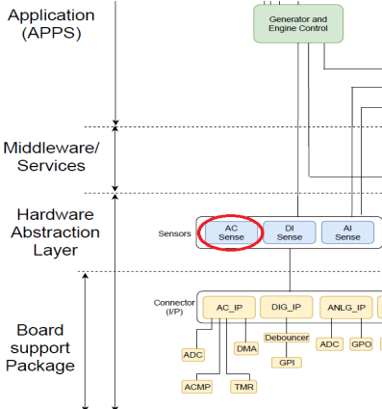
Design AC SENSE module which computes AC parameters like RMS voltages, power, energy etc from the ADC samples corresponding to instantaneous voltage and current. These samples will be available to AC_SENSE module asynchronously via a call-back function called at 5 KHz. which takes in ADC samples from the genset, mains and current transformer (CT) sent by the APIs of the Board Support Package (BSP) as input which either correspond to voltage or current values. From these samples, parameters such as Voltage RMS, Current RMS, Active power, Apparent power, Reactive power, Power factor, Active energy, Apparent energy, Reactive energy and Frequency for each of the phases (R, Y, and B) are computed. AC_SNESE belongs to the Hardware Abstraction Layer (HAL).
Figure 1: Scaled down software architecture.

Definition of AC Parameters
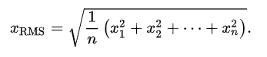
RMS – The root mean square is defined as the square root of the arithmetic mean of the squares of a set of numbers.

Active power – The power which is consumed or utilised in an AC Circuit is called True power or Active power or Real power. It is measured in kilowatt (kW) or MW. It is the actual outcomes of the electrical system which runs the electric circuits or load. It is calculated as the rooted mean of V*I where V is the instantaneous voltage, and I is the instantaneous current.
Apparent power – The product of root mean square (RMS) value of voltage and current is known as Apparent Power. This power is measured in kVA or MVA. It has been seen that this power is consumed only in resistance.
$$Apparent power = Vrms*Irms$$

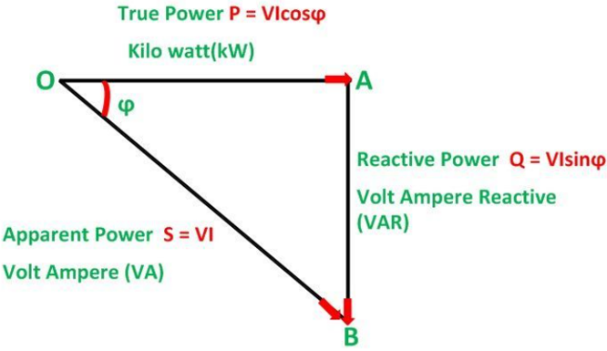
Reactive power – The product of voltage with the out of phase (i.e., current signal shifted by 90 degrees) current is known as Reactive power. It is measured in kVAR or MVAR.
Figure 2: Relationship between active, reactive and apparent power.
Power factor – It is the ratio of active power to apparent power. It is unitless.
Active energy – The product of Active power with the time that has elapsed. It is measured in kilowatt hour (kWH)
$$Active energy=\int{ActivePower dt}$$
Apparent energy – The product of Apparent power with the time that has elapsed. It is measured in kVAH.
$$Apparent energy=\int{ApparentPower dt}$$
Reactive energy – The product of Reactive power with the time that has elapsed. It measured in kVARH.
$$Reactive energy=\int{ReactivePower dt}$$
Frequency –Defines as the number of times the signal repeats in one second. Alternatively, it could also be defined as the inverse of the time taken between two successive positive to negative zero crossings. It is measured in hertz (Hz).
Power factor sign – It denotes whether the current is leading the voltage or lagging behind it. It is 1 if the current is lagging and it is -1 if the current is leading.
Phase Reversal – It is when two of the phases have been switched out while making the connections. This causes an incorrect phase sequence.

Software Workflow

NO
Software Development
Develop Unit tests in desktop
Test in target
PASS
PASS
DONE
NO
YES
YES

Figure 3: Software workflow

Figure 3 depicts the software development workflow that was followed. All algorithms for the energy parameter calculation were implemented and unit tested in a desktop environment. Multiple tests corresponding to each parameter has been implemented and added to the test suite. This enabled to easily test the correctness of implementation during development. The tests primarily generate different kinds of sinewaves (i.e., their ADC values) and pass that as an input to AC_SENSE. Subsequentially, the output from the AC_SENSE module is compared with the expected output to determine the correctness of the algorithm. The tests use C++ sine function to generate sinewaves. AC_SENSE dependencies (ex: AC_IP) where mocked.

Directory Structure
- AC_SENSE – Contains the implementation of the AC_SENSE and its sub-modules.
- C_QUEUE – Contains implementation of circular queue used by AC_SENSE. Primarily used for RMS computation.
- Mocks – Contains mocks of AC_SENSE dependencies.
- Tests – Contains implementation of tests. The Sine.cpp is a sub-module used by Tests.cpp to generate a desired sine wave.

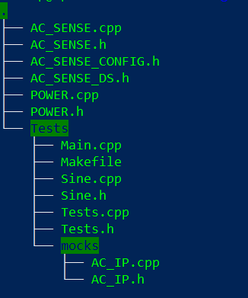
Figure 4: Project Directory structure

AC Parameter Computation Algorithms
- V_{rms} & I_{rms}
All parameters RMS values are calculated using the same algorithm. Moving window averaging is used to compute the RMS values. The ADC sample values are squared and accumulated till u16SamplesPerEntry (i.e currently configured to 100) number of samples are received. The accumulated value is then added to the windowing queue by dequeuing the oldest element. Subsequentially, The RMS is computed as the square root of the mean of the samples multiplied with a scaling factor. The scaling factor is a combination of hardware constants and the ADC conversion factor. The hardware constant represents the voltage scaling due to the resistor networks, op-amps etc. The ADC scaling factor represents the conversion factor from sample count to voltage. X_{i} represents an element in the moving window queue.
$$Vrms=√( \frac{⅀\left(Xi\right)}{u16SamplesPerEntry × sizeof\left(RMS Queue\right)} )×scaling_factor$$

Figure 5 depicts the control flow for RMS computation.
YES
Start
Is sample count = 100?
Obtain ADC samples from BSP
Add squared ADC sample value to the accumulator
Enqueue new accumulated value to circular queue and set sample count to 0.
Is circular queue full?
Dequeue oldest accumulated value from circular queue
Is circular queue full?
End
Sum up all values in the circular queue, divide by size of queue and then square root it
Multiply by scaling factor to get RMS value
NO
YES
YES
NO
NO

Figure 5: Control Flow for RMS computation
- Active Power
Active power is calculated very similar to I_{rms}/V_{rms}. Unlike I_{rms}/V_{rms}, the product of V&I is accumulated for u16SamplesPerEntry number of samples. The accumulated value is then added to the windowing queue by dequeuing the oldest element. Subsequentially, The RMS is computed as the square root of the mean of the samples multiplied with a scaling factor. The scaling factor is a combination of hardware constants and the ADC conversion factor.
- Apparent Power
Apparent power is obtained from the product of voltage and current RMS values.
- Reactive Power
Reactive power is calculated by getting the difference obtained from subtracting the square of active power from the square of apparent power and then rooting this difference.
$$reactive_power=√({apparent_{power}}^{2}- {active_{power}}^{2})$$
- Frequency
Frequency is computed by determining the time difference between successive zero-crossing of the signal. Here we start counting samples when the sample value crosses some lower limit while going from a higher to a lower value and stores the count value when it crosses this lower limit again while going from a higher to a lower value. This count value is multiplied with the time taken to get one sample to get the period. We then divide 1 by this period to get the frequency. Every time a new value is generated it is passed through a IIR filter which applies a multiplier to current frequency value and sums it up with the previous value multiplied with one minus the multiplier to ensure that variations in the current value do not affect the frequency value much.
- Energies
Active energy, Apparent energy and Reactive energy are calculated by multiplying the respective power with the time that has passed up till now. This is done by multiplying the power value with the number of samples that are passed every time the window moves with the update time of each sample.
- Power factor
The Power Factor is calculated as the product of its magnitude and the Power Factor Sign. The power factor magnitude is calculated by dividing the active power by its apparent power.
$$( \frac{Active Power}{Apparent Power} )$$
The power factor sign is calculated by checking whether the current is leading or lagging by comparing the current sample value with the voltage sample value at the positive to negative zero-cross of the voltage. If the current sample value is above the voltage sample value at the zero-cross (i.e., current is lagging) and the sign is set to -1 (leading) then the detection counter is incremented and it is reset if we don’t get 10 consecutive similar readings, once we get 10 consecutive similar readings the sign is switched. The same process is used to detect a leading current as well.
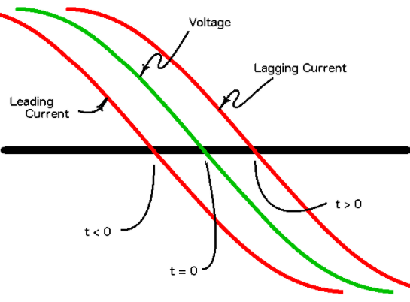
Figure 6: Graph showing leading and lagging current with respect to voltage
- Phase Reversal
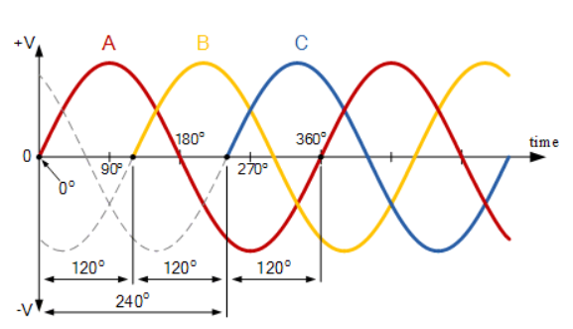
Phase reversal is detected by checking the R-phase, Y-phase and B-Phase with respect to each other at the positive to negative zero crossing of the R-phase voltage sample value. If the Y-phase voltage sample value is above the R-phase and the B-phase voltage sample value is below the R-phase the there is no phase reversal otherwise there is some phase reversal.
Figure 7: Graph showing the 3 phases. R-phase - Red, Y-phase - Yellow,B-phase - Blue

Class Organization
There are three classes in this module namely AC_SENESE, POWER and C_QUEUE. The POWER class has member functions which mainly handle the calculation of the different AC parameters per phase, the class C_QUEUE is a circular queue used in the implementation of the moving window for RMS calculation and contains functions for enqueue, dequeue and returning the number of filled cells and the AC_SENSE class has a POWER class object for each phase and calls its member functions while also receiving the input from the super loop and clipping it to the maximum and minimum limit values.
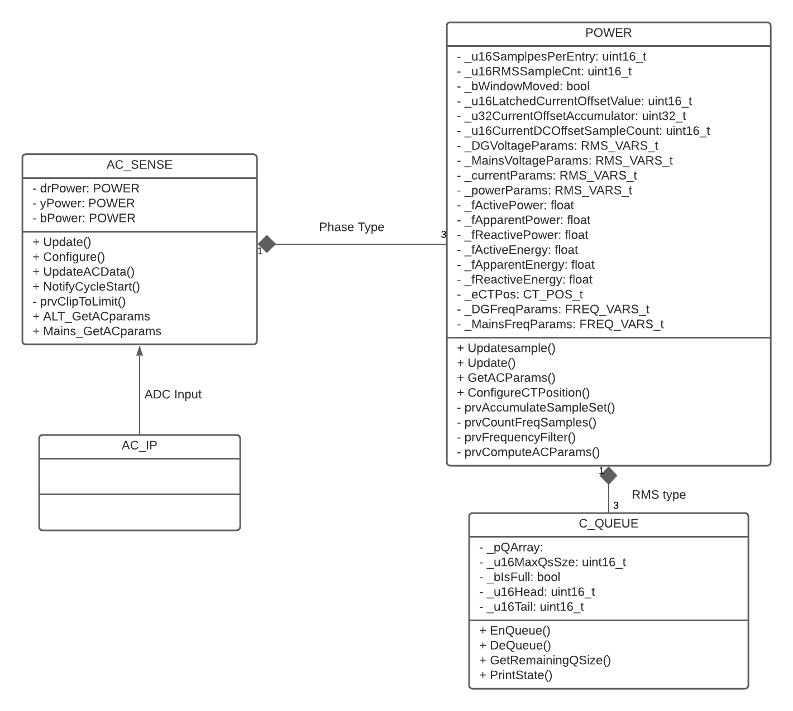
Figure 8: UML Class Representation of AC_SENSE

How to Run Tests
The test code is compiled, and an executable is created using a Makefile where all the source files and their directories are included and used to make the object files.
1. Make clean – Cleans up the old object files and removes the executable.
2. Make – Creates the dependencies (object files) according to the rules and make files and creates the executable.
3. Make run – Runs the created executable.

Prepared By:  Name: Naveen Ramaswamy  Designation: Intern Engineer  Date: 31/05/2021 | Reviewed By:  Name:  Designation:  Date: | Approved By:  Name:  Designation:  Date:

