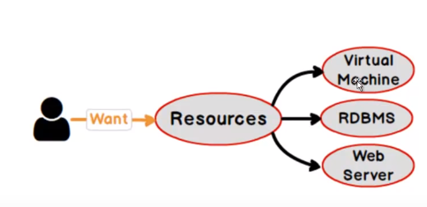

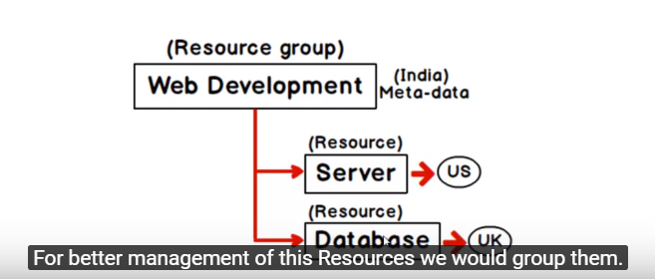



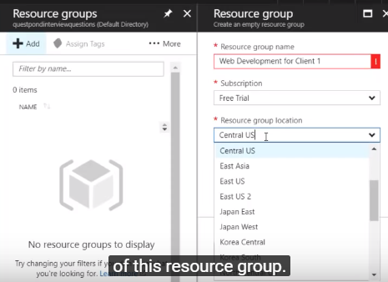

**Resource group** :- put the resources in specific container to monitor them, do accounting

**Region** :- where u want to store the metadata of this resource group

**APP SERVICES**

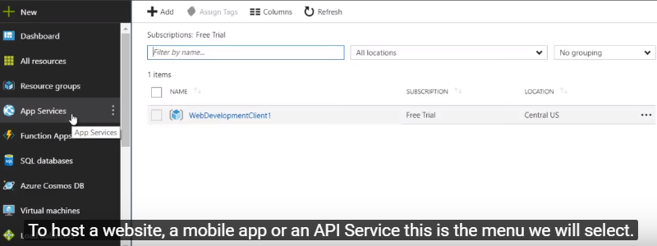

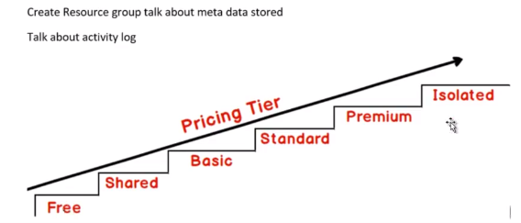

To check all you deployed files in portal:-

Go to Console > Type Dir

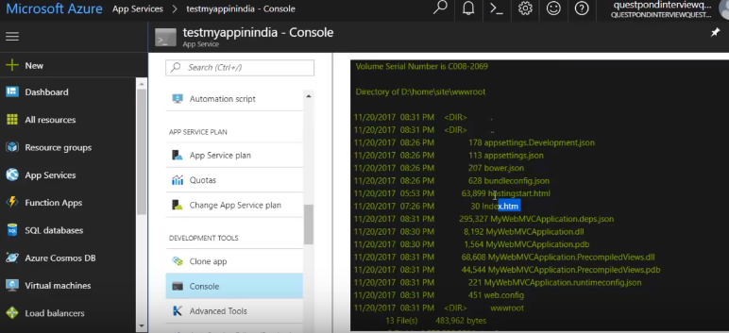

**AppService Editor** - to quickly do any changes in file

