**44. using useState() hook for state manipulation:-**

**Using the State Hook**

Hooks are a new addition in React 16.8. They let you use state and other React features without writing a class.

What is a Hook? A Hook is a special function that lets you “hook into” React features. For example, useState is a Hook that lets you add React state to function components. We’ll learn other Hooks later.

When would I use a Hook? If you write a function component and realize you need to add some state to it, previously you had to convert it to a class. Now you can use a Hook inside the existing function component. We’re going to do that right now!

**45. State full and stateless components**



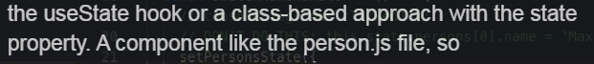



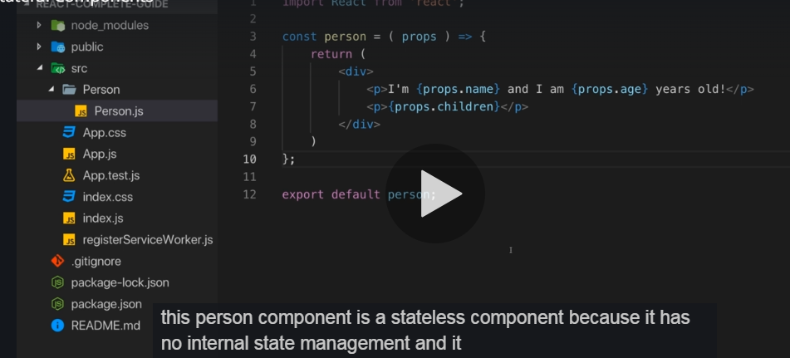

Stateless components like Person.js re also called as **Dumb** components

Statefull components like in App.js [usestate()] are also called as **Smart** components

**46. Passing method references between componenets**

We can pass methods inside components :-

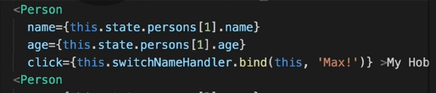

**47. Adding 2 way bindings**

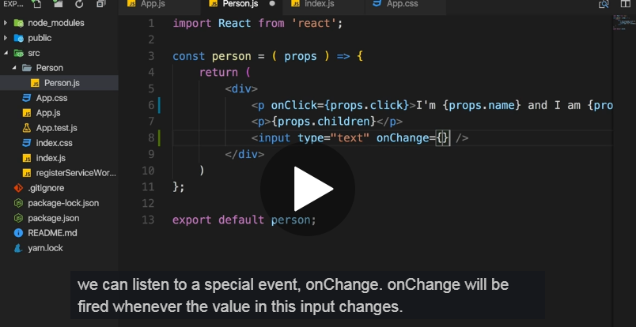

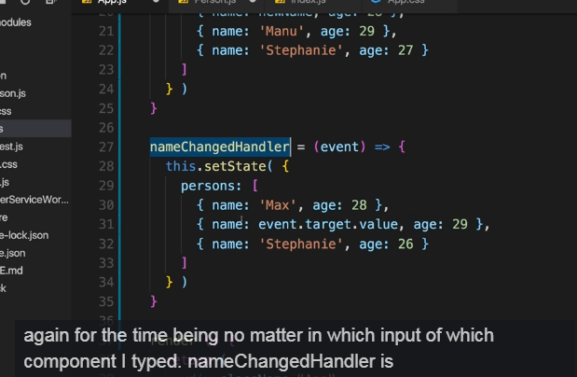

**48. Adding styling with stylesheets**

