Advanced software engineering

I-explore (Increment-1)

Vishnu Praveen gude

Ravi sankar are

Venkata Naveen pandala

Ayyappa kumar neerukonda

**Importing existing services/API**:

First, by using visual studio, we created 2 web forms, in which one of them is sign up form and another is login page. We designed sign up form for registration, which includes client first and last names, country, e-mail, user name and password. After client registration is completed, he/she is directed to flight simulator mode.

Class Diagram



Sequence Diagram:



**Implementation:**

Here, we created just the login page to register, after registration is complete it is directed to flight simulator view page.

First we created a database to store the user and administrator data.

In that we created a table consists of

1. First name
2. Last name
3. Country
4. Email
5. Username
6. Password

**Increment report:**

Here is the login page

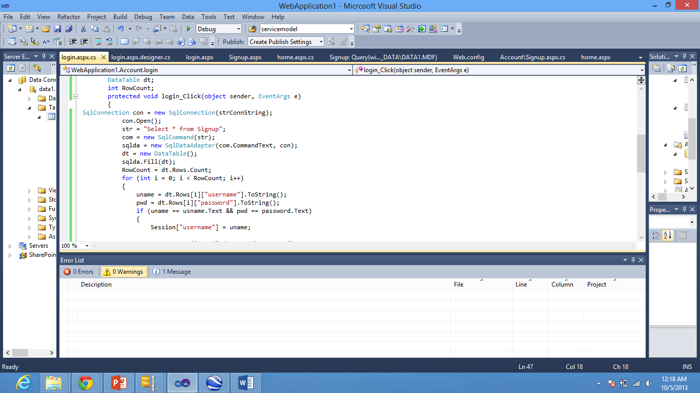

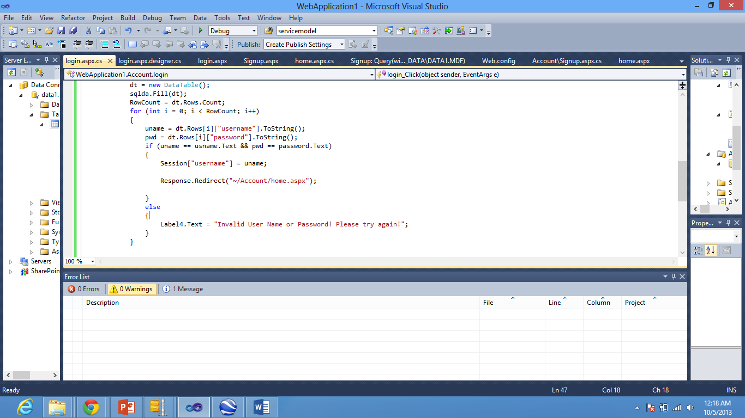

Here is the sign up form

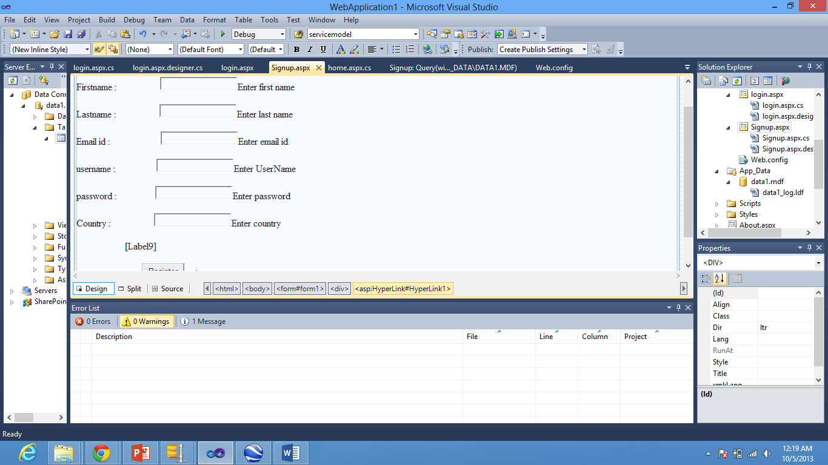

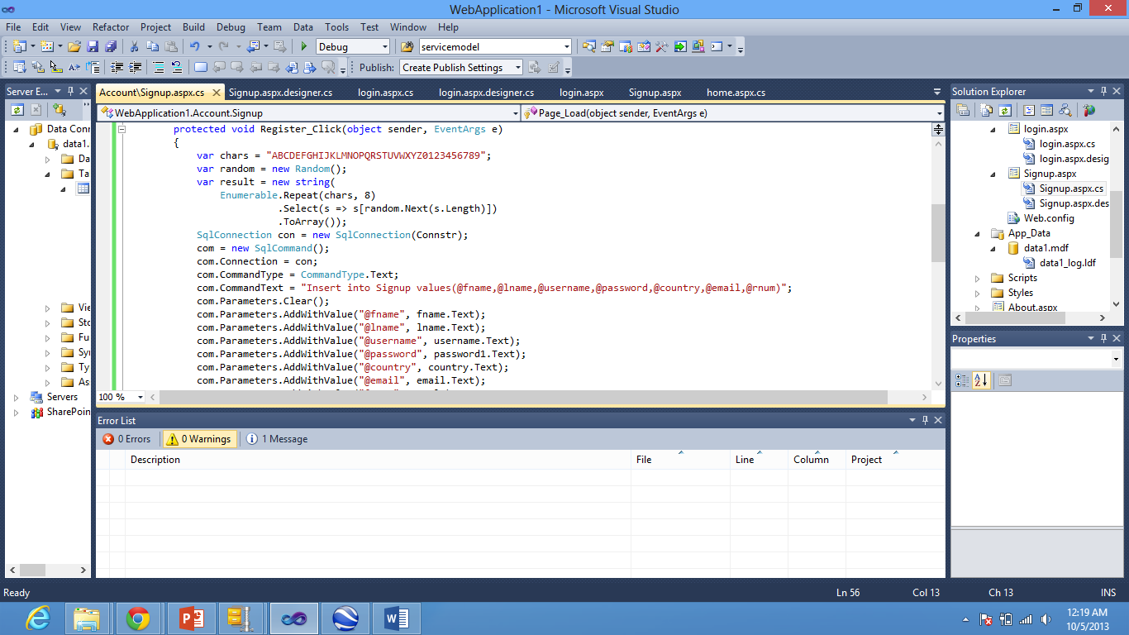

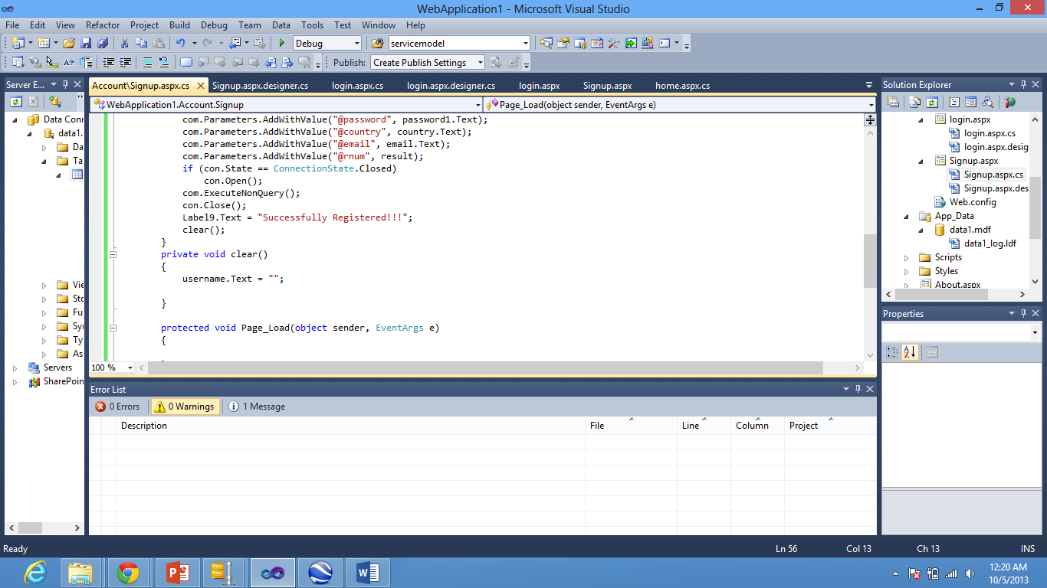

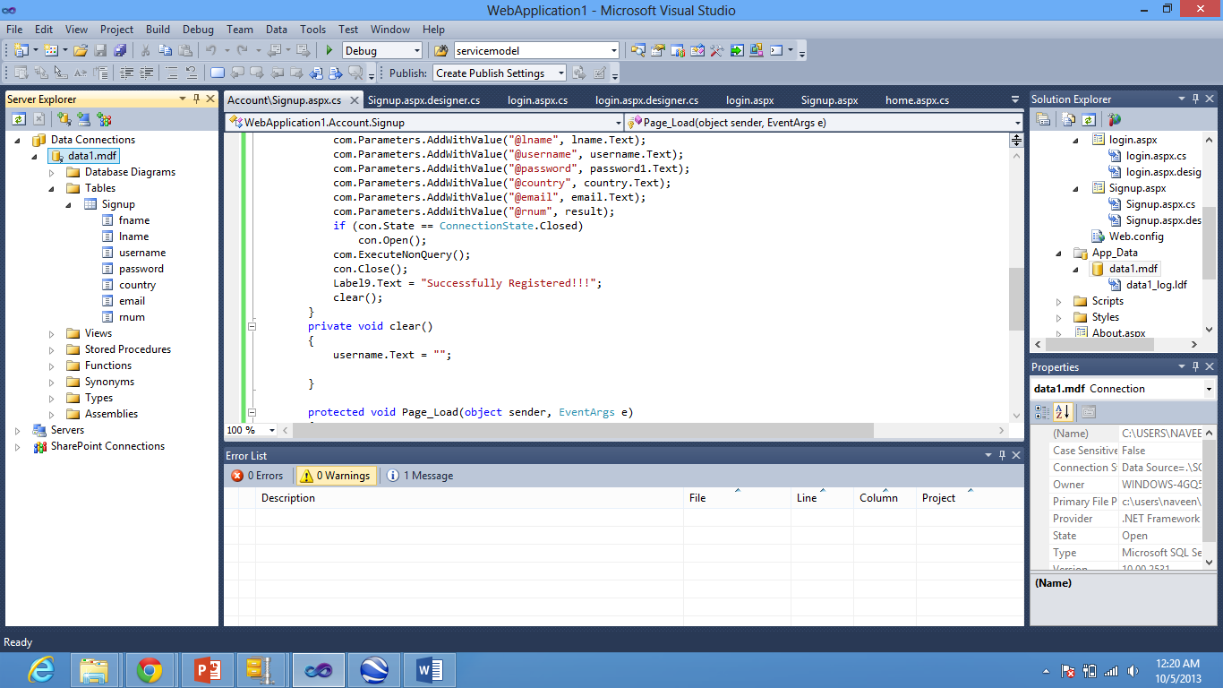

This is the home page after the user login successfully.

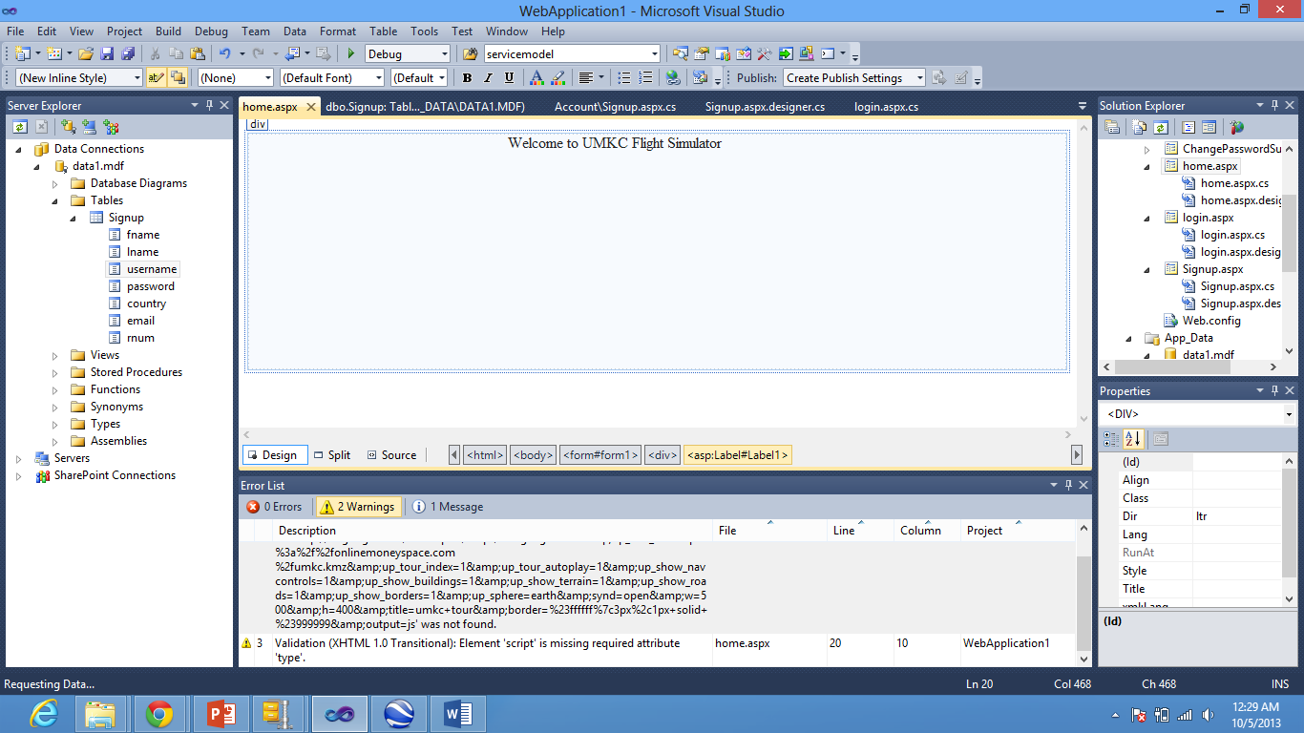

Here is Google Api Flight simulator code that is recorded is inserted into the Home.aspx

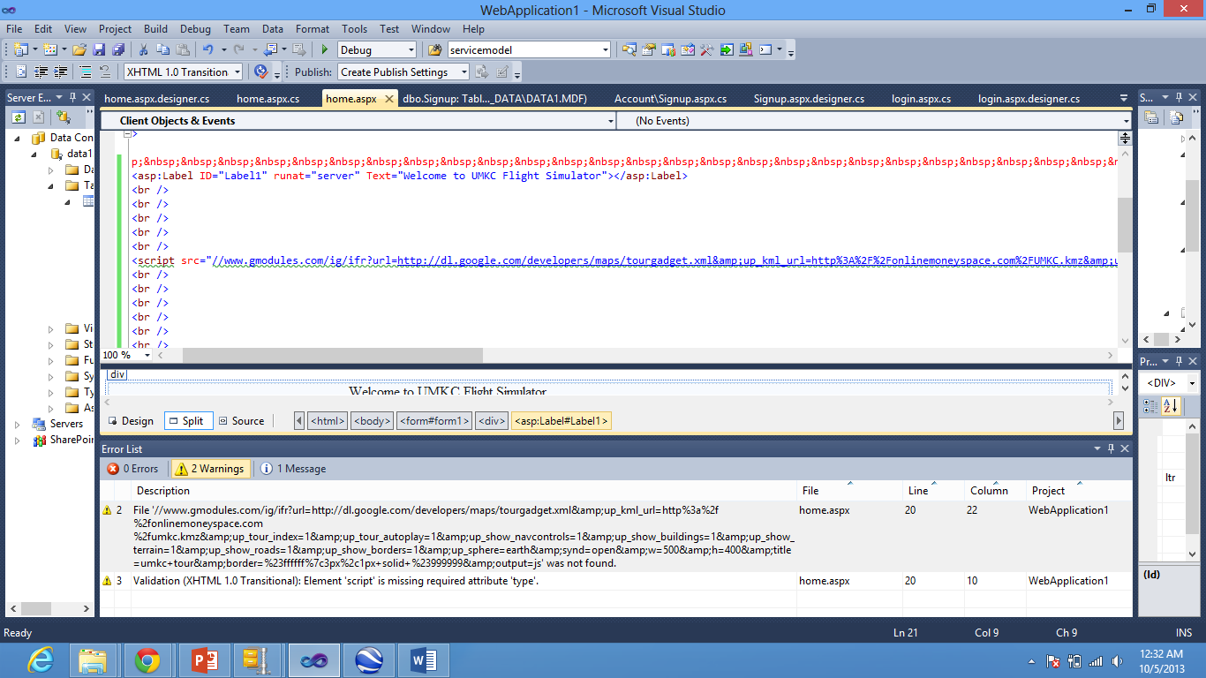

Output screenshots in the browser.

Sign up form

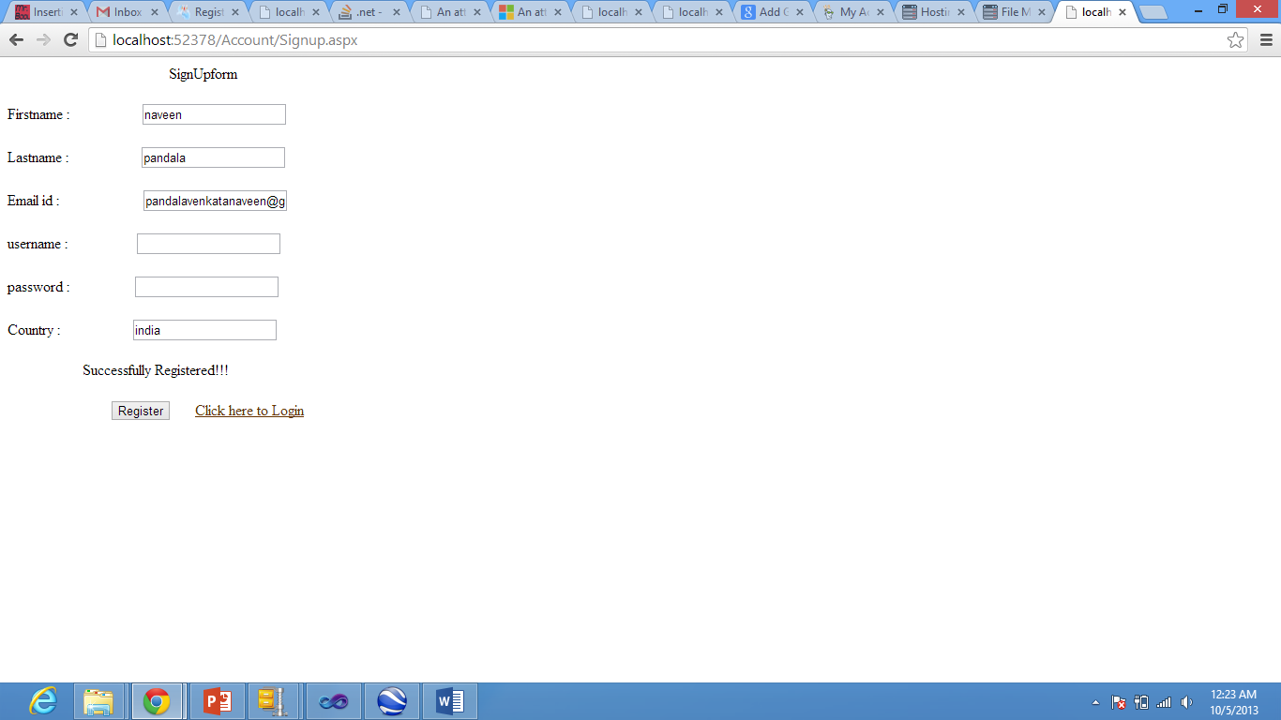

Login page

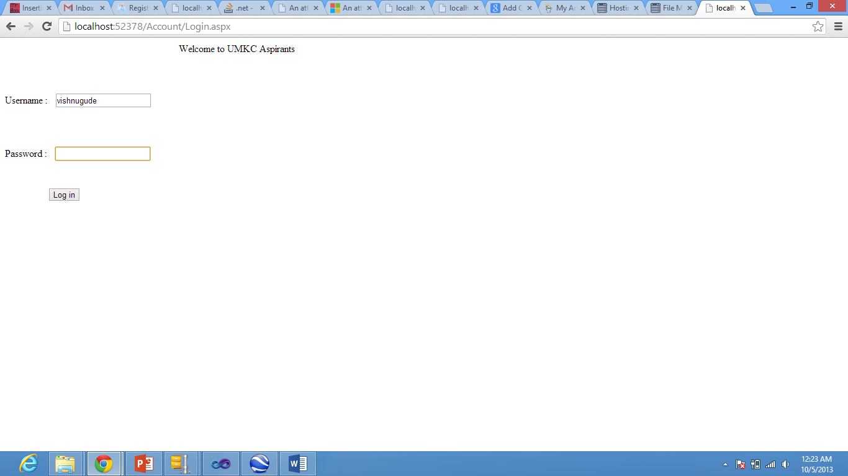

After successfully logined then the Flight simulator is activated to show the UMKC

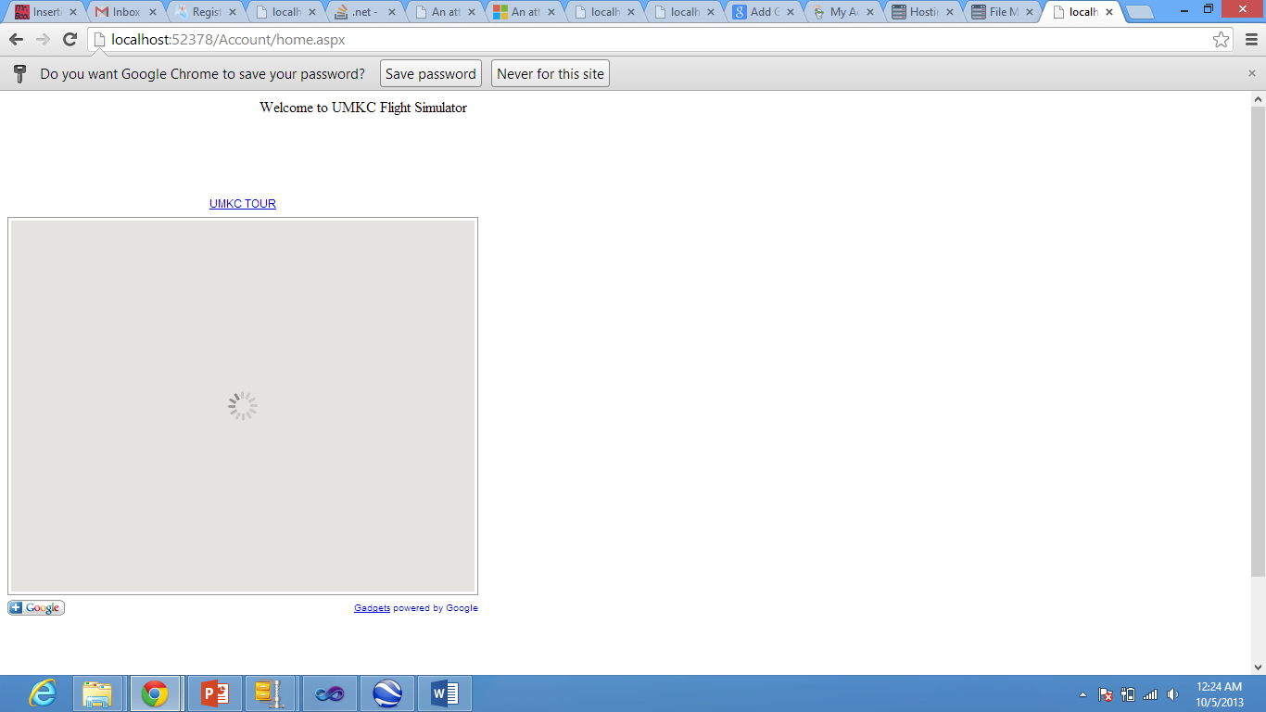

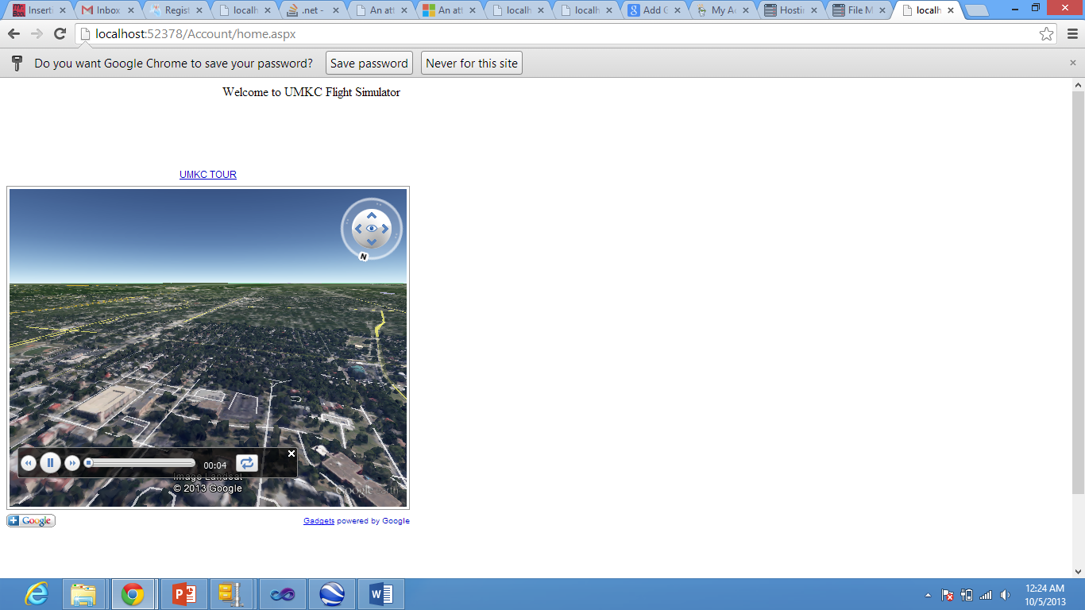

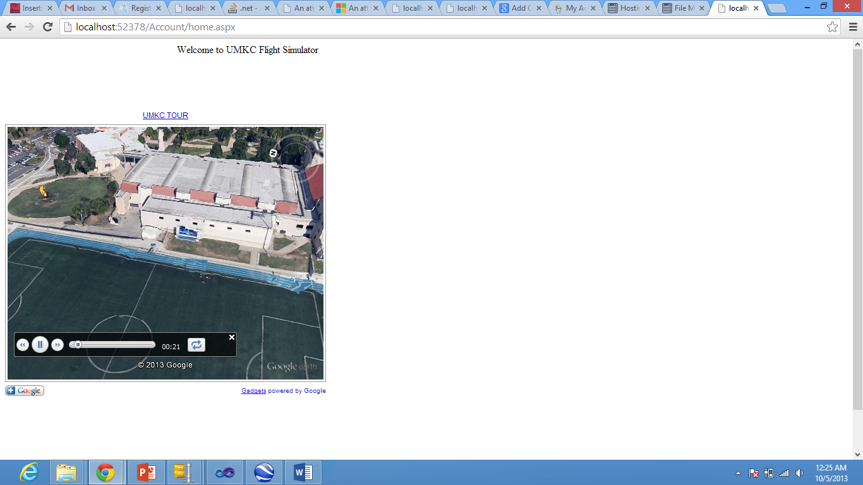

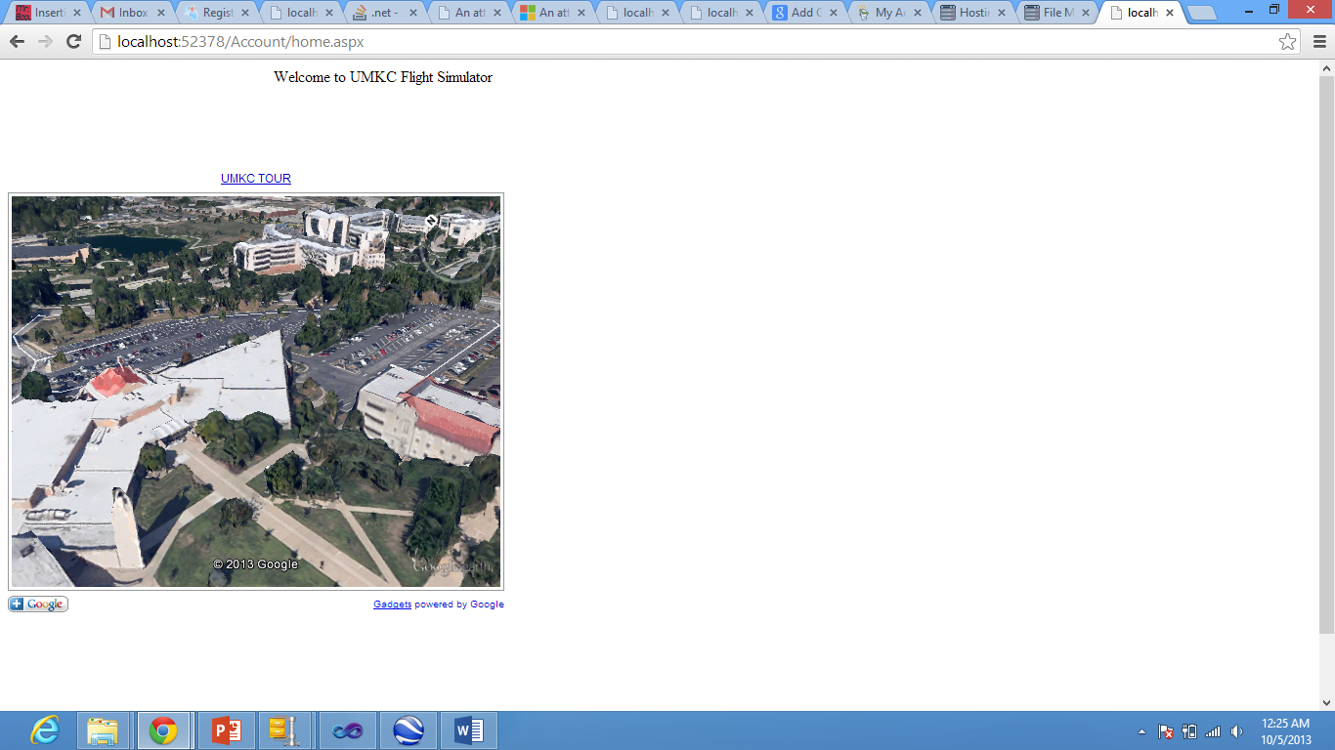

Deploying in cloud

