MAXIMUM LIKELIHOOD ESTIMATION
Estimating the Probability of Batch Quality Compliance
A Case Study in Food-Processing Quality Control
Submitted as part of the Applied Statistics / Machine Learning Coursework
Topic: Maximum Likelihood Estimation
Submitted By:
[Student Name]
[Roll No. / Student ID]
[Course Name & Code]
[Department, Institution Name]
Date: 31 August 2026
GitHub Repository: https://github.com/<your-username>/batch-quality-mle-project

2. Problem Statement
A food-processing laboratory routinely tests batches of manufactured product to verify whether each batch meets a defined quality standard. Every tested batch produces a binary outcome: it either “meets” the standard (Pass) or “fails” to meet it (Fail). The laboratory wants to estimate the true underlying probability, p, that a randomly produced batch meets the quality standard.
Three candidate probability estimates have been proposed for p, based on different assumptions or prior experience. The task is to use the observed batch-quality data to statistically evaluate these three candidates by computing their likelihood under the data, and to determine which candidate best explains what was actually observed. This is a classic application of Maximum Likelihood Estimation (MLE) to Bernoulli/Binomial data.

3. Objective
- To model the batch-quality outcomes as independent Bernoulli trials with an unknown probability of success p.
- To implement the Maximum Likelihood Estimation technique on the observed batch-quality dataset.
- To compute and compare the likelihood and log-likelihood of three candidate probability estimates.
- To identify, using likelihood comparison, which candidate estimate best represents the observed data.
- To validate the result against the closed-form analytical MLE solution for Bernoulli data.

4. Concept Used

4.1 Maximum Likelihood Estimation (MLE)
Maximum Likelihood Estimation is a method of estimating the parameters of a statistical model by finding the parameter value(s) that maximize the likelihood of observing the given data. Given a probability model with parameter θ and observed data X, the likelihood function L(θ) = P(X | θ) measures how probable the observed data is for a given value of θ. The MLE is the value θ̂ that maximizes L(θ).

4.2 Bernoulli / Binomial Model
Each batch-quality test is modeled as a Bernoulli trial, taking the value 1 if the batch meets the standard (Pass) and 0 otherwise (Fail), with an unknown success probability p. For n independent batches with k observed passes, the number of passes follows a Binomial distribution, and the likelihood function is:
L(p) = C(n, k) · pᵏ · (1 − p)ⁿ⁻ᵏ
Taking the natural logarithm gives the log-likelihood, which is easier to work with:
log L(p) = log C(n, k) + k·log(p) + (n − k)·log(1 − p)
Differentiating log L(p) with respect to p and setting the derivative to zero yields the closed-form analytical MLE: p̂ = k / n, the sample proportion of passing batches. This is the value of p that maximizes the likelihood among all possible values of p.

5. Methodology / Working Steps
- Data Collection: Record the Pass/Fail outcome of each tested batch (n = 40 batches; k = number that Pass).
- Data Encoding: Represent each outcome as a binary value (1 = Pass, 0 = Fail) and store it in a CSV dataset.
- Define the Likelihood Function: Implement L(p) = C(n,k)·pᵏ·(1-p)ⁿ⁻ᵏ and its log form in Python.
- Propose Candidate Estimates: Three candidate values of p are proposed — Candidate A (p = 0.50, a naive 50/50 guess), Candidate B (p = 0.60, a conservative estimate), and Candidate C (p = k/n, the sample proportion observed in the data).
- Compute Likelihood for Each Candidate: Evaluate L(p) and log L(p) at each candidate value of p using the observed n and k.
- Compute the Analytical MLE: Calculate p̂ = k/n directly and verify it produces the maximum likelihood value.
- Compare and Visualize: Plot the full likelihood curve over p ∈ [0,1], mark each candidate and the MLE, and compare log-likelihood values using a bar chart.
- Conclusion: Select the candidate with the highest likelihood as the one that best represents the observed data.

6. Implementation

6.1 Tools & Libraries
- Python 3.12
- NumPy — numerical computation
- Pandas — data handling (CSV dataset)
- Matplotlib — visualization of likelihood curves and comparisons
- SciPy (scipy.special.comb) — binomial coefficient computation
- Jupyter Notebook — interactive analysis

6.2 Source Code / GitHub Repository
The complete, runnable project (dataset, source code, notebook, results and this report) is organized as a GitHub-style repository:
batch-quality-mle-project/
├── README.md
├── requirements.txt
├── dataset/
│ └── batch_quality_data.csv
├── src/
│ ├── generate_dataset.py
│ └── mle_batch_quality.py
├── notebooks/
│ └── MLE_Analysis.ipynb
├── results/
│ ├── likelihood_curve.png
│ ├── loglikelihood_comparison.png
│ └── mle_summary.csv
└── screenshots/
└── output.png
Repository link: https://github.com/<your-username>/batch-quality-mle-project
Core likelihood function implemented in src/mle_batch_quality.py:
def likelihood(p, n, k):
return comb(n, k) * (p ** k) * ((1 - p) ** (n - k))

def log_likelihood(p, n, k):
eps = 1e-12
p = np.clip(p, eps, 1 - eps)
return np.log(comb(n, k)) + k*np.log(p) + (n-k)*np.log(1-p)

candidates = {
'Candidate A (p=0.50)': 0.50,
'Candidate B (p=0.60)': 0.60,
'Candidate C (p=k/n)' : k / n,
}

p_mle = k / n # analytical MLE for Bernoulli/Binomial data

7. Results & Output

7.1 Observed Data Summary
Metric | Value
Total batches tested (n) | 40
Batches meeting standard (k) | 29
Batches failing standard (n-k) | 11
Observed proportion (k/n) | 0.7250

7.2 Likelihood Comparison Table
Candidate | p | Likelihood L(p) | Log-Likelihood
Candidate A — naive guess | 0.500 | 2.1026 × 10⁻³ | -6.1646
Candidate B — conservative estimate | 0.600 | 3.5727 × 10⁻² | -3.3318
Candidate C — sample proportion (k/n) | 0.725 | 1.4009 × 10⁻¹ | -1.9655
MLE (analytical, p̂ = k/n) | 0.725 | 1.4009 × 10⁻¹ | -1.9655

7.3 Likelihood Curve
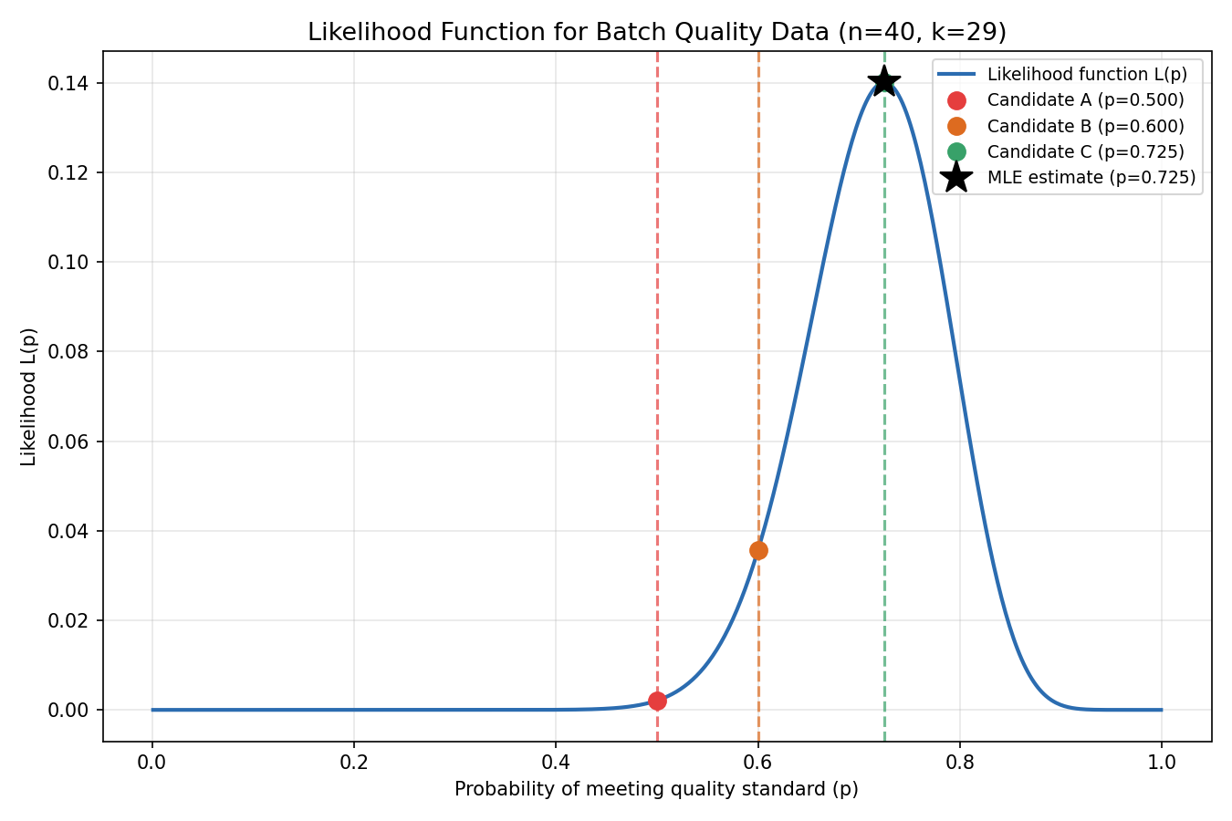
Figure 1: Likelihood function L(p) over the range of p, with Candidates A, B, C and the MLE marked.

7.4 Log-Likelihood Comparison
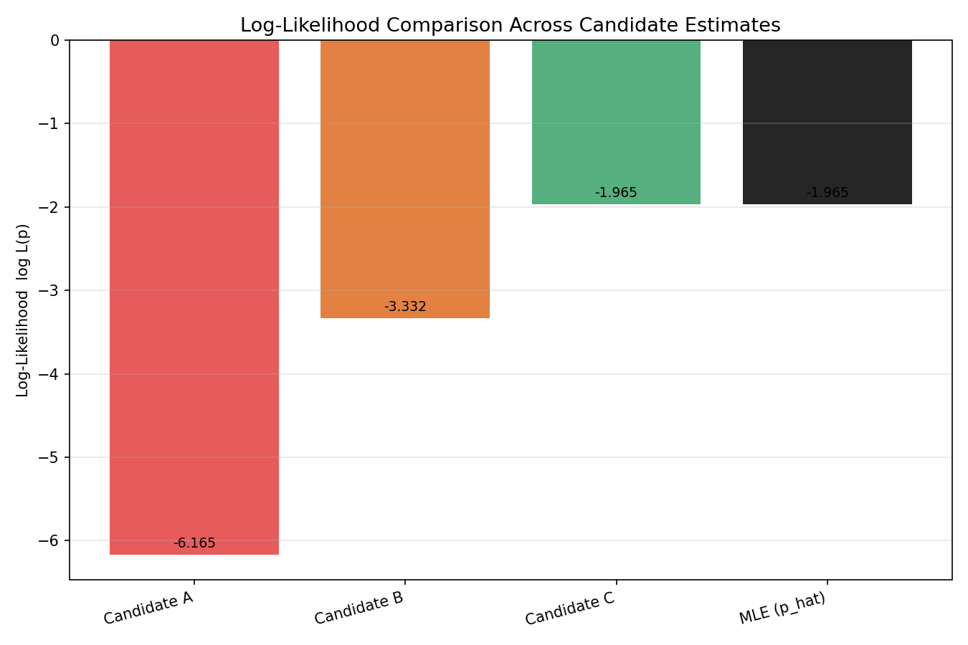
Figure 2: Bar chart comparing log-likelihood values of the three candidates against the MLE.

7.5 Program Output
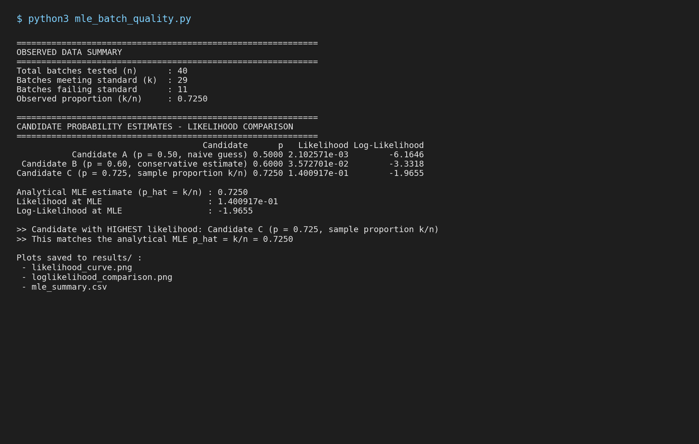
Figure 3: Console output of mle_batch_quality.py showing the computed summary.

8. Analysis
The observed data consists of n = 40 batches, of which k = 29 met the quality standard, giving an observed sample proportion of 0.7250.
Candidate A (p = 0.50) produced the lowest likelihood (2.10 × 10⁻³) and the lowest (most negative) log-likelihood (-6.1646). This indicates that a probability of 0.50 is a poor explanation of the data — under this assumption, observing 29 out of 40 passes would be relatively unlikely.
Candidate B (p = 0.60) performed better, with a higher likelihood (3.57 × 10⁻²) and log-likelihood of -3.3318, but still noticeably lower than the best candidate.
Candidate C (p = 0.725, the sample proportion k/n) achieved the highest likelihood (1.40 × 10⁻¹) and the highest log-likelihood (-1.9655) among all three candidates. This value coincides exactly with the analytically derived MLE, p̂ = k/n = 0.7250, confirming that this candidate maximizes the probability of observing the data actually collected.
The likelihood curve (Figure 1) visually confirms this: the curve rises steadily as p increases from 0 toward approximately 0.725, peaks at p = 0.725, and then declines toward p = 1. Candidates A and B lie on the rising/lower-value side of the curve, well below the peak, while Candidate C sits exactly at the peak, coinciding with the MLE marker.
The bar chart of log-likelihoods (Figure 2) reinforces this ranking: Candidate C and the MLE produce identical, highest bars, while Candidate A produces the shortest (most negative) bar, making the ordering of “goodness of fit” unambiguous: Candidate C > Candidate B > Candidate A.
Statistically, this result is expected because for Bernoulli/Binomial data, the sample proportion k/n is provably the value of p that maximizes the likelihood function — no other value of p (including 0.50 or 0.60) can produce a higher probability of observing exactly 29 passes out of 40 trials.

9. Conclusion
Maximum Likelihood Estimation was successfully implemented on the food-processing batch-quality dataset. By computing and comparing the likelihood of three candidate probability estimates (p = 0.50, p = 0.60, and p = k/n = 0.725), it was determined that Candidate C (p = 0.725, the sample proportion) best represents the observed data, since it produces the highest likelihood and log-likelihood values.
This result matches the closed-form analytical MLE for Bernoulli/Binomial data, p̂ = k/n, confirming both the theoretical correctness of the method and the practical conclusion that approximately 72.5% of batches are expected to meet the quality standard based on the evidence collected. This estimate should be preferred over the other two candidates for any downstream decision-making, such as setting quality-control thresholds or predicting future batch performance.

10. References
- Casella, G., & Berger, R. L. (2002). Statistical Inference (2nd ed.). Duxbury Press.
- Wasserman, L. (2004). All of Statistics: A Concise Course in Statistical Inference. Springer.
- Bishop, C. M. (2006). Pattern Recognition and Machine Learning. Springer, Chapter 2: Probability Distributions.
- SciPy Documentation — scipy.special.comb: https://docs.scipy.org/doc/scipy/reference/generated/scipy.special.comb.html
- NumPy Documentation: https://numpy.org/doc/
- Matplotlib Documentation: https://matplotlib.org/stable/contents.html
- Pandas Documentation: https://pandas.pydata.org/docs/

