FIT5196 Data Wrangling
Semester 1, 2026 - Assessment 1
Exploratory Data Analysis Report
Group 64 - Flickr Photo Metadata Dataset
Group Members

Hao Xie | 32613571
Yilin Shen | 34754954
Vincent Ha | 32518714
Tianyang Huang | 35310464

Table of Content
1. Introduction 3
2. EDA Design and Methodology 3
2.1 Data Familiarisation 3
2.2 Data Quality Assessment 3
2.3 Univariate Analysis 4
2.4 Bivariate Analysis 4
2.5 Multivariate Analysis 4
2.6 Insight and ML Question 4
3. Findings 5
3.1 Dataset Overview 5
3.2 Missing Value Analysis 5
3.3 Temporal Analysis 5
3.3.1 Post time analysis 6
3.3.2 Taken time analysis 7
3.4 Geographic Analysis 8
3.5 Tag Analysis 10
3.6 Description Length Analysis 11
3.7 User Activity Analysis 12
3.8 Correlationship among key features 12
4. Key Insights 15
4.1 Geographic Concentration Limits Generalisability 15
4.2 Country Labels Inconsistency 15
4.3 City Rankings Reflect Individual User Behaviour 15
4.4 User Contributions Follow a Power-Law Distribution 16
4.5 Missing Value in Country and City 16
4.6 Public-Centric Privacy-related Attributes 16
4.7 Photo-Taking and Uploading Exhibit Distinct Temporal Patterns 17
4.8 Tags Contain Semantic Duplicates and Mixed Labelling Purposes 17
4.9 Missing Content Metadata Shows Structured Co-occurrence 17
4.10 The Narrow Dataset’s Temporal Scope 18
5. Machine Learning Research Questions and Justifications 18
5.1 Can we predict missing Country and City labels from geographic coordinates and tag patterns using classification? 18
5.2 Can we detect templated or non-organic content using anomaly detection or binary classification? 19
5.3 Can we segment users into behavioural personas using clustering techniques? 19
5.4 Can we standardise noisy and semantically duplicated tags into meaningful subject categories using multi-label classification? 20
5.5 Can we predict upload delay using regression based on temporal and contextual features? 20
6. Conclusion 20
7. References 21

1. Introduction
This report presents an exploratory data analysis (EDA) of the cleaned Flickr dataset. The purpose of this analysis is to examine the overall structure of the dataset, identify key patterns and relationships, detect potential data quality issues, and generate insights to support further analysis and modelling.
The EDA focuses on multiple aspects of the dataset, including data completeness, temporal behaviour, geographic distribution, textual characteristics, and user activity patterns. Through a structured analytical approach, the report aims to provide a clear understanding of the dataset and highlight important factors that may influence downstream machine learning tasks.

2. EDA Design and Methodology
The EDA composes a structured, multi-stage approach to gain a better understanding of the dataset. Starting from data familiarisation, assessing data quality, to structural multivariate analysis, which covers univariate analysis, bivariate analysis, multivariate analysis. Lastly, the insights and relevant ML questions will be provided based on EDA analysis.

2.1 Data Familiarisation
The first step is loading the cleansed CSV file, then inspecting its structure: checking data shape, verifying data types, computing summary statistics for both numeric columns (using describe() function to obtain mean, standard deviation), and categorical columns(unique counts, and frequent values). This provides an overview of the dataset before diving into deeper EDA analysis.

2.2 Data Quality Assessment
Missing values are assessed across all columns and visualised as a horizontal bar (Figure 1). The extent and pattern of missing values are analysed to determine whether values are missing stochastic or systematic. For instance, City and Country entries tend to be missing together. Additional data quality checks include identifying constant columns (Is_Public, Is_Friend, Is_Family), examining inconsistent categorical labels (e.g., multiple country names for the same region), and verifying data integrity in non-text columns.

2.3 Univariate Analysis
Each attribute is examined individually to understand its distribution and identify outliers. For temporal attributes, time-series plots (monthly, weekly, hourly) expose posting and photo-taking patterns (Figures 3.1–3.4). For categorical attributes (Country, City, Tags), frequency bar charts highlight dominant categories (Figures 4.2, 4.3, 5.1). For text-derived features (description length, tag count), histograms characterise the distribution of user-generated content (Figures 5.2, 6). User activity is analysed through post frequency distributions (Figure 7). Box plots are used alongside histograms to detect outliers in continuous variables such as upload delay.

2.4 Bivariate Analysis
Relationships between pairs of variables will be explored. Key analyses include: the temporal delay between photo capture and upload (Post_Date minus Taken_Date), comparing the hourly distributions of posting versus photo-taking times, and examining whether tag presence relates to description presence. These reveal dependencies between features that would inform feature engineering for ML models.

2.5 Multivariate Analysis
A Pearson correlation heatmap across derived features (has_city, has_country, has_tags, has_description, tag_count, post_hour) is computed to identify linear relationships and potential multicollinearity.. The geographic scatter plot combines latitude, longitude, and density to reveal spatial clustering patterns. Constant-variance columns are excluded from correlation analysis to avoid undefined values.

2.6 Insight and ML Question
Findings from each analysis stage are reviewed and translated into actionable insights. Each insight is using specific visualisation or statistical results. Machine learning questions are formulated by identifying prediction targets, available features, and appropriate ML paradigms (classification, regression, clustering, anomaly detection) supported by the evidence.

3. Findings

3.1 Dataset Overview
The cleaned dataset comprises 29,536 records and 18 columns. The records span photos posted between January 2008 and May 2022, contributed by 1,904 unique users across 109 distinct country labels and 517 city labels. All photos have Is_Public set to 1 (public), Is_Friend and Is_Family both set to 0, meaning the dataset exclusively contains publicly shared photos.

3.2 Missing Value Analysis (Univariate analysis)
Missing values are unevenly distributed across columns and represent a significant data quality concern. The most affected attributes are Country (55.3% missing), City (54.7% missing). Description (42.9% missing), and Tags (34.5% missing). Structural columns (PostID, UserID, Post_Date, Latitude, Longitude) are essentially complete. This pattern suggests that geographic labelling and content description are optional activities for Flickr users, while coordinate-based location data is captured automatically by the platform or device.
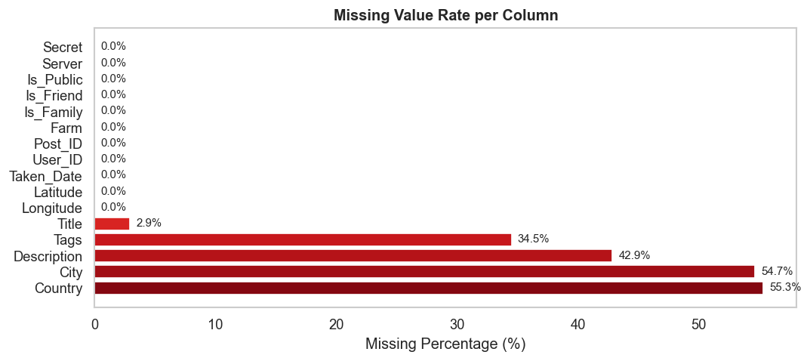
Figure 1: Missing values by column, showing high missingness in City, Country, Description, and Tags.

3.3 Temporal Analysis

3.3.1 Post time analysis (Univariate analysis)
The yearly post volume (Figure 3.1) reveals that the vast majority of photos were posted at the beginning of 2020, there are some increasing the number of posts nearby 2021. Post volume almost 0 from 2008 to 2020, and after 2021.
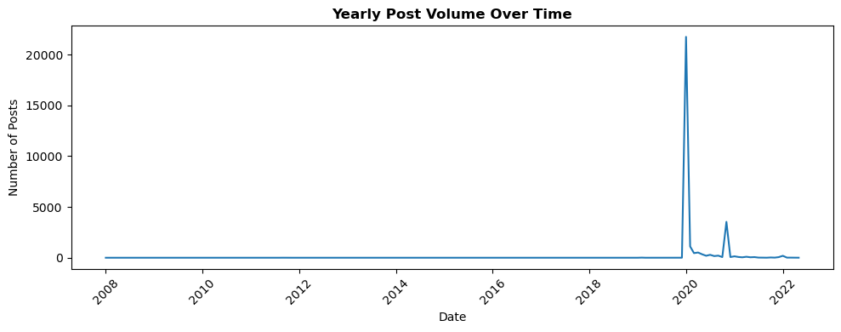
Figure 3.1: Yearly distributions of post uploads
The weekly post volume (Figure 3.2) shows that Sunday records the highest volume, almost 7000 posts, followed by Monday and Tuesday, from Wednesday to Saturday is steady no more than 4000.
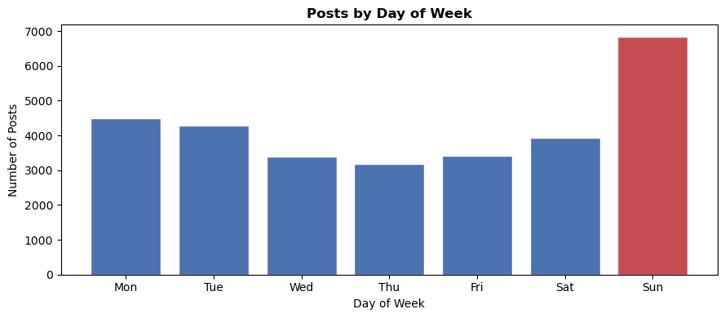
Figure 3.2: Weekly distributions of post uploads.
The Posting and Taking time compare plots (Figure 3.3) across the day. The distribution of Taken shows a clear peak during daytime, particularly around early afternoon (approximately 14:00), indicating that most photos are captured when users are active and lighting conditions are favourable. In contrast, the distribution of posting gradually increases throughout the day and reaches its highest point in the afternoon and evening (e.g.15:00-17:00, 21:00–22:00).
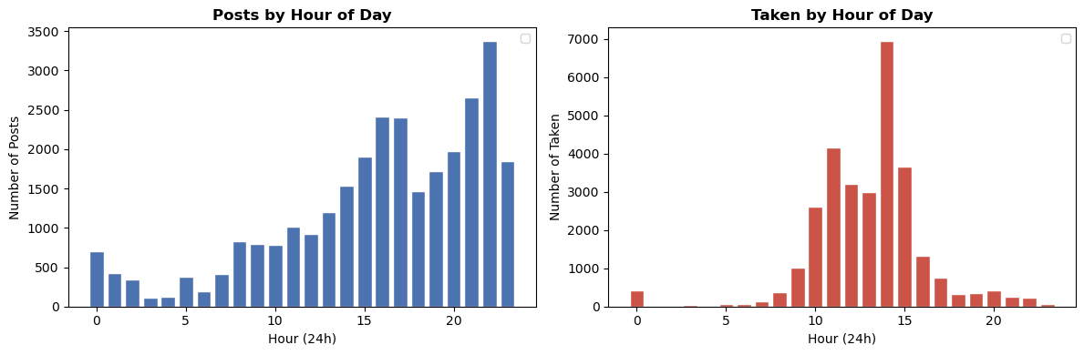
Figure 3.3: Daily distributions of post and taken uploads.
This temporal pattern is consistent with leisure-driven media sharing, where users tend to take photos during the day but prefer to upload them later, likely when they have more free time or are more engaged with social media. Additionally, very few photos are taken late at night, while some posting activity still occurs, further highlighting that posting is less constrained by real-world conditions compared to content creation. Moreover, users are active on weekends. For ML models predicting engagement or content volume, time-of-day and day-of-week are likely to be strong engineered features.

3.3.2 Upload time analysis (Bivariate analysis)
A new variable, upload_delay (defined as Post_Date − Taken_Date), was created to measure the time lag between when a photo was taken and when it was uploaded. During data inspection, some records were found to exhibit negative upload delays, indicating that the recorded posting time precedes the photo capture time. This is likely due to incorrect timestamps or inconsistencies in metadata. These values are considered invalid and were excluded from further analysis.
After removing invalid values such as negative delay statistics to improve the data quality, the distribution of upload delay is observed to be highly right-skewed. Most posts are uploaded within a short period after being taken, with a median delay of approximately 39.9 hours, suggesting that users typically share content within about one or two days.
However, the distribution also exhibits a long tail extending to several hundred hours. The large number of outliers observed in the boxplot reflects this long-tailed behaviour rather than data errors. These outliers represent delayed posting patterns, such as users sharing archived or previously captured photos days or even weeks after creation. This indicates that user behaviour is heterogeneous, with both immediate and delayed posting practices coexisting.
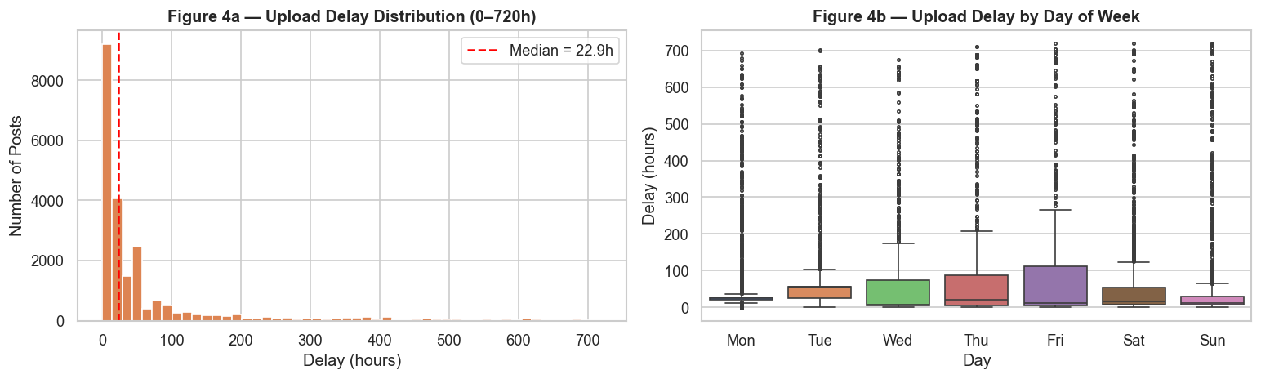
Figure 3.4: Upload delay from Photo Taken to Post.

3.4 Geographic Analysis (Bivariate analysis)
The geographic scatter plot (Figure 4.1) confirms that the dataset is heavily concentrated in the British Isles, with the mean latitude about 53.4 and mean longitude about -1 placing the centre of mass squarely over central England. Scattered points appear across continental Europe, with very few from other continents.
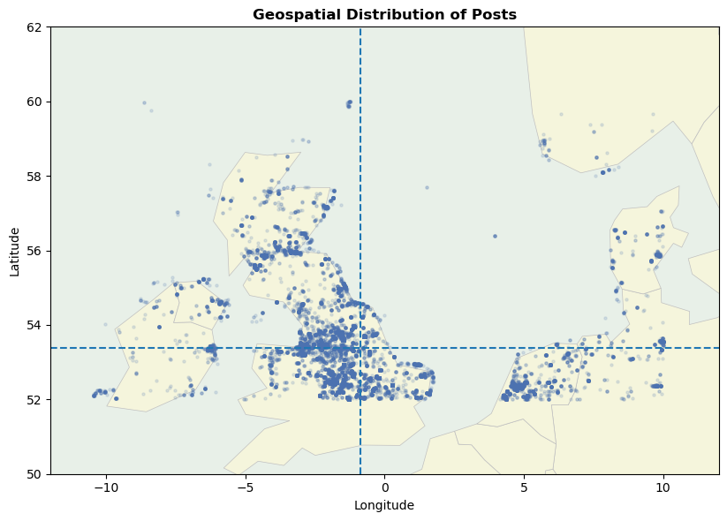
Figure 4.1: Geographic distribution of photos.
The Country attribute suffers from inconsistent labelling. In Figure 4.2, the ‘United Kingdom’ ranks first with 5508 records, but there are also records for regions such as ‘uk’, ‘england’, ‘scotland’, and ‘wales’, and the number of records is significantly higher than the previous chart. They are parts of the United Kingdom or shortname. It also has a label ‘united kingdon’ which is spelled wrong. However, the conclusion that Britain is at the top of the list can still be drawn.
This inconsistency is a significant data quality issue that would require resolution before any location-based modelling. Examples include unifying different names for a country and correcting spelling errors. The goal is to reduce data complexity and make it easier to use and read.
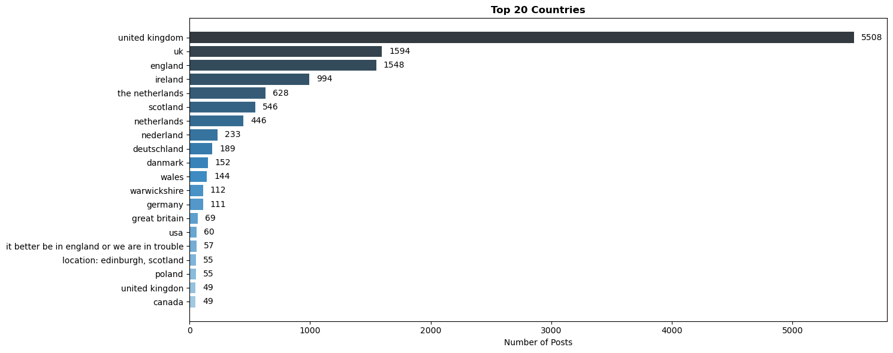
Figure 4.2: Top20 countries upload.
Regarding the distribution of the top ten cities in terms of post volume (Figure 4.3), the data is highly concentrated. The city entry 'royston, barnsley' leads by a wide margin with nearly 3,000 posts. This is likely attributable to one or two prolific users who consistently tag their location this way. It far surpassed Dublin in second place. The number of posts in other cities decreases rapidly, showing a clear head effect overall.
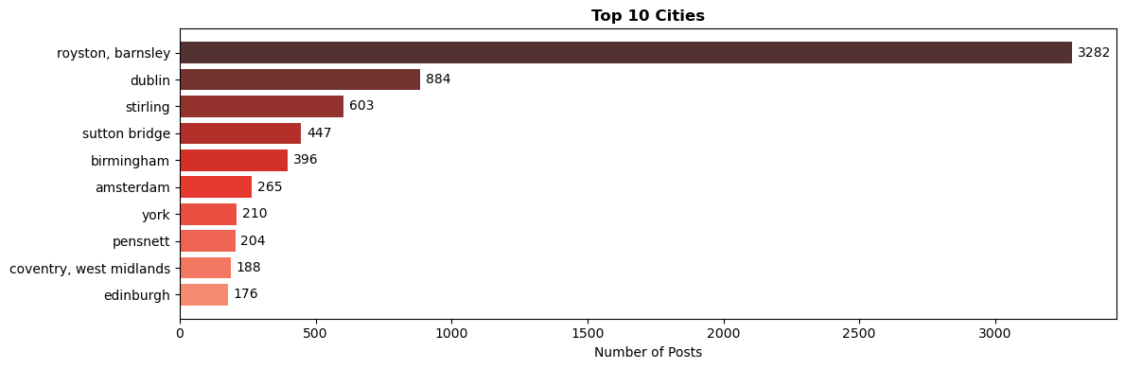
Figure 4.3: Top10 cities uploaded.

3.5 Tag Analysis (Univariate analysis)
Tags are present in 65.5% of records. The most common tag is '2020' (5508 occurrences), followed by user-specific tags such as 'barrycornelius' and 'oxonraces', and subject-matter tags like 'bird' and 'birds'.
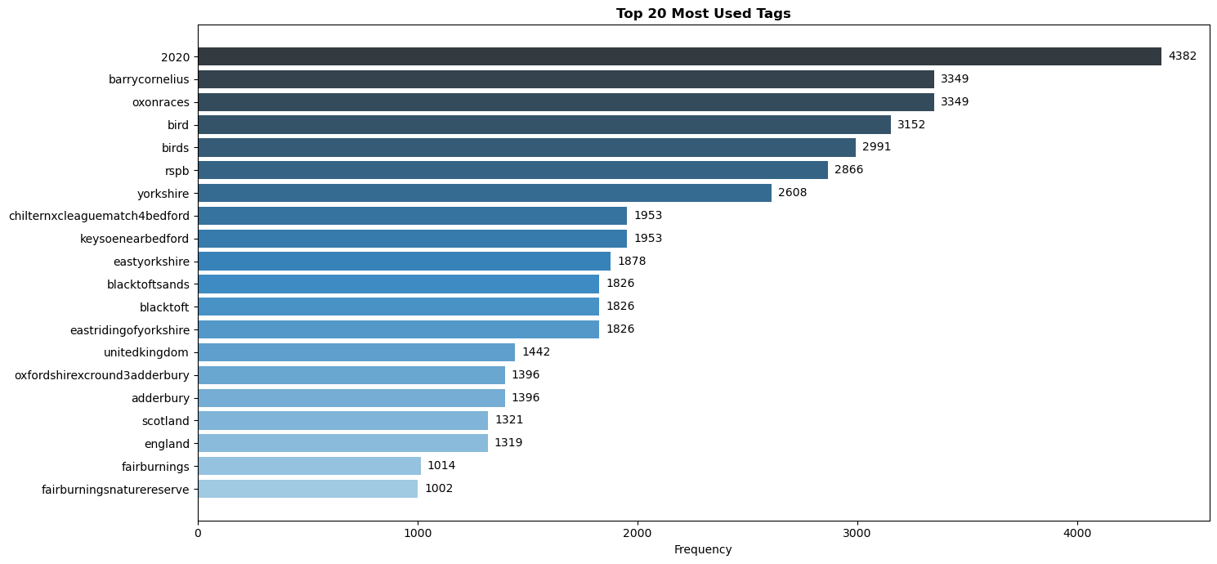
Figure 5.1: Top20 most used Tags
This histogram shows the distribution of tags per post, with a pattern peaking at 7 (over 4,000), followed by 4 and 10-13 tags. The mean is 11, and the median is 9 tags, indicating a right-skewed trend. Posts with over 20 tags are rare, and very few use more than 30 tags. It's worth noting that there's a significant number of tags at the 40 tags, which could include the subsequent ML.
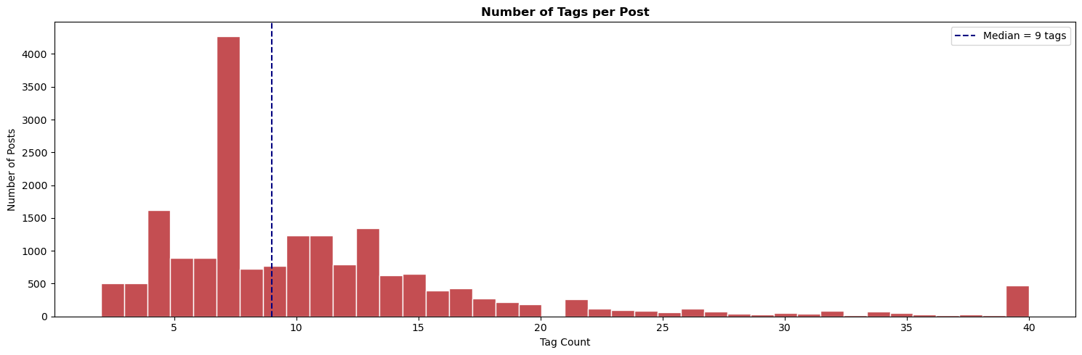
Figure 5.2: Tags number per Post.

3.6 Description Length Analysis (Univariate analysis)
This length of description shows the character distribution of post descriptions (Figure 6, left), exhibiting a bimodal, right-skewed distribution. The first peak occurs in the very short range (0-20 characters), representing the most concentrated description length; the second secondary peak occurs around 220-240 characters. The median is 83 characters, indicating that half of the posts have descriptions shorter than 83 characters. As the character count increases, the number of posts decreases rapidly, with posts exceeding 500 characters accounting for a very small percentage, suggesting that users generally prefer short descriptions.
According to Figure 6 (right), the most common post format is fewer than 50 words, totaling 6800 posts, indicating that short text posts are the primary popular method. This is followed by Medium and Short posts, with the fewest being descriptions longer than 500 words, totaling only 847 posts. Both figures illustrate that users primarily use brief descriptions when posting, with long text descriptions accounting for a very small percentage, and the overall content style leaning towards conciseness and directness.
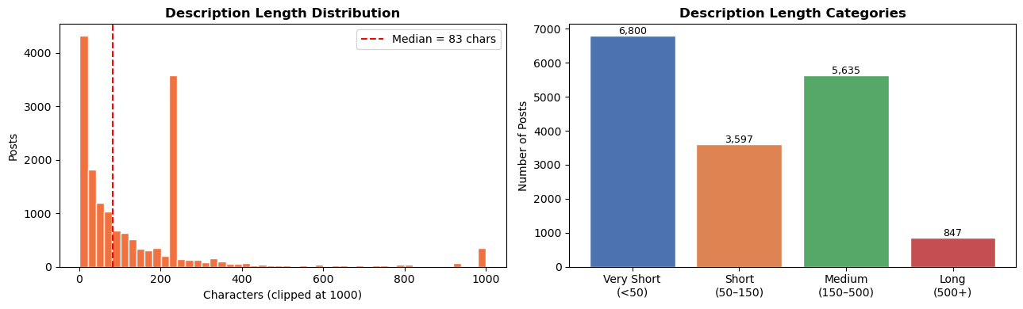
Figure 6: Description Length Distribution and Categories.

3.7 User Activity Analysis (Univariate analysis)
Most users on the platform are low-frequency contributors. The largest group, totaling 1,293 users, posted 5 or fewer times. The number of users drops sharply as posting frequency rises: 408 users made 6–20 posts, 132 users made 21–50 posts, and only 71 users made more than 51 posts. This confirms that highly active users represent a small minority of the platform’s user base.
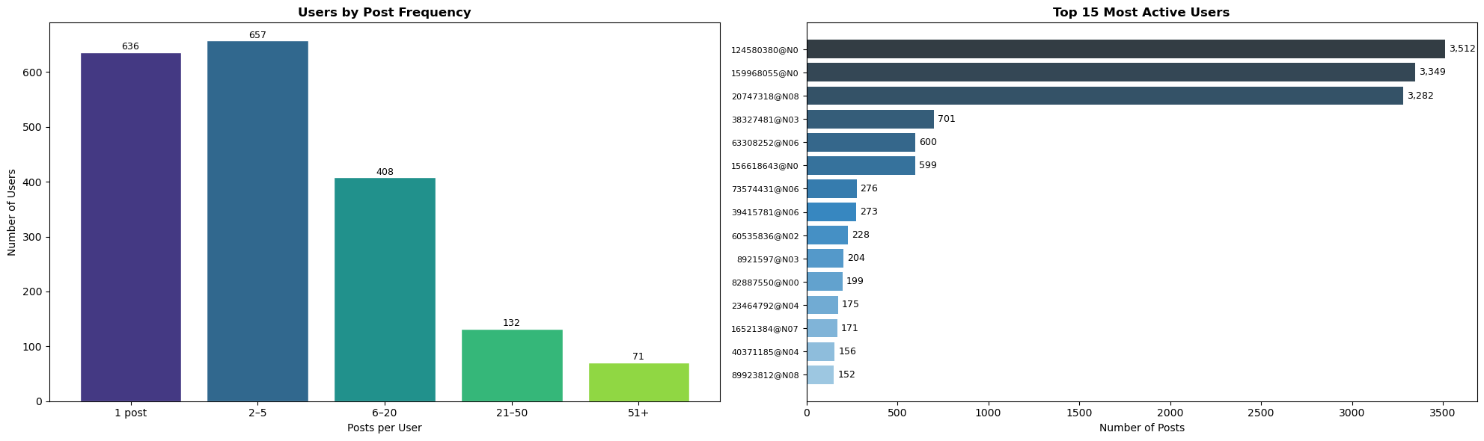
Figure 7: Post Frequency per User.
However, the top 15 most active users show a highly polarization. The leading user posts more than 3,500 items, far exceeding others. A steep decline appears after the top three users, showing that only a minimal share of users contribute a disproportionate volume of posts. This demonstrates a typical core-periphery structure: most users are inactive or lowly active, while a small group of super users accounts for the majority of published content on the platform.

3.8 Correlationship among key features (Multivariate analysis)
Binary indicator variables (has_city, has_country, has_tags, has_description) were derived to represent the presence or absence of each attribute, enabling consistent correlation analysis across mixed-type features.
The heatmap reveals strong correlations between location-related features, particularly between ‘has_city’ and ‘has_country’ (r = 0.82), indicating that these variables often co-occur and may contain redundant information. Content-related features also show moderate correlations, with ‘has_tags’ positively associated with both ‘has_description’ and ‘tag_count’, suggesting that users who include tags tend to provide richer metadata overall. In contrast, post_hour exhibits near-zero correlation with all other variables, indicating that posting time is largely independent of content and location characteristics. The variables ‘has_tags’ and ‘tag_count’ capture related but distinct aspects of user behaviour. While ‘has_tags’ indicates the presence of tags, ‘tag_count’ reflects the intensity of tagging activity. Their moderate correlation (r ≈ 0.54) suggests that although related, they are not redundant, and both provide complementary information.
The variables ‘has_tags’, ‘has_description’, and ‘tag_count’ are the symbol of content richness, which can be used to see if the user is serious about editing the content. The variables ‘Is_Public’, ‘Is_Friend’, and ‘Is_Family’ are excluded from the correlation analysis as they exhibit no variation in the dataset (e.g., all posts are public). Including such variables would result in undefined or misleading correlation values.
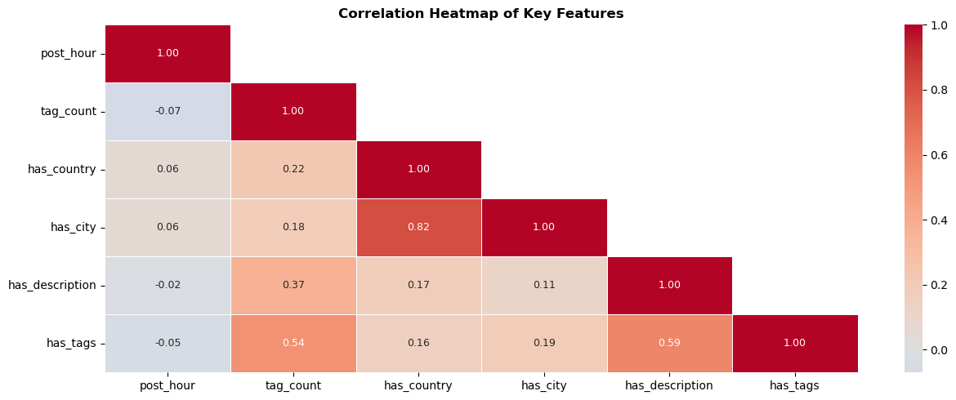
Figure 8.1: The Correlation heatmap of Key Features.
While the geospatial plot provides a clear visual representation of the spatial distribution of posts(Figure 8.2), the latitude and longitude histograms offer a univariate perspective, confirming that the data is concentrated within a specific geographic range. This supports the observation that the dataset is geographically biased, primarily within the UK region. The data is concentrated within the UK region, approximately between latitudes 50–58 and longitudes −8 to 2.
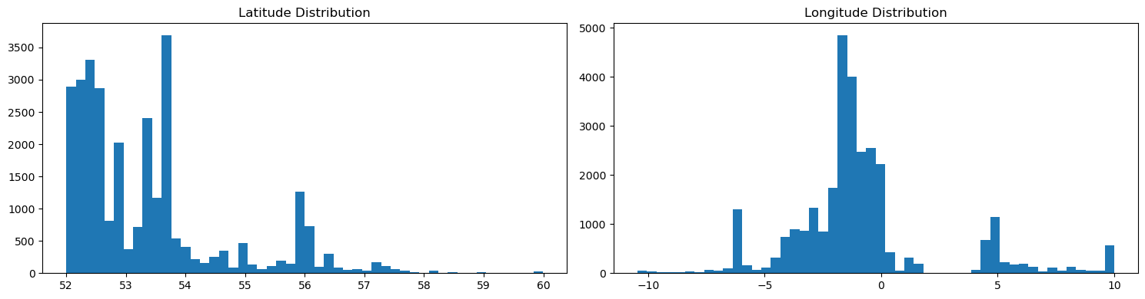
Figure 8.2: Univariate analysis of longitude and latitude.
A cross-tabulation shows that posts with tags are more likely to include descriptions, reinforcing the observed correlation. The results show a strong association between tagging and description usage. Posts with tags are far more likely to include descriptions (15,179) compared to those without tags (1,700). Conversely, posts without tags are predominantly associated with the absence of descriptions (8,492). This indicates a clear behavioural pattern where users either provide richer content with both tags and descriptions or minimal content with neither.
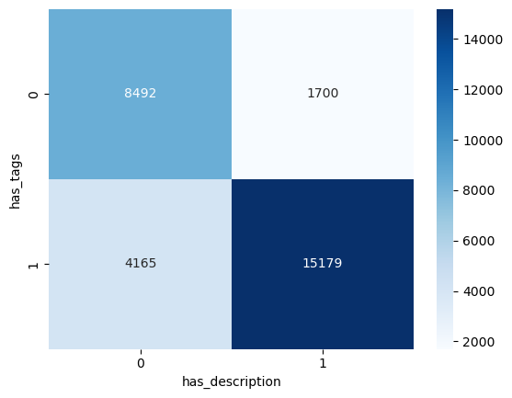
Figure 8.3: Cross-tabulation of Tag Usage and Description Presence.

4. Key Insights

4.1 Geographic Concentration
The geographic scatter plot (Figure 4.1) and summary statistics confirm that records are concentrated within the British Isles, with a mean latitude of 53.38°N and mean longitude of −0.88°W. Latitude ranges narrowly from 52.0° to 60.0°, and longitude from −10.5° to 10.0°. Of the 13,194 records carrying country labels, more than 73% (9,630 records distributed across 43 UK-related variants) refer to the United Kingdom or its constituent nations. This homogeneity implies that any model trained on the corpus would be biased toward UK-specific patterns in geography, language, and photographic subject matter, and would not generalise to global Flickr content. The concern is consistent with prior evidence that geographic skew in training data degrades model performance in underrepresented regions (Shankar et al., 2017).

4.2 Country Labels Inconsistency
The Country attribute contains 109 unique labels, many of which denote the same geographic entity. The United Kingdom alone is recorded under 43 variant forms, including "united kingdom" (5,473), "uk" (1,560), "england" (1,545), "scotland" (499), "wales" (144), and "great britain" (69). Further variants include trailing whitespace ("scotland ", 47), full-sentence entries ("it better be in England or we are in trouble", 57), and metadata-style strings ("location: edinburgh, scotland", 55). Comparable inconsistency affects the Netherlands, which appears as both "the Netherlands" and "Nederland". As illustrated in Figure 4.2, frequency-based or classification analyses would produce misleading results in the absence of entity resolution, which is a challenge in user-contributed geographic data (Ballatore et al., 2013).

4.3 City Rankings Reflect Individual User Behaviour
The city "royston, barnsley" leads the dataset with 3,282 posts (Figure 4.3), substantially exceeding the second-ranked city, Dublin. However, all 3,282 posts originate from a single user (20747318@N08) through inspection, indicating that the ranking reflects the activity of individuals rather than genuine geographic popularity. Analysis of popular photography locations must account for user-level confounding, for instance by normalising city counts by unique user count. This phenomenon exemplifies the "prolific user problem" in user-generated content research (Benevenuto et al., 2009).

4.4 User Contributions Follow a Power-Law Distribution
User activity analysis (Figure 7) reveals a classic long-tail distribution. A total of 636 users (33.4%) posted only once; the median user contributed 3 posts; yet the top 10 users collectively account for 44.1% of all records, and the single most active user contributed 3,512 posts (11.9% of the corpus). This skew is consistent with the "1% rule" observed across user-generated content platforms, whereby a small fraction of users generates the majority of content (van Mierlo, 2014). For modelling, this implies that user-level features would be dominated by a small set of contributors, and that stratified sampling or user-level weighting would be necessary to avoid bias.

4.5 Missing Value in Country and City
Missing-value analysis (Figure 1) exposes a striking asymmetry: Latitude and Longitude are populated for 99.99% of records (only one missing value each), while City is missing for 54.7% of records and Country for 55.3%. This pattern reflects the mechanism of capture — coordinates are recorded automatically through device EXIF metadata or the Flickr platform, whereas city and country labels depend on manual user input. The asymmetry presents a practical opportunity: reverse geocoding via services such as the Google Maps API or OpenStreetMap Nominatim could impute the 16,144 missing city values and 16,342 missing country values with high accuracy (Goldberg et al., 2007).

4.6 Public-Centric Privacy-related Attributes
Inspection of the privacy-related attributes reveals that Is_Public is uniformly set to 1, while Is_Friend and Is_Family are uniformly set to 0 across all 29,535 non-null records. These values indicate that every photo in the dataset is fully public with no friend-only or family-only viewing restrictions. This uniformity is expected, as the dataset was collected through Flickr's public API, which only returns publicly accessible content. From an analytical standpoint, these three columns exhibit zero variance and carry no discriminative power — including them in correlation analysis would produce undefined values, and including them in machine learning models would introduce noise without predictive benefit. They should be excluded during preprocessing, effectively reducing the usable feature set from 18 to 15 columns.

4.7 Photo-Taking and Uploading Exhibit Distinct Temporal Patterns
The hourly comparison (Figure 3.3) shows that photo-taking peaks sharply around 14:00, reflecting daylight conditions, whereas posting is distributed more evenly across the day with peaks at 15:00–17:00 and 21:00–22:00. The weekly distribution (Figure 3.2) indicates elevated posting volume on Sundays. The median upload delay of approximately 39.9 hours (Figure 3.4) indicates that most users upload in two days. The massive divergence between mean(1631.4 hours) and median(39.9 hours) indicates a highly skewed delay distribution and suggests two patterns: immediate sharers who upload within 2 days, and creators who upload a batch of older content. This is a comparable bimodal pattern which has been identified in the broader social media literature (Bakhshi et al., 2014).

4.8 Tags Contain Semantic Duplicates and Mixed Labelling Purposes
The tag analysis (Figure 5.1) demonstrates that individual tags serve heterogeneous functions: temporal markers ("2020", 4,382 occurrences), user signatures ("barrycornelius", 3,349), geographic labels ("yorkshire", 2,608), and content descriptors ("bird", 3,152). Semantic duplication is also present, such as "bird" (3,152) and "birds" (2,991) appear as separate tags, alongside more than 60 bird-related variants including "birdwatching", "birdsofprey", and "blackbird". Therefore, Raw tag-frequency analysis overestimates vocabulary diversity and underestimates true topic prevalence. Tag standardisation through stemming or lemmatisation would be necessary before tags could be used as features for classification or clustering (Heymann et al., 2008).

4.9 Missing Content Metadata Shows Structured Co-occurrence
Cross-tabulation of content completeness indicates that 8,492 records (28.8%) lack both tags and descriptions, constituting a content missing subset. Among content records, 15,179 contain both tags and descriptions, 4,165 contain tags without a description, and only 1,700 contain a description without tags. The geographic labels exhibit a comparable pattern: 11,971 records include both city and country, 14,921 include neither, while only 1,421 carry a city without a country and 1,223 a country without a city. This structured missingness suggests that users tend to populate metadata fields comprehensively or omit them entirely, rather than filling individual fields selectively. This is a pattern consistent with prior research on metadata provision behaviour in social media (Ames & Naaman, 2007).

4.10 The Narrow Dataset’s Temporal Scope
The Min_Taken_Date column contains only 16 unique values, all falling between 1 January 2020 and 16 January 2020. These dates represent batch extraction windows rather than meaningful photo metadata in which each batch contains between 576 and 3,784 records. While Post_Date spans from January 2008 to May 2022 and Taken_Date covers the first 17 days of January 2020, this apparent temporal range is misleading. The Taken_Date concentration into a 17-day window (1–17 January 2020) means the dataset captures a seasonal snapshot rather than a longitudinal record of Flickr activity. Consequently, any temporal analysis (seasonal trends, year-over-year growth, holiday effects) is unreliable because the data reflects a single time slice collected in batches. Researchers working with similarly constructed web-scraped datasets have noted that batch extraction artefacts can introduce temporal bias that distorts trend analysis if not properly accounted for (Thelwall, 2014).

5. Machine Learning Research Questions and Justifications

5.1 Can we predict missing Country and City labels from geographic coordinates and tag patterns using classification?
The Missing Value Analysis (Figure 1) shows that Country (55.3%) and City (54.7%) have more than half of their values missing in the dataset, whereas latitude and longitude have near full coverage at 99.99% (Insight 4.5). Additionally, there are 109 inconsistent labels found within the Country field, including 43 variants of the United Kingdom (Insight 4.2). A multi-class classification model (e.g. Random Forest) could be used on the dataset of 13,194 rows having country labels in order to make predictions on standardised geographic labels in another 16,000+ rows. The latitude, longitude, and tag-related indicators will be used as predictors, whereas Country or City labels will serve as a target variable in the model. This approach addresses the high rate of missing values of geographic metadata as well as inconsistencies of location labels provided by the users, allowing for data enrichment through automation.

5.2 Can we detect templated or non-organic content using anomaly detection or binary classification?
The description analysis reveals that there are two recurring templates used by one individual user which occupy 3,349 out of 16,879 non-null descriptions (19.8%), indicating the presence of non-organic content (Insight 4.6). Tags like “barrycornelius” have been used to denote user identity rather than describing content. A binary classification task where Is_Template serves as the target variable, with 1 meaning that the post is a templated post and 0 meaning it is organic content. A classification or anomaly detection model (e,g, Isolation Forest) could be trained on inputs such as TF-IDF descriptions, description length, number of tags and user posting frequency. This ensures that any subsequent analysis such as topic modelling or trend detection does not contain skewed data due to templated posts.

5.3 Can we segment users into behavioural personas using clustering techniques?
User activity follows a power-law distribution (Figure 7), where 636 users (33.5%) posts only once, while the top 10 contributes to 44.1% of all posts with the most active user creating 3,512 posts (11.9%) (Insight 4.4). Additionally, city-level dominance (e.g. “royston, barnsley” with 3,282 posts from a single user) indicates a pattern influenced by individual activities rather than genuine geographic popularity (Insight 4.3). To capture the behavioural differences, unsupervised clustering algorithms such as K-Means by clustering users according to their behavioural data, which includes the frequency of posts, average upload date, average number of tags, percentage of posts with description and geographic spread. The clustering model will output distinct user types, such as casual users, prolific posters and metadata-heavy users. This approach facilitates a method to help understand heterogeneity among users and minimise the effects of dominant users in future analysis.

5.4 Can we standardise noisy and semantically duplicated tags into meaningful subject categories using multi-label classification?
Tag analysis shows over 7,000 unique tag combinations with substantial semantic duplication. Examples include “bird” used 3,152 times and “birds” used 2,991 times, together with 60 related variants (Insight 4.8). To address this, a multi-label classification (e.g. Fine-tuned BERT) can be created to classify unstructured tags into standardised subject categories. In this model, input features consist of tokenised tags, titles and descriptions while the output is a set of standardised subject category labels assigned to each post. This method helps reduce vocabulary noise, ensures semantic consistency and improves the quality of recommendation and search engines.

5.5 Can we predict upload delay using regression based on temporal and contextual features?
The upload delay distribution (Figure 3.4) is highly skewed with a median of 34.8 hours and a mean of 1,573.7 hours, indicating a long-tailed distribution driven by a subset of significantly delayed uploads (Insight 4.7). While most users upload content within one to two days, a small group of users exhibit substantially longer delays, indicating the presence of distinct posting behaviours rather than a uniform pattern. Temporal analysis shows that the peak hours for photo taking are around 14:00, while posting is concentrated later in the day, especially Sunday evenings, indicating users do not immediately upload their photos. To model this behaviour, the Gradient Boosted Regression approach can be applied, where input variables are taken hour, day of week, weekend flag and user activity level, and output variable is the upload delay measured in hours. The model can be used to optimise content freshness and user engagement by enabling the platform to schedule content visibility and notifications based on predicted upload timing.

6. Conclusion
This exploratory data analysis provides a comprehensive understanding of the providing dataset, which consists of publicly shared photos over a long time period and is geographically concentrated in the UK region.
According to the analysis, several key behavioural patterns were identified. Most users upload photos shortly after they are taken, with a median delay of approximately one day, although a long-tailed distribution indicates that some users upload content much later. Temporal analysis shows that photo-taking activity occurs mainly during the day, while posting behaviour extends into the evening. In addition, content-related features such as tags and descriptions are strongly associated, suggesting that users either provide rich metadata or minimal information. User activity is also highly uneven, with a small number of highly active users contributing a large proportion of posts.
The analysis also revealed several data quality issues, including invalid negative upload delays, extreme outliers, inconsistent location labels, and missing values in textual fields. These issues highlight the need for appropriate data cleaning and preprocessing before modelling.
These findings provide important guidance for machine learning modelling. The presence of non-linear relationships, mixed data types, and interaction effects suggests that tree-based models, such as Random Forest, are well-suited for this dataset. Features derived from temporal behaviour (e.g., posting hour), content richness (e.g., tag usage and description presence), and user activity are likely to be informative predictors. Overall, the EDA results support the selection of suitable features and modelling approaches for predicting user behaviour or engagement.

7. References
Ames, M., & Naaman, M. (2007). Why we tag: Motivations for annotation in mobile and online media. In Proceedings of the SIGCHI Conference on Human Factors in Computing Systems (pp. 971–980). ACM. https://doi.org/10.1145/1240624.1240772
Bakhshi, S., Shamma, D. A., & Gilbert, E. (2014). Faces engage us: Photos with faces attract more likes and comments on Instagram. In Proceedings of the SIGCHI Conference on Human Factors in Computing Systems (pp. 965–974). ACM. https://doi.org/10.1145/2556288.2557403
Ballatore, A., Bertolotto, M., & Gavin, D. (2013). Geographic knowledge extraction and semantic similarity in OpenStreetMap. Knowledge and Information Systems, 37(1), 61–81. https://doi.org/10.1007/s10115-012-0571-0
Benevenuto, F., Rodrigues, T., Cha, M., & Almeida, V. (2009). Characterizing user behavior in online social networks. In Proceedings of the 9th ACM SIGCOMM Internet Measurement Conference (pp. 49–62). ACM. https://doi.org/10.1145/1644893.1644900
Goldberg, D. W., Wilson, J. P., & Knoblock, C. A. (2007). From text to geographic coordinates: The current state of geocoding. URISA Journal, 19(1), 33–46.
Heymann, P., Ramage, D., & Garcia-Molina, H. (2008). Social tag prediction. In Proceedings of the 31st Annual International ACM SIGIR Conference (pp. 531–538). ACM. https://doi.org/10.1145/1390334.1390425
Shankar, S., Halpern, Y., Breck, E., Atwood, J., Wilson, J., & Sculley, D. (2017). No classification without representation: Assessing geodiversity issues in open data sets for the developing world. In NeurIPS Workshop on Machine Learning for the Developing World. https://arxiv.org/abs/1711.08536
van Mierlo, T. (2014). The 1% rule in four digital health social networks. Journal of Medical Internet Research, 16(2), e33. https://doi.org/10.2196/jmir.2966
Thelwall, M. (2014). Big data and social web research methods. University of Wolverhampton. https://doi.org/10.5281/zenodo.10600

