

TITLE: Data Backup and Recovery Guide
ORGANIZATION: Northwind Analytics, Inc.
DEPARTMENT: IT
SENSITIVITY: Internal
VERSION: 1.0
EFFECTIVE_DATE: 2025-05-01
_______________________________________________________________________________________________

Data Backup and Recovery Guide

1. Backup Schedule, RTO, and RPO
System | Backup Method | RTO | RPO
Production databases | Continuous replication + nightly snapshot (30-day retain) | 4 hours | 15 minutes
Internal business systems (HR portal, ticketing) | Included in standard backup cycle | 24 hours | Standard cycle
File shares / SharePoint | Daily backup (90-day retain) | 48 hours | 24 hours
Employee laptops | Automatic cloud backup via OneDrive sync (continuous) | Not applicable | Continuous

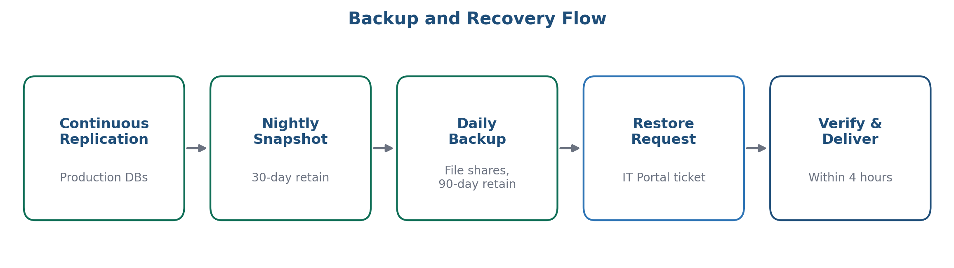
Figure 1: Backup and recovery flow

2. Requesting a Restore
Submit a "Data Restore" ticket via the IT Service Portal specifying the file/system, desired restore point, and business justification. Restores for individual files typically complete within 4 business hours.

3. Frequently Asked Questions

How far back can I restore a file?
File shares retain 90 days of daily backups; production databases retain 30 days of nightly snapshots plus continuous replication for near-instant recovery within that window.

What's the difference between RTO and RPO?
RTO (Recovery Time Objective) is how long a system may be down before it must be restored. RPO (Recovery Point Objective) is how much data loss is acceptable, measured as time since the last backup point.

Can I restore just one file, or does a restore affect the whole system?
Individual file and folder restores are supported and are the most common request type; specify the exact file/system scope in your Data Restore ticket.

4. Contact
it-helpdesk@company.com (routine) | it-oncall@company.com (P1 emergency)

