

TITLE: Security Incident Response Runbook
ORGANIZATION: Northwind Analytics, Inc.
DEPARTMENT: IT
SENSITIVITY: Confidential
VERSION: 1.4
EFFECTIVE_DATE: 2026-03-01
_______________________________________________________________________________________________

Security Incident Response Runbook

1. Severity Levels
Severity | Definition | Response Time
SEV1 | Active data breach or system-wide outage | Immediate, 24/7; incident commander assigned within 15 minutes
SEV2 | Suspected compromise of a single system/account | 1 hour during business hours, 4 hours off-hours
SEV3 | Policy violation or low-risk anomaly | Within 1 business day

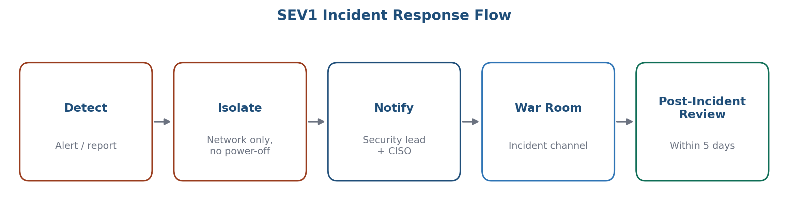
Figure 1: SEV1 incident response flow

2. Immediate Actions (SEV1)
- Isolate affected systems from the network (do not power off, to preserve forensic evidence).
- Notify the Security on-call lead and CISO immediately.
- Open an incident channel and war room bridge.
- Begin the incident log (timeline of actions taken).

3. Communication
- Internal stakeholders notified within 30 minutes of SEV1 declaration.
- Legal and Compliance loop in immediately if customer data may be involved (potential breach notification obligations).
- Do not communicate externally without Legal/Comms sign-off.

4. Post-Incident
A post-incident review (blameless retrospective) is required within 5 business days of SEV1/SEV2 resolution, documenting root cause, timeline, and remediation action items with owners and due dates.

5. Frequently Asked Questions

Who has authority to declare a SEV1 incident?
Any employee who identifies a credible active data breach or system-wide outage should immediately notify the Security on-call lead, who confirms severity classification and assigns an incident commander.

What if I'm unsure whether something is a SEV1 or SEV2?
When in doubt, escalate as the higher severity (SEV1) -- it is far easier to de-escalate a confirmed lower-severity issue than to recover time lost from an under-classified active breach.

6. Contact
security-oncall@company.com

