

TITLE: Software Request and Provisioning SOP
ORGANIZATION: Northwind Analytics, Inc.
DEPARTMENT: IT
SENSITIVITY: Internal
VERSION: 1.2
EFFECTIVE_DATE: 2025-08-01
_______________________________________________________________________________________________

Software Request and Provisioning SOP

1. Purpose
Defines how employees request new software licenses or SaaS tools.

2. Approval Thresholds
Estimated Annual Cost | Approval Required | SLA
Under $500/year | Auto-approved by IT if on pre-approved vendor list | 1 business day
$500 - $5,000/year | Manager approval + IT security review | 5-7 business days
Over $5,000/year | Above + Finance approval + vendor security questionnaire | 5-7 business days

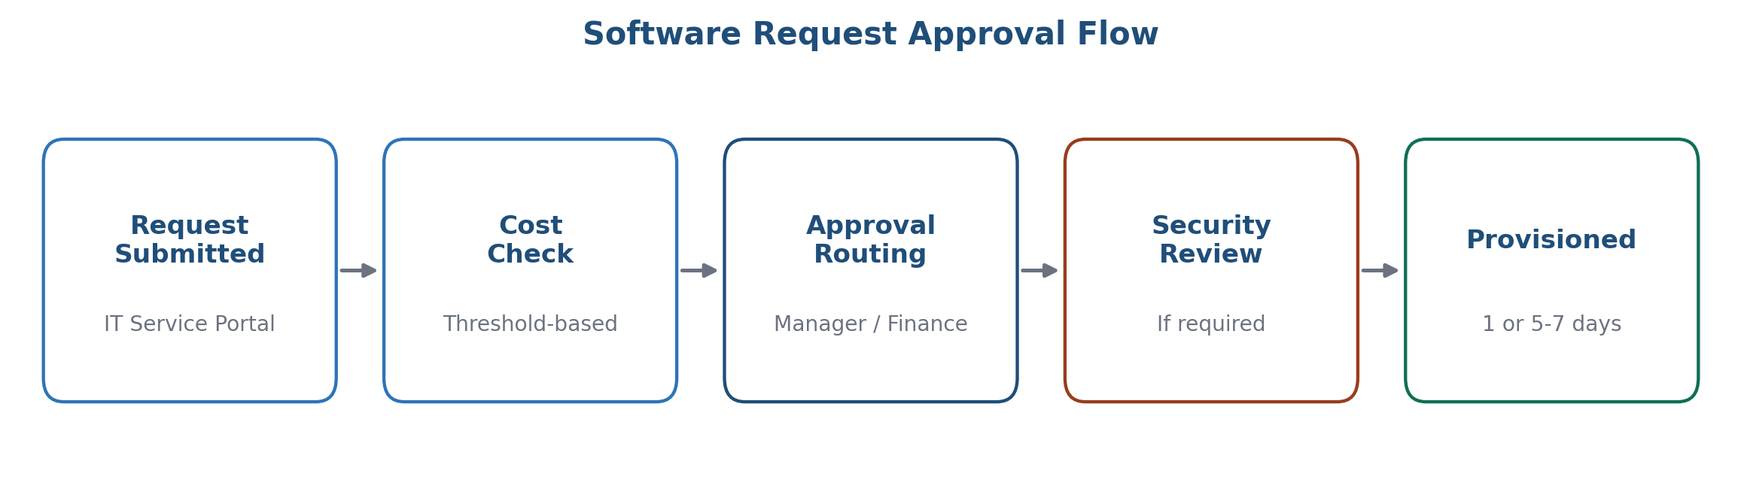
Figure 1: Software request approval flow

3. Process
Submit a request via the IT Service Portal ("Software Request" form), including business justification and estimated cost. The request is then routed automatically based on the cost threshold above.

4. Prohibited
Employees may not install unapproved software on company devices or use personal cloud storage (e.g., personal Dropbox/Google Drive) for company data.

5. Frequently Asked Questions

What counts as "business justification"?
A brief explanation of the work need the tool addresses and why existing approved tools don't cover it -- typically 2-3 sentences is sufficient for the request form.

My request was flagged for security review -- what does that involve?
IT security reviews data handling practices and SSO compatibility for the requested tool; most reviews complete within the standard 5-7 business day SLA.

6. Contact
it-helpdesk@company.com

