

TITLE: VPN Access and Troubleshooting Guide
ORGANIZATION: Northwind Analytics, Inc.
DEPARTMENT: IT
SENSITIVITY: Internal
VERSION: 1.4
EFFECTIVE_DATE: 2025-11-15
_______________________________________________________________________________________________

VPN Access and Troubleshooting Guide

1. Overview
This guide covers how employees request VPN access, connect to the corporate network remotely, and resolve common VPN connection issues.

2. Requesting VPN Access
New employees and contractors must submit a VPN access request via the IT Service Portal under "Network Access > VPN Request". Approval from the employee's manager is required. Provisioning typically takes 1 business day.

3. Installing the VPN Client
- Download the GlobalProtect client from the IT Software Center (internal only, not accessible from personal devices).
- Install using default settings. Administrator rights are not required on company-managed laptops.
- Enter the gateway address: vpn.companyinternal.com
- Authenticate using your corporate SSO credentials and MFA (Okta Verify).
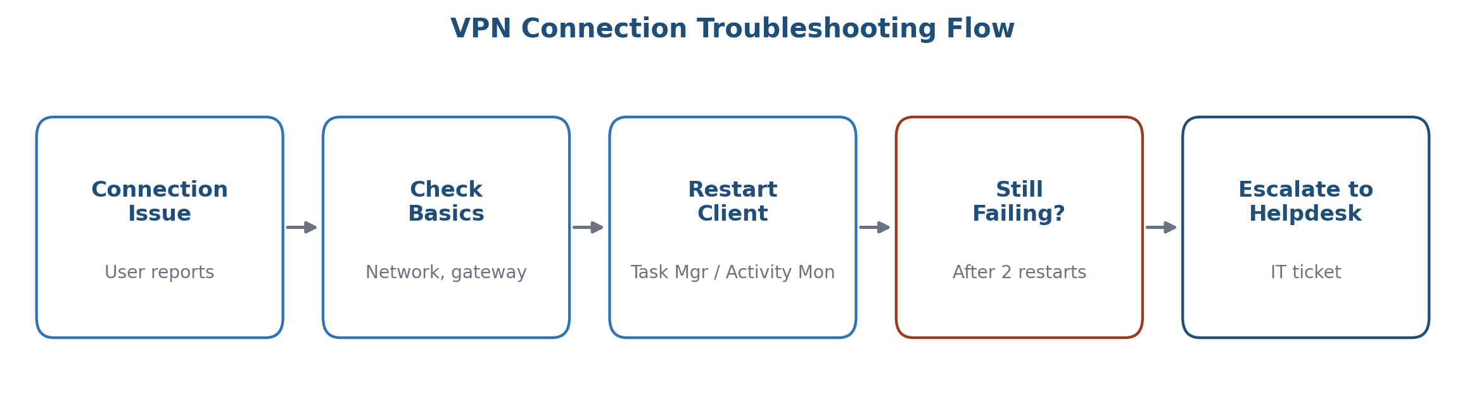
Figure 1: VPN connection troubleshooting flow

4. Common Issues and Fixes
Issue | Fix
"Connection Timed Out" error | Check internet connection; confirm gateway address; restart GlobalProtect service; escalate to IT Helpdesk after 2 restarts
MFA prompt not received | Ensure Okta Verify is installed and time-synced; try "Resend push"; use backup SMS code if no prompt within 2 minutes
Slow VPN performance | Split tunneling is on by default; run a speed test with/without VPN and share results with IT Helpdesk
VPN disconnects after 8 hours | Expected behavior -- sessions are capped at 8 hours for security compliance; simply reconnect

5. Escalation
If issues are not resolved using the steps above, raise a P2 ticket on the IT Service Portal or contact the IT Helpdesk at ext. 4100 (business hours) or the 24x7 emergency line for P1 (production-impacting) issues only.

6. Frequently Asked Questions

Can I use the VPN on my personal phone or tablet?
The GlobalProtect client used for this guide is for company-managed laptops only. For mobile email access on personal devices, see the BYOD Policy.

Why does my session disconnect every 8 hours even though I'm actively working?
This is expected, security-driven behavior, not a bug -- simply reconnect and your work session will resume.

7. Security Note
Never share your VPN credentials or MFA codes with anyone, including IT staff. IT will never ask for your password over phone or email.

